Fig.S3
(a)
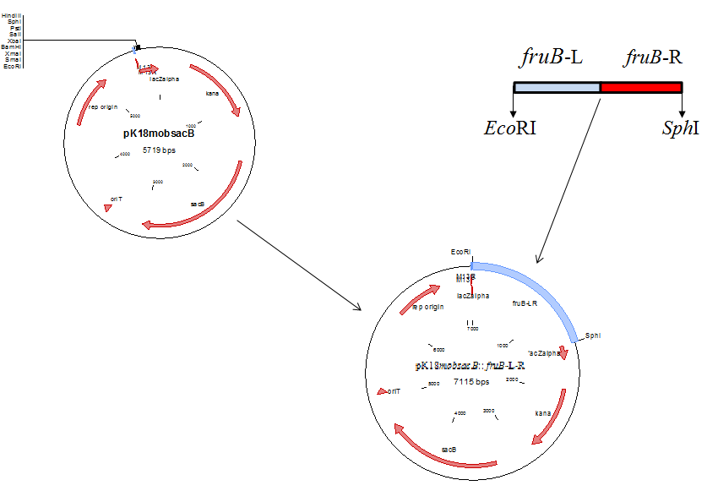
(b)
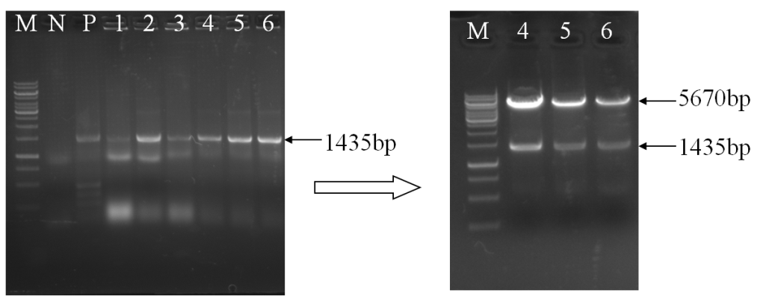
(c)
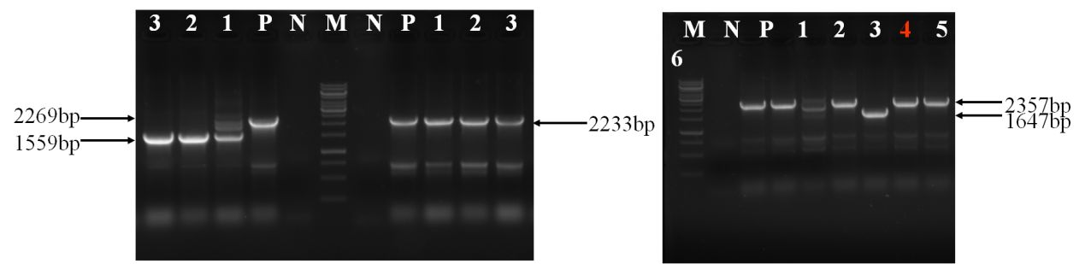
Fig.S3 (a) Construction flowchart of the fruB gene deletion vector pK18mobsacB:: fruB-L-R; (b) Construction of glk gene deletion vector pK18mobsacB:: fruB -L-R; and (c) Filtration and verification of △fruA△fruB

