Supplementary Information
Piezo1 is the cardiac mechanosensor that initiates the hypertrophic response to pressure overload
Ze-Yan Yu^{1,2,3}, Hutao Gong^{1,2,3}, Scott Kesteven^{2,3}, Yang Guo^{1,2,3}, Jianxin Wu¹, Jinyuan Li¹, Siiri E. Iismaa^{1,3}, Xenia Kaidonis¹, Robert M. Graham^{1,3}, Charles D. Cox^{1,3}, Michael P. Feneley^{2,3,4#} & Boris Martinac^{1,3#}
¹ Molecular Cardiology and Biophysics Division, Victor Chang Cardiac Research Institute, Sydney, New South Wales, Australia.
² Cardiac Physiology and Transplantation Division, Victor Chang Cardiac Research Institute, Sydney, New South Wales, Australia.
³ St Vincent’s Clinical School, Faculty of Medicine, University of New South Wales, Sydney, New South Wales, Australia.
⁴ Department of Cardiology, St Vincent’s Hospital, Sydney, New South Wales, Australia.

#To whom correspondence should be addressed:
Dr Boris Martinac
E-mail: b.martinac@victorchang.edu.au
Tel: (+61) 92958743
Dr Michael P. Feneley
E-mail: Michael.feneley@svha.org.au
Tel: (+61) 92958743

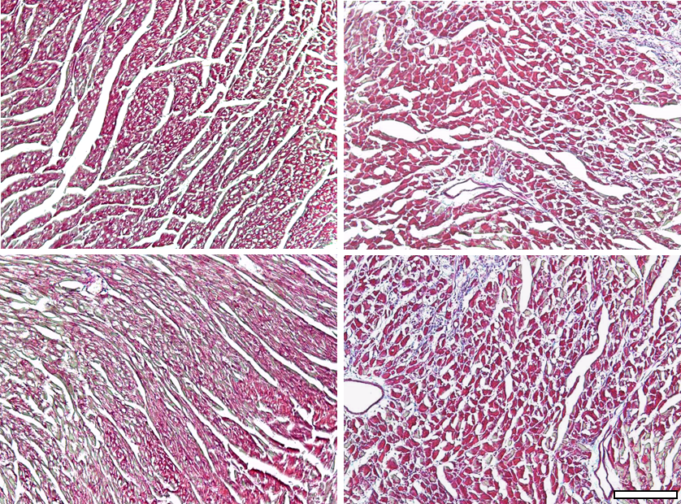
Piezo1^{P1-tdT/P1-tdT}
WT
Sham TAC
Sham TAC
WTLs
2mm
Piezo1^{P1-tdT/P1-tdT}
A
B
Sham TAC
100µm

Supplementary Fig. 1. Cardiac enlargement and cardiac fibrosis were detected 14 days after TAC. (A) Representative photos of hearts from wild type littermates (WTLs) and Piezo1^{P1-tdT/P1-tdT} mice at 14 days after sham or TAC. (B) Representative photos of cardiac fibrosis, evaluated by Masson’s trichrome staining of LV tissue from WTLs mice subjected to TAC versus sham-operated controls. Scale bar = 100 µm.

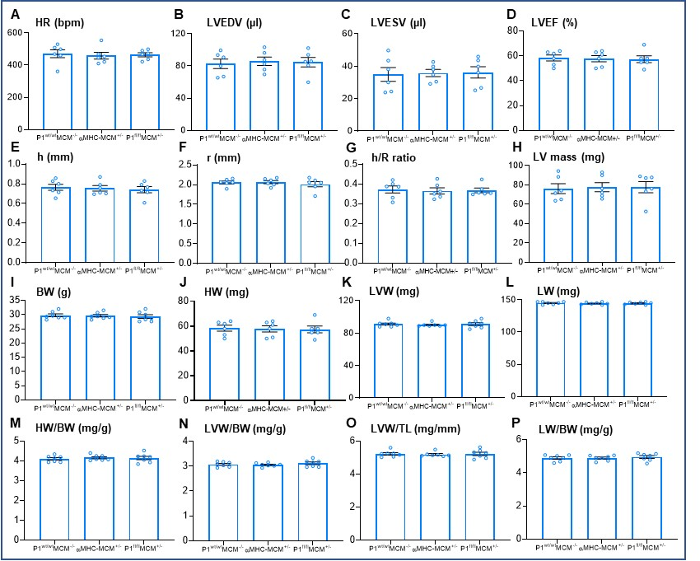
Supplementary Figure 2. The Piezo1^{fl/fl}MCM^{+/-} mice show normal cardiac function and morphology under baseline conditions. (A-F) Echocardiographic analysis of (A) HR, heart rate, (B) LVEDV, LV end-diastolic volumes, (C) LVESV, LV end-systolic volumes, (D) LVEF, LV ejection fraction, (E) h, LV wall thickness, (F) r, chamber radius, (G) h/r ratio, LV wall thickness to chamber radius ratio and (H) LV mass, n = 6/group. (I-P) Anatomic analysis of (I) BW, body weight, (J) HW, heart weight, (K) LVW, left ventricular weight, (L) LW, lung weight, (M) HW/BW, heart weight to body weight ratio, (N) LVW/BW, left ventricular weight to body weight ratio, (O) LVW/TL, left ventricular weight to tibia length ratio, (P) LW/BW, lung weight to body weight ratio, n = 7/group. Results are presented as mean ± SEM, One-way ANOVA followed with Tukey’s post-hoc test.
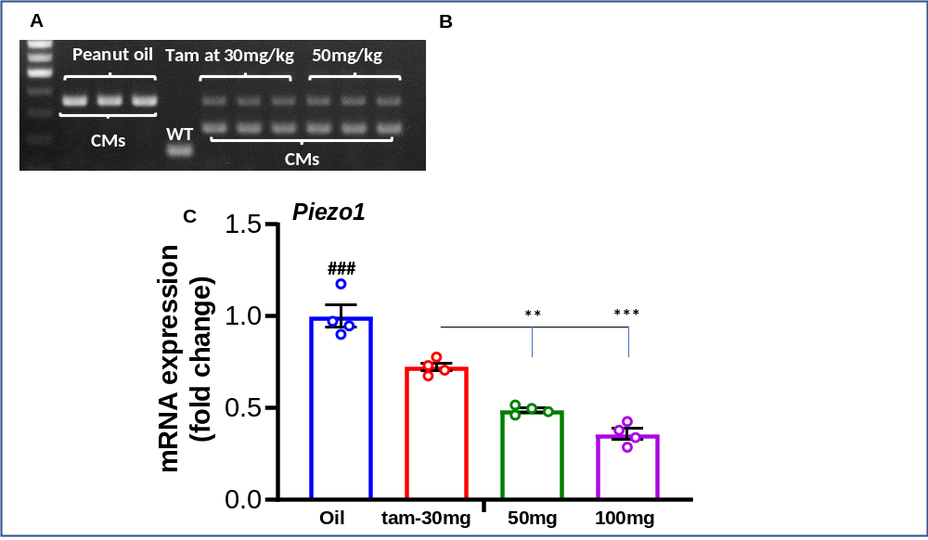
Supplementary Figure 3. Tamoxifen induced recombinase activity in a dose-dependent manner. (A-B) Confirmation of Cre-recombination by PCR of cardiac genomic DNA extracted from isolated CMs from P1^{fl/fl}MCM^{+/-} hearts 10 days after the last injection with tamoxifen (tam) at 30mg, 50mg and 100 mg/kg/d for 3 consecutive days or with peanut oil (n = 3/group). (C) Piezo1 mRNA expression confirmed by RT-PCR in isolated CMs from P1^{fl/fl}MCM^{+/-} hearts from tamoxifen or peanut oil treated mice (n = 4/group) using GAPDH as an internal control. Results are presented as mean ± SEM, One-way ANOVA followed with Tukey’s post-hoc analysis, ### p < 0.001 vs. all tamoxifen-treated groups, **p < 0.01, ***p < 0.001 vs. tamoxifen 30mg/kg/d group.

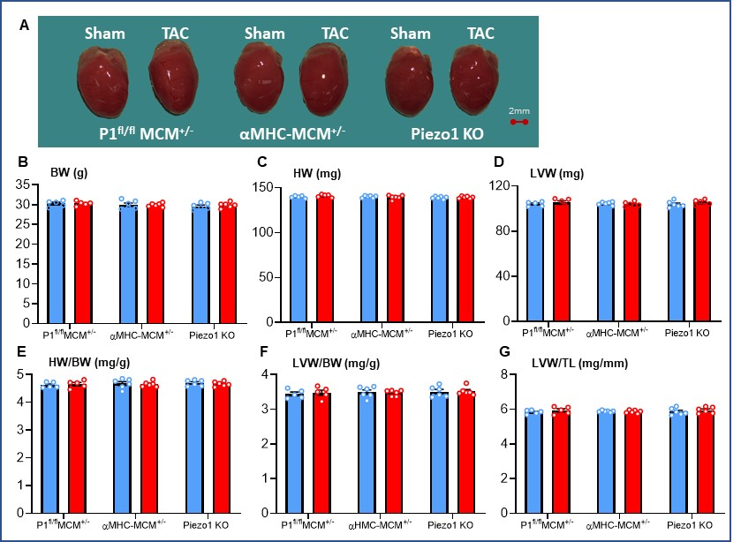
Supplementary Figure 4. Piezo1 KO mice and control mice do not develop LVH in response to pressure overload 2 days after TAC. (A) Representative photos indicate normal heart size 2 days after TAC or sham surgery in αMHC-MCM^{+/-} mice, Piezo1 KO mice and P1^{fl/fl}MCM^{+/-} controls. (B-G) Morphological analysis of (B) BW, body weight. (C) HW, heart weight. (D) LVW, left ventricular weight. (E) HW/BW, heart weight to body ratio. (E) LVW/BW, left ventricular weight to body weight ratio. (G) LVW/TL, left ventricular weight to tibia length ratio, n = 5-6/group. Results are presented as mean ± SEM, Two-way ANOVA followed with Tukey’s post-hoc test.

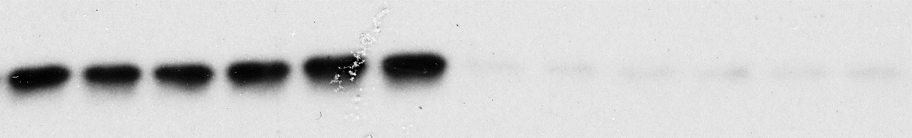
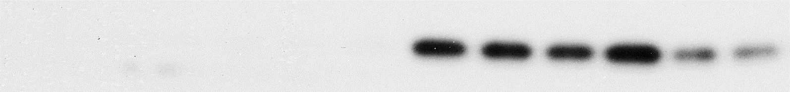
GAPDH
Histone H2B
Cytoplasmic
Nuclear
37kDa
14kDa

Supplementary figure 5. Demonstration of successful fractionation of compartments. The purity of the fractions extracted from the LV tissue was assessed by western blot using specific marker proteins: GAPDH for cytoplasmic fraction and Histone H2B for nuclear fraction. Each fraction (n=6/group) was run side-by-side on the same blot and then probed separately against each of two primary antibodies: GAPDH and H2B to validate fraction purity.

 | 2 days
 | WTLs |  | Piezo1^{P1-tdT/P1-tdT}
 | Sham | TAC | Sham | TAC
Anatomical parameter
n | 7 | 6 | 7 | 7
BW (g) | 29.76 ± 0.39 | 29.27 ± 0.58 | 29.50 ± 0.48 | 28.57 ± 0.29
HW (mg) | 132.71 ± 2.84 | 131.86 ± 2.59 | 135.17 ± 4.59 | 132.43 ± 2.58
LVW (mg) | 98.57 ± 3.99 | 96.14 ± 3.97 | 97.33 ± 4.13 | 97.86 ± 3.22
HW/BW (mg/g) | 4.45 ± 0.09 | 4.52 ± 0.08 | 4.54 ± 0.10 | 4.60 ± 0.12
LVW/BW (mg/g) | 3.27 ± 0.10 | 3.34 ± 0.12 | 3.28 ± 0.08 | 3.44 ± 0.12
LVW/TL (mg/mm) | 5.66 ± 0.22 | 5.51 ± 0.23 | 5,.60 ± 0.23 | 5.64 ± 0.19
LW/BW (mg/g) | 4.91 ± 0.08 | 5.01 ± 0.09 | 4.96 ± 0.08 | 5.07 ± 0.04

Supplementary Table 1. Anatomical parameters at 2 days after sham or TAC in WTLs and Piezo1^{P1-tdT/P1-tdT} mice. Post-mortem analysis of parameters was measured in Piezo1^{P1-tdT/P1-tdT} and their wild type littermates (WTLs) 2 days after being subjected to TAC or sham surgery (n = 6-7/group). BW: body weight; HW: heart weight; LVW: left ventricular weight; LW: HW/BW: heart weight to body weight ratio; LVW/BW: LV weight to body weight ratio; LVW/TL: LV weight to tibia length ratio; LW/BW: lung weight to body weight ratio. Data are presented as mean ± SEM, Two-way ANOVA followed with Tukey’s post-hoc test.

Genotype | P1^{fl/fl}MCM^{+/-} | P1^{fl/fl}MCM^{+/-} | P1^{fl/fl}MCM^{+/-} | αMHC-MCM^{+/-} | P1^{fl/fl}MCM^{+/-} | αMHC-MCM^{+/-}
Peanut oil  Tamoxifen | Peanut oil | 30 mg | 50 mg | 50 mg | 100 mg | 100 mg
n | 4 | 4 | 4 | 4 | 4 | 4
Parameters
BW (g) | 28.5 ±0.5 | 28.6 ±0.4 | 29.5 ±1.4 | 28.4 ±1.0 | 29.2 ±1.3 | 30.1 ±1.1
HR (bpm) | 477 ±15 | 489 ±44 | 463 ±17 | 438±18 | 385 ±16 * | 384 ±9 *
LVEDV (µL) | 82.3 ±3.9 | 77.2 ±2.9 | 138±7.2 *** | 133 ±5.7 ** | 141 ±8.7 *** | 146 ±13 ***
LVESV (µL) | 29.3 ±3.5 | 27.9 ±1.2 | 114 ±6.7 *** | 117 ±5.1 *** | 120 ±7 *** | 124 ±7.8 ***
LVEF (%) | 58.2 ±1.8 | 56.3 ±1.7 | 14.9 ±1.1 *** | 15.1 ±1.3 *** | 9.5 ±0.9 *** | 10.2 ±1.9 ***
CO (mL/min) | 24.6 ±1.9 | 24.1 ±2.3 | 15.6 ±1.6 * | 14.7 ±1.0 ** | 14.8 ±0.9 ** | 15.1 ±1.9 **
h (mm) | 0.80 ±0.03 | 0.82 ±0.02 | 0.76 ±0.05 | 0.73 ±0.02 | 0.75 ±0.01 | 0.70 ±0.01
r (mm) | 2.01 ±0.06 | 1.95 ±0.03 | 2.62 ±0.03 *** | 2.49 ±0.01 *** | 2.52 ±0.03 *** | 2.54 ±0.05 ***
h/r | 0.39 ±0.01 | 0.41 ±0.01 | 0.29 ±0.01 *** | 0.29 ±0.01 *** | 0.29 ±0.01 *** | 0.27 ±0.02 ***
LV wall mass (mg) | 83.3 ±2.2 | 81.7 ±4.7 | 113 ±12 | 96.5 ±4.6 | 98.3 ±4.9 | 104 ±14

Supplementary Table 2: Tamoxifen injection causes dose-dependent left ventricular dilatation and impaired contraction. Left ventricular function, wall thickness and mass were assessed by echocardiography 10 days after the last injection of tamoxifen at 30, 50 or 100 mg/kg/d on three consecutive days in P1^{fl/fl}MCM^{+/-} and ^{P1wt/wt}MCM^{+/-} mice. P1^{fl/fl}MCM^{+/-} mice injected with peanut oil provided control measurements. BW, body weight; HR, heart rate; LVEDV, LV end-diastolic volume; LVESV, LV end-systolic volume; LVEF, LV ejection fraction; CO, cardiac output; h, LV wall thickness; r, chamber radius; h/r ratio, LV wall thickness to chamber radius ratio and LV mass, n = 4/group. Results are presented as mean ± SEM, One-way ANOVA followed with Tuck’s post-hoc test, *p < 0.05, **p < 0.01, ***p < 0.001 when compared with peanut oil injected group.

 | P1^{fl/fl}MCM^{+/-} (Peanut oil) |  | αMHC-MCM^{+/-} |  | Piezo1 KO
 | Sham | TAC | Sham | TAC | Sham | TAC
Echocardiographic parameters
n | 6 | 6 | 6 | 6 | 6 | 6
HR (bpm) | 468 ± 5 | 461 ± 18 | 476± 11 | 496 ± 15 | 480 ± 6 | 475 ± 9
LVEDV (µL) | 95.22 ±  4.15 | 115.57 ±  9.94 | 101.05 ±  4.03 | 116.13 ±  5.17 | 100.23 ±  3.03 | 114.40 ±  6.19
LVESV (µL) | 46.991 ±  4.33 | 54.71 ±  7.10 | 51.14 ±  2.83 | 56.25 ±  4.22 | 50.25 ±  1.25 | 59.68 ±  7.20
LVEF (%) | 51.33 ±  3.01 | 53.50 ±  3.23 | 53.33 ±  1.76 | 51.67 ±  2.26 | 52.67 ±  1.31 | 56.40 ±  4.95
CO (mL/min) | 22.64 ±  0.40 | 27.87 ±  1.94 | 27.64 ±  1.24 | 29.68 ±  1.38 | 26.97 ±  1.08 | 30.24 ±  1.89
h (mm) | 0.75 ±  0.02 | 0.94 ±  0.03 *** | 0.76 ±  0.02 | 0.99 ±  0.03 *** | 0.77 ±  0.03 | 0.73 ±  0.03 ###
r (mm) | 2.06 ±  0.03 | 2.19 ±  0.09 | 2.22 ±  0.05 | 2.19 ±  0.05 | 2.19 ±  0.04 | 2.29 ±  0.05
h/r | 0.37 ±  0.01 | 0.43 ±  0.01 *** | 0.34 ±  0.01 | 0.45 ±  0.01 *** | 0.35 ±  0.01 | 0.32 ±  0.01 ###
LV mass (mg) | 86.32 ±  3.82 | 125.75 ±  8.73 *** | 91.80 ±  2.61 | 135.70 ±  6.64*** | 92.5 ±  3.47 | 89.00 ±  3.97 ###
Hemodynamic parameters
n | 6 | 6 | 7 | 7 | 7 | 7
HR (bpm) | 506 ± 6 | 504 ± 5 | 517 ± 6 | 516 ± 8 | 503 ± 4 | 504 ± 7
LVSP (mmHg) | 102.33 ±  2.29 | 164.83 ±  2.12 *** | 101.57 ±  0.72 | 163.43 ±  1.90 *** | 103.29 ±  2.30 | 163.83 ±  3.58 ***
dP/dt_{max} (mmHg/s) | 10016.57 ±  526.19 | 9950.33 ±  451.60 | 9789.86 ±  470.54 | 9827.43± 617.22 | 9640.57 ±  505.21 | 9854.83 ±  551.42
dP/dt_{min} (mmHg/s) | -9318.67 ±  423.82 | -9639.50 ±  440.37 | -9435.43  ± 445.60 | -9447.57 ±  549.52 | -9364.57 ±  439.88 | -9390.86 ±  330.96
Anatomical parameters
n | 6 | 6 | 7 | 8 | 7 | 10
BW (g) | 28.78 ±  0.21 | 28.93 ±  0.28 | 28.80 ±  0.75 | 28.24 ±  0.48 | 29.20 ±  0.37 | 29.78 ±  0.23
HW (mg) | 141.11 ±  1.03 | 177.95 ±  2.32 *** | 137.66 ±  2.50 | 170.35 ±  1.55 *** | 137.65 ±  1.02 | 156.87 ###  ± 1.55 ***
LVW (mg) | 98.67 ±  1.49 | 142.37 ±  1.96 *** | 99.26 ±  2.29 | 140.25 ±  2.27 *** | 101.71 ±  0.76 | 122.52 ###  ± 1.09 ***
HW/BW (mg/g) | 4.89 ±  0.01 | 6.15 ±  0.13 *** | 4.79 ±  0.06 | 6.04 ±  0.07 *** | 4.72 ±  0.07 | 5.28 ###  ± 0.08 ***
LVW/BW (mg/g) | 3.43 ±  0.03 | 4.92 ±  0.08 *** | 3.29 ±  0.11 | 4.97 ±  0.05 *** | 3.49 ±  0.05 | 4.05 ###  ± 0.04 ***
LVW/TL (mg/mm) | 5.65 ±  0.09 | 8.12 ±  0.12 *** | 5.66 ±  0.12 | 8.06 ±  0.09 *** | 5.79 ±  0.05 | 6.85 ###  ± 0.07 ***
LW/BW (mg/g) | 4.99 ±  0.08 | 4.98 ±  0.08 | 5.01 ±  0.14 | 5.09 ±  0.08 | 4.97 ±  0.09 | 4.84 ±  0.07

Supplementary Table 3. Echocardiographic, hemodynamic and anatomical parameters 14 days after TAC or sham surgery in αMHC-MCM^{+/-} mice and Piezo1 KO mice, and P1^{fl/fl}MCM^{+/-} controls. Echocardiographic and hemodynamic parameters were measured in αMHC-MCM^{+/-} mice and Piezo1 KO mice, and P1^{fl/fl}MCM^{+/-} controls 14 days after TAC or sham surgery (n = 6-7/group). Post-mortem analysis of mice was performed14 days after TAC or sham surgery (n = 6-10/group). HR: heart rate; LVEDV: left ventricular (LV) end-diastolic volume; LVESV: LV end-systolic volume; LVEF: LV ejection fraction; CO: cardiac output; h: LV wall thickness; r; chamber radius; h/r: LV wall thickness to chamber radius ratio. LVSP: Left ventricular systolic pressure; HR: heart rate; dP/dt_{max}: the peak rate of pressure increase; dP/dt_{min}: the peak rate of pressure decrease; BW: body weight; HW: heart weight; LVW: left ventricular weight; LW: HW/BW: heart weight to body weight ratio; LVW/BW: LV weight to body weight ratio; LVW/TL: LV weight to tibia length ratio; LW/BW: lung weight to body weight ratio. Data are presented as mean ± SEM, Two-way ANOVA followed with Tukey’s post-hot test, **p < 0.01, ***p < 0.001 vs sham-operated groups, ###p < 0.001 vs TAC- operated αMHC-MCM^{+/-} and -P1^{fl/fl}MCM^{+/-} mice.

Reagent type (species) or resource | Designation | Source or reference | Identifiers | Additional information
antibody | anti-mCherry  (rat monoclonal) | Thermo Fisher Scientific | Cat#  PA5-104159,  RRID:  AB_2536611 | Western blot (1:500)
antibody | anti-CACNA1H  (rabbit polyclonal) | Abcam | Cat# ab135974,  RRID:  AB_2892219 | Western blot (1:2000)
antibody | anti-NCX1  (rabbit polyclonal) | Thermo Fisher Scientific | Cat#  PA5-104159,  RRID:  AB_2853487 | Western blot (1:1000)
antibody | anti-TRPM4  (rabbit polyclonal) | Alomone Labs | Cat# ACC-044,  RRID:  AB_2040250 | Western blot (1:200)
antibody | anti-CaMKII delta  (rabbit monoclonal) | Abcam | Cat# ab181052,  RRID:  AB_2891241 | Western blot (1:1000)
antibody | anti-p-CaMKII (Thr287)  (rabbit polyclonal) | Thermo Fisher Scientific | Cat# PA5-37833,  RRID:  AB_2554441 | Western blot (1:5000)
antibody | anti-HDAC4  (rabbit monoclonal) | Cell Signaling Technology | Cat# 7628  RRID:  AB_10860255 | Western blot (1:1500)
antibody | anti-p- HDAC4 (Ser246)  (rabbit monoclonal) | Cell Signaling Technology | Cat# 3443  RRID:  AB_2118723 | Western blot (1:1500)
antibody | anti-MEF2A  (rabbit polyclonal) | Cell Signaling Technology | Cat# 9736  RRID:  AB_10691852 | Western blot (1:3000)
antibody | anti-NFATc4  (rabbit polyclonal) | Abcam | Cat# ab99431, RRID:  AB_10675673 | Western blot (1:1500)
antibody | anti-GATA4  (mouse monoclonal) | Santa Cruz Biotechnology | Cat# sc-25310, RRID:  AB_627667 | Western blot (1:1000)
antibody | anti-GAPDH  (rabbit monoclonal) | Cell Signaling Technology | Cat# 2118,  RRID:  AB_561053 | Western blot  (1:10000)
antibody | anti-Histone H2B  (rabbit polyclonal) | Abcam | Cat# ab1790, RRID:  AB_302612 | Western blot (1:5000)
antibody | goat anti-rabbit IgG (goat polyclonal) | Abcam | Cat# ab6721,  RRID:  AB_955447 | Western blot (1:5000)
antibody | rabbit anti-mouse IgG  (rabbit polyclonal) | Abcam | Cat# ab6728, RRID:  AB_955440 | Western blot (1:5000)
antibody | goat anti-rat IgG  (goat polyclonal) | Abcam | Cat# ab97057, RRID:  AB_10680316 | Western blot (1:5000)
sequence-based reagent | ANP  (Nppa)_F | Sigma-Aldrich | PCR primers | TGATAGATGAAGGCAGGAAGCCGC
sequence-based reagent | ANP (Nppa)_R | Sigma-Aldrich | PCR primers | AGGATTGGAGCCCAGAGTGGACTAGG
sequence-based reagent | BNP (Nppb)_F | Sigma-Aldrich | PCR primers | TCTCCAGAGCAATTCAAGAT
sequence-based reagent | BNP (Nppb)_R | Sigma-Aldrich | PCR primers | AACAACTTCAGTGCGTTACA
sequence-based reagent | α-SA (Acta1)_F | Sigma-Aldrich | PCR primers | GTGAGATTGTGCGCGACATC
sequence-based reagent | α-SA (Acta1)_R | Sigma-Aldrich | PCR primers | GGCAACGGAAACGCTCATT
sequence-based reagent | Collagen III (Col3A1)_F | Sigma-Aldrich | PCR primers | GACAGATTCTGGTGCAGAGA
sequence-based reagent | Collagen III (Col3A1)_R | Sigma-Aldrich | PCR primers | CATCAACGACATCTTCAGGAAT
sequence-based reagent | Piezo1 m112_R | Sigma-Aldrich | PCR primers | CTATGAGCCACTGTTCACCAT
sequence-based reagent | Piezo1 m112_F | Sigma-Aldrich | PCR primers | CTGCATGGCTAGTGGATAGG
sequence-based reagent | Trpm4_F | Sigma-Aldrich | PCR primers | GAGAAGCCCACAGATGCCTATG
sequence-based reagent | Trpm4_R | Sigma-Aldrich | PCR primers | AGCACCGACACCACCAAGTTTG
sequence-based reagent | NCX1(Slc8a1)_F | Sigma-Aldrich | PCR primers | AAGAAACCGAATGGAGAGAC
sequence-based reagent | NCX1(Slc8a1)_R | Sigma-Aldrich | PCR primers | TGGTCCCTCTCATCAACTTC
sequence-based reagent | Cav3.2(Cacna1h)_F | Sigma-Aldrich | PCR primers | GTCCAGGATGCTCTCGCTAC
sequence-based reagent | Cav3.2(Cacna1h)_R | Sigma-Aldrich | PCR primers | GCGAGTGAGCAGAGGTGAC
sequence-based reagent | Piezo1 KO_F | Sigma-Aldrich | PCR primers | CCAACAATACCAACTTGCAG
sequence-based reagent | Piezo1 KO_R | Sigma-Aldrich | PCR primers | TGCAGGTGGTTCTGGATATAG
sequence-based reagent | Piezo1 _F | Sigma-Aldrich | PCR primers | CTTGACCTGTCCCCTTCCCCATCAAG
sequence-based reagent | Piezo1 WT/fl_R | Sigma-Aldrich | PCR primers | CAGTCACTGCTCTTAACCATTGAGCCATCTC
sequence-based reagent | Piezo1 P1KO_R | Sigma-Aldrich | PCR primers | AGGTTGCAGGGTGGCATGGCTCTTTTT

Supplementary Table 4. Key resource

