Supplementary Materials for

Impaired type I interferon signaling activity implicated in the peripheral blood transcriptome of preclinical Alzheimer’s disease

This file includes:
Supplementary Figure 1-10
Supplementary Table 4, 8

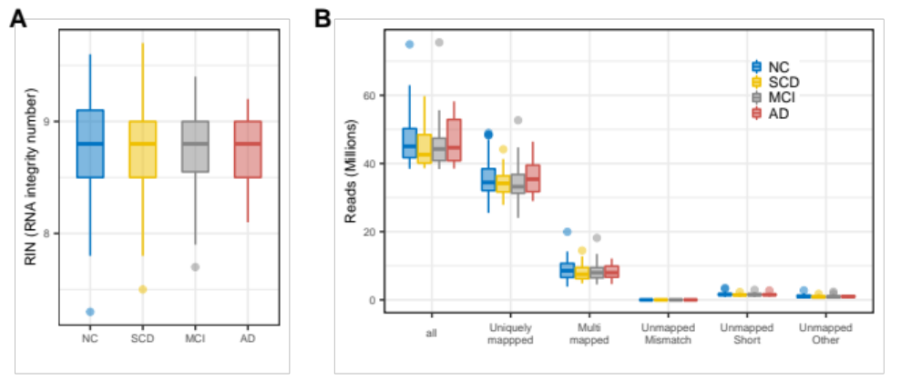
Figure 1: Sequencing characteristics for each group. (A) RNA integrity number of each group. (B) Number of raw sequenced reads and reads uniquely mapped to the human reference genome.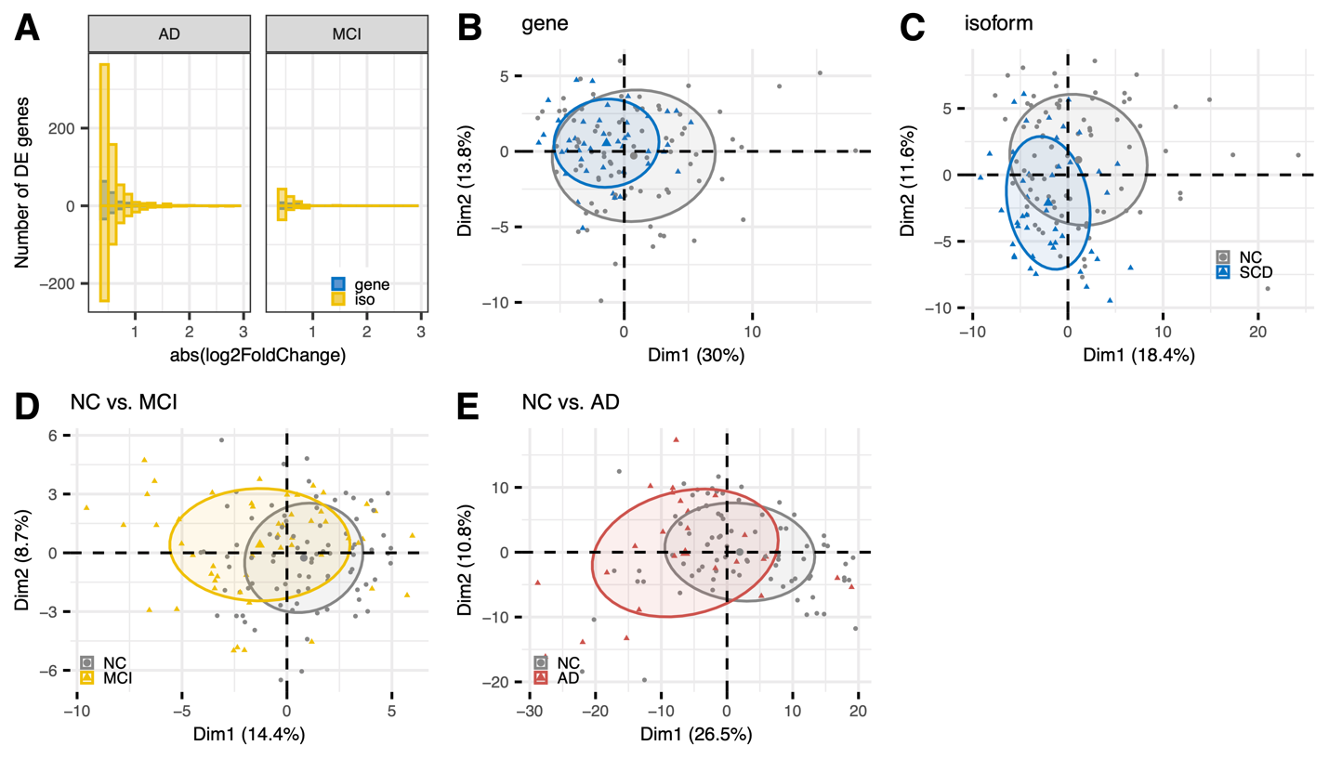

Supplementary Figure 2. Differentially expressed genes and transcripts. (A) DE effect size (|log2FC|) histograms for up or down-regulated protein-coding genes (blue) and isoforms (yellow) in MCI and AD. (B-C) principal component analysis (PCA) using differentially expressed genes (B) or isoforms (C) in SCD. (D-E) PCA plot on differentially expressed genes OR isoforms in MCI, and AD.

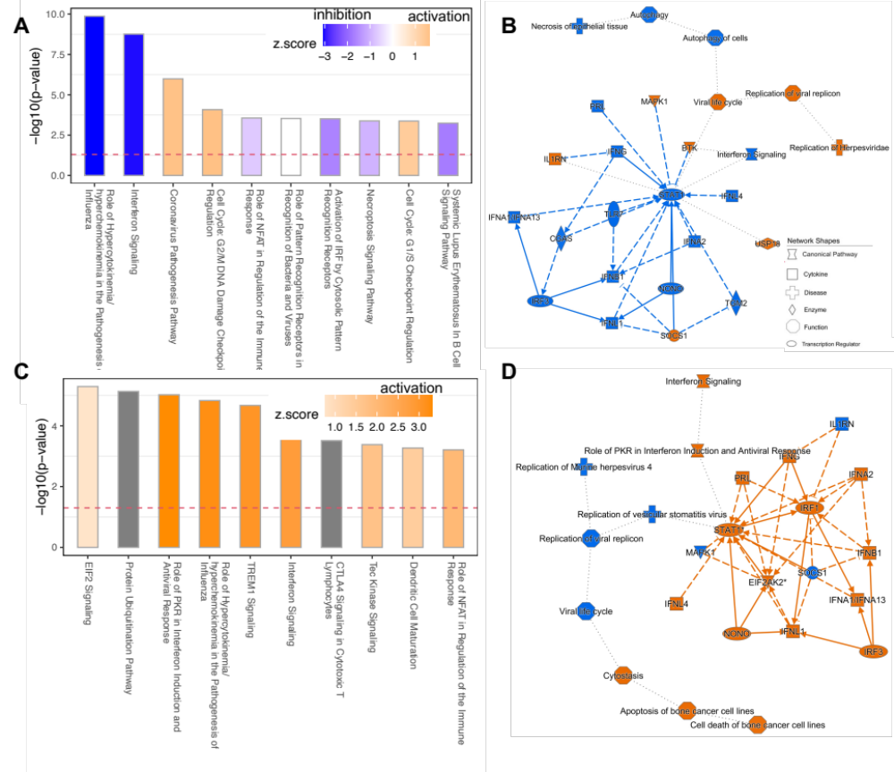
Supplementary Figure 3. IPA analysis of DE genes at gene or isoform level in SCD (A-B) and AD (C-D). Blue and orange represents inhibition and activation, separately.

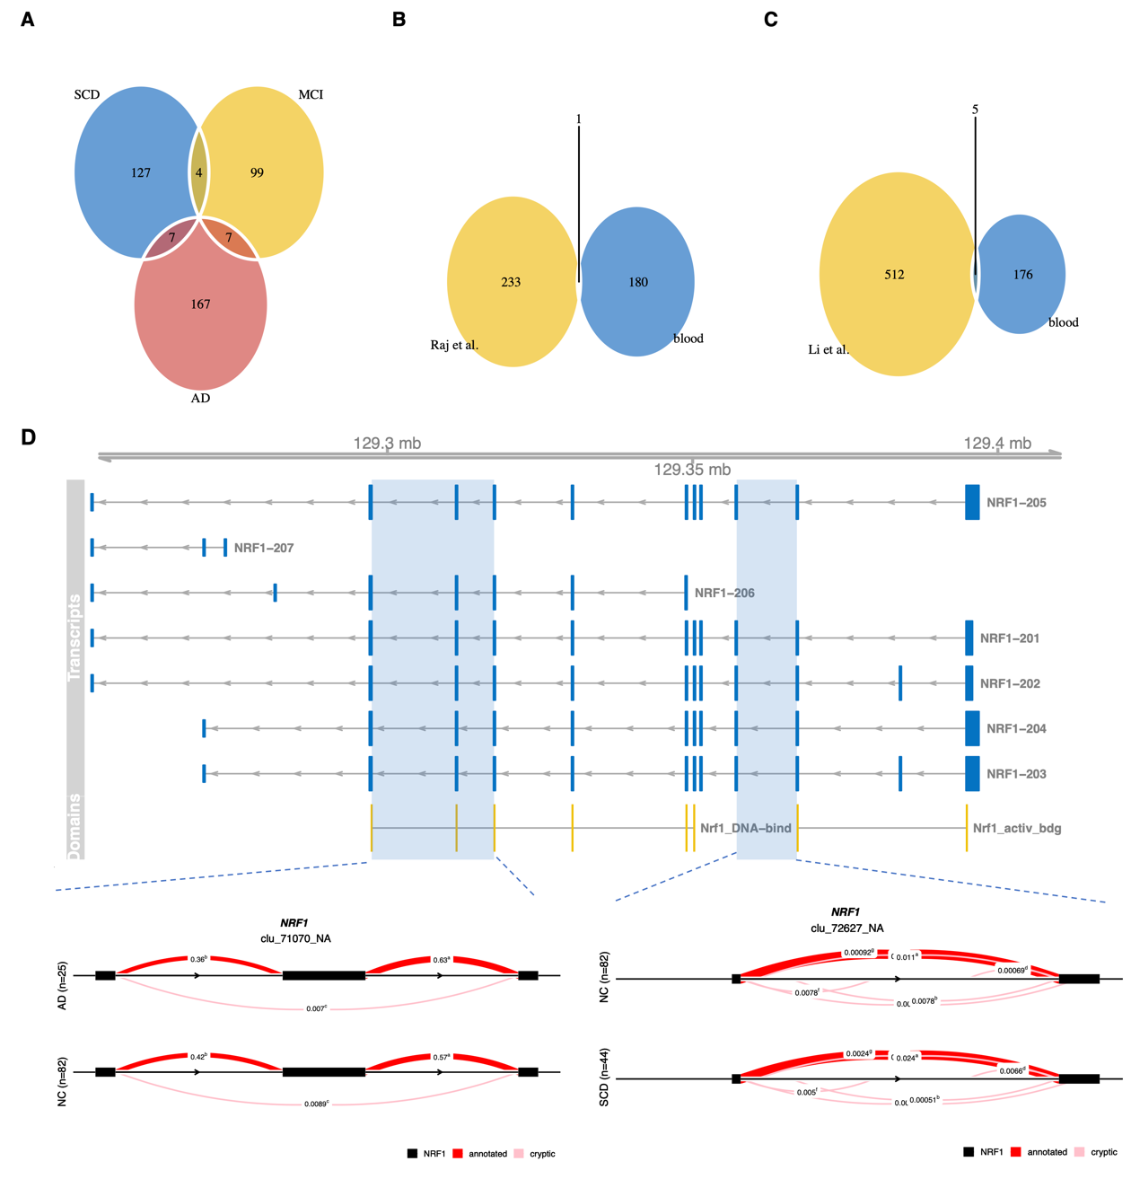

Supplementary Figure 4: Differential splicing. (A) Venn diagram showing cross-disorder overlap for genes with significant differentially spliced (DS) intron clusters. (B-C) Venn diagram showing the overlapped DS genes using transcript data in brain and blood. (D) Whole-gene view of NRF1 highlighting (blue blocks, chr2:191874730-191878744) the intron cluster with significant DS in SCD (P = 9.8e-07) and AD (P = 9.7e-4). Protein domain mappings from Pfma database are shown in yellow. Nrf1_activ_bdg, Nrf1 activator activation site binding domain; Nrf1_DNA-bind, NLS-binding and DNA-binding and dimerisation domains of Nrf1.
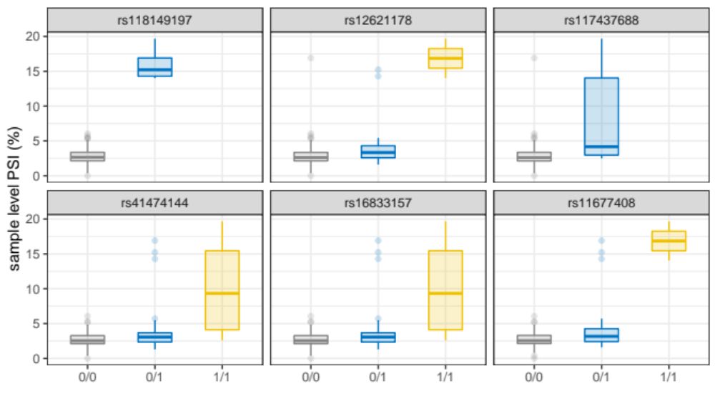
Supplementary Figure 5: Splicing QTLs for the intron cluster (chr2:191874730-191878744) of STAT1.

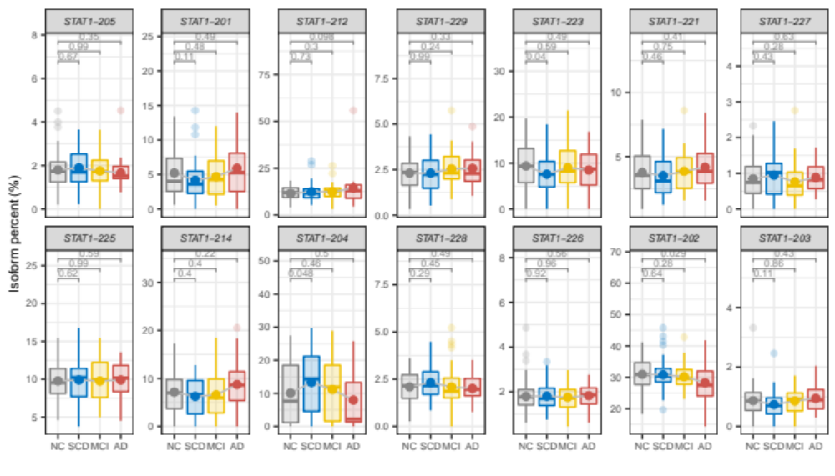
Supplementary Figure 6. Transcript usages (isoform percent) of STAT1.
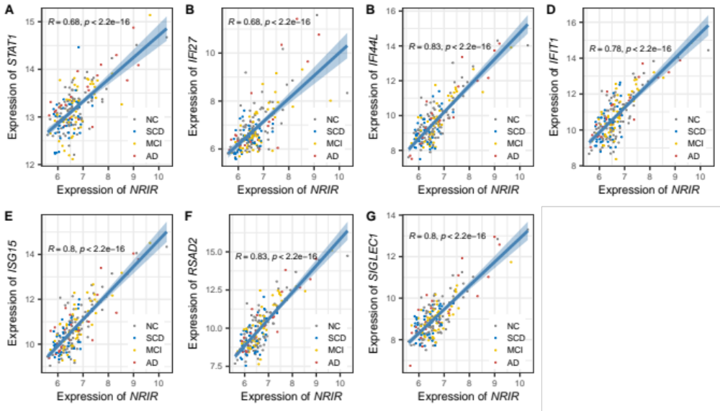
Supplementary Figure 7. Correlation between normalized expression of NRIR and STAT1 (A) and ISG genes( B-G).

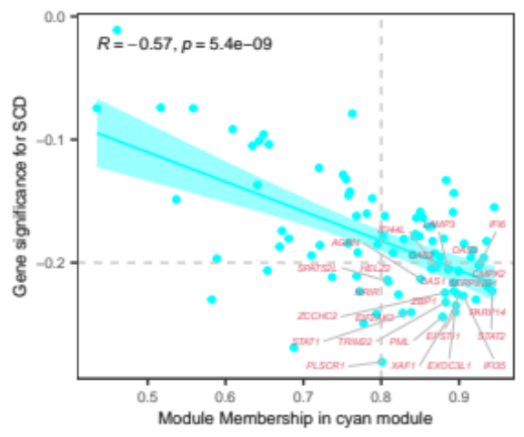
Supplementary Figure 8: Scatterplot of gene significance for SCD versus module membership in the cyan module. Hub genes are labeled.
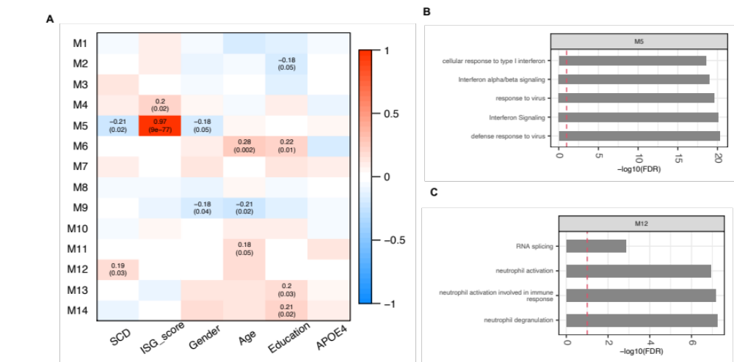
Supplementary Figure 9. Network modules at the isoform level defined in SCD. (A) Pearson correlation between module eigengenes and phenotype traits. Left module-blocks represent the miRNA-lncRNA-mRNA co-expression modules at the isoform level defined in SCD. Correlation coefficients (top) and P-value (bottom) are shown in the grid, where red and blue colors indicate positive and negative correlations, separately. Only significant associations (P < 0.05) are displayed. (B) Top 5 enriched pathways of genes in the module M5. (C) Top 5 enriched pathways of genes in the module M12.
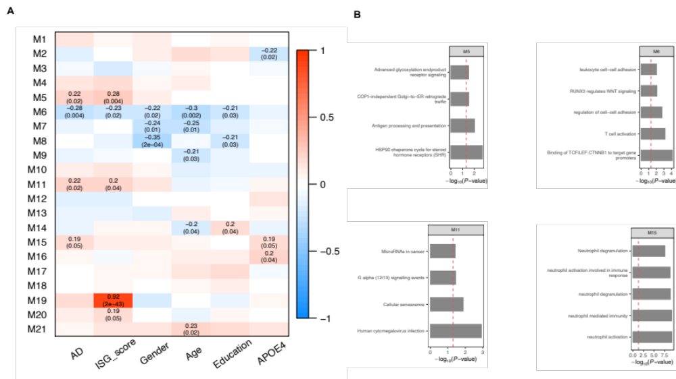
Supplementary Figure 10. Gene co-expression network modules in AD.

Supplementary Table 4. Splicing QTLs for the intron cluster chr2:191874730-191878744 of STAT1.
SNP | P-value | FDR | n_NC | n_SCD | n_MCI | n_AD | Ref | Alt | Func.knownGene | Gene.knownGene | EAS.sites.2015_08 | ALL.sites.2015_08 | dpsi_max_tissue | dpsi_zscore
rs11677408 | 1.38E-07 | 0.00067 | 15 | 10 | 7 | 4 | C | T | intronic | STAT1 | 0.1101 | 0.0834665 | . | .
rs118149197 | 4.33E-20 | 2.12E-16 | 0 | 2 | 3 | 0 | C | G | UTR5 | STAT1 | 0.0238 | 0.00519169 | -2.4761 | -2.036
rs117437688 | 1.25E-08 | 6.12E-05 | 5 | 3 | 5 | 0 | C | A | intronic | GLS | 0.0655 | 0.014377 | . | .
rs12621178 | 6.71E-07 | 0.0032 | 7 | 3 | 7 | 0 | G | A | intergenic | NAB1;GLS | 0.0853 | 0.0175719 | . | .
rs41474144 | 7.70E-06 | 0.038 | 26 | 15 | 11 | 6 | A | G | intronic | STAT1 | 0.1577 | 0.146166 | . | .
rs16833157 | 7.70E-06 | 0.038 | 26 | 15 | 11 | 6 | G | A | intronic | STAT1 | 0.1528 | 0.107428 | -0.004 | 0.002

Supplementary Table 8. Conversion analysis grouped by median of hub genes of IFN signaling module.

hub gene | P-value | #conversion / # < median | #conversion / # >= median | FDR
TRIM22 | 0.0022 | 27/122 | 12/122 | 0.036
STAT1 | 0.0031 | 27/122 | 12/122 | 0.036
ZCCHC2 | 0.012 | 26/122 | 13/122 | 0.092
ZBP1 | 0.032 | 13/122 | 26/122 | 0.18
CMPK2 | 0.11 | 23/122 | 16/122 | 0.42
PML | 0.11 | 15/122 | 24/122 | 0.42
PLSCR1 | 0.18 | 23/122 | 16/122 | 0.52
SERPING1 | 0.18 | 23/122 | 16/122 | 0.52
STAT2 | 0.25 | 22/120 | 17/124 | 0.62
IFI44L | 0.3 | 22/122 | 17/122 | 0.62
OAS3 | 0.31 | 22/122 | 17/122 | 0.62
IFI6 | 0.35 | 22/122 | 17/122 | 0.62
LAMP3 | 0.36 | 22/122 | 17/122 | 0.62
XAF1 | 0.38 | 22/122 | 17/122 | 0.62
HELZ2 | 0.44 | 17/122 | 22/122 | 0.65
OAS2 | 0.46 | 21/122 | 18/122 | 0.65
EXOC3L1 | 0.48 | 17/121 | 22/123 | 0.65
SPATS2L | 0.55 | 17/122 | 22/122 | 0.7
EPSTI1 | 0.58 | 21/122 | 18/122 | 0.7
IFI35 | 0.65 | 18/122 | 21/122 | 0.74
OAS1 | 0.68 | 18/122 | 21/122 | 0.74
PARP14 | 0.87 | 20/122 | 19/122 | 0.91
EIF2AK2 | 0.97 | 20/122 | 19/122 | 0.97

