Estimation of methane emissions using TROPOMI and divergence analysis: A top-down assessment of Ghana’s national-scale methane budget.
Nadine Osei-Essahª (nadine.oseiessah.u3@elms.hokudai.ac.jp, n.oessah@gmail.com; 0009-0000-7004-7136) and
Yuichi S. Hayakawa^{b} (hayakawa@eis.hokudai.ac.jp; 0000-0003-2053-8986)
ªDivision of Environmental Science Development, Graduate School of Environmental Science, Hokkaido University, Sapporo. Japan.
^{b}Faculty of Environmental Earth Science, Hokkaido University. Sapporo. Japan.

SUPPLEMENTARY INFORMATION

SUPPLEMENTARY IMAGES
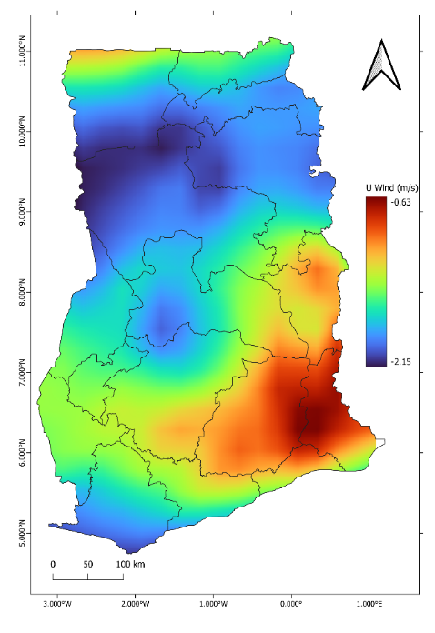  a | 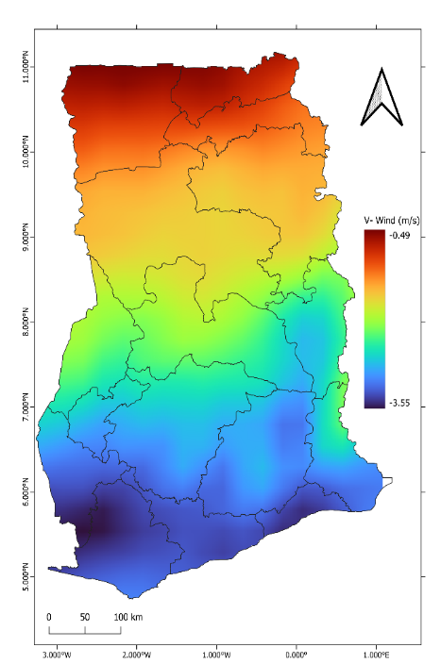  b
Fig.1: Spatial distribution of average wind gradients for the study period ((a). East wind gradient and (b). North wind gradient)
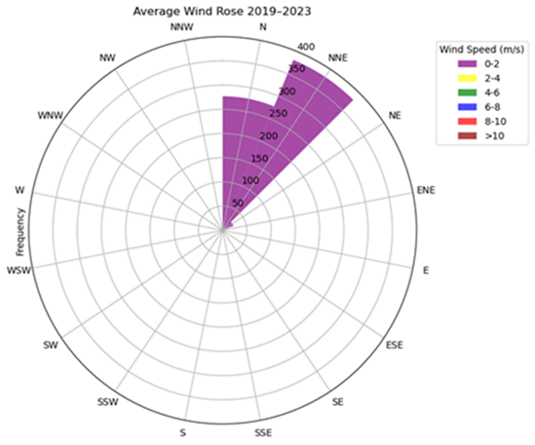
Fig. 2: Visual representation of multi-year averaged wind data showing direction and magnitude

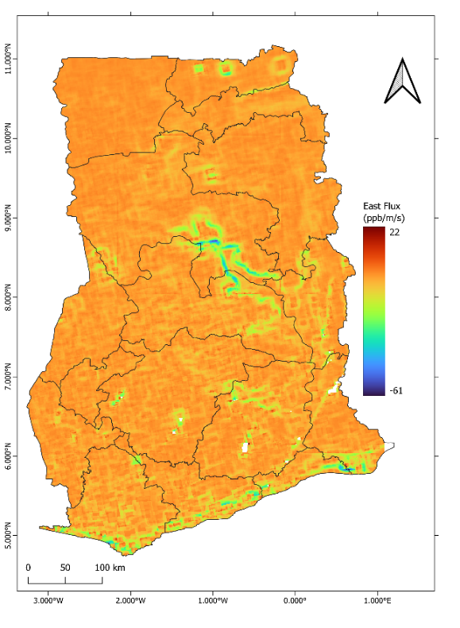 | 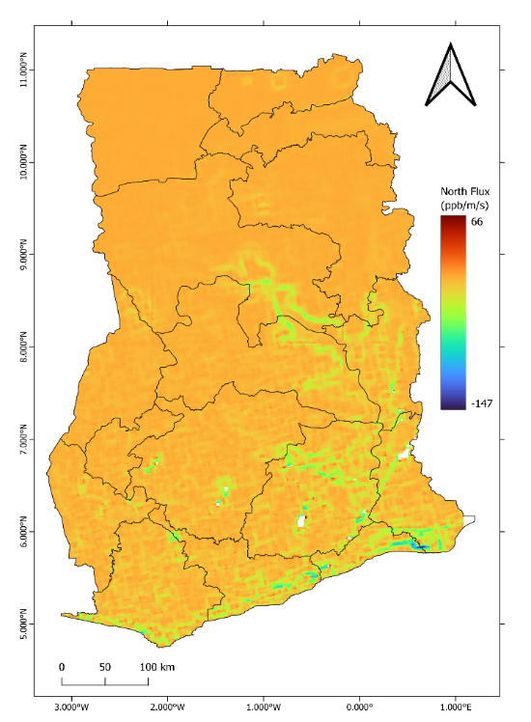
Fig. 3: Spatial distribution of averaged wind fluxes
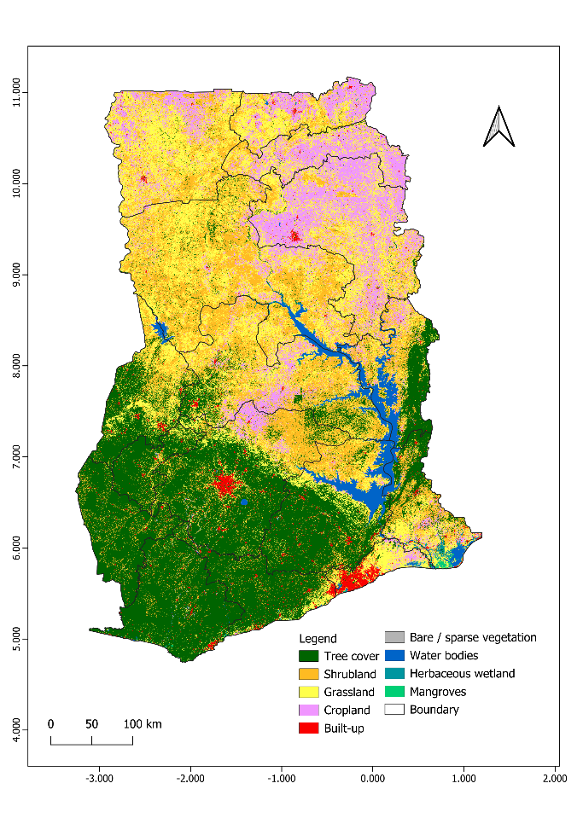  a | 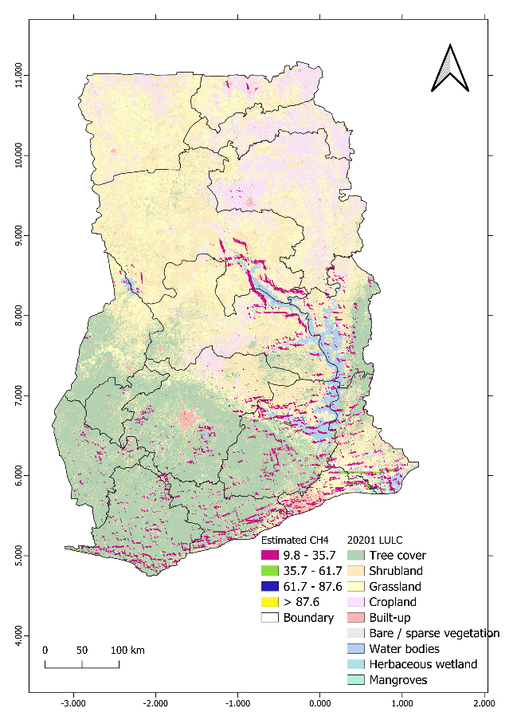  b
Fig. 4: (a) 2021 LULC map of Ghana and (b) An overlay of the inferred emissions on the LULC map

