Supporting Information
Contents
1 Detailed inventory analysis of units
Table S1. Mixed sludge dewatering unit
Table S2. Dewatering and lime stabilization units
Table S3. Composting and production units
Table S4.Thermal dewatering unit
Table S5. Incineration unit
Table S6.Digested sludge dewatering process units
Table S7.Anaerobic digestion unit
Table S8. Landfill unit
Table S9 Land application unit
2 Dry basis variations in case scenarios
Figure S1.Dry basis variation in sludge treatment process
3 Related standards in article
Table S10.“Urban sewage treatment plant pollutant discharge standard”(GB18918－2002)
Table S11. Environmental Quality Standards for Surface Water” (GB 3838-2002)

1 Detailed inventory analysis of units
Table S1. Mixed sludge dewatering unit
 | Inventory | Quantity | Fresh water /m³
Input | Sludge | 1 t DS
Input | Electricity | 107.10 kW‧h ¹ | 0.82
Input | Flocculation agent(FeSO₄) | 4.17kg ¹ | 0.004
Output | Sludge | 1 t DS | Gray water /m³
Output | Pressure filtrate | 35 t | Level 1 A | Level 1 B | Level 2 | Level1 3
Output | COD | 20.40 Kg ² | 673.23 | 510.02 | 265.21 | 204.00
Output | BOD₅ | 6.22 Kg ² | 1038.07 | 391.61 | 236.21 | 105.67
Output | NH₄⁺-N | 2.62 Kg ² | 654.06 | 374.12 | 109.88 | 109.88

Table S2. Dewatering and lime stabilization units
 | Inventory | Quantity | Fresh water/m³
Input | Sludge | 1 t DS
Input | Electricity | 106.20 kW‧h ¹ | 0.81
Input | Fecl₃ | 19.20kg ¹ | 116.58
Input | CaO | 500kg ¹ | 4
Output | Stabilized Sludge | 1.52 t DS | Gray water/m³
Output | Pressure filtrate | 37.52t | Level1 A | Level1 B | Level 2 | Level 3
Output | COD | 82.19 Kg ³ | 2711.57 | 2054.22 | 1027.11 | 821.64
Output | BOD₅ | 42.02 Kg ³ | 7017.74 | 2626.40 | 1596.85 | 714.34
Output | NH₄⁺-N | 4.50Kg ³ | 1125.60 | 643.84 | 189.09 | 189.09

Table S3. Composting and production units
 | Inventory | Quantity | Fresh water/m³
Input | Sludge | 1 t DS
Input | Electricity | 141.40 kW‧h ⁴ | 0.45
Input | water | 11.60 t⁴ | 11.60
Output | product | 2.35(Add the auxiliary materials)⁴ | Gray water /m³
Output | Leachate | 60kg | Level1 A | Level1 B | Level 2 | Level 3
Output | COD | 12kg | 396.00 | 300.00 | 150.00 | 120.00
Output | TN | 1.20kg | 300.00 | 171.60 | 50.40 | 50.40

Table S4.Thermal dewatering unit
 | Inventory | Quantity | Moisture content/% | Fresh water/m³
Input | Sludge | 1 t DS | 80
Input | Coal | 501.81kg⁵ |  | 1.2
Input | steam | 5.4t⁶ |  | 5.4
Output | Sludge | 1 t DS | 10 | Gray water /m³
Output | evaporation water | 3.89 t⁶ |  | Level1 A | Level1 B | Level 2 | Level 3
Output |  |  |  | 3.89 | 3.89 | 3.89 | 3.89

Table S5. Incineration unit
 | Inventory | Quantity | Fresh water /m³
Input | Sludge | 1 t DS
Input | Electricity | 36.50 ⁵ | 0.28
Input | Coal | 0.35t ⁷ | 0.84
Input | Lime | 50kg ⁷ | 0.40
Output | Electricity | 364.60 kW‧h ⁵
Output |  |  | Gray water /m³
Output | residue | 280 kg ⁸ | Level1 A | Level1 B | Level 2 | Level 3
Output | COD | 4.06kg ⁹ | 133.52 | 101.15 | 50.58 | 40.46
Output | NH₄⁺-N | 0.42kg ⁹ | 105 | 60.06 | 17.64 | 16.64

Table S6.Digested sludge dewatering process units
 | Inventory | Quantity | Fresh water /m³
Input | Sludge | 1 t DS
Input | Electricity | 107.10 kW‧h ¹ | 0.82
Input | Flocculation agent(FeSO₄) | 4.17kg ¹ | 0.004
Output | Sludge | 1 t DS | Gray water /m³
Output | Pressure filtrate | 26.07t | Level1 A | Level1 B | Level 2 | Level 3
Output | COD | 10.95 Kg ¹⁰ | 361.33 | 273.73 | 136.86 | 109.49
Output | NH₄⁺-N | 8.94 Kg/L ¹⁰ | 2235.48 | 1278.70 | 375.56 | 375.56

Table S7.Anaerobic digestion unit
 | Inventory | Quantity | Fresh water /m³
Input | Sludge | 1 t DS
Input | Electricity | 88.60 kW‧h ⁹ | 0.67
Input | Lime | 62 kg ¹⁰ | 0.50
Output | Sludge | 0.32 t DS
Output | Electricity | 1479.70 kWh¹⁰ | 10.54
CH₄ production = 227 m³/DT, assume 60% methane converse to electricity

Table S8. Landfill unit
 | Inventory | Quantity | Fresh water/m³
Input | Sludge | 1 t DS
Input | fuel | 0.46L¹¹ | 0.11
Input | Electricity | 0.17 kW‧h | 0.001(ignore)
Input | Water | 0.05 | 0.05
Input | HDPE | 0.03⁹ | 0.006
Input | Pesticide | 0.02⁹ | 1.87
Output |  |  | Gray water /m³
Output | Leachate | 0.2T | Level1 A | Level1 B | Level 2 | Level 3
Output | COD | 4.4 Kg ⁹ | 145.2 | 110 | 55 | 44
Output | NH₄⁺ | 2.4 Kg ⁹ | 60 | 34.32 | 10.08 | 10.08

Table S9 Land application unit
 | Inventory | Quantity | Fresh water/m³
Input | Sludge | 1 t DS
Input | Electrical | 58.5 kW‧h ¹² | 0.44
Input | Diesel | 0.73 kg¹² | 0.17

2 Dry basis variations in case scenarios
Figure S1.Dry basis variation in sludge treatment process
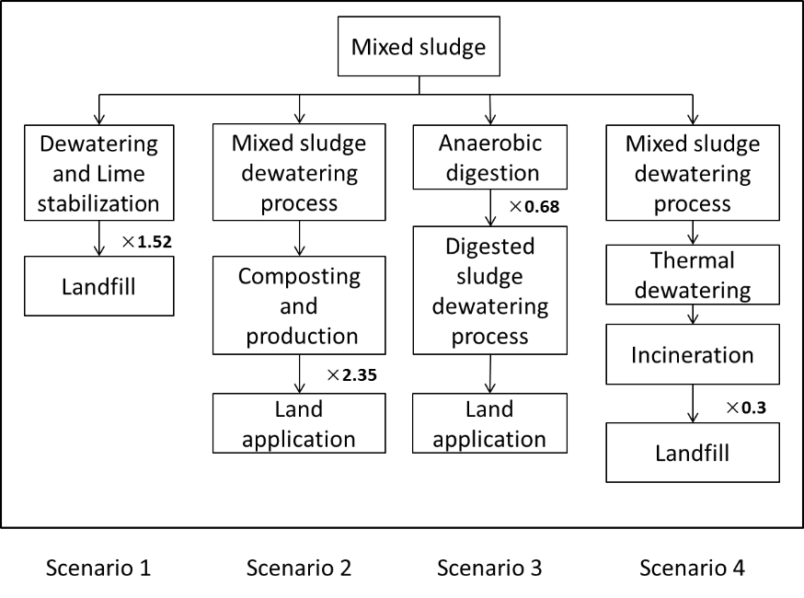
During sludge management process, dry basis will change for auxiliary materials addition, organic matter degradation and organic matter burning. Dry basis increases 52% caused by lime addition and increases 135% by auxiliary materials addition during composting process. Dry basis decreases 32% by anaerobic degeneration and decreases 70% by incineration.

3 Related standards in article
Table S10. “Urban sewage treatment plant pollutant discharge standard”(GB18918－2002)
Unit: mg/L
 | Inventory | Level 1 |  | Level 2 | Level 3
 | Inventory | A | B | Level 2 | Level 3
1 | Chemical oxygen demand（COD） | 50 | 60 | 100 | 120
2 | Biochemical oxygen demand（BOD₅） | 10 | 20 | 30 | 60
3 | Ammonia nitrogen (NH₄⁺-N) | 5 | 8 | 25 | －

Table S11. “Environmental Quality Standards for Surface Water” (GB 3838-2002)
Unit: mg/L
 | Inventory | LevelⅠ | LevelⅡ | LevelⅢ | LevelⅣ | LevelⅤ
1 | Chemical oxygen demand（COD） | 15 | 15 | 20 | 30 | 40
2 | Biochemical oxygen demand（BOD₅） | 3 | 3 | 4 | 6 | 10
3 | Ammonia nitrogen (NH₄⁺-N) | 0.15 | 0.5 | 1.0 | 1.5 | 2.0

References:
1. Xie, X.Q.; Huang, Z.Y.; Dai, L. H.; Xie, X. M.; Liu, M.L. Study on Deep Dewatering and Recycling of Municipal Sludge in Xia men. China Water & Wastewater 2010, 26(5), 138-140. (In Chinese)
2. Zhang, Y.X.; Wang, L.T.; Wang, X.; Shi, Z.L.; Duan, K. Design Scheme on Landfill Site of Dredged Sediment from Dagu River. China Water & Wastewater 2010,22(8),46-50. (In Chinese)
3. Xie, X.Q.; Huang, Y.Z.; Dai, L.H.; Xie, X.M.; Liu, M.L. Study on Deep Dewatering and Recycling of Municipal Sludge in Xia men. China Water & Wastewater 2010,26(5),138-140. (In Chinese)
4. Tao, Y.J.; Sun, Z.H.;Wei,L.L.;Li,T. Aerobic Composting of Excess Sludge from Second WWTP in Jinan. China Water & Wastewater 2012,28(8),64-67. (In Chinese)
5. Xi, Y.Q. Life Cycle Assessment on the Dry Sludge Combustion to Generate Electricity. Energy and Energy Conservation 2013,2, 47-48. (In Chinese)
6. Wu,J.;Li,E.;Zhou,H.J.;Nao,S.X.;Qi,T.X.;Chen,X.Z.;Kang,D. Application of all sludge dewatering process in Wuchang Southern Sludge Treatment Plant. Water Supply and Drainage 2010,36(10), 19-23. (In Chinese)
7. Cheng,Z.M.;Bao,S.K.;Gu,J.;Zhang,D.Y. Application of Drying and Incineration Process to Disposal of Sludge from Municipal Wastewater Treatment Plants in Wenzhou. China Water & Wastewater 2012,28(22),95-98. (In Chinese)
8. Suh Y. and Rousseaux P., An LCA of alternative wastewater sludge treatment scenarios. Resources, Conservation and Recycling 2002,35, 191-200 .
9. Wei,B.R.; Wang,J.; TAHARA Kiyotaka; KOBAYASHI Kensuke; SAGISAKA Masayuki. Life Cycle Assessment on Disposal Methods of Municipal Solid Waste in SuZhou. China Population Resources and Environment,2009,19(2),93-97. (In Chinese)
10. Hao,R.X.;Zhao,J.C.;Ma,N.;Wan,H.W.;Zhang,Y. Analysis of Waste Liquid Quality from Sludge Treatment Area in Sewage Treatment Plant. China Water & Wastewater 2008, 24(23),75-84. (In Chinese)
11. Hara K. and Mino T., Environmental assessment of sewage sludge recycling options and treatment processes in Tokyo. Waste Manage, 2008,28, 2645-2652 .
12. Hospido A., Martin M. and Feijoo G., Environmental evaluation of different treatment processes for sludge from urban wastewater treatments: Anaerobic digestion versus thermal processes. International journal of life cycle assessment, 2005,10, 336-345.

