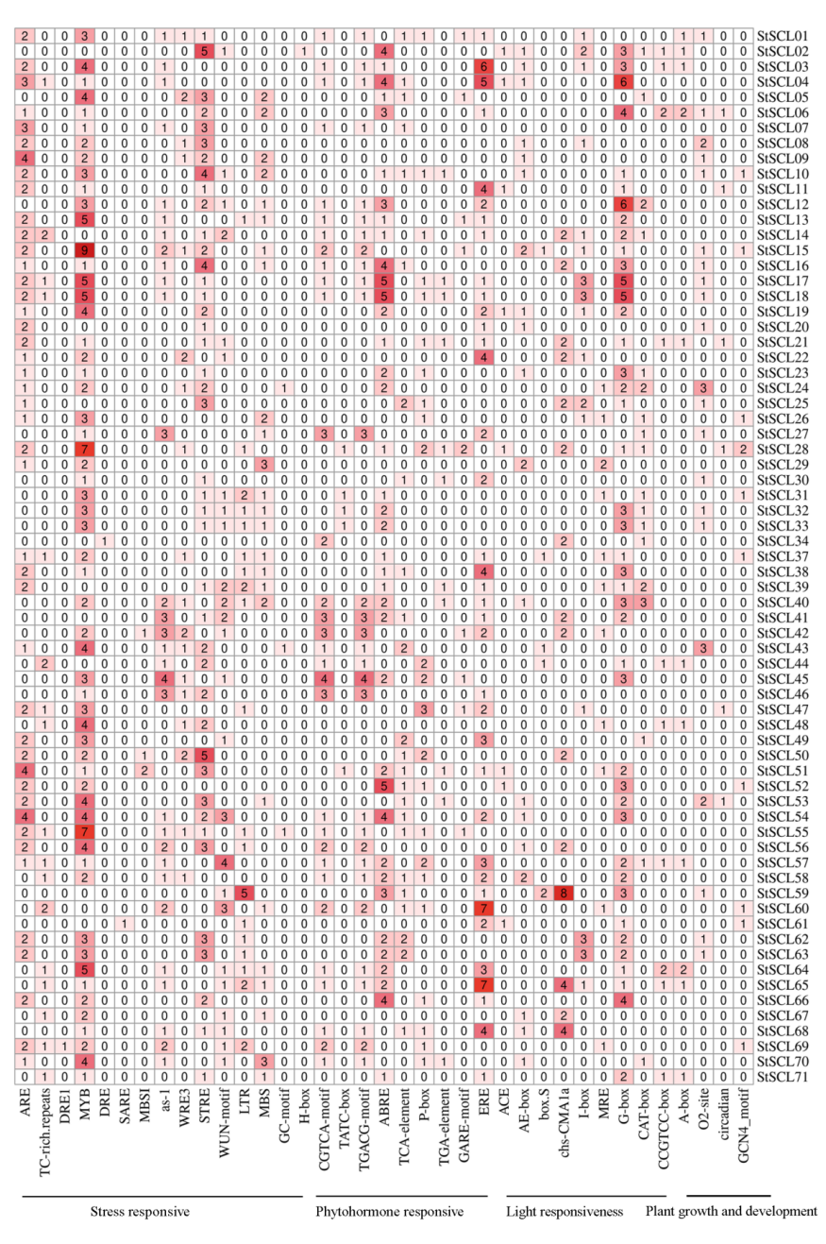
Figure S2. Cis-acting elements on the promoters of StSCLs

