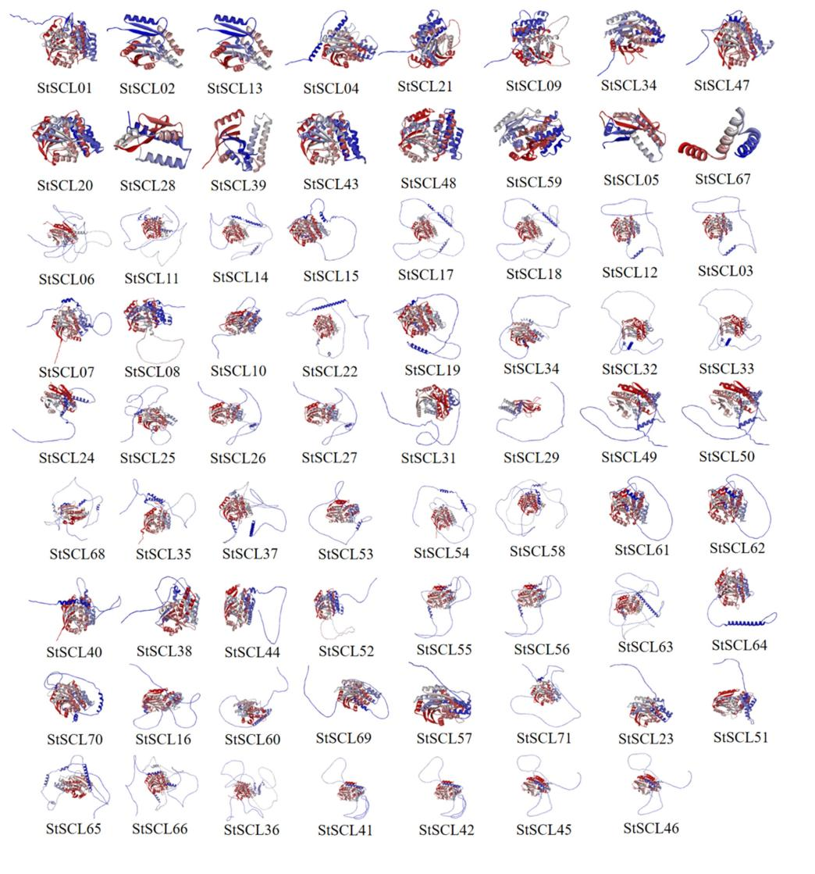
Figure S1. Predictive 3D structures of StSCLs

