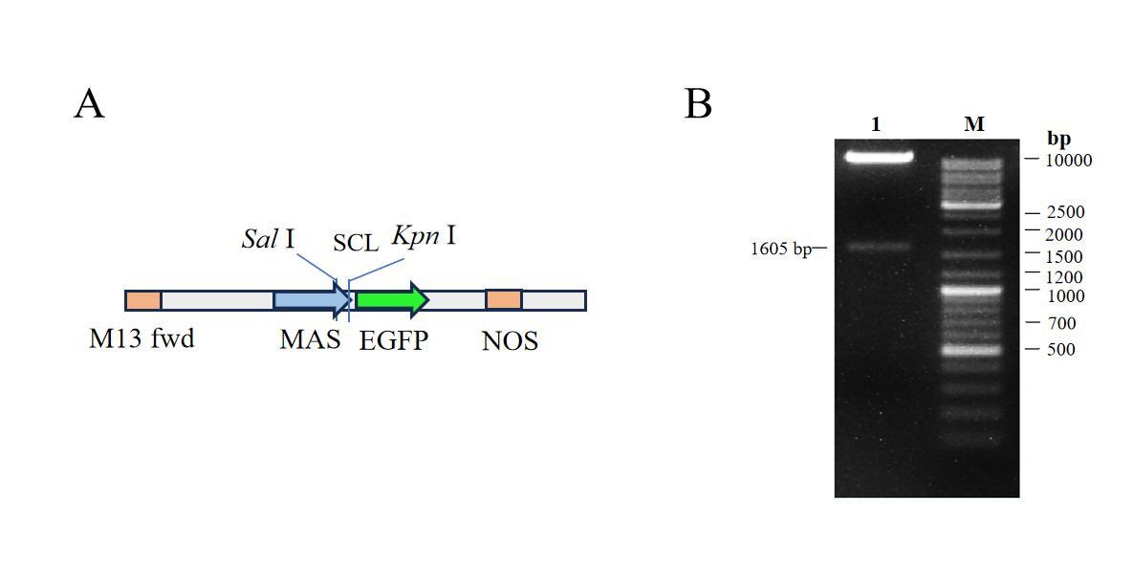
Fig. S3 Construction of pCAMBIAsuper1300 subcellular localization vector
- The map of pCAMBIAsuper1300 vector and the clone site selected for constructing pCAMBIAsuper1300-StSCL3 vector.
B. Double enzyme digestion electropherogram of pCAMBIAsuper1300-StSCL3.
Lane 1: StSCL3 (1605 bp), linearized empty vectors (10 000 bp);
Lane M: RealBand DNA markers (100~10 000 bp) .

Supplementary Material: Sequencing Validation of pCAMBIA1300-GFP-StSCL3
The pCAMBIA1300-GFP-StSCL3 were subjected to Sanger sequencing (Sangon Biotech, Shanghai, China) using vector-specific primers (forward primer: 5’-TGTAAAACGACGGCCAGT-3’; reverse primer: 5’-CAGGAAACAGCTATGACC-3’) for validation of the inserted fragment integrity. Sequencing quality was evaluated by Q30 score (≥ 80% of bases with Q30 ≥ 30, indicating high sequence accuracy).
The complete sequencing report is provided as Supplementary File (PDF format, YC6314F ABX7470-9) for peer review and reproducibility.

