Supplementary Information

Table S1. Bacterial strains used in this study
E. coli BL21(DE3) strains transformed with plasmids harboring LUX genes from various organisms-Shewanella woodyi ATCC 51908, Photorhabdus luminescens, Vibrio fischeri ES114, Vibrio harveyi- whose lux systems are known to generate long-chain aldehydes from fatty acids via the associated LuxCDE reductase complex, as well as fatty acyl-CoA reductase genes from various plants..

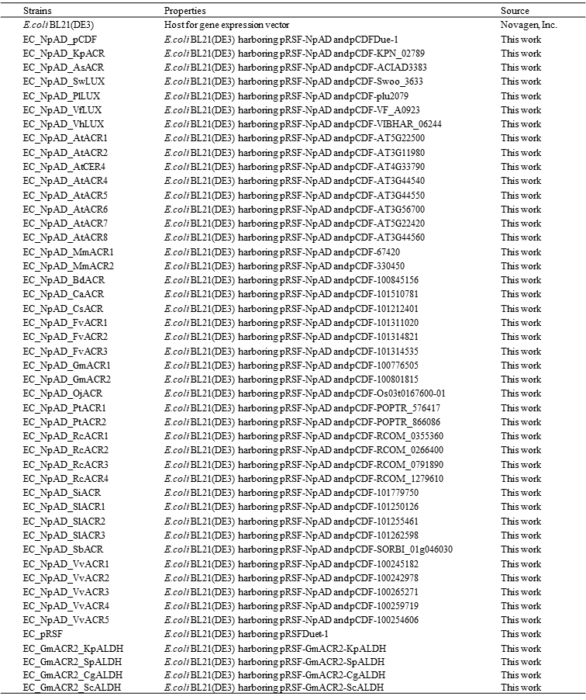
Table S2. Plasmids and primers used in this study
(A) Fatty acyl-CoA reductase homologue genes and bacterial luciferase were inserted into the Nde I site of the plasmid for expression under the T7 promoter. The aldehyde dehydrogenase homologue genes were inserted into the Nco I site for expression under T7 promoter control.

(B) Primers used for coexpressing the aldehyde dehydrogenase homologue gene and acyl CoA reductase gene in pRSFDuet-1 vector.

(A)
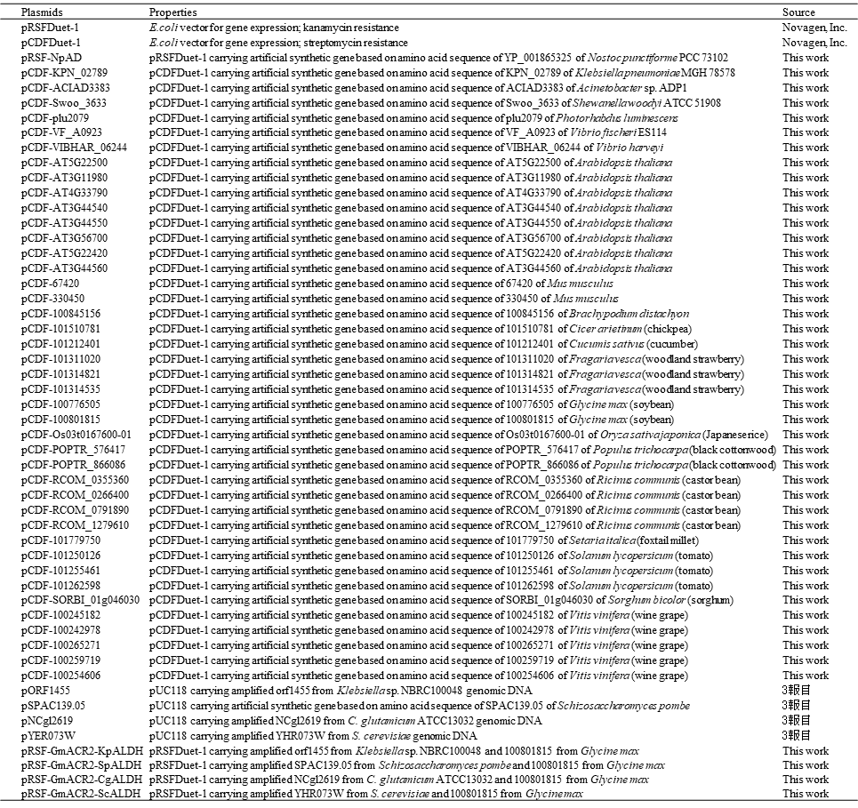

(B)
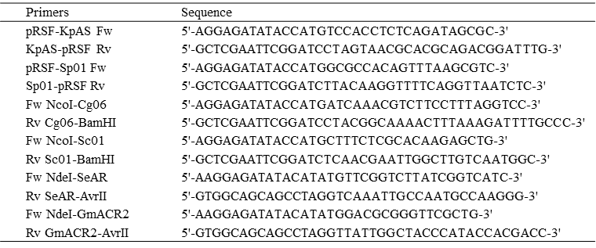

Table S3. Synthetic DNA used in this study
Artificial synthetic genes optimized for E. coli codon usage based on amino acid sequences, were synthesized by GenScript Biotech Corporation.

