Supplementary Material

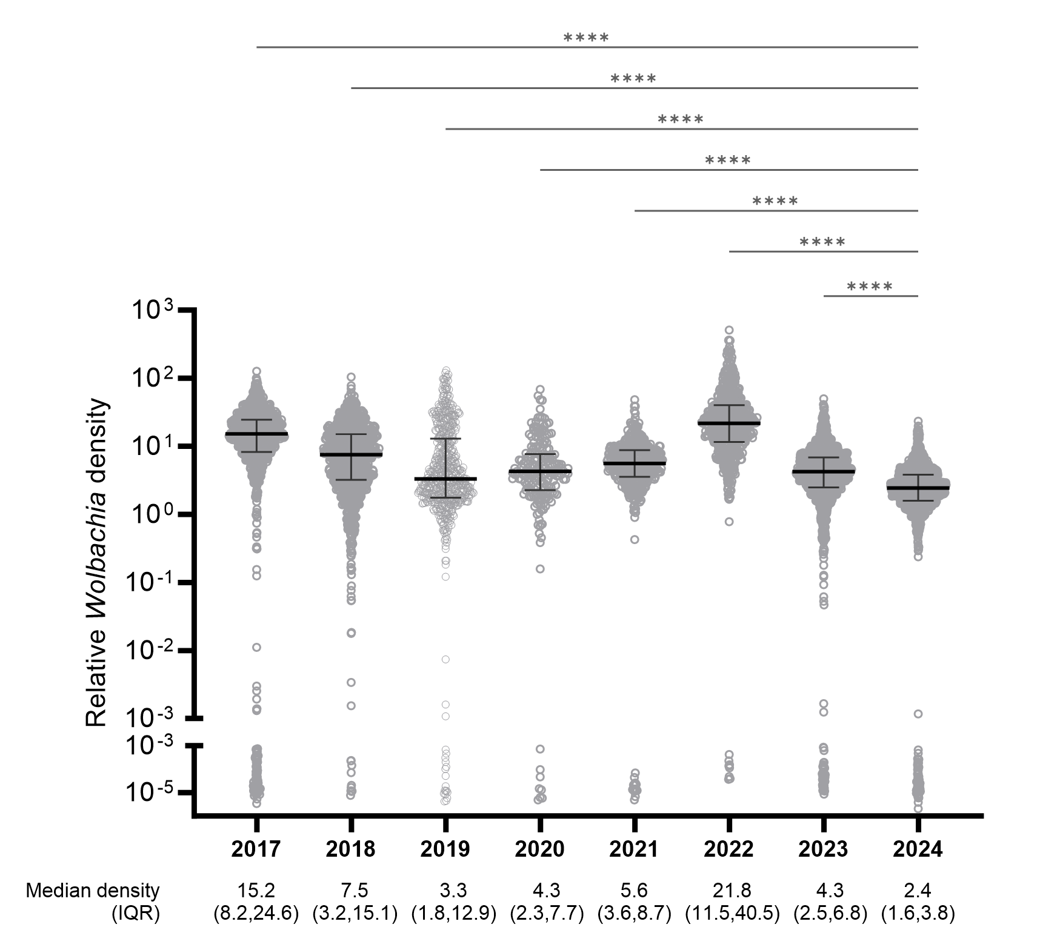
Figure S1. Relative Wolbachia density. Data points represent Wolbachia density in individual Ae. aegypti collected in Yogyakarta in November-December of each year 2017 - 2024. Collections in 2017 - 2019 were from the 12 intervention clusters of the AWED RCT with releases Mar - Dec 2017 (see Figure 1 and ref Utarini et al); collections in 2020 from the areas with fill-in releases in Oct 2020 - Jan 2021; and collections in 2021 - 2024 from the whole city. Wolbachia density was compared across years by Kruskal-Wallis test, followed by Dunn’s multiple comparison test to compare Wolbachia density in 2024 with each preceding year (P<0.0001 ****). The median and interquartile range (IQR) of density values for each year are shown.

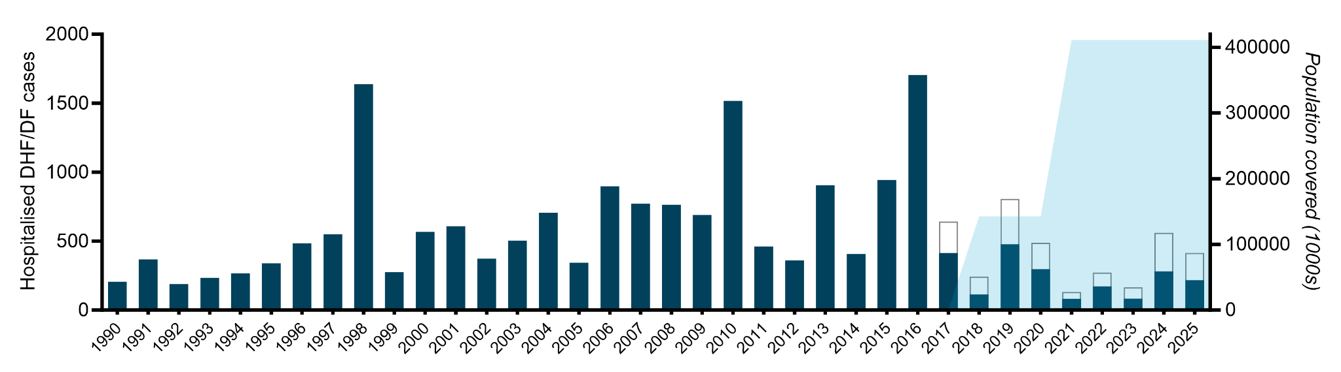
Figure S2. Dengue case notifications in Yogyakarta. Annual case numbers (bars) and 3-year rolling average incidence (line) of clinically diagnosed dengue hemorrhagic fever (DHF) and dengue fever (DF) cases notified to the Yogyakarta district health office before and after Wolbachia deployments, from 1990 to 2025 (data to 31 October 2025). DF cases have only been notifiable since 2017. Blue shading indicates the phased deployment of Wolbachia, with coverage of approximately a third of the population by December 2017 and the total population by January 2021.
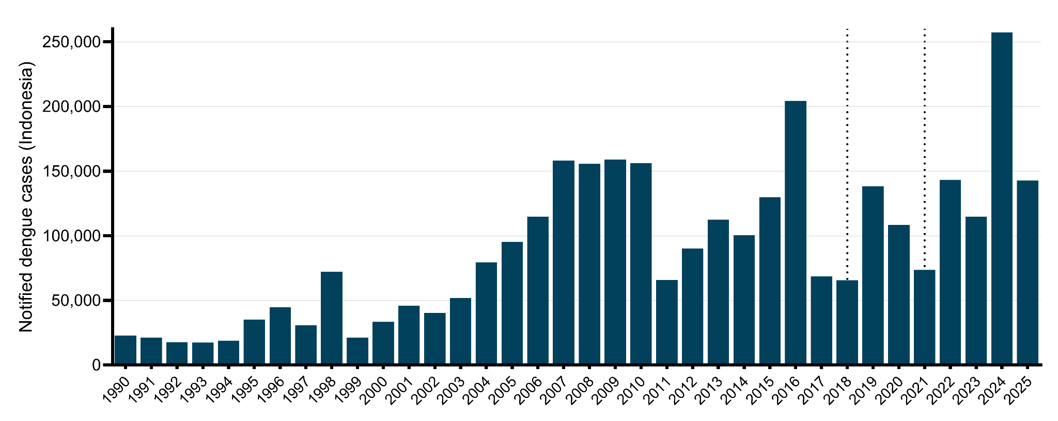

Figure S3. Dengue case notifications in Indonesia. Annual number of dengue cases notified nationally in Indonesia from 1990 to 2025 (data to 31 October 2025). Vertical dashed lines indicate the timing of Wolbachia implementation in Yogyakarta across approximately a third of the city population by December 2017 and the remainder of the city by January 2021.

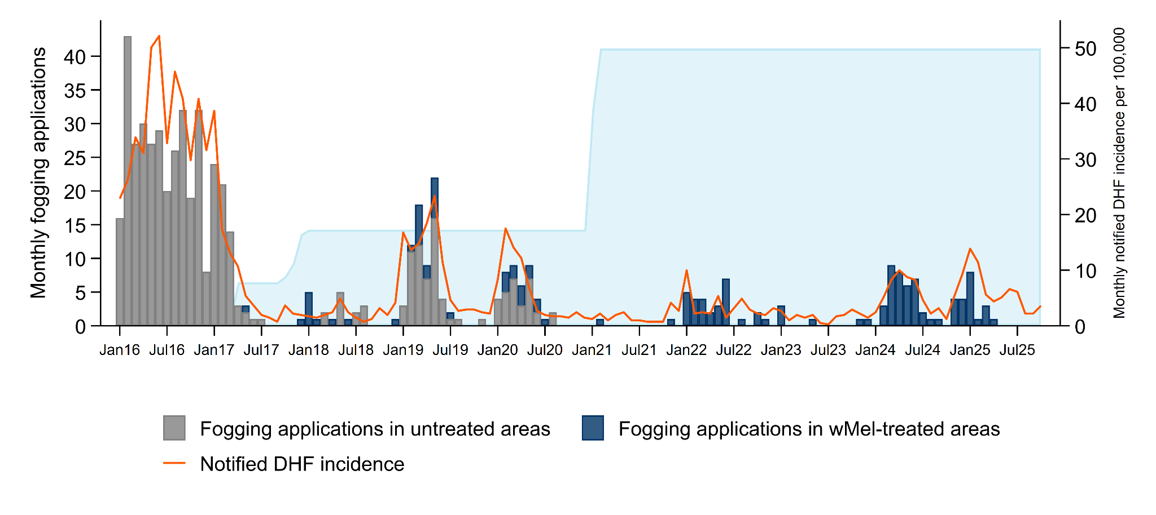
Figure S4. Insecticide fogging for vector control in Yogyakarta. Focal spraying of insecticide (cypermethrin in 2016-2018, malathion in 2019-2023 and cypermethrin in 2024-2025) around the residence of notified dengue cases is done by the Yogyakarta District health Office. Stacked bars show the number of fogging applications per month by wMel Wolbachia treatment status of the fogged location (data unavailable after April 2025). The line shows the incidence of hospitalised DHF cases per 100,000 population up to October 2025. Blue shading indicates the phase deployment of Wolbachia, with city-wide coverage by January 2021 and thus all subsequent fogging applications were in Wolbachia-treated areas.

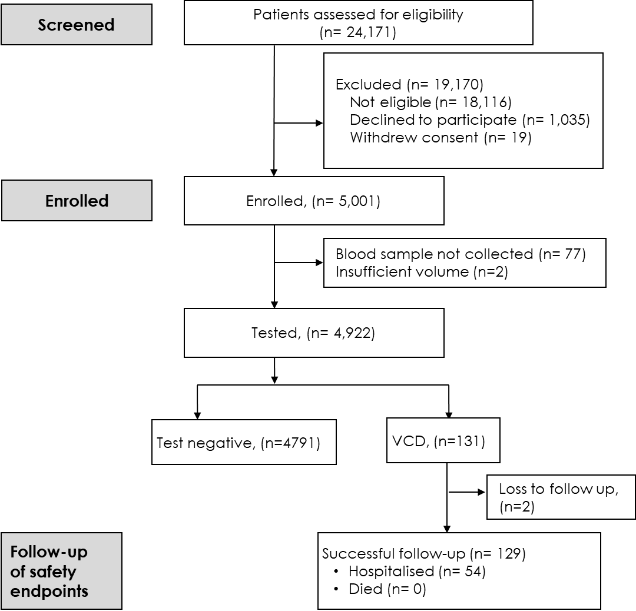

Figure S5. Flow-chart of participant screening and enrolment in the enhanced surveillance study.

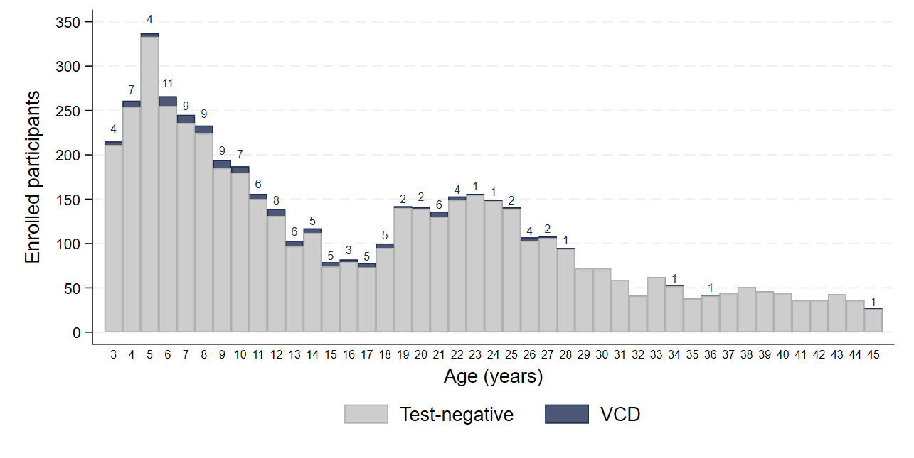
Figure S6. Age distribution of virologically-confirmed dengue (VCD) cases and test-negative cases of other febrile illness enrolled in the enhanced surveillance study. Numbers above bars indicate dengue case counts.

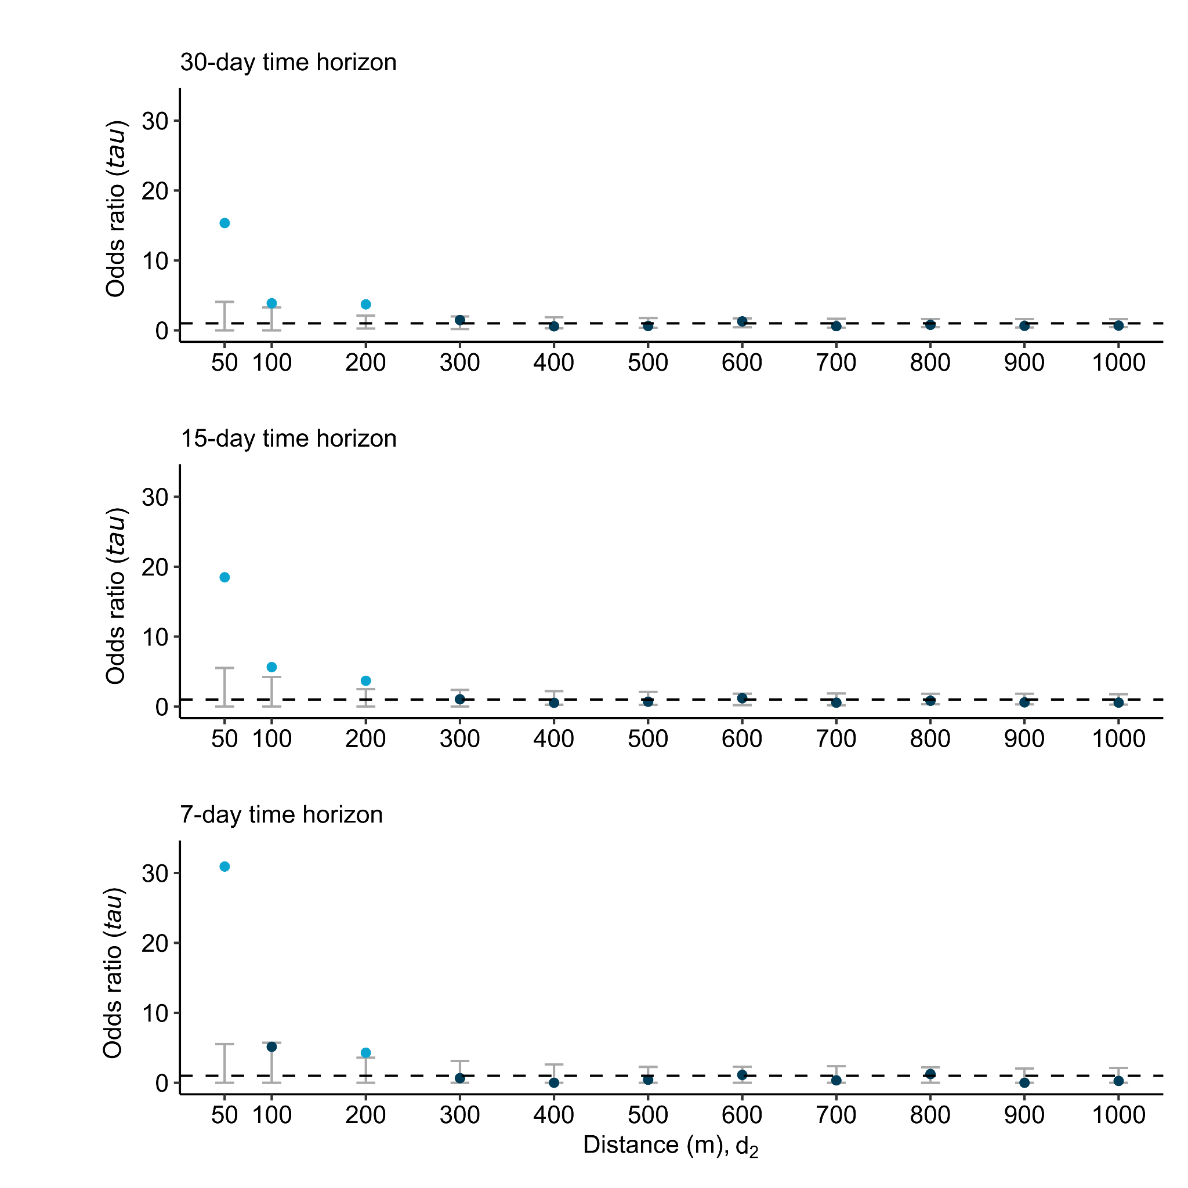
a.

Figure S7: Spatiotemporal dependence in dengue case occurrence. Estimated odds ratio (tau) comparing the odds of a homotypic dengue case pair within (d₁, d₂) versus the odds of a homotypic dengue case pair at any distance within Yogyakarta, among participant pairs with illness onset occurring within 30, 15 or 7 days; for all dengue cases in aggregate (a) and stratified by serotype for DENV1 (b), DENV2 (c) and DENV3 (d). There were insufficient DENV4 cases for analysis. Circle markers are point estimates and bars the permutation-based null rejection region based on 1000 permutations of the data.

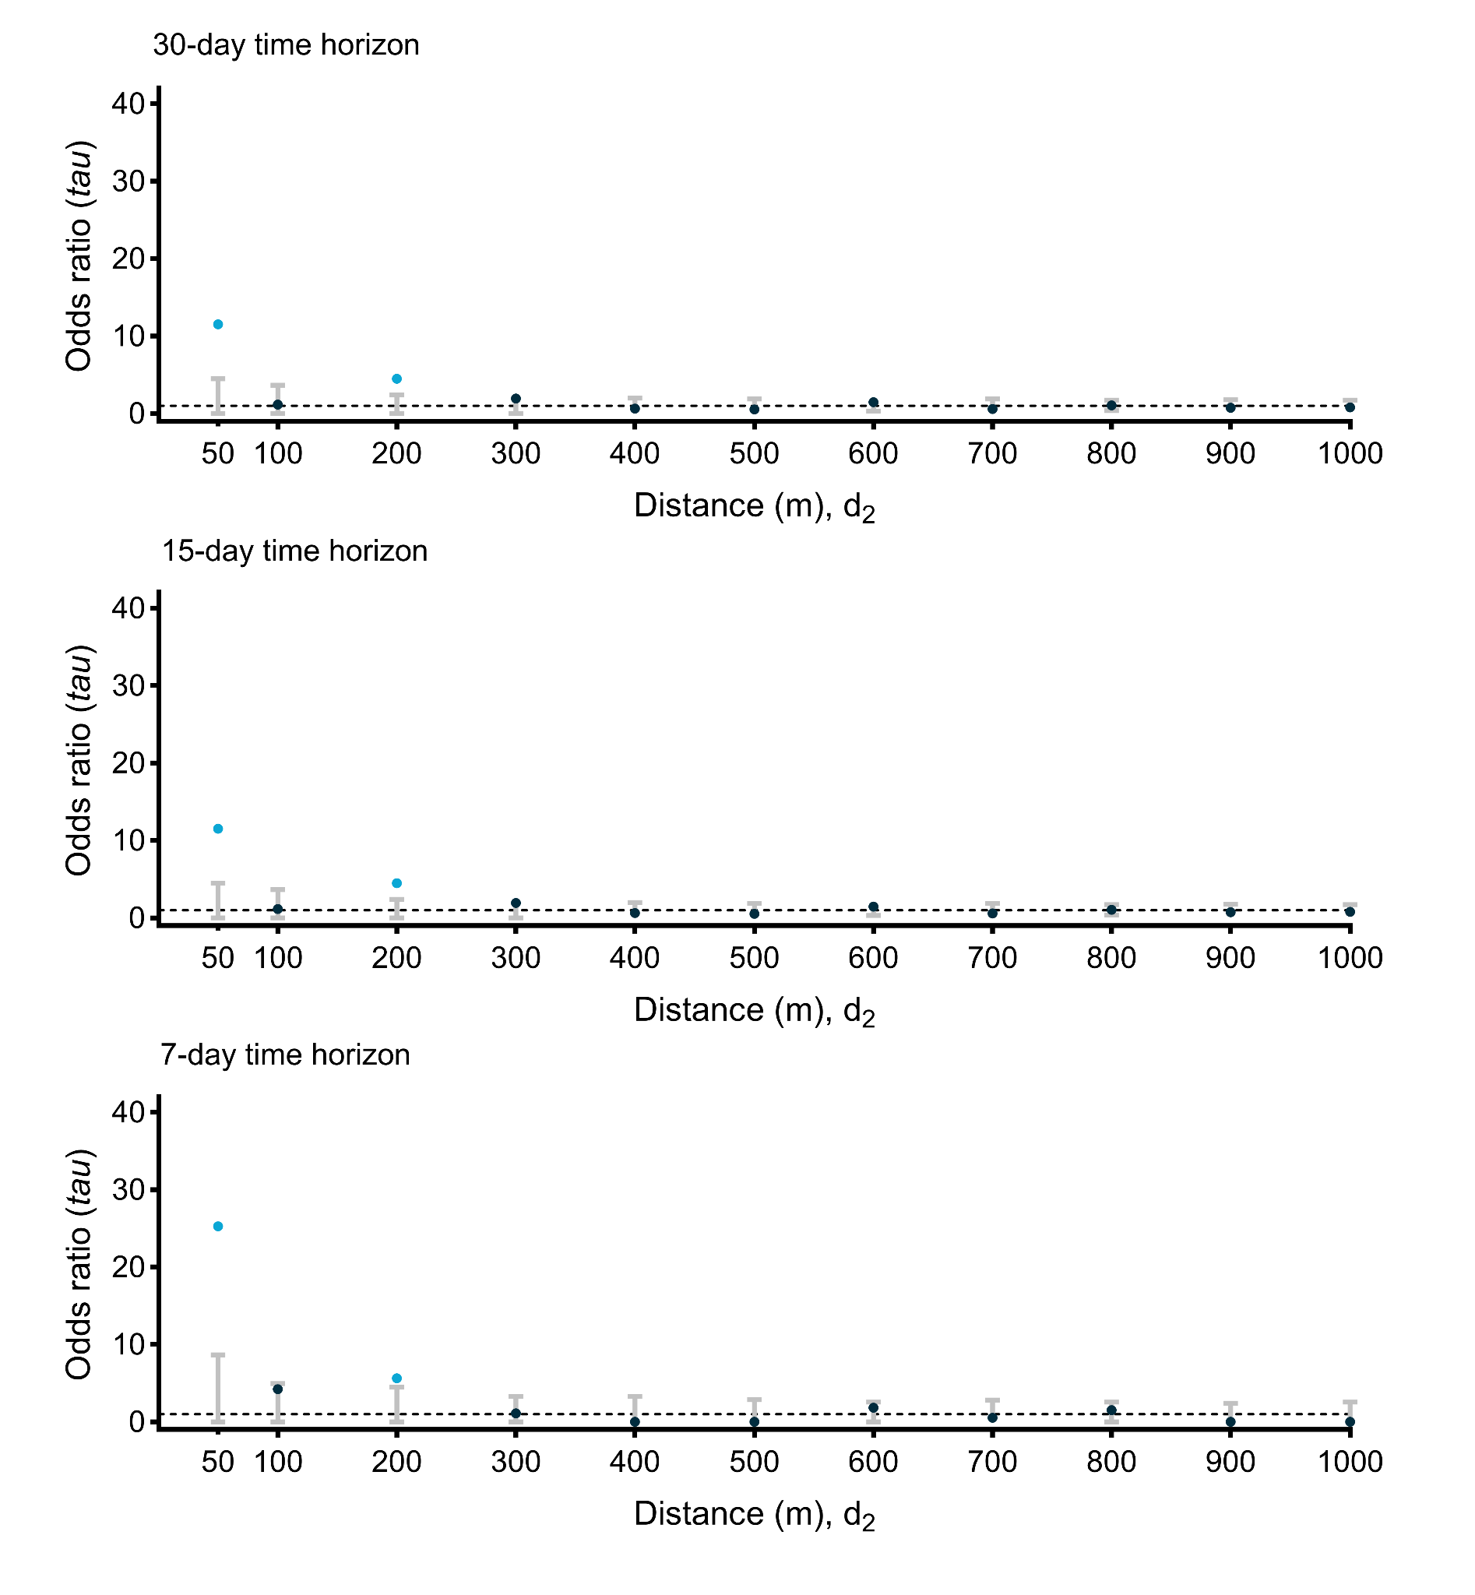
b.

Figure S7: Spatiotemporal dependence in dengue case occurrence. Estimated odds ratio (tau) comparing the odds of a homotypic dengue case pair within (d₁, d₂) versus the odds of a homotypic dengue case pair at any distance within Yogyakarta, among participant pairs with illness onset occurring within 30, 15 or 7 days; for all dengue cases in aggregate (a) and stratified by serotype for DENV1 (b), DENV2 (c) and DENV3 (d). There were insufficient DENV4 cases for analysis. Circle markers are point estimates and bars the permutation-based null rejection region based on 1000 permutations of the data.
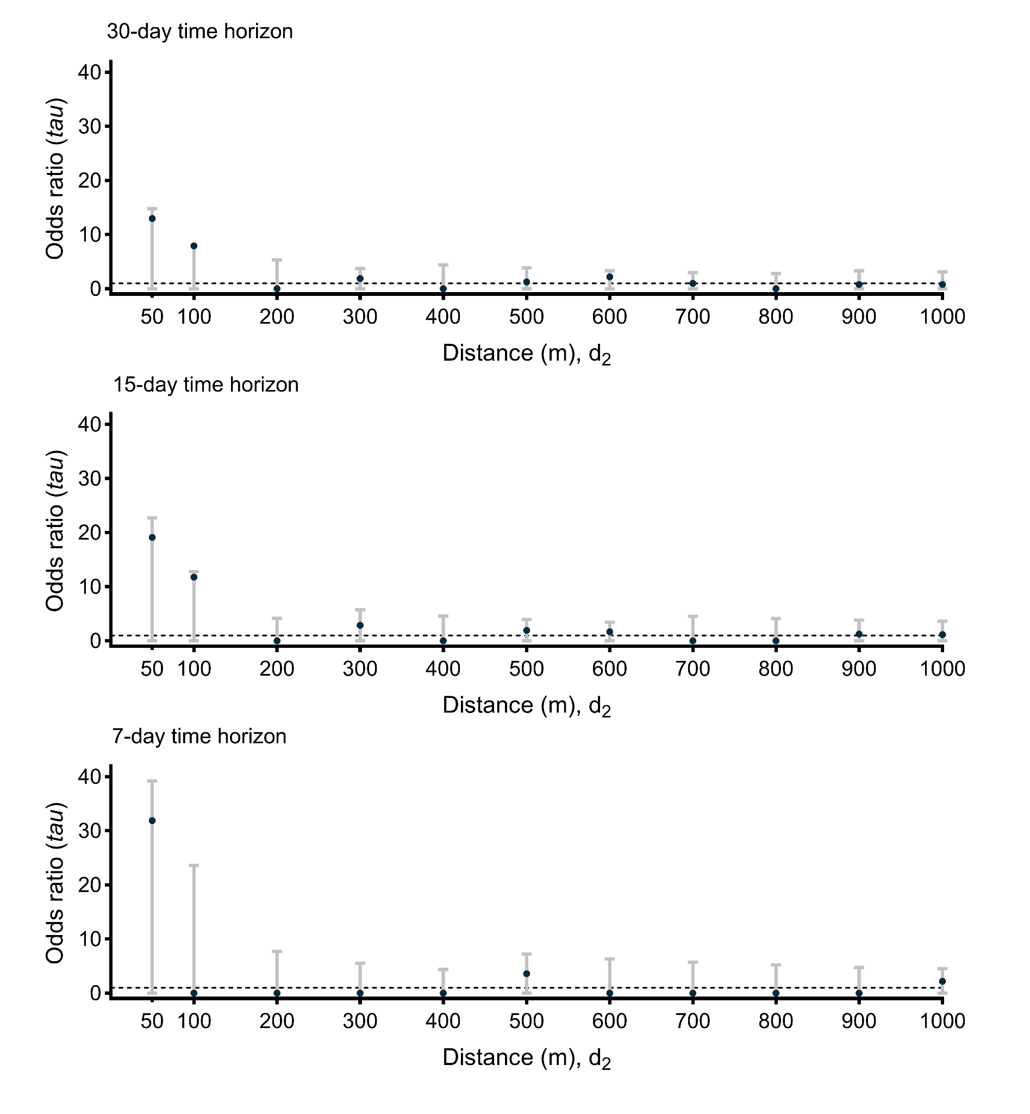
c.

Figure S7: Spatiotemporal dependence in dengue case occurrence. Estimated odds ratio (tau) comparing the odds of a homotypic dengue case pair within (d₁, d₂) versus the odds of a homotypic dengue case pair at any distance within Yogyakarta, among participant pairs with illness onset occurring within 30, 15 or 7 days; for all dengue cases in aggregate (a) and stratified by serotype for DENV1 (b), DENV2 (c) and DENV3 (d). There were insufficient DENV4 cases for analysis. Circle markers are point estimates and bars the permutation-based null rejection region based on 1000 permutations of the data.
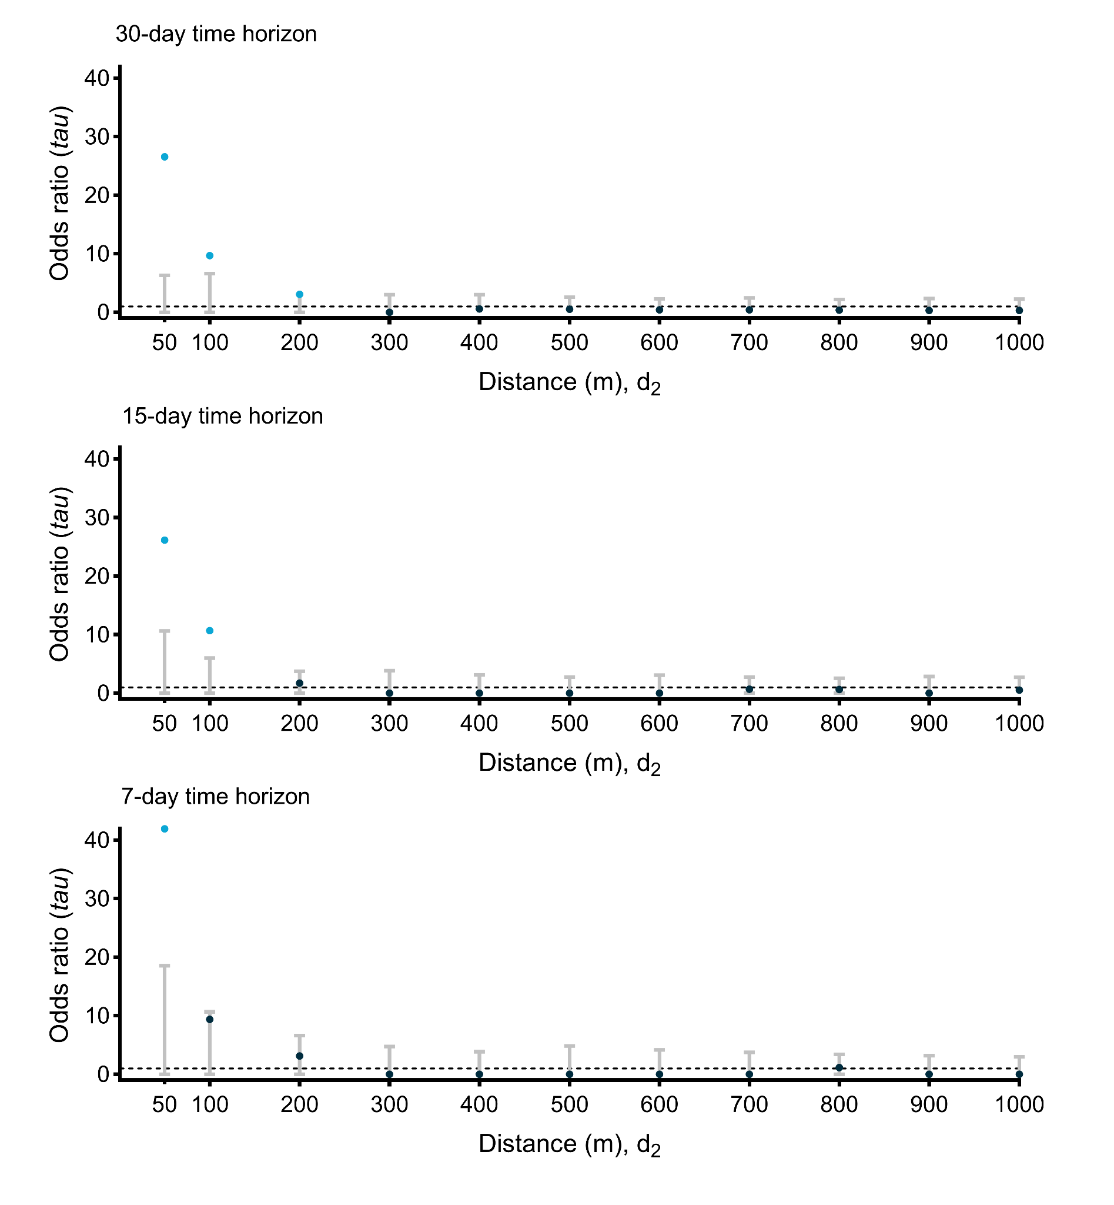
d.

Figure S7: Spatiotemporal dependence in dengue case occurrence. Estimated odds ratio (tau) comparing the odds of a homotypic dengue case pair within (d₁, d₂) versus the odds of a homotypic dengue case pair at any distance within Yogyakarta, among participant pairs with illness onset occurring within 30, 15 or 7 days; for all dengue cases in aggregate (a) and stratified by serotype for DENV1 (b), DENV2 (c) and DENV3 (d). There were insufficient DENV4 cases for analysis. Circle markers are point estimates and bars the permutation-based null rejection region based on 1000 permutations of the data.
a.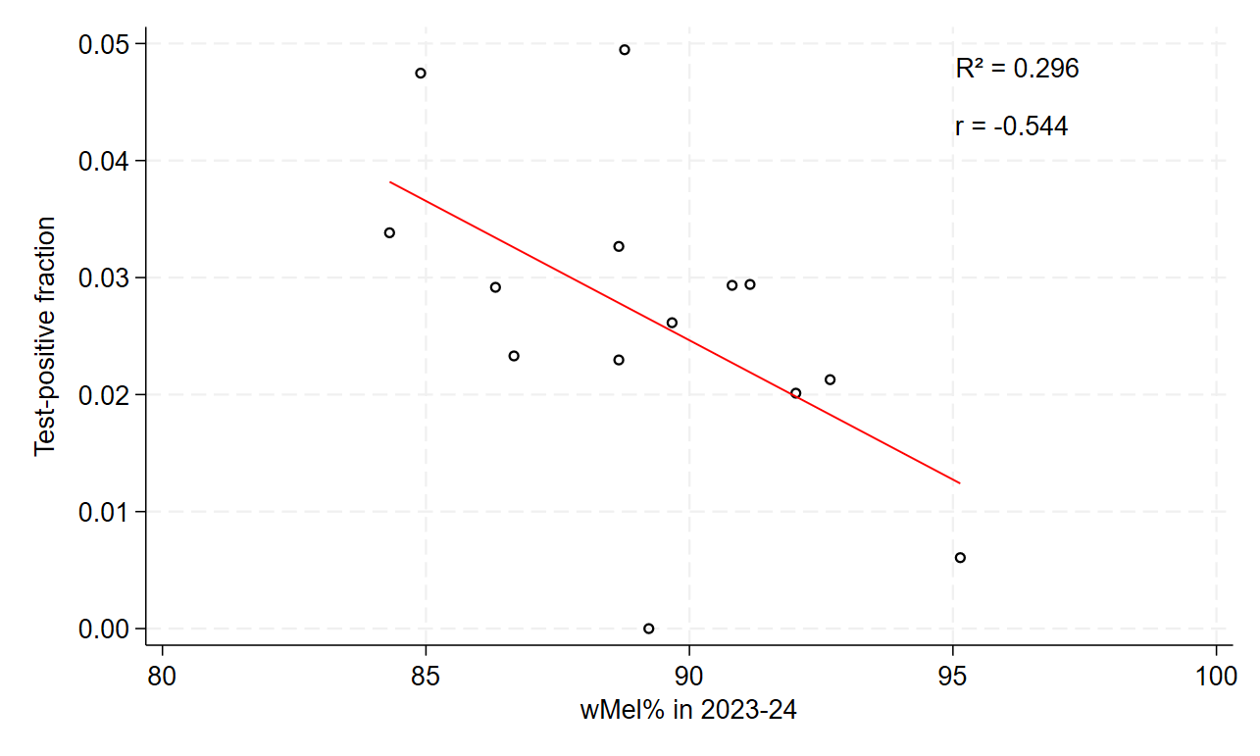
b.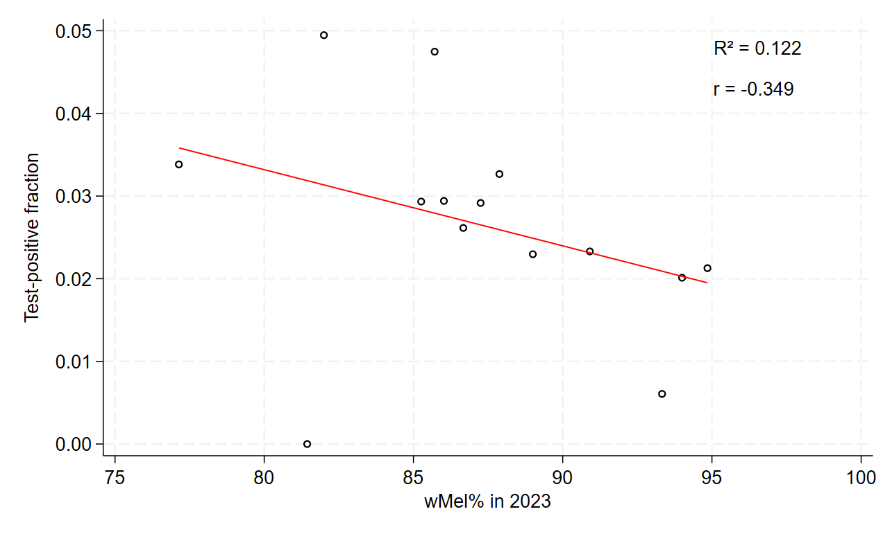
c.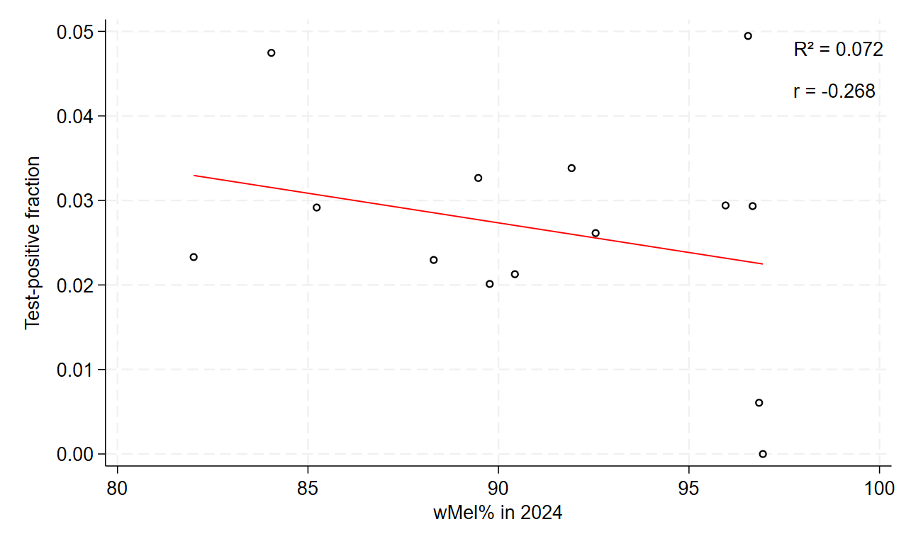

Figure S8. Correlation between the dengue test-positive fraction of participants enrolled in the enhanced surveillance study and Wolbachia frequency in 14 subdistricts of Yogyakarta. a. Based on Wolbachia frequency in Ae. aegypti collected in December 2023 and November 2024 combined. b. Based on 2023 monitoring data only. c. Based on 2024 monitoring data only.

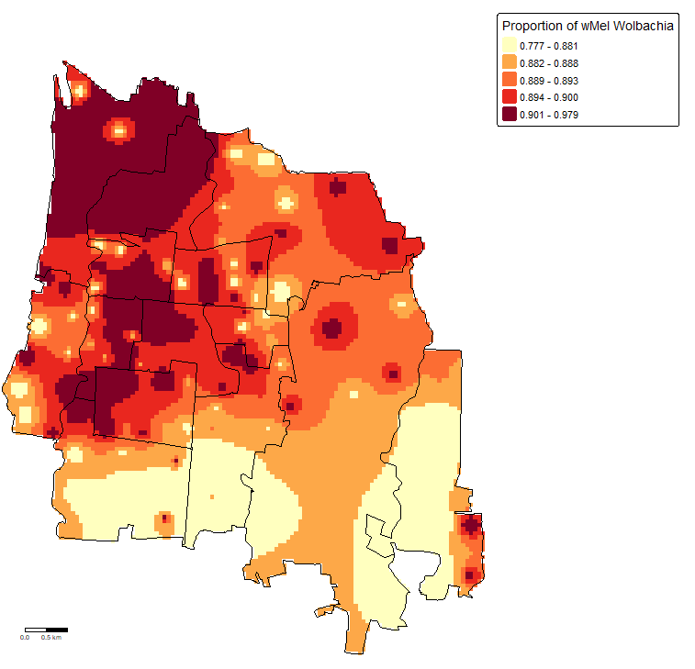
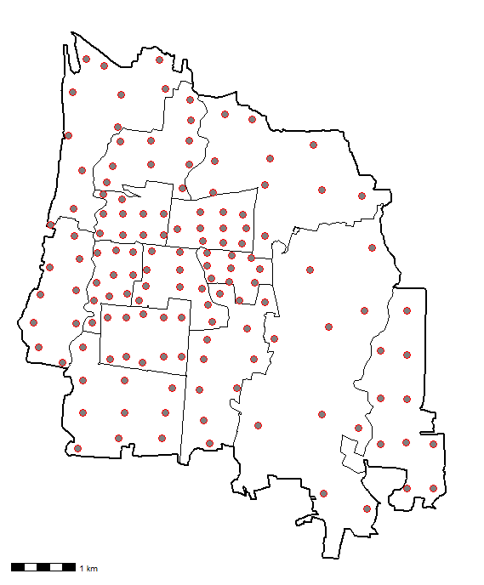
a. b.

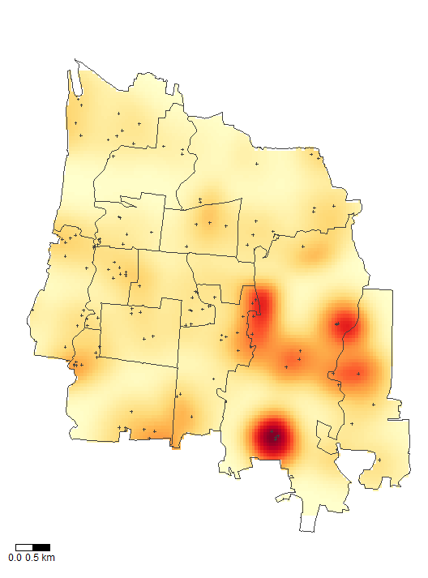
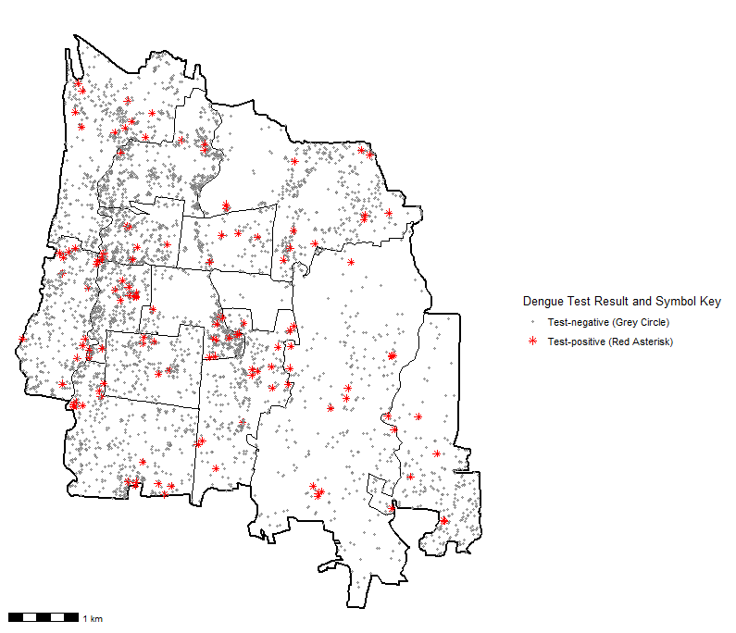
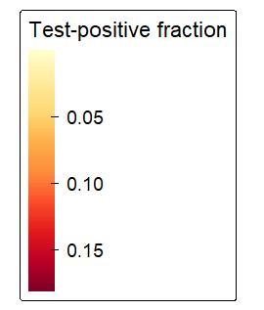
c. d.

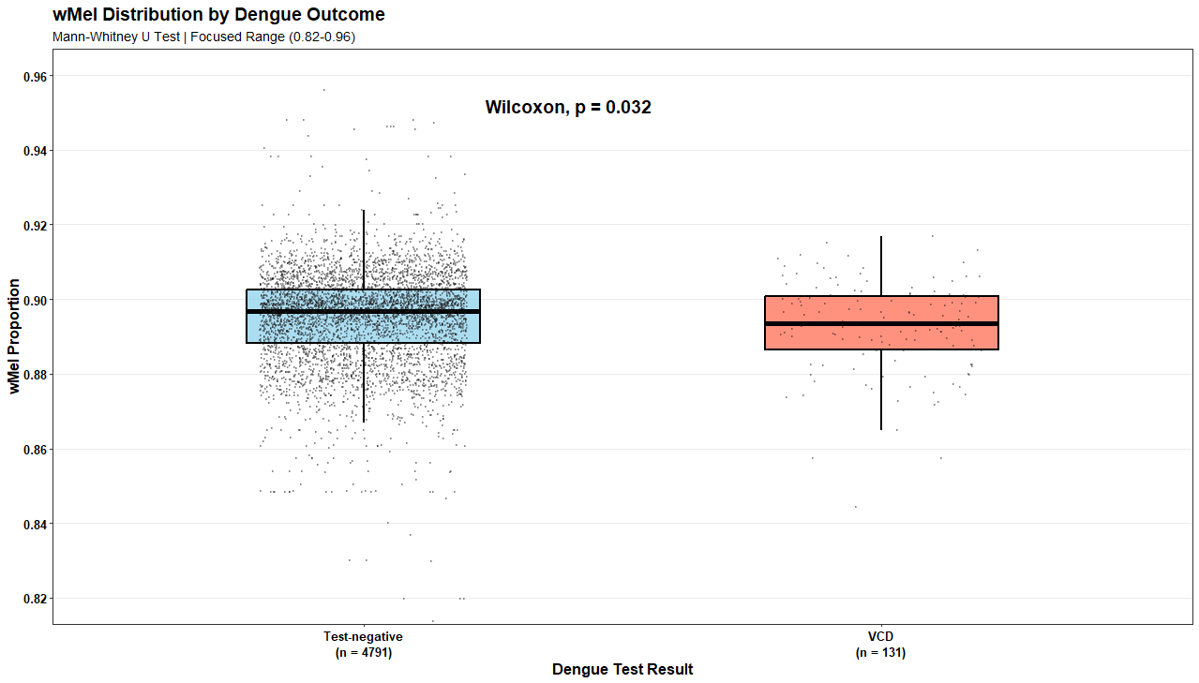
e.

Figure S9. Fine scale spatial variability in Wolbachia frequency in 2023-24 and the spatial distribution of virologically-confirmed dengue cases. a. Locations of mosquito collections for Wolbachia monitoring in December 2023 and November 2024. b. Spatial inverse distance weighted maps of wMel infection prevalence in Ae. aegypti in 2023 and 2024 interpolated across a 50 x 50 meter grid. c. Residential locations of virologically-confirmed dengue cases and test-negative participants enrolled in the enhanced clinical surveillance study January 2023 - September 2024. d. Kernel smoothing estimates of the spatially-varying dengue test-positive fraction of enrolled participants. e. Interpolated Wolbachia frequency at the residential location of virologically-confirmed dengue (VCD) cases and test-negative participants, indicating slightly lower local Wolbachia frequency among dengue cases than test-negative participants. The Tukey’s boxplot shows the median and interquartile range (IQR) of interpolated Wolbachia frequency, with spikes showing Q1 - 1.5 x IQR to Q3 + 1.5 x IQR.

