Cell Research
February 23, 2026

The N-degron pathway modulates autophagosome biogenesis in selective autophagy via the p62-TRAF6-VPS34 circuit

Su Bin Kim^{1*}, Su Hyun Lee^{2*}, Dong Hyun Kim^{3*}, Jeong Su Jo^{4*}, Min Ju Lee¹, Su Jin Lee¹, Soon Chul Kwon¹, Jingi Bae^{4,5}, Chan Hoon Jung⁶, Su Ran Mun¹, Hye Yeon Kim¹, Ah Jung Heo⁷,
Hee Yeon Kim⁸, Yoon Jee Lee¹, Ho Chul Lim⁹, Kyeong Tae Noh⁹, Dae Eun Kang¹⁰, Hyo Sun Cha¹¹, Woo-Dong Jang¹⁰, Cheol Yong Choi¹¹, Hyunjoo Cha-Molstad¹², Sang Won Lee^{4,5,13§}, Yong Tae Kwon^{1,13,14,15,16§}, and Chang Hoon Ji^{1,16§}

¹Cellular Degradation Biology Center, College of Medicine, Seoul National University, Seoul 03080, Korea.
²Department of Oncology, St. Jude Children’s Research Hospital, Memphis, TN 38105, USA
³Cancer Metastasis Branch, Division of Cancer Biology, National Cancer Center, Goyang 10408, Korea
⁴Department of Chemistry, Korea University, Seoul 02841, Korea
⁵ TargetX Inc., Seoul 02841, Korea
⁶School of Biological Sciences, Seoul National University, Gwanak-gu, Seoul 08826, Korea
⁷Goethe University Frankfurt, Medical Faculty, Institute of Biochemistry II, Theodor-Stern-Kai 7, 60590 Frankfurt, Germany
⁸Severance Hospital, Yonsei University College of Medicine, Seoul 03722, Korea
⁹Bioinformatics and Molecular Design Research Center, Yonsei University, Incheon 21983, Korea
¹⁰Department of Chemistry, Yonsei University, Seoul 03722, Korea
¹¹Department of Biological Sciences, Sungkyunkwan University, Suwon 16419, Korea.
¹²World Class Institute, Anticancer Agents Research Center, Korea Research Institute of Bioscience and Biotechnology, Ochang, Cheongwon, 28116, Korea
¹³National Research Laboratory for Convergence Degradation Biology, Korea University, Seoul 02841, South Korea
¹⁴Convergence Dementia Research Center, Seoul National University Medical Research Center, Seoul 03080, Korea
¹⁵Ischemic/Hypoxic Disease Institute, Medical Research Center, Seoul National University, Seoul 03080, Korea.
¹⁶AutotacBio Inc., Gasan digital-1-ro 225, Geumcheon-gu, Seoul 08501, Korea

*These authors equally contributed to this work.

§Correspondence:

Chang Hoon Ji. Department of Biomedical Sciences, College of Medicine, Seoul National University, Seoul 03080, Korea
Telephone: 82-2-6328-1121. Fax: 82-2-3673-2167. Email: changhoon.ji@snu.ac.kr.

Yong Tae Kwon. Department of Biomedical Sciences, College of Medicine, Seoul National University, Seoul 03080, Korea

Telephone: 82-2-740-8547. Fax: 82-2-3673-2167. Email: yok5@snu.ac.kr.

Sang Won Lee. Department of Chemistry, Korea University, Seoul 02841, Korea

Telephone: 82- 2-3290-3137. Fax: 82- 2-3290-3121. Email: sw_lee@korea.ac.kr.

Supplementary Figures and Figure Legends
Figure S1. Proteomic analyses of bulk autophagy and chemically-induced selective autophagy. a KEGG pathway analysis of dynamically downregulated proteins between vehicle control and serum starvation (6 h). b KEGG pathway analysis of dynamically upregulated proteins between vehicle control and serum starvation (6 h). c KEGG pathway analysis of dynamically downregulated proteins between vehicle control and treatment of MG132 (1 μM, 24 h). d KEGG pathway analysis of dynamically upregulated proteins between vehicle control and treatment of MG132 (1 μM, 24 h). e Reactome pathway analysis of dynamically downregulated proteins between vehicle control and serum starvation (6 h). f Reactome pathway analysis of dynamically upregulated proteins between vehicle control and serum starvation (6 h). g Reactome pathway analysis of dynamically downregulated proteins between vehicle control and treatment of MG132 (1 μM, 24 h). h Reactome pathway analysis of dynamically upregulated proteins between vehicle control and treatment of MG132 (1 μM, 24 h).

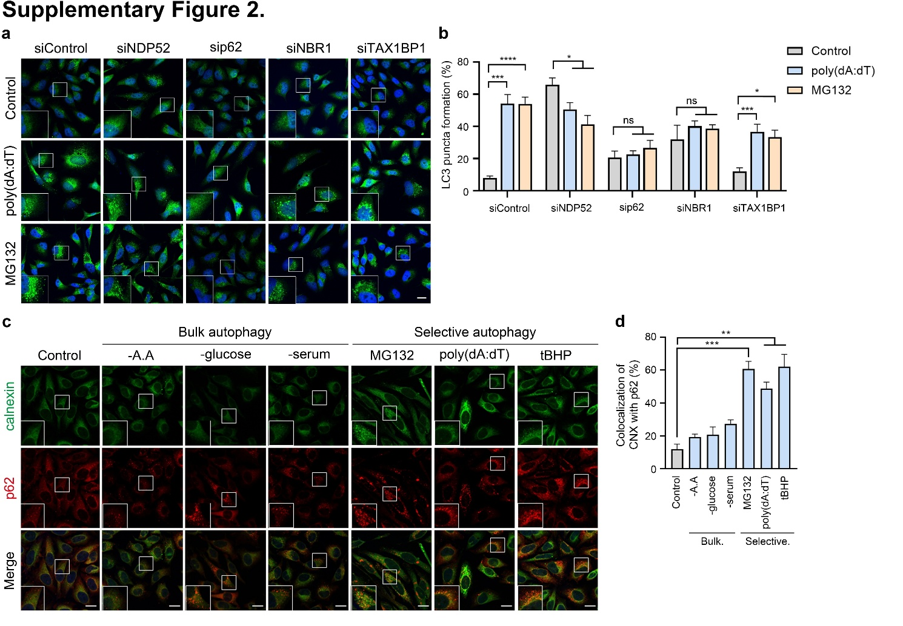
Figure S2. p62 condensates near the ER recruit ubiquitinated cargoes during selective autophagy. a Immunostaining of analysis in HeLa cells under siRNA-mediated interference of autophagic cargo adapters (NDP52, p62, NBR1, or TAXBP1) and treated with poly(dA:dT) (1 μg, 8 h) and MG132 (5 mM, 6 h). Scale bar: 10 μm. b Quantification of a (150 cells/group). c Immunostaining of analysis in HeLa cells with amino acids starvation (6 h), glucose starvation (6 h), serum starvation (6 h), MG132 (5 mM, 6 h), poly(dA:dT) (1 μg, 8 h), or tBHP (250 mM, 6 h). Scale bar: 10 μm. d Quantification of c (150 cells/group). Error bars represent SEM (n=3 replicates). *p<0.05, **p<0.01, ***p<0.001 using the paired t-test.

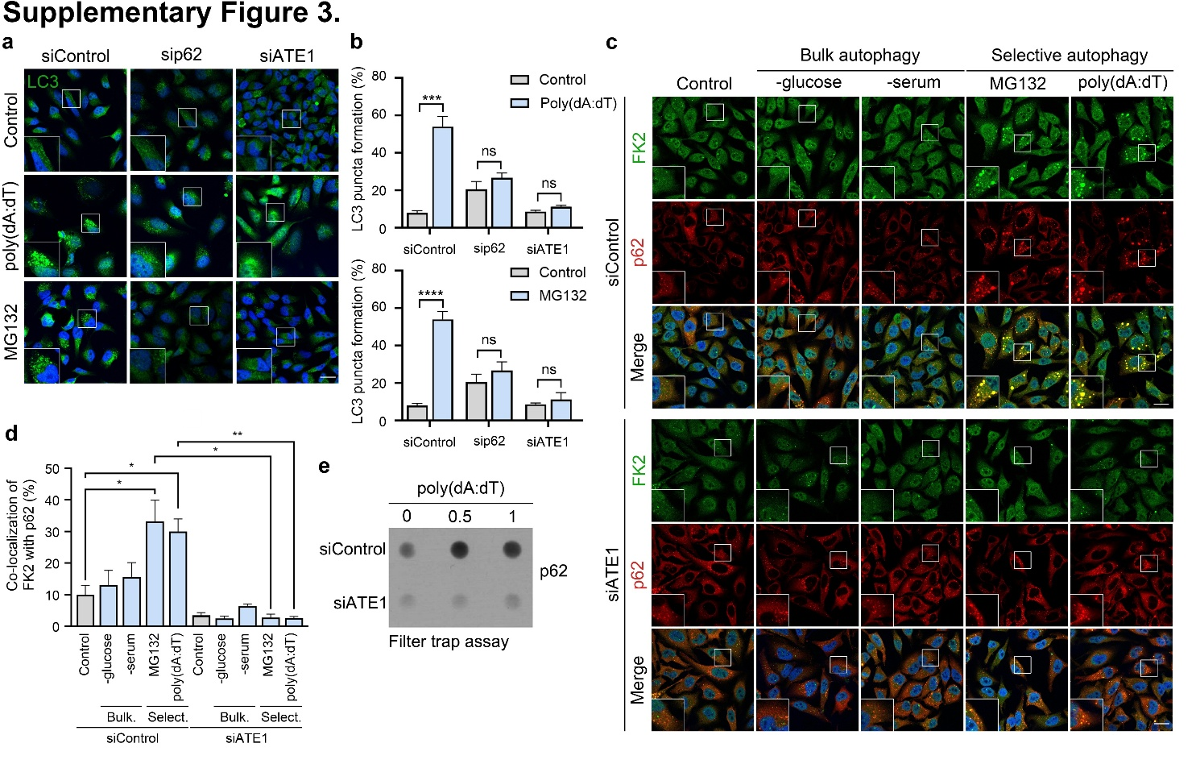
Figure S3. p62 condensates are generated in an ATE1-dependent manner during selective autophagy. a Immunostaining of analysis in HeLa cells under siRNA-mediated interference of p62 or ATE1 (40 nM, 48 h) and treated with poly(dA:dT) (1 μg, 8 h) and MG132 (5 mM, 6 h). Scale bar: 10 μm. b Quantification of a (150 cells/group). c Immunostaining of analysis in HeLa cells under siRNA mediated-interference of ATE1 treated with glucose starvation (6 h), serum starvation (6 h), MG132 (1 μM, 24 h) or poly(dA:dT) (1 μg, 8 h). Scale bar: 10 μm. d Quantification of c (150 cells/group). e In vivo filter trap assay of p62 in HeLa cells under siRNA-mediated interference (40 nM, 48 h) and treated with poly(dA:dT) (1 μg, 24 h). Error bars represent SEM (n=3 replicates). *p<0.05, **p<0.01, ***p<0.001 using the paired t-test.

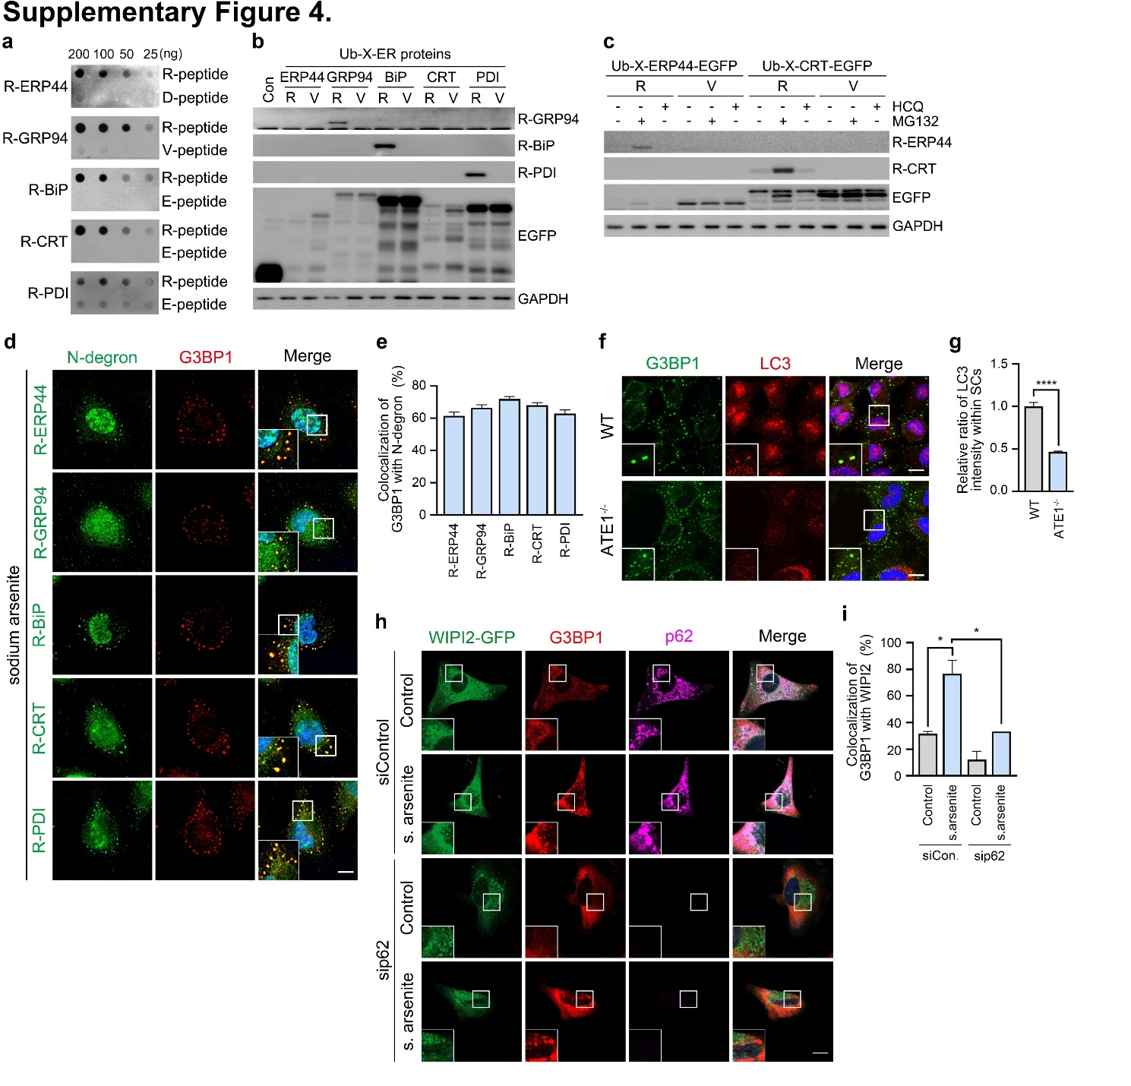
Figure S4. The Arg/N-degron pathway induces autophagy targeting of G3BP1. a In vivo filter trap assay of R-ERP44, R-GRP94, R-BiP, R-CRT, and R-PDI in HeLa cells with R-peptide or D-peptide. b Immunoblotting analysis in HeLa cells transiently overexpressed with Ub-R-ERP44, Ub-V-ERP44, Ub-R-GRP94, Ub-V-GRP94, Ub-R-BiP, Ub-V-BiP, Ub-R-CRT, Ub-V-CRT, Ub-R-PDI, or Ub-V-PDI. c Same as b but overexpressed with Ub-R-ERP44-EGFP, Ub-V-ERP44-EGFP, Ub-R-CRT-EGFP, Ub-V-CRT-EGFP, and treated with MG132 (1 mM, 18 h) and HCQ (25 mM, 24 h). d Immunostaining of analysis in HeLa cells treated with sodium arsenite (0.5 mM, 30 min). Scale bar: 5 μm. e Quantification of d (150 cells/group). f Immunostaining analysis in wild-type and ATE1^{-/-} HeLa cells treated with sodium arsenite (0.5 mM, 30 min). Scale bar: 5 μm. g Quantification of f (50 cells/group). h Immunostaining in HeLa cells transiently overexpressing WIPI2-GFP and under p62 siRNA interference with treatment of sodium arsenite (0.5 mM, 30 min). i Quantification of h (150 cells/group). Error bars represent SEM (n=3 replicates). *p<0.05, **p<0.01, ***p<0.001 using the paired t-test.

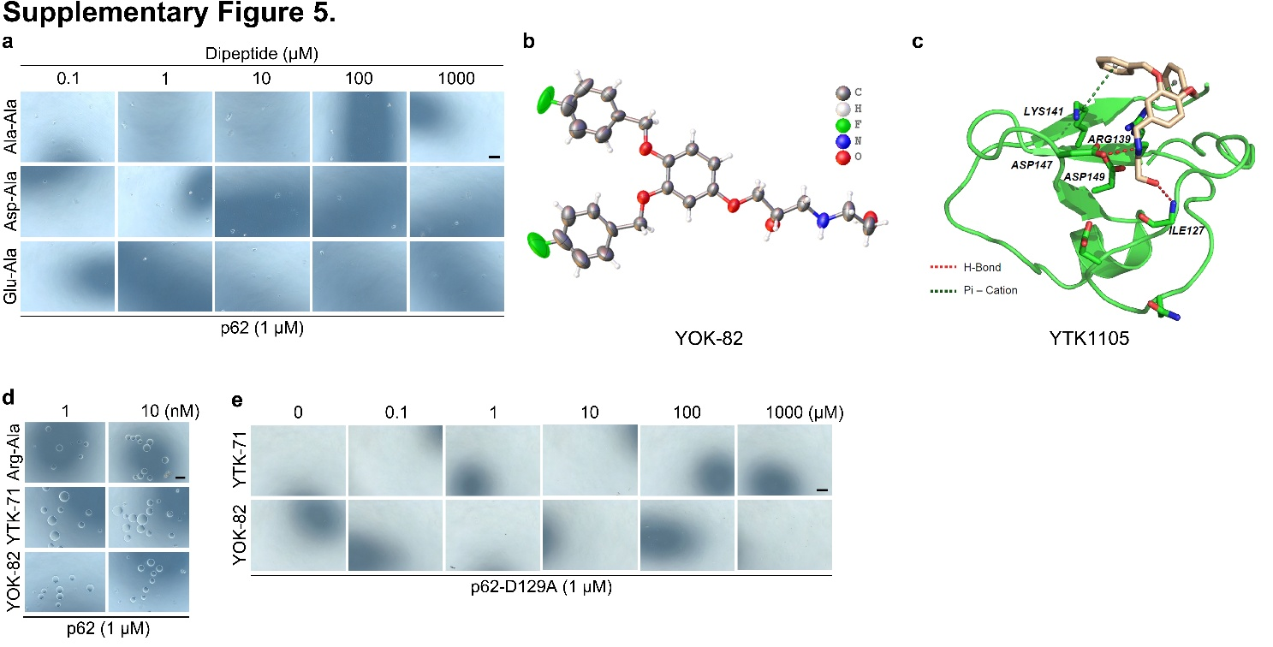
Figure S5. Activation of p62 using model N-degrons induces its liquid-liquid phase separation as oligomeric bodies. a In vitro p62 peptide condensation assay using 1 μM p62 with dipeptides (Ala-Ala, Asp-Ala, and Glu-Ala). Scale bar, 100 μm. b Chemical crystallography of YOK-82. C Docking model of p62 with YTK1105. d In vitro p62 peptide condensation assay using 1 μM p62 with dipeptide (Arg-Ala) and chemical N-degrons (YTK-71 and YOK-82; 5 min). Scale bar, 100 μm. e Same as d but using 1 μM p62-D129A. Scale bar, 100 μm.

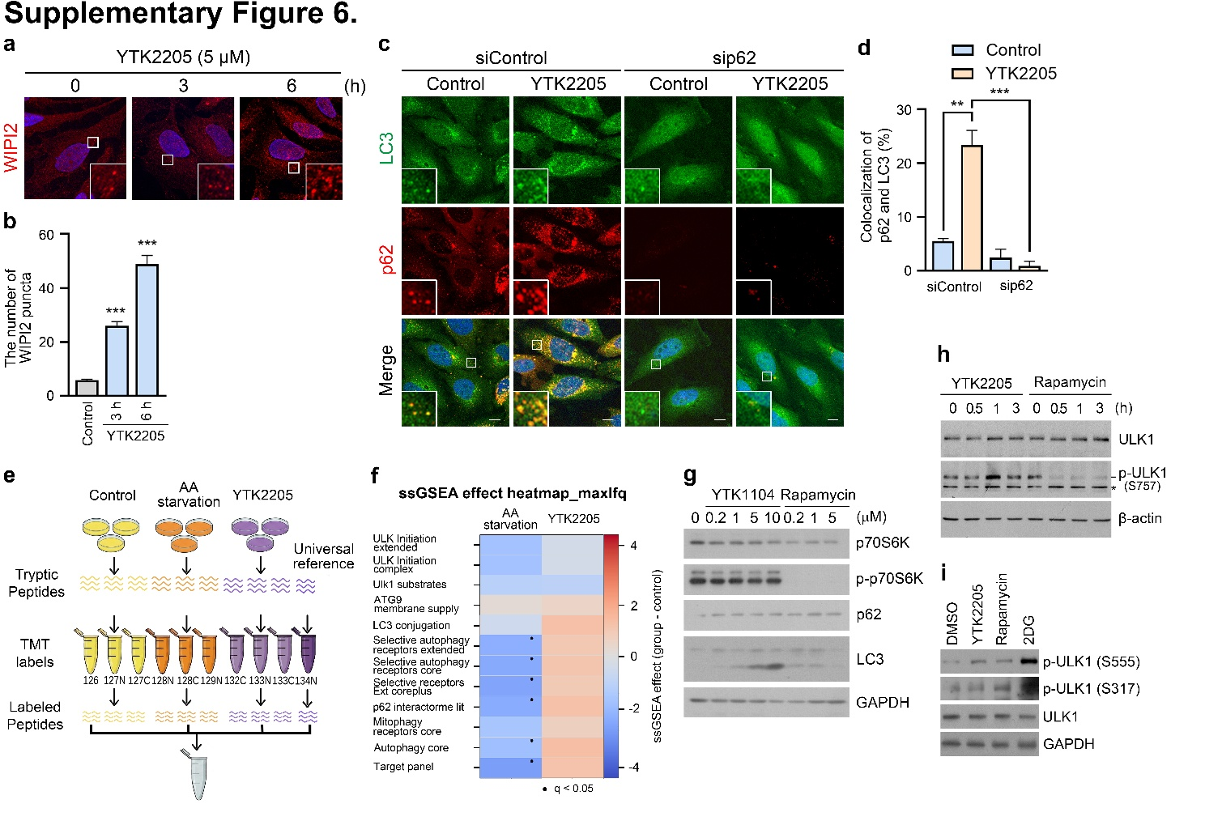
Figure S6. Chemical N-degrons mimicking Nt-Arg induce selective autophagy independent of the mTOR pathway. a Immunostaining analysis in HeLa cells treated with YTK2205 (5 μM). Scale bar = 10 μm. b Quantification of a (20 cells/group). c Immunostaining analysis in HeLa cells under siRNA-mediated interference of p62 treated with YTK2205 (5 μM, 6 h). Scale bar = 10 μm. d Quantification of c (150 cells/group). e Workflow of proteomic analysis of HeLa cells treated with vehicle control, amino acids starvation (3 h), and YTK2205 (5 μM, 6 h). f SsGSEA effect heatmap of proteins expressed in HeLa cells treated with vehicle control, amino acids starvation (3 h), and YTK2205 (5 μM, 6 h). g Immunoblotting analysis in HEK293 cells treated with YOK1104 or rapamycin in a concentration-dependent manner. h Immunoblotting analysis in HEK293 cells treated with YTK2205 or rapamycin in a time-dependent manner at a concentration of 5 μM. i Same as f but treated with YTK2205, rapamycin, and 2DG (5 μM, 6 h). Error bars represent SEM (n=3 replicates). *p<0.05, **p<0.01, ***p<0.001 using the paired t-test.

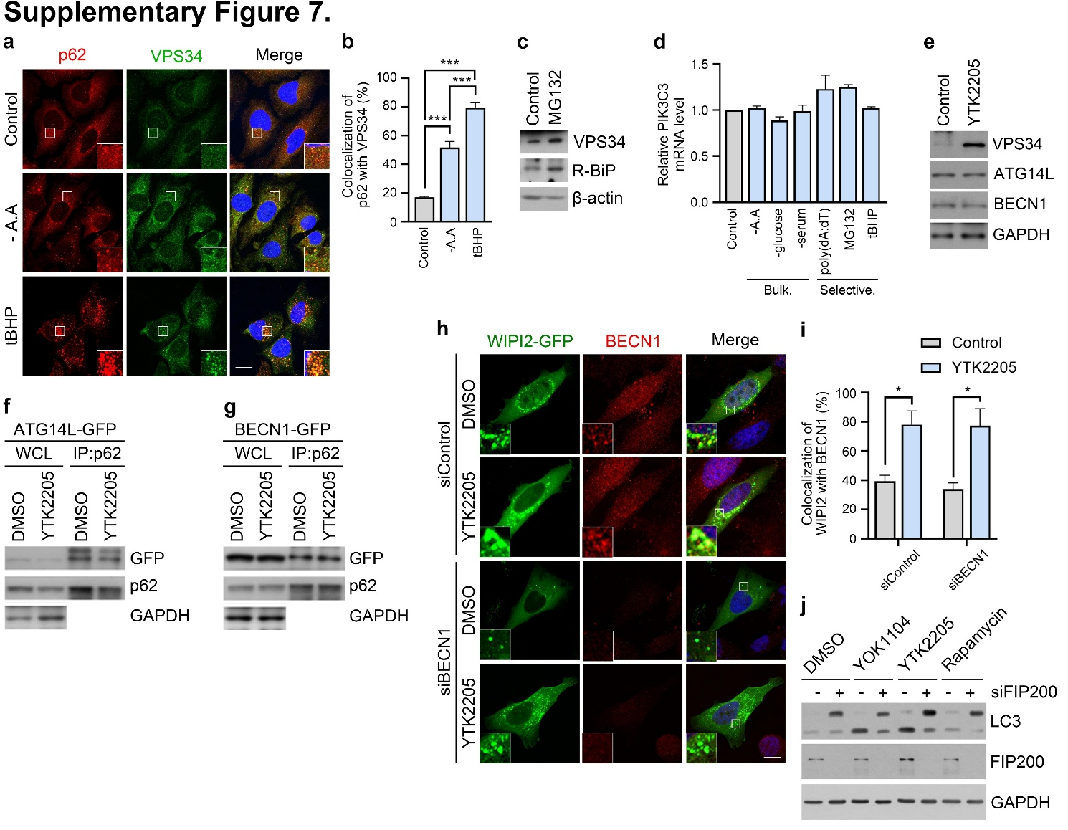
Figure S7. P62-mediated selective autophagy stabilizes VPS34 but is independent of ATG14L and Beclin1. a Immunostaining analysis in HeLa cells treated with amino acids starvation (6 h), or tBHP (250 μM, 6 h). Scale bar = 10 μm. b Quantification of a (70 cells/group). c Immunoblotting analysis in HeLa cells treated with MG132 (1 μM, 24 h). d Relative mRNA level of PIK3C3 in HeLa cells treated with serum starvation (6 h), amino acids starvation (6 h), and glucose starvation (6 h), MG132 (5 μM, 6 h), poly(dA:dT) (1 μg, 8 h), or tBHP (250 μM, 6 h). e Immunoblotting analysis in HeLa cells treated with YTK2205 (5 μM, 6 h). f IP assay in HEK293 cells transfected with ATG14L-GFP and treated with YTK2205 (5 μM, 6 h). g Same as f but with BECN1-GFP. h Immunostaining analysis in HeLa cells under siRNA-mediated interference of BECN1 treated with YTK2205 (5 μM, 6 h). Scale bar = 10 μm. i Quantification of h (150 cells/group). j Immunoblotting analysis in HEK293 cells under siRNA-mediated interference of FIP200 treated with YTK1105 (5 μM, 6 h), YOK1104 (5 μM, 6 h), or Rapamycin (5 μM, 6 h). Error bars represent SEM (n=3 replicates). *p<0.05, **p<0.01, ***p<0.001 using the paired t-test.

