Supplementary Methods:
Base Data for PRS Construction:
The base data for this study were extracted from the genome-wide association study (GWAS) catalogs based on data from recently published articles.¹⁻³ The harmonized summary statistics from Biobank Japan (GCST90018641), Veterans Affairs (VA) Million Veterans Program (MVP) (GCST90480147, GCST90480148), and 7 European-ancestry case-control cohorts (GCST90435254) were extracted and used for the polygenic risk score (PRS) construction. The non-European component of the PRS was primarily derived from MVP (29% Non-European) and the Biobank Japan (predominantly East-Asian).
The 7 European case-control cohort study populations have been described elsewhere.² Briefly, the Hypertrophic Cardiomyopathy Registry recruited 2,755 incident hypertrophic cardiomyopathy (HCM) cases with unexplained left ventricular hypertrophy (defined as left ventricular wall thickness {LVWT} >15mm) that underwent gene panel sequencing and were divided into sarcomere-positive and sarcomere-negative groups using the American College of Medical Genetics and Genomics Guidelines.^{4,5} This cohort used 40,283 age and sex matched controls from the UK Biobank. The Canadian HCM cohort included unrelated clinically diagnosed HCM cases (defined as LVWT ≥ 15mm or LVWT > 13mm in the presence of family history of HCM or in carriers of pathogenic or likely pathogenic variants of sarcomere encoding genes) from the HCM clinic of Toronto General Hospital, the Cardiovascular Genetics Clinic of the Montreal Heart Institute (MHI), the MHI Biobank, and the London Health Science Centre. HCM cases were excluded if they had syndromic etiologies for HCM, underlying metabolic diseases, or had >1 sarcomeric pathogenic or likely pathogenic variants. Controls were included from the MHI Biobank and the London Health Science Center. The analysis of the Netherlands HCM cohort comprised 999 cases from Amsterdam University Medical Center, Erasmus Medical Center, and the University Medical Center Groningen, and 2,117 controls from the project Mine.^{6,7} The analysis from the Genomics England 100K Genome Project (GEL) included 471 clinically diagnosed HCM cases, and 2,355 controls were selected from relatives of probands without a cardiac phenotype and matched 5:1 with the cases for sex. The analysis of the Royal Brompton Hospital HCM cohort included 118 sarcomere-positive patients and 330 sarcomere-negative cases recruited from the Royal Brompton & Harefield Hospitals NHS Trust Cardiovascular Research Biobank. Controls were selected from the UK Digital Health Project, in whom HCM had been ruled out by cardiac magnetic resonance imaging.⁸ The analysis of the Italian HCM cohort comprised 111 sarcomere-positive and 183 sarcomere-negative HCM cases of the Cardiomyopathy Unit of the Careggi University Hospital, with HCM defined as unexplained LV hypertrophy with a maximal LV wall thickness > 13mm on echocardiography or CMR, complemented with family history or genotype status. 1,293 unrelated Italian controls were selected from the multicenter international HYPERGENESIS study.⁹ The analysis of the BioResource for Rare Disease cohort, a pilot study of the GEL, included 239 sarcomere-negative HCM cases and 7,203 controls.^{4,10}
The BioBank Japan (BBJ) Project was launched in 2003 as a national hospital-based prospective cohort. The BBJ collected clinical data and serum samples of nearly 200,000 patients from 66 hospitals that were affiliated with 12 medical institutions. Participants were recruited from June 2003 to March 2008, and their clinical information was collected on an annual basis through interviews and medical record review until 2013. The participants were of predominantly Japanese ancestry, the mean age at recruitment was 63.0 years, and 46.3% were females. The cohort comprised 383 cases of HCM and 177,745 controls. Details of phenotype determination have been described extensively.³
The VA MVP, a national cohort, was initiated in 2011 with the objective of determining the influence of genetics, lifestyle, and military exposure on the health of the US Veterans, and comprises nearly 30% non-European population.¹ DNA isolation and genotyping were performed on the collected blood biospecimens. The VA electronic health records, which included details of diagnosis codes recorded, laboratory values, and the details from questionnaires that were collected at the time of enrollment for all Veterans, were linked to the biorepository. The summary statistics were derived from 635,969 participants, of whom 8.8% were females, and the mean age was 61.9 years. The referenced study derived data from individuals of European (715 cases of ICD-10-CM: I42.1 and 538 cases of ICD-10-CM: I42.2 and 450,257 and 450,403 controls, respectively) and African ancestry (275 cases of ICD-10-CM: I42.1 and 247 cases of ICD-10-CM: I42.2 and 121,450 and 121,468 controls, respectively).¹
Validation Cohort:
The UK Biobank is a population-based study of nearly half a million UK-based participants, which recruited individuals aged 40 to 69 years between 2006 and 2010. Consenting participants underwent surveys, anthropometry, biological sample collections, and electronic health record linkage, which facilitated more robust longitudinal follow-up. Certain subsets of participants also underwent genotyping, exome sequencing, and whole-body magnetic resonance imaging. The UK Biobank was used for validation of the polygenic risk score, and individuals with cardiac imaging data were excluded during the derivation of the validation cohort. The HCM cases were identified using the self-reported history of disease, ICD-9 and ICD-10 codes, hospital encounters, and the death registry. Further details of the UK Biobank have been described extensively previously.^{11,12}
Testing Dataset:
The All of Us Research Program (AoURP) is a longitudinal cohort comprising unrelated adults aged 18 years and older enrolled from over 340 sites across the United States starting in 2018. The electronic health records, baseline demographic surveys, physical examination data, laboratory data, billing codes, and medication data of the consenting participants were collected. Detailed methodologies of phenotypic and genotypic data collection and processing in the AoURP have been described previously.^{13,14}
Genome Sequencing:
In the UK Biobank, WGS was performed using the Illumina NovaSeq 6000 sequencer, ensuring a minimum 23.5x coverage per individual. Variant calling was performed using both Graphtyper and the Dragen Bio-IT Platform. The Dragen called WGS data was used for this analysis. Data processing and QC steps have been extensively described previously.¹⁵ Genetically derived ancestry and computed kinship were used for the analysis.
In the All of Us Research Program, whole genome sequencing (WGS) was performed with coverage of more than 30x. Similar protocols were implemented for PCR-free library construction (PCR Free Kapa Hyper Prep), sequencing (using NovaSeq600), and variant calling (DRAGEN v3.4.12) across the different sequencing centers. Quality control (QC) steps, such as fingerprint concordance (log-likelihood ratio >-3), cross-individual contamination (<0.03), sex concordance, etc., were implemented by the AoU data and research center, which handled the mapping of genetic data to the latest reference genome build (GRCh38).^{13,14} The details of the sequencing, ancestry derivation, and quality control metrics implemented by the All of Us Genome Centers and the Data and Research Center have been extensively described in previous publications and are available at https://www.researchallofus.org/data-tools/methods/.¹⁶ ¹⁷
Pathogenic variants ascertainment:
Pathogenic or likely pathogenic variants in hypertrophic cardiomyopathy sarcomere-encoding genes (SARC-HCM-P/LP) from 8 definitive evidence (MYBC3, MYH7, TNNT2, TPM1, MYL2, MYL3, ACTC1, and TNNI3) and 1 moderate evidence sarcomere-encoding gene (TNNC1) were extracted from the All of Us dataset.^{17,18} These genes were curated based on the data from Clinical Genome Resource Gene (ClinGen) Curation Expert Panels. SARC-HCM-P/LP variants with 2 stars or more level of evidence based on ClinVar were included for the analysis. SARC VUS annotations were conducted based on the data provided in ClinVar. Annotation was performed using SNP Effect Annotation Tool 5.3a (build 2025-09-02 10:24, by Palo Cingolani) and ClinVar (File Dated: 2025-10-07).¹⁹ Variants meeting these criteria and demonstrating putative or predicted deleterious effects consistent with HCM were used to define genetic carrier status. Individuals carrying at least one qualifying variant were classified as SARC-HCM-P/LP carriers.
Additionally, variants identified based on a previously validated variant annotation pipeline were extracted across sarcomeric HCM genes and used for an additional analysis for the current study.^{16,17} Briefly, a filtering allele frequency of 4x10⁻⁵, based on the population prevalence of hypertrophic cardiomyopathy, was used to identify predicted deleterious variants.²⁰ Variants exceeding this frequency were unlikely to be pathogenic. Data from ClinGen and the Gene Curation Coalition were used to identify the disease mechanisms of the genes with definitive/strong evidence to incorporate additional variants. Similarly, for the gene with moderate evidence, gene characteristics reported on gnomAD in accordance with the ClinGen Variant Interpretation Working Group framework were used to incorporate additional variants. These mechanisms ensure variants were included from genes with a Z-score >3.09 or a probability loss-of-function intolerant (pLI) score ≥ 0.9.²¹
A popmax filtering allele frequency (defined as the maximum alternate frequency across different ancestry groups) of ≤0.001 on the Genome Aggregation Database or the All of Us Research program was used as part of the purification of the selection process to ensure that only truly deleterious genetic variants, which would be maintained at lower frequencies across all ancestry groups, were selected.
Study Outcomes:
Hypertrophic cardiomyopathy was defined using the ICD-9 (425.11 - hypertrophic obstructive cardiomyopathy, 425.18 - other hypertrophic cardiomyopathy) and ICD-10 (I42.1 - obstructive hypertrophic cardiomyopathy and I42.2 - other hypertrophic cardiomyopathy) codes. Participants with secondary causes of left ventricular hypertrophy, such as valvular diseases (I35.0, I06.0, Q23.0, I08.0, and Q25.3) and infiltrative cardiac diseases such as amyloidosis (E85) and Fabry’s disease (E75.21) were excluded. The study also explored adverse cardiovascular outcomes such as heart failure, arrhythmias, and composite outcomes. These outcomes were generated using electronic health records available on the platform, and the coding strategies and diagnosis codes used for each outcome have been detailed. (Table S11) Age was used on the time scale in the analysis to determine the lifetime risk of developing the event.
Supplemental Figures and Tables:
Supplementary Figure 1a: PRS Distribution Among SARC-HCM-P/LP Carriers with the SARC-HCM-P/LP Non-carriers as the Reference Group
Supplementary Figure 1b: PRS Distribution Among SARC VUS Carriers with the SARC VUS Non-Carriers as the Reference Group
Supplementary Figure 1c: PRS Distribution Among Predicted Deleterious Variant Carriers with the Predicted Deleterious Variant Non-Carriers as the Reference Group
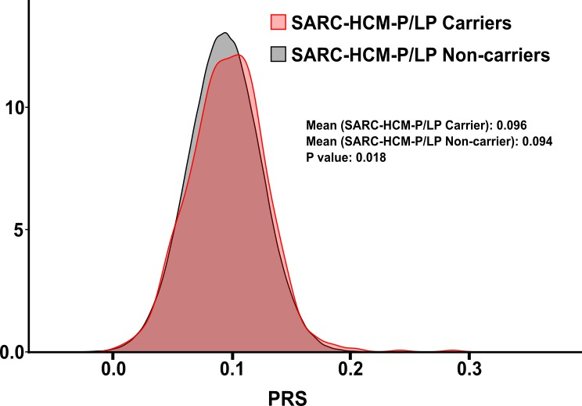

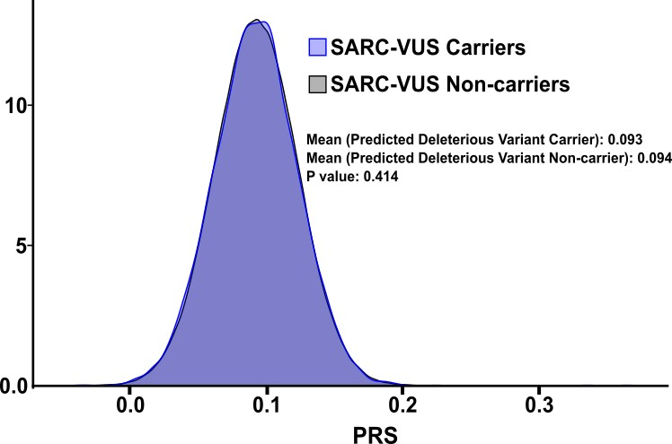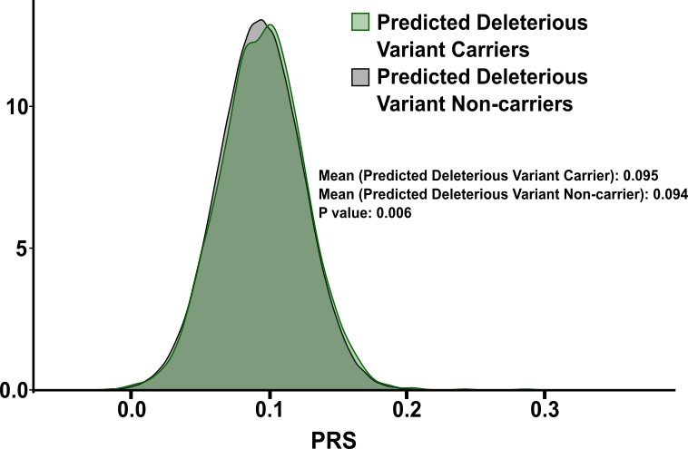
Figures S2a: A higher mean PRS was noted among the HCM cases compared with the non-cases within the predicted deleterious variant carriers
Figure S2b: Among the predicted deleterious variant carriers, the prevalence of HCM demonstrated an increasing trend with a 2.3-fold higher penetrance among those in the highest quintile (HCM prevalence of 5.02%) compared to those in the lowest quintile (HCM prevalence of 2.16%)

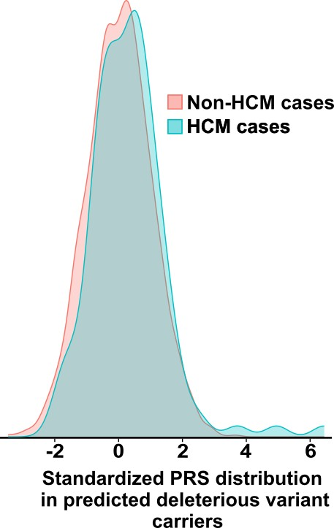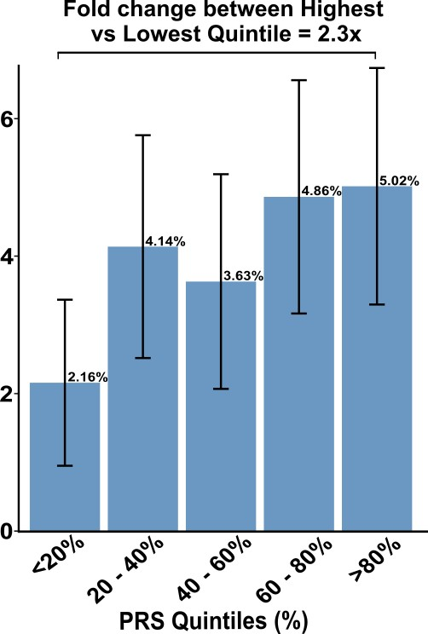

Figures S3a and S3b: Six distinct genetic risk categories were created for the analysis, divided by predicted deleterious variant carrier status and varying PRSs (<20% - low, 20-80% - intermediate, and >80% - high). Survival analyses were performed to determine the lifetime risk of development of HCM, and predicted deleterious variant non-carriers with low PRS were used as the reference group for risk assessments. The predicted deleterious variant non-carriers with a high PRS demonstrated a 2.16-fold (HR: 2.16; 95% CI: 1.71 – 2.71) higher risk of development of HCM. Among the predicted deleterious variant carriers, those with a low PRS exhibited nearly 8-fold (HR: 7.99; 95% CI: 3.15 - 20.26) higher risk of development of HCM, and those with a high PRS demonstrated a significantly higher risk of HCM development of nearly 20-fold (HR: 19.69; 95% CI: 13.77 - 28.14).

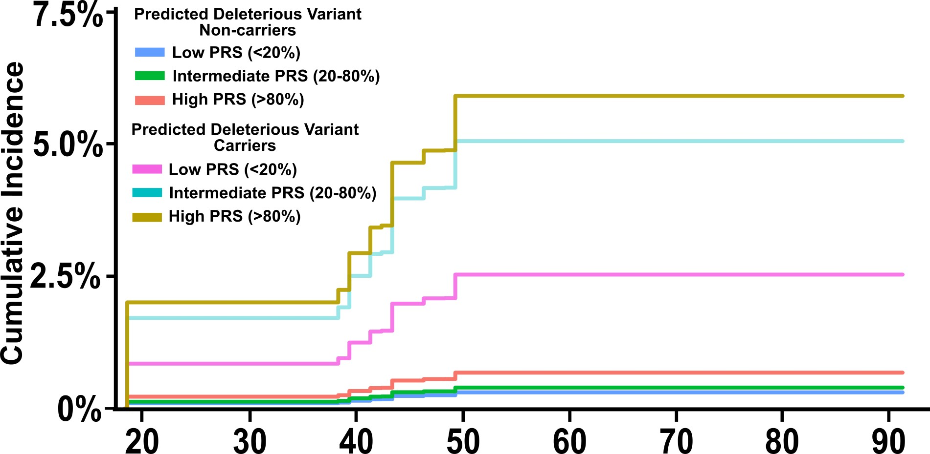
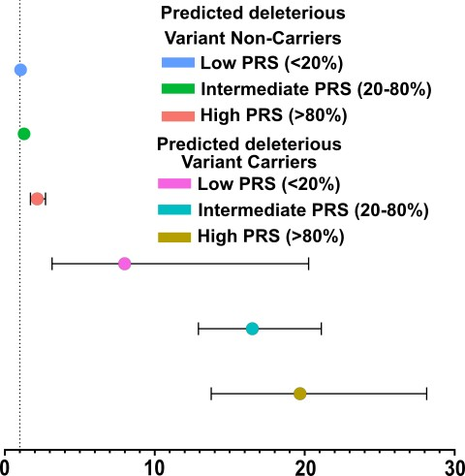

Table S1: Baseline characteristics according to SARC-HCM-P/LP carrier status

 | Overall | SARC HCM P/LP Carriers | SARC HCM P/LP Non-Carriers | p value
 | 258,361 | 785 | 257,576
Age (SD) | 52.7 (16.8) | 51.4 (16.9) | 52.7 (16.8)
Sex |  |  |  | 0.8
Male | 98,753 (38.2) | 304 ( 38.7) | 98,449 ( 38.2)
Female | 159,608 (61.8) | 481 ( 61.3) | 159,127 ( 61.8)
Ancestry (%) |  |  |  | 0.287
Europeans | 155,127 (60.0) | 492 ( 62.7) | 154,635 ( 60.0)
Africans | 48,350 (18.7) | 148 ( 18.9) | 48,202 ( 18.7)
Admixed | 45,220 (17.5) | 119 ( 15.2) | 45,101 ( 17.5)
Asians | 9,664 ( 3.7) | 26 ( 3.3) | 9,638 ( 3.7)
Self-reported Race |  |  |  | 0.298
Non-Hispanic White | 144,367 (55.9) | 458 ( 58.3) | 143,909 ( 55.9)
Non-Hispanic Black | 40,404 (15.6) | 127 ( 16.2) | 40,277 ( 15.6)
Hispanic | 45,976 (17.8) | 128 ( 16.3) | 45,848 ( 17.8)
Others | 27,614 (10.7) | 72 ( 9.2) | 27,542 ( 10.7)
Comorbidities
Hypertension | 76,213 (29.8) | 251 ( 32.3) | 75962 ( 29.8) | 0.139
Diabetes | 55,162 (21.6) | 164 ( 21.1) | 54998 ( 21.6) | 0.782
Obesity | 76,923 (30.1) | 261 ( 33.5) | 76662 ( 30.0) | 0.037
Chronic Kidney Disease | 25,375 ( 9.9) | 86 ( 11.1) | 25289 ( 9.9) | 0.315
Outcomes (%)
Hypertrophic Cardiomyopathy | 1,017 ( 0.4) | 93 ( 11.8) | 924 ( 0.4) | <0.001
Dilated Cardiomyopathy | 1,992 ( 0.8) | 17 ( 2.2) | 1975 ( 0.8) | <0.001
Heart Failure | 19,163 ( 7.4) | 116 ( 14.8) | 19047 ( 7.4) | <0.001
Arrhythmias | 29,111 (11.3) | 160 ( 20.4) | 28969 ( 11.2) | <0.001
All-cause mortality | 3,417 ( 1.3) | 11 ( 1.4) | 3406 ( 1.3) | 0.971

Table S2: PRS performance of C+T and PRS-CSx approaches

Category | Adjusted R² | Adjusted AUC | Adjusted AUC | Adjusted OR per SD
Category | Adjusted R² | 70% Training dataset | 30% Testing dataset | Adjusted OR per SD
C+T: p value = 1, R2 = 0.2, Window = 250kb | 0.0409 | 0.6962 | 0.7107 | 1.27 (1.18 - 1.36)
C+T: p value = 1, R2 = 0.2, Window = 500kb | 0.0411 | 0.6962 | 0.7111 | 1.28 (1.19 - 1.37)
C+T: p value = 1, R2 = 0.5, Window = 250kb | 0.0418 | 0.6982 | 0.7117 | 1.30 (1.21 - 1.39)
C+T: p value = 1, R2 = 0.5, Window = 500kb | 0.0418 | 0.6983 | 0.7123 | 1.30 (1.21 - 1.39)
C+T: p value = 1, R2 = 0.8, Window = 250kb | 0.0423 | 0.7001 | 0.713 | 1.31 (1.22 - 1.41)
C+T: p value = 1, R2 = 0.8, Window = 500kb | 0.0423 | 0.7001 | 0.7133 | 1.31 (1.22 - 1.41)
C+T: p value = 1, R2 = 0.9, Window = 250kb | 0.0427 | 0.7013 | 0.7148 | 1.33 (1.24 - 1.43)
C+T: p value = 1, R2 = 0.9, Window = 500kb | 0.0428 | 0.7014 | 0.7151 | 1.33 (1.24 - 1.43)
C+T: p value <0.05, R² = 0.2, Window = 250kb | 0.0409 | 0.6962 | 0.7107 | 1.27 (1.18 - 1.36)
C+T: p value <0.05, R² = 0.2, Window = 500kb | 0.0411 | 0.6962 | 0.7111 | 1.28 (1.19 - 1.37)
C+T: p value <0.05, R² = 0.5, Window = 250kb | 0.0418 | 0.6982 | 0.7117 | 1.30 (1.21 - 1.39)
C+T: p value <0.05, R² = 0.5, Window = 500kb | 0.0418 | 0.6983 | 0.7123 | 1.30 (1.21 - 1.39)
C+T: p value <0.05, R² = 0.8, Window = 250kb | 0.0423 | 0.7001 | 0.713 | 1.31 (1.22 - 1.41)
C+T: p value <0.05, R² = 0.8, Window = 500kb | 0.0423 | 0.7001 | 0.7133 | 1.31 (1.22 - 1.41)
C+T: p value <0.05, R² = 0.9, Window = 250kb | 0.0427 | 0.7013 | 0.7148 | 1.33 (1.24 - 1.43)
C+T: p value <0.05, R² = 0.9, Window = 250kb | 0.0428 | 0.7014 | 0.7151 | 1.33 (1.24 - 1.43)
C+T: p value 5x10⁻⁴, R² = 0.2, Window = 250kb | 0.038 | 0.6951 | 0.7037 | 1.15 (1.07 - 1.23)
C+T: p value 5x10⁻⁴, R² = 0.2, Window = 500kb | 0.0381 | 0.6957 | 0.7033 | 1.16 (1.08 - 1.24)
C+T: p value 5x10⁻⁴, R² = 0.5, Window = 250kb | 0.0392 | 0.6974 | 0.7061 | 1.20 (1.12 - 1.29)
C+T: p value 5x10⁻⁴, R² = 0.5, Window = 500kb | 0.0392 | 0.6974 | 0.7061 | 1.20 (1.12 - 1.29)
C+T: p value 5x10⁻⁴, R² = 0.8, Window = 250kb | 0.0406 | 0.7007 | 0.7088 | 1.26 (1.17 - 1.35)
C+T: p value 5x10⁻⁴, R² = 0.8, Window = 500kb | 0.0406 | 0.7007 | 0.7088 | 1.26 (1.17 - 1.35)
C+T: p value 5x10⁻⁴, R² = 0.9, Window = 250kb | 0.0416 | 0.7027 | 0.7104 | 1.29 (1.20 - 1.39)
C+T: p value 5x10⁻⁴, R² = 0.9, Window = 500kb | 0.0416 | 0.7028 | 0.7104 | 1.29 (1.20 - 1.39)
C+T: p value 5x10⁻⁶, R² = 0.2, Window = 250kb | 0.0377 | 0.6955 | 0.7095 | 1.13 (1.05 - 1.21)
C+T: p value 5x10⁻⁶, R² = 0.2, Window = 500kb | 0.0375 | 0.6949 | 0.7091 | 1.12 (1.04 - 1.20)
C+T: p value 5x10⁻⁶, R² = 0.5, Window = 250kb | 0.039 | 0.6986 | 0.7161 | 1.19 (1.11 - 1.28)
C+T: p value 5x10⁻⁶, R² = 0.5, Window = 500kb | 0.039 | 0.6986 | 0.7164 | 1.19 (1.11 - 1.28)
C+T: p value 5x10⁻⁶, R² = 0.8, Window = 250kb | 0.0405 | 0.7014 | 0.7174 | 1.25 (1.16 - 1.34)
C+T: p value 5x10⁻⁶, R² = 0.8, Window = 500kb | 0.0405 | 0.7013 | 0.7174 | 1.25 (1.16 - 1.34)
C+T: p value 5x10⁻⁶, R² = 0.9, Window = 250kb | 0.041 | 0.7023 | 0.718 | 1.27 (1.18 - 1.36)
C+T: p value 5x10⁻⁶, R² = 0.9, Window = 500kb | 0.041 | 0.7023 | 0.7182 | 1.27 (1.18 - 1.36)
C+T: p value 5x10⁻⁷, R² = 0.2, Window = 250kb | 0.0376 | 0.6952 | 0.7078 | 1.12 (1.05 - 1.21)
C+T: p value 5x10⁻⁷, R² = 0.2, Window = 500kb | 0.0375 | 0.6948 | 0.7075 | 1.12 (1.04 - 1.20)
C+T: p value 5x10⁻⁷, R² = 0.5, Window = 250kb | 0.0385 | 0.6975 | 0.7125 | 1.17 (1.09 - 1.26)
C+T: p value 5x10⁻⁷, R² = 0.5, Window = 500kb | 0.0386 | 0.6976 | 0.7128 | 1.17 (1.09 - 1.26)
C+T: p value 5x10⁻⁷, R² = 0.8, Window = 250kb | 0.0397 | 0.6999 | 0.714 | 1.22 (1.14 - 1.31)
C+T: p value 5x10⁻⁷, R² = 0.8, Window = 500kb | 0.0397 | 0.6998 | 0.714 | 1.22 (1.14 - 1.31)
C+T: p value 5x10⁻⁷, R² = 0.9, Window = 250kb | 0.0402 | 0.7008 | 0.7152 | 1.24 (1.15 - 1.33)
C+T: p value 5x10⁻⁷, R² = 0.9, Window = 500kb | 0.0402 | 0.7007 | 0.7152 | 1.24 (1.15 - 1.33)
PRS-CSx Phi = 5x10⁻² | 0.0434 | 0.7018 | 0.7122 | 1.33 (1.24 - 1.43)
PRS-CSx Phi = 5x10⁻⁴ | 0.0437 | 0.7048 | 0.7235 | 1.35 (1.26 - 1.45)
PRS-CSx Phi = 5x10⁻⁶ | 0.0422 | 0.7035 | 0.7237 | 1.31 (1.22 - 1.40)
PRS-CSx Phi = 5x10⁻⁸ | 0.0409 | 0.7024 | 0.7136 | 1.26 (1.18 - 1.36)
PRS-CSx Phi = Auto | 0.0441 | 0.7063 | 0.7266 | 1.36 (1.27 - 1.46)

Table S3: Performance of PRS-CSx with shrinkage prior set to auto in UK Biobank and AoURP

Association in All of Us
 | OR (95%CI) | R² | AUC
Unadjusted | 1.37 (1.28 - 1.48) | 0.008 | 0.6
Adjusted | 1.36 (1.27 - 1.46) | 0.0441 | 0.73
Association in UK Biobank
 | OR (95%CI) | R² | AUC
Unadjusted | 1.75 (1.58 - 1.92) | 0.02 | 0.65
Adjusted | 1.75 (1.58 - 1.92) | 0.04 | 0.71

Table S4: Hazards of developing HCM by rare variant carrier status and varying PRS levels

 | SARC-HCM-P/LP |  | SARC VUS |  | Predicted Deleterious Variant
 | Carriers | Non-Carriers | Carriers | Non-Carriers | Carriers | Non-Carriers
Low PRS | 18.30 (6.83-49.01) | Ref | 1.53 (0.72-3.29) | Ref | 7.99 (3.15-20.26) | Ref
Intermediate PRS | 55.60 (45.82-67.47) | 1.26 (1.06-1.51) | 1.74 (1.04-2.90) | 1.27 (1.02-1.59) | 16.51 (12.91-21.11) | 1.28 (1.05-1.56)
High PRS | 69.42 (43.62-110.49) | 2.11 (1.81-2.46) | 4.06 (2.55-6.47) | 2.07 (1.68-2.55) | 19.69 (13.77-28.14) | 2.16 (1.71-2.71)

Table S5: Ancestry-wise OR per SD, AUCs, and prevalence of HCM

Ancestry | Adjusted OR per SD | Adjusted AUC | Prevalence | Mean difference with Europeans as reference
Europeans | 1.49 (1.39 - 1.60) | 0.70 (0.66 - 0.74) | 0.435772 | -
African | 1.24 (1.09 - 1.41) | 0.65 (0.59 - 0.71) | 0.4570838 | 0.00252755
Asians | 1.22 (0.86 - 1.74) | 0.71 (0.58 - 0.83) | 0.3000828 | -0.02599189
Admixed | 1.32 (1.08 - 1.62) | 0.68 (0.58 - 0.78) | 0.2012384 | -0.0054282

Table S6-S8: Adverse CV outcomes among HCM cases stratified by SARC-HCM-P/LP and PRS status

Heart Failure
 | SARC-HCM-P/LP
 | Carriers | Non-Carriers
Low PRS | -* | Reference
Intermediate PRS | 0.78 (0.52-1.18) | 0.80 (0.64-0.99)
High PRS | 1.91 (1.14-3.21) | 0.79 (0.58-1.06)

Arrhythmias
 | SARC-HCM-P/LP
 | Carriers | Non-Carriers
Low PRS | 0.85 (0.28-2.57) | Reference
Intermediate PRS | 0.99 (0.60-1.64) | 0.79 (0.64-0.97)
High PRS | 1.62 (0.89-2.97) | 0.83 (0.62-1.09)

Composite Outcome
 | SARC-HCM-P/LP
 | Carriers | Non-Carriers
Low PRS | -* | Reference
Intermediate PRS | 1.01 (0.60-1.69) | 0.83 (0.69-1.00)
High PRS | 1.52 (0.85-2.72) | 0.96 (0.71-1.28)
Event counts too low*

Table S9-S10: Adverse CV outcomes in the general population stratified by SARC-HCM-P/LP and PRS status

Heart Failure
 | SARC-HCM-P/LP
 | Carriers | Non-Carriers
Low PRS | 1.69 (1.15-2.47) | Reference
Intermediate PRS | 1.93 (1.29-2.89) | 0.94 (0.90-0.97)
High PRS | 2.58 (1.84-3.64) | 0.89 (0.86-0.92)

Arrhythmias
 | SARC-HCM-P/LP
 | Carriers | Non-Carriers
Low PRS | 1.88 (1.35-2.61) | Reference
Intermediate PRS | 1.99 (1.77-2.25) | 0.99 (0.95-1.03)
High PRS | 2.06 (1.72-2.46) | 1.01 (0.96-1.06)

Table S11: ICD codes

Phenotype | Code Diagnosis | Data Codes | Data code Definitions
Arrhythmia | ICD-10 | I48 | Atrial fibrillation and flutter
 |  | I48.0 | Paroxysmal atrial fibrillation
 |  | I48.1 | Persistent atrial fibrillation
 |  | I48.11 | Longstanding persistent atrial fibrillation
 |  | I48.19 | Other persistent atrial fibrillation
 |  | I48.2 | Chronic atrial fibrillation
 |  | I48.20 | Chronic atrial fibrillation, unspecified
 |  | I48.21 | Permanent atrial fibrillation
 |  | I48.3 | Typical atrial flutter
 |  | I48.4 | Atypical atrial flutter
 |  | I48.91 | Unspecified atrial fibrillation
 |  | I48.92 | Unspecified atrial flutter
 |  | I44 | Atrioventricular and left bundle-branch block
 |  | I44.0 | Atrioventricular block, first degree
 |  | I44.1 | Atrioventricular block, second degree
 |  | I44.2 | Atrioventricular block, complete
 |  | I44.30 | Unspecified atrioventricular block
 |  | I44.39 | Other atrioventricular block
 |  | I44.4 | Left anterior fascicular block
 |  | I44.5 | Left posterior fascicular block
 |  | I44.60 | Unspecified fascicular block
 |  | I44.69 | Other fascicular block
 |  | I44.7 | Left bundle-branch block, unspecified
 |  | I45 | Other conduction disorders
 |  | I45.0 | Right fascicular block
 |  | I45.10 | Unspecified right bundle-branch block
 |  | I45.19 | Other right bundle-branch block
 |  | I45.2 | Bifascicular block
 |  | I45.3 | Trifascicular block
 |  | I45.4 | Nonspecific intraventricular block
 |  | I45.6 | Pre-excitation syndrome
 |  | I47.0 | Re-entry ventricular arrhythmia
 |  | I47.2 | Ventricular tachycardia
 |  | I49 | Other cardiac arrhythmias
 |  | I49.0 | Ventricular fibrillation and flutter
 |  | I46 | Cardiac arrest
 |  | I46.9 | Cardiac arrest, cause unspecified
 | ICD-9 | 427.3 | Atrial fibrillation and flutter
 |  | 427.31 | Atrial fibrillation
 |  | 427.32 | Atrial flutter
 |  | 427.1 | Paroxysmal ventricular tachycardia
 |  | 427.41 | Ventricular fibrillation
 |  | 427.42 | Ventricular flutter
 |  | 427.5 | Cardiac arrest
 |  | 426 | Atrioventricular block, complete
 |  | 426.1 | Atrioventricular block, second degree
 |  | 426.6 | Other heart block
 |  | 426.3 | Other left bundle branch block
 |  | 426.4 | Right bundle branch block
 |  | 426.5 | Unspecified fascicular block
 |  | 426.51 | Right bundle branch block with left posterior fascicular block
 |  | 426.52 | Right bundle branch block with left anterior fascicular block
 |  | 426.53 | Right bundle branch block with Bifascicular block
 |  | 426.54 | Other Bifascicular block
 |  | 426.7 | Anomalous atrioventricular excitation
Heart Failure | ICD 10 | I11.0 | Hypertensive heart disease with heart failure
 |  | I50 | Heart failure
 |  | I50.0 | Congestive heart failure
 |  | I50.1 | Left ventricular failure
 |  | I50.20 | Unspecified systolic (congestive) heart failure
 |  | I50.21 | Acute systolic (congestive) heart failure
 |  | I50.22 | Chronic systolic (congestive) heart failure
 |  | I50.23 | Acute on chronic systolic (congestive) heart failure
 |  | I50.30 | Unspecified diastolic (congestive) heart failure
 |  | I50.31 | Acute diastolic (congestive) heart failure
 |  | I50.32 | Chronic diastolic (congestive) heart failure
 |  | I50.33 | Acute on chronic diastolic (congestive) heart failure
 |  | I50.40 | Unspecified combined systolic and diastolic heart failure
 |  | I50.41 | Acute combined systolic and diastolic heart failure
 |  | I50.42 | Chronic combined systolic and diastolic heart failure
 |  | I50.43 | Acute on chronic combined systolic and diastolic heart failure
 |  | I50.9 | Heart failure, unspecified
 | ICD-9 | 402.01 | Malignant hypertensive heart disease with heart failure
 |  | 402.11 | Benign hypertensive heart disease with heart failure
 |  | 402.91 | Unspecified hypertensive heart disease with heart failure
 |  | 404.01 | Malignant hypertensive heart and chronic kidney disease with heart failure
 |  | 404.03 | Malignant hypertensive heart and chronic kidney disease with heart failure and chronic kidney disease stage V or end stage renal disease
 |  | 404.11 | Benign hypertensive heart and chronic kidney disease with heart failure
 |  | 404.13 | Benign hypertensive heart and chronic kidney disease with heart failure and chronic kidney disease stage V or end stage renal disease
 |  | 404.91 | Unspecified hypertensive heart and chronic kidney disease with heart failure
 |  | 404.93 | Unspecified hypertensive heart and chronic kidney disease with heart failure and chronic kidney disease stage V or end stage renal disease
 |  | 428 | Heart failure
 |  | 428 | Congestive heart failure, unspecified
 |  | 428.1 | Left heart failure
 |  | 428.2 | Systolic heart failure
 |  | 428.3 | Diastolic heart failure
 |  | 428.4 | Combined systolic and diastolic heart failure
 |  | 428.9 | Heart failure, unspecified
Stroke/TIA | ICD-10 | G45 | Transient cerebral ischemic attacks (TIAs) and related syndromes
 |  | G45.0 | Vertebro-basilar artery syndrome
 |  | G45.1 | Carotid artery syndrome (hemispheric)
 |  | G45.3 | Amaurosis fugax
 |  | G45.4 | Transient global amnesia
 |  | G45.8 | Other transient cerebral ischemic attacks and related syndromes
 |  | G45.9 | Transient cerebral ischemic attack, unspecified
 |  | G46 | Clinical stroke syndrome
 |  | G46.3 | Brain stem stroke syndrome
 |  | G46.4 | Cerebellar stroke syndrome
 |  | G46.5 | Lacunar syndrome
 |  | G46.7 | Pure sensory lacunar syndrome
 |  | G46.8 | Other vascular syndromes of brain in cerebrovascular diseases
 |  | I63 | Cerebral infarction (ischemic stroke)
 |  | I63.0 | Cerebral infarction due to thrombosis of precerebral arteries
 |  | I63.2 | Cerebral infarction due to unspecified occlusion or stenosis of precerebral arteries
 |  | I63.3 | Cerebral infarction due to thrombosis of cerebral arteries
 |  | I63.5 | Cerebral infarction due to unspecified occlusion or stenosis of cerebral arteries
 |  | I63.8 | Other cerebral infarction
 |  | I63.9 | Cerebral infarction, unspecified
 |  | I64 | Stroke, not specified as hemorrhage or infarction
 |  | I65 | Occlusion and stenosis of precerebral arteries, not resulting in cerebral infarction.
 |  | I65.0 | Occlusion and stenosis of vertebral artery
 |  | I65.1 | Occlusion and stenosis of basilar artery
 |  | I65.2 | Occlusion and stenosis of carotid artery
 |  | I65.3 | Occlusion and stenosis of bilateral carotid arteries, not resulting in cerebral infarction
 |  | I65.8 | Occlusion and stenosis of other precerebral arteries
 |  | I65.9 | Occlusion and stenosis of unspecified precerebral artery
 |  | I66 | Occlusion and stenosis of cerebral arteries, not resulting in cerebral infarction.
 |  | I66.0 | Occlusion and stenosis of middle cerebral artery
 |  | I66.1 | Occlusion and stenosis of anterior cerebral artery
 |  | I66.2 | Occlusion and stenosis of posterior cerebral artery
 |  | I66.3 | Occlusion and stenosis of cerebellar arteries
 |  | I66.4 | Occlusion and stenosis of multiple and bilateral cerebral arteries
 |  | I66.8 | Occlusion and stenosis of other cerebral arteries
 |  | I66.9 | Occlusion and stenosis of unspecified cerebral artery
 |  | I67.2 | Cerebral atherosclerosis
 |  | I69.4 | Sequelae of stroke, not specified as hemorrhage or infarction
 | ICD-9 | 433 | Occlusion and stenosis of precerebral arteries
 |  | 434 | Occlusion of cerebral arteries
 |  | 433.1 | Carotid artery occlusion and stenosis
 |  | 433.9 | Unspecified precerebral artery
 |  | 434.9 | Cerebral artery occlusion, unspecified
 |  | 435.9 | Unspecified transient cerebral ischemia (TIA)
 |  | 436.9 | Acute, but ill-defined cerebrovascular disease
 |  | 437 | Other and ill-defined cerebrovascular disease
 |  | 437.1 | Other generalized ischemic cerebrovascular disease
 |  | 437.8 | Other specified cerebrovascular disease
 |  | 437.9 | Unspecified cerebrovascular disease
 |  | 438.9 | Late effects of cerebrovascular disease, unspecified
Septal reduction therapies | ICD-10-PCS | 02BL0ZZ | Septal myectomy
 |  | 02BM0ZZ | Septal myectomy
 |  | 02BL3ZZ | Septal myectomy
 |  | 02BM3ZZ | Septal myectomy
 |  | 025BL0ZZ | Alcohol septal ablation
 |  | 025BM0ZZ | Alcohol septal ablation
 |  | 025BL3ZZ | Alcohol septal ablation
 |  | 025BM3ZZ | Alcohol septal ablation
Implantable Cardioverter-Defibrillator Placement | CPT |  | 33240, 33245, 33246, 33249, 33230, 33231, 33270, 33271, 33216
 | ICD-9-CM |  | 00.51, 00.54, 37.94, 37.95, 37.96, 37.97, 37.98
 | ICD-10-PCS |  | 0JH608Z, 0JH638Z, 0JH808Z, 0JH838Z, 0JH609Z, 0JH639Z, 0JH809Z, 0JH839Z, 02HK3KZ, 02HK4KZ, 02H43KZ, 02H70KZ, 02H73KZ, 02H74KZ, 02HK0KZ, 02HL0KZ, 02HL3KZ, 02HL4KZ, 0JH60FZ, 0JH63FZ, 02H63KZ, 02HN0KZ, 02HN4KZ, 02H44KZ, 02H60KZ, 02H64KZ
Heart Transplant | CPT |  | 33945
 | ICD-10 |  | Z94.1
LVAD implantation | ICD-10-PCS |  | 02HA0QZ
Composite Outcome | Heart failure + Arrhythmias + Stroke/TIA + Septal Reduction Therapy + ICD placement + Heart transplant + LVAD implantation

References

1 Verma, A. et al. Diversity and scale: Genetic architecture of 2068 traits in the VA Million Veteran Program. Science 385, eadj1182 (2024). https://doi.org/10.1126/science.adj1182
2 Tadros, R. et al. Large scale genome-wide association analyses identify novel genetic loci and mechanisms in hypertrophic cardiomyopathy. medRxiv (2023). https://doi.org/10.1101/2023.01.28.23285147
3 Sakaue, S. et al. A cross-population atlas of genetic associations for 220 human phenotypes. Nat Genet 53, 1415–1424 (2021). https://doi.org/10.1038/s41588-021-00931-x
4 Harper, A. R. et al. Common genetic variants and modifiable risk factors underpin hypertrophic cardiomyopathy susceptibility and expressivity. Nat Genet 53, 135–142 (2021). https://doi.org/10.1038/s41588-020-00764-0
5 Richards, S. et al. Standards and guidelines for the interpretation of sequence variants: a joint consensus recommendation of the American College of Medical Genetics and Genomics and the Association for Molecular Pathology. Genet Med 17, 405–424 (2015). https://doi.org/10.1038/gim.2015.30
6 Tadros, R. et al. Shared genetic pathways contribute to risk of hypertrophic and dilated cardiomyopathies with opposite directions of effect. Nat Genet 53, 128–134 (2021). https://doi.org/10.1038/s41588-020-00762-2
7 van Rheenen, W. et al. Genome-wide association analyses identify new risk variants and the genetic architecture of amyotrophic lateral sclerosis. Nat Genet 48, 1043–1048 (2016). https://doi.org/10.1038/ng.3622
8 Schafer, S. et al. Titin-truncating variants affect heart function in disease cohorts and the general population. Nat Genet 49, 46–53 (2017). https://doi.org/10.1038/ng.3719
9 Salvi, E. et al. Genomewide association study using a high-density single nucleotide polymorphism array and case-control design identifies a novel essential hypertension susceptibility locus in the promoter region of endothelial NO synthase. Hypertension 59, 248–255 (2012). https://doi.org/10.1161/HYPERTENSIONAHA.111.181990
10 Turro, E. et al. Whole-genome sequencing of patients with rare diseases in a national health system. Nature 583, 96–102 (2020). https://doi.org/10.1038/s41586-020-2434-2
11 Bycroft, C. et al. The UK Biobank resource with deep phenotyping and genomic data. Nature 562, 203–209 (2018). https://doi.org/10.1038/s41586-018-0579-z
12 Zheng, S. L. et al. Evaluation of polygenic scores for hypertrophic cardiomyopathy in the general population and across clinical settings. Nat Genet 57, 563–571 (2025). https://doi.org/10.1038/s41588-025-02094-5
13 All of Us Research Program, I. et al. The "All of Us" Research Program. N Engl J Med 381, 668–676 (2019). https://doi.org/10.1056/NEJMsr1809937
14 All of Us Research Program Genomics, I. Genomic data in the All of Us Research Program. Nature 627, 340–346 (2024). https://doi.org/10.1038/s41586-023-06957-x
15 Consortium, U. K. B. W.-G. S. Whole-genome sequencing of 490,640 UK Biobank participants. Nature 645, 692–701 (2025). https://doi.org/10.1038/s41586-025-09272-9
16 Shetty, N. S. et al. Association of Pathogenic/Likely Pathogenic Inherited Cardiomyopathy Variants With Heart Failure: A TOPMed Multiancestry Analysis. Mayo Clin Proc 100, 1948–1955 (2025). https://doi.org/10.1016/j.mayocp.2025.01.021
17 Shetty, N. S. et al. Association of Pathogenic/Likely Pathogenic Genetic Variants for Cardiomyopathies With Clinical Outcomes: A Multiancestry Analysis in the All of Us Research Program. Circ Genom Precis Med 18, e005113 (2025). https://doi.org/10.1161/CIRCGEN.124.005113
18 Ingles, J. et al. Evaluating the Clinical Validity of Hypertrophic Cardiomyopathy Genes. Circ Genom Precis Med 12, e002460 (2019). https://doi.org/10.1161/CIRCGEN.119.002460
19 Cingolani, P. et al. A program for annotating and predicting the effects of single nucleotide polymorphisms, SnpEff: SNPs in the genome of Drosophila melanogaster strain w1118; iso-2; iso-3. Fly (Austin) 6, 80–92 (2012). https://doi.org/10.4161/fly.19695
20 Whiffin, N. et al. Using high-resolution variant frequencies to empower clinical genome interpretation. Genet Med 19, 1151–1158 (2017). https://doi.org/10.1038/gim.2017.26
21 Harrison, S. M., Biesecker, L. G. & Rehm, H. L. Overview of Specifications to the ACMG/AMP Variant Interpretation Guidelines. Curr Protoc Hum Genet 103, e93 (2019). https://doi.org/10.1002/cphg.93

