Stephanoside B Modulates PPARγ-Dependent Metabolic Genes and Lengthens the Circadian Bmal1 Oscillation Period in Differentiated Myotubes Revealed by Real-Time Bioluminescence

Papawee Saiki,* Tatsunosuke Tomita,* and Saori Yamamoto
Cellular and Molecular Biotechnology Research Institute, National Institute of Advanced Industrial Science and Technology, Tsukuba, Ibaraki 305-8565, Japan
* Correspondence and requests for materials should be addressed to Papawee Saiki (E-mail: papawee-saiki@aist.go.jp) and Tatsunosuke Tomita (E-mail: tatsunosuke-tomita@aist.go.jp)

Supplement data

Table S1 Primers for qRT- PCR.
Target gene | Direction | Primer (5′3′)
Ppargc1α | Forward | GTAGGCCCAGGTACGACAGC
 | Reverse | GCTCTTTGCGGTATTCATCCC
Pparg | Forward | AACTCTGGGAGATTCTCCTGTTGA
 | Reverse | TGGTAATTTCTTGTGAAGTGCTCATA
Per2 | Forward | GAAAGCTGTCACCACCATAGAA
 | Reverse | AACTCGCACTTCCTTTTCAGG
Bmal1 | Forward | GGCCGAATGATTGCTGAGGAAATCATGG
 | Reverse | TTACAGCGGCCATGGCAAGTCACTAAAG
Nr1d1 | Forward | CCTGGACTCCAACAACAACAC
Nr1d1 | Reverse | ACACTCGGTTGCTGTCCTCCA
Cry1 | Forward | CACTGGTTCCGAAAGGGACTC
 | Reverse | CTGAAGCAAAAATCGCCACCT
Actb | Forward | TACGCCAACACAGTGCTGTCTG
 | Reverse | TTTTCTGCGCAAGTTAGGTTTTGTC

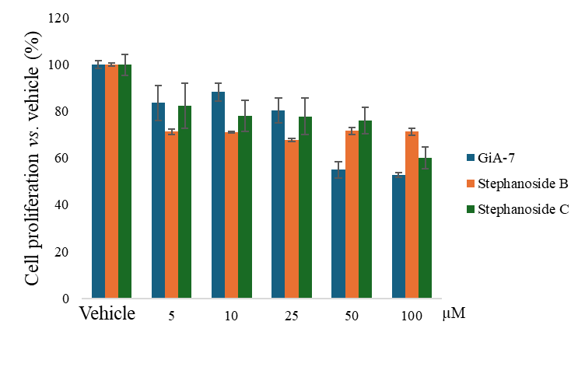
Figure S1. Effects of GiA-7, stephanoside B and C on C2C12 cells.
We incubated C2C12 cells with 5–100 μm of GiA-7, stephanoside B or C for 24 h. Cell proliferation was evaluated using MTS assays as described in Materials and Methods. MTS, 3-(4,5-dimethylthiazol-2-yl)-5-(3-carboxymethoxyphenyl)-2-(4-sulfophenyl)-2H-tetrazolium assay.

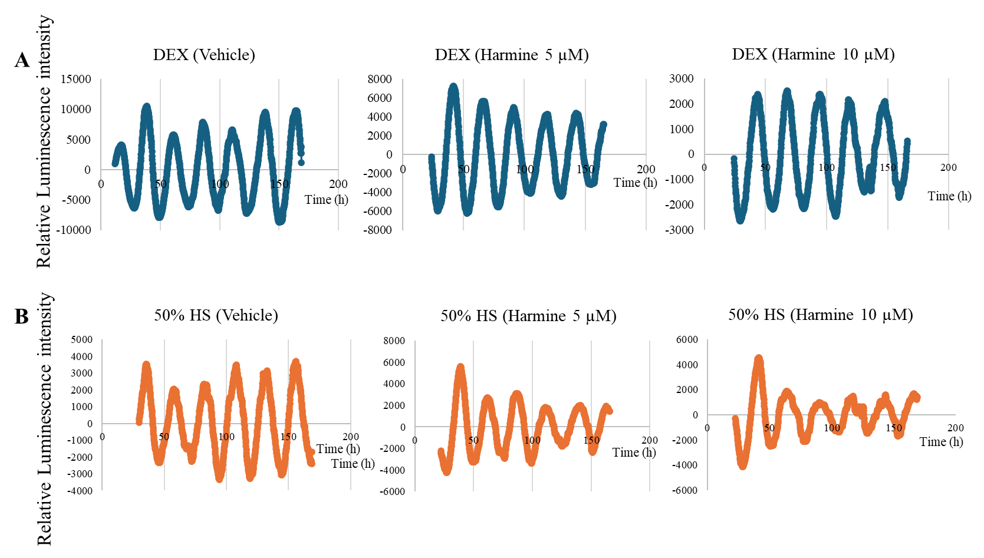
Figure S2. Transcriptional activity of Bmal1 in C2C12 myotubes incubated with harmine under various synchronization conditions monitored in real-time.
We transfected and cultured C2C12 cells with Bmal1-luciferase reporter plasmids for 3 days to differentiate into myotubes. We then synchronized circadian rhythms in myotubes for 2 h using either 100 nM DEX (A) or 50% HS (B), followed by harmine (5 or 10 µM). Bmal1 promoter activity was continuously monitored as bioluminescence intensity in real time. We confirmed that 100 nM DEX was sufficient to reset circadian periods in C2C12 cells. DEX, dexamethasone; HS, horse serum.

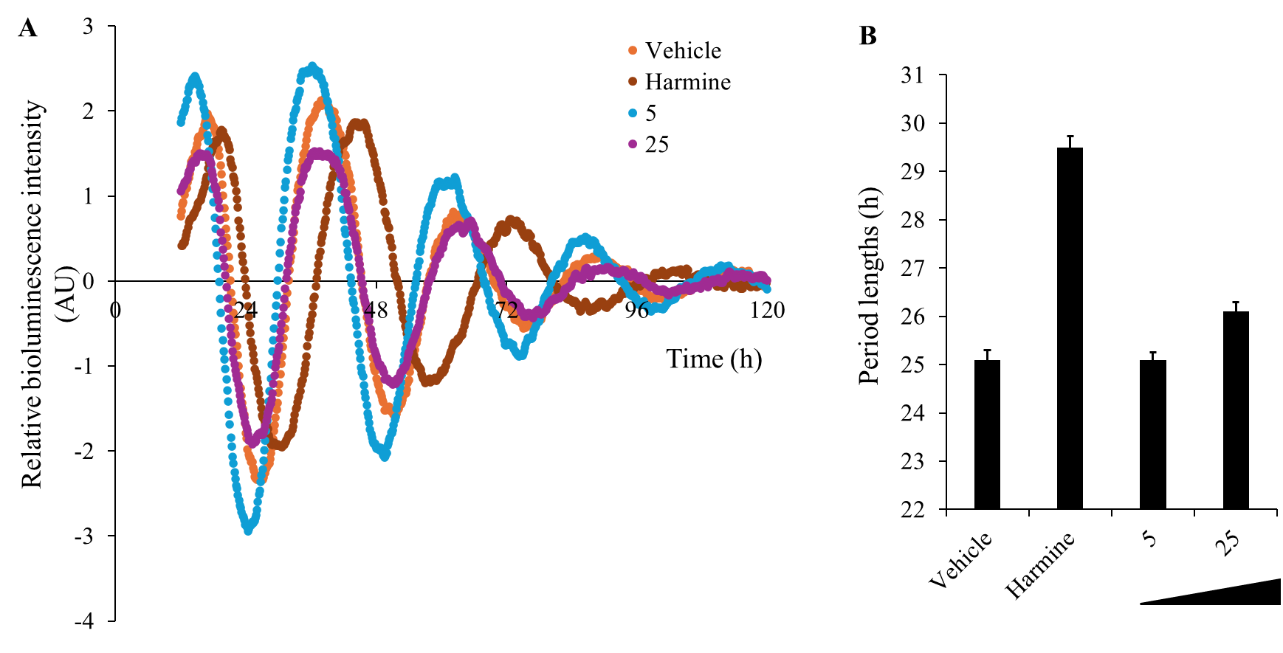
Figure S3. Effects of stephanoside B at 5 and 25 µM on Bmal1-luciferase activity in stable NIH3T3 cells.
(A) Real-time bioluminescence profiles and (B) analysis of period lengths estimated by curve fitting. This extract elongated the circadian periods of Bmal1 in NIH3T3 fibroblasts and C2C12 muscle cells, indicating that circadian period was elongated to both cell types. AU, arbitrary units.

