Supplementary Material:

Mental Health Assessment Methods and Attitudes
in Clinical Practices

Elaboration on Ethics 2
Elaborations of Attitudes 2
Attitudes Toward Standardized Assessment Methods 2
Summary of Responses 2
Agreement 2
Disagreement 2
Mixed agreement/disagreement 3
Attitude Towards AI Decision-Support 3
Agreement 3
Disagreement 3
Mixed agreement/disagreement 4
Elaboration of Cultural Comparisons 4
Assessments 6
Duration of assessment 6
Data collection methods across countries 6
Data combination methods across countries 10
Attitudes toward standardized assessment methods and AI across countries 10
Follow up 12

Elaboration on Ethics
According to Swedish law (2003:460) and the Swedish Ethical Review Authority, research must undergo external ethical review whenever it involves i) collecting personal information, ii) presenting an “obvious” risk for physical or psychological harm, or iii) manipulating or deceiving individuals. Since this research involves asking clinicians about their assessment method at work, it does not fall within these criteria.

Elaborations of Attitudes

Attitudes Toward Standardized Assessment Methods
Many clinicians (n = 237) elaborated on their level of agreement with the statement: “When assessing depression, it is important to use standardized assessment methods…”. Three authors structured These answers into common themes (C.W., D.N., V.E.; see open material for all anonymized, open answers).

Summary of Responses

Agreement
Some clinicians emphasized the importance and effectiveness of using standardized methods to minimize human errors and biases. They noted: “We are human and mental health is a complex phenomenon, which is why standardized and reliable tools are needed.”
Others argued for using a combination of unstructured interviews and standardized methods to complement each other. One example of a statement is: “It is important because you cannot rely solely on clinical experience and conversations/interviews, you can miss something. [...] ”.

Disagreement
Many also expressed concerns about using standardized assessment methods. Two of the most commonly reported arguments against standardized methods were that they do not cover all aspects of a patient clinical picture. One such response is: “I think that qualitative information can provide a much richer detail of the person's experiences. [...]”. Another response affirms how unstructured interviews are sufficiently valid, suggesting that “[...] The clinical unstructured interview is often sufficient. Diagnosing depression is not that complicated.”

Mixed agreement/disagreement
Many also reported that they would rather focus on individualized treatment and the therapeutic relationship with the patient than on obtaining the most accurate assessment since it would have little relevance to the choice of treatment or the quality of care provided, writing, “I assess my patients for the treatment I provide. Whether or not the patients meet the diagnostic criteria is rarely relevant to the choice of method [...]”. Some clinicians reported practical issues mainly concerning time constraints: “It takes an awful lot of time to classify according to the rules of the DSM (with accompanying questionnaires and interviews), which takes away from the time and attention for the emergence, maintenance, protective factors, the building of treatment relationships, etc. [...]”.

Attitude Towards AI Decision-Support
Many clinicians (n = 211) elaborated on their answers regarding AI-decision support, which three of the co-authors (C.W., D.N., V.E.) structured into common themes (see open material for all anonymized, open answers).

Agreement
Many stated an interest in implementing AI decision support in assessing depression, as long as it could be incorporated well into the clinical practice and provides positive value, one such comment read, “[...] As long as this can be deployed safely, well (scientifically) substantiated and according to privacy rules, I am open to this, as long as it benefits the patient.”. Others highlighted the benefits of AI over human capacities, noting, “I am positive about using AI to support assessment and treatment because algorithms can pick up on things that a human is not able to detect [...].”

Disagreement
Issues regarding potential biases, privacy, accountability, or the risk-to-benefit ratio were recurring topics among the comments, with some examples of those being “ [...] I am concerned about how to detect bias in AI models.”; “Privacy is an important issue for me in this”, “[...] I think there is a danger that a therapist could start to ‘hide’ behind the AI information, that it could lead to tunnel vision [...].”; and “I have a very difficult time seeing how this would be additive in any way while the risks are clear and significant.”.
The capability of AI compared to the superiority of clinical experience and human judgment was one aspect that was recurring, with one such example reading, “I trust human judgment more than a human-made algorithm run through a data set. You probably aren’t going to follow the outcome that would roll out anyway, even or especially if that outcome deviates enormously from your clinical judgment. [...]”.

Mixed agreement/disagreement
Many also suggested that a person seeking treatment wants to be seen as a human being, which an AI cannot provide, writing, “It sounds interesting, but I would be concerned about this being impersonal and having the potential to miss the human being underneath the difficulties.” The most frequently expressed reservation was that there is a lack of research regarding the assessment accuracy of AI instruments and the need for more information on the AI in question. One respondent wondered: “[...] what is the information based on, how was it generated/using what information and algorithms [...]”.

Elaboration of Cultural Comparisons
The cross-cultural analyses compare the Netherlands, Sweden, the U.S., and the U.K. Table S1 illustrates the distribution of occupations within each country, showing significant imbalance between the different represented occupations (e.g., Psychologist, Psychotherapist, General Practitioner, Nurses) within each country. While occupational diversity highlights the extensive range within the mental health assessment field, it hinders our cross-cultural comparisons due to the numerous comparison groups with significant sample-size imbalances, including several with very few cases. The majority of clinicians from the Netherlands and Sweden were Psychologists or Psychotherapists, whereas in the U.K., the majority were Nurses. Since the occupation of the respondents might confound the findings of the cross-cultural comparisons, we decided to include occupation as a second variable in the ANOVAs. All ANOVAs were calculated for unbalanced designs (type “III” ANOVA) and did not assess interaction effects due to the dependence between occupation and country.
The occupation categories “psychiatrist” and “occupational therapist” were removed from the cross-cultural analyses because there were too few in these categories. Moreover, the “other” categories within the country and occupation were removed because they were too heterogeneous. For the cross-cultural analyses, the occupation variables were recoded so that each clinician only had one job title; the occupation title requiring the highest education in Psychology was chosen for analysis. The exclusions resulted in a sample of n = 476 for the exploratory cross-country comparisons. In the survey, clinicians could indicate more than one occupation.
For more detailed comparisons, e.g., across age groups, or a combination of variables, we invite the reader to explore the Mental Health Assessment Dashboard and the open data (https://cwiebel.shinyapps.io/ClinicalPractices/).
Table S1 | Cross-tabulation table for the occupations within each country.
Occupations | The Netherlands | Sweden | The U.S. | The U.K.
Nurse | 2 | 2 | 61 | 89
Physician / GP | 3 | 14 | 27 | 25
Psychologist | 54 | 81 | 25 | 9
Psychotherapist | 39 | 18 | 21 | 6
Notes. GP = General Practitioner

Assessments

Duration of assessment
Reported assessment times for depression varied widely across clinicians (Figure S1A); but did not significantly differ by country (main effect for country: F(3, 469) = .486, p = .692) nor occupations (main effect: F(3, 469) = .431, p = .233; see Figure S1B).

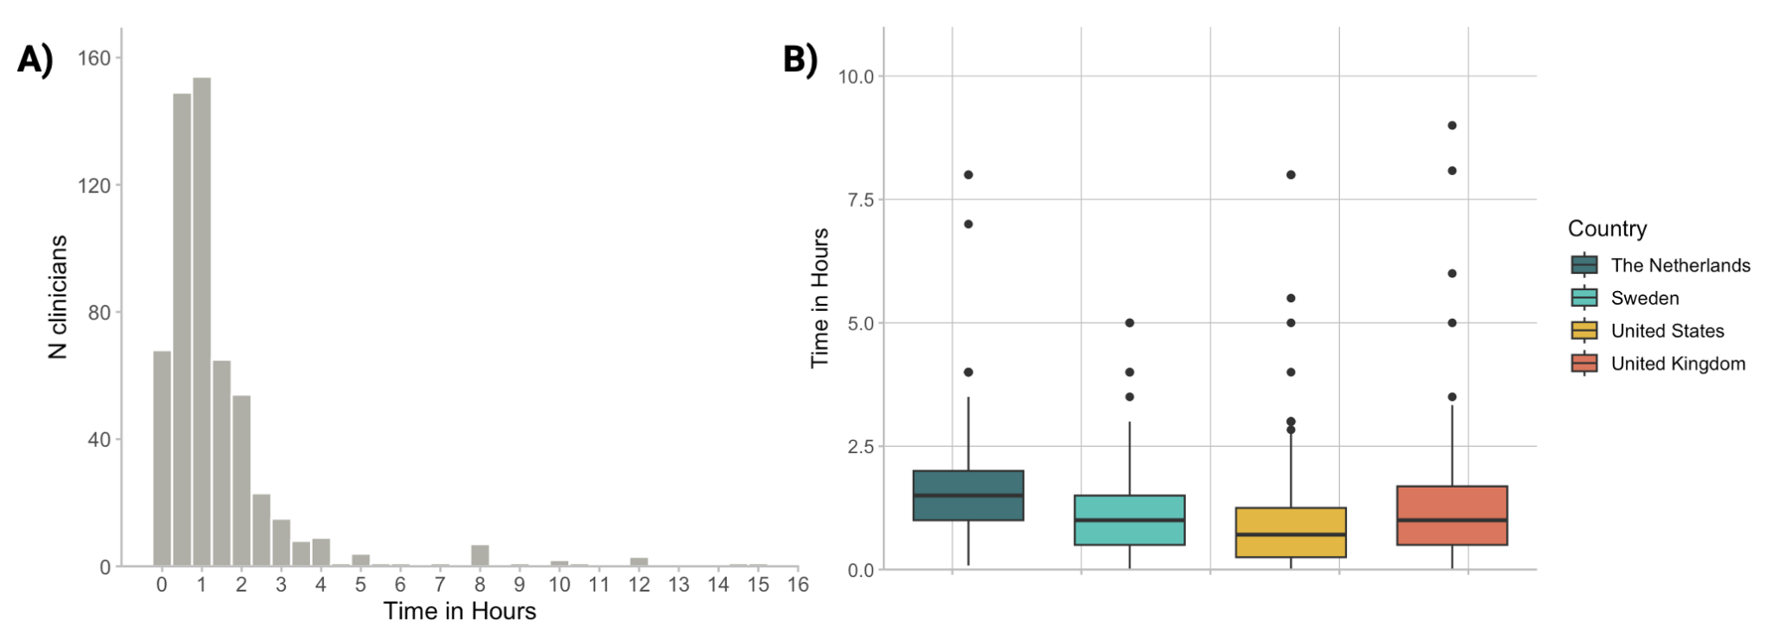
Figure S1 A-B | Self-reported Time Taken Identifying Depression: A) Distributions of hours taken to identify depression and B) Comparisons across countries.
Question: On average, approximately how much time do you spend on identifying depression for a typical patient showing signs of depression or low mood? n = 476

Data collection methods across countries
Figure S2 presents the data collection methods used by clinicians across the four countries. The differences across the countries (i.e., the effects of country) are described in the main paper. Regarding occupation, there was a small but significant effect on the use of unstructured interviews (main effect: F(3, 469) = 4.76, p = .003, η² = .03). After Bonferroni correction, the main effect of occupation was only significant for the use of rating scales (F(3, 469) = 15.02, p < .001).

- Percentage of clinicians who use a certain method
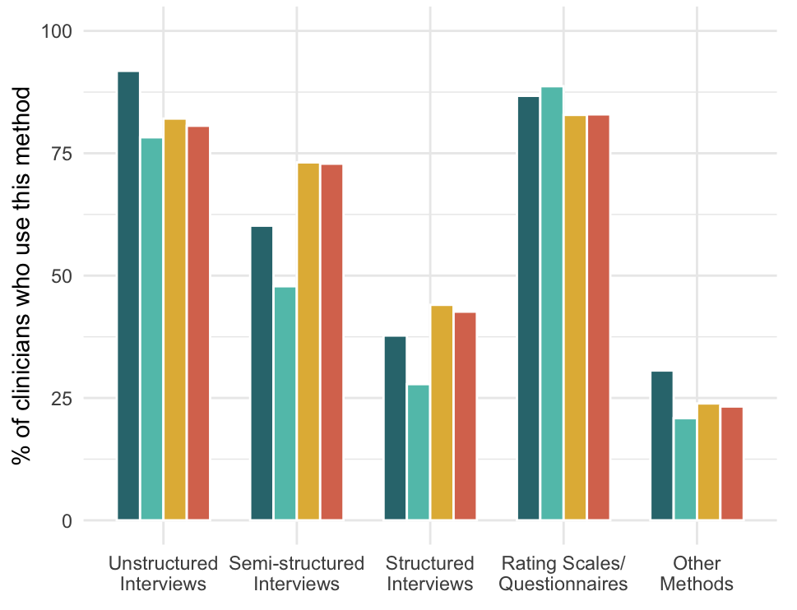
- Mean percentage of patients for which this method is used
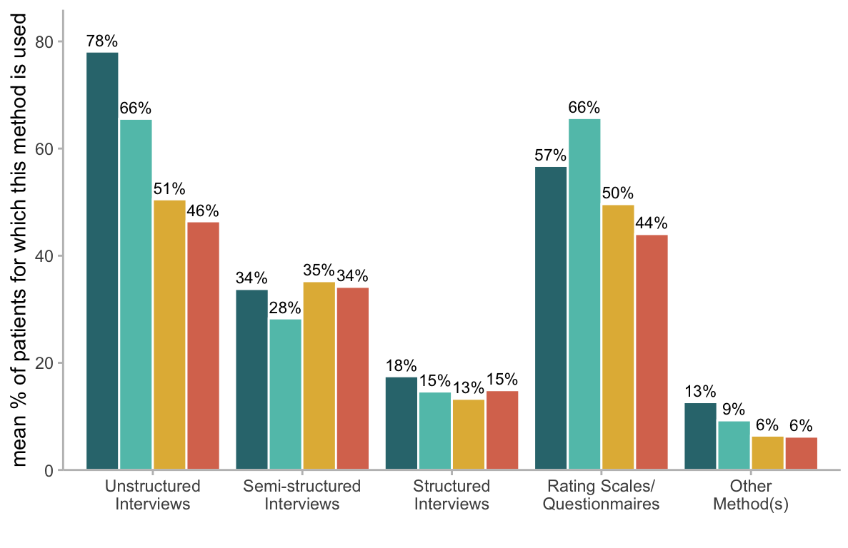
- Number of different methods used per clinician
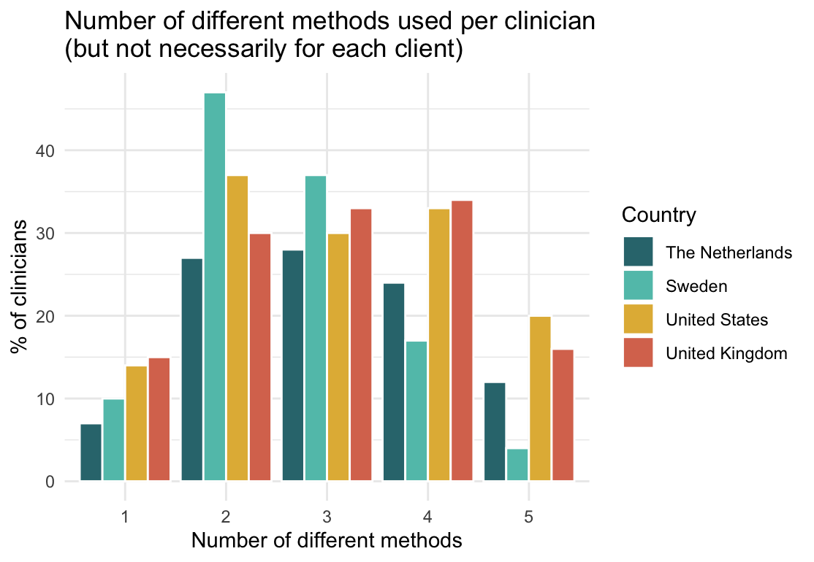
Figure S2 A-C | Data Collection Methods Across Countries: A) Percentage of clinicians using each method, B) Mean percentage of patients each method is used for, and C) Number of methods used per clinician (although not necessarily for each patient).
Question: What method(s) do you use, and how often do you use them when identifying, assessing, and/or excluding (ruling out) depression? n = 476.

Figure S3 shows specific questionnaires and (semi-)structured interviews clinicians use for the different data collection methods across the four countries. Main findings tend to hold across the four countries – We only find a few substantial exceptions, such as the PHQ-9 being the most frequently used rating scale in all countries except for the Netherlands, where they most frequently report using the BDI, and Sweden, where MADRS is preferred.
Among the clinicians who indicated which structured or semi-structured interviews they use, the DIS is more commonly reported in the U.K. and the U.S. (although the MINI is also reported being used); and the SCID is the most commonly reported structured interview across all four countries.

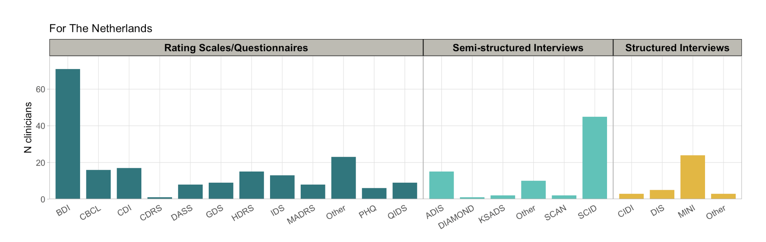

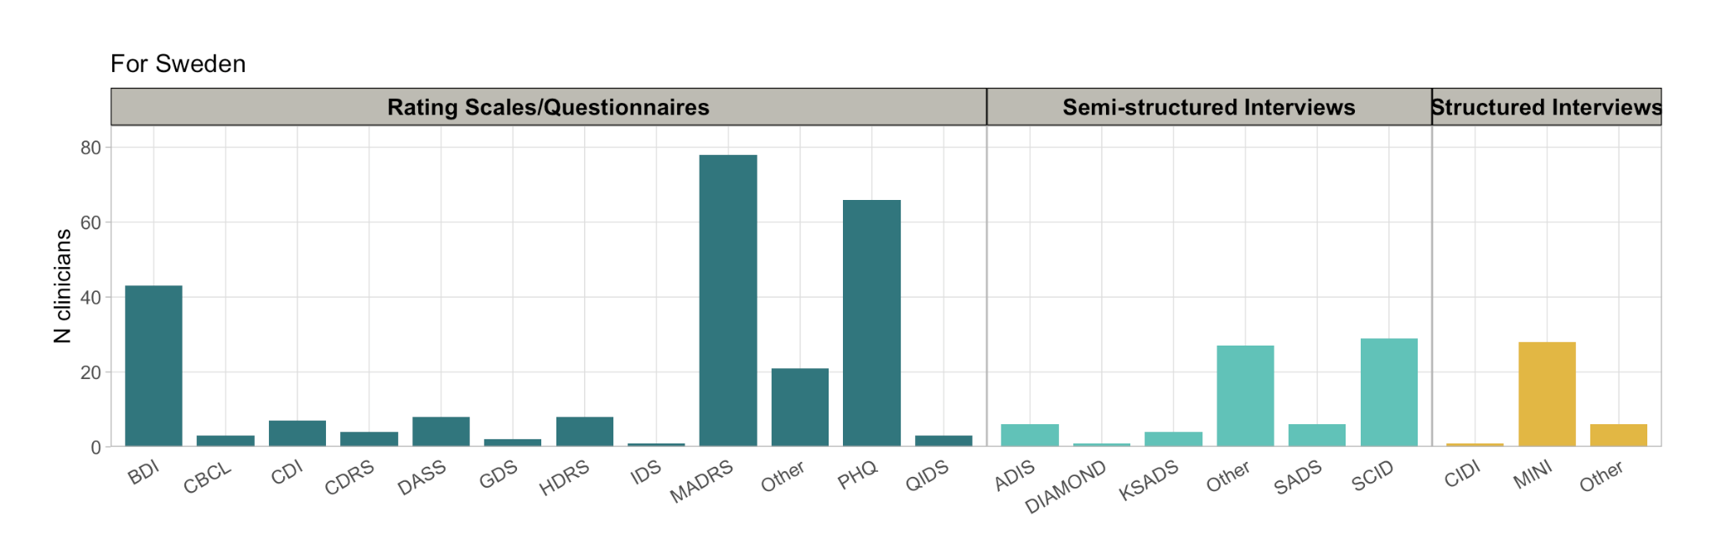

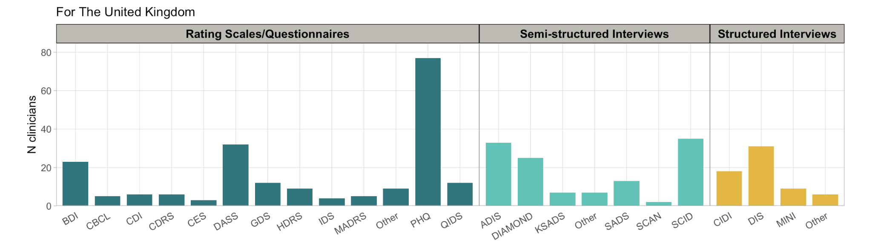

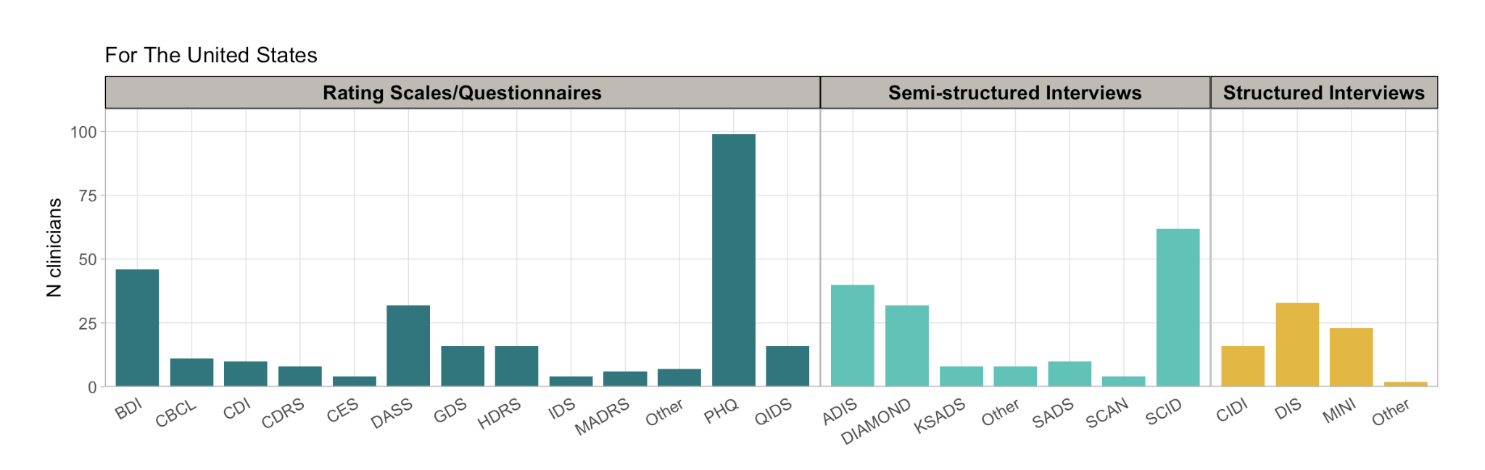
Figure S3 A-D | Clinicians’ reported use of data collection instruments for assessing depression across rating scales, semi-structured interviews, and structured interviews.
Questions: Which rating scale(s) [semi-structured interview(s) / structured interview(s)] do you use for assessing depression?
BDI = Beck Depression Inventory, CBCL = Child Behavior Checklist, CDI = Children's Depression Inventory, CDRS = Children’s Depression Rating Scale, CES = Center for Epidemiologic Studies Depression Scale, DASS = Depression and Anxiety Stress Scales, GDS = Geriatric Depression Scale, HDRS = Hamilton Depression Rating Scale, IDS = Inventory of Depressive Symptomatology, MADRS = Montgomery-Åsberg Depression Rating Scale, PHQ = Patient Health Questionnaire, QIDS = Quick Inventory of Depressive Symptoms, ADIS = Anxiety and Related Disorders Interview Schedule for DSM-5, DIAMOND = Diagnostic Interview For Anxiety, Mood, And Obsessive-Compulsive And Related Neuropsychiatric Disorders, KSADS = Kiddie Schedule for Affective Disorders and Schizophrenia, SADS = Schedule for Affective Disorders and Schizophrenia, SCAN = Schedules for Clinical Assessment in Neuropsychiatry, SCID = The Structured Clinical Interview for DSM-5, CIDI = Composite International Diagnostic Interview, DIS = Diagnostic Interview Schedule, MINI = Mini International Neuropsychiatric Interview

Data combination methods across countries
Figure S4 shows specific data combination methods clinicians use across the four countries. The differences across the countries (i.e., the effects of the country) are detailed in the main paper.

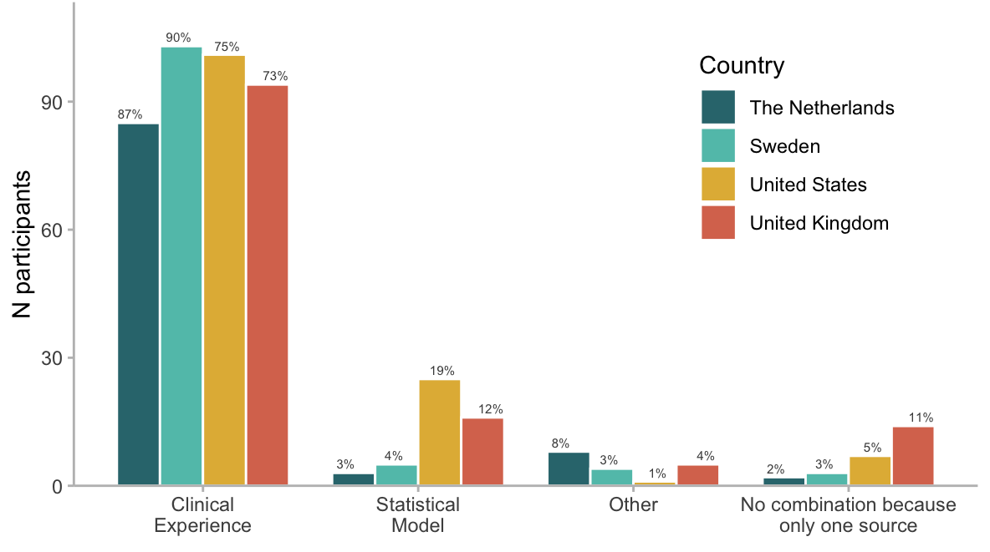

Figure S4 | Clinicians’ reported use of different data combination methods across countries
Question: How do you typically weigh the gathered information from different sources when assessing depression? n = 476.

Attitudes toward standardized assessment methods and AI across countries
The reported attitude towards standardized methods differs across countries (main effect: F(3, 469) = 7.35, p < .0001, η² = .04), but not occupations (main effect: F(3, 469) = 0.59, p = .621). The largest difference was noted between the U.S. (M = 5.64) and the U.K. (M = 4.88), even though the overall differences were relatively small.

The interest in receiving AI decision support also differed significantly across countries (main effect: F(3, 469) = 10.56, p < .001, η² = .07; Figure S5), but not occupations (main effect: F(3, 469) = 0.88, p = .604), where Sweden (M = 3.67) demonstrated the highest interest, and the U.K. (M = 2.76) the lowest interest. Across the four countries, the effect size is medium (Cohen, 1988).

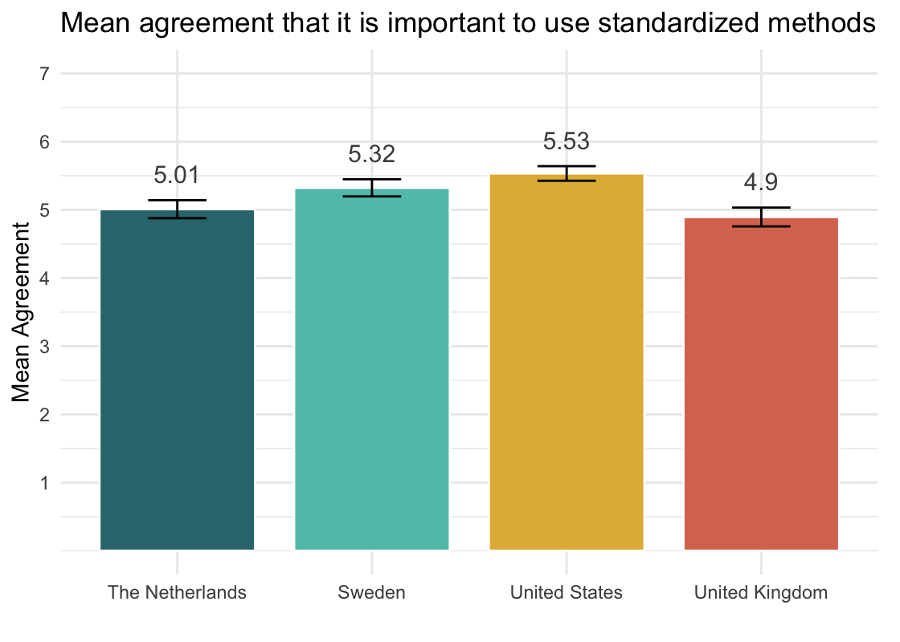

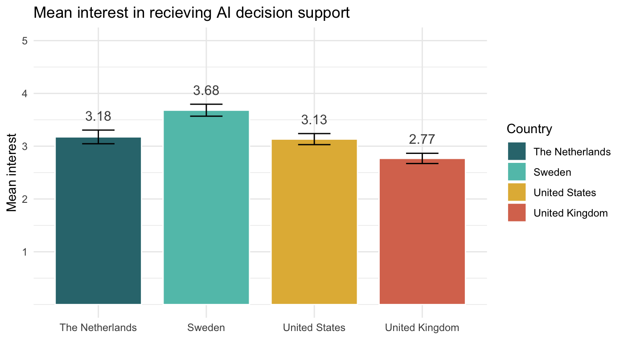
Figure S5 A-B | Clinicians' attitudes towards using A) standardized assessment methods and B) AI-decision support across countries.
Questions: a) When assessing depression, it is important to use standardized assessment methods that are demonstrated in research to have high validity¹ and reliability² (¹The degree to which the assessment method measures what it is supposed to measure; ²The degree to which the assessment method produces similar results under similar conditions); and b) If given the opportunity, would you be interested in receiving decision support from Artificial Intelligence (AI) when assessing depression? n = 476.

Follow up
Figure S6 shows how the vast majority of clinicians follow up with the majority of their patients, with 68% following up on 60% or more, while 45% follow up with all of their patients, with “100%” being the most frequently reported percentage (mode = 100%) after the initial assessment. However, a significant portion (16%) report they never follow up with any of their patients.
The frequency of different assessment methods used for follow-up generally mirrors their usage during the initial assessment. Notably, unstructured interviews and rating scales/questionnaires were used at similar rates for the initial assessment (83% each). However, unstructured interviews are used more frequently for follow-up (65%) compared to rating scales/questionnaires (51%). The use of semi-structured interviews is reported at 22%, structured interviews at 11%, and other methods at 7%.
- Number (percentage) of patients that clinicians follow-up
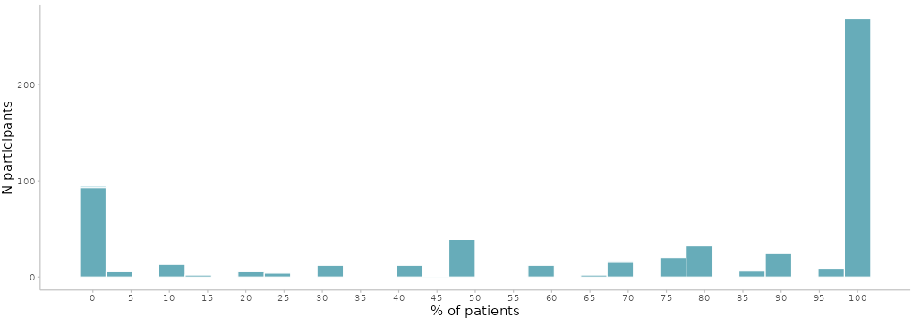
- The specific methods used for the follow-ups (although not necessarily for each patient)
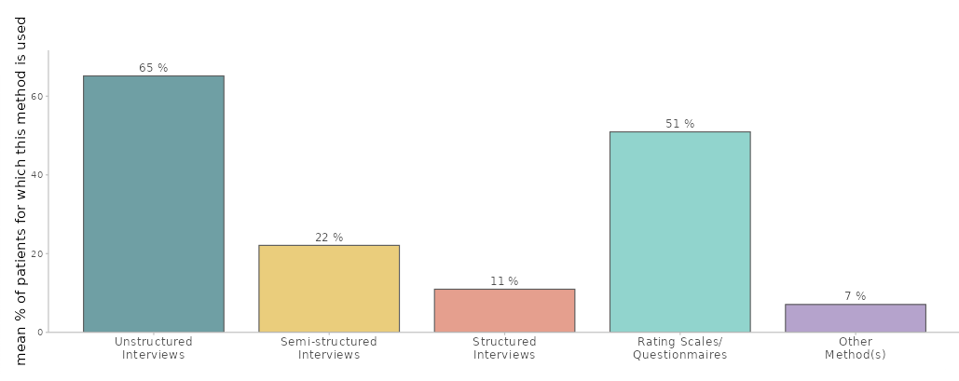

Figure S6 A-B | Methods of Follow-up Assessments: A) Percentage of patients that clinicians follow-up, and B) Specific methods used for follow-ups (although not necessarily for each patient).
Question: A) How often (if at all) do you follow up on the patients’ development during the course of a depression treatment? n = 581 B) What method(s) do you use, and how often do you use them during the follow-up when treating depression? n = 581.

