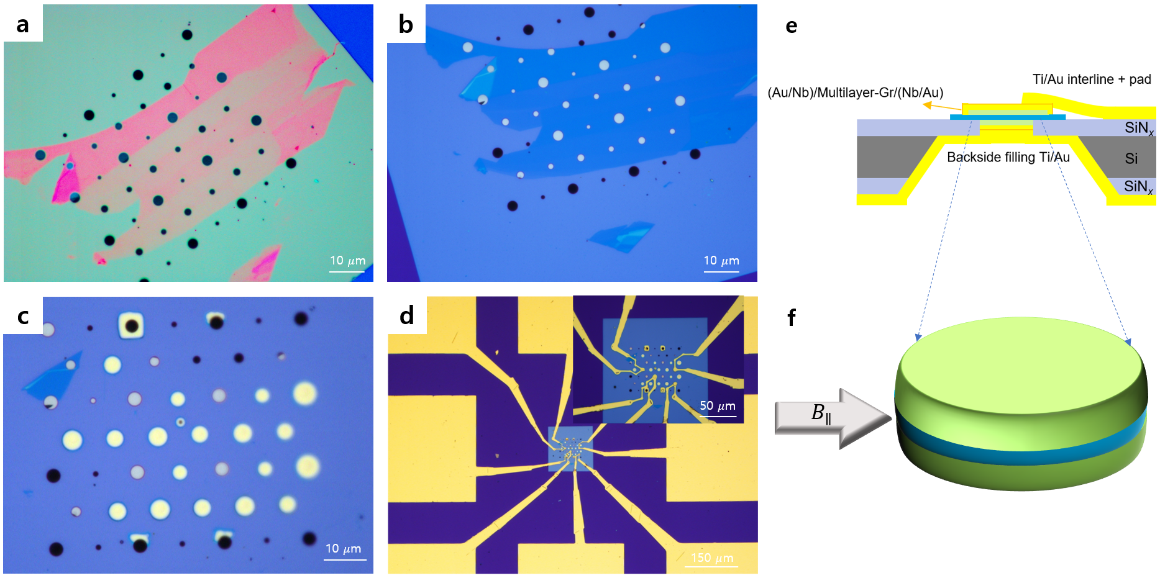
Extended Data Figure 1. Josephson junction fabrication processes and schematic diagrams.
(a)-(d) Optical microscope images illustrating the sequential fabrication processes of Josephson junctions. (a) Multilayer graphene is first transferred onto a freestanding SiN_{x} membrane patterned with a through-hole array, followed by chemical and thermal cleaning steps. (b) Backside deposition of Nb/Au (47/20 nm) by sputtering, followed by Ti/Au (10/240 nm) deposition via e-beam evaporation, results in the filling of the through-holes beneath the regions covered by multilayer graphene. (c) Optical image of the device after top-side Nb/Au (47/30 nm) deposition by sputtering and subsequent reactive ion etching (RIE) to define individual top contacts. (d) Optical image of the final device, including interconnecting lines and bonding pads formed by Ti/Au (10/140 nm). (e), (f) Cross-sectional schematic of the final device geometry and a schematic illustration of the externally applied magnetic field oriented parallel to the in-plane direction of the multilayer graphene.
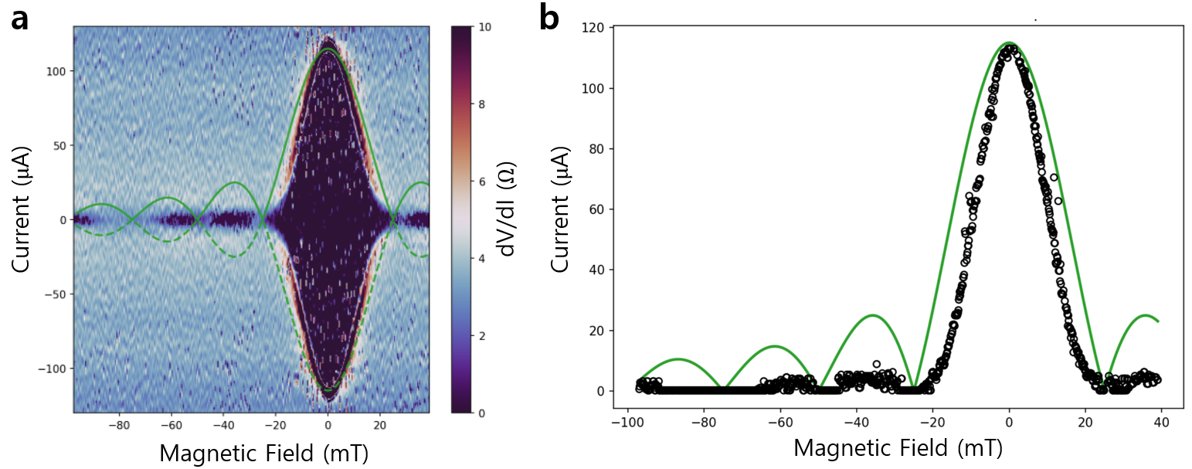
Extended Data Figure 2. Comparison of Fraunhofer patterns with a rectangular junction geometry model.
(a) Experimental dV/dI map as a function of bias current and magnetic field, showing a well-defined Fraunhofer interference pattern with a periodicity of ~25 mT, overlaid with the envelope (green) expected for a rectangular junction of equal nominal area. (b) Critical current extracted from the map in (a), compared with the same rectangular-junction envelope. The rectangular model fails to reproduce the experimentally observed node positions, in contrast to the circular-aperture model shown in Fig. 3.

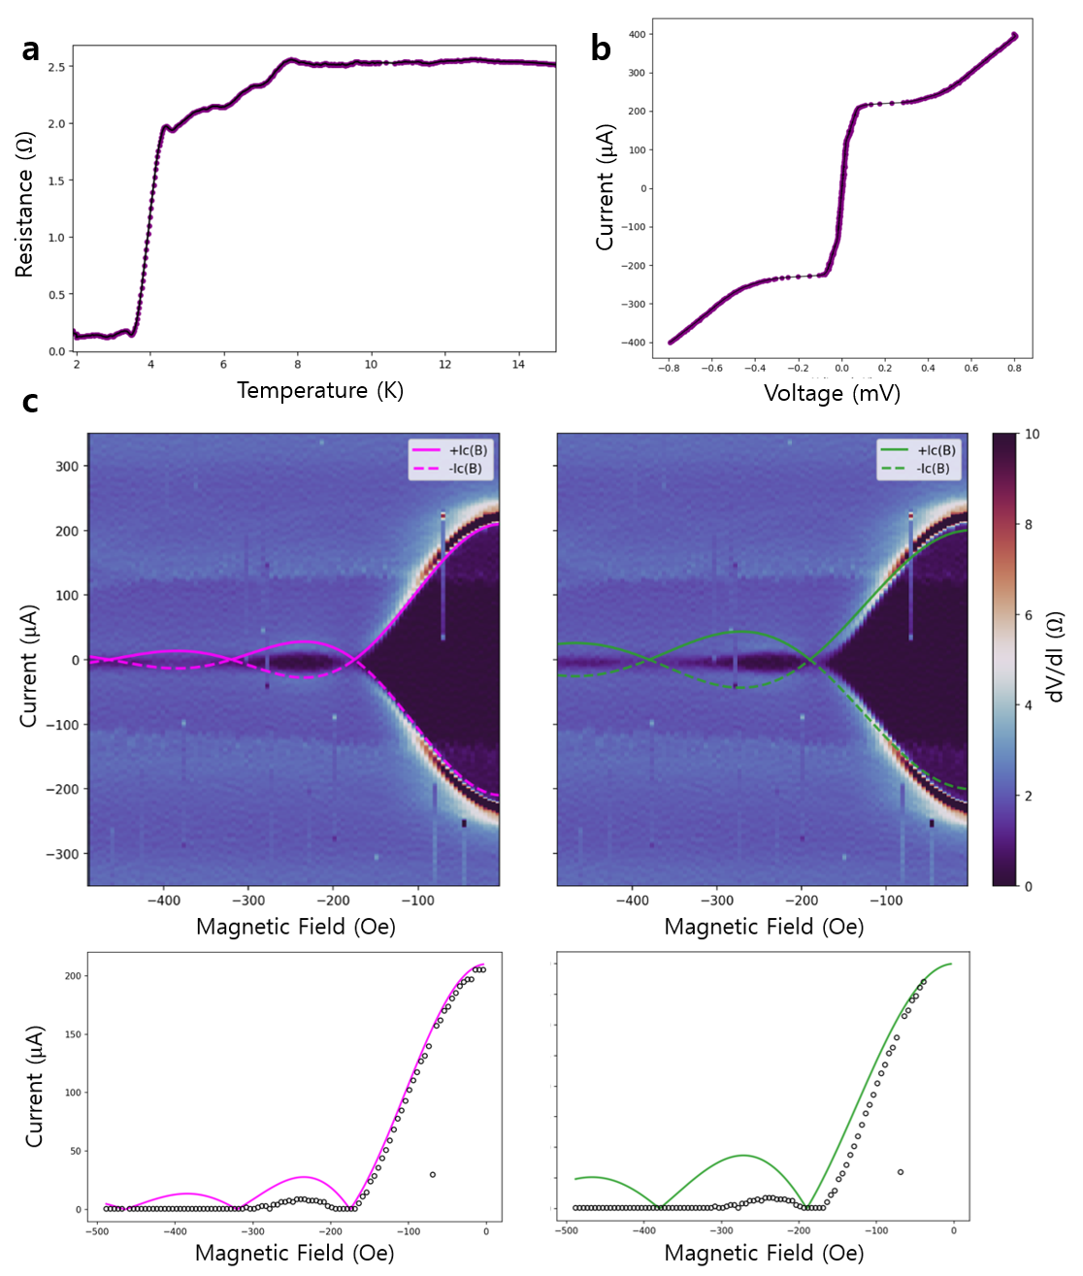
Extended Data Figure 3. Reproducibility of Josephson characteristics in an additional device.
(a) Temperature-dependent resistance of an additional Nb/multilayer graphene/Nb junction fabricated on the membrane platform. The superconducting transition and overall resistance evolution closely resemble those of the main device. (b) Current–voltage characteristics measured at 2 K, showing a clear supercurrent branch. (c) Magnetic-field-dependent differential-resistance maps with a periodicity of ~17.5 mT, consistent with the larger effective junction area of this device. The left column shows the experimental dV/dI map and the extracted critical current as a function of magnetic field, overlaid with the envelope (magenta) expected for a cylindrical junction geometry defined by the through-hole aperture. The right column shows a comparison with the rectangular-junction envelope (green), which fails to capture the observed node positions. These measurements demonstrate that the key Josephson characteristics are reproducible across multiple devices.
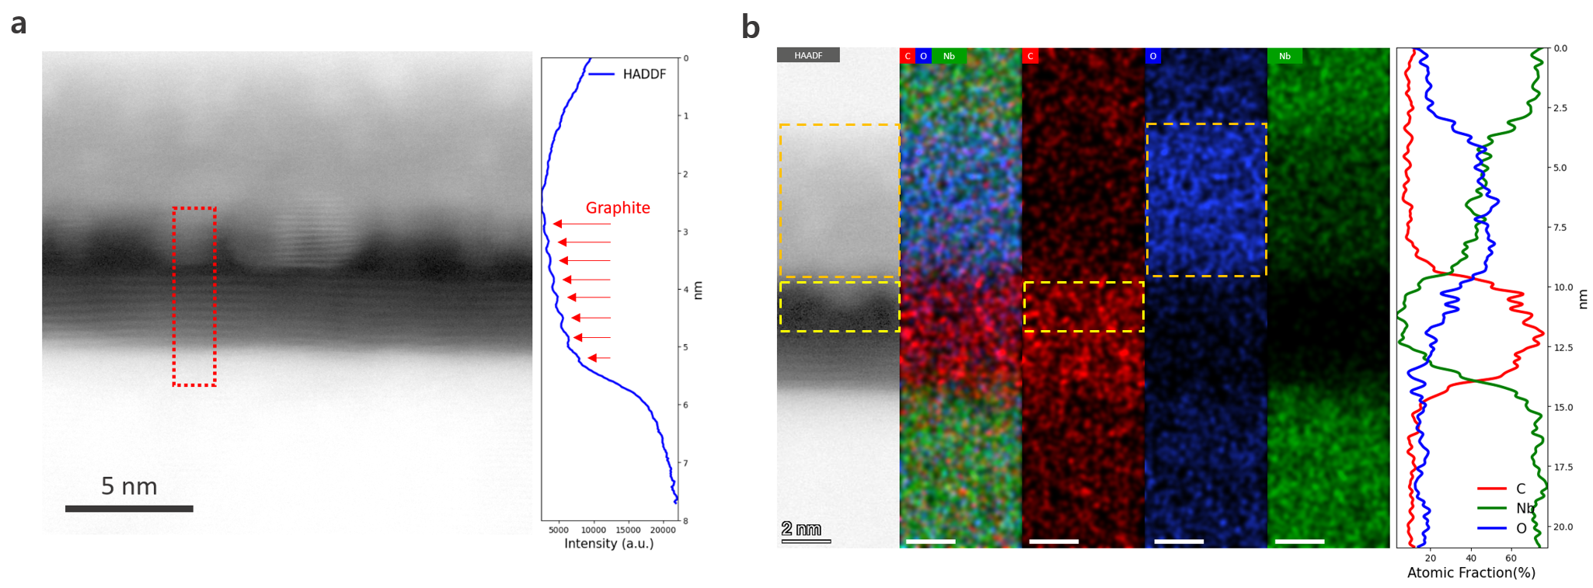
Extended Data Figure 4. Structural and compositional analysis of a non-functional junction.
(a) High-angle annular dark-field scanning transmission electron microscopy (HAADF-STEM) image of the Nb/8L-graphene/Nb stack. The layered contrast of the transferred 8-layer graphene is visible in the highlighted region, while additional contrast near the top Nb interface suggests the presence of an unintended interfacial layer. The line-intensity profile on the right clearly resolves the individual graphene layers. (b) Elemental maps of the same cross-section acquired by energy-dispersive X-ray spectroscopy (EDS). The yellow boxes denote regions where carbon-rich signals extend into the upper region above the graphene, outside the intrinsic graphene stack, while the orange boxes highlight areas where oxygen and Nb signals coexist near the top interface. The atomic-fraction profiles on the right confirm localized enrichment of C above the graphene region and identify a region of overlapping O and Nb signals, consistent with the formation of a C-O-Nb interfacial layer. In contrast, the graphene/bottom-Nb interface exhibits neither an oxygen-rich region nor anomalous carbon signals.

