Supplementary Materials
Table S1. Adjusted* relative risks (RR with 95% CIs) for the yearly musculoskeletal disorder-specific SA prevalence in 2005, 2012, and 2019 by occupational class and migrant status.
 | Natives |  |  | Migrants
 | 2005 | 2012 | 2019 | 2005 | 2012 | 2019
 | RR  (95% CIs) | RR  (95% CIs) | RR  (95% CIs) | RR  (95% CIs) | RR  (95% CIs) | RR  (95% CIs)
All
Upper non-manual employees | – | – | – | – | – | –
Lower non-manual employees | 2.40  (2.34–2.46) | 2.51  (2.45–2.58) | 2.66  (2.59–2.74) | 2.06  (1.65–2.58) | 2.66  (2.25–3.14) | 3.36  (2.88–3.91)
Manual workers | 3.81  (3.72–3.90) | 3.57  (3.49–3.66) | 3.59  (3.49–3.69) | 3.72  (3.07–4.52) | 3.85  (3.30–4.50) | 4.29  (3.71–4.96)
Self-employed | 1.46  (1.42–1.51) | 1.55  (1.50–1.60) | 1.72  (1.66–1.78) | 1.03  (0.76–1.39) | 1.38  (1.12–1.69) | 1.80  (1.50–2.16)
Unemployed | 1.35  (1.31–1.40) | 1.63  (1.57–1.68) | 2.41  (2.33–2.49) | 1.39  (1.12–1.74) | 1.59  (1.33–1.89) | 3.41  (2.93–3.98)
Men
Upper non-manual employees | – | – | – | – | – | –
Lower non-manual employees | 2.15  (2.06–2.24) | 2.08  (2.00–2.17) | 2.29  (2.18–2.41) | 1.54  (1.05–2.26) | 1.86  (1.39–2.50) | 2.65  (2.04–3.44)
Manual workers | 4.54  (4.38–4.71) | 3.98  (3.83–4.13) | 4.23  (4.05–4.42) | 3.96  (2.99–5.25) | 3.83  (3.03–4.82) | 4.75  (3.82–5.91)
Self-employed | 1.74  (1.67–1.83) | 1.79  (1.71–1.88) | 2.06  (1.96–2.17) | 0.94  (0.61–1.45) | 1.50  (1.11–2.02) | 2.44  (1.88–3.15)
Unemployed | 1.56  (1.49–1.65) | 1.84  (1.75–1.93) | 2.92  (2.77–3.08) | 1.67  (1.21–2.31) | 2.03  (1.57–2.63) | 4.45  (3.53–5.61)
Women
Upper non-manual employees | – | – | – | – | – | –
Lower non-manual employees | 2.14  (2.08–2.21) | 2.38  (2.30–2.45) | 2.47  (2.39–2.55) | 2.03  (1.52–2.71) | 2.59  (2.09–3.21) | 3.07  (2.52–3.75)
Manual workers | 3.55  (3.44–3.66) | 3.71  (3.59–3.83) | 3.72  (3.58–3.86) | 3.52  (2.69–4.60) | 3.99  (3.24–4.90) | 4.07  (3.35–4.94)
Self-employed | 1.37  (1.31–1.43) | 1.51  (1.44–1.58) | 1.68  (1.59–1.76) | 1.19  (0.79–1.79) | 1.33  (0.99–1.78) | 1.32  (1.00–1.73)
Unemployed | 1.23  (1.17–1.28) | 1.57  (1.50–1.64) | 2.23  (2.13–2.34) | 1.17  (0.86–1.58) | 1.29  (1.02–1.63) | 2.75  (2.24–3.37)
*Adjusted for age, gender (excluding gender-specific models), marital status, region of residence and length of stay (for migrants only).

Table S2. Adjusted* relative risks (RR with 95% CIs) for the yearly mental disorders-related diseases-specific SA prevalence in 2005, 2012, and 2019 by occupational class, migrant status and gender.
 | Natives |  |  | Migrants
 | 2005 | 2012 | 2019 | 2005 | 2012 | 2019
 | RR  (95% CIs) | RR  (95% CIs) | RR  (95% CIs) | RR  (95% CIs) | RR  (95% CIs) | RR  (95% CIs)
All
Upper non-manual employees | – | – | – | – | – | –
Lower non-manual employees | 1.37  (1.33–1.40) | 1.47  (1.43–1.51) | 1.50  (1.47–1.54) | 1.50  (1.21–1.87) | 1.45  (1.20–1.75) | 1.55  (1.36–1.76)
Manual workers | 0.95  (0.92–0.98) | 0.92  (0.89–0.96) | 0.78  (0.76–0.81) | 1.04  (0.84–1.28) | 0.91  (0.75–1.09) | 0.75  (0.66–0.86)
Self-employed | 0.52  (0.49–0.54) | 0.66  (0.63–0.69) | 0.56  (0.53–0.58) | 0.54  (0.38–0.77) | 0.65  (0.50–0.85) | 0.45  (0.37–0.56)
Unemployed | 1.34  (1.29–1.38) | 1.73  (1.67–1.80) | 2.03  (1.97–2.09) | 1.39  (1.12–1.71) | 1.35  (1.12–1.63) | 1.96  (1.73–2.23)
Men
Upper non-manual employees | – | – | – | – | – | –
Lower non-manual employees | 1.26  (1.20–1.33) | 1.35  (1.28–1.43) | 1.40  (1.34–1.47) | 1.15  (0.77–1.71) | 1.72  (1.22–2.44) | 1.50  (1.19–1.88)
Manual workers | 1.09  (1.04–1.14) | 1.06  (1.00–1.12) | 0.99  (0.95–1.04) | 0.98  (0.71–1.35) | 1.20  (0.89–1.62) | 0.83  (0.68–1.02)
Self-employed | 0.63  (0.59–0.68) | 0.85  (0.79–0.92) | 0.80  (0.75–0.85) | 0.41  (0.23–0.74) | 0.82  (0.54–1.25) | 0.50  (0.37–0.69)
Unemployed | 1.75  (1.65–1.85) | 2.12  (1.99–2.25) | 2.78  (2.65–2.92) | 1.51  (1.10–2.09) | 1.89  (1.38–2.59) | 2.60  (2.13–3.18)
Women
Upper non-manual employees | – | – | – | – | – | –
Lower non-manual employees | 1.17  (1.13–1.21) | 1.28  (1.24–1.33) | 1.28  (1.25–1.31) | 1.42  (1.08–1.87) | 1.12  (0.89–1.40) | 1.31  (1.12–1.54)
Manual workers | 1.03  (0.99–1.07) | 1.09  (1.04–1.14) | 0.94  (0.91–0.98) | 1.12  (0.85–1.48) | 0.79  (0.62–1.00) | 0.75  (0.63–0.90)
Self-employed | 0.52  (0.48–0.55) | 0.66  (0.62–0.71) | 0.56  (0.53–0.59) | 0.71  (0.45–1.10) | 0.60  (0.42–0.86) | 0.46  (0.35–0.62)
Unemployed | 1.16  (1.11–1.21) | 1.71  (1.63–1.79) | 1.93  (1.86–1.59) | 1.28  (0.97–1.68) | 1.08  (0.85–1.37) | 1.59  (1.35–1.87)
*Adjusted for age, gender (excluding gender-specific models), marital status, region of residence and length of stay (for migrants only).

Table S3. Adjusted* relative risks (RR with 95% CIs) for the yearly injury-related diseases-specific SA prevalence in 2005, 2012, and 2019 by occupational class, migrant status and gender.
 | Natives |  |  | Migrants
 | 2005 | 2012 | 2019 | 2005 | 2012 | 2019
 | RR  (95% CIs) | RR  (95% CIs) | RR  (95% CIs) | RR  (95% CIs) | RR  (95% CIs) | RR  (95% CIs)
All
Upper non-manual employees | – | – | – | – | – | –
Lower non-manual employees | 1.53  (1.48–1.58) | 1.55  (1.50–1.60) | 1.69  (1.63–1.74) | 1.38  (1.03–1.84) | 1.60  (1.29–1.99) | 1.71  (1.41–2.07)
Manual workers | 2.34  (2.27–2.42) | 2.15  (2.08–2.22) | 2.18  (2.11–2.25) | 2.07  (1.61–2.66) | 2.19  (1.80–2.66) | 2.45  (2.06–2.90)
Self-employed | 1.58  (1.51–1.64) | 1.80  (1.74–1.87) | 1.65  (1.58–1.72) | 1.01  (0.70–1.47) | 1.90  (1.50–2.42) | 1.82  (1.47–2.24)
Unemployed | 1.47  (1.40–1.53) | 1.36  (1.30–1.42) | 1.61  (1.54–1.68) | 0.94  (0.70–1.27) | 1.24  (0.99–1.56) | 1.90  (1.57–2.29)
Men
Upper non-manual employees | – | – | – | – | – | –
Lower non-manual employees | 1.67  (1.59–1.75) | 1.60  (1.53–1.68) | 1.80  (1.71–1.90) | 1.13  (0.73–1.75) | 1.52  (1.10–2.11) | 1.57  (1.19–2.07)
Manual workers | 2.53  (2.42–2.64) | 2.27  (2.18–2.37) | 2.51  (2.40–2.63) | 2.37  (1.73–3.25) | 2.46  (1.91–3.18) | 2.55  (2.06–3.16)
Self-employed | 1.72  (1.63–1.81) | 1.96  (1.86–2.06) | 1.83  (1.73–1.94) | 1.03  (0.65–1.63) | 2.07  (1.51–2.82) | 2.05  (1.59–2.65)
Unemployed | 1.68  (1.58–1.77) | 1.50  (1.42–1.59) | 1.96  (1.84–2.08) | 1.13  (0.77–1.66) | 1.75  (1.31–2.33) | 2.24  (1.76–2.85)
Women
Upper non-manual employees | – | – | – | – | – | –
Lower non-manual employees | 1.48  (1.41–1.55) | 1.53  (1.46–1.60) | 1.58  (1.51–1.65) | 1.65  (1.09–2.50) | 1.67  (1.22–2.27) | 1.94  (1.46–2.57)
Manual workers | 1.82  (1.73–1.92) | 1.77  (1.68–1.86) | 1.69  (1.60–1.79) | 1.47  (0.97–2.23) | 1.66  (1.22–2.26) | 2.03  (1.53–2.70)
Self-employed | 1.30  (1.21–1.39) | 1.51  (1.41–1.61) | 1.49  (1.39–1.59) | 0.94  (0.50–1.76) | 1.68  (1.15–2.45) | 1.23  (0.83–1.81)
Unemployed | 1.23  (1.16–1.32) | 1.18  (1.10–1.26) | 1.27  (1.19–1.37) | 0.77  (0.48–1.21) | 0.77  (0.53–1.10) | 1.59  (1.17–2.16)
*Adjusted for age, gender (excluding gender-specific models), marital status, region of residence and length of stay (for migrants only).

Table S4. Adjusted* relative risks (RR with 95% CIs) for the annual all-cause SA prevalence in 2005, 2012, and 2019 by occupational class and region of origin.
 | 2005 |  | 2012 |  | 2019
 | RR | 95% CIs | RR | 95% CIs | RR | 95% CIs
Native
Upper non-manual employees | – | – | – | – | – | –
Lower non-manual employees | 1.65 | 1.63–1.67 | 1.73 | 1.71–1.75 | 1.76 | 1.74–1.78
Manual workers | 1.94 | 1.92–1.96 | 1.91 | 1.89–1.94 | 1.70 | 1.68–1.72
Self-employed | 1.02 | 1.00–1.04 | 1.18 | 1.17–1.20 | 1.21 | 1.19–1.23
Unemployed | 1.10 | 1.09–1.12 | 1.25 | 1.23–1.27 | 1.65 | 1.62–1.67
Observations | 2,265,262 |  | 2,219,147 |  | 2,154,954
European & Western countries
Upper non-manual employees | – | – | – | – | – | –
Lower non-manual employees | 2.09 | 1.73–2.52 | 2.09 | 1.84–2.37 | 2.11 | 1.91–2.33
Manual workers | 2.45 | 2.06–2.91 | 2.26 | 2.01–2.54 | 2.51 | 1.93–2.31
Self-employed | 1.05 | 0.78–1.40 | 1.26 | 1.07–1.49 | 1.27 | 1.12–1.44
Unemployed | 1.75 | 1.44–2.13 | 1.07 | 1.23–1.64 | 2.17 | 1.95–2.41
Observations | 20,766 |  | 46,310 |  | 71,007
Russia/Former Soviet Union
Upper non-manual employees | – | – | – | – | – | –
Lower non-manual employees | 1.54 | 1.26–1.89 | 1.57 | 1.34–1.84 | 1.78 | 1.55–2.04
Manual workers | 1.83 | 1.52–2.21 | 1.98 | 1.70–2.30 | 1.84 | 1.61–2.10
Self-employed | 0.73 | 0.52–1.04 | 1.03 | 0.83–1.28 | 1.14 | 0.95–1.37
Unemployed | 1.11 | 0.91–1.36 | 0.98 | 1.83–1.16 | 1.31 | 1.13–1.51
Observations | 19,882 |  | 33,266 |  | 42,447
Asian Countries
Upper non-manual employees | – | – | – | – | – | –
Lower non-manual employees | 1.46 | 0.93–2.31 | 2.62 | 1.92–3.58 | 2.73 | 2.22–3.36
Manual workers | 2.04 | 1.39–2.99 | 2.99 | 2.25–3.97 | 2.64 | 2.18–3.20
Self-employed | 0.94 | 0.59–1.51 | 1.75 | 1.26–2.42 | 1.21 | 0.95–1.55
Unemployed | 1.32 | 0.87–2.01 | 1.82 | 1.33–2.50 | 2.73 | 2.22–3.37
Observations | 9,155 |  | 21,524 |  | 40,098
Refugee-origin countries
Upper non-manual employees | – | – | – | – | – | –
Lower non-manual employees | 1.16 | 0.73–1.84 | 2.01 | 1.45–2.78 | 1.75 | 1.40–2.17
Manual workers | 1.38 | 0.93–2.03 | 1.96 | 1.43–2.67 | 1.49 | 1.21–1.83
Self-employed | 0.89 | 0.51–1.53 | 1.10 | 0.73–1.65 | 0.92 | 0.70–1.22
Unemployed | 0.90 | 0.63–1.31 | 1.20 | 0.88–1.64 | 1.85 | 1.51–2.26
Observations | 6,118 |  | 13,114 |  | 27,083
Other countries
Upper non-manual employees | – | – | – | – | – | –
Lower non-manual employees | 1.51 | 1.30–1.75 | 1.75 | 1.51–2.03 | 1.87 | 1.62–2.15
Manual workers | 1.88 | 1.65–2.15 | 1.75 | 1.52–2.02 | 1.81 | 1.58–2.07
Self-employed | 0.73 | 0.60–0.90 | 1.00 | 0.83–1.22 | 1.17 | 0.98–1.40
Unemployed | 0.81 | 0.68–0.96 | 1.17 | 0.99–1.37 | 1.81 | 1.57–2.10
Observations | 18,823 |  | 25,907 |  | 34,366
*Adjusted for age, gender, marital status, region of residence and length of stay.

Table S5. Adjusted* relative risks (RR with 95% CIs) for the annual musculoskeletal-related SA prevalence in 2005, 2012, and 2019 by occupational class and region of origin.
 | 2005 |  | 2012 |  | 2019
 | RR | 95% CIs | RR | 95% CIs | RR | 95% CIs
Native
Upper non-manual employees | – | – | – | – | – | –
Lower non-manual employees | 2.40 | 2.34–2.46 | 2.51 | 2.45–2.58 | 2.66 | 2.59–2.74
Manual workers | 3.81 | 3.72–3.90 | 3.57 | 3.49–3.66 | 3.59 | 3.49–3.69
Self-employed | 1.46 | 1.42–1.51 | 1.55 | 1.50–1.60 | 1.72 | 1.66–1.78
Unemployed | 1.35 | 1.31–1.40 | 1.63 | 1.57–1.68 | 2.41 | 2.33–2.49
Observations | 2,265,262 |  | 2,219,147 |  | 2,154,954
European & Western countries
Upper non-manual employees | – | – | – | – | – | –
Lower non-manual employees | 1.87 | 1.24–2.84 | 3.38 | 2.55–4.49 | 3.97 | 3.09–5.10
Manual workers | 3.84 | 2.71–5.46 | 4.94 | 3.80–6.43 | 5.44 | 4.30–6.89
Self-employed | 1.04 | 0.57–1.90 | 1.75 | 1.22–2.52 | 2.33 | 1.74–3.14
Unemployed | 1.54 | 1.01–2.34 | 2.30 | 1.70–3.13 | 4.53 | 3.50–5.86
Observations | 20,766 |  | 46,310 |  | 71,007
Russia/former Soviet Union
Upper non-manual employees | – | – | – | – | – | –
Lower non-manual employees | 2.00 | 1.22–3.29 | 2.33 | 1.67–3.24 | 2.62 | 1.94–3.54
Manual workers | 3.40 | 2.18–5.29 | 3.40 | 2.65–4.98 | 3.20 | 2.39–4.28
Self-employed | 0.76 | 0.32–1.78 | 0.76 | 0.75–1.87 | 1.57 | 1.07–2.32
Unemployed | 1.19 | 0.72–1.95 | 1.19 | 0.83–1.70 | 1.60 | 1.16–2.20
Observations | 19,882 |  | 33,266 |  | 42,447
Asian Countries
Upper non-manual employees | – | – | – | – | – | –
Lower non-manual employees | 1.39 | 0.52–3.72 | 2.61 | 1.43–4.75 | 4.12 | 2.53–6.70
Manual workers | 3.16 | 1.43–6.97 | 3.54 | 2.05–6.11 | 5.35 | 3.38–8.45
Self-employed | 0.82 | 0.29–2.32 | 1.84 | 1.00–3.39 | 1.57 | 0.90–2.75
Unemployed | 1.49 | 0.62–3.60 | 1.49 | 0.80–2.77 | 5.38 | 3.33–8.69
Observations | 9,155 |  | 21,524 |  | 40,098
Refugee-origin countries
Upper non-manual employees | – | – | – | – | – | –
Lower non-manual employees | 1.37 | 0.43–4.33 | 2.40 | 1.29–4.46 | 3.47 | 2.05–5.88
Manual workers | 2.59 | 1.02–6.59 | 2.85 | 1.58–5.14 | 3.50 | 2.10–5.83
Self-employed | 2.11 | 0.70–6.35 | 0.87 | 0.37–2.01 | 1.81 | 0.99–3.33
Unemployed | 1.26 | 0.50–3.21 | 1.36 | 0.75–2.49 | 3.63 | 2.18–6.02
Observations | 6,118 |  | 13,114 |  | 27,083
Other countries
Upper non-manual employees | – | – | – | – | – | –
Lower non-manual employees | 2.33 | 1.69–3.21 | 2.40 | 1.75–3.30 | 2.74 | 2.00–3.75
Manual workers | 3.87 | 2.89–5.17 | 3.48 | 2.59–4.67 | 3.45 | 2.57–4.64
Self-employed | 0.96 | 0.62–1.49 | 1.30 | 0.88–1.92 | 1.60 | 1.09–2.34
Unemployed | 1.15 | 0.79–1.67 | 1.59 | 1.13–2.23 | 2.95 | 2.15–4.05
Observations | 18,823 |  | 25,907 |  | 34,366
*Adjusted for age, gender, marital status, region of residence and length of stay.

Table S6. Adjusted* relative risks (RR with 95% CIs) for the annual mental disorder-related SA prevalence in 2005, 2012, and 2019 by occupational class and region of origin.
 | 2005 |  | 2012 |  | 2019
 | RR | 95% CIs | RR | 95% CIs | RR | 95% CIs
Native
Upper non-manual employees | – | – | – | – | – | –
Lower non-manual employees | 1.37 | 1.33–1.40 | 1.47 | 1.43–1.51 | 1.50 | 1.47–1.54
Manual workers | 0.95 | 0.92–0.98 | 0.92 | 0.89–0.96 | 0.78 | 0.76–0.81
Self-employed | 0.52 | 0.49–0.54 | 0.66 | 0.63–0.69 | 0.56 | 0.53–0.58
Unemployed | 1.34 | 1.29–1.38 | 1.73 | 1.67–1.80 | 2.03 | 1.97–2.09
Observations | 2,265,262 |  | 2,219,147 |  | 2,154,954
European & Western countries
Upper non-manual employees | – | – | – | – | – | –
Lower non-manual employees | 2.22 | 1.46–3.36 | 1.51 | 1.15–1.97 | 1.61 | 1.34–1.93
Manual workers | 1.48 | 0.99–2.22 | 0.85 | 0.65–1.12 | 0.75 | 0.62–0.91
Self-employed | 0.83 | 0.41–1.68 | 0.59 | 0.38–0.91 | 0.44 | 0.32–0.61
Unemployed | 2.23 | 1.47–3.38 | 1.53 | 1.15–2.04 | 2.02 | 1.67–2.44
Observations | 20,766 |  | 46,310 |  | 71,007
Russia/former Soviet Union
Upper non-manual employees | – | – | – | – | – | –
Lower non-manual employees | 1.36 | 0.86–2.15 | 1.39 | 0.94–2.07 | 1.26 | 0.97–1.64
Manual workers | 0.91 | 0.58–1.42 | 1.04 | 0.69–1.56 | 0.68 | 0.51–0.90
Self-employed | 0.48 | 0.19–1.16 | 0.68 | 0.36–1.26 | 0.39 | 0.24–0.65
Unemployed | 1.27 | 0.81–1.98 | 1.25 | 0.82–1.90 | 1.37 | 1.03–1.81
Observations | 19,882 |  | 33,266 |  | 42,447
Asian Countries
Upper non-manual employees | – | – | – | – | – | –
Lower non-manual employees | 4.59 | 0.97–21.61 | 3.99 | 1.48–10.70 | 2.67 | 1.69–4.22
Manual workers | 2.45 | 0.52–11.38 | 3.12 | 1.22–7.98 | 1.33 | 0.85–2.09
Self-employed | 1.67 | 0.31–8.78 | 1.90 | 0.64–5.60 | 0.64 | 0.34–1.23
Unemployed | 4.65 | 1.01–21.32 | 5.27 | 2.04–13.62 | 3.41 | 2.14–5.42
Observations | 9,155 |  | 21,524 |  | 40,098
Refugee-origin countries
Upper non-manual employees | – | – | – | – | – | –
Lower non-manual employees | 0.77 | 0.29–2.04 | 2.25 | 0.91–5.51 | 1.24 | 0.83–1.85
Manual workers | 0.61 | 0.26–1.42 | 1.28 | 0.52–3.13 | 0.52 | 0.34–0.79
Self-employed | 0.60 | 0.18–1.96 | 1.86 | 0.67–5.14 | 0.40 | 0.21–0.76
Unemployed | 1.05 | 0.52–2.12 | 1.92 | 0.84–4.42 | 1.78 | 1.24–2.55
Observations | 6,118 |  | 13,114 |  | 27,083
Other countries
Upper non-manual employees | – | – | – | – | – | –
Lower non-manual employees | 1.26 | 0.91–1.74 | 1.29 | 0.92–1.83 | 1.35 | 1.02–1.78
Manual workers | 1.01 | 0.73–1.38 | 0.69 | 0.49–0.99 | 0.74 | 0.56–0.99
Self-employed | 0.37 | 0.21–0.65 | 0.54 | 0.32–0.90 | 0.51 | 0.33–0.78
Unemployed | 0.94 | 0.66–1.33 | 1.15 | 0.81–1.65 | 1.70 | 1.28–2.25
Observations | 18,823 |  | 25,907 |  | 34,366
*Adjusted for age, gender, marital status, region of residence and length of stay.

Table S7. Adjusted* relative risks (RR with 95% CIs) for the annual injury-related SA prevalence in 2005, 2012, and 2019 by occupational class and region of origin.
 | 2005 |  | 2012 |  | 2019
 | RR | 95% CIs | RR | 95% CIs | RR | 95% CIs
Native
Upper non-manual employees | – | – | – | – | – | –
Lower non-manual employees | 1.53 | 1.48–1.58 | 1.55 | 1.50–1.60 | 1.69 | 1.63–1.74
Manual workers | 2.34 | 2.27–2.42 | 2.15 | 2.08–2.22 | 2.18 | 2.11–2.25
Self-employed | 1.58 | 1.51–1.64 | 1.80 | 1.74–1.87 | 1.65 | 1.58–1.72
Unemployed | 1.47 | 1.40–1.53 | 1.36 | 1.30–1.42 | 1.61 | 1.54–1.68
Observations | 2,265,262 |  | 2,219,147 |  | 2,154,954
European & Western countries
Upper non-manual employees | – | – | – | – | – | –
Lower non-manual employees | 1.80 | 1.10–2.94 | 1.82 | 1.28–2.59 | 1.52 | 1.15–2.02
Manual workers | 2.45 | 1.58–3.78 | 2.70 | 1.96–3.71 | 2.80 | 2.20–3.57
Self-employed | 1.12 | 0.54–2.34 | 2.88 | 1.98–4.19 | 2.30 | 1.71–3.10
Unemployed | 1.63 | 0.97–2.75 | 1.50 | 1.01–2.21 | 2.08 | 1.56–2.78
Observations | 20,766 |  | 46,310 |  | 71,007
Russia/former Soviet Union
Upper non-manual employees | – | – | – | – | – | –
Lower non-manual employees | 1.26 | 0.71–2.23 | 1.20 | 0.81–1.78 | 2.33 | 1.47–3.70
Manual workers | 1.88 | 1.13–3.12 | 1.63 | 1.13–2.34 | 3.56 | 2.29–5.52
Self-employed | 0.65 | 0.24–1.76 | 1.68 | 1.07–2.63 | 2.24 | 1.30–3.84
Unemployed | 1.05 | 0.60–1.83 | 0.79 | 0.52–1.20 | 2.34 | 1.45–3.78
Observations | 19,882 |  | 33,266 |  | 42,447
Asian Countries
Upper non-manual employees | – | – | – | – | – | –
Lower non-manual employees | 0.56 | 0.14–2.28 | 2.09 | 0.85–5.12 | 1.64 | 0.93–2.87
Manual workers | 1.23 | 0.46–3.28 | 2.70 | 1.20–6.07 | 1.94 | 1.19–3.16
Self-employed | 0.73 | 0.22–2.39 | 2.61 | 1.07–6.37 | 1.37 | 0.75–2.51
Unemployed | 0.10 | 0.01–0.91 | 1.99 | 0.80–4.92 | 1.52 | 0.86–2.70
Observations | 9,155 |  | 21,524 |  | 40,098
Refugee-origin countries
Upper non-manual employees | – | – | – | – | – | –
Lower non-manual employees | 0.55 | 0.16–1.86 | 1.83 | 0.74–4.55 | 0.89 | 0.49–1.61
Manual workers | 0.68 | 0.27–1.71 | 2.42 | 1.04–5.63 | 1.28 | 0.75–2.18
Self-employed | 0.61 | 0.16–2.33 | 1.11 | 0.35–3.46 | 0.95 | 0.47–1.89
Unemployed | 0.43 | 0.18–1.00 | 1.35 | 0.57–3.15 | 1.39 | 0.82–2.35
Observations | 6,118 |  | 13,114 |  | 27,083
Other countries
Upper non-manual employees | – | – | – | – | – | –
Lower non-manual employees | 1.54 | 0.95–2.52 | 1.61 | 1.06–2.45 | 1.78 | 1.20–2.65
Manual workers | 2.50 | 1.63–3.84 | 1.85 | 1.27–2.71 | 1.95 | 1.34–2.83
Self-employed | 1.50 | 0.87–2.60 | 1.41 | 0.86–2.29 | 1.51 | 0.95–2.41
Unemployed | 0.79 | 0.45–1.40 | 1.30 | 0.83–2.01 | 1.78 | 1.18–2.69
Observations | 18,823 |  | 25,907 |  | 34,366
*Adjusted for age, gender, marital status, region of residence and length of stay.

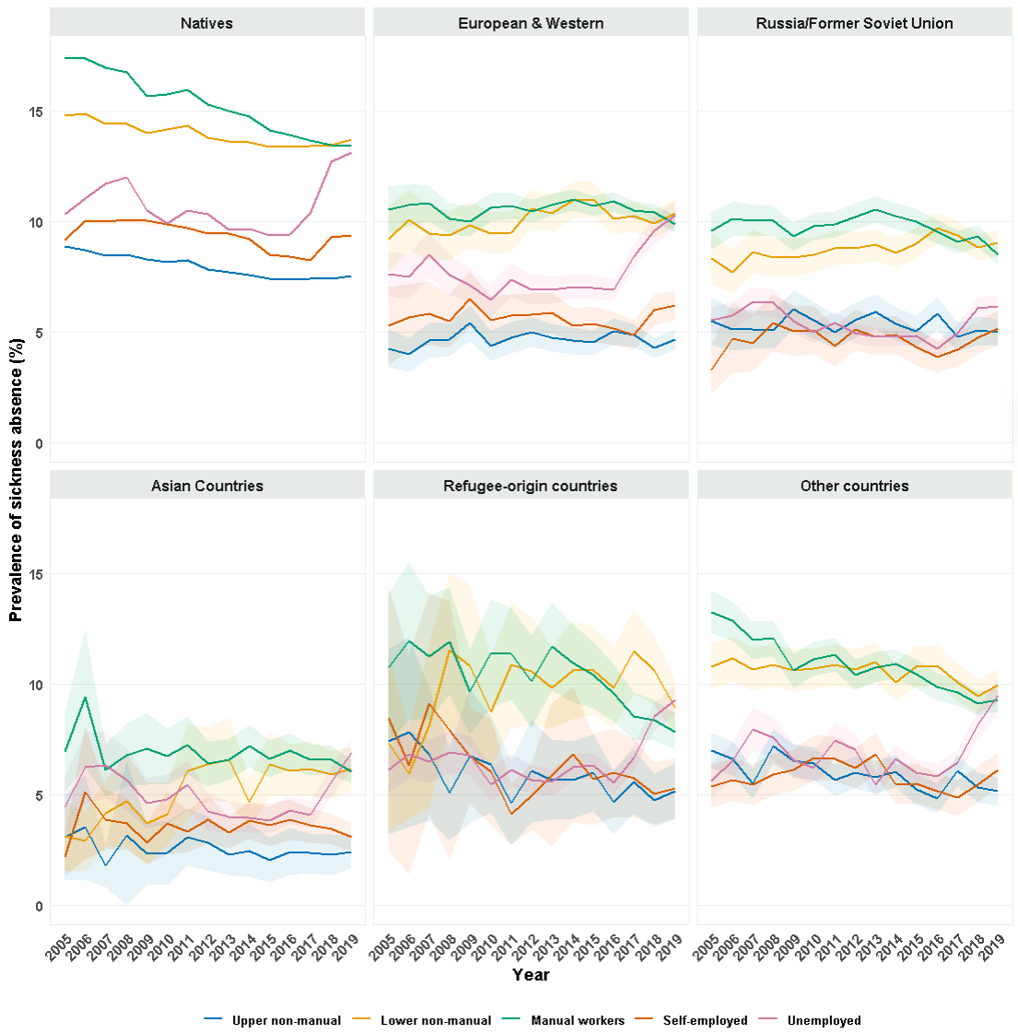
Figure S1. Age-adjusted all-cause SA prevalence with 95% CIs by occupational class and region of origin.
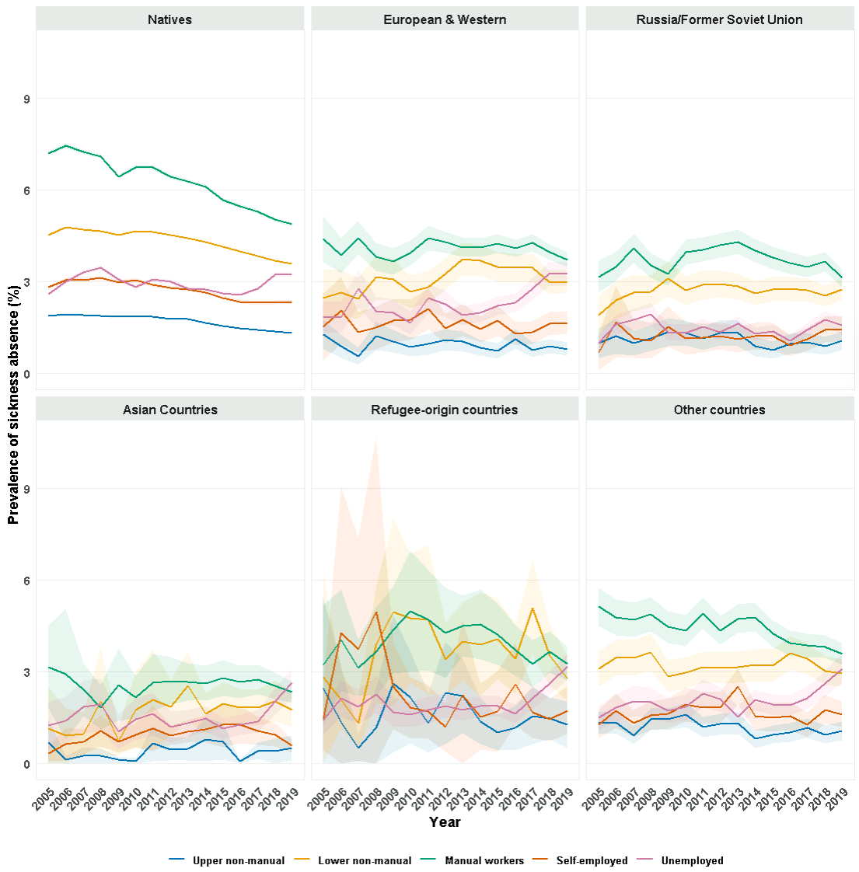
Figure S2. Age-adjusted musculoskeletal disorders-related SA prevalence with 95% CIs by occupational class and region of origin.
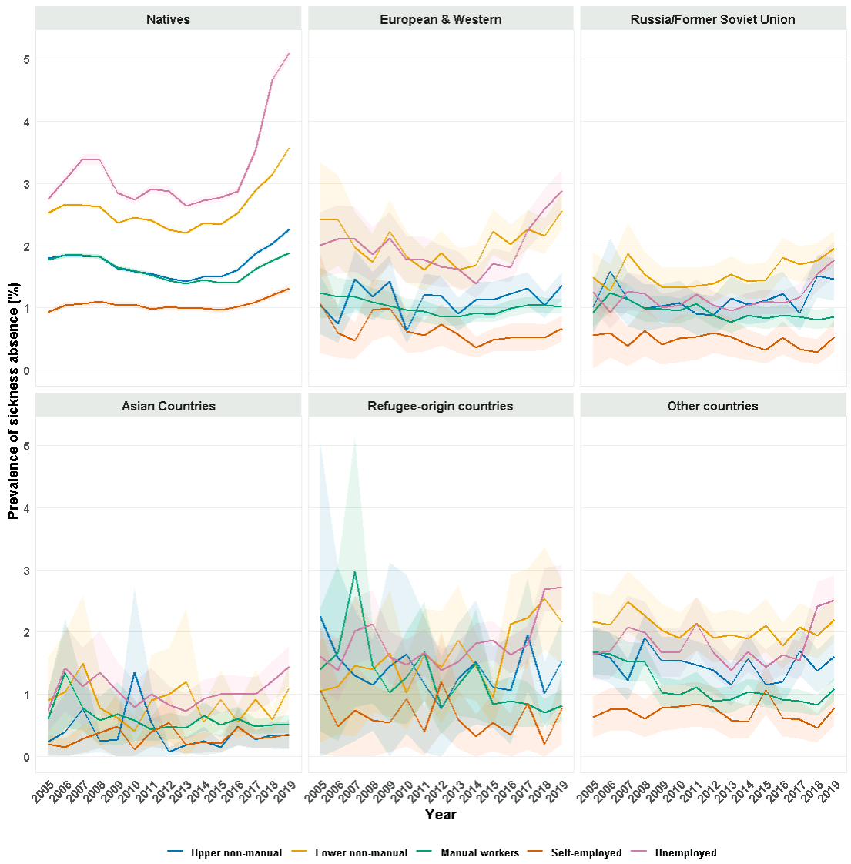
Figure S3. Age-adjusted mental disorders-related SA prevalence with 95% CI by occupational class and region of origin.

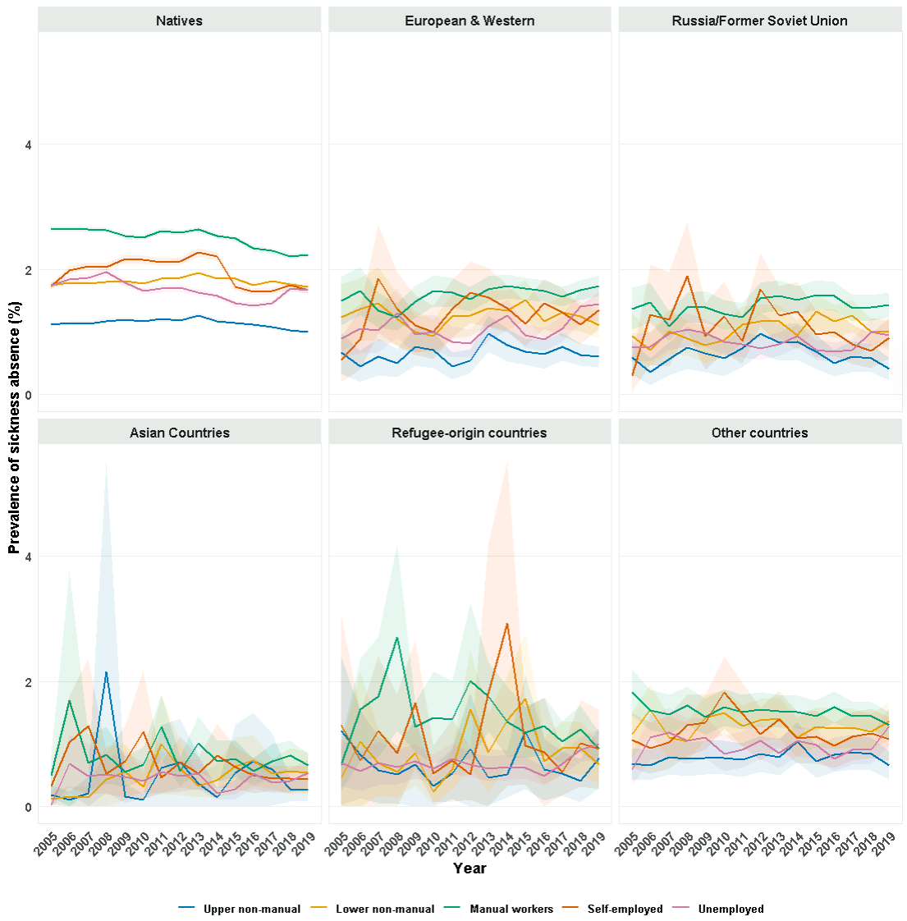
Figure S4. Age-adjusted injury-related SA prevalence with 95% CI by occupational class and region of origin.

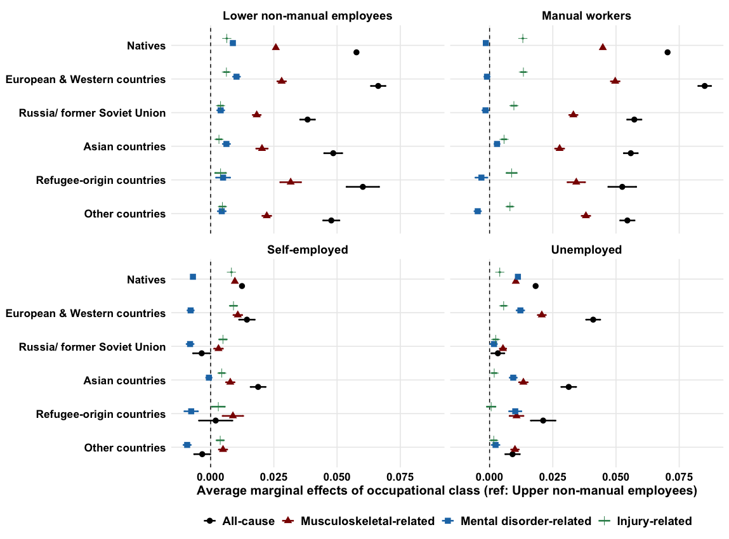

Figure S5. Average marginal effects of occupational class on SA prevalence with 95% CIs by region of origin and diagnostic groups.

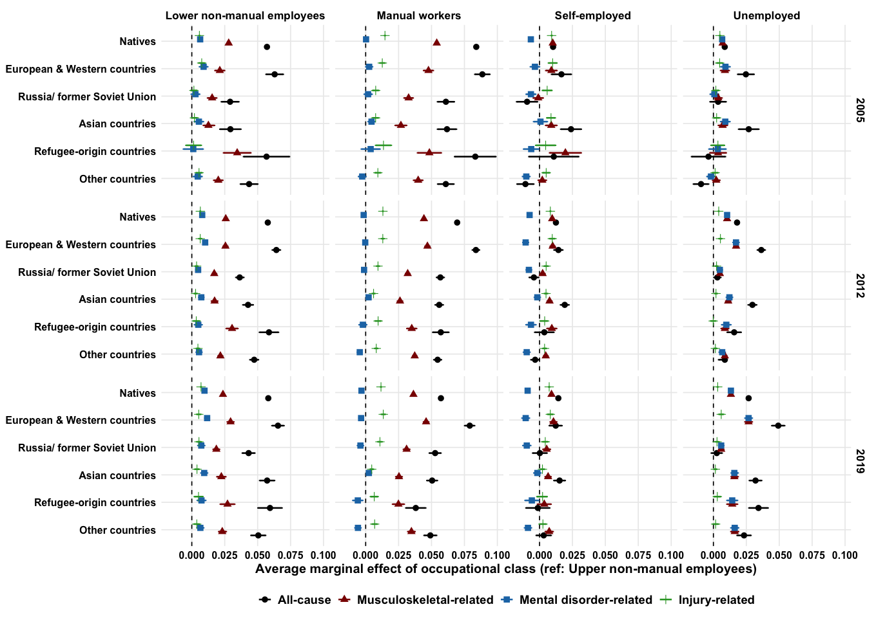

Figure S6. Average marginal effects of occupational class on SA prevalence with 95% CIs by region of origin, diagnostic groups, and time.

