Long-term environmental stability promotes reproducible, depth-structured sediment microbiomes
Hernández-Oaxaca Diana^{1,4}, Lona-Téllez Yaxché¹, Balvino-Olvera Francisco¹, Pérez-Ceballos Rosela^{2,3}, Olivares-Miranda Mizraim⁴, Carlos Burelo⁵, Ibarra-Laclette Enrique⁴, Vázquez-Rosas-Landa Mirna^{1*}

¹Unidad Académica de Ecología y Biodiversidad Acuática, Instituto de Ciencias del Mar y Limnología, Universidad Nacional Autónoma de México, Ciudad de México, México.
²Instituto de Ciencias del Mar y Limnología Estación El Carmen, Universidad Nacional Autónoma de México, Ciudad del Carmen, México.
³Secretaría de Ciencias, Humanidades, Tecnología e Innovación (SECIHTI).
⁴Red de Estudios Moleculares Avanzados, Campus III, Instituto de Ecología A. C., Carretera Antigua a Coatepec 351, Xalapa, Veracruz, CP 91073, México.
⁵Laboratorio de Manglares Interiores. División Académica de Ciencias Biológicas. Universidad Juárez Autónoma de Tabasco. México

*Corresponding Author:
Vázquez-Rosas-Landa Mirna¹
¹ Unidad Académica de Ecología y Biodiversidad Acuática, Instituto de Ciencias del Mar y Limnología, Universidad Nacional Autónoma de México, Ciudad de México, México.

Email address:
mvazquez@cmarl.unam.mx

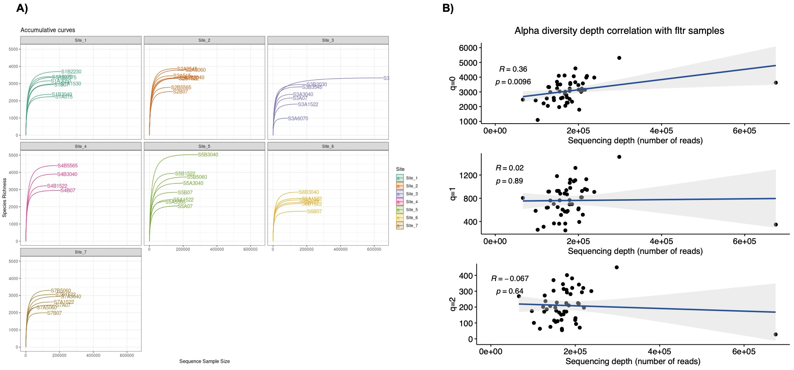
Figure S1. Sampling effort curves and depth sequencing correlation with alpha diversity. A) Accumulation curves of observed richness. The curves show that most samples reach an asymptote, indicating adequate capture of microbial diversity. B) Relationship between sequencing depth (number of reads) and alpha diversity estimated by Hill numbers (q=0, q=1, and q=2).

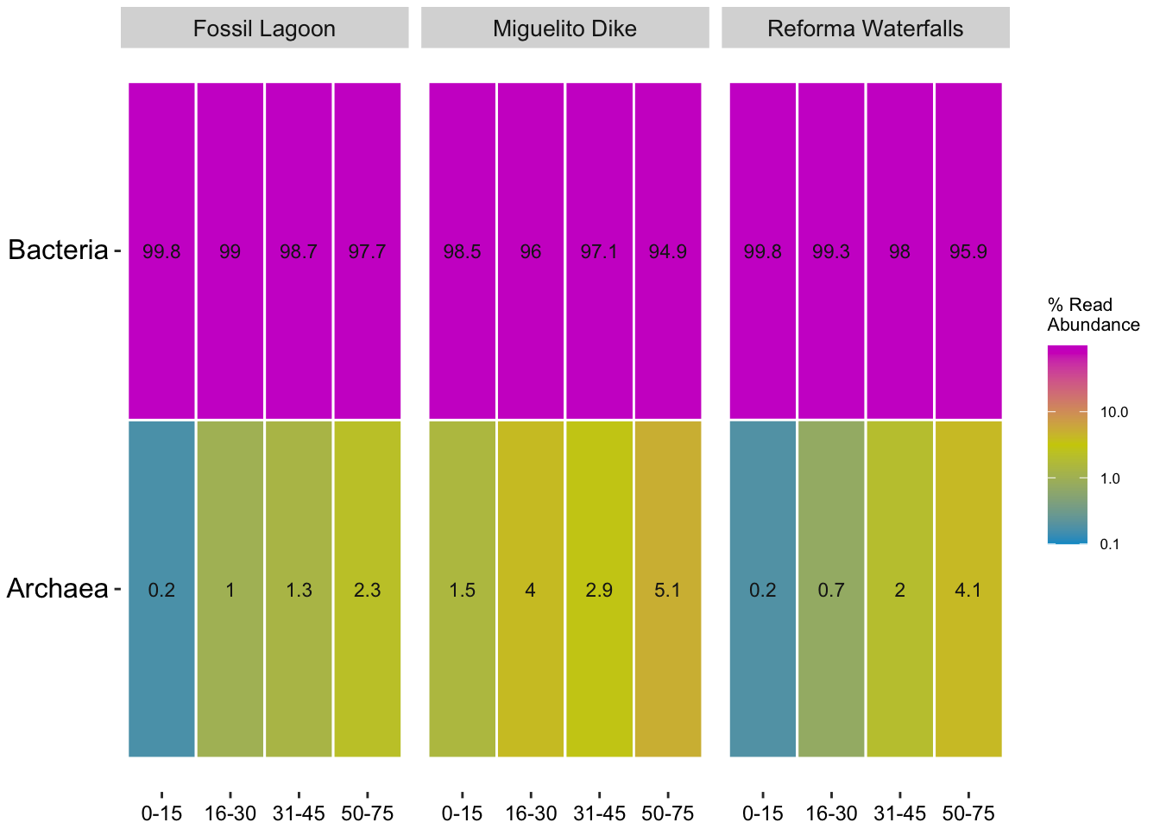
Figure S2. Relative abundance of readings assigned to Bacteria and Archaea domains in inland mangrove sediments along the Rio San Pedro Martir, distributed by locality and depth. The color gradient from blue to magenta indicates the percentage of abundance.
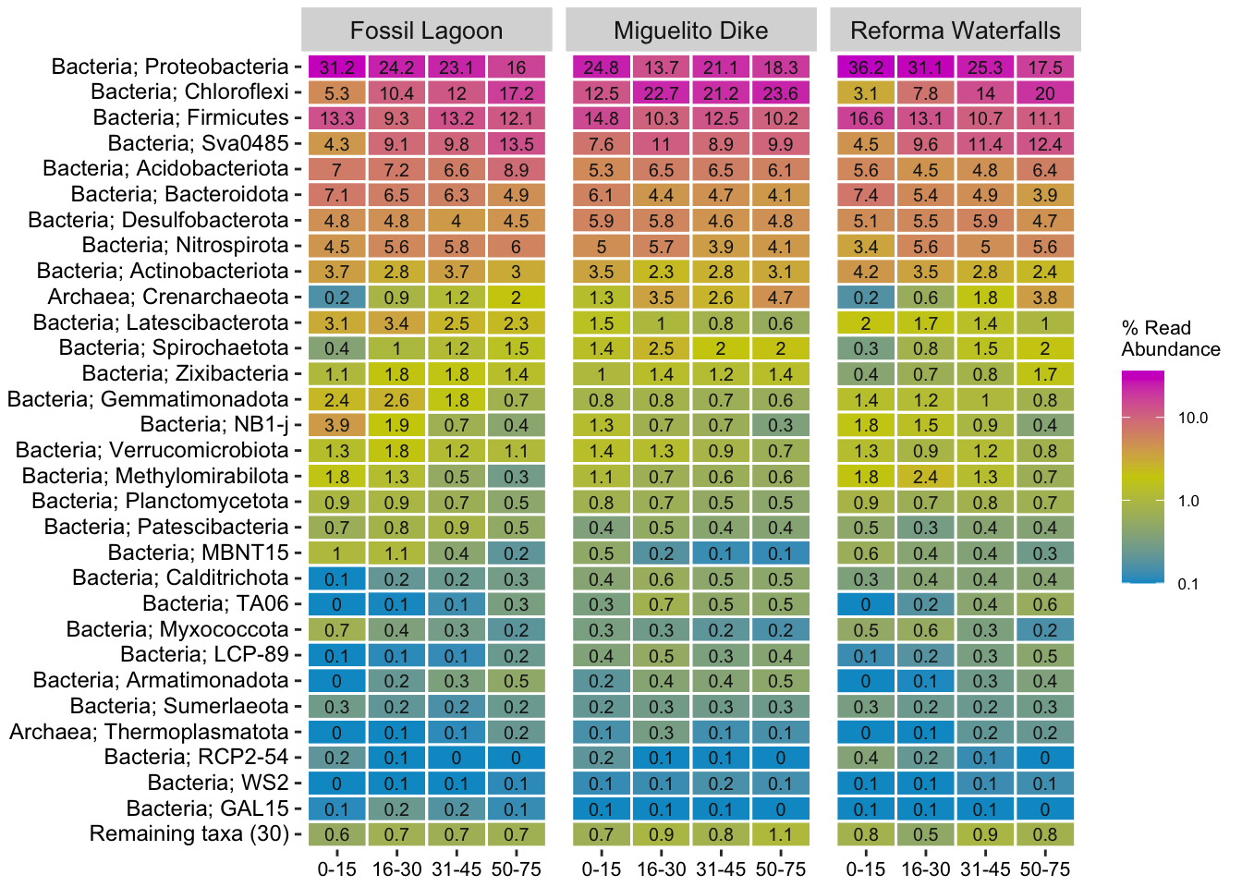
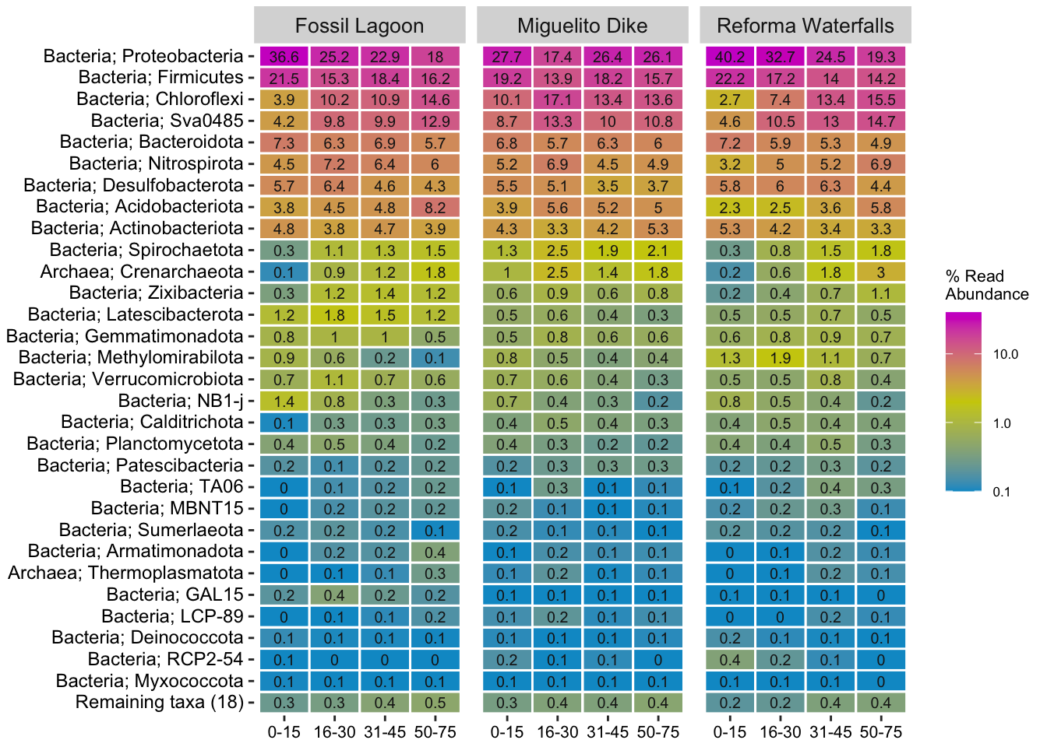
Figure S3. Phylum distribution between depths and localities, in the whole community and the microbial core. A) Relative abundance (%) of all microbial phyla detected in the localities at different depths. B) Relative abundance of microbial phyla belonging to the microbial core, defined as taxa shared among all depths and localities. The color gradient from blue to magenta indicates the percentage of abundance
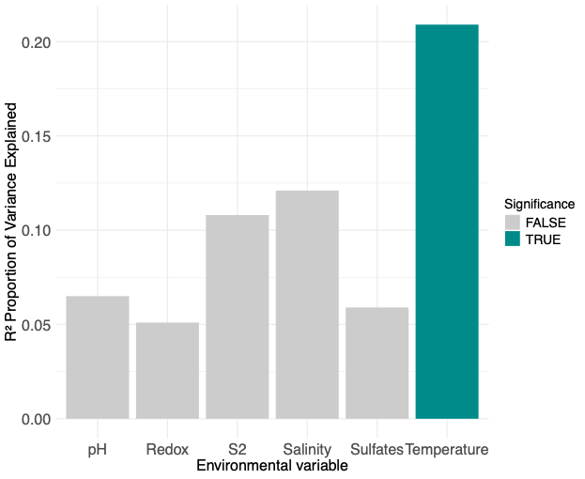

 | F | p-value | Explained | Cumulative
CAP1 | 5.04 | 0.15 | 0.325 | 0.325
CAP2 | 1.82 | 0.76 | 0.117 | 0.443
CAP3 | 1.27 | 0.83 | 0.0818 | 0.5247
CAP4 | 0.63 | 0.96 | 0.0405 | 0.5652
CAP5 | 0.41 | 0.97 | 0.0265 | 0.5916
CAP6 | 0.32 | 0.97 | 0.0208 | 0.6124

Figure S4. Contribution of physicochemical variables to microbial composition in inland mangrove sediments along the Rio San Pedro Martir. A) The graph represents the R² values derived from a permutational analysis (PERMANOVA), evaluating the influence (y-axis) of the environmental variables (x-axis). B) db-RDA variance explained of each canonical axis. Columns indicate: F statistic, p-value, variance and the cumulative variance calculated by the permutational like ANOVA.

