Supplementary Figures for

Genetic associations with cortical thickness and surface area and their distinct developmental trajectories
Authors
Nana Liu^{1,4}, Jiayuan Xu^{1,4}, Jie Tang^{1,4}, Jilian Fu¹, Sijia Wang¹, Yuan Ji¹, Hui Xue¹, Nannan Zhang¹, Qiang Xu¹, Lining Guo¹, Hao Ding¹, Libo Su², Ping Wang², Huaigui Liu¹, Feng Liu¹, Meng Liang^{3,*}, Wen Qin^{1,*}, Chunshui Yu^{1,*}
Affiliations
¹Department of Radiology, Tianjin Key Lab of Functional Imaging and State Key Laboratory of Experimental Hematology, Tianjin Medical University General Hospital; 300052, Tianjin, China.
²Division of Medical Technology, Tianjin Medical University; 300203, Tianjin, China.
³Division of Medical Technology and Tianjin Key Laboratory of Functional Imaging and The Province and Ministry Cosponsored Collaborative Innovation Center for Medical Epigenetics, Tianjin Medical University; 300203, Tianjin, China.
⁴These authors contributed equally to this work.
*Correspondence to:
Chunshui Yu, e-mail: chunshuiyu@tmu.edu.cn
Wen Qin, e-mail: wayne.wenqin@gmail.com
Meng Liang, e-mail: liangmeng@tmu.edu.cn

The whole cerebral cortex
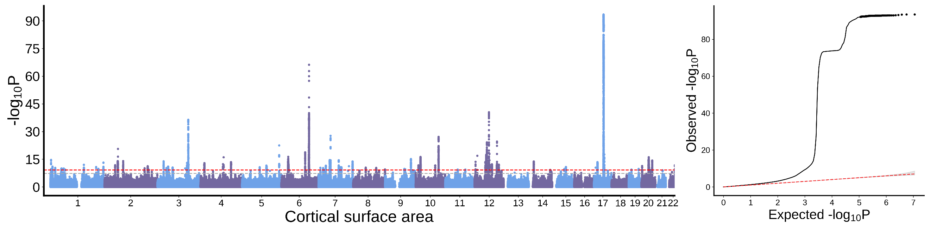
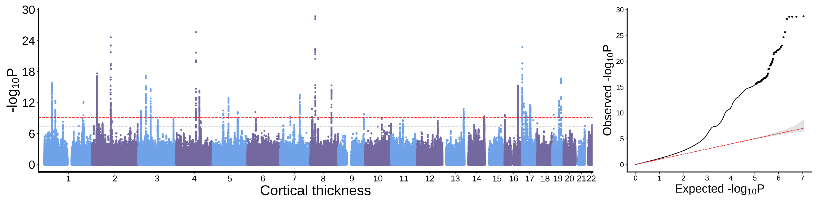
Frontal pole
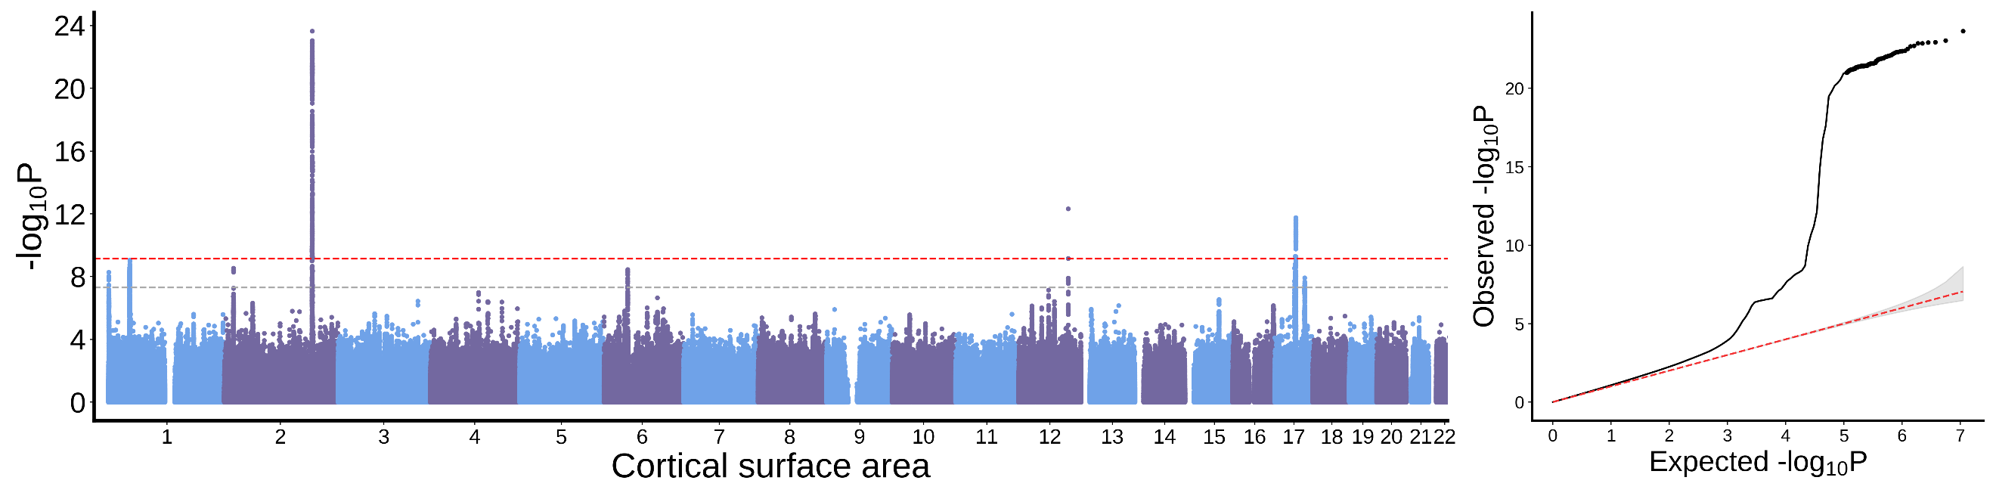
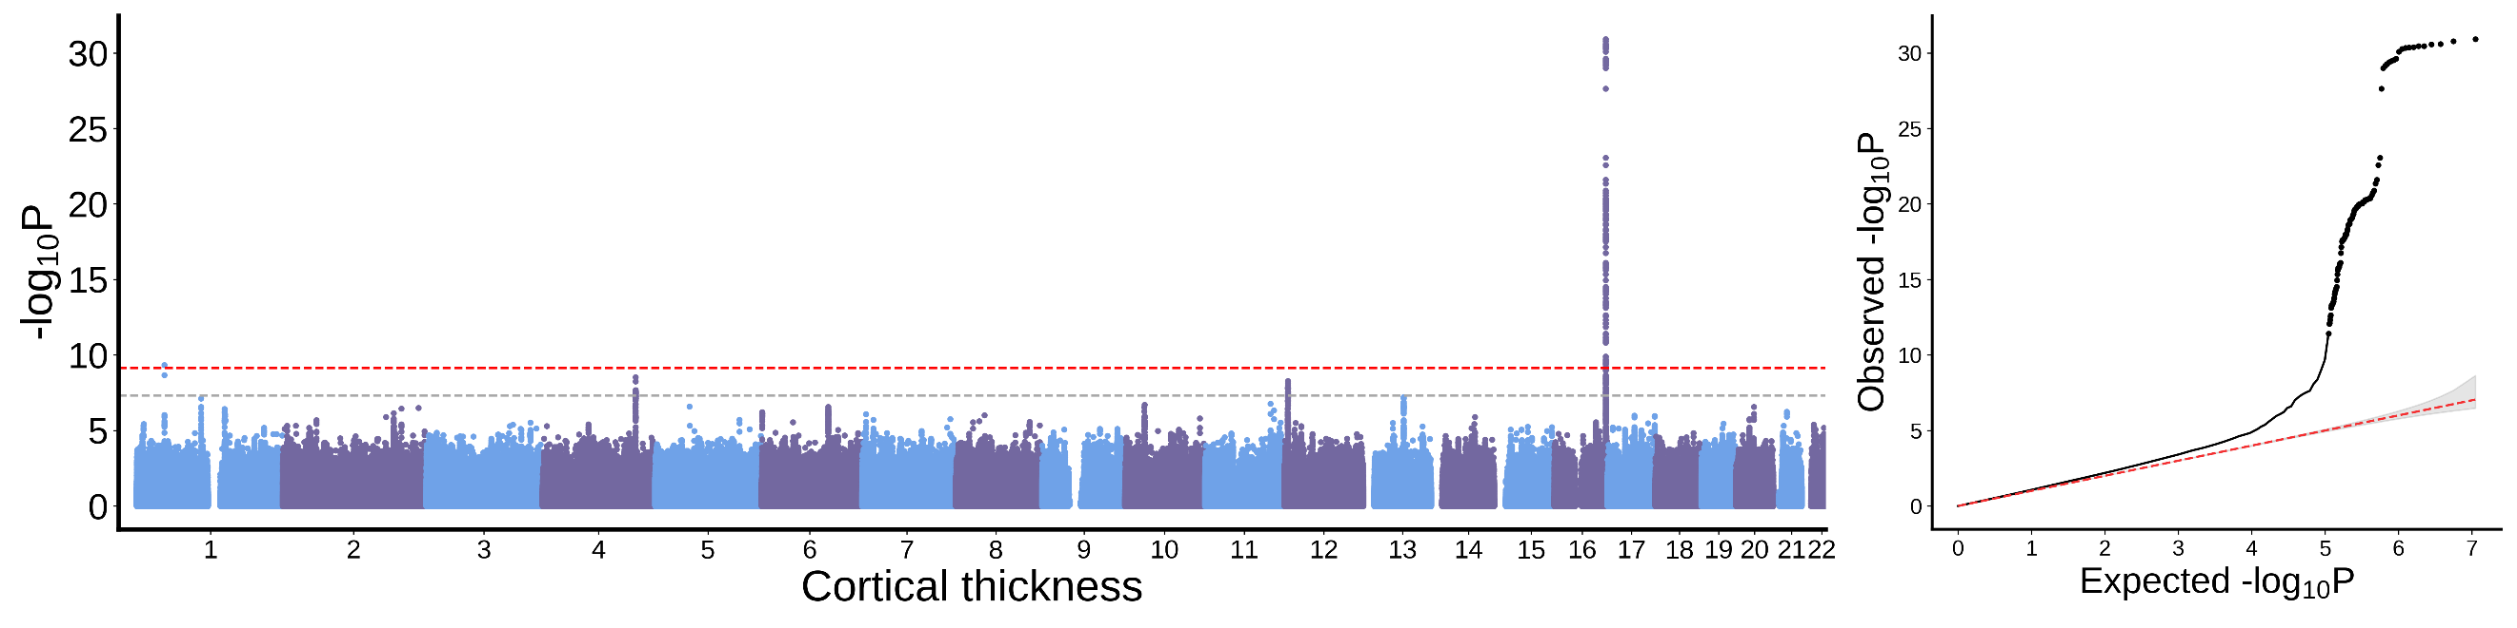
Medial orbitofrontal cortex
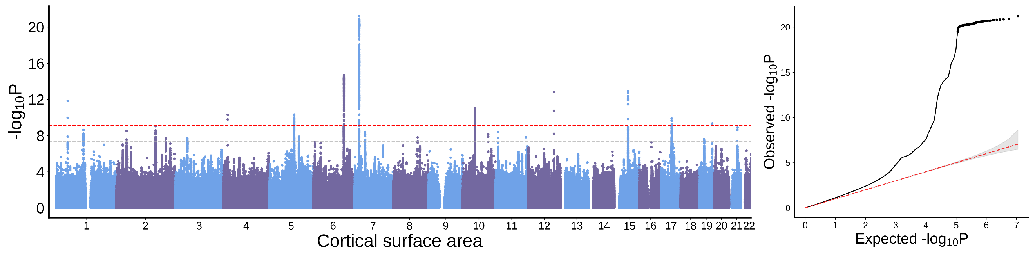
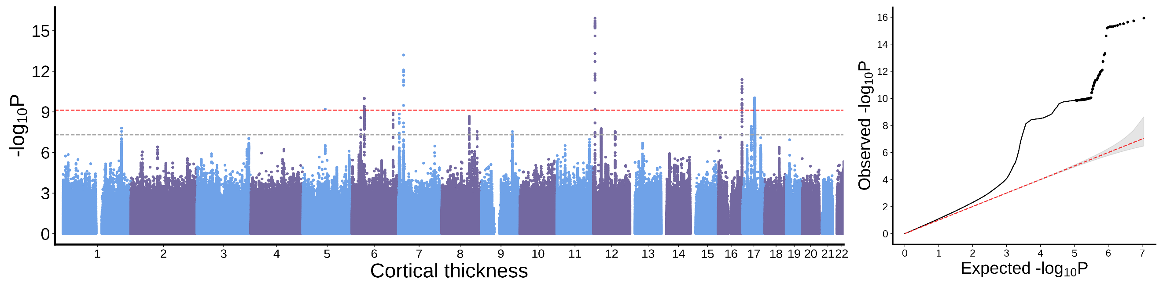
Lateral orbitofrontal cortex
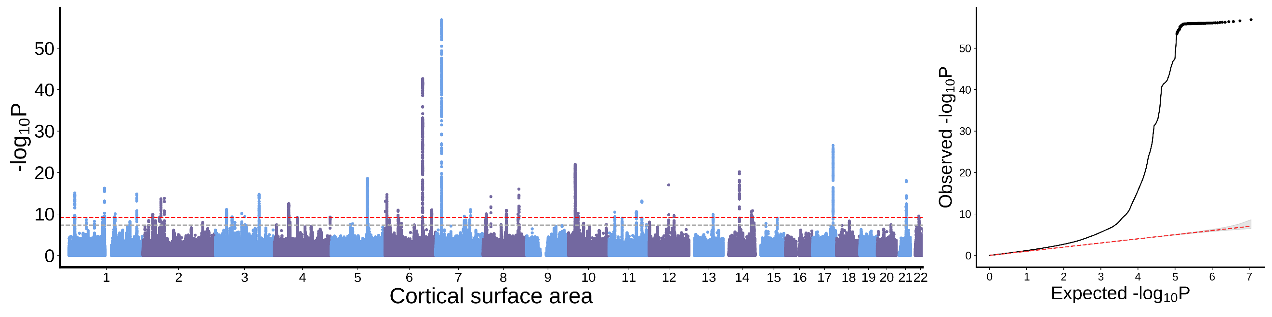
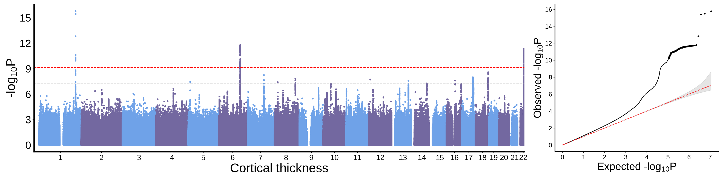
Rostral anterior cingulate cortex
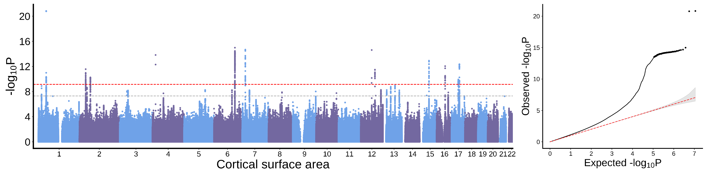
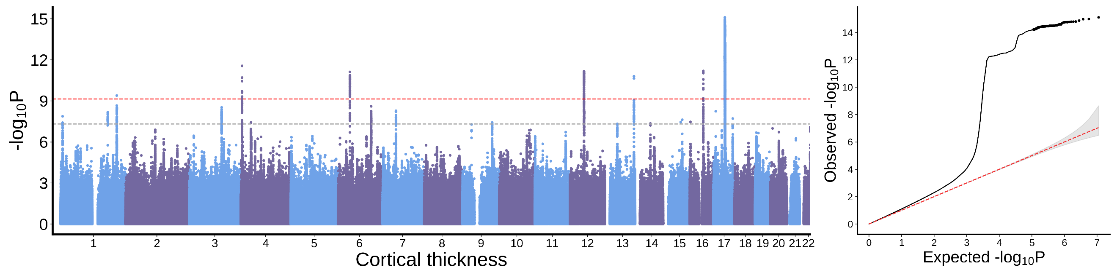

Caudal anterior cingulate cortex
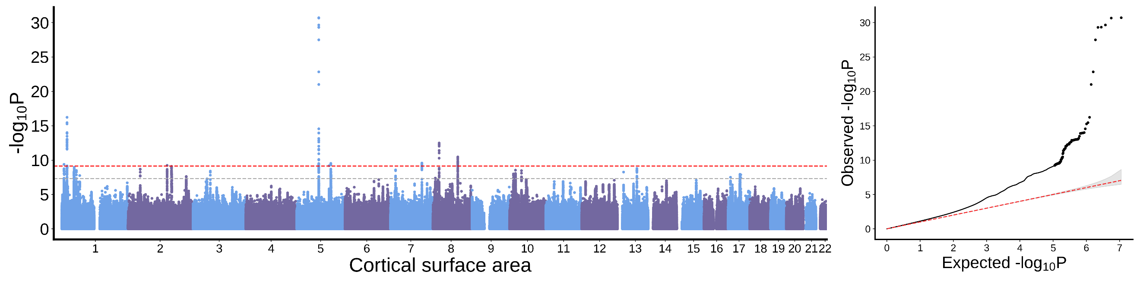
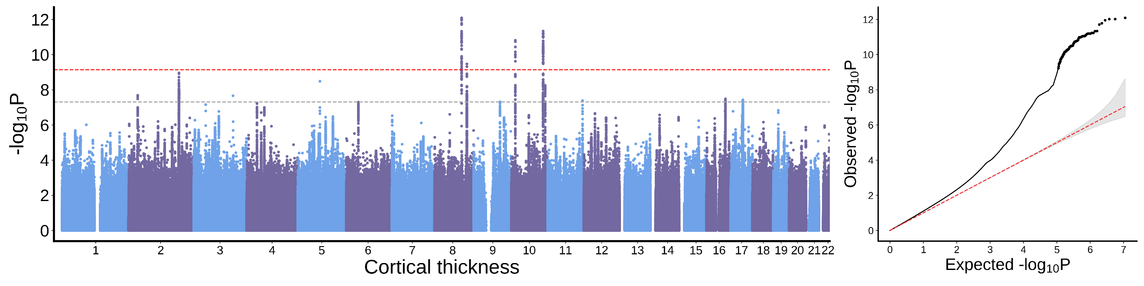
Superior frontal cortex
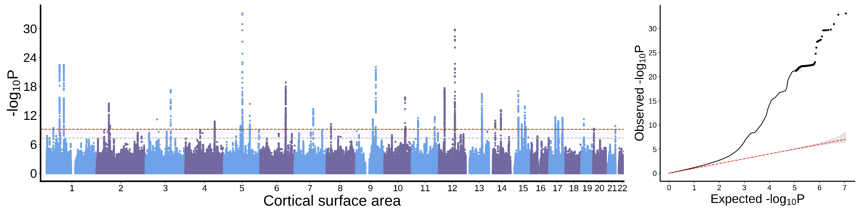
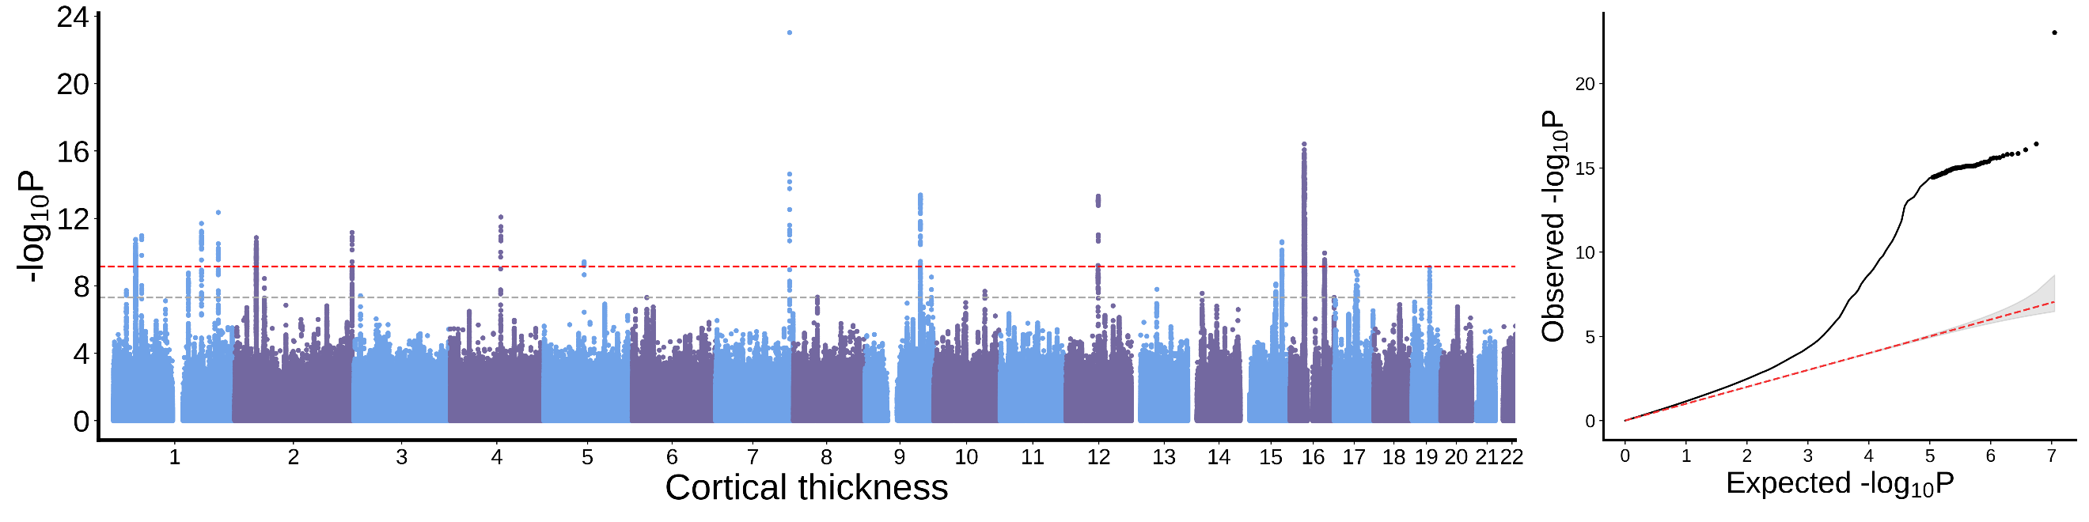
Rostral middle frontal cortex
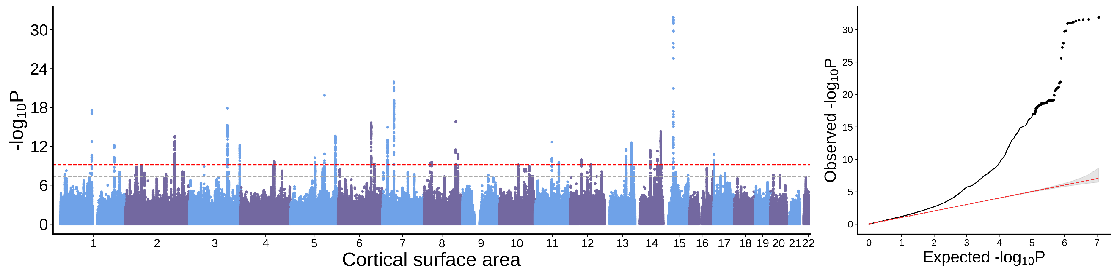
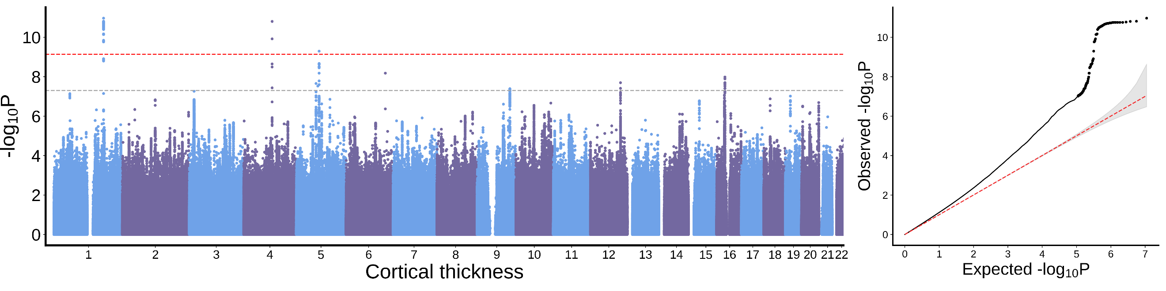
Pars orbitalis
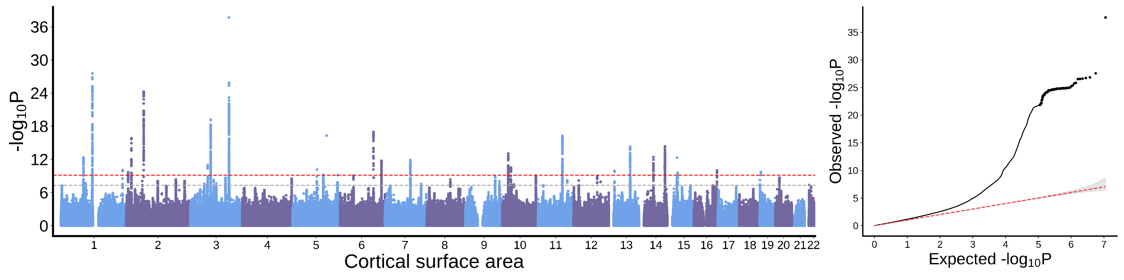
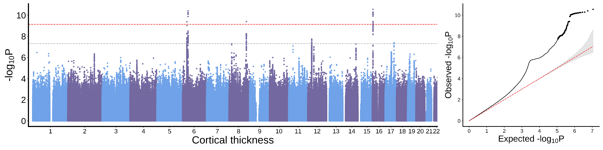
Pars triangularis
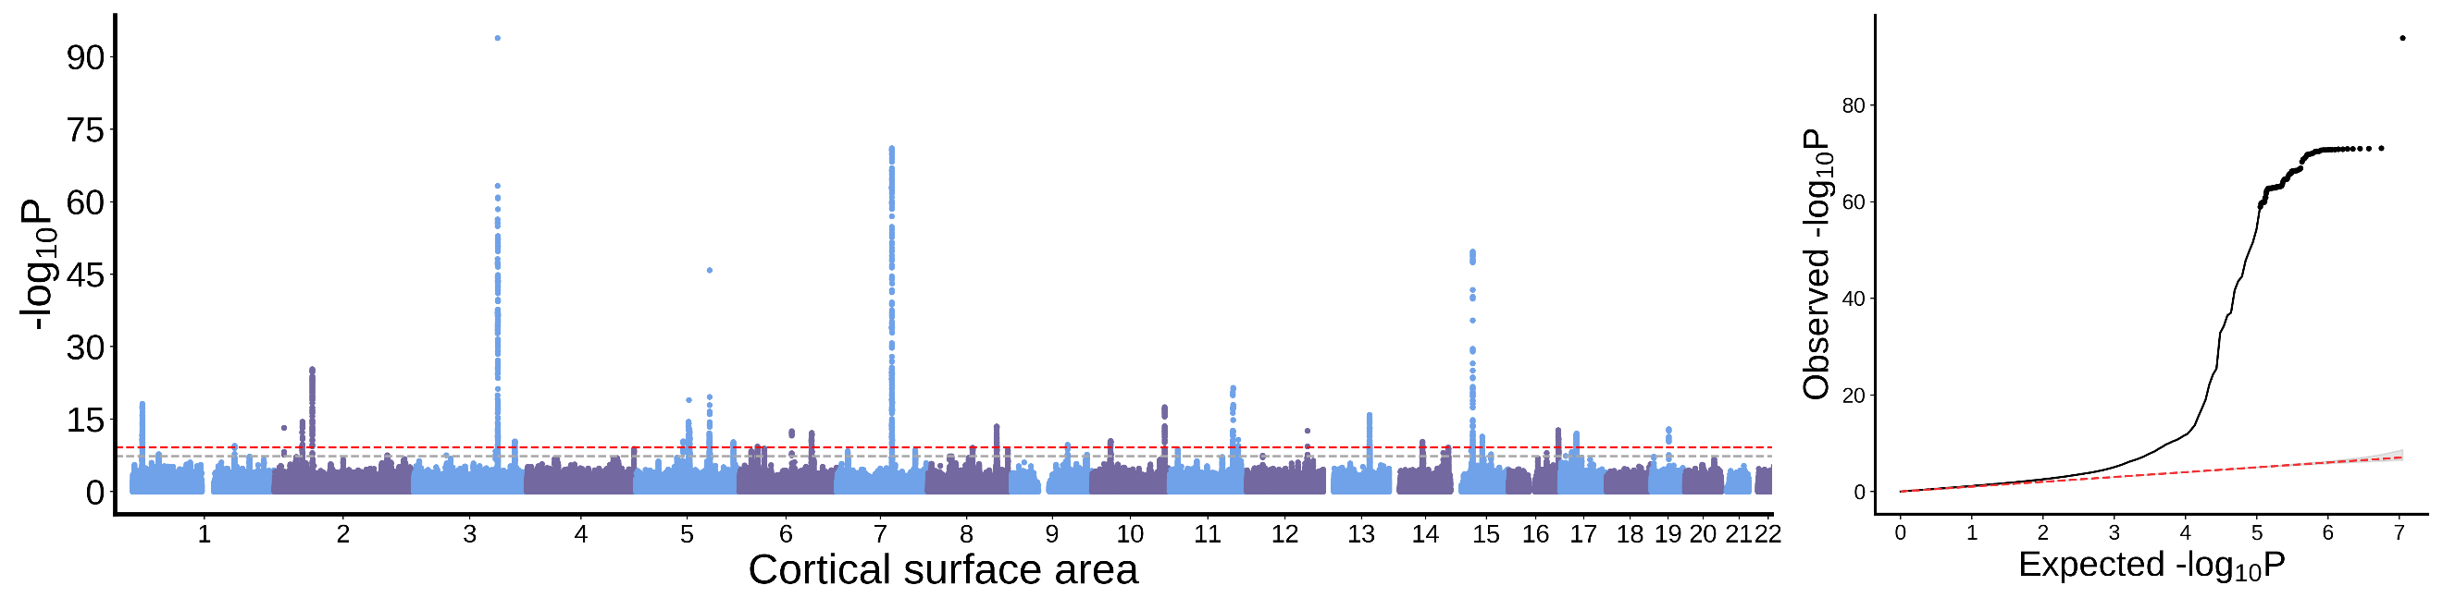
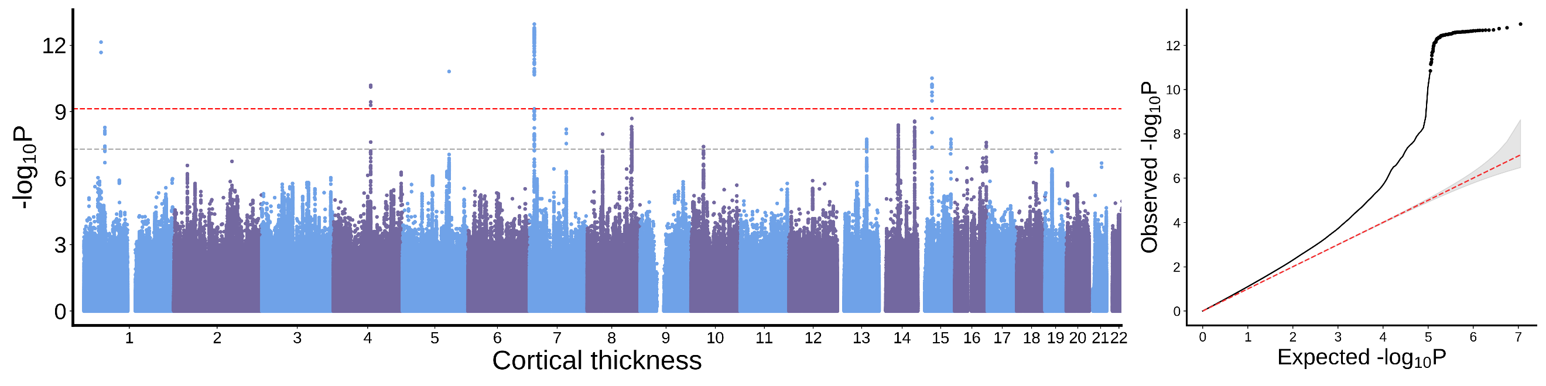

Pars opercularis
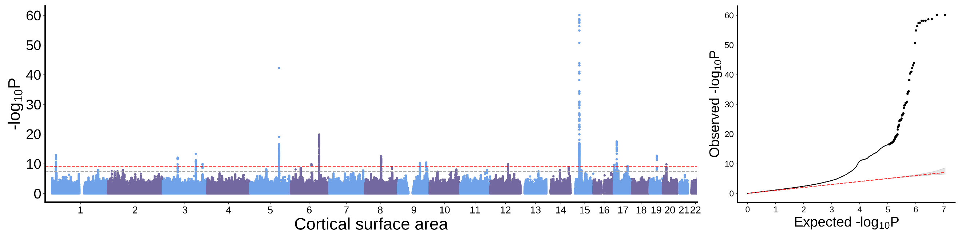
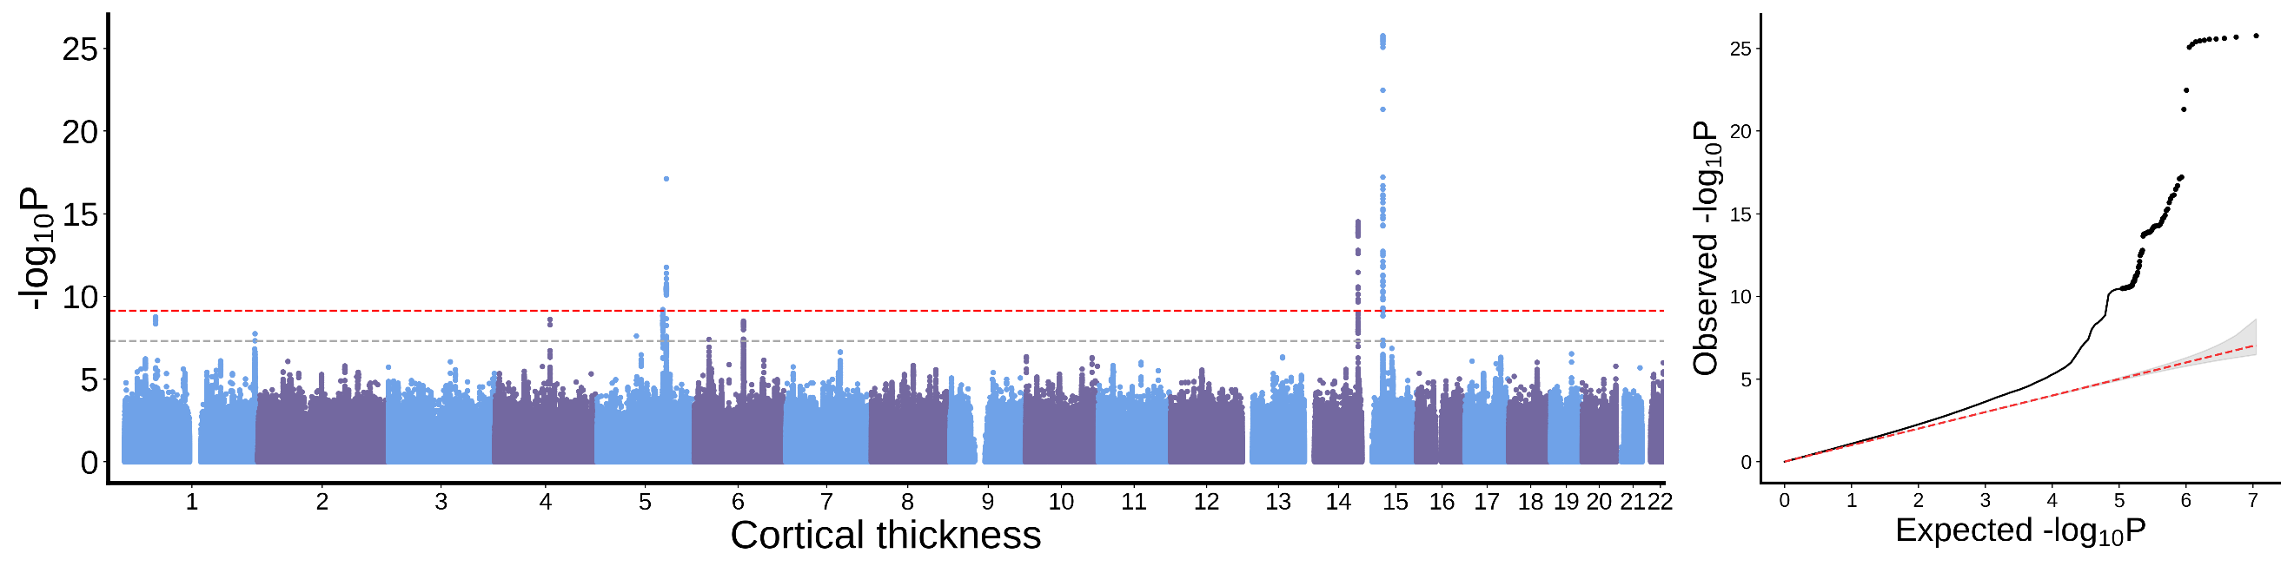
Caudal middle frontal cortex
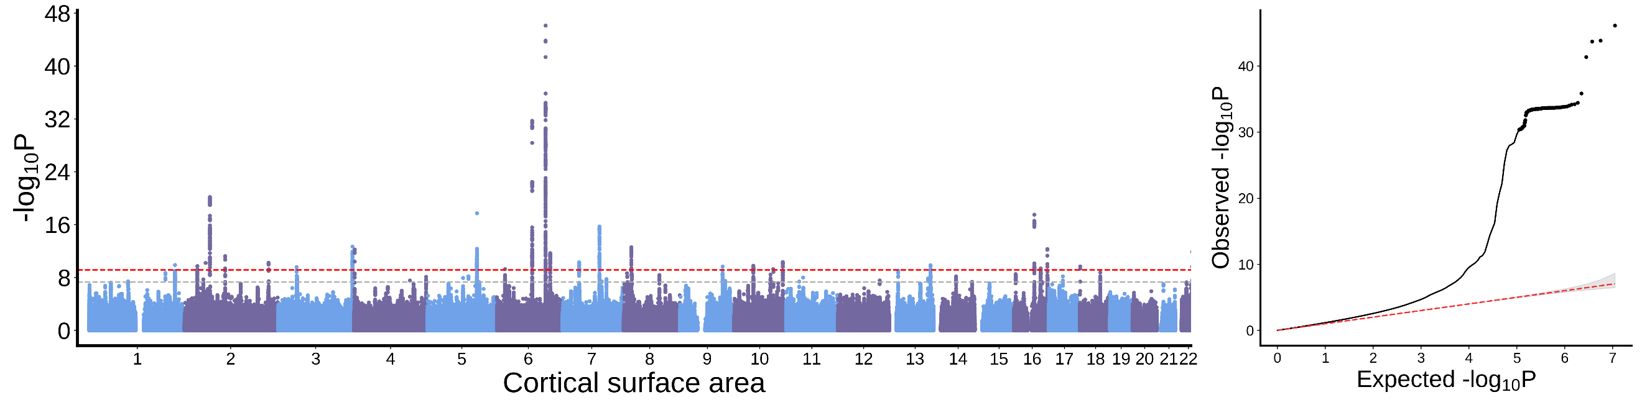
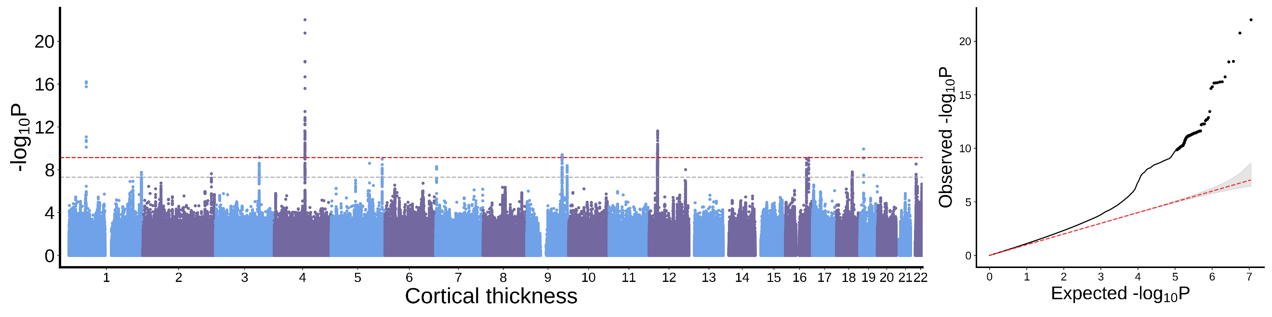
Paracentral cortex
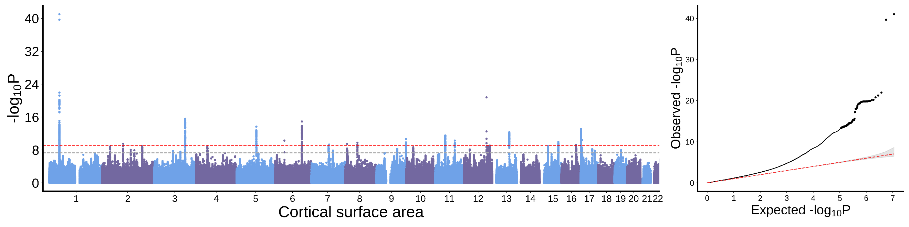
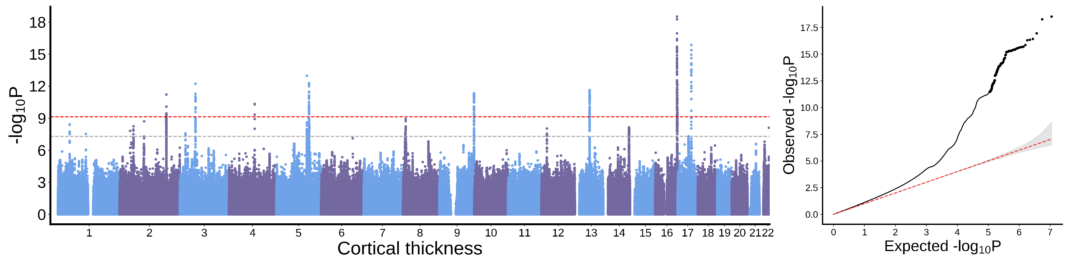
Precentral cortex
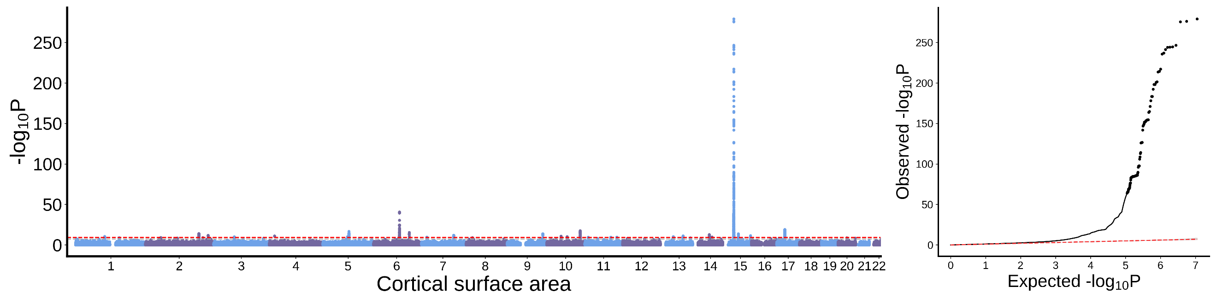
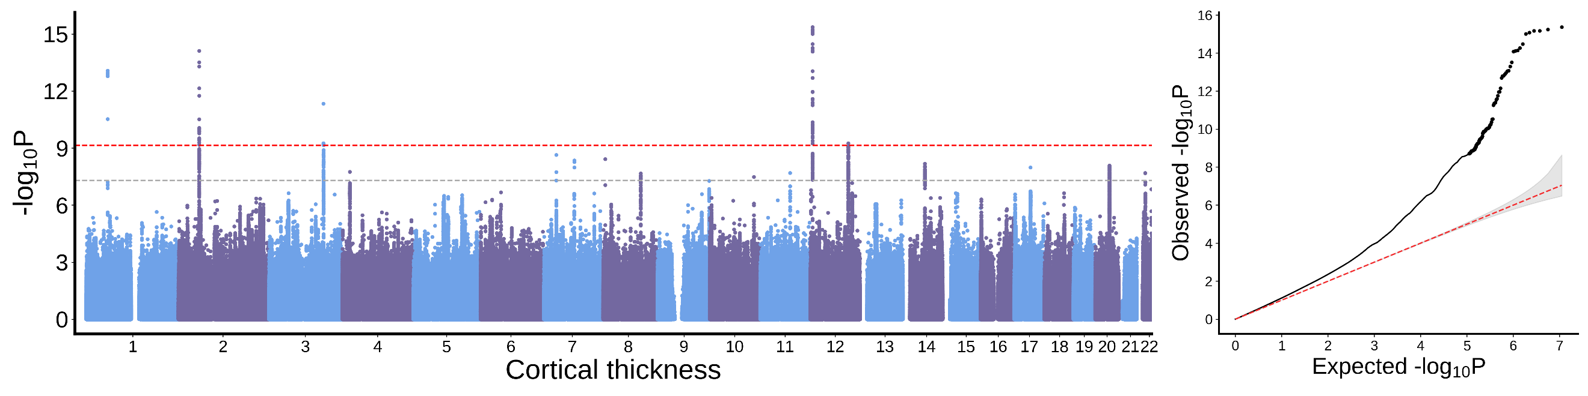
Postcentral cortex
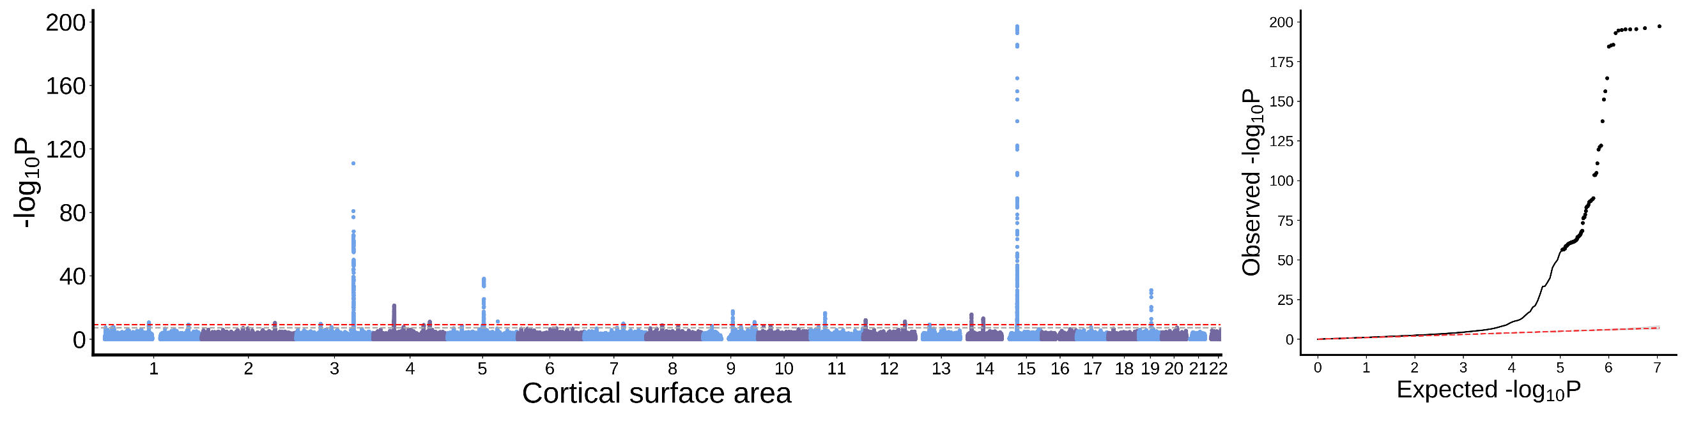
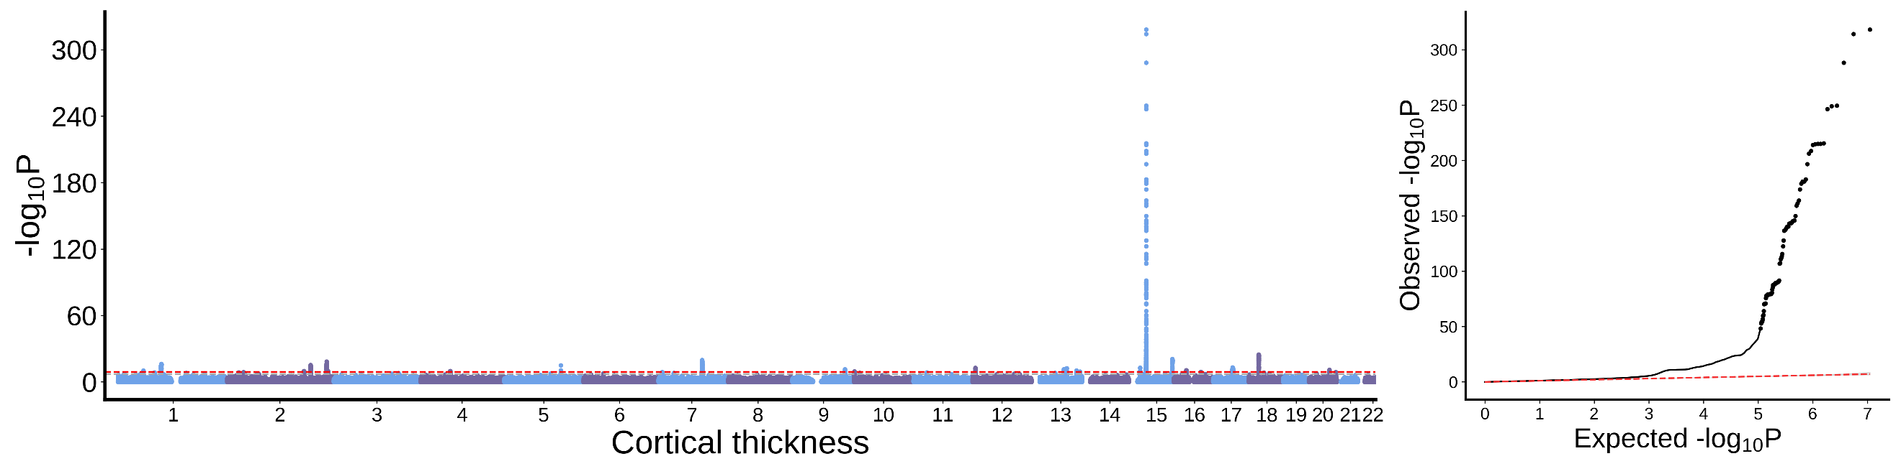

Precuneus cortex
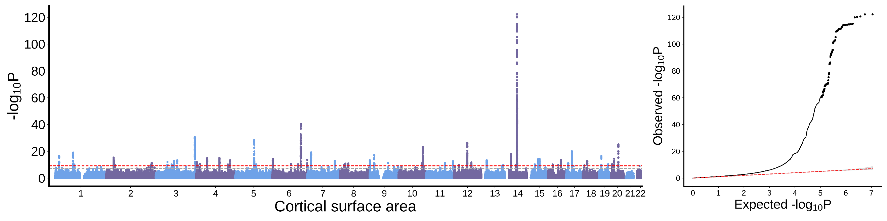
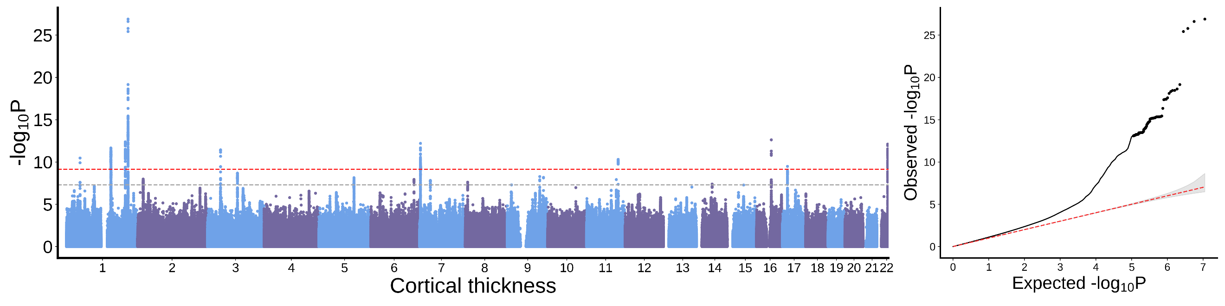
Superior parietal cortex
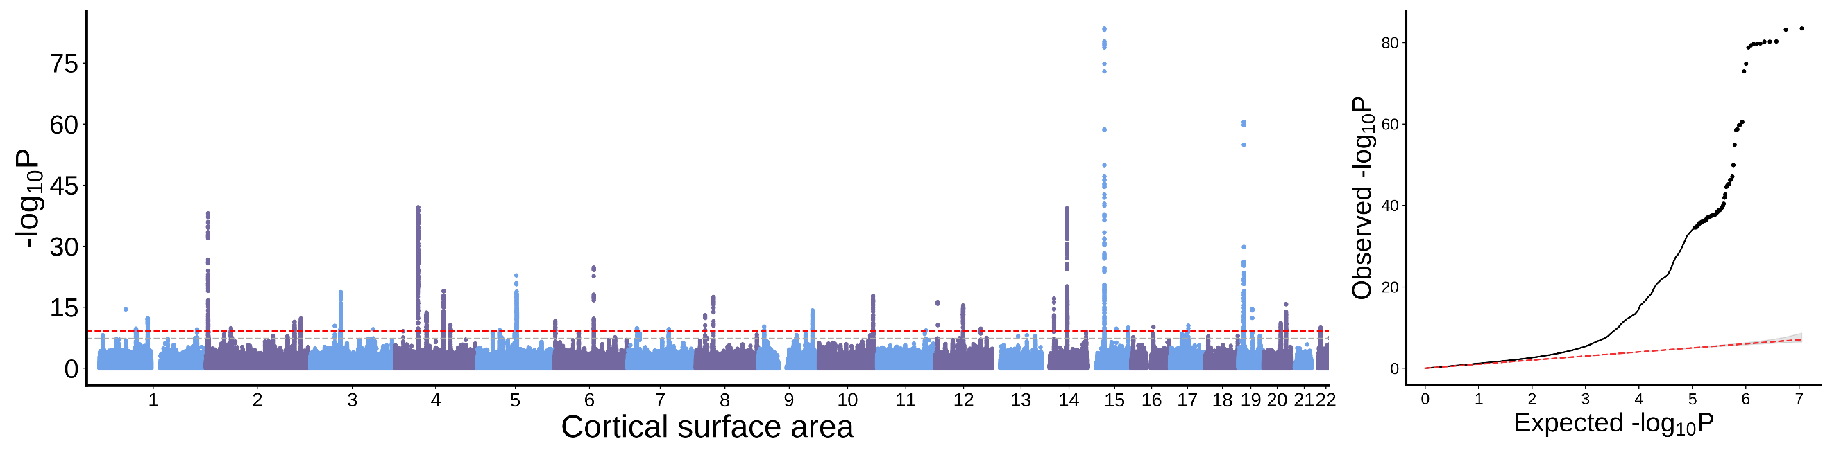
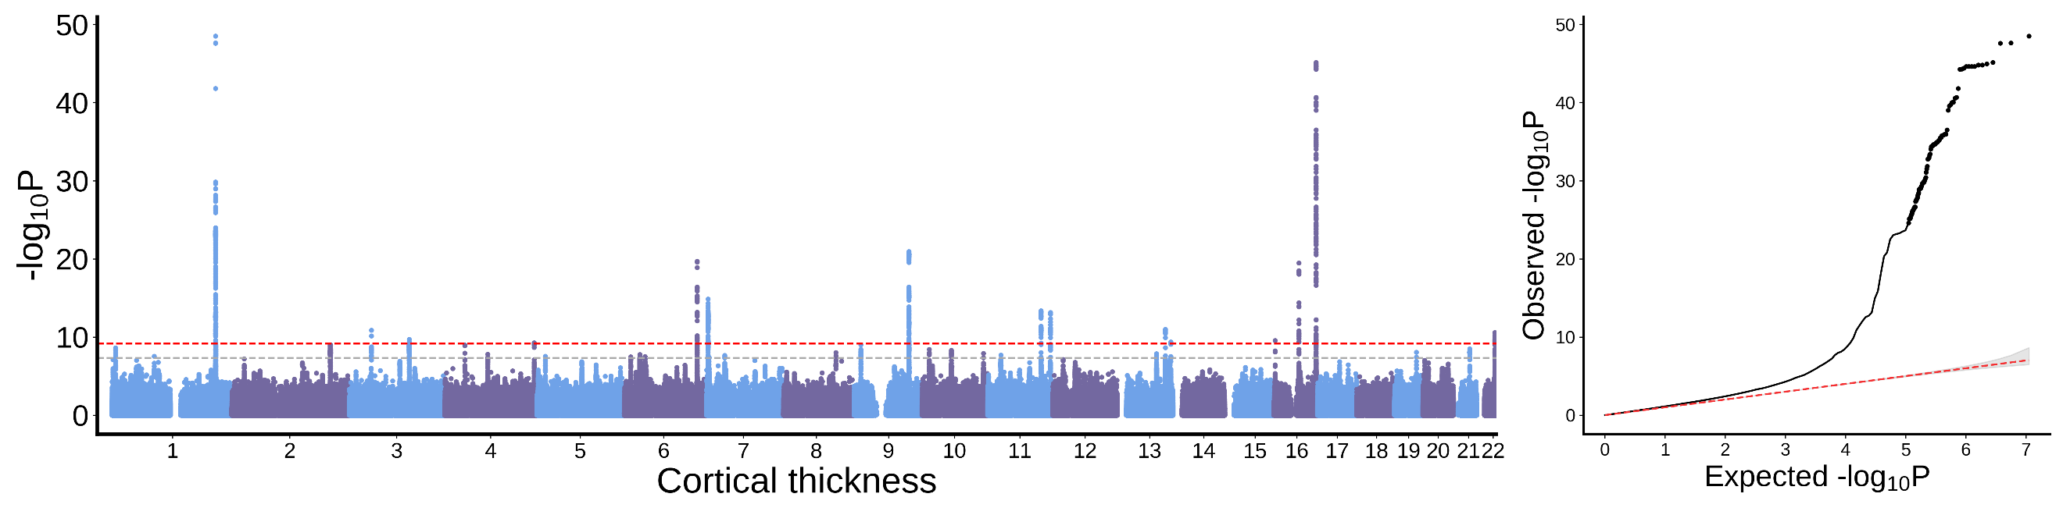
Supramarginal cortex
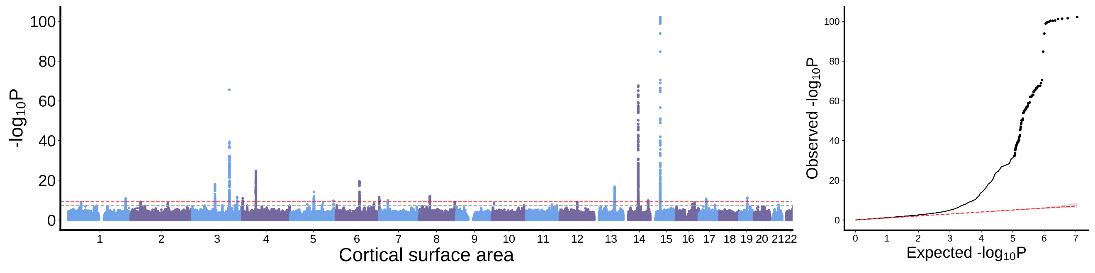
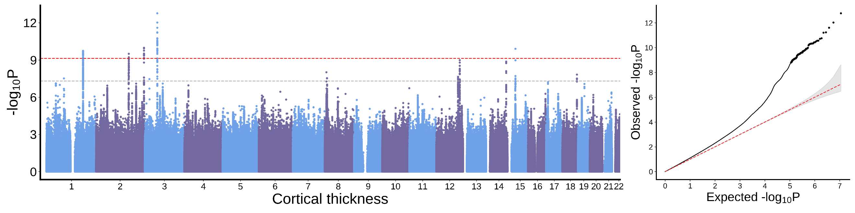
Inferior parietal cortex
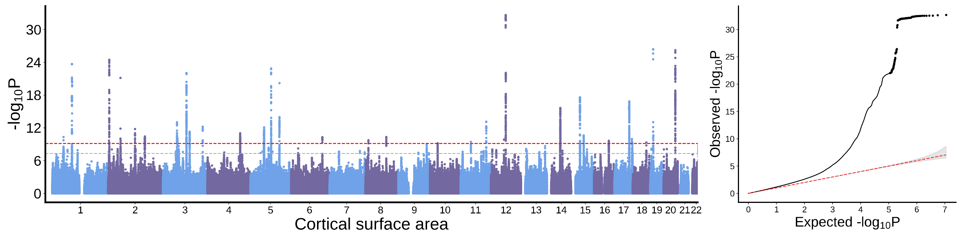
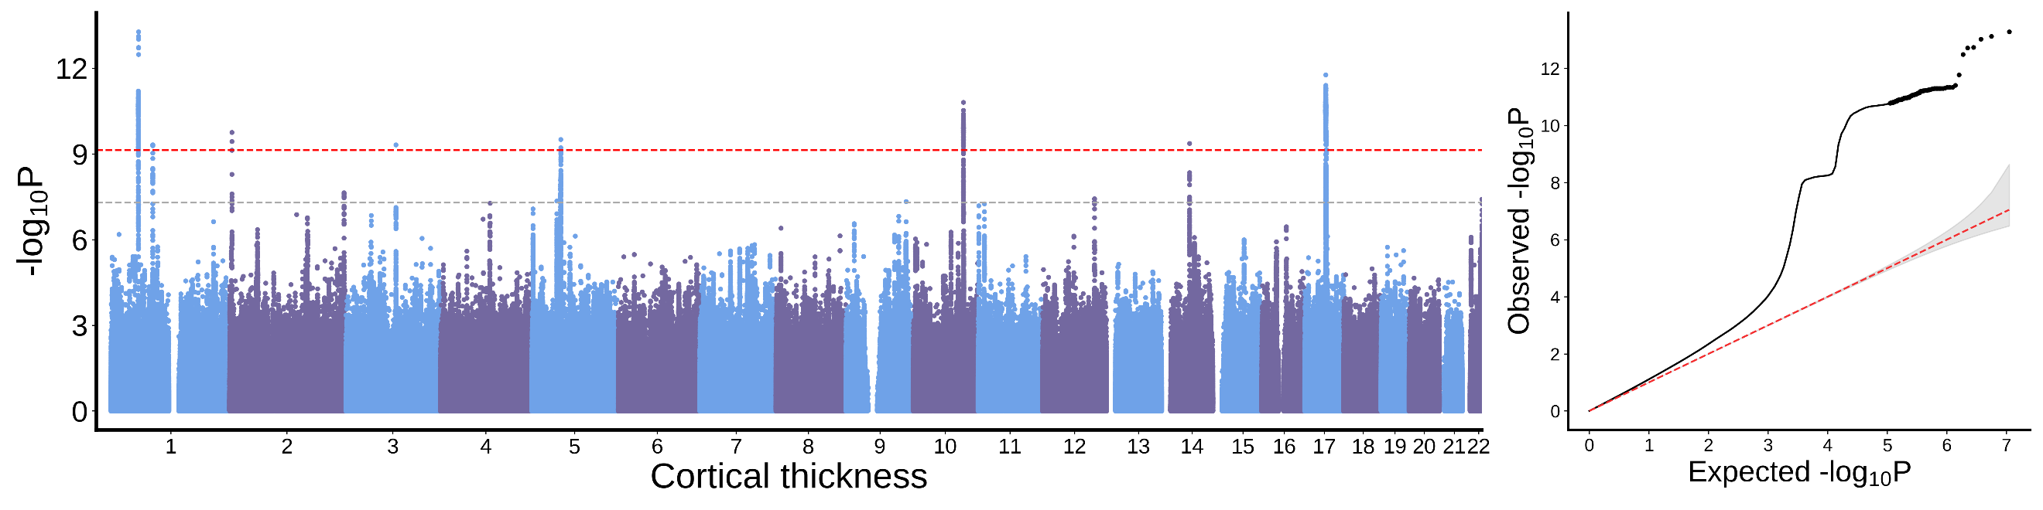
Posterior cingulate cortex
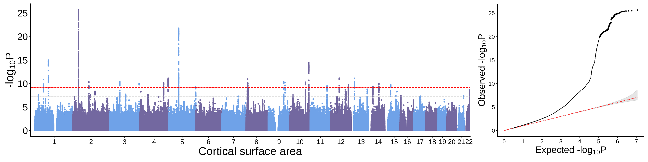
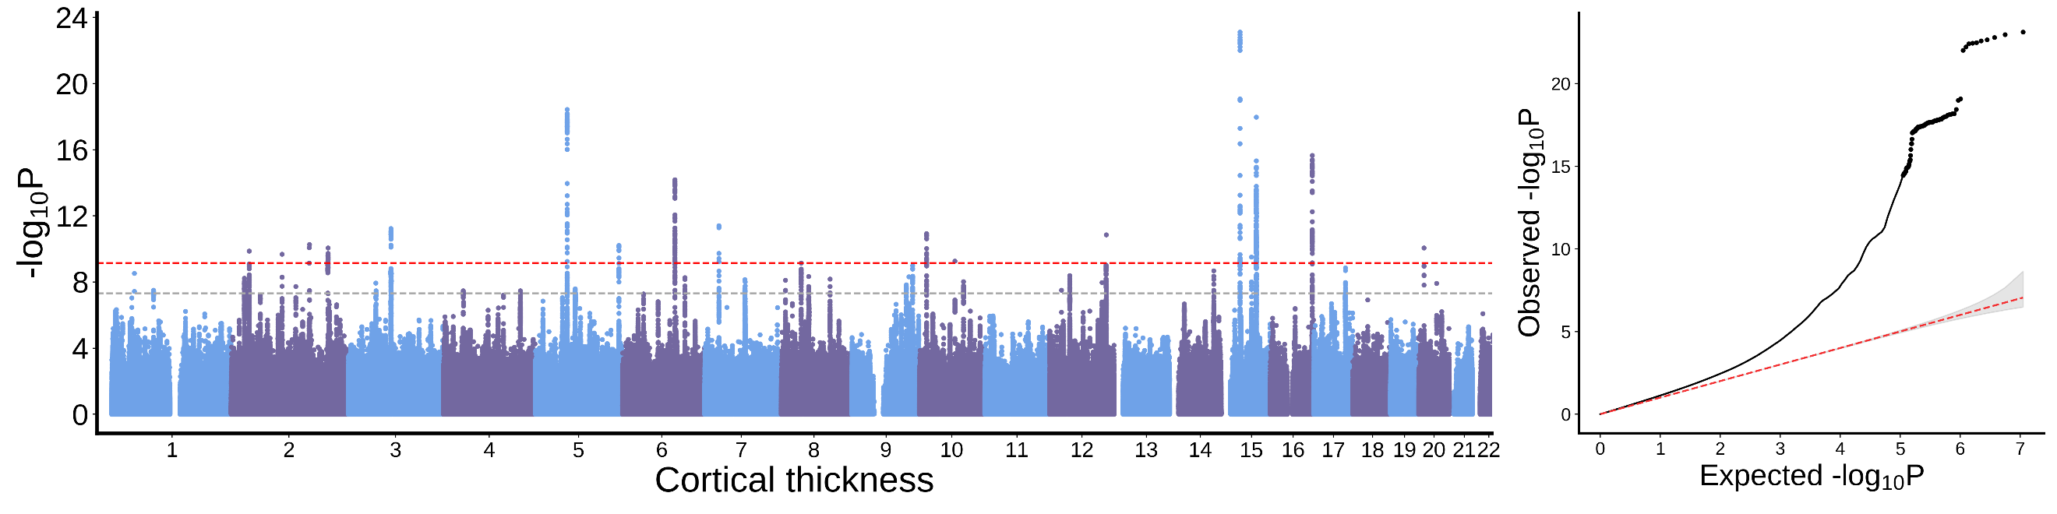

Isthmus cingulate cortex
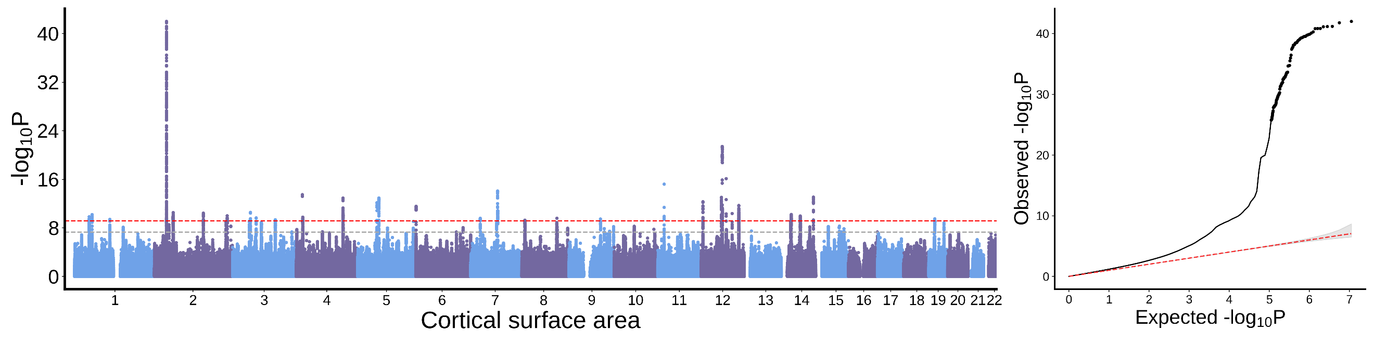
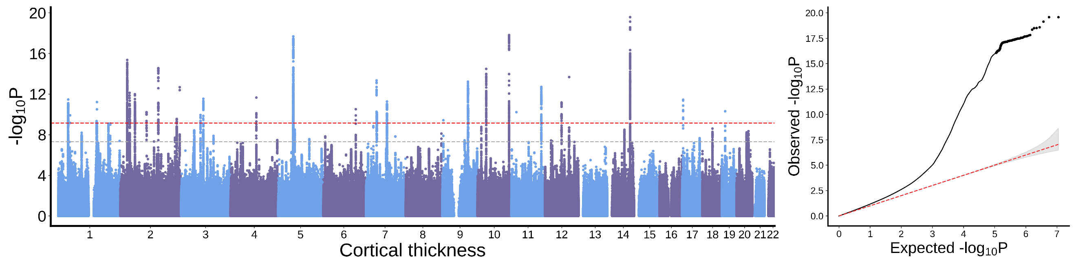
Insula cortex
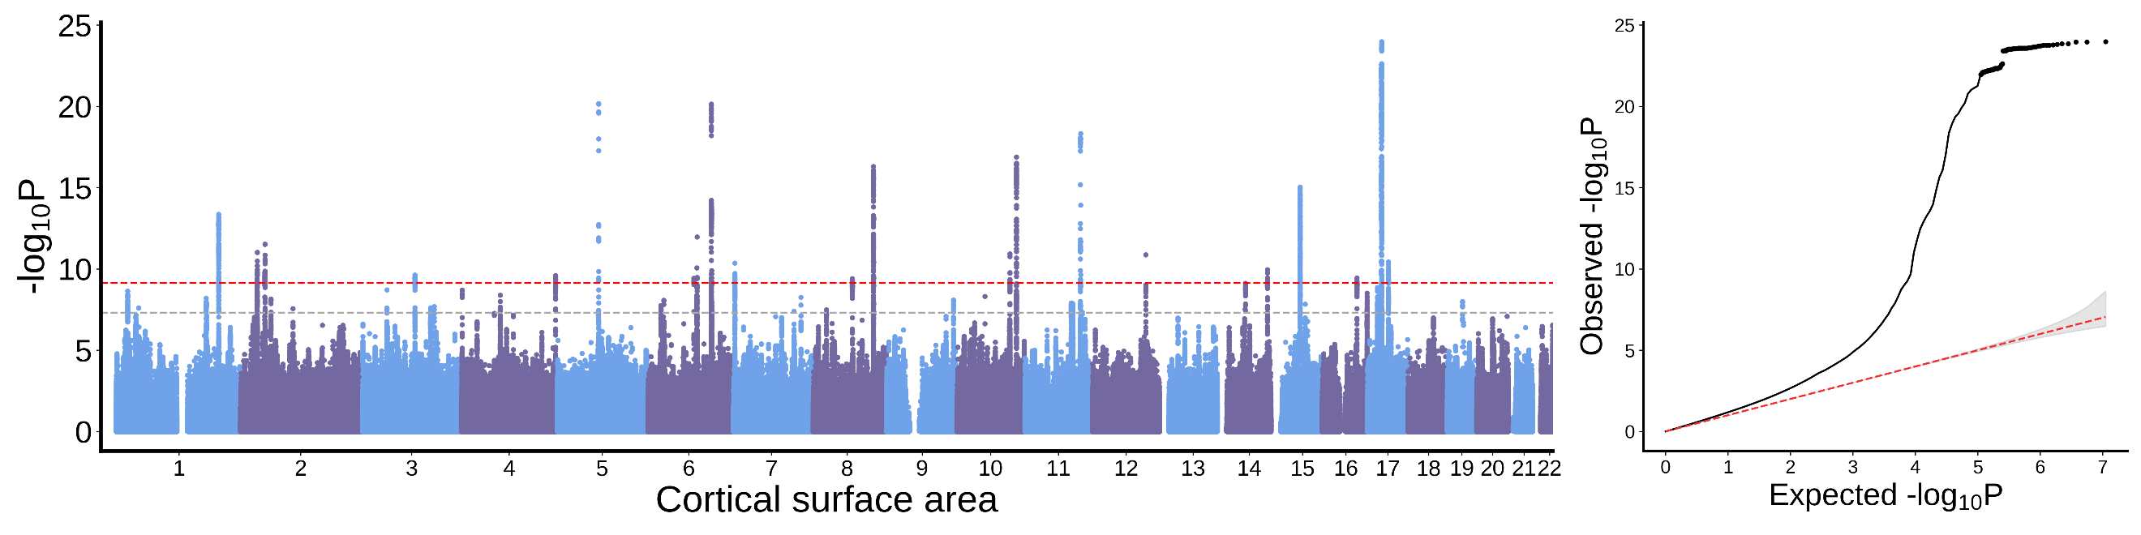
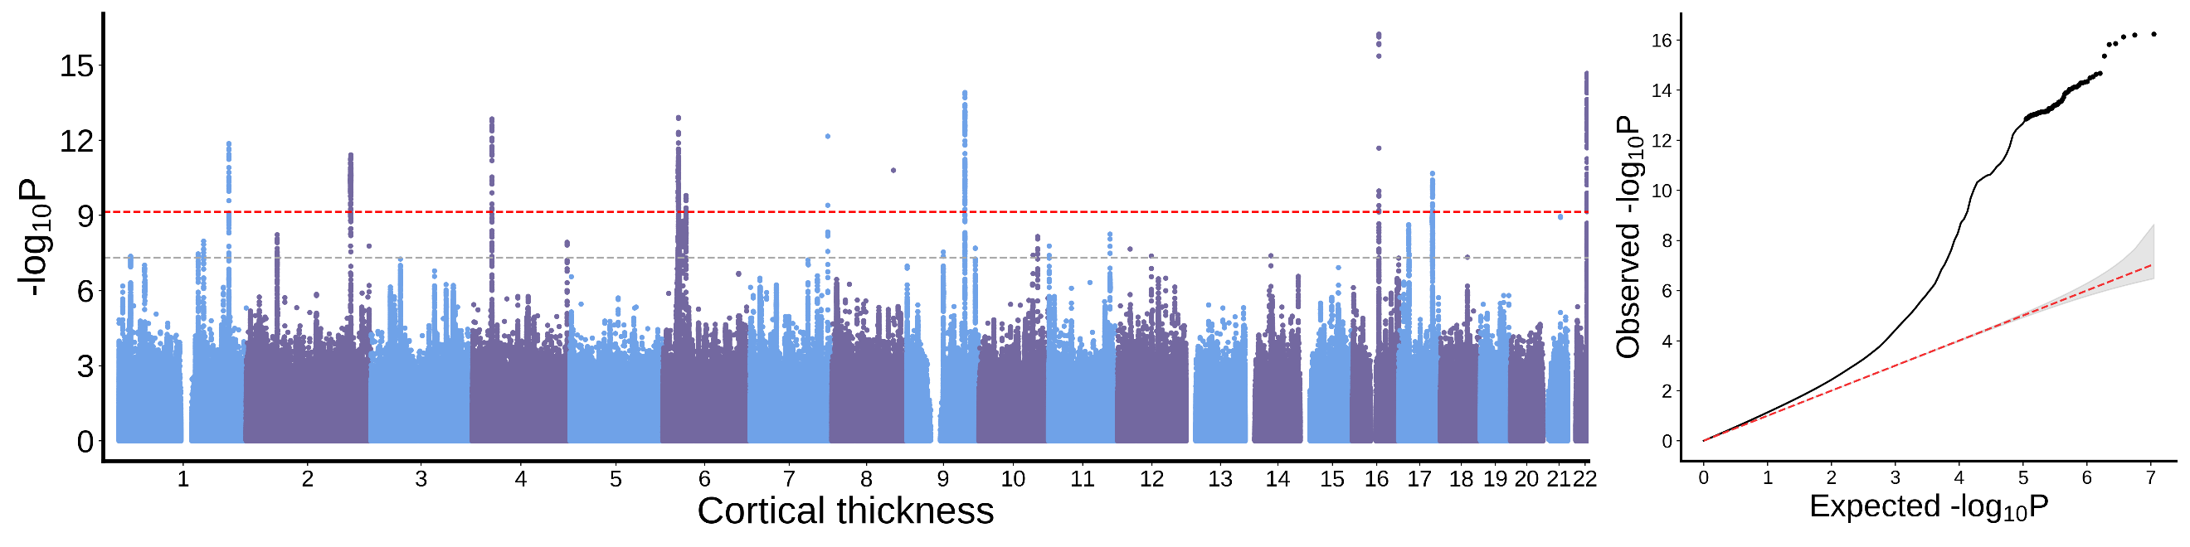
Entorhinal cortex
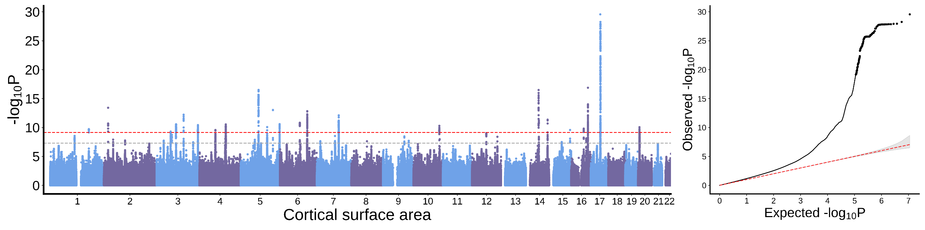
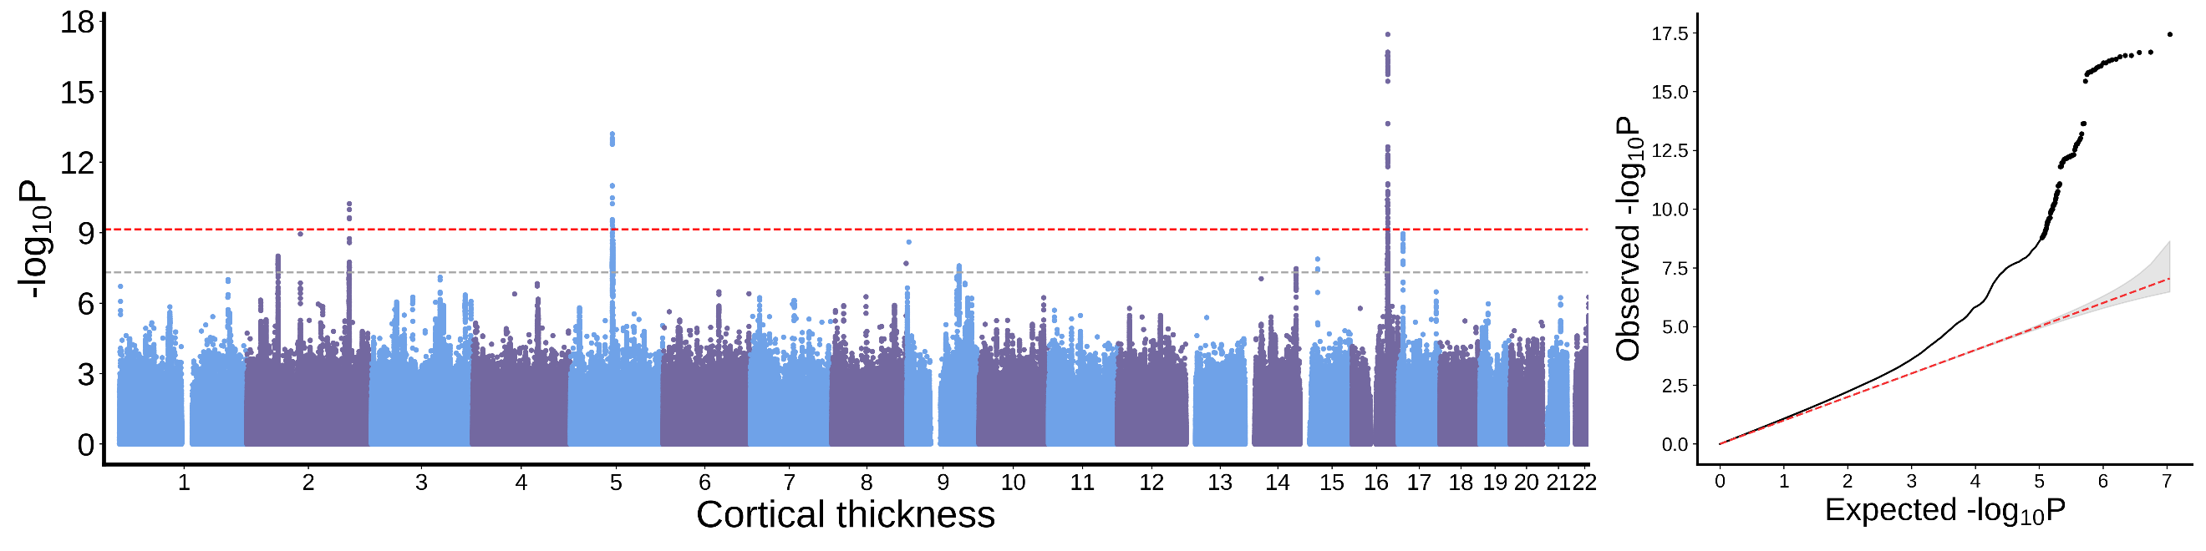
Parahippocampal cortex
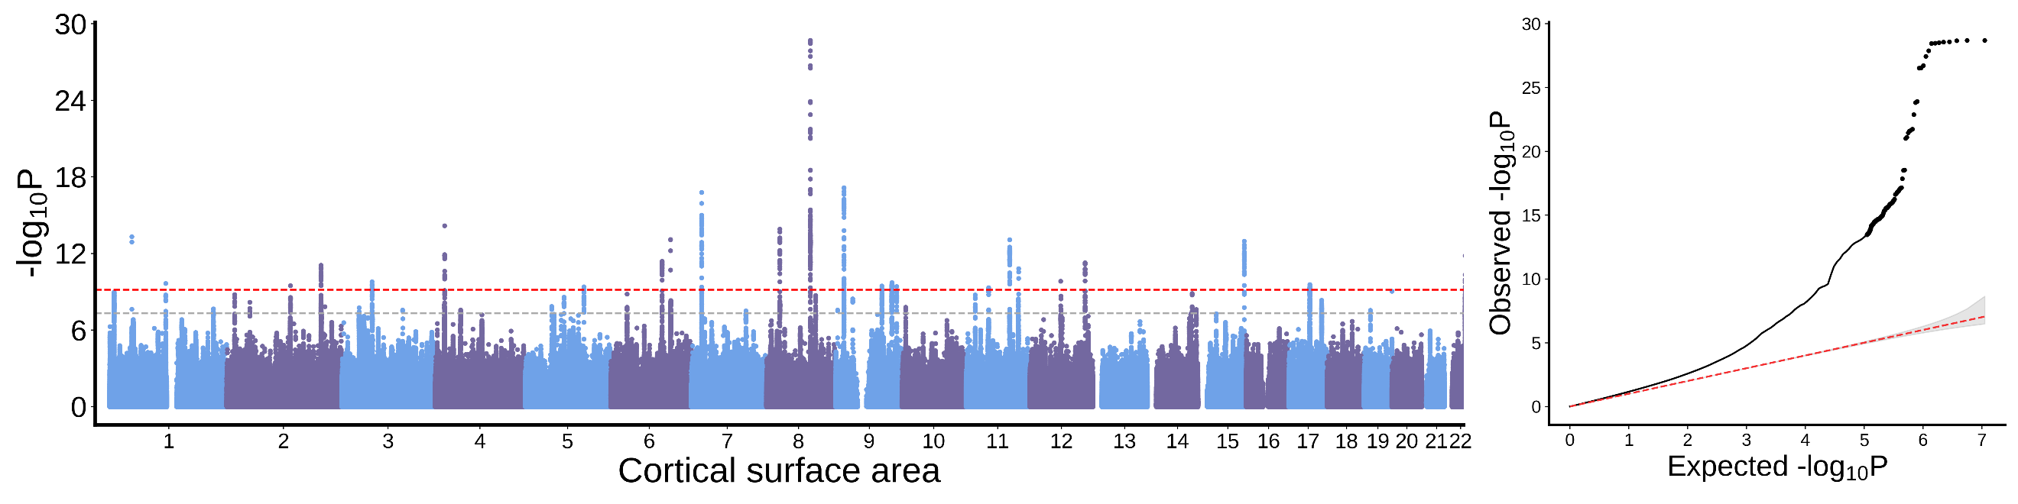
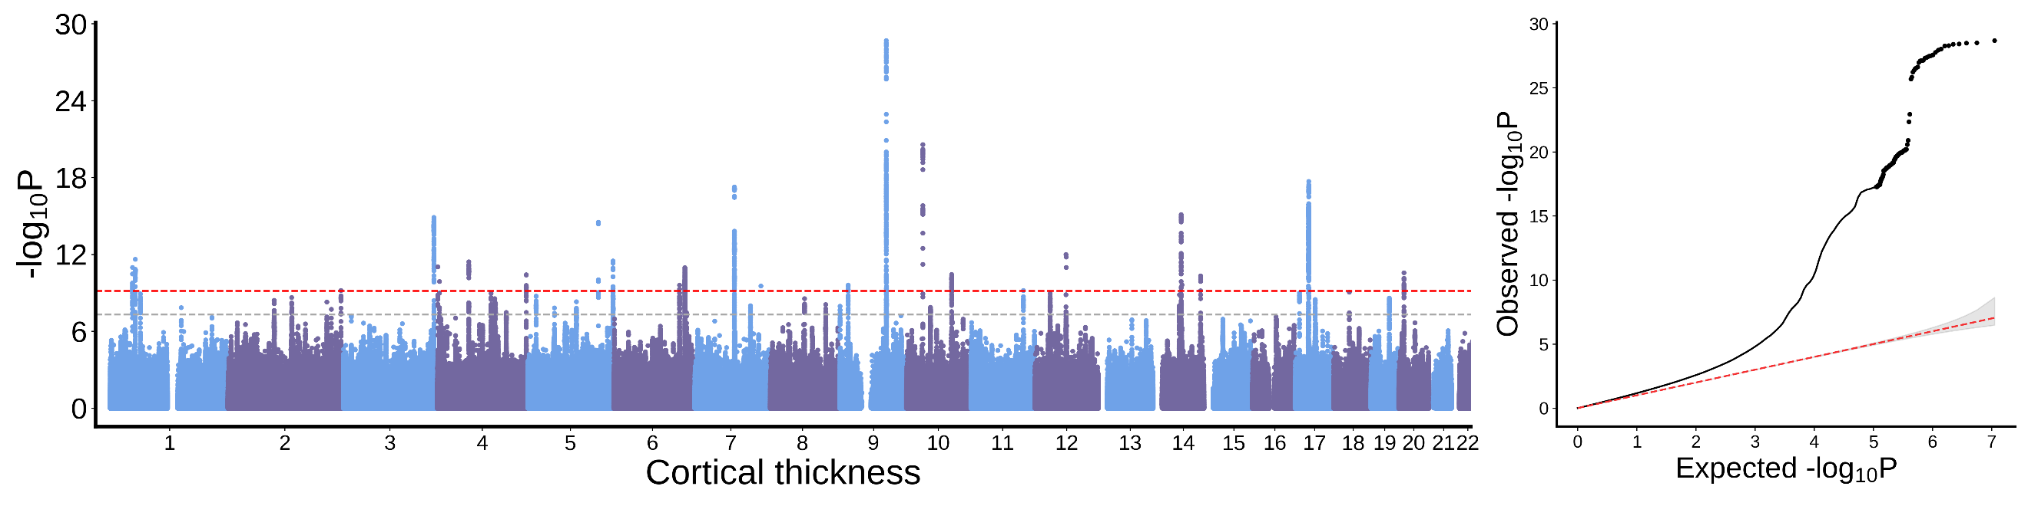
Fusiform cortex
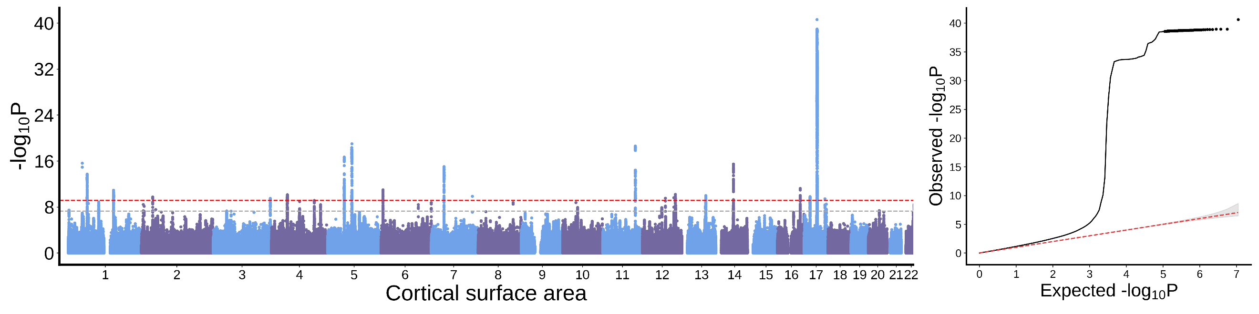
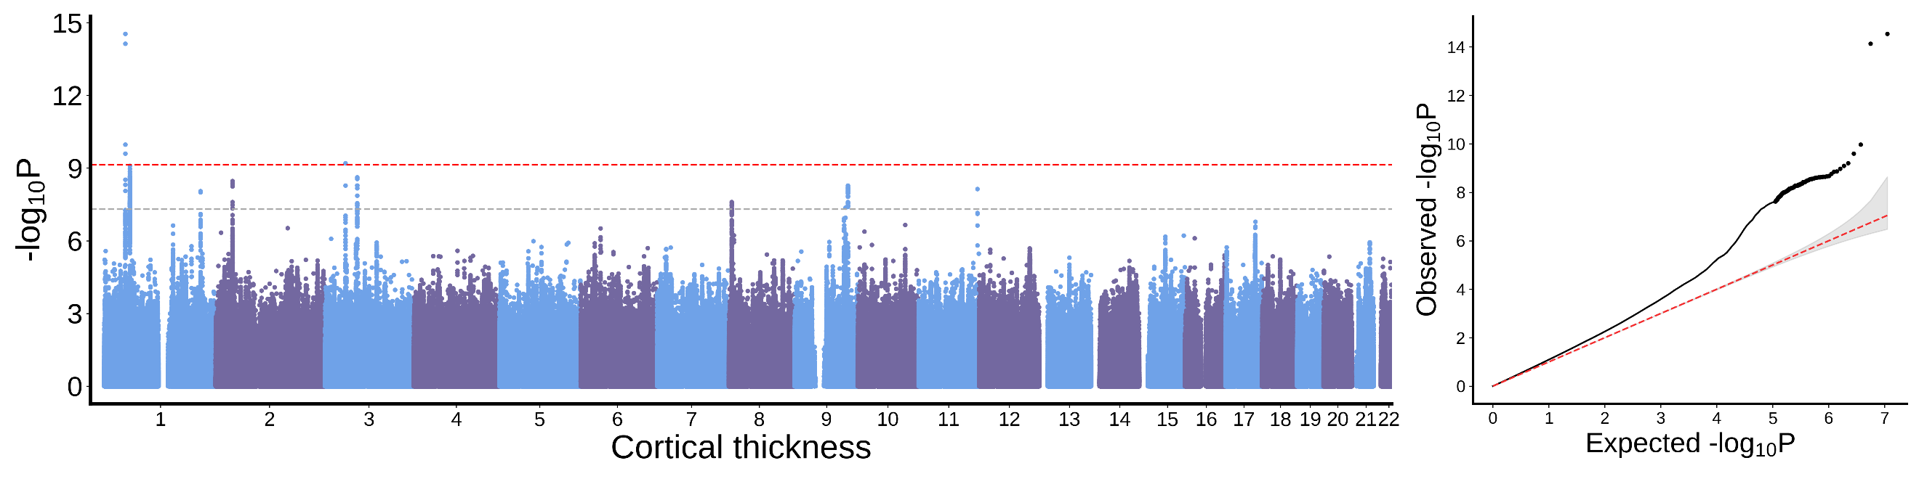

Inferior temporal cortex
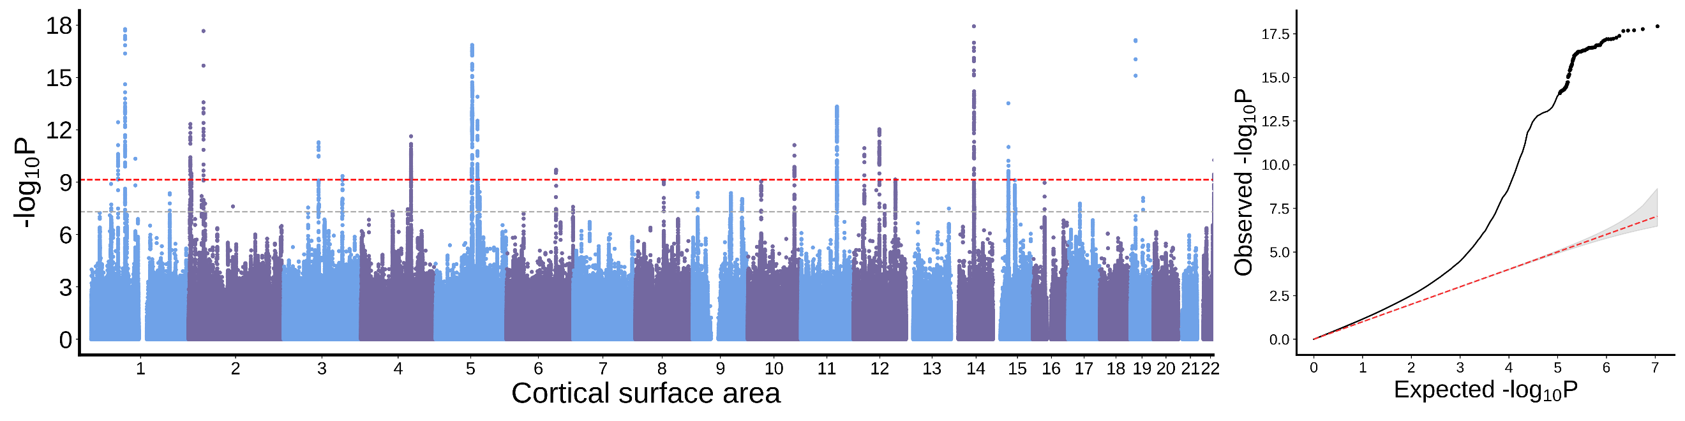
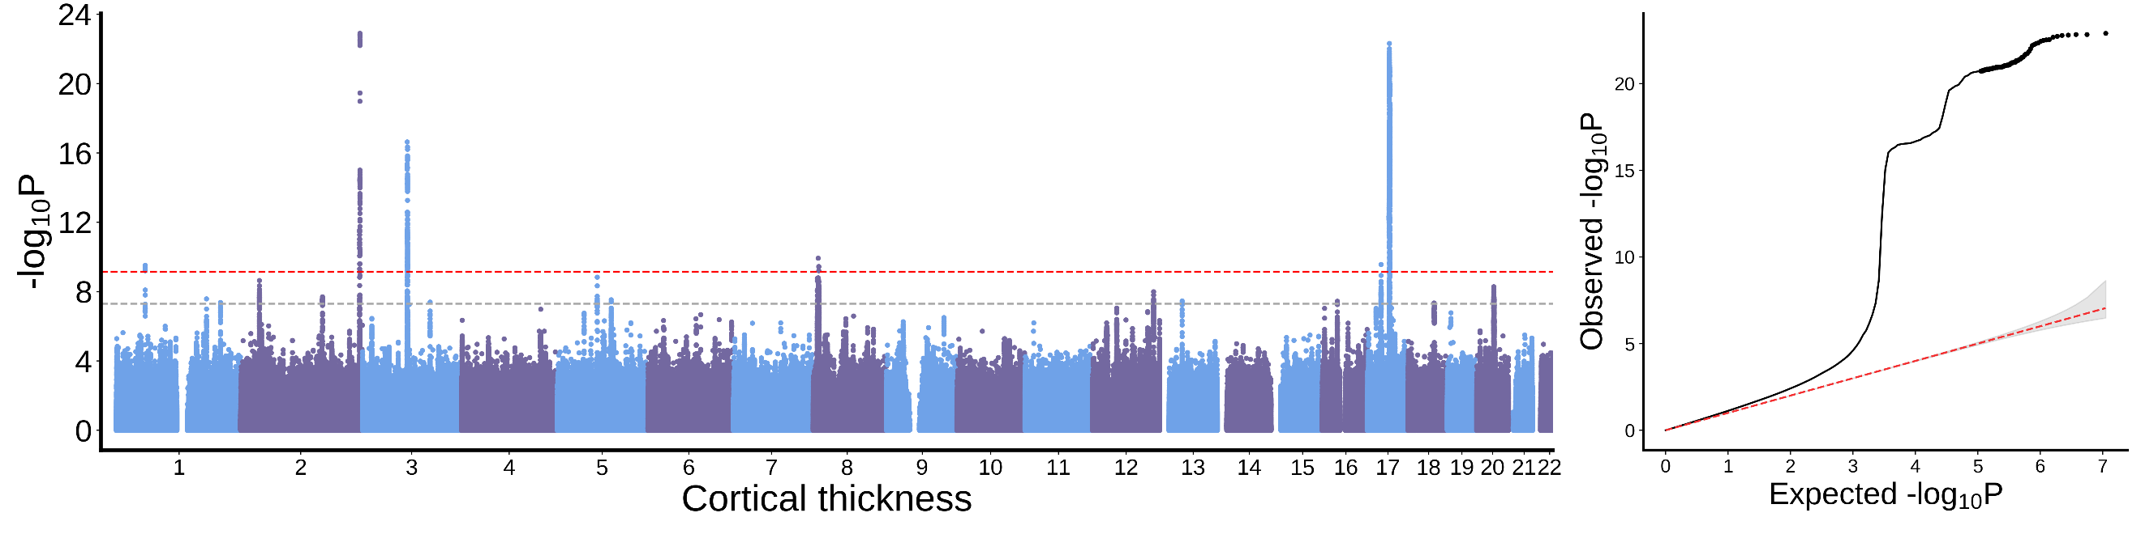
Middle temporal cortex
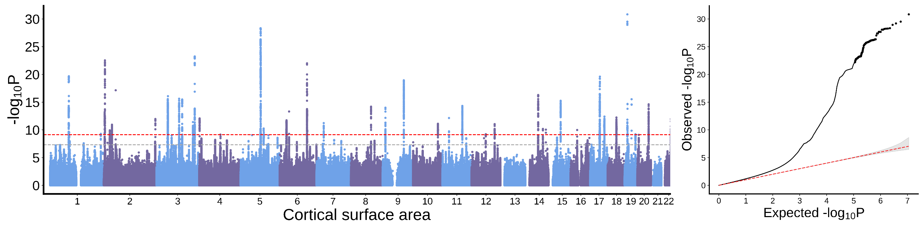
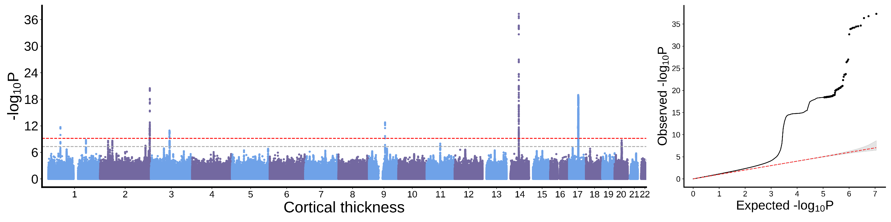
Superior temporal cortex
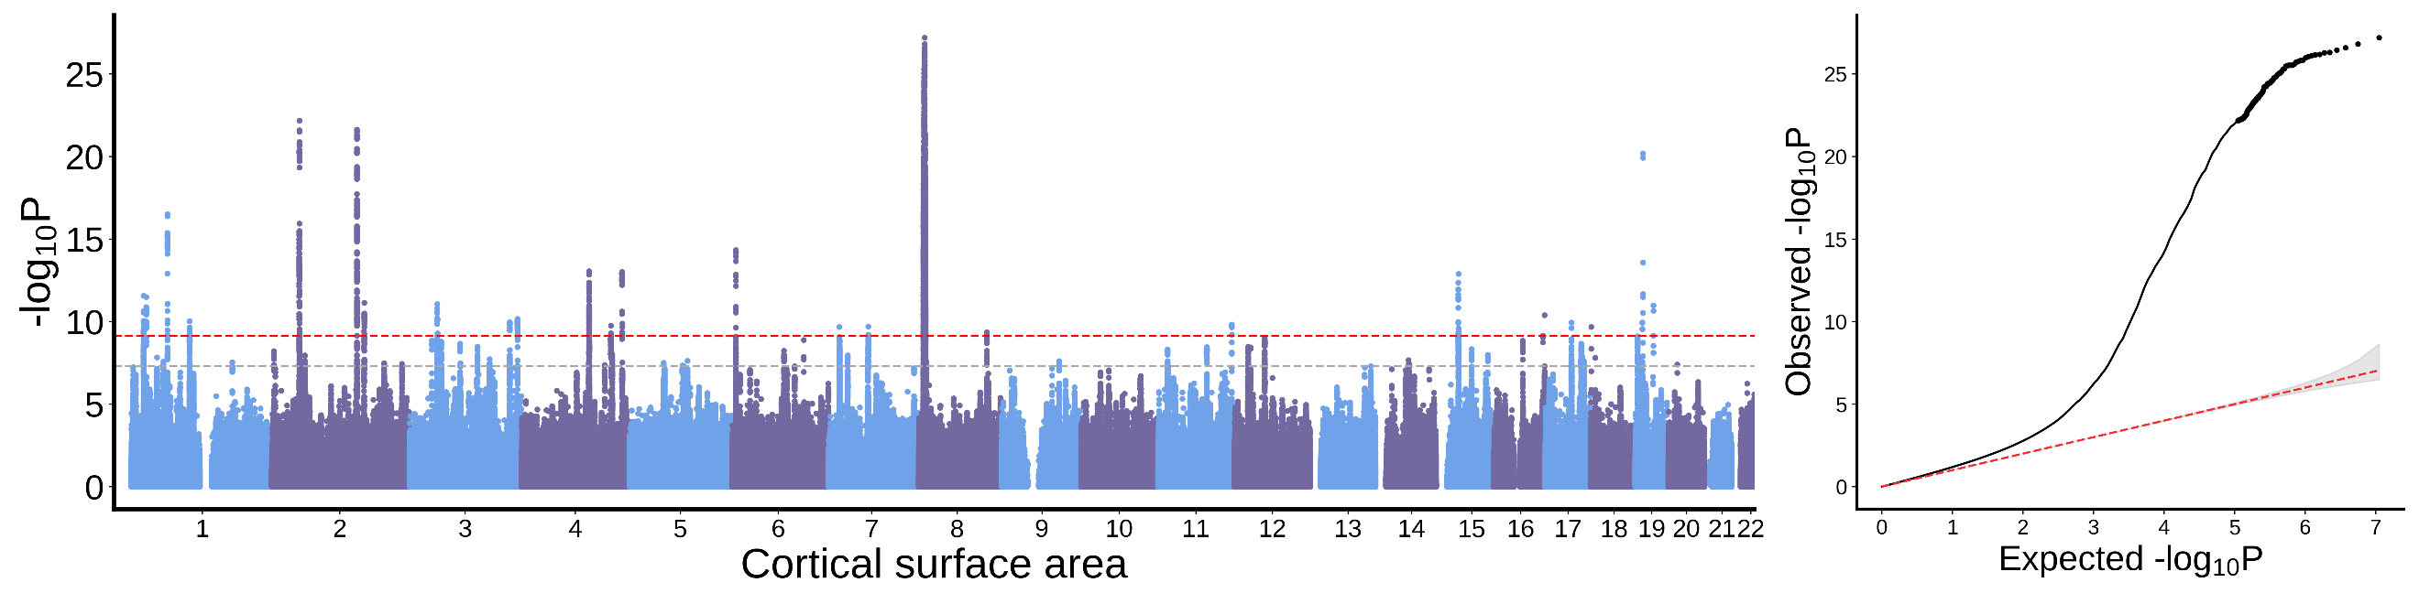
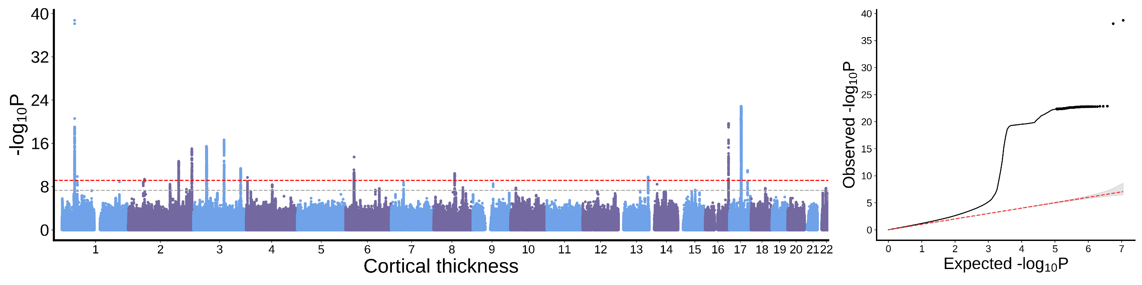
Banks of the superior temporal sulcus
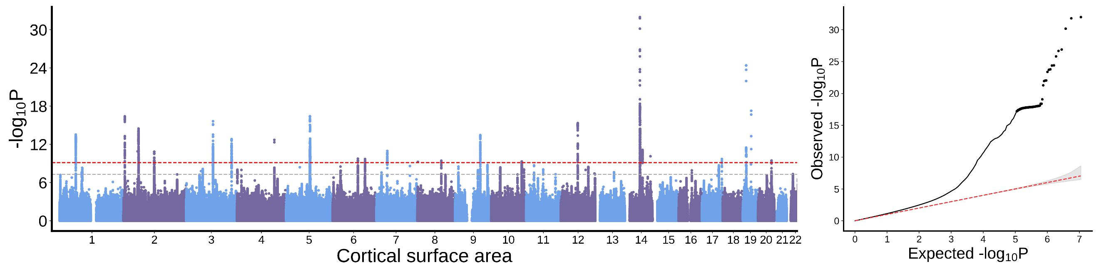
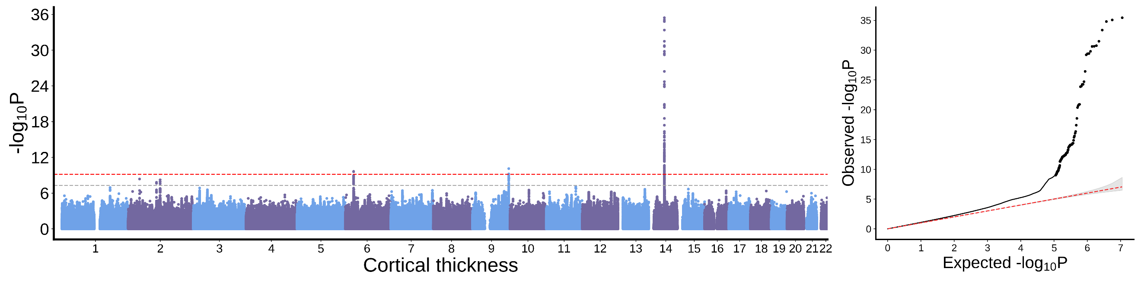
Transverse temporal cortex
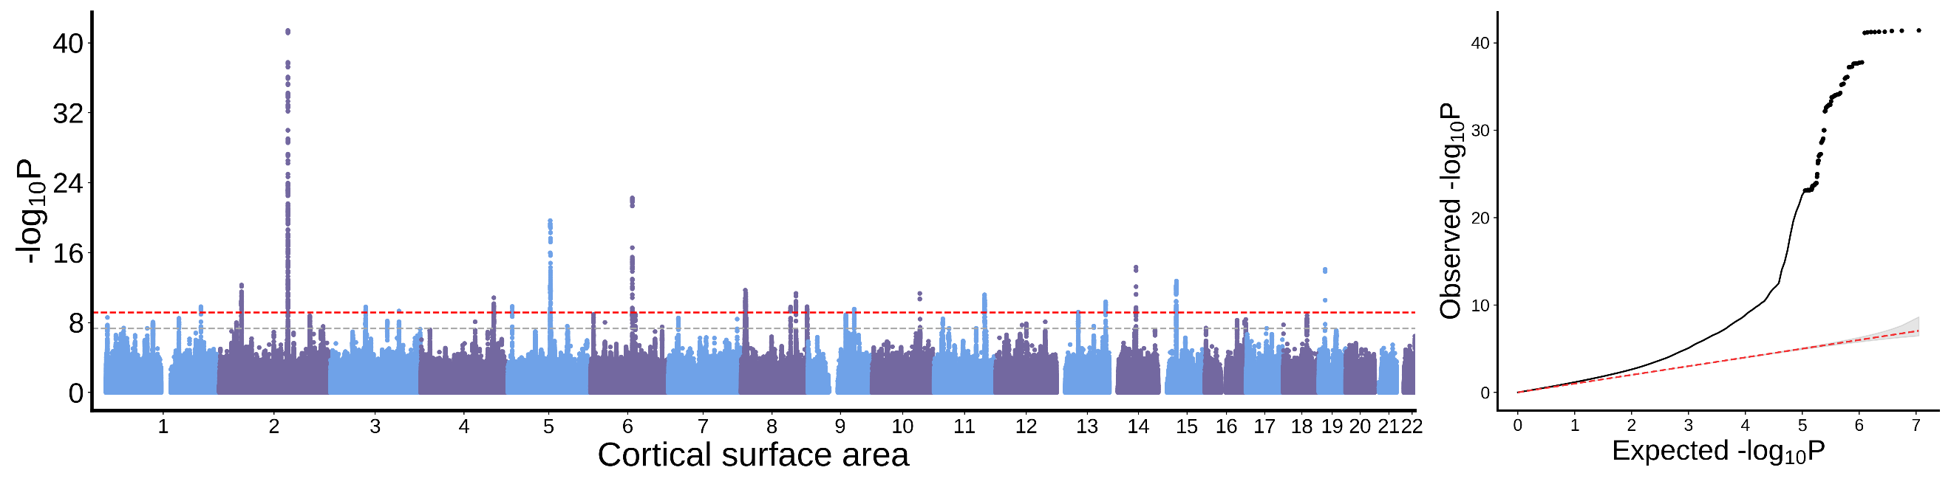
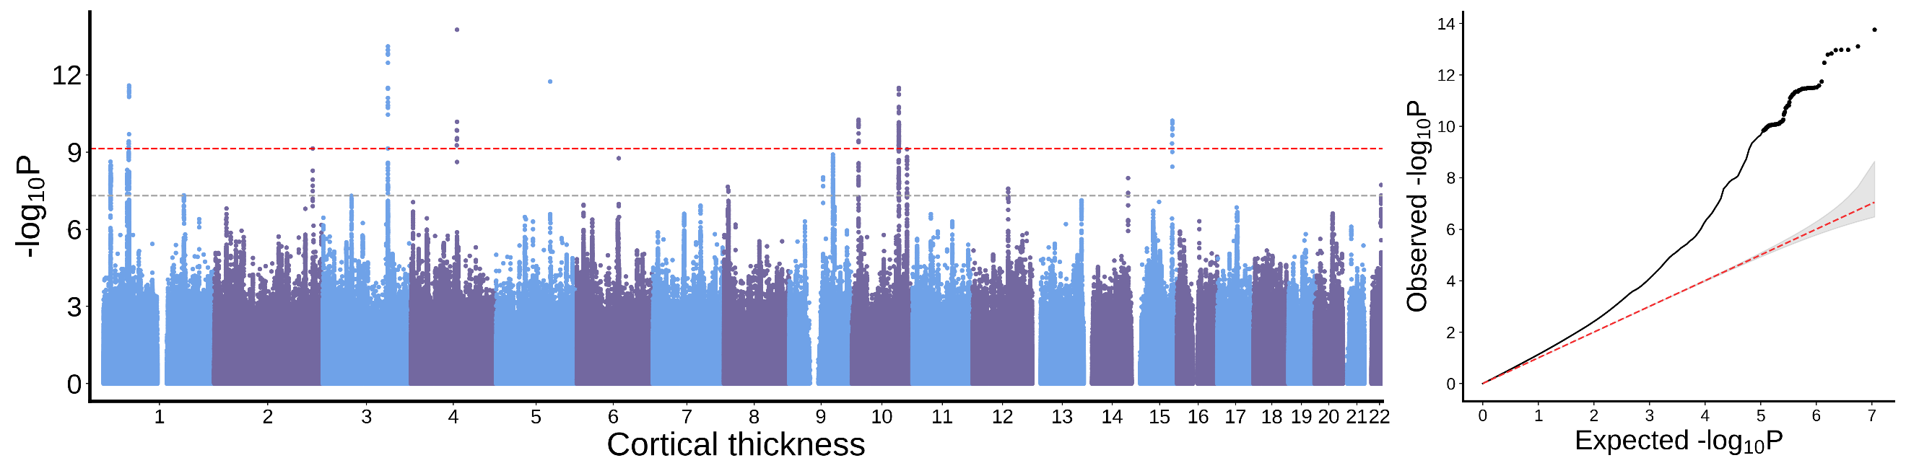

Lingual cortex
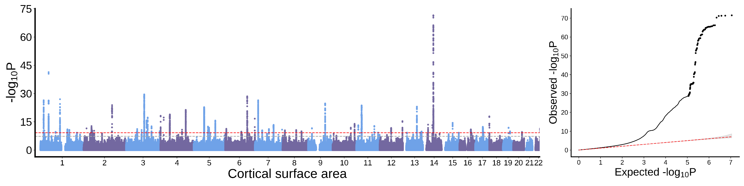
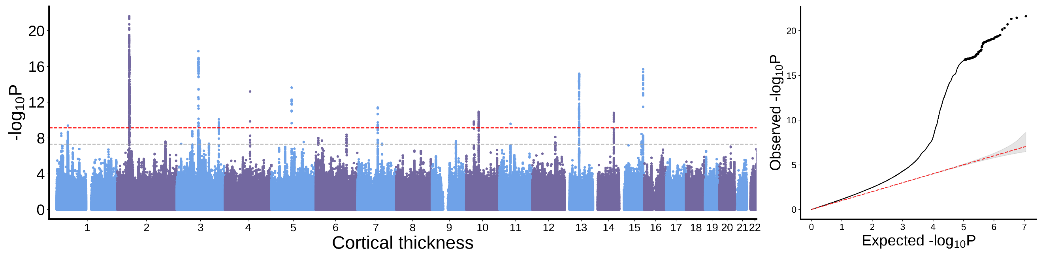
Pericalcarine cortex
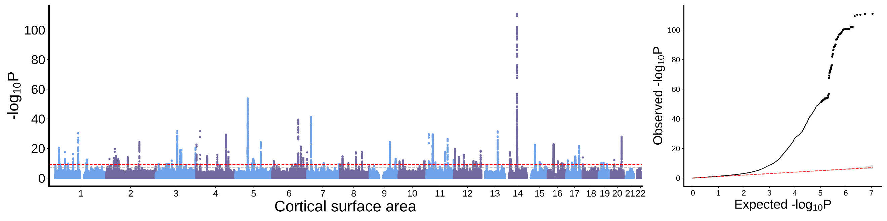
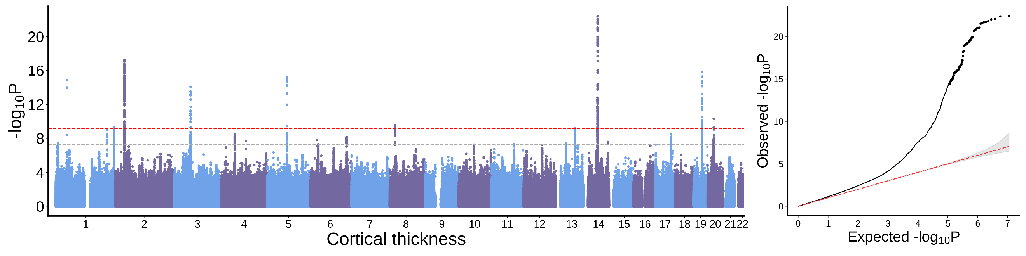
Cuneus cortex
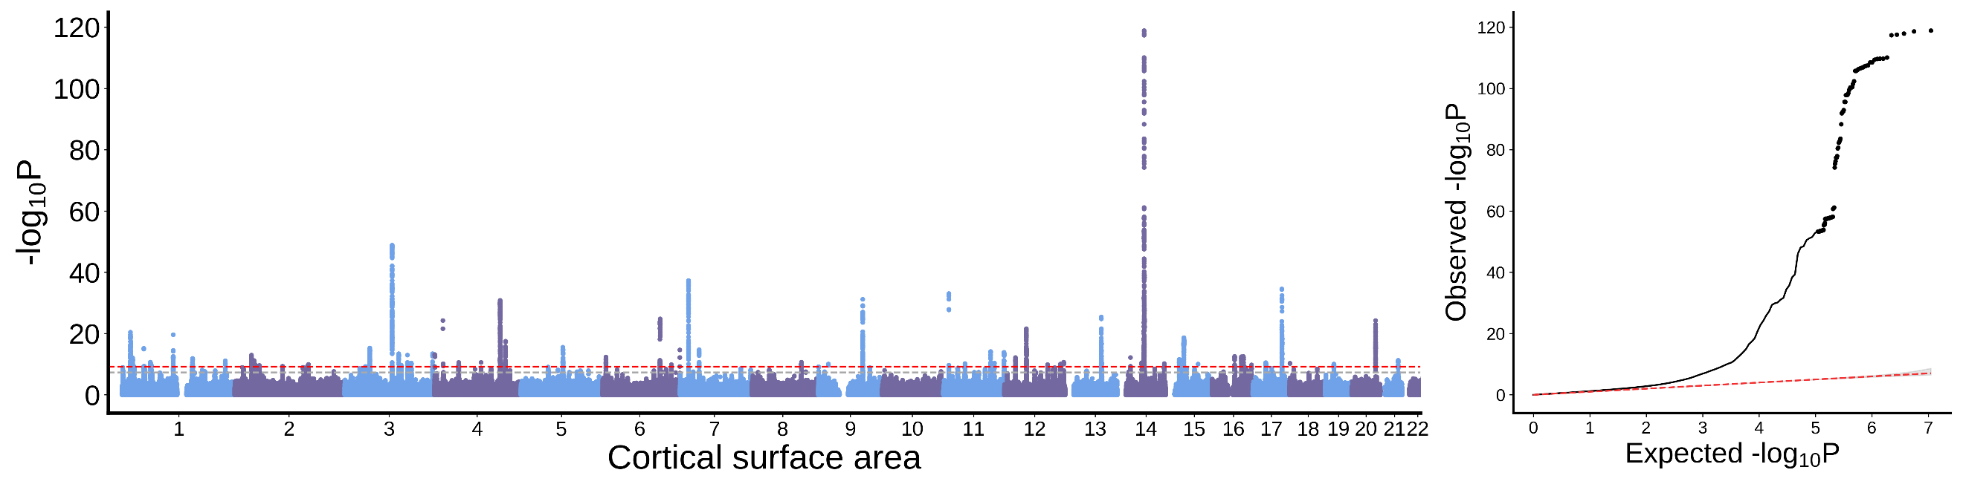
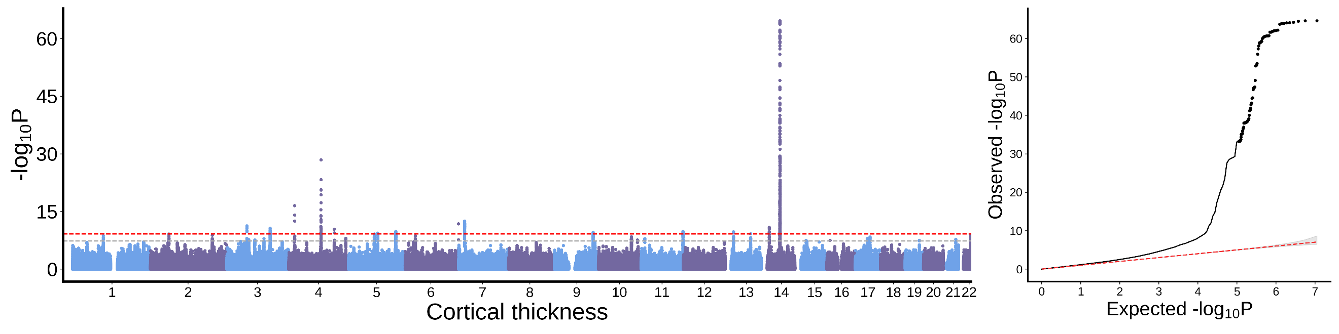
Lateral occipital cortex
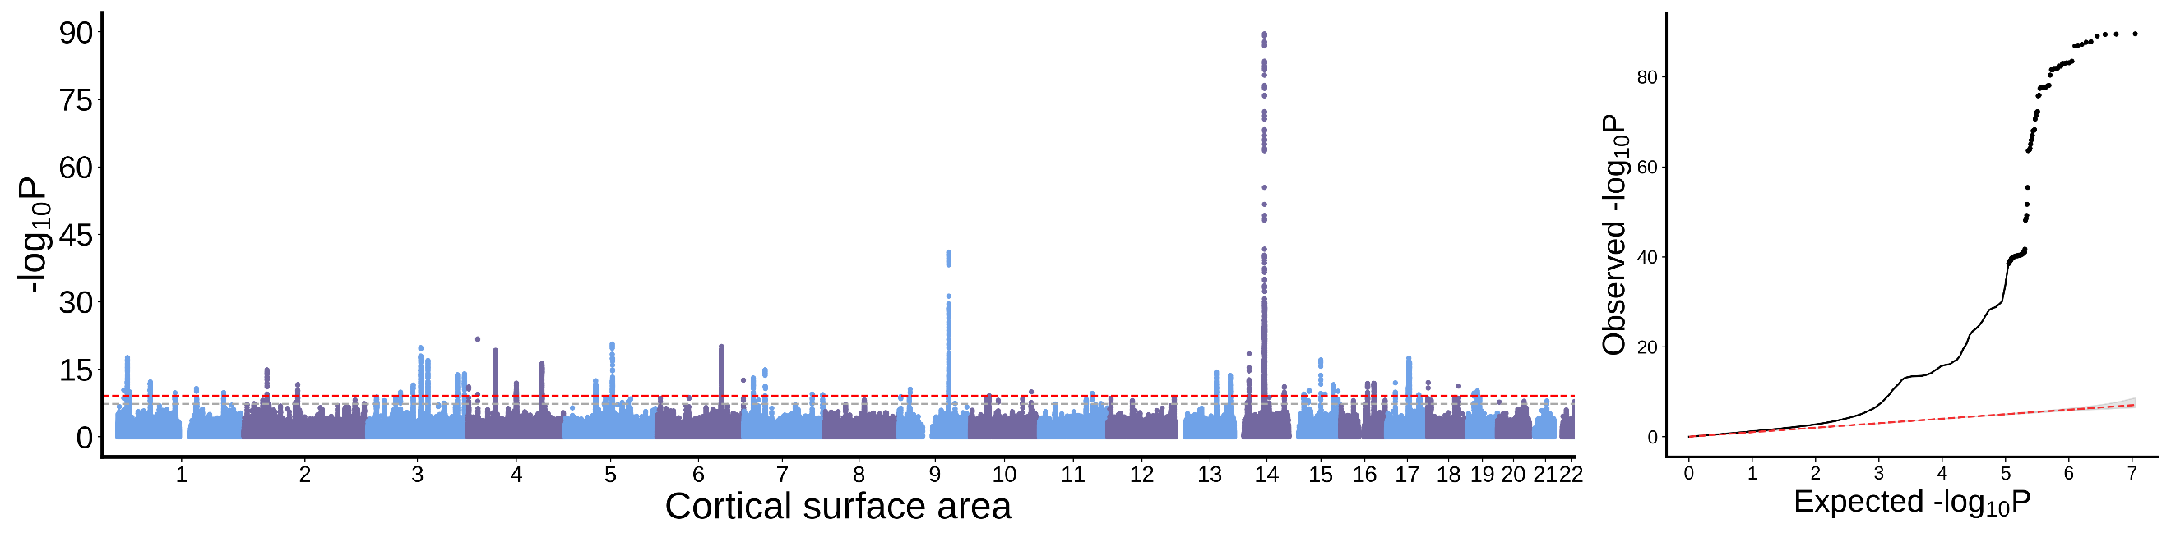
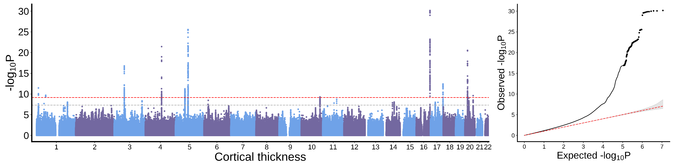
Fig. S1 | Manhattan and quantile-quantile plots for EUR-GWAS meta-analyses of cortical thickness and surface area for each cortical region in 80,384 participants. The meta-analyses are conducted using a fixed-effect model. In each Manhattan plot (left panel), the x-axis shows genomic position and the y-axis shows statistical significance as -log10(P). The gray dotted lines denote genome-wide significance (P < 5 × 10⁻⁸) and the red dotted lines denote significance at P < 7.35 × 10⁻¹⁰, further Bonferroni-correcting for 68 cortical IDPs. The Quantile-quantile (Q-Q) plots (right panel) show observed versus expected P values for genetic associations with each IDP. The dotted red line shows the distribution of P values under the null hypothesis, and the grey shaded area represents 95% confidence interval.

Fig. S2 | Pearson's correlation of effect sizes between the discovery and replication datasets. This analysis is performed on 2,022 significant variant-trait associations (P < 7.35 × 10⁻¹⁰) in the discovery sample that are also available in the replication sample. Effect sizes are assessed using standardized beta-coefficients.

Fig. S3 | Genetic correlations between SA-IDPs (x-axis) and CT-IDPs (y-axis). Bonferroni-corrected significance: *P_{c} < 0.05, **P_{c} < 0.01, ***P_{c} < 0.001.
Fig. S4 | Genetic correlations within CT-IDPs and within SA-IDPs. Genetic correlations for SA-IDPs are shown in the upper triangle, while those for CT-IDPs are shown in the lower triangle. Bonferroni-corrected significance: *P_{c} < 0.05, **P_{c} < 0.01, ***P_{c} < 0.001.

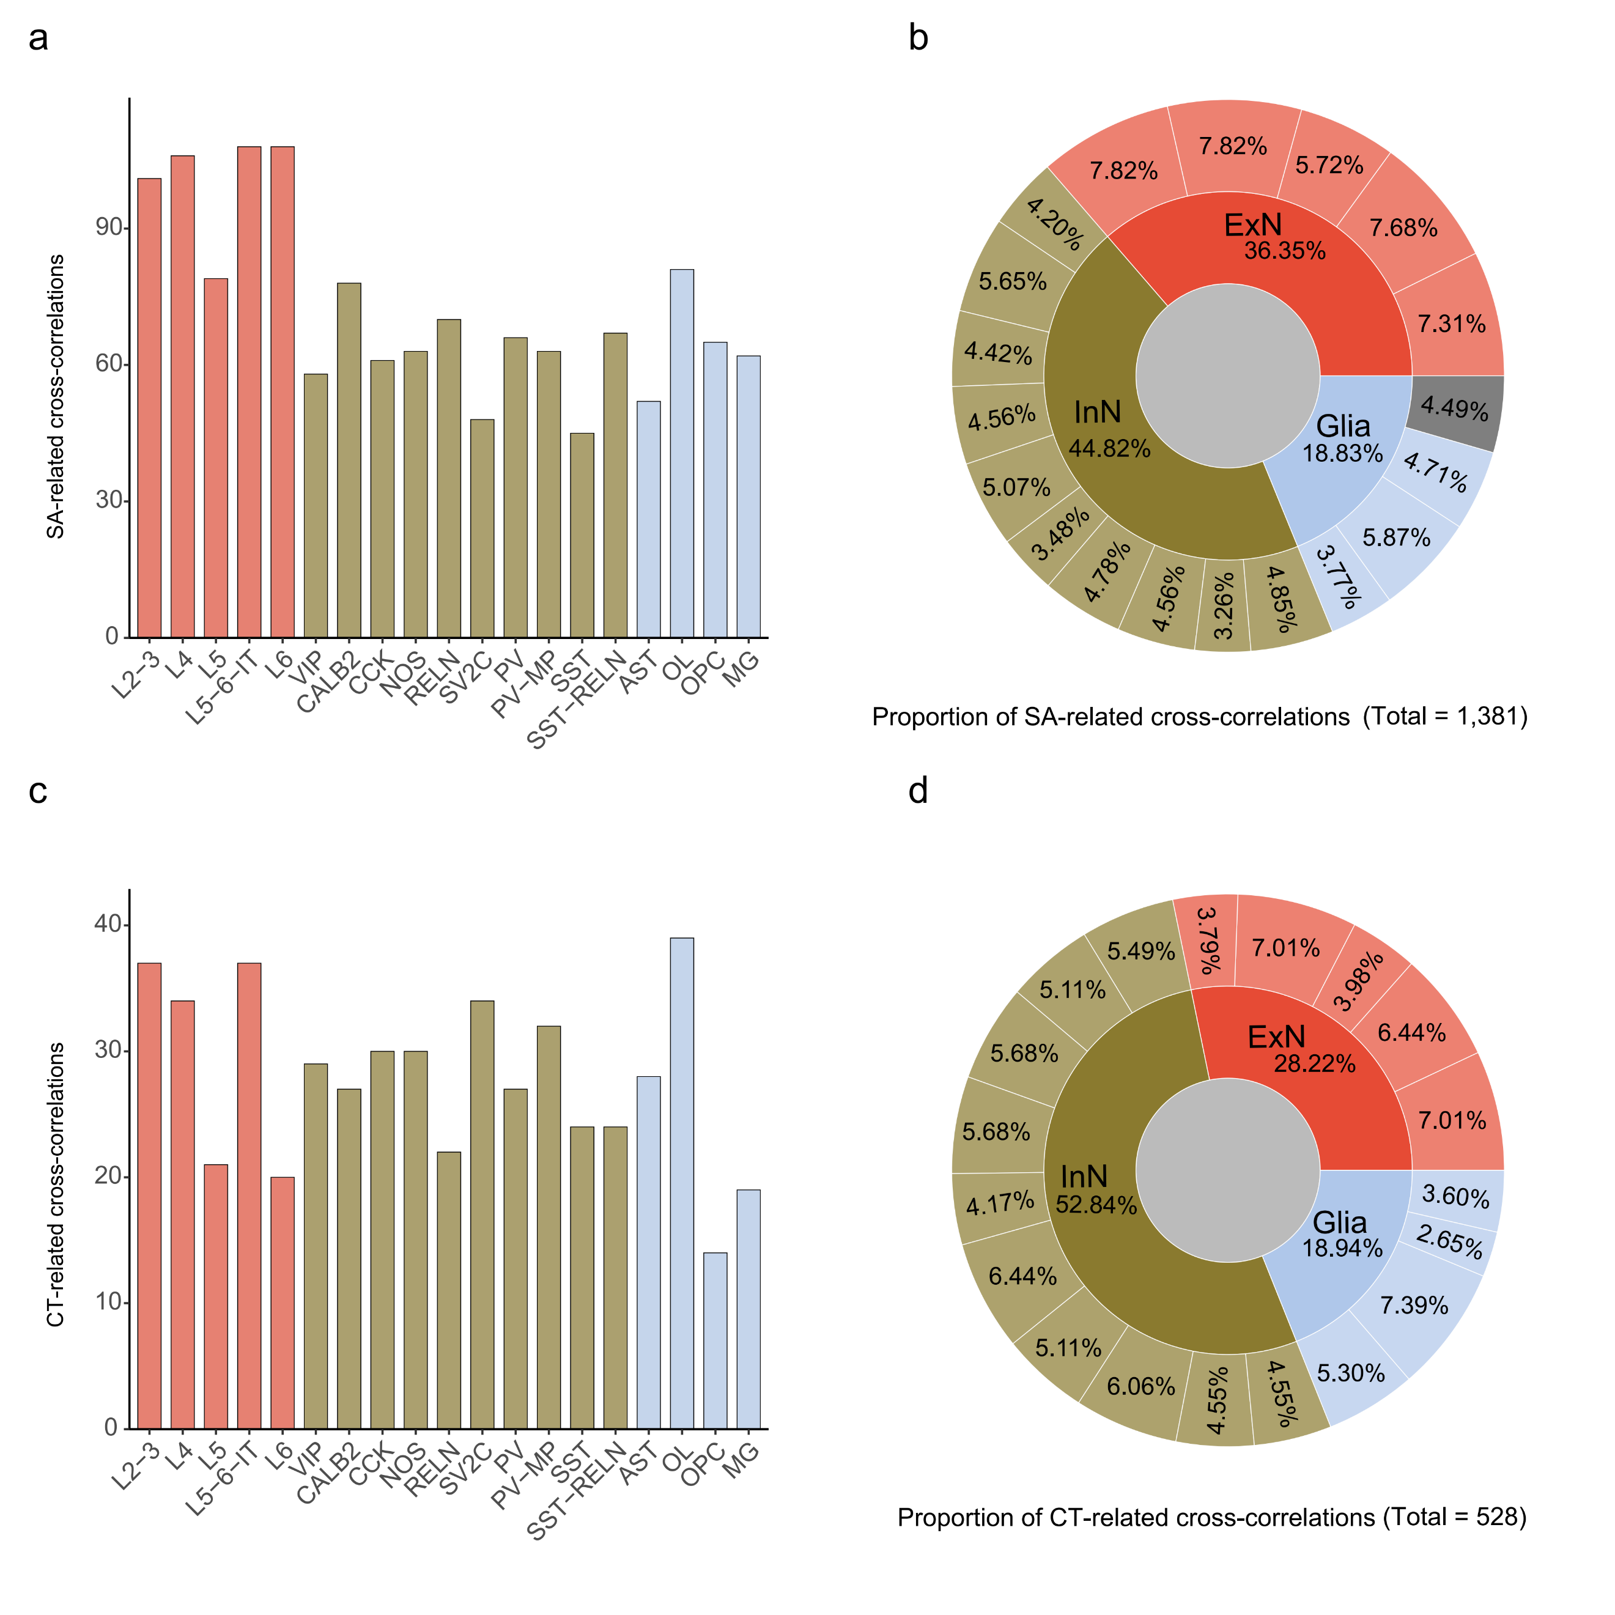
Fig. S5 | Cross-correlations of cell type-specific gene expression curves with SA and CT growth-rate curves during development in the validation dataset. a, Counts of SA cross-correlations (|r_{xy} (k)| > 0.8; n = 1,381) for the 19 cell types. b, Sunburst chart illustrates the proportions of SA cross-correlations across major cell types (inner ring) and their subtypes (outer ring). c, Counts of CT cross-correlations (|r_{xy} (k)| > 0.8; n = 528) for the 19 cell types. d, Sunburst chart illustrates the proportions of CT cross-correlations across major cell types (inner ring) and their subtypes (outer ring).
Fig. S6 | UMAP (uniform manifold approximation and projection) of the 1000 genome (left panel) and ABCD (right panel) populations using the first four genetic principal components.

