Fig S2: Electrophoretic screening for molecular markers linked to the major cassava mosaic disease resistance loci, CMD1, CMD2 and CMD3.
Results are presented for 4 Manihot germplasm, including 3 cassava germplasm (Manihot esculenta subsp esculenta) namely, TME3, TMS60444 and TMEB117, and the wild relative from which the CMD1 locus is thought to derive, Manihot glaziovii, screened with six molecular markers associated with the cassava mosaic disease (CMD) resistance quantitative trait loci (QTLs) CMD1, CMD2 and CMD3. The Roman numerals used to annotate marker bands correspond to the marker amplicon analysis presented in Supplementary Table S7. aI: Screening results are presented for the simple sequence repeat (SSR) marker NS169 linked to the CMD2 resistance locus. Marker amplicons were resolved on an 8% polyacrylamide gel, run at 110 V, 400 mA, for 70 min, and visualised using the acidic silver staining. A 50 bp GeneRuler (Invitrogen, Thermofisher) was included as a molecular weight marker. aII: Amplicons from (aI) resolved on 3% agarose gel with 20 ppm Ethidium Bromide (EtBr) stain, run at 80 V, 400 mA, and visualised after 90 min. A 50 bp GeneRuler (Invitrogen, Thermofisher) was included as a molecular weight marker. bI: Screening results for the NS158 marker , liked to the CMD2, run conditions as in (aI) bII: Amplicons from section bI resolved on agarose as in aII cI: Results for the CMD1 linked SSRY40 marker, run conditions as in aI. cII: Amplicons from section cI resolved on agarose as in aII dI: Results for the CMD3 linked NS198, run conditions as in aI dII: Amplicons from section cI resolved on agarose as in aII eI: Results for the CMD2 linked SSRY28 marker, run conditions as in aI eII: Amplicons from section cI resolved on agarose as in aII f: Screening results are presented for the sequence characterised amplified region (SCAR) marker RME1, linked to the CMD2 resistance locus. Marker amplicons were resolved on 1.5% agarose gel with 20 ppm EtBr run at 80 V, 400 mA, and visualised after 90 min. A 1kb GeneRuler (Invitrogen, Thermofisher) was included as a molecular weight marker.

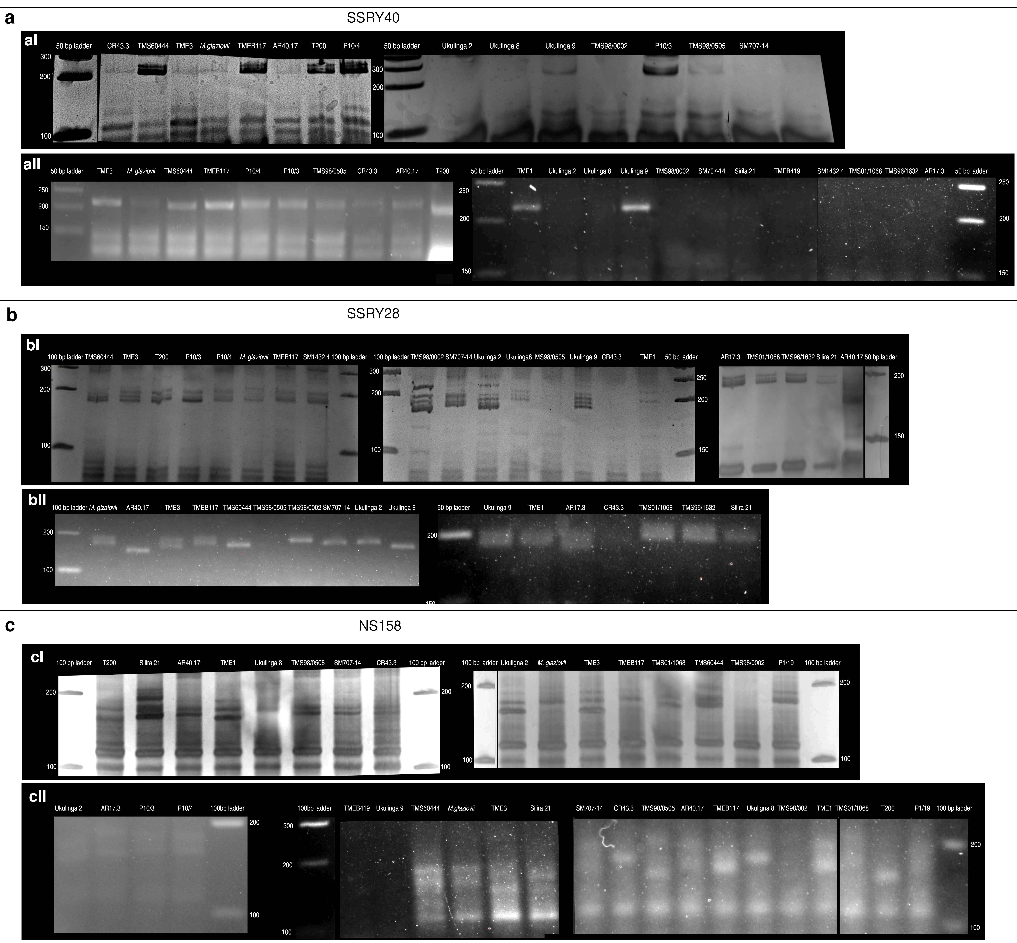
Fig. S2: Electrophoretic screening for molecular markers linked to cassava mosaic disease resistance
Results are presented for 22 Manihot germplasm, including 21 cassava germplasm (Manihot esculenta subsp esculenta) and the wild relative from which the CMD1 locus is thought to derive, Manihot glaziovii, screened with six molecular markers associated with the cassava mosaic disease (CMD) resistance quantitative trait loci (QTLs) CMD1, CMD2 and CMD3. aI: Screening results are presented for simple sequence repeat (SSR) marker the SSRY40 marker linked to the CMD1 resistance locus. Marker amplicons were resolved on an 8% polyacrylamide gel, run at 110 V, 400 mA, for 70 min, and visualised using the acidic silver staining. A 50 bp GeneRuler (Invitrogen, Thermofisher) was included as a molecular weight marker. aII: Amplicons from aI resolved on 3% agarose gel with 20 ppm Ethidium Bromide (EtBr) stain, run at 80 V, 400 mA, and visualised after 90 min. A 50 bp GeneRuler (Invitrogen, Thermofisher) was included as a molecular weight marker. bI: Results for CMD2 linked SSRY28 marker. run as in aI bII: Amplicons from Ib, resolved on agarose as in aII cI: Results for the CMD2 linked marker NS158, run conditions as in aI cII: Amplicons from Ib, resolved on agarose as in aII
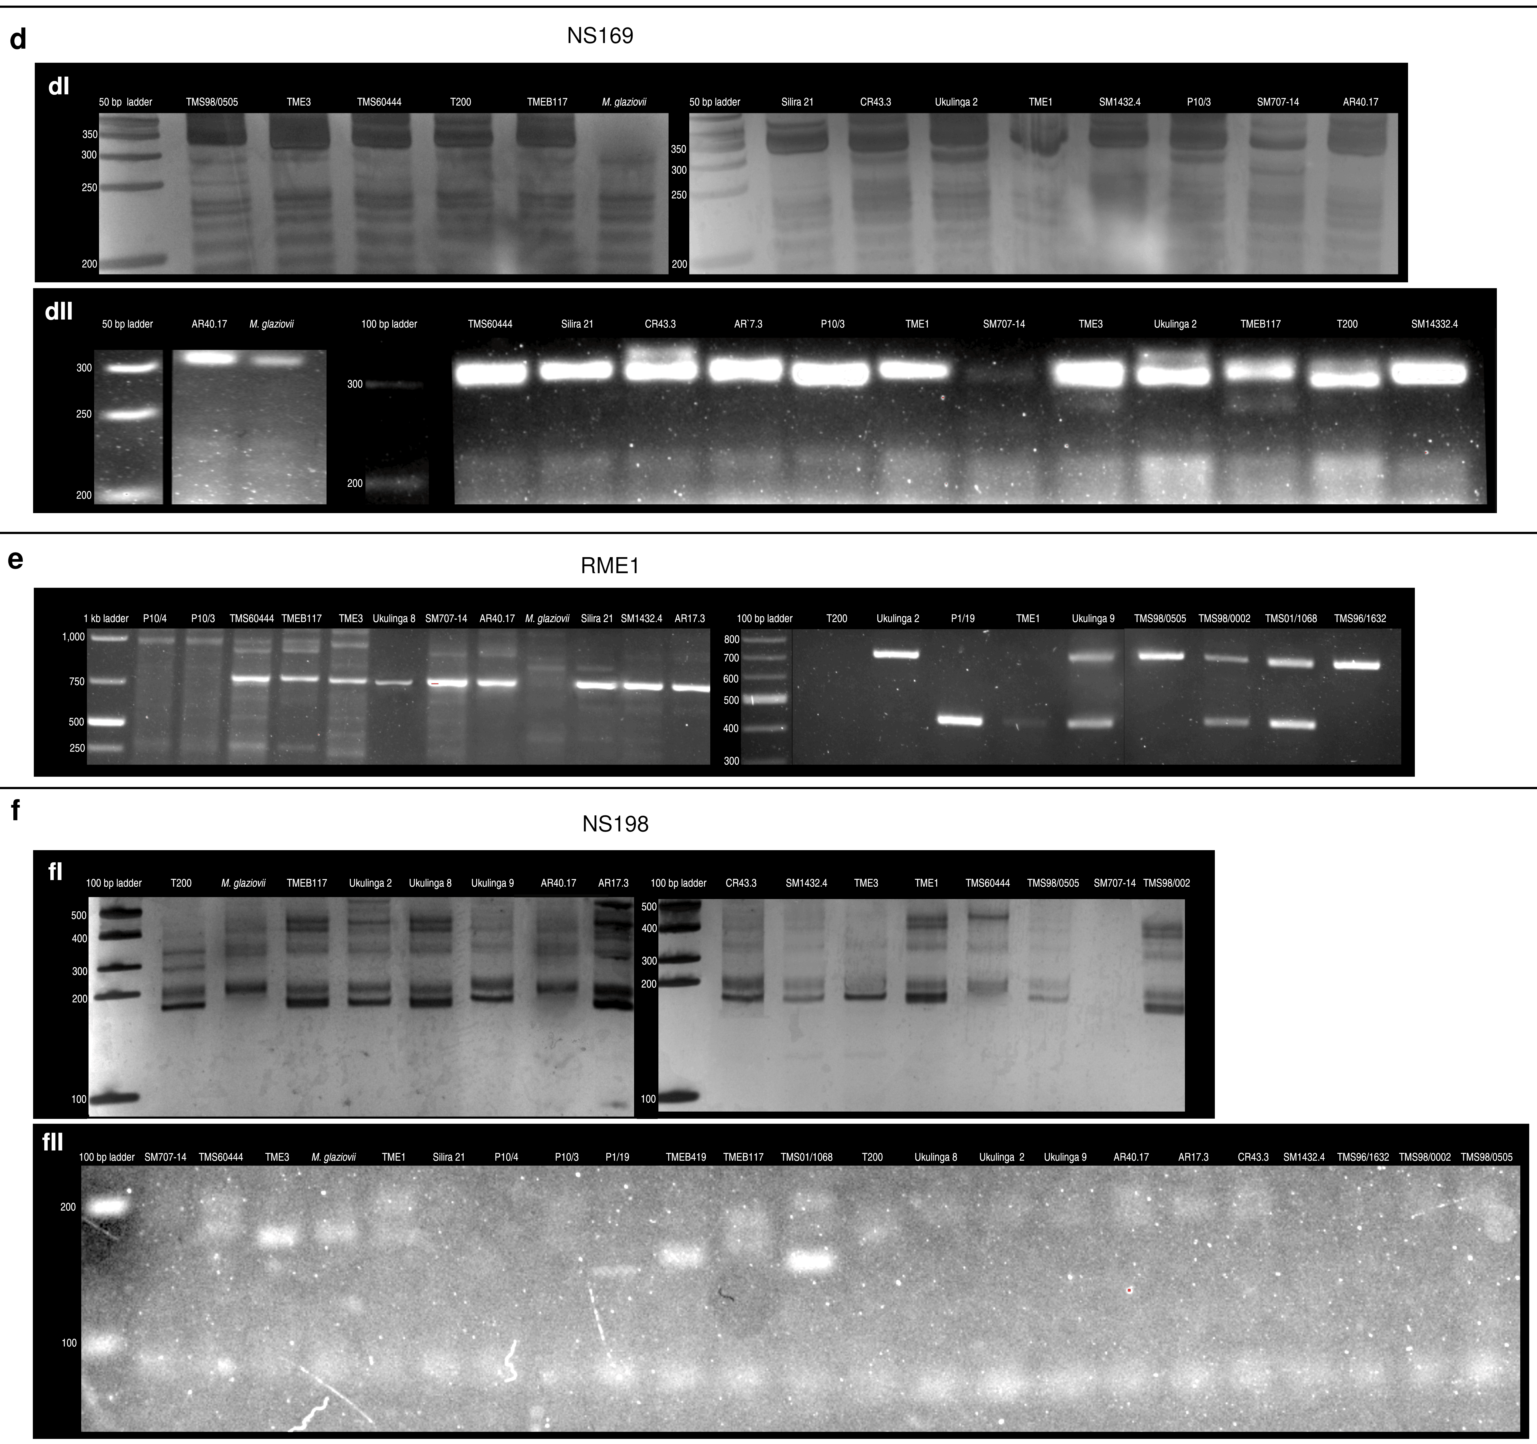
Fig S2: Electrophoretic screening for molecular markers linked to cassava mosaic disease resistance
Results are presented for 22 Manihot germplasm, including 21 cassava germplasm (Manihot esculenta subsp esculenta) and the wild relative from which the CMD1 locus is thought to derive, Manihot glaziovii, screened with six molecular markers associated with the cassava mosaic disease (CMD) resistance quantitative trait loci (QTLs) CMD1, CMD2 and CMD3. dI: Results for the CMD2 linked NS169 marker. Marker amplicons were resolved on an 8% polyacrylamide gel, run at 110 V, 400 mA, for 70 min, and visualised using the acidic silver staining. A 50 bp GeneRuler (Invitrogen, Thermofisher) was included as a molecular weight marker. dII: Amplicons from (dI) resolved on 3% agarose gel with 20 ppm EtBr stain, run at 80 V, 400 mA, and visualised after 90 min. A 50 bp GeneRuler (Invitrogen, Thermofisher) was included as a molecular weight marker. e: Screening results are presented for the sequence characterised amplified region (SCAR) marker RME1, linked to the CMD2 resistance locus. Marker amplicons were resolved on 1.5% agarose gel with 20 ppm EtBr run at 80 V, 400 mA, and visualised after 90 min. A 1kb GeneRuler (Invitrogen, Thermofisher) was included as a molecular weight marker. Screening results are presented for the sequence characterised amplified region (SCAR) marker RME1, linked to the CMD2 resistance locus. Marker amplicons were resolved on 1.5% agarose gel with 20 ppm EtBr run at 80 V, 400 mA, and visualised after 90 min. A 1kb GeneRuler (Invitrogen, Thermofisher) was included as a molecular weight marker. fI: Results for the CMD3 linked marker NS198, run condition as as in dI fII: Amplicons from fl, resolved on agarose as in dII.

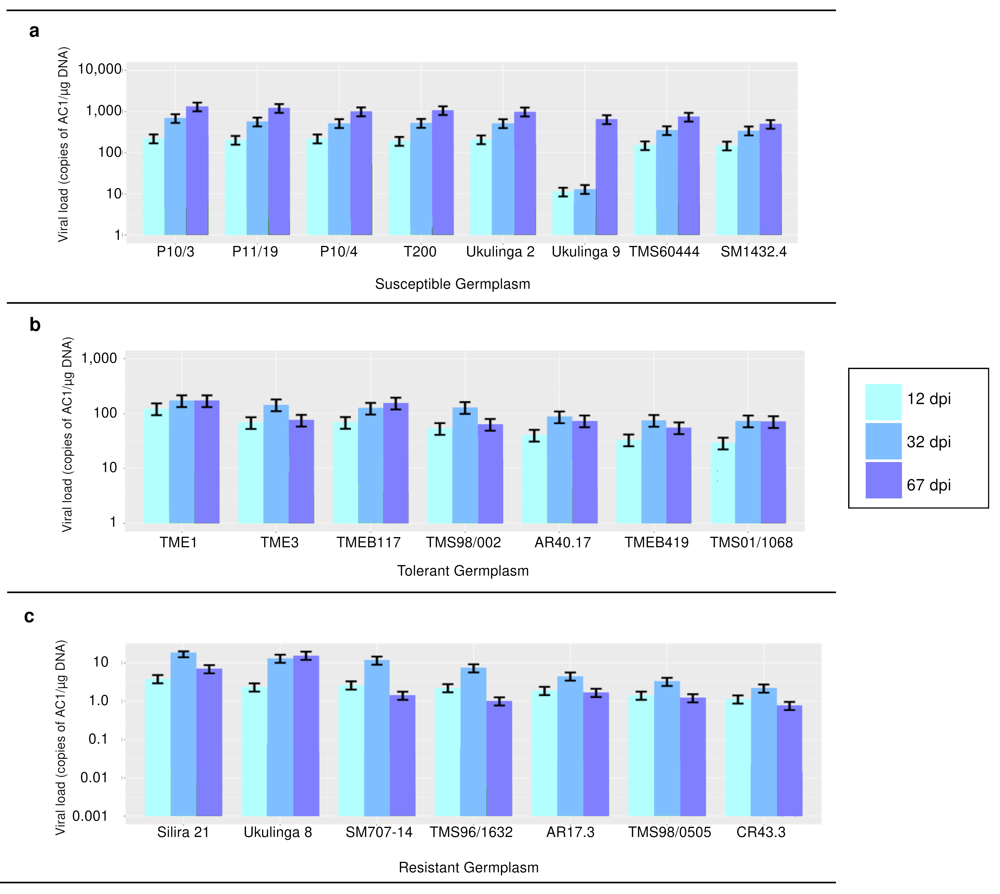
Fig S3. Viral load post challenge with South African cassava mosaic virus
Viral load is presented for 22 cassava germplasm at 12, 32 and 67 days post inoculation (dpi) with agroinfectious clones of Begomovirus warburgi . Viral load, is given by the copy number of the AV1 viral coat protein genes per µg of total DNA extracted from SACMV infected leaf tissue, determined via qPCR. Error bars represent 95% confidence intervals obtained from error propagation via second order corrected Taylor expansion. Where viral load differed significantly between time-points for a given germplasm the transitions is marked with an asterix (* for p<0.01, **p<0.0001) The R package ggplot2 was used for data visualisation a: Viral load is presented for eight cassava germplasm which showed a susceptible response to SACMV. Germplasm are arranged left to right from most to least susceptible. b: Leaf symptom severity is presented which showed a tolerance response to SACMV. Germplasm are arranged left to right from least to most tolerant. c: Leaf symptom severity is presented for seven cassava germplasm which showed a resistance response to SACMV. Germplasm are arranged left to right from least to most resistant

