Title: A Pan-Biome Metagenomic Atlas of the Brazilian Rhizosphere, Root, and Soil Microbiomes
Luisa Mayumi Arake de Tacca¹, Rayane Nunes Lima¹, Patrícia Verdugo Pascoal¹, Marco Antônio de Oliveira¹, Carlos Alexandre Xavier de Azevedo¹, Deborah Bambil¹, Paula Mizotte¹, Grácia Maria Soares Rosinha¹, Daniela Matias de Carvalho Bittencourt¹, Ahmed Moustafa⁷, Diana Signor², Magna Soelma Beserra de Moura², José Pedro Pereira Trindade³, Leandro Bochi da Silva Volk³, Fernando Antônio Fernandes⁴, Ricardo Lopes⁵, Jean Luiz Simões-Araújo⁶, Marcelo Freire^{7,8}* , and Elibio Rech¹*
¹Embrapa Genetic Resources and Biotechnology/National Institute of Science and Technology in Engineering Biological Systems, Brasília, Distrito Federal, Brazil.
²Embrapa Semiarid, Petrolina, Recife, Brazil;
³Embrapa Southern Livestock, Bagé, Rio Grande do Sul, Brazil;
⁴Embrapa Pantanal, Corumbá, Mato Grosso, Brazil;
⁵Embrapa Western Amazon, Manaus, Amazonas, Brazil;
⁶ Embrapa Agrobiology, Seropédica, Rio de Janeiro, Brazil;
⁷ The J. Craig Venter Institute, La Jolla, California, United States.
⁸ University of California San Diego, La Jolla, California, United States.
*corresponding authors

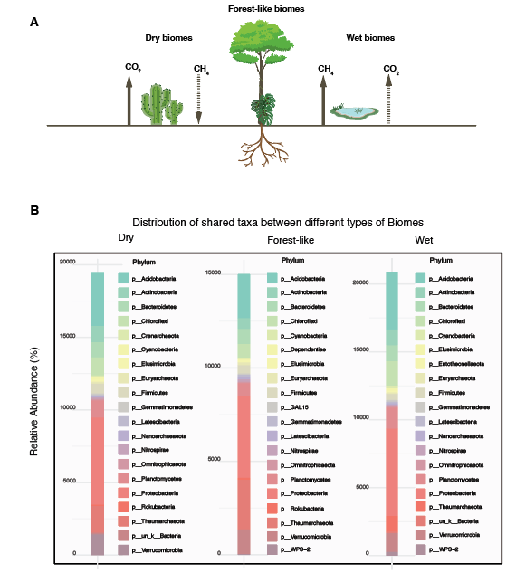
Supplemental figure 1. Differences between dry, wet and forest-like biomes. A. Graphical representation of the three different biome categories. B. Distribution of the shared phylum taxa on their relative abundances for each biome category.

