Additional file 1

Cascading rupture of patches of high seismic energy release controls the growth process of episodic tremor and slip events

Keita Nakamoto, Yoshihiro Hiramatsu, Takahiko Uchide, Kazutoshi Imanishi

Migration of tremors, spatial distribution of cumulative seismic energy release, rupture extent along strike direction, and start point of ETS events:

Analyses of seismic array data in the Kii Peninsula reveal the detailed rupture process of 17 ETS events in the Nankai subduction zone. The rupture process is represented here by the migration of tremor and the spatial distribution of cumulative seismic energy release during the 14 ETS events not shown in the main text (Fig. S1) and the rupture extent along strike and the location of the start point for all ETS events (Fig. S2).

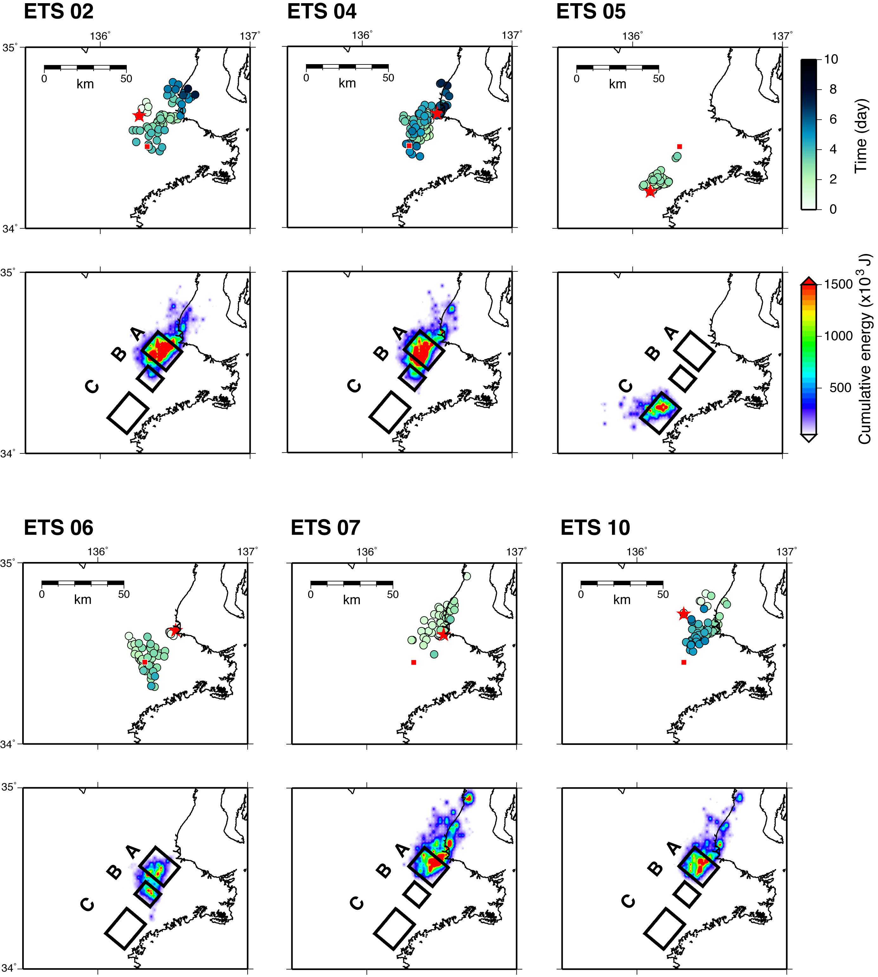
Figure S1. Plots showing (upper) the migration of tremors and (lower) the spatial distribution of cumulative seismic energy of all ETS events other than those in Fig. 4 (ETS 3, 9, and 20). All symbols are the same as in Fig. 4.

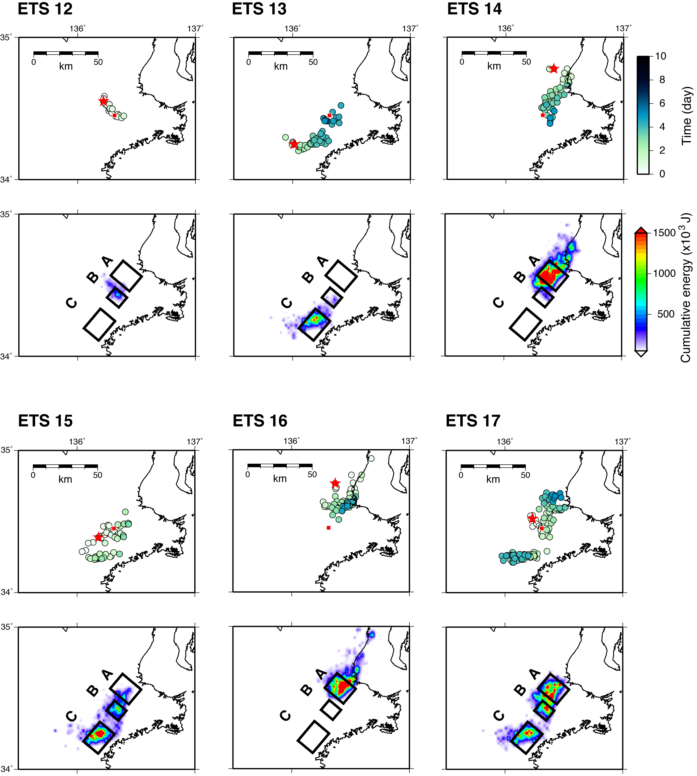
Figure S1. continued.

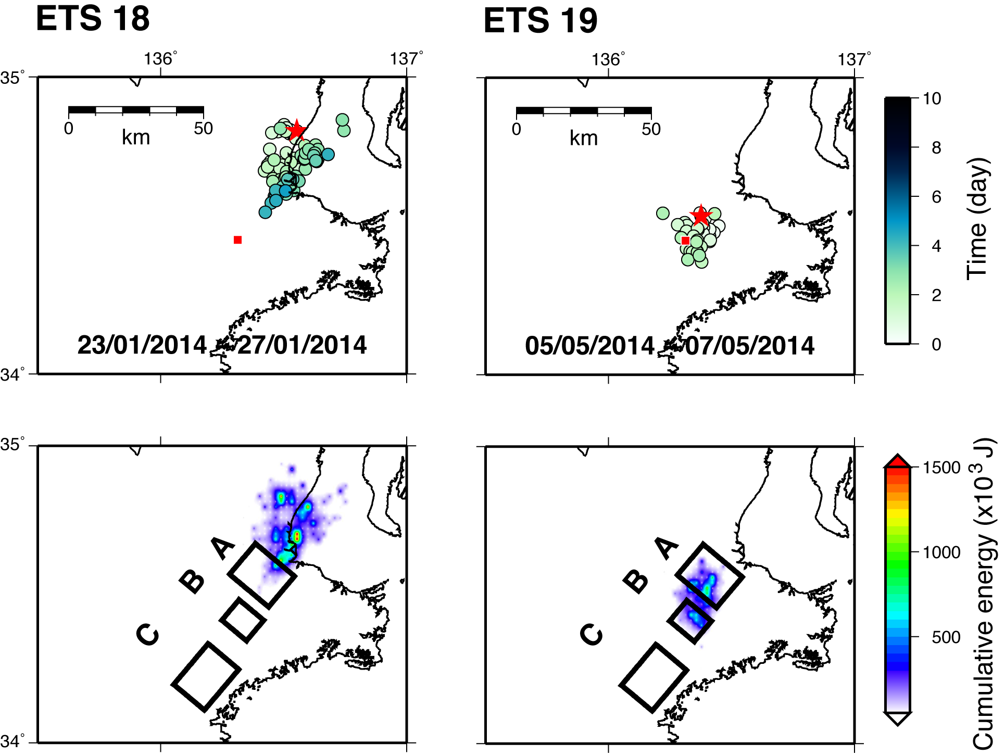

Figure S1. continued.

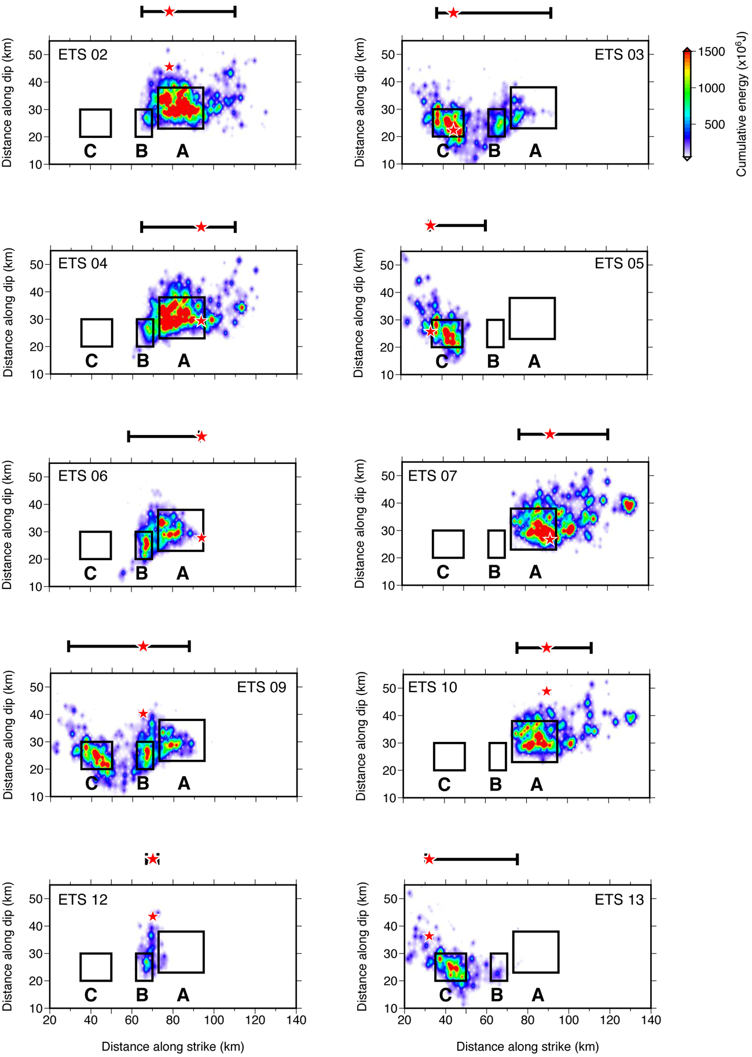
Figure S2. Plots of all ETS events showing the spatial distribution of cumulative seismic energy release in the plane of the plate interface, with symbols showing the rupture extent along the strike direction (black bar) and the start point (red star). Black rectangles represent the location of high-energy patches as shown in Fig. 4.

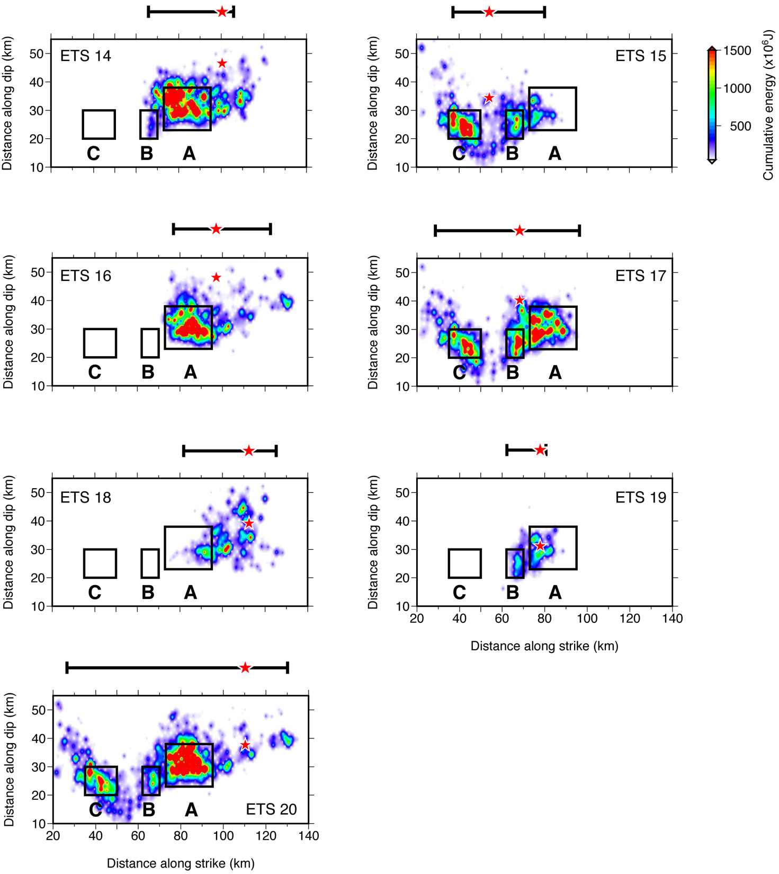

Figure S2. continued.

