Supplement Table 1: Primer sequences for qPCR assays
Gene name | Forward (5′-3′) | Reverse (5′-3′)
Actin | CTACCTCATGAAGATCCTCCGA | TTCTCCTTAATGTCACGCACGATT
C1QTNF1 | AAGTTCTACTGCTACGTGCCC | TGTGCAGGTAGGTCTCCTTCT-
GFPT2 | AGGATCCTTGCTTCGCCAAA | GTATAATGGGG CGACCCTGG
FSTL3 | ACTGCGTGGTGTGTCGAG | TGGCACGAGGAGATGTAGGT
PLXNA4 | ATCTCCGTCTCTCAGTACAA | GTGATAGGCTTGATCACCTC

Supplementary figure 1: CAF infiltration and stromal score are associated with OS in stage I and II LUSC patients; data extracted from the TCGA-LUSC cohort (n=406). A, survival analysis based on the stromal scores calculated using the ESTIMATE software; B and C, Survival analysis based on the extent of CAF infiltration calculated using two different methods (MCP_Counter and xCell, respectively).
LUSC, Lung Squamous Cell Carcinoma; CAF, Cancer-associated Fibroblast;
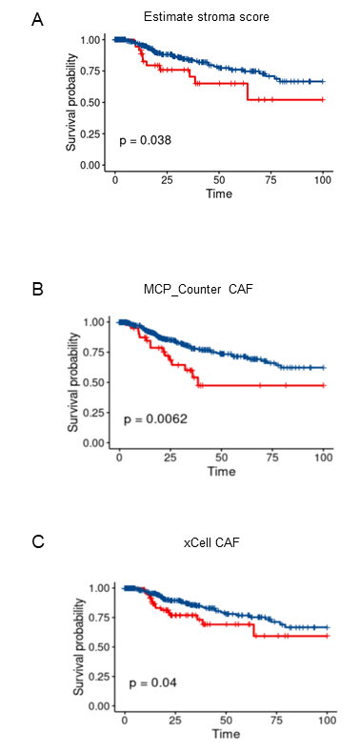

Supplementary figure 2: Co-expression network constructed by WGCNA. A, a soft-thresholding power (β) of 3 was selected based on the scale-free topology criterion; B, Genes with similar expression patterns were clustered into the same co-expression module in clustering dendrograms.
WGCNA, Weighted Gene Co-Expression Analysis;
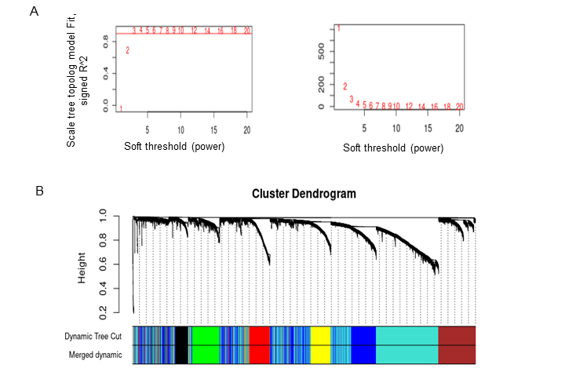

Supplementary figure 3: LASSO Cox regression analysis.

