Table S1 List of targeted genes and their sequences used in qPCR.
Targeted gene | Sequence | Base pair (bp)
Actin F | CGAGGGTTATGCTTTGCCTC | 20
Actin R | AGCAAGCTCCTCCTTCATGT | 20
PR1 F | CGTCTTTGTAGCTCTTGTAGG | 21
PR1 R | AGTCTGCAGTTGCCTCTT | 18
PR-3 F | TAGCCCTGGCGACAATCTTG | 20
PR-3 R | ATAGCTGTCCCCTGCATTGC | 20
LOX F | CTTCACTGCTGGTGCATACGG | 21
LOX R | TCGTTGGCGTACGGATAGTC | 20
CAT F | GTCGGAGGAGGAAATCATAGCC | 22
CAT R | GCCAAGTCTTCGTCACATCAAG | 22
TPX F | AGCATTGACAACACGTACC | 19
TPX R | AGCACTCCCTGTCTTAACT | 19
CRT F | TCCCAAATTCTGCGTACAAAGGTCC | 25
CRT R | GAGCCAGCCTTCACCTGCCA | 20
NR F' | TGCGTGGACTACTCAGAGAC | 19
NR R' | CACCAACACCAGTACTTGCC | 20
NiR F | GACATGGATGATCTAGCTCG | 20
NiR R | GAGAATAGGTGGATCAGGTG | 20
NRT1.1 F | CATGATTCTTTGTATTGAGGCCGTGGAGA | 29
NRT1.1 R | ATGAACGGAATTGTTCAGCAGTGTGTGGCA | 27
NRT1.2 F | CATCGAGTTTTTGGGATTGATCATACTCACAAT | 33
NRT1.2 R | AACCGAAGCCGCAAGAAGAACCTTC | 25
NRT2.1 F | CCGACAAGACGGCCAAGTTCGACCT | 25
NRT2.1 R | TCCGTAGAGAAGAACGAAGATCCAAG | 26
NRT2.2 F | CAGGTGGAAACAGAGCTGCCATGG | 24
NRT2.2 R | GGACCATAGATACAACGGCAGTGACGAG | 28
GS F | TTTCAAGTTGGACCTTCAGTTGG | 23
GS R | CATACCCTCCCTCATTTCTCATA | 23
GSH F | GAAATGGAGAGACTTGGC | 18
GSH R | CAACAAGAAGCAATATGGGG | 20

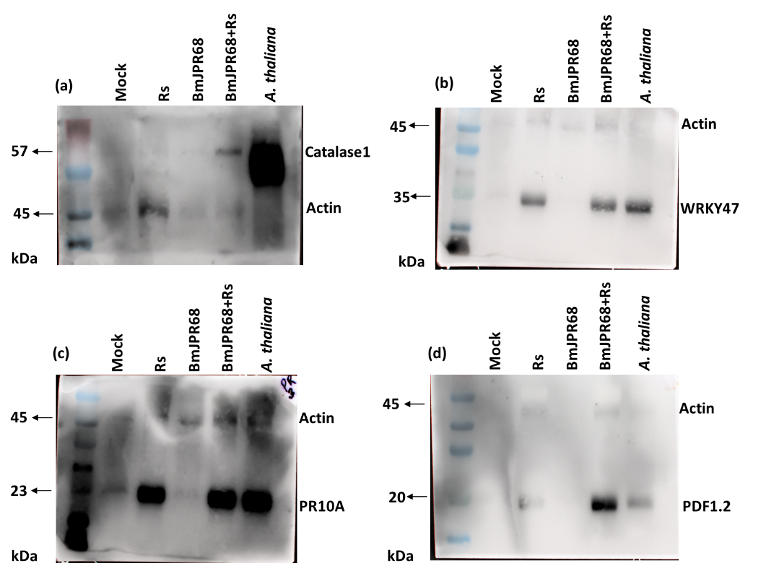

Fig. S1 Western blot analyses of pathogenesis-related (PR) protein. (a-d) images showing full blot of actin expressed in the same blot after targeted protein detection. Each lane was loaded with 100 mg of protein. Arabidopsis thaliana L. ecotype Columbia-O, was used as positive control. Protein size given in kilodalton (kDa). Each gel was blotted and reacted with a different stress-specific protein antibody.

Fig. S2 Chromatogram obtained by Bhut Jolokia extracts showing peaks for nordihydrocapsaicin, capsaicin, dihydrocapsaicin, homocapsaicin, homodihydrocapsaicin, and chemical structure of nordihydrocapsaicin and dihydrocapsaicin.

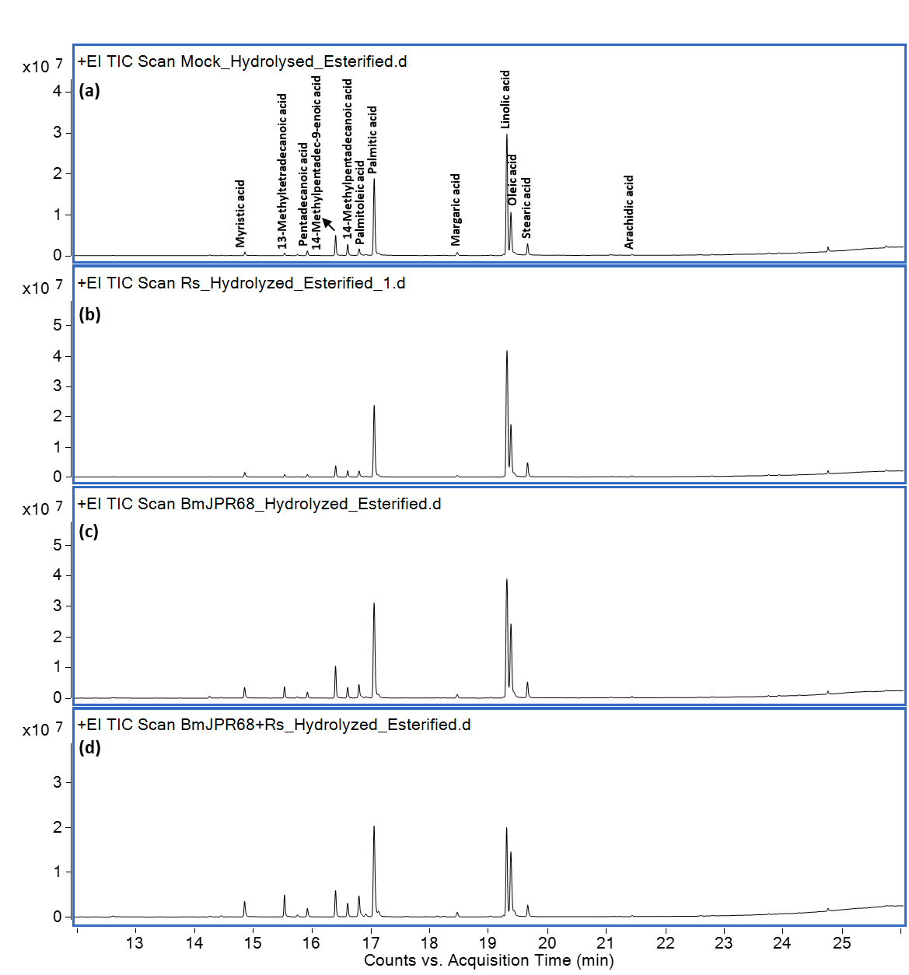

Fig. S3 The stackplot of GCMS chromatogram for the esterified samples of Bhut Jolokia n-hexane extracts. The methylester pictures are labelled with corresponding fatty acids. a. water treated (mock) fruit extracts; b. pathogen (Rs) treated fruit extracts; c. BmJPR68 treated fruit extracts; d. BmJPR68+Rs treated fruit extracts.

Table S2 Physico-chemical properties of soil in the study area. Different lowercase letters on the bars indicated a significant difference, as determined by Tukey test (p≤0.05). All data points were means ± SD (n = 3). Mean values and SDs at least for three biological replicates are shown.

Soil | Sand  (%) | Slit  (%) | Clay  (%) | pH  (in H₂O) | EC (dSm-1) | MWHC (%) | N | P | K | Zn | Cu | Fe | Mn | Organic Carbon
 |  |  |  |  |  |  | mg g⁻¹
Mock | 22.5 | 21.27 | 56.23 | 6.5 | 3.3 | 65.42096 | 2.65±0.0721^{c} | 0.43±0.001^{c} | 0.659±0.01^{b} | 0.069±0.002ª | 0.0040±0.0012^{c} | 4.19±0.027^{b} | 0.535±0.009ª | 2.61±1.07^{c}
Rs | 24.16 | 30.29 | 45.5 | 5.9 | 3.1 | 39.78448 | 3.05±0.259^{bc} | 0.68±0.002^{d} | 0.56±0.03^{ab} | 0.06±0.002^{b} | 0.0021±0.009^{d} | 3.99±0.035^{d} | 0.65±0.01^{b} | 1.4±0.17b^{c}
BmJPR68 | 23.21 | 32.45 | 44.34 | 5.5 | 4.1 | 50.78512 | 3.39±0.095^{c} | 2.01±0.004ª | 0.82±0.078ª | 0.1±0.003ª | 0.0078±0.0049^{b} | 6.28±0.012^{c} | 0.697±0.007^{c} | 17.5±2.63^{b}
BmJPR68+Rs | 20.24 | 28.34 | 51.45 | 6.0 | 3.7 | 57.2093 | 4.342±0.1411ª | 1.8±0.002^{b} | 0.82±0.07^{ab} | 0.1±0.007ª | 0.015±0.006ª | 5.62±0.035ª | 0.659±0.011^{d} | 20.1±0.44ª

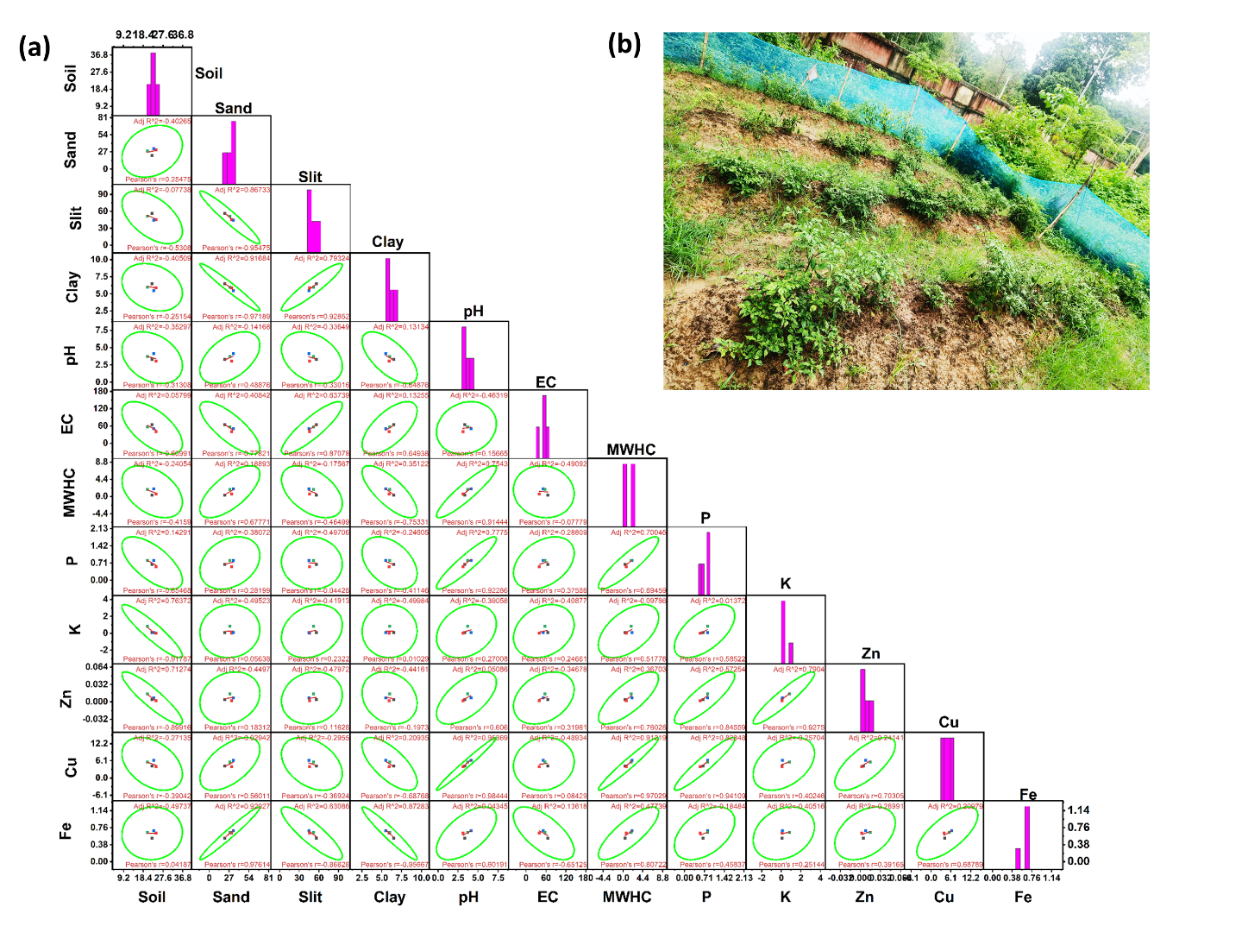
Fig. S4 (a) Pearson correlation among the variables of soil and their interaction; (b) a view of field study at CSIR-NEIST, Jorhat, Assam.

