Support information
Mapping of the CaPP2C35 gene involved in the formation of light-green immature pepper (Capsicum annuum L.) fruits via GWAS and BSA
Lang Wu, Haoran Wang, Sujun Liu, Mengmeng Liu, Jinkui Liu, Yihao Wang, Liang Sun, Wencai Yang, Huolin Shen*
Beijing Key Laboratory of Growth and Developmental Regulation for Protected Vegetable Crops, Department of Vegetable Science, College of Horticulture, China Agricultural University, Beijing 100193, China
*Correspondence author
✉Huolin Shen: shl1606@cau.edu.cn

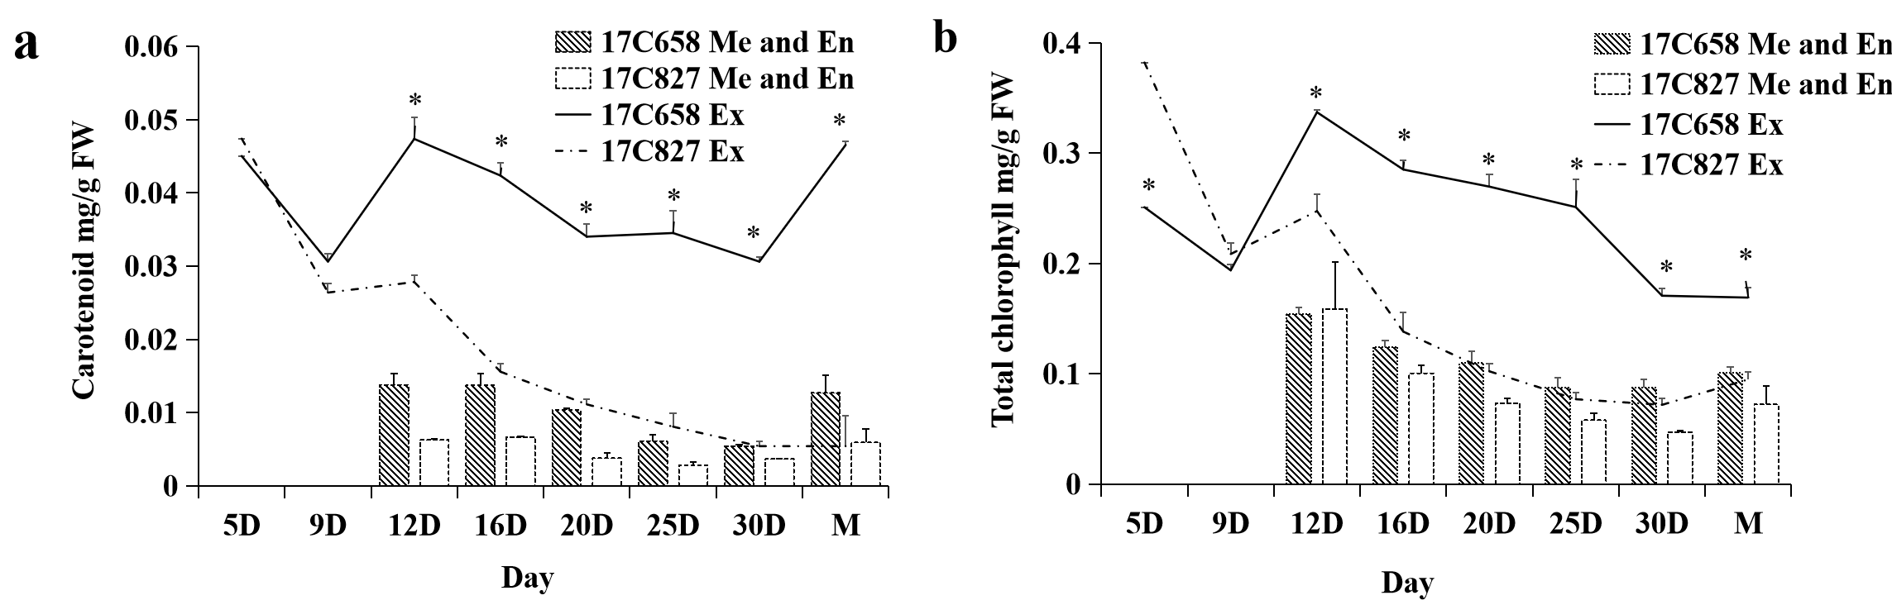
Supplementary Figure 1 Carotenoid and total chlorophyll content analysis of 17C658 and 17C827 fruits
a: The carotenoid content in the exocarp and endocarp (including mesocarp) of 17C658 and 17C827; b: The total chlorophyll content in the exocarp and endocarp (including mesocarp) of 17C658 and 17C827. 5D, 9D, 12D, 16D, 20D, 25D, 30D and M are 5 days, 9 days, 12 days, 16 days, 20 days, 25 days, 30 days after anthesis and immature stage (or 35 days after anthesis), respectively. The carotenoid content or total chlorophyll content at 5D and 9D are that in intact pepper pericarp (including exocarp, endocarp and mesocarp). ‘*’ indidcates significant differences at the 0.05 level. Ex indicates the exocarp of pepper fruits. Me indicates the mesocarp of pepper fruits. En indicates the endocarp of pepper fruits. Data is means of three independent replicates.
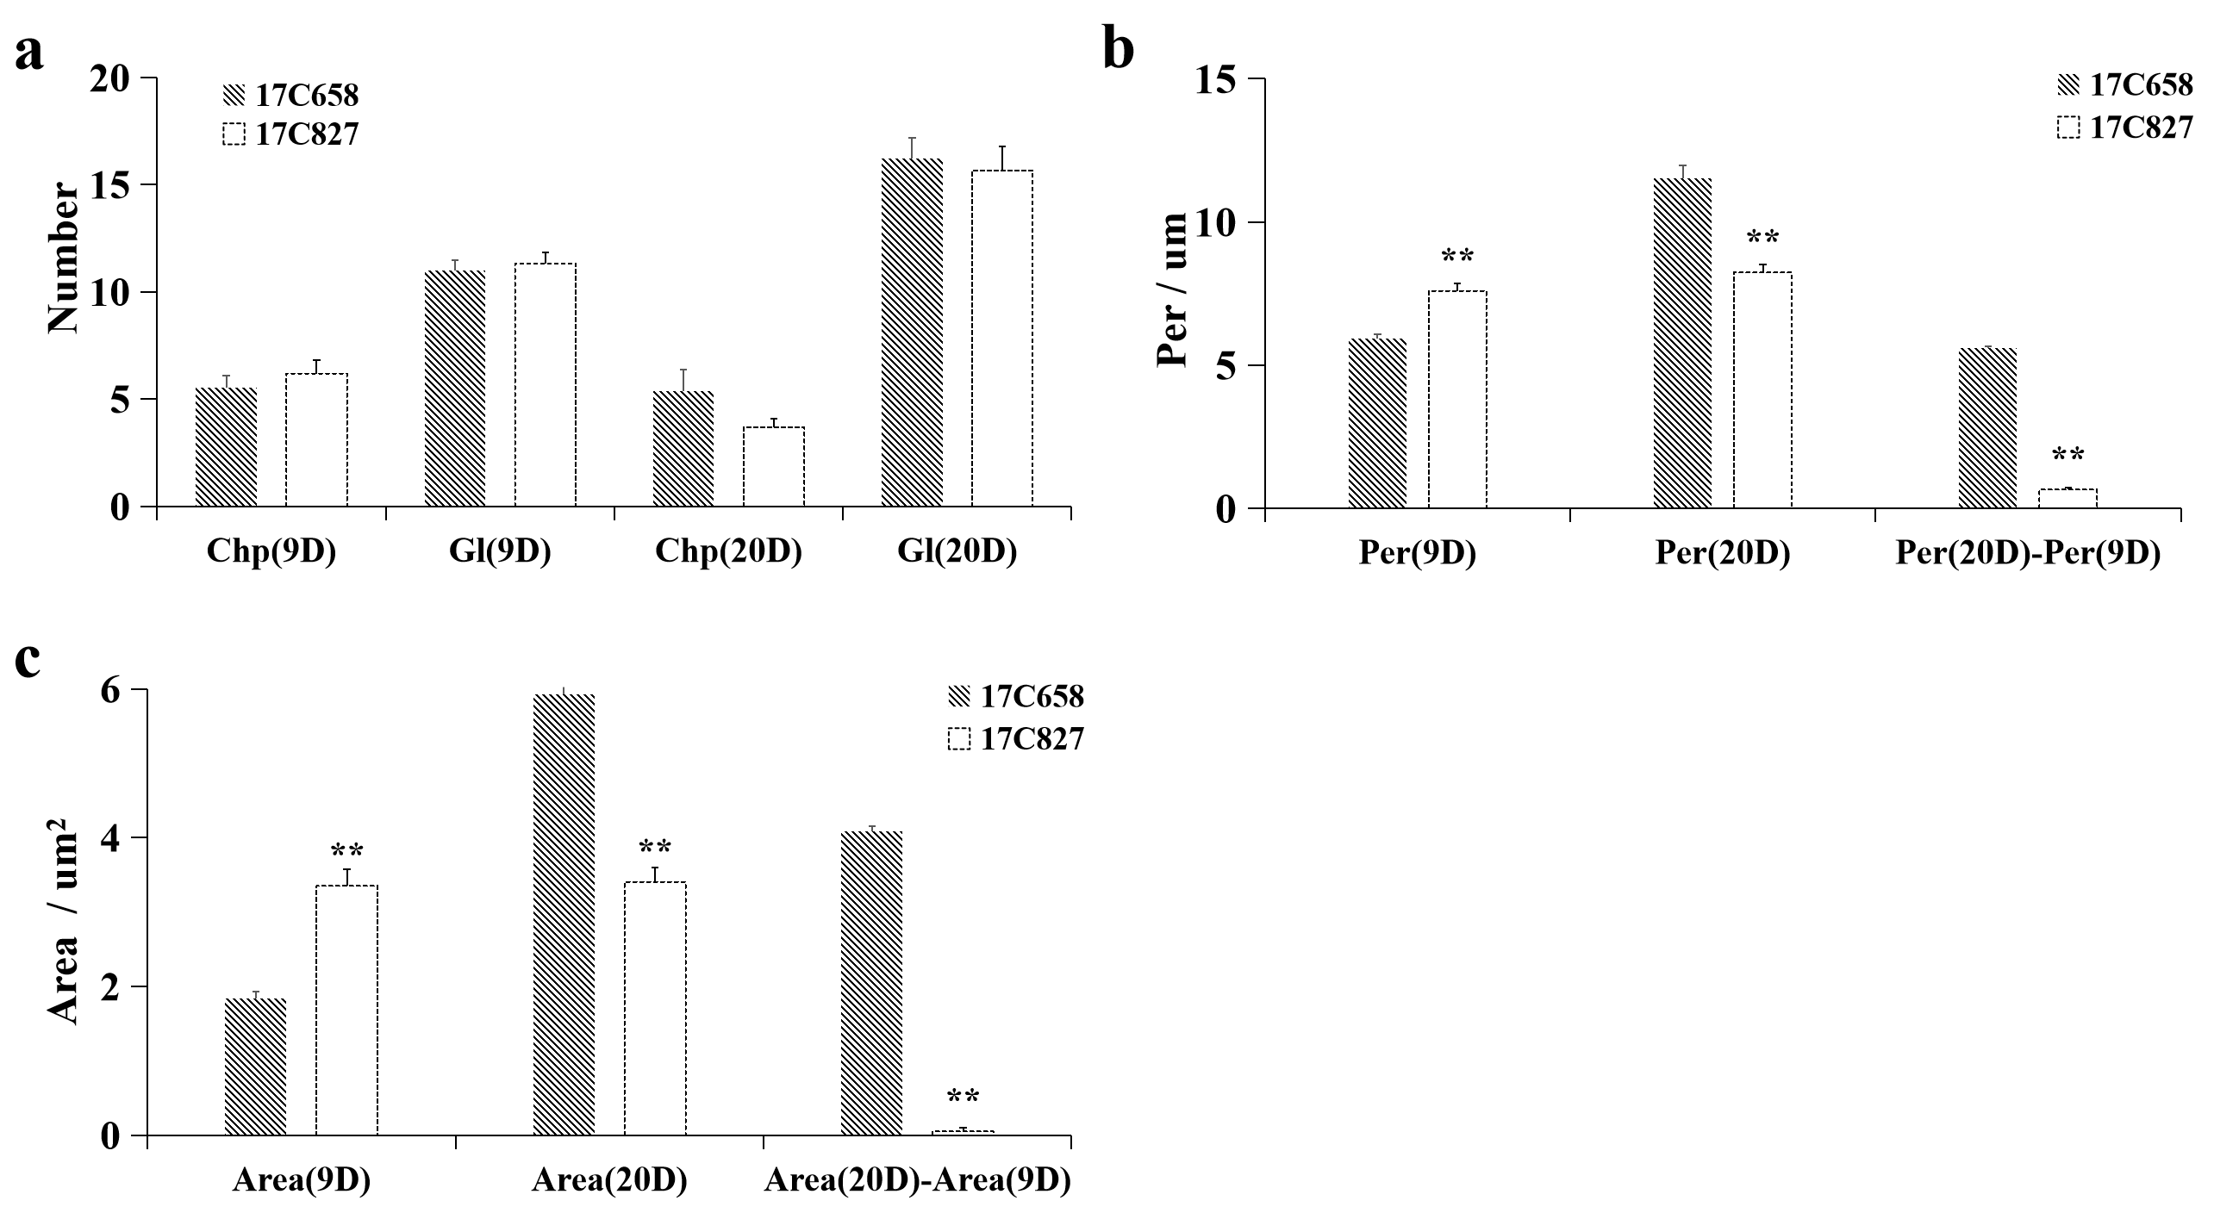
Supplementary Figure 2 Comparison analysis of chloroplast in the exocarp of 17C658 and 17C827 fruits
a: The number of chloroplast and chloroplast grana in the exocarp of 17C658 and 17C827 fruits; b: Cross-section perimeter of chloroplast in the exocarp of 17C658 and 17C827 fruits; c: Cross-section area of chloroplast in the exocarp of 17C658 and 17C827 fruits. Chp and Gl are the chloroplasts number of unicellular and the chloroplast grana number of single chloroplast in exocarp of pepper fruits, respectively. Per and Area are cross-section perimeter of chloroplast and cross-sectional area of chloroplast in exocarp of pepper fruits, respectively. Per(20D)-Per(9D) and Area(20D)-Area(9D) are the increments of the chloroplast cross-section perimeter and area from 9D to 20D, respectively. 9D and 20D were 9 days after anthesis and 20 days after anthesis, respectively. ‘**’ indicates significant differences at 0.01 level. Data is means of three independent replicates.

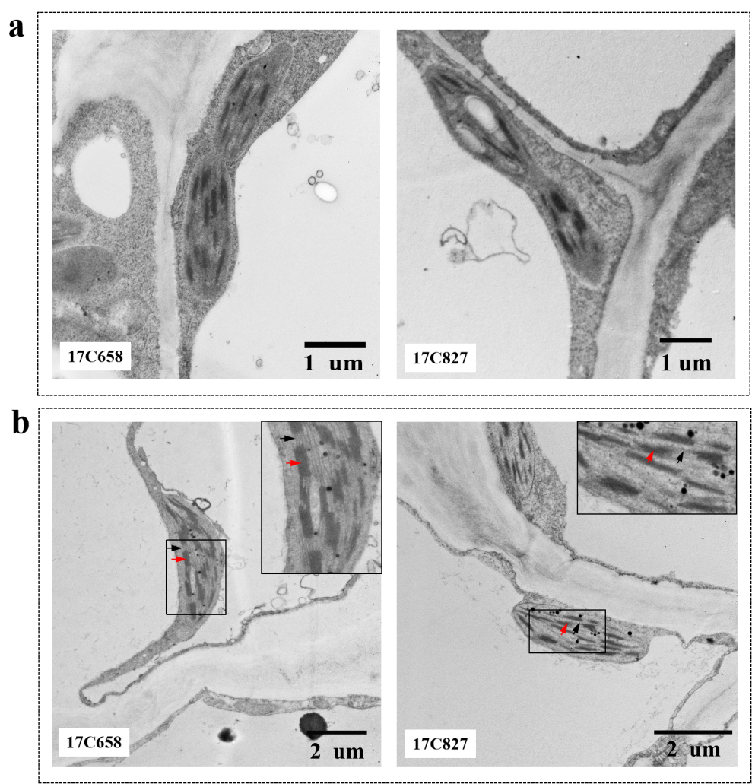
Supplementary Figure 3 Submicrostructure comparison of chloroplast in exocarp of 17C658 and 17C827 fruits
a: The chloroplast in the exocarp of pepper fruits at 9 days after anthesis; b: The chloroplast in the exocarp of pepper fruits at 20 days after anthesis. The black line boxed regions are magnified for better visualization. The red arrow indicate the chloroplast grana. The black arrow indicate the stroma lamella.

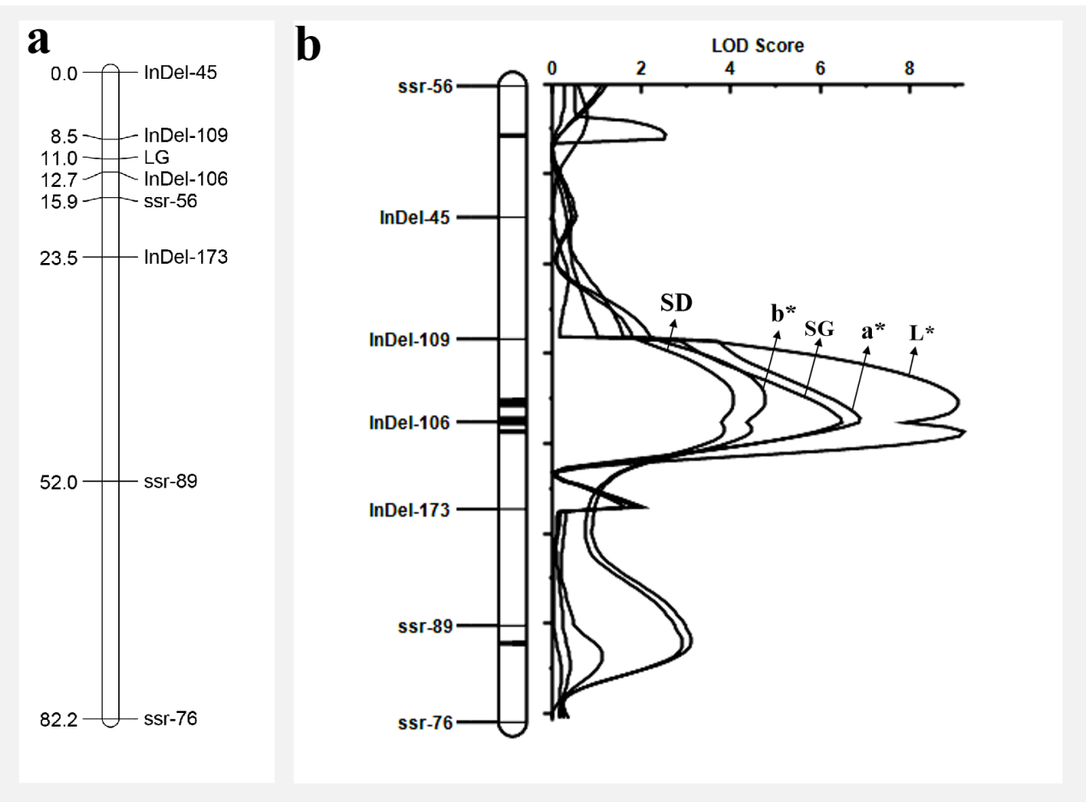
Supplementary Figure 4 Initial mapping of LG locus controlling light-green immature fruit in pepper
a: Linkage analysis of LG locus controlling light-green immature fruits in F₂ constructed from a cross between 17C658 and 17C827; b: QTL analysis of the value of L*, a*, b*, chromaticity (SD) and shade (SG) measured by the colorimeter for immature-fruit color in F₂ (315 F₂ individuals) constructed from a cross between 17C658 and 17C827.
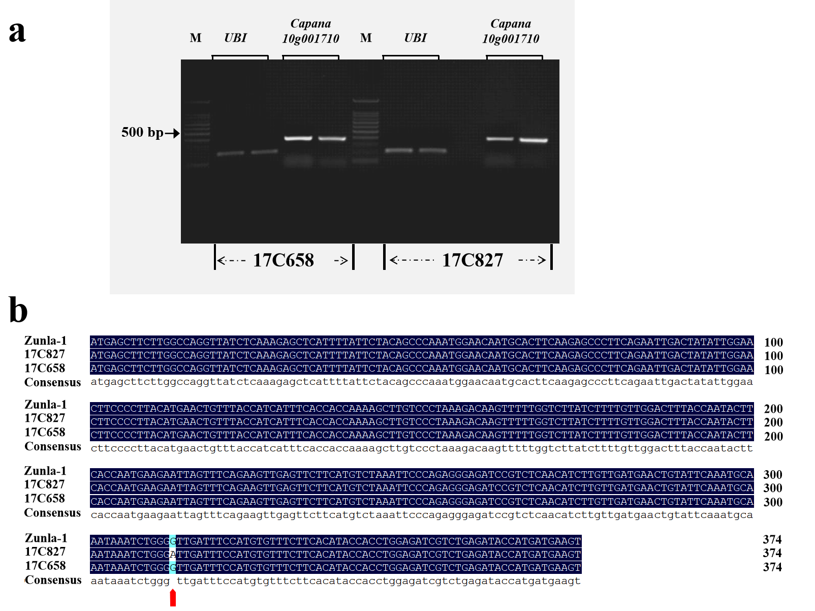
Supplementary Figure 5 Sequence amplification and alignment of Capana10g001710 CDS for 17C658 and 17C827
a: Sequence amplification of Capana10g001710 coding sequence (CDS) for 17C658 and 17C827; b: Sequence alignment of Capana10g001710 CDS for 17C658 and 17C827. The red arrow indicates the replacement base position.
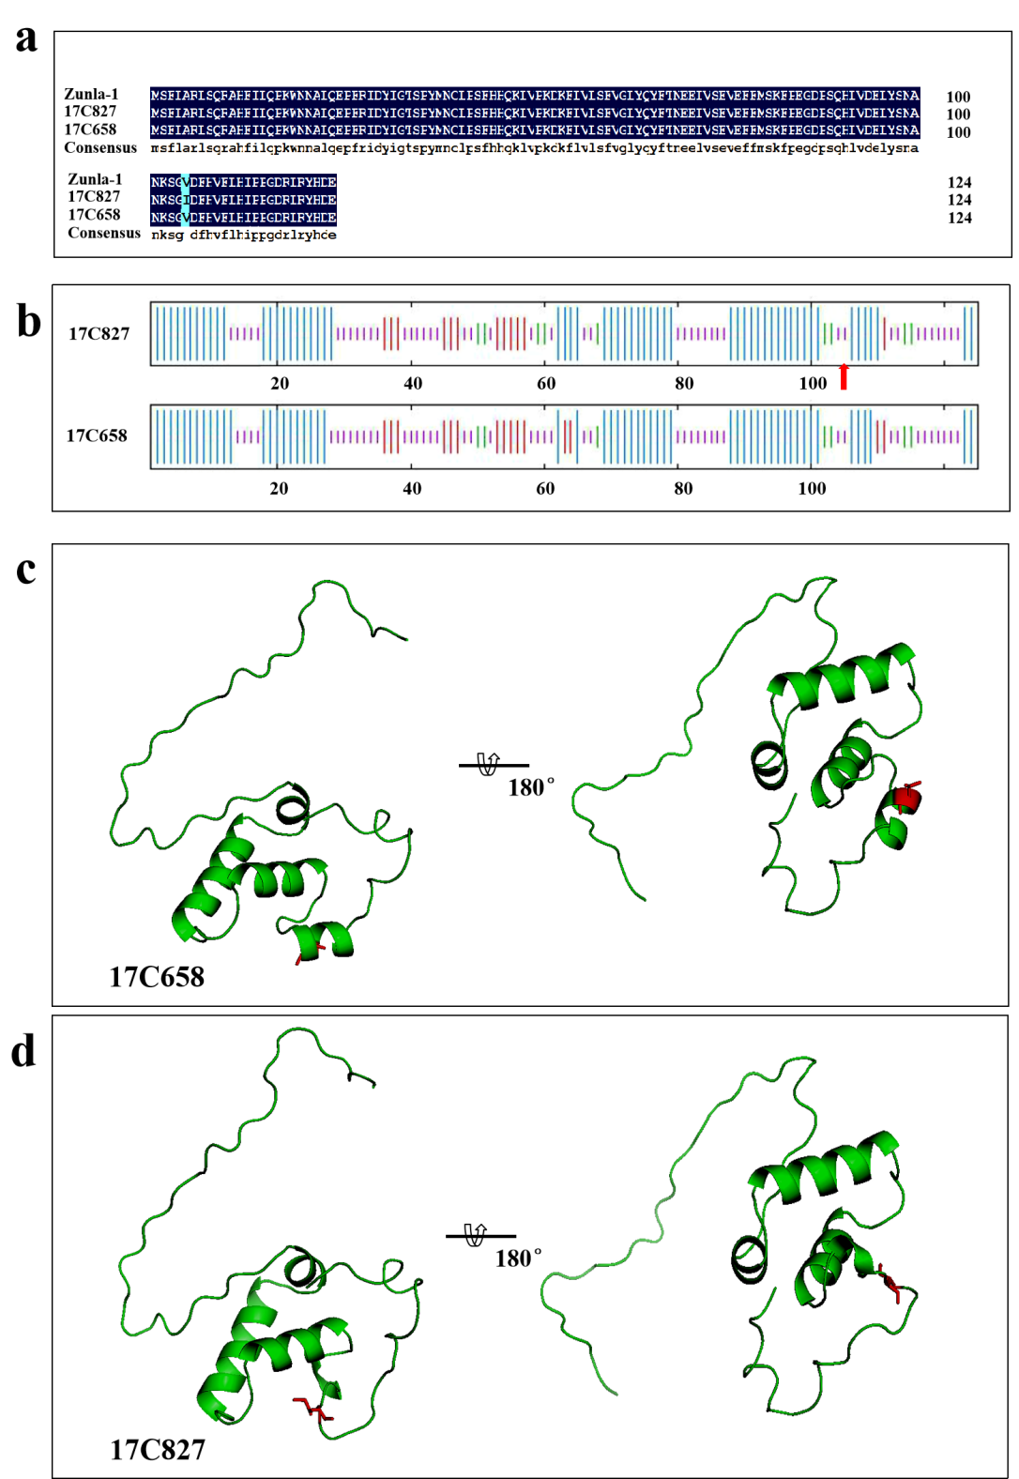
Supplementary Figure 6 Comparison of PP2C35 protein structure between 17C658 and 17C827
a: Comparison of PP2C35 protein primary structure between 17C658 and 17C827; b: Comparison of PP2C35 protein secondary structure between 17C658 and 17C827; c and d: Comparison of PP2C35 protein three-dimensional structure between 17C658 and 17C827. The blue longest vertical line in (b) is alpha helix, the red secondary long vertical line in (b) is the extension chain, the pink secondary short vertical line in (b) is random crimping, the green shortest vertical line in (b) is beta-turning angle, and the red arrow in (b) is the position where the amino acid is replaced.

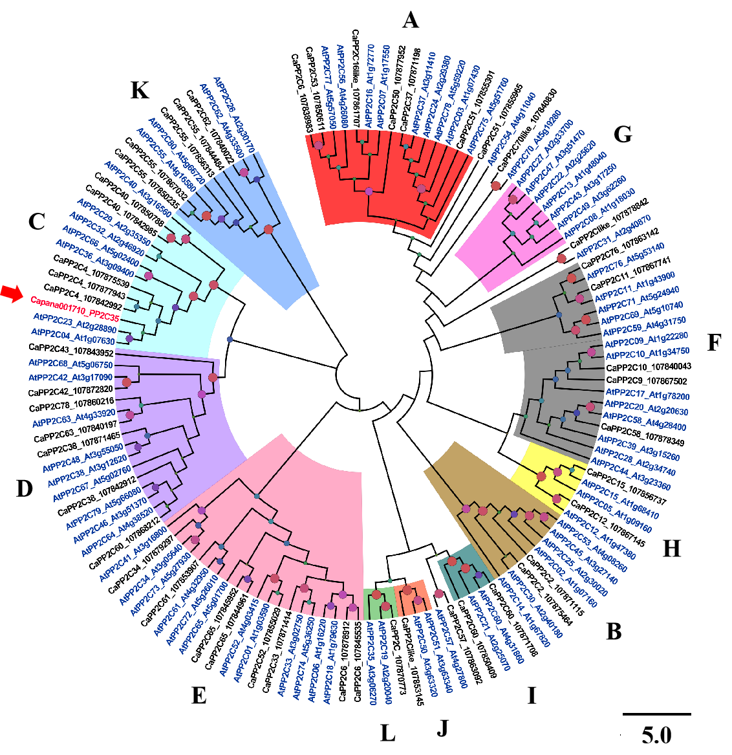
Supplementary Figure 7 Evolutionary analysis of 2C phosphatase family proteins in Capsicum and Arabidopsis thaliana
A-L is the subfamily name of PP2C phosphatase protein family. The same background color of branches indicates that the proteins on the branches belong to the same subfamily. The blue font are members of the PP2C protein family in Arabidopsis thaliana; The black font are members of PP2C protein family in Capsicum. Node size represents the similarity ratio of protein sequences.

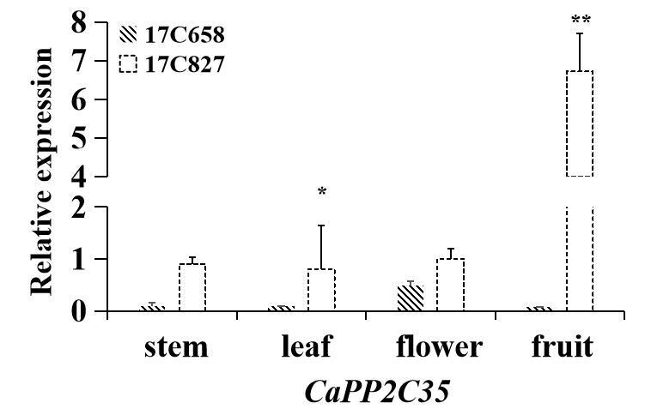
Supplementary Figure 8 The tissue-specific expression pattern of CaPP2C35
The samples used for gene expression analysis were stems, leafs, flowers, and the exocarp of fruits. And the reference gene was UBI (AY486137.1). Gene relative expression data was calculated by 2^{-ΔΔCT} method, with three biological and three technical repeats. ‘*’ and ‘**’ indicate significant differences at 0.05 and 0.01 level, respectively. Data is means of three biological replicates.

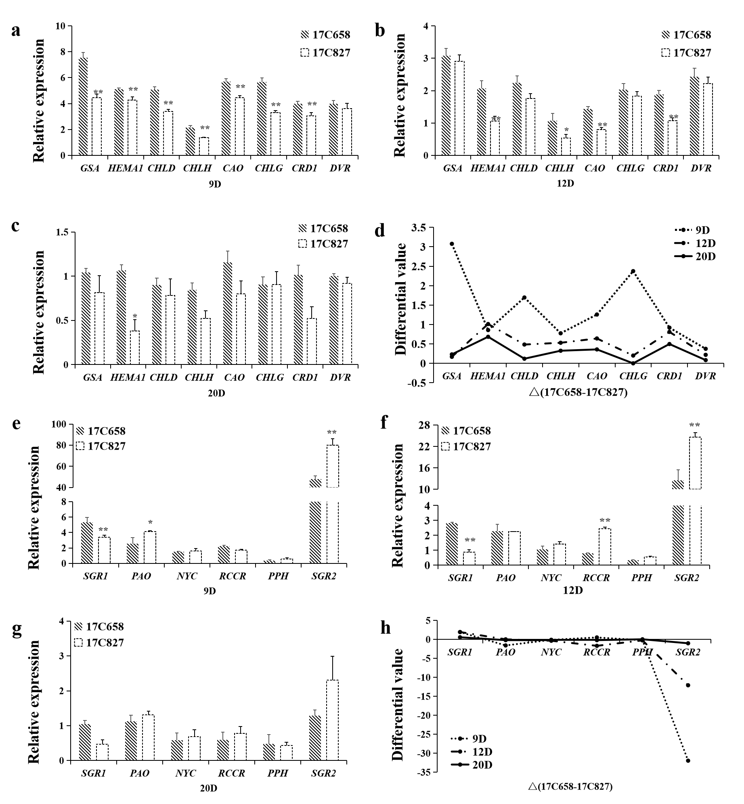
Supplementary Figure 9 Expression analysis of some chlorophyll metabolism-related genes for 17C658 and 17C827
a: Expression analysis of key genes of chlorophyll synthesis pathway for 17C658 and 17C827 at 9 days after anthesis; b: Expression analysis of key genes of chlorophyll synthesis pathway for 17C658 and 17C827 at 12 days after anthesis; c: Expression analysis of key genes of chlorophyll synthesis pathway for 17C658 and 17C827 at 20 days after anthesis; d: Difference value of expression of key genes of chlorophyll synthesis pathway between 17C658 and 17C827; e: Expression analysis of key genes of chlorophyll degradation pathway for 17C658 and 17C827 at 9 days after anthesis; f: Expression analysis of key genes of chlorophyll degradation pathway for 17C658 and 17C827 at 12 days after anthesis; g: Expression analysis of key genes of chlorophyll degradation pathway for 17C658 and 17C827 at 20 days after anthesis; h: Difference value of expression of key genes of chlorophyll degradation pathway between 17C658 and 17C827. 9D, 12D and 20D are 9 days, 12 days, 20 days after anthesis, respectively. The samples used for gene expression analysis were the exocarp of fruits and the reference gene was UBI (AY486137.1). Gene relative expression data was calculated by 2^{-ΔΔCT} method, with three biological and three technical repeats. ‘*’ and ‘**’ indicate significant differences at 0.05 and 0.01 level, respectively. Data is means of three biological replicates.

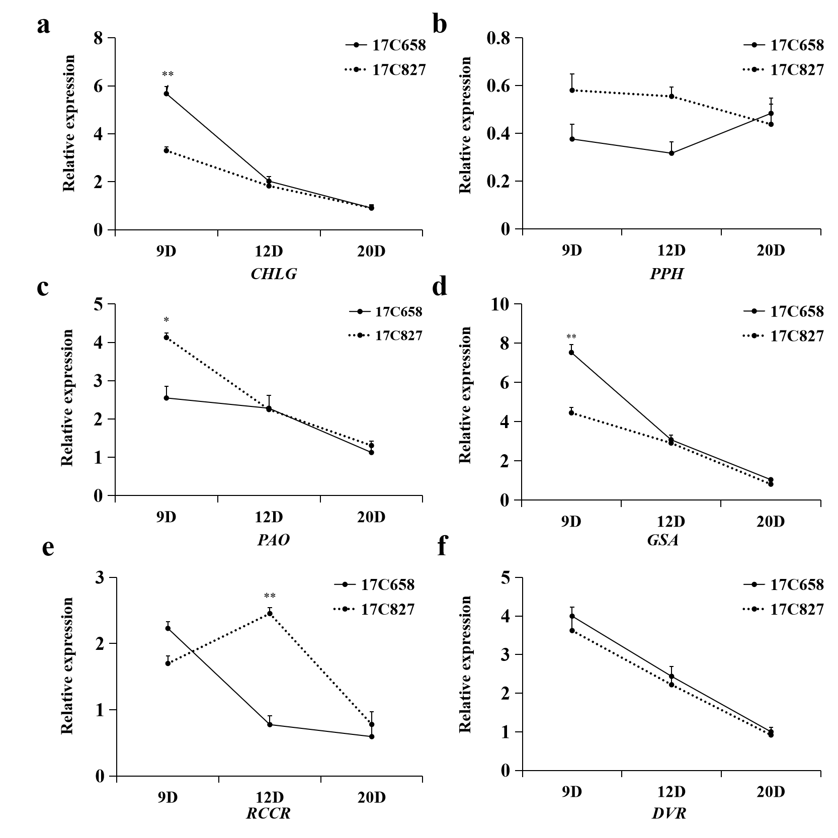
Supplementary Figure 10 Expression patterns of key genes of chlorophyll metabolism and CaPP2C35 in 17C658 and 17C827
9D, 12D and 20D are 9 days, 12 days, 20 days after anthesis, respectively. The samples used for gene expression analysis were the exocarp of fruits and the reference gene was UBI (AY486137.1). Gene relative expression data is calculated by 2^{-ΔΔCT} method, with three biological and three technical repeats. ‘*’ and ‘**’ indicate significant differences at 0.05 and 0.01 level, respectively. Data is means of three biological replicates.
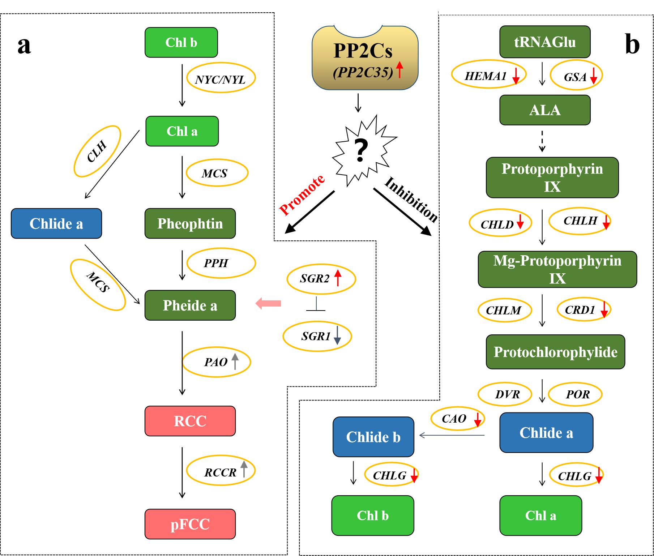
Supplementary Figure 11 Regulation analysis of key genes of chlorophyll metabolism in 17C827
a: Chlorophyll degradation pathway; b: Chlorophyll synthesis pathway. The upward and downward arrows near genes indicate that expression of the gene in the 17C827 are up-regulated and down-regulated compared with 17C658.

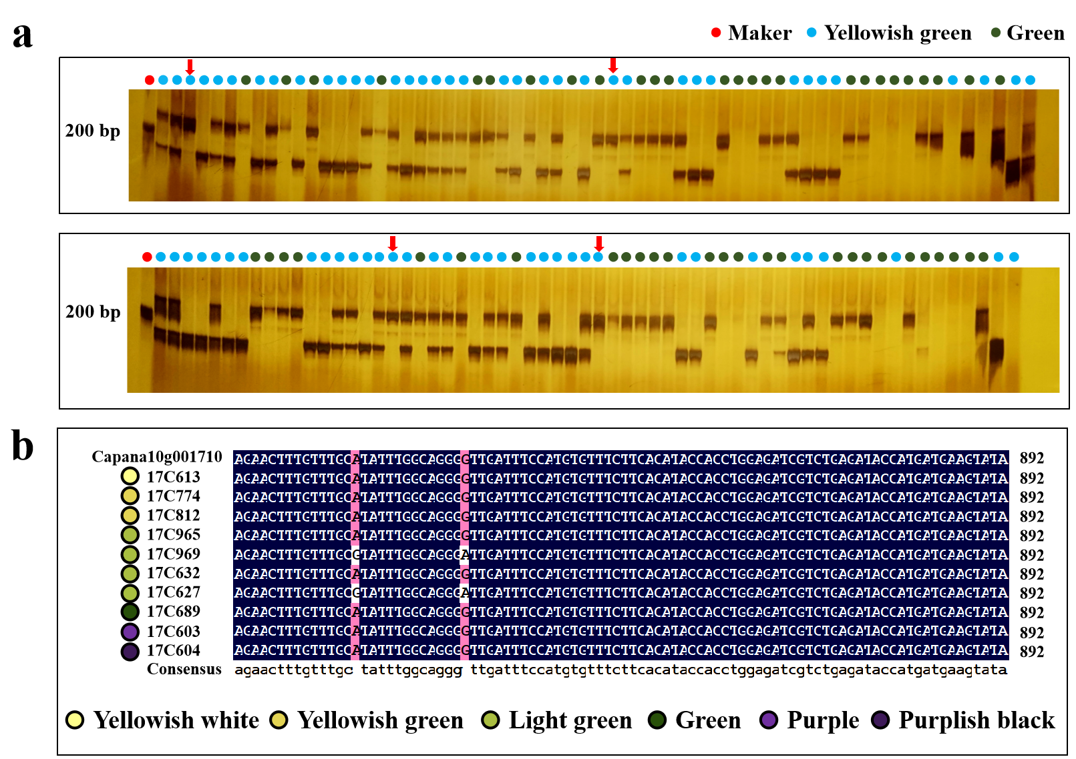
Supplementary Figure 12 Application evaluation of dCAPS10-1 for selection of light-green immature fruit in pepper
a: Banding types of dCAPS10-1 in some F₂ individuals constructed from the cross between 17C658 and 17C827; b: Sequence alignment of Capana10g001710 gene among pepper accessions with different immature fruit color. Red circle in (a) indicates the Marker. Blue circle in (a) indicates light-green immature pepper fruits. Green circle in (a) indicates green immature pepper fruits. Red arrow in (a) indicates a mismatch between banding type and phenotype.

