Supplemental material to the manuscript

The Mental Cost of Urban Living: A Study of Spatial Deprivation
Supplement A. Settlement Structure
Settlement type was classified according to the BBSR, based on three criteria: population share in large and medium-sized cities, population density, and population density excluding large and medium-sized cities.
- Urban counties: population share ≥50% in large/medium-sized cities combined with a density of ≥150 inhabitants/km², or a density excluding these cities of ≥150 inhabitants/km²
- Rural counties: population share ≥50% in large/medium-sized cities with a density below 150 inhabitants/km², or a population share <50% combined with a density excluding these cities of ≥100 inhabitants/km²
- Sparsely populated rural counties: population share <50% in large/medium-sized cities and a density excluding these cities below 100 inhabitants/km²
Figure A1.
German Settlement Structure Types of Districts (2020)
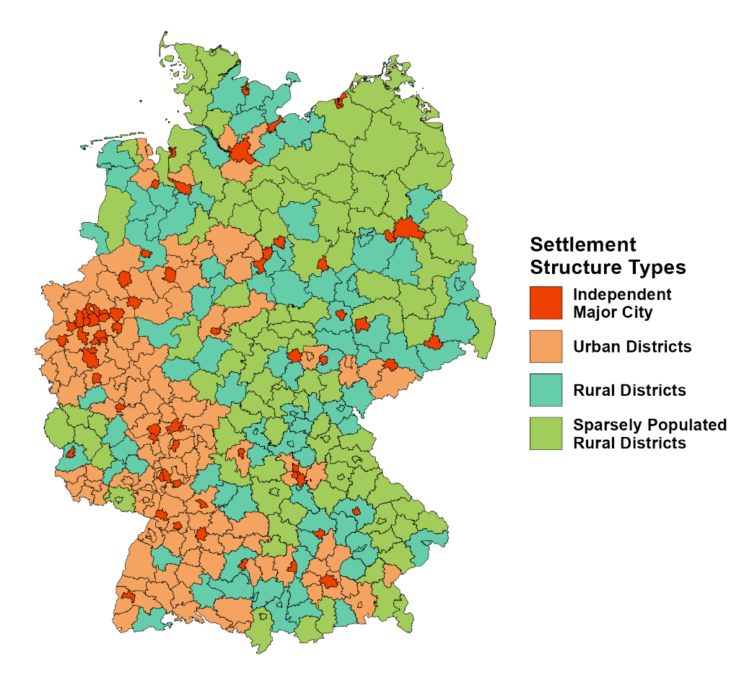
Note. The map displays the spatial distribution of settlement structure types across Germany’s 401 districts as defined by the BBSR.

Supplement B1. R packages used for the analyses
Table A1 provides an overview of the R packages and versions used for the statistical analyses and visualization.
Table B1.
R-Packages used for the Analysis
Package | Version | Reference
car | 3.1-2 | Fox J, Weisberg S (2019). An R Companion to Applied Regression, Third Edition. Sage, Thousand Oaks CA. R package version 3.1-2, https://CRAN.R-project.org/package=car.
emmeans | 1.10.0 | Lenth RV (2024). emmeans: Estimated Marginal Means, aka Least-Squares Means. R package version 1.10.0, https://CRAN.R-project.org/package=emmeans.
foreign | 0.8-86 | R Core Team (2023). foreign: Read Data Stored by 'Minitab', 'S', 'SAS', 'SPSS', 'Stata', 'Systat'. R package version 0.8-86, https://CRAN.R-project.org/package=foreign.
ggplot2 | 3.5.1 | Wickham H (2016). ggplot2: Elegant Graphics for Data Analysis. Springer-Verlag New York.
ggpubr | 0.6.0 | Kassambara A (2023). ggpubr: 'ggplot2' Based Publication Ready Plots. R package version 0.6.0, https://CRAN.R-project.org/package=ggpubr.
ggsignif | 0.6.4 | Ahlmann-Eltze C, Patil I (2021). ggsignif: R Package for Displaying Significance Brackets for 'ggplot2'. Journal of Open Source Software, 6(60), 3266. doi:10.21105/joss.03266.
haven | 2.5.4 | Wickham H, Miller E, Smith D (2023). haven: Import and Export 'SPSS', 'Stata' and 'SAS' Files. R package version 2.5.4, https://CRAN.R-project.org/package=haven.
janitor | 2.2.0 | Firke S (2023). janitor: Simple Tools for Examining and Cleaning Dirty Data. R package version 2.2.0, https://CRAN.R-project.org/package=janitor.
labelled | 2.13.0 | Larmarange J (2024). labelled: Manipulating Labelled Data. R package version 2.13.0, https://CRAN.R-project.org/package=labelled.
lme4 | 1.1-35.2 | Bates D, Mächler M, Bolker B, Walker S (2015). Fitting Linear Mixed-Effects Models Using lme4. Journal of Statistical Software, 67(1), 1–48. doi:10.18637/jss.v067.i01.
patchwork | 1.2.0 | Pedersen TL (2024). patchwork: The Composer of Plots. R package version 1.2.0, https://CRAN.R-project.org/package=patchwork.
psych | 2.4.3 | Revelle W (2024). psych: Procedures for Psychological, Psychometric, and Personality Research. Northwestern University, Evanston, Illinois. R package version 2.4.3, https://CRAN.R-project.org/package=psych.
rstatix | 0.7.2 | Kassambara A (2023). rstatix: Pipe-Friendly Framework for Basic Statistical Tests. R package version 0.7.2, https://CRAN.R-project.org/package=rstatix.
sjlabelled | 1.2.0 | Lüdecke D (2024). sjlabelled: Labelled Data Utility Functions. R package version 1.2.0, https://CRAN.R-project.org/package=sjlabelled.
sjmisc | 2.8.10 | Lüdecke D (2018). sjmisc: Data and Variable Transformation Functions. Journal of Open Source Software, 3(26), 754. doi:10.21105/joss.00754.
sjPlot | 2.8.16 | Lüdecke D (2024). sjPlot: Data Visualization for Statistics in Social Science. R package version 2.8.16, https://CRAN.R-project.org/package=sjPlot.
sjstats | 0.19.0 | Lüdecke D (2024). sjstats: Statistical Functions for Regression Models (Version 0.19.0). doi:10.5281/zenodo.1284472.
stats | 4.4.1 | R Core Team (2024). stats: The R Stats Package. R package version 4.4.1, https://CRAN.R-project.org/package=stats.
tidyverse | 2.0.0 | Wickham H, Averick M, Bryan J, Chang W, D’Agostino McGowan L, François R, Grolemund G, Hayes A, Henry L, Hester J, Kuhn M, Pedersen TL, Miller E, Bache SM, Müller K, Ooms J, Robinson D, Seidel DP, Spinu V, Takahashi K, Vaughan D, Wilke C, Woo K, Yutani H (2019). Welcome to the tidyverse. Journal of Open Source Software, 4(43), 1686. doi:10.21105/joss.01686.
Note. Listed are all R packages, including version numbers and recommended references, that were used for data management, statistical analyses, and visualization in this study.

Supplement Figure B2.
Comparison of LOESS and OLS Trend Estimates
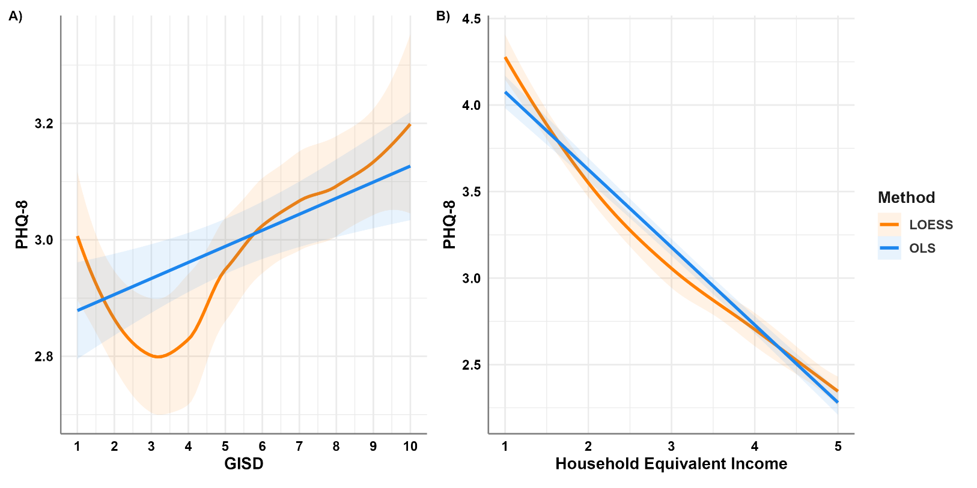
Note. Comparison of nonparametric LOESS smoothing and ordinary least squares (OLS) regression in modelling the association between neighbourhood socioeconomic deprivation (GISD) and depressive symptoms (PHQ-8). Panel A shows the full GISD range (deciles 1–10), while Panel B illustrates the relationship across household equivalent income quintiles. Shaded areas represent 95% confidence intervals.

Supplement B2. Polynomial Model Comparisons: Quadratic vs. Cubic Specifications
Table B2 shows the comparison between the quadratic and cubic model specifications. Adding the cubic term did not yield a significant improvement in model fit (F(5, 20,313) = 0.68, p = .638), and the AIC slightly increased, indicating a worse fit relative to the quadratic model. We therefore retained the more parsimonious quadratic specification for all main analyses.
Table B2.
Comparison of Quadratic and Cubic Polynomial Models Predicting Depressive Symptoms (PHQ-8)
 | Res.Df | RSS | Df | Sum of Sq. | F | p | AIC
Quadratic Model | 20318 | 219079 |  |  |  |  | 106163.1
Cubic Model | 20313 | 219042 | 5 | 36.701 | 0.6807 | 0.638 | 106169.7
Note. Res.Df = residual degrees of freedom; RSS = residual sum of squares; Df = difference in degrees of freedom; Sum of Sq. = sum of squares; F = F statistic; p = significance level; AIC = Akaike Information Criterion. Lower AIC indicate better model fit.

Supplement B3. Robustness Checks: Survey Timing (2019 vs. 2020)
To examine whether the timing of data collection influenced results, we compared participants surveyed in 2019 and 2020. As shown in Table B3, income distributions differed significantly between the two years, with fewer respondents in the lowest income quintile and more in the highest quintile in 2020. Moreover, mean PHQ-8 scores were significantly lower in 2020 compared to 2019. These differences indicate a shift in sample characteristics and symptom levels across years. However, the overall associations between neighbourhood deprivation, household income, and settlement type remained stable, suggesting that the main findings are robust to period effects.
Table B3.
Comparison of Sample Characteristics and Depressive Symptoms (PHQ-8) Between 2019 and 2020
Year (n) | Q1 (%) | Q2 (%) | Q3 (%) | Q4 (%) | Q5 (%) | PHQ-8, M (SD)
2019 (10,892) | 12.9 % | 18.6 % | 17.1 % | 23.1 % | 28.3 % | 3.15 (3.54)
2020 (9,881) | 10.8 % | 17.0 % | 17.0 % | 23.7 % | 31.5 % | 2.82 (3.37)
Note. Q1–Q5 = income quintiles, where Q1 represents the lowest and Q5 the highest household income group. Income distributions differed significantly between 2019 and 2020, with fewer participants in Q1 and more in Q5 in 2020, χ²(4) = 46.14, p < .001. Mean PHQ-8 scores were also significantly lower in 2020 compared to 2019 (ΔM = –0.43, 95% CI [–0.53, –0.34], p < .001).

Supplement B4. Variance Inflation Factors for Model 1
Predictor | GVIF | Df | GVIF^(1/(2·Df))
Sex | 1.05 | 1 | 1.03
Age | 2.93 | 1 | 1.71
Household type | 20.55 | 4 | 1.46
Living without partner | 14.33 | 1 | 3.79
Employment | 4.05 | 7 | 1.11
Migration background | 1.06 | 1 | 1.03
Household equivalent income | 25.97 | 4 | 1.50
Deprivation | 5.38 | 1 | 2.32
Deprivation [quadratic] | 5.09 | 1 | 2.26
Household equivalent income × Deprivation | 5.77 | 4 | 1.25
Household equivalent income × Deprivation [quadratic] | 67.73 | 4 | 1.69
Note. GVIF = generalized variance inflation factor (Fox & Monette 1992). For predictors with more than one degree of freedom (Df), GVIF^1/(2·Df) is reported for comparability with the conventional √VIF threshold. Values below 2 are generally considered unproblematic.
Fox, J., & Monette, G. (1992). Generalized collinearity diagnostics. Journal of the American Statistical Association, 87(417), 178-183.
Supplement C. Correlation matrices stratified by district structure
Table C1
Correlation Matrix of the key variables (cities)
 | 1. | 2. | 3. | 4. | 5.
1. PHQ-8
2. Gender | .102***
3. Age | -.045*** | .086***
4. Migration Status | -.050*** | .005 | .175***
5. Income Quintiles | -.184*** | -.091*** | .042*** | .098***
6. GISD | .019 | -.006 | .086*** | .064*** | -.083***
Note. Correlations were computed using Pearson’s r with pairwise deletion. p < .05 = *, p < .01 = **, p < .001 = ***. PHQ-8 = Patient Health Questionnaire-8; GISD = German Index of Socioeconomic Deprivation.

Table C2
Correlation Matrix of the key variables (urban)
 | 1. | 2. | 3. | 4. | 5.
1. PHQ-8
2. Gender | .117***
3. Age | -.055*** | .035**
4. Migration Status | -.065*** | .027* | .133***
5. Income Quintiles | -.172*** | -.119*** | .028* | .109***
6. GISD | .033** | .013 | .082*** | .043*** | -.102***
Note. Correlations were computed using Pearson’s r with pairwise deletion. p < .05 = *, p < .01 = **, p < .001 = ***. PHQ-8 = Patient Health Questionnaire-8; GISD = German Index of Socioeconomic Deprivation.

Table C3
Correlation Matrix of the key variables (rural)
 | 1. | 2. | 3. | 4. | 5.
1. PHQ-8
2. Gender | .117***
3. Age | -.051** | .087***
4. Migration Status | .005 | -.001 | .083***
5. Income Quintiles | -.189*** | -.123*** | .001 | .033
6. GISD | -.003 | -.010 | .099*** | .096*** | -.103***
Note. Correlations were computed using Pearson’s r with pairwise deletion. p < .05 = *, p < .01 = **, p < .001 = ***. PHQ-8 = Patient Health Questionnaire-8; GISD = German Index of Socioeconomic Deprivation.

Table C4
Correlation Matrix of the key variables (sparsely)
 | 1. | 2. | 3. | 4. | 5.
1. PHQ-8
2. Gender | .080***
3. Age | -.027 | .045*
4. Migration Status | -.031 | -.014 | .080***
5. Income Quintiles | -.178*** | -.081*** | -.012 | .036
6. GISD | .052** | -.025 | .096*** | .089*** | -.086***
Note. Correlations were computed using Pearson’s r with pairwise deletion. p < .05 = *, p < .01 = **, p < .001 = ***. PHQ-8 = Patient Health Questionnaire-8; GISD = German Index of Socioeconomic Deprivation.

Supplement D. Complete Regression Tables
Table D1.
Weighted Regression Model Testing the Moderating Role of Settlement Type (H4), Full Model
 | PHQ-8
Predictors | Estimates | CI | p
Intercept | 6.85 | 6.27 – 7.42 | <.001
Female | .63 | .53 – .74 | <.001
Age | -.02 | -.02 – -.01 | <.001
Household Type [Single parent with child] | -.49 | -.78 – -.19 | .001
Household Type [Couple no children] | -.56 | -.96 – -.15 | .007
Household Type [Couple with children] | -.96 | -1.37 – -.55 | <.001
Household Type [Other type of household] | -.70 | -.92 – -.49 | <.001
Living without partner | .07 | -.32 – .45 | .723
Employment [Not employed for other reasons] | .14 | -.39 – .67 | .608
Employment [Retired] | -1.79 | -2.12 – -1.45 | <.001
Employment [Unable to work due to long-term health problems] | 3.52 | 3.12 – 3.92 | <.001
Employment [Employed] | -1.79 | -2.09 – -1.48 | <.001
Employment [Student] | -1.70 | -2.08 – -1.33 | <.001
Employment [Homemaker] | -1.73 | -2.17 – -1.30 | <.001
Employment [Military or Civil Service] | -.81 | -2.46 – .83 | .333
Without Migration Background | -.59 | -.75 – -.44 | <.001
Household Equivalent Income [2nd quint.] | -.44 | -.67 – -.20 | <.001
Household Equivalent Income [3rd quint.] | -.63 | -.88 – -.38 | <.001
Household Equivalent Income [4th quint.] | -1.08 | -1.33 – -.84 | <.001
Household Equivalent Income [5th quint.] | -1.39 | -1.64 – -1.14 | <.001
Deprivation | .03 | -.02 – .07 | .257
Deprivation [quadratic] | .05 | .03 – .06 | <.001
Settlement Type [Urban County] | .20 | .01 – .39 | .042
Settlement Type [Rural County] | .41 | .18 – .64 | .001
Settlement Type [Sparsely Populated Rural County] | .21 | -.04 – .47 | .104
Household Equivalent Income [2] × Deprivation | .03 | -.03 – .09 | .287
Household Equivalent Income [3] × Deprivation | .04 | -.02 – .10 | .177
Household Equivalent Income [4] × Deprivation | .00 | -.06 – .05 | .906
Household Equivalent Income [5] × Deprivation | -.01 | -.07 – .04 | .641
Household Equivalent Income [2] × Deprivation [quadratic] | -.01 | -.04 – .01 | .205
Household Equivalent Income [3] × Deprivation [quadratic] | -.03 | -.05 – -.00 | .023
Household Equivalent Income [4] × Deprivation [quadratic] | -.01 | -.04 – .01 | .191
Household Equivalent Income [5] × Deprivation [quadratic] | -.01 | -.03 – .01 | .361
Settlement Type [Urban County] × Deprivation | -.04 | -.08 – .01 | .132
Settlement Type [Rural County] × Deprivation | -.07 | -.13 – -.01 | .022
Settlement Type [Sparsely Populated Rural County] × Deprivation | .06 | -.02 – .13 | .120
Settlement Type [Urban County] × Deprivation [quadratic] | -.03 | -.05 – -.02 | <.001
Settlement Type [Rural County] × Deprivation [quadratic] | -.06 | -.08 – -.03 | <.001
Settlement Type [Sparsely Populated Rural County] × Deprivation [quadratic] | -.06 | -.08 – -.03 | <.001
Observations | 20,348
R² / R² adjusted | .131 / .129
Note. Reference Group for Female is Male; Reference Group Household Type is Single Person Household; Reference for Living without Partner is Living with Partner; Reference for Employment status is Unemployed; Reference for Household Equivalent Income is under 1st quintile; Reference for Without Migration Background is With Migration Background; Reference for Settlement Type is Cities. Model compared to Model 1 via nested F-test, F(9, 20309) = 5.97, p < .001.

Table D2.
Weighted Regression Model Testing the Moderating Role of Settlement Type and Income (H5), Full Model
 | PHQ-8
Predictors | Estimates | CI | p
Intercept | 6.15 | 5.53 – 6.78 | <.001
Female | .63 | .52 – .73 | <.001
Age | -.01 | -.02 – -.01 | <.001
Household Type [Single parent with child] | -.53 | -.82 – -.24 | <.001
Household Type [Couple no children] | -.55 | -.96 – -.15 | .007
Household Type [Couple with children] | -.95 | -1.36 – -.55 | <.001
Household Type [Other type of household] | -.72 | -.93 – -.50 | <.001
Living without partner | .08 | -.31 – .46 | .688
Employment [Not employed for other reasons] | .12 | -.41 – .65 | .649
Employment [Retired] | -1.79 | -2.12 – -1.45 | <.001
Employment [Unable to work due to long-term health problems] | 3.53 | 3.12 – 3.93 | <.001
Employment [Employed] | -1.78 | -2.09 – -1.47 | <.001
Employment [Student] | -1.66 | -2.04 – -1.29 | <.001
Employment [Homemaker] | -1.73 | -2.17 – -1.29 | <.001
Employment [Military or Civil Service] | -.63 | -2.28 – 1.02 | .454
Without Migration Background | -.59 | -.75 – -.43 | <.001
Household Equivalent Income [2nd quint.] | .26 | -.20 – .72 | .265
Household Equivalent Income [3rd quint.] | .40 | -.09 – .90 | .109
Household Equivalent Income [4th quint.] | -.33 | -.81 – .15 | .179
Household Equivalent Income [5th quint.] | -.42 | -.90 – .05 | .080
Deprivation, Cities & 1st quintile [reference] | .11 | .04 – .17 | .001
Deprivation [quadratic], Cities & 1st quintile [reference] | .10 | .07 – .12 | <.001
Settlement Type [Urban County] | 1.15 | .72 – 1.57 | <.001
Settlement Type [Rural County] | 1.56 | 1.06 – 2.06 | <.001
Settlement Type [Sparsely Populated Rural County] | .77 | .19 – 1.36 | .010
Household Equivalent Income [2] × Deprivation | -.13 | -.22 – -.04 | .005
Household Equivalent Income [3] × Deprivation | -.03 | -.13 – .06 | .479
Household Equivalent Income [4] × Deprivation | -.10 | -.19 – -.01 | .031
Household Equivalent Income [5] × Deprivation | -.10 | -.19 – -.00 | .040
Household Equivalent Income [2] × Deprivation [quadratic] | -.08 | -.12 – -.05 | <.001
Household Equivalent Income [3] × Deprivation [quadratic] | -.09 | -.13 – -.05 | <.001
Household Equivalent Income [4] × Deprivation [quadratic] | -.08 | -.11 – -.04 | <.001
Household Equivalent Income [5] × Deprivation [quadratic] | -.08 | -.12 – -.05 | <.001
Settlement Type [Urban County] × Deprivation | -.28 | -.38 – -.17 | <.001
Settlement Type [Rural County] × Deprivation | .04 | -.11 – .18 | .619
Settlement Type [Sparsely Populated Rural County] × Deprivation | .01 | -.18 – .20 | .916
Settlement Type [Urban County] × Deprivation [quadratic] | -.11 | -.16 – -.07 | <.001
Settlement Type [Rural County] × Deprivation [quadratic] | -.18 | -.23 – -.13 | <.001
Settlement Type [Sparsely Populated Rural County] × Deprivation [quadratic] | -.13 | -.19 – -.07 | <.001
Household Equivalent Income [2] × Settlement Type [Urban County] | -.94 | -1.52 – -.35 | .002
Household Equivalent Income [3] × Settlement Type [Urban County] | -1.50 | -2.13 – -.88 | <.001
Household Equivalent Income [4] × Settlement Type [Urban County] | -1.07 | -1.68 – -.46 | .001
Household Equivalent Income [5] × Settlement Type [Urban County] | -1.35 | -1.95 – -.75 | <.001
Household Equivalent Income [2] × Settlement Type [Rural County] | -1.27 | -1.96 – -.58 | <.001
Household Equivalent Income [3] × Settlement Type [Rural County] | -1.59 | -2.33 – -.86 | <.001
Household Equivalent Income [4] × Settlement Type [Rural County] | -1.46 | -2.18 – -.75 | <.001
Household Equivalent Income [5] × Settlement Type [Rural County] | -1.60 | -2.33 – -.86 | <.001
Household Equivalent Income [2] × Settlement Type [Sparsely Populated Rural County] | -.74 | -1.52 – .05 | .066
Household Equivalent Income [3] × Settlement Type [Sparsely Populated Rural County] | -.83 | -1.66 – .00 | .051
Household Equivalent Income [4] × Settlement Type [Sparsely Populated Rural County] | -.45 | -1.27 – .37 | .281
Household Equivalent Income [5] × Settlement Type [Sparsely Populated Rural County] | -.99 | -1.84 – -.15 | .021
Household Equivalent Income [2] × Settlement Type [Urban County] × Deprivation | .41 | .27 – .56 | <.001
Household Equivalent Income [3] × Settlement Type [Urban County] × Deprivation | .24 | .09 – .40 | .002
Household Equivalent Income [4] × Settlement Type [Urban County] × Deprivation | .27 | .12 – .42 | <.001
Household Equivalent Income [5] × Settlement Type [Urban County] × Deprivation | .26 | .11 – .41 | .001
Household Equivalent Income [2] × Settlement Type [Rural County] × Deprivation | -.10 | -.30 – .09 | .290
Household Equivalent Income [3] × Settlement Type [Rural County] × Deprivation | -.17 | -.37 – .03 | .097
Household Equivalent Income [4] × Settlement Type [Rural County] × Deprivation | -.09 | -.28 – .10 | .353
Household Equivalent Income [5] × Settlement Type [Rural County] × Deprivation | -.11 | -.30 – .08 | .267
Household Equivalent Income [2] × Settlement Type [Sparsely Populated Rural County] × Deprivation | .24 | -.00 – .49 | .054
Household Equivalent Income [3] × Settlement Type [Sparsely Populated Rural County] × Deprivation | .07 | -.19 – .32 | .602
Household Equivalent Income [4] × Settlement Type [Sparsely Populated Rural County] × Deprivation | -.06 | -.30 – .18 | .617
Household Equivalent Income [5] × Settlement Type [Sparsely Populated Rural County] × Deprivation | .03 | -.22 – .28 | .793
Household Equivalent Income [2] × Settlement Type [Urban County] × Deprivation [quadratic] | .12 | .06 – .17 | <.001
Household Equivalent Income [3] × Settlement Type [Urban County] × Deprivation [quadratic] | .10 | .04 – .16 | .001
Household Equivalent Income [4] × Settlement Type [Urban County] × Deprivation [quadratic] | .09 | .03 – .15 | .002
Household Equivalent Income [5] × Settlement Type [Urban County] × Deprivation [quadratic] | .12 | .06 – .17 | <.001
Household Equivalent Income [2] × Settlement Type [Rural County] × Deprivation [quadratic] | .15 | .08 – .22 | <.001
Household Equivalent Income [3] × Settlement Type [Rural County] × Deprivation [quadratic] | .16 | .08 – .23 | <.001
Household Equivalent Income [4] × Settlement Type [Rural County] × Deprivation [quadratic] | .15 | .08 – .22 | <.001
Household Equivalent Income [5] × Settlement Type [Rural County] × Deprivation [quadratic] | .17 | .10 – .24 | <.001
Household Equivalent Income [2] × Settlement Type [Sparsely Populated Rural County] × Deprivation [quadratic] | .08 | .00 – .16 | .047
Household Equivalent Income [3] × Settlement Type [Sparsely Populated Rural County] × Deprivation [quadratic] | .06 | -.02 – .15 | .150
Household Equivalent Income [4] × Settlement Type [Sparsely Populated Rural County] × Deprivation [quadratic] | .11 | .03 – .19 | .009
Household Equivalent Income [5] × Settlement Type [Sparsely Populated Rural County] × Deprivation [quadratic] | .08 | -.00 – .17 | .056
Observations | 20,348
R² / R² adjusted | .135 / .132
Note. Reference Group for Female is Male; Reference Group Household Type is Single Person Household; Reference for Living without Partner is Living with Partner; Reference for Employment status is Unemployed; Reference for Household Equivalent Income is 1st quintile; Reference for Without Migration Background is With Migration Background; Reference for Settlement Type is Cities. Deprivation and Deprivation [quadratic] main effects apply to the joint reference group (Cities, 1st income quintile). Model compared to H4 model via nested F-test, F(36, 20273) = 2.93, p < .001.

