Supplemental material to the manuscript

The Mental Cost of Urban Living: A Study of Spatial Deprivation
Supplement A. Settlement Structure
Figure A1.
German Settlement Structure Types of Districts (2020)
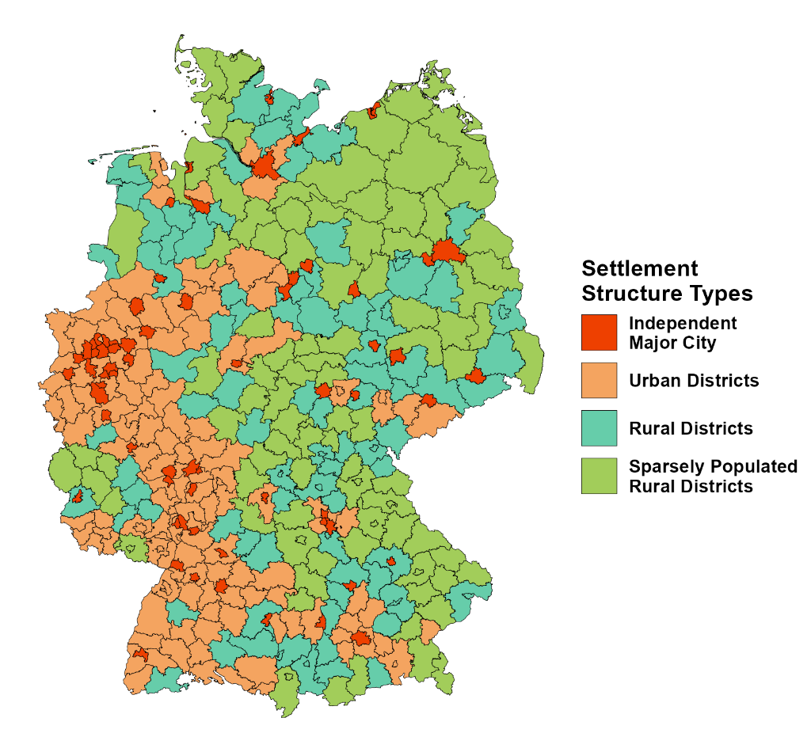
Note. The map displays the spatial distribution of settlement structure types across Germany’s 401 districts as defined by the BBSR.

Supplement B1. R packages used for the analyses
Table A1 provides an overview of the R packages and versions used for the statistical analyses and visualization.
Table B1.
R-Packages used for the Analysis
Package | Version | Reference
car | 3.1-2 | Fox J, Weisberg S (2019). An R Companion to Applied Regression, Third Edition. Sage, Thousand Oaks CA. R package version 3.1-2, https://CRAN.R-project.org/package=car.
emmeans | 1.10.0 | Lenth RV (2024). emmeans: Estimated Marginal Means, aka Least-Squares Means. R package version 1.10.0, https://CRAN.R-project.org/package=emmeans.
foreign | 0.8-86 | R Core Team (2023). foreign: Read Data Stored by 'Minitab', 'S', 'SAS', 'SPSS', 'Stata', 'Systat'. R package version 0.8-86, https://CRAN.R-project.org/package=foreign.
ggplot2 | 3.5.1 | Wickham H (2016). ggplot2: Elegant Graphics for Data Analysis. Springer-Verlag New York.
ggpubr | 0.6.0 | Kassambara A (2023). ggpubr: 'ggplot2' Based Publication Ready Plots. R package version 0.6.0, https://CRAN.R-project.org/package=ggpubr.
ggsignif | 0.6.4 | Ahlmann-Eltze C, Patil I (2021). ggsignif: R Package for Displaying Significance Brackets for 'ggplot2'. Journal of Open Source Software, 6(60), 3266. doi:10.21105/joss.03266.
haven | 2.5.4 | Wickham H, Miller E, Smith D (2023). haven: Import and Export 'SPSS', 'Stata' and 'SAS' Files. R package version 2.5.4, https://CRAN.R-project.org/package=haven.
janitor | 2.2.0 | Firke S (2023). janitor: Simple Tools for Examining and Cleaning Dirty Data. R package version 2.2.0, https://CRAN.R-project.org/package=janitor.
labelled | 2.13.0 | Larmarange J (2024). labelled: Manipulating Labelled Data. R package version 2.13.0, https://CRAN.R-project.org/package=labelled.
lme4 | 1.1-35.2 | Bates D, Mächler M, Bolker B, Walker S (2015). Fitting Linear Mixed-Effects Models Using lme4. Journal of Statistical Software, 67(1), 1–48. doi:10.18637/jss.v067.i01.
patchwork | 1.2.0 | Pedersen TL (2024). patchwork: The Composer of Plots. R package version 1.2.0, https://CRAN.R-project.org/package=patchwork.
psych | 2.4.3 | Revelle W (2024). psych: Procedures for Psychological, Psychometric, and Personality Research. Northwestern University, Evanston, Illinois. R package version 2.4.3, https://CRAN.R-project.org/package=psych.
rstatix | 0.7.2 | Kassambara A (2023). rstatix: Pipe-Friendly Framework for Basic Statistical Tests. R package version 0.7.2, https://CRAN.R-project.org/package=rstatix.
sjlabelled | 1.2.0 | Lüdecke D (2024). sjlabelled: Labelled Data Utility Functions. R package version 1.2.0, https://CRAN.R-project.org/package=sjlabelled.
sjmisc | 2.8.10 | Lüdecke D (2018). sjmisc: Data and Variable Transformation Functions. Journal of Open Source Software, 3(26), 754. doi:10.21105/joss.00754.
sjPlot | 2.8.16 | Lüdecke D (2024). sjPlot: Data Visualization for Statistics in Social Science. R package version 2.8.16, https://CRAN.R-project.org/package=sjPlot.
sjstats | 0.19.0 | Lüdecke D (2024). sjstats: Statistical Functions for Regression Models (Version 0.19.0). doi:10.5281/zenodo.1284472.
stats | 4.4.1 | R Core Team (2024). stats: The R Stats Package. R package version 4.4.1, https://CRAN.R-project.org/package=stats.
tidyverse | 2.0.0 | Wickham H, Averick M, Bryan J, Chang W, D’Agostino McGowan L, François R, Grolemund G, Hayes A, Henry L, Hester J, Kuhn M, Pedersen TL, Miller E, Bache SM, Müller K, Ooms J, Robinson D, Seidel DP, Spinu V, Takahashi K, Vaughan D, Wilke C, Woo K, Yutani H (2019). Welcome to the tidyverse. Journal of Open Source Software, 4(43), 1686. doi:10.21105/joss.01686.
Note. Listed are all R packages, including version numbers and recommended references, that were used for data management, statistical analyses, and visualization in this study.

Supplement B2. Polynomial Model Comparisons: Quadratic vs. Cubic Specifications
Table A2 shows the comparison between the quadratic and cubic model specifications. Adding the cubic term did not yield a significant improvement in model fit (F(5, 20,313) = 0.68, p = .638), and the AIC slightly increased, indicating a worse fit relative to the quadratic model. We therefore retained the more parsimonious quadratic specification for all main analyses.
Table B2.
Comparison of Quadratic and Cubic Polynomial Models Predicting Depressive Symptoms (PHQ-8)
 | Res.Df | RSS | Df | Sum of Sq. | F | p | AIC
Quadratic Model | 20318 | 219079 |  |  |  |  | 106163.1
Cubic Model | 20313 | 219042 | 5 | 36.701 | 0.6807 | 0.638 | 106169.7
Note. Res.Df = residual degrees of freedom; RSS = residual sum of squares; Df = difference in degrees of freedom; Sum of Sq. = sum of squares; F = F statistic; p = significance level; AIC = Akaike Information Criterion. Lower AIC indicate better model fit.

Supplement B3. Robustness Checks: Survey Timing (2019 vs. 2020)
To examine whether the timing of data collection influenced results, we compared participants surveyed in 2019 and 2020. As shown in Table A2, income distributions differed significantly between the two years, with fewer respondents in the lowest income quintile and more in the highest quintile in 2020. Moreover, mean PHQ-8 scores were significantly lower in 2020 compared to 2019. These differences indicate a shift in sample characteristics and symptom levels across years. However, the overall associations between neighbourhood deprivation, household income, and settlement type remained stable, suggesting that the main findings are robust to period effects.
Table B3.
Comparison of Sample Characteristics and Depressive Symptoms (PHQ-8) Between 2019 and 2020
Year (n) | Q1 (%) | Q2 (%) | Q3 (%) | Q4 (%) | Q5 (%) | PHQ-8, M (SD)
2019 (10,892) | 12.9 % | 18.6 % | 17.1 % | 23.1 % | 28.3 % | 3.15 (3.54)
2020 (9,881) | 10.8 % | 17.0 % | 17.0 % | 23.7 % | 31.5 % | 2.82 (3.37)
Note. Q1–Q5 = income quintiles, where Q1 represents the lowest and Q5 the highest household income group. Income distributions differed significantly between 2019 and 2020, with fewer participants in Q1 and more in Q5 in 2020, χ²(4) = 46.14, p < .001. Mean PHQ-8 scores were also significantly lower in 2020 compared to 2019 (ΔM = –0.43, 95% CI [–0.53, –0.34], p < .001).

Supplement C. Correlation matrices stratified by district structure
Table C1
Correlation Matrix of the key variables (cities)
 | 1. | 2. | 3. | 4. | 5.
1. PHQ-8
2. Gender | .102***
3. Age | -.045*** | .086***
4. Migration Status | -.050*** | .005 | .175***
5. Income Quintiles | -.184*** | -.091*** | .042*** | .098***
6. GISD | .019 | -.006 | .086*** | .064*** | -.083***
Note. Correlations were computed using Pearson’s r with pairwise deletion. p < .05 = *, p < .01 = **, p < .001 = ***. PHQ-8 = Patient Health Questionnaire-8; GISD = German Index of Socioeconomic Deprivation.

Table C2
Correlation Matrix of the key variables (urban)
 | 1. | 2. | 3. | 4. | 5.
1. PHQ-8
2. Gender | .117***
3. Age | -.055*** | .035**
4. Migration Status | -.065*** | .027* | .133***
5. Income Quintiles | -.172*** | -.119*** | .028* | .109***
6. GISD | .033** | .013 | .082*** | .043*** | -.102***
Note. Correlations were computed using Pearson’s r with pairwise deletion. p < .05 = *, p < .01 = **, p < .001 = ***. PHQ-8 = Patient Health Questionnaire-8; GISD = German Index of Socioeconomic Deprivation.

Table C3
Correlation Matrix of the key variables (rural)
 | 1. | 2. | 3. | 4. | 5.
1. PHQ-8
2. Gender | .117***
3. Age | -.051** | .087***
4. Migration Status | .005 | -.001 | .083***
5. Income Quintiles | -.189*** | -.123*** | .001 | .033
6. GISD | -.003 | -.010 | .099*** | .096*** | -.103***
Note. Correlations were computed using Pearson’s r with pairwise deletion. p < .05 = *, p < .01 = **, p < .001 = ***. PHQ-8 = Patient Health Questionnaire-8; GISD = German Index of Socioeconomic Deprivation.

Table C4
Correlation Matrix of the key variables (sparsely)
 | 1. | 2. | 3. | 4. | 5.
1. PHQ-8
2. Gender | .080***
3. Age | -.027 | .045*
4. Migration Status | -.031 | -.014 | .080***
5. Income Quintiles | -.178*** | -.081*** | -.012 | .036
6. GISD | .052** | -.025 | .096*** | .089*** | -.086***
Note. Correlations were computed using Pearson’s r with pairwise deletion. p < .05 = *, p < .01 = **, p < .001 = ***. PHQ-8 = Patient Health Questionnaire-8; GISD = German Index of Socioeconomic Deprivation.

Supplement D. Complete Regression Tables

Table D1.
Weighted Regression Model Predicting Depressive Symptoms (PHQ-8) – Model 1
 | PHQ-8
Predictors | Beta | CI | p
Intercept | .71 | .58 – .84 | <.001
Female | .16 | .13 – .19 | <.001
Age | -.07 | -.09 – -.05 | <.001
Household Type [Single parent with child] | -.12 | -.20 – -.05 | .001
Household Type [Couple no children] | -.14 | -.24 – -.04 | .007
Household Type [Couple with children] | -.24 | -.35 – -.14 | <.001
Household Type [Other type of household] | -.18 | -.23 – -.12 | <.001
Living without partner | .02 | -.08 – .12 | .671
Employment [Not employed for other reasons] | .03 | -.10 – .16 | .667
Employment [Retired] | -.46 | -.54 – -.37 | <.001
Employment [Unable to work due to long-term health problems] | .89 | .79 – .99 | <.001
Employment [Employed] | -.46 | -.54 – -.38 | <.001
Employment [Student] | -.43 | -.52 – -.34 | <.001
Employment [Homemaker] | -.44 | -.55 – -.33 | <.001
Employment [Military or Civil Service] | -.21 | -.63 – .21 | .326
Without Migration Background | -.16 | -.20 – -.12 | <.001
Household Equivalent Income [2nd quint.] | -.11 | -.17 – -.05 | <.001
Household Equivalent Income [3rd quint.] | -.16 | -.22 – -.09 | <.001
Household Equivalent Income [4th quint.] | -.27 | -.33 – -.21 | <.001
Household Equivalent Income [5th quint.] | -.35 | -.41 – -.29 | <.001
Deprivation | -.01 | -.04 – .02 | .469
Deprivation [quadratic] | .04 | .01 – .07 | .011
Household Equivalent Income [2] × Deprivation | .03 | -.01 – .07 | .198
Household Equivalent Income [3] × Deprivation | .04 | -.00 – .08 | .081
Household Equivalent Income [4] × Deprivation | .01 | -.04 – .05 | .802
Household Equivalent Income [5] × Deprivation | -.00 | -.05 – .04 | .826
Household Equivalent Income [2] × Deprivation [quadratic] | -.03 | -.07 – .01 | .146
Household Equivalent Income [3] × Deprivation [quadratic] | -.06 | -.10 – -.01 | .014
Household Equivalent Income [4] × Deprivation [quadratic] | -.03 | -.07 – .01 | .179
Household Equivalent Income [5] × Deprivation [quadratic] | -.02 | -.06 – .02 | .392
Observations | 20,348
R² / R² adjusted | .128 / .127
Note. Reference Group for Female is Male; Reference Group Household Type is Single Person Household; Reference for Living without Partner is Living with Partner; Reference for Employment status is Unemployed; Reference for Household Equivalent Income is under 1st quintile; Reference for Without Migration Background is With Migration Background.

Table D2.
Weighted Regression Models Predicting Depressive Symptoms (PHQ-8), Stratified by Settlement Type – Model 2 to 5
 | Cities |  |  |  | Urban |  |  | Rural |  |  |  | Sparsely Populated
Predictors |  | Beta | CI | p | Beta | CI | p |  | Beta | CI | p | Beta | CI | p
Intercept |  | .22 | -.02 – .45 | .075 | 1.14 | .93 – 1.36 | <.001 |  | .93 | .56 – 1.30 | <.001 | .62 | .23 – 1.01 | .002
Female |  | .19 | .15 – .24 | <.001 | .17 | .13 – .21 | <.001 |  | .14 | .07 – .21 | <.001 | .09 | .02 – .17 | .016
Age |  | -.08 | -.12 – -.04 | <.001 | -.05 | -.09 – -.02 | .003 |  | -.07 | -.13 – -.01 | .023 | -.11 | -.17 – -.05 | <.001
Household Type [Single parent with child] |  | -.15 | -.28 – -.02 | .023 | -.15 | -.27 – -.03 | .015 |  | -.21 | -.41 – -.00 | .046 | .02 | -.18 – .22 | .876
Household Type [Couple no children] |  | -.12 | -.33 – .08 | .245 | -.15 | -.32 – .02 | .078 |  | -.31 | -.57 – -.06 | .014 | -.04 | -.31 – .22 | .750
Household Type [Couple with children] |  | -.19 | -.40 – .02 | .069 | -.32 | -.49 – -.15 | <.001 |  | -.42 | -.68 – -.16 | .001 | -.07 | -.34 – .20 | .609
Household Type [Other type of household] |  | -.12 | -.20 – -.03 | .010 | -.17 | -.26 – -.08 | <.001 |  | -.29 | -.44 – -.15 | <.001 | -.21 | -.39 – -.04 | .015
Without Migration Background |  | -.16 | -.22 – -.10 | <.001 | -.23 | -.30 – -.17 | <.001 |  | .00 | -.15 – .15 | .981 | .04 | -.10 – .18 | .574
Living without partner |  | .05 | -.15 – .25 | .617 | -.04 | -.20 – .12 | .645 |  | -.09 | -.32 – .15 | .476 | .12 | -.13 – .36 | .362
Employment [Not employed for other reasons] |  | .37 | .17 – .57 | <.001 | -.41 | -.65 – -.18 | .001 |  | .05 | -.30 – .40 | .790 | -.16 | -.60 – .29 | .495
Employment [Retired] |  | -.17 | -.30 – -.03 | .015 | -.71 | -.85 – -.57 | <.001 |  | -.54 | -.79 – -.29 | <.001 | -.51 | -.76 – -.26 | <.001
Employment [Unable to work due to long-term health problems] |  | .82 | .66 – .98 | <.001 | 1.02 | .84 – 1.19 | <.001 |  | .75 | .46 – 1.05 | <.001 | .89 | .59 – 1.19 | <.001
Employment [Employed] |  | -.25 | -.36 – -.13 | <.001 | -.64 | -.77 – -.51 | <.001 |  | -.49 | -.73 – -.25 | <.001 | -.63 | -.87 – -.39 | <.001
Employment [Student] |  | -.30 | -.43 – -.16 | <.001 | -.62 | -.79 – -.46 | <.001 |  | -.28 | -.58 – .01 | .062 | -.39 | -.74 – -.05 | .025
Employment [Homemaker] |  | -.35 | -.54 – -.16 | <.001 | -.51 | -.67 – -.34 | <.001 |  | -.55 | -.88 – -.22 | .001 | -.78 | -1.14 – -.42 | <.001
Employment [Military or Civil Service] |  | -.51 | -1.42 – .40 | .275 | .22 | -.46 – .89 | .524 |  | -1.27 | -2.74 – .21 | .093 | -.26 | -1.07 – .55 | .530
Household Equivalent Income [2nd quint.] |  | .03 | -.07 – .14 | .533 | -.22 | -.31 – -.13 | <.001 |  | -.24 | -.39 – -.09 | .002 | -.09 | -.27 – .09 | .345
Household Equivalent Income [3rd quint.] |  | .05 | -.07 – .17 | .393 | -.30 | -.40 – -.21 | <.001 |  | -.27 | -.44 – -.11 | .001 | -.11 | -.30 – .08 | .270
Household Equivalent Income [4th quint.] |  | -.12 | -.23 – -.01 | .040 | -.37 | -.46 – -.28 | <.001 |  | -.43 | -.59 – -.27 | <.001 | -.23 | -.42 – -.04 | .016
Household Equivalent Income [5th quint.] |  | -.14 | -.25 – -.02 | .018 | -.47 | -.56 – -.38 | <.001 |  | -.48 | -.66 – -.31 | <.001 | -.38 | -.58 – -.18 | <.001
Deprivation |  | -.01 | -.06 – .04 | .650 | -.09 | -.14 – -.04 | .001 |  | .04 | -.04 – .12 | .355 | -.02 | -.11 – .08 | .756
Deprivation [quadratic] |  | .24 | .18 – .30 | <.001 | -.03 | -.07 – .02 | .221 |  | -.13 | -.21 – -.05 | .002 | -.06 | -.17 – .05 | .271
Household Equivalent Income [2] × Deprivation |  | -.03 | -.10 – .04 | .417 | .14 | .07 – .21 | <.001 |  | -.11 | -.22 – .00 | .056 | .10 | -.02 – .23 | .103
Household Equivalent Income [3] × Deprivation |  | .07 | -.01 – .15 | .086 | .13 | .05 – .20 | .001 |  | -.10 | -.21 – .02 | .105 | -.02 | -.16 – .11 | .726
Household Equivalent Income [4] × Deprivation |  | -.01 | -.09 – .06 | .737 | .10 | .03 – .17 | .006 |  | -.08 | -.19 – .04 | .175 | -.02 | -.16 – .12 | .787
Household Equivalent Income [5] × Deprivation |  | .01 | -.06 – .08 | .830 | .07 | .00 – .14 | .046 |  | -.08 | -.19 – .04 | .201 | -.01 | -.16 – .14 | .899
Household Equivalent Income [2] × Deprivation [quadratic] |  | -.21 | -.29 – -.12 | <.001 | .05 | -.01 – .11 | .111 |  | .11 | -.00 – .22 | .055 | .02 | -.12 – .16 | .801
Household Equivalent Income [3] × Deprivation [quadratic] |  | -.23 | -.33 – -.14 | <.001 | .02 | -.05 – .08 | .599 |  | .10 | -.02 – .21 | .092 | -.05 | -.19 – .09 | .499
Household Equivalent Income [4] × Deprivation [quadratic] |  | -.19 | -.28 – -.11 | <.001 | .02 | -.04 – .08 | .481 |  | .11 | -.00 – .22 | .053 | .06 | -.08 – .20 | .416
Household Equivalent Income [5] × Deprivation [quadratic] |  | -.21 | -.29 – -.12 | <.001 | .05 | -.01 – .11 | .086 |  | .13 | .01 – .24 | .029 | .01 | -.14 – .15 | .922
Observations | 7,224 |  |  |  | 7,999 |  |  |  | 2,690 |  |  | 2,435
R² / R² adjusted | .120 / .117 |  |  |  | .155 / .152 |  |  |  | .139 / .130 |  |  | .144 / .133
Note. Reference Group for Female is Male; Reference Group Household Type is Single Person Household; Reference for Living without Partner is Living with Partner; Reference for Employment status is Unemployed; Reference for Household Equivalent Income is under 1st quintile; Reference for Without Migration Background is With Migration Background.

