(A)
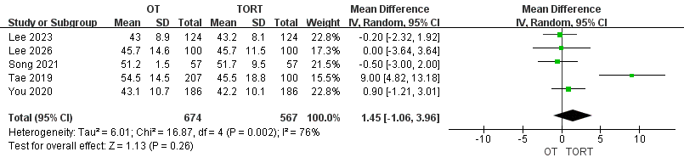
(B)
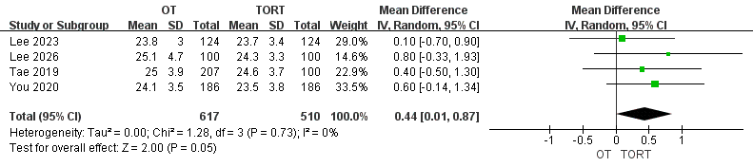
(C)
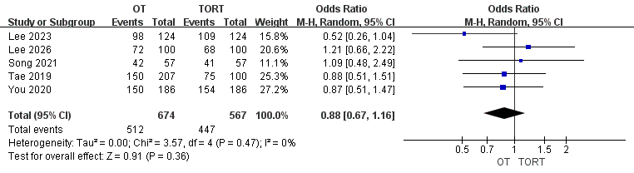
(D)
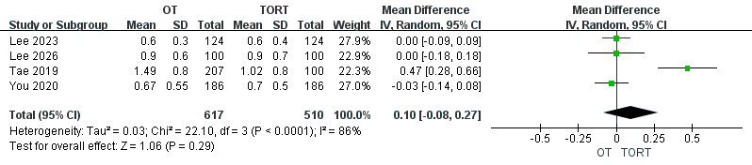
(E)
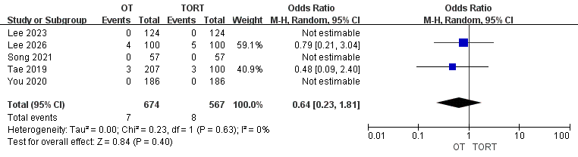
(F)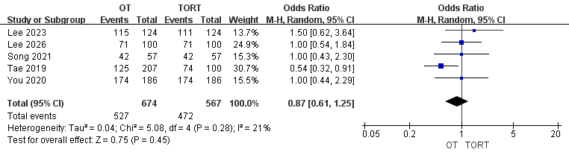
(G)
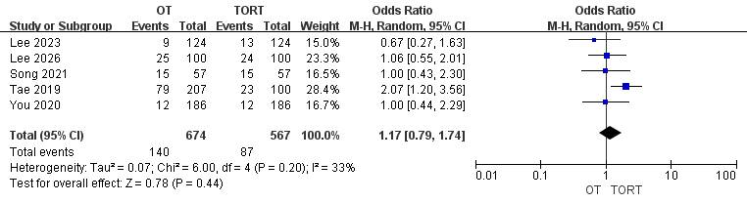
(H)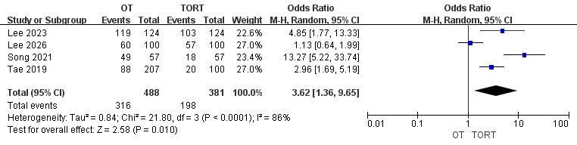
(I)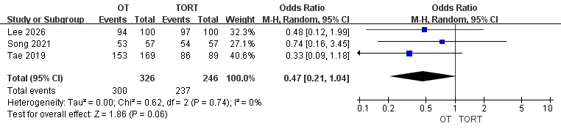
(J)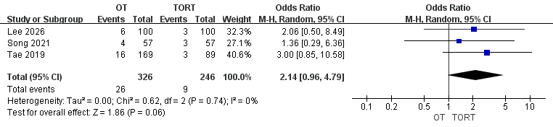
(K)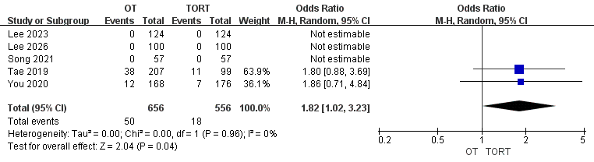
(L)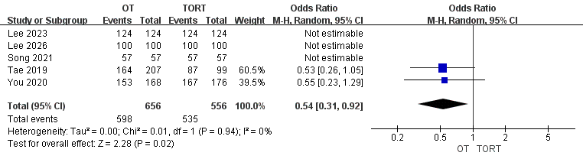
(M)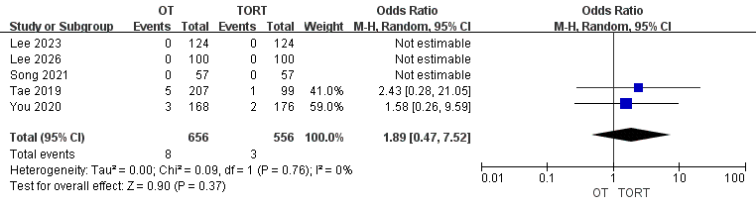
Forest plot of meta-analysis of the following variables: (A) age, (B) BMI, (C) Number of female, (D) Tumor size, (E) Isthmusectomy, (F) Lobectomy, (G) Total thyroidectomy, (H) Central neck dissection, (I) TNM Stage of I, (J) TNM Stage of II, (K) Benign tumor, (L) PTC,(L) FTC.

