SUPPLEMENTAL MATERIAL

SUPPLEMENTAL TABLES
Table S1
Antibodies used for flow cytometry of immune cells in kidney tissue. Staining sets 1 and 2 were stained in parallel using identical buffers and laboratory materials for comparability. APC = Allophycocyanin, PE Cy7 = Phycoerythrin-Cyanine 7, FITC = Fluorescein isothiocyanate, BV = Brilliant
Staining set | Antibody | Dilution | Manufacturer/Catalogue number
1 – Macrophages | CD45 BV510 | 1:500 | Biolegend/103138
1 – Macrophages | CD11b APC | 1:200 | Biolegend/101212
1 – Macrophages | Ly6G APC Cy7 | 1:500 | Biolegend/127623
1 – Macrophages | Ly6C FITC | 1:500 | BD Bioscience/553104
1 – Macrophages | F4/80 PE Cy7 | 1:200 | Biolegend/123114
2 – T cells | CD45 APC Cy7 | 1:500 | Biolegend/103115
2 – T cells | TCRβ BV510 | 1:200 | Biolegend/109234
2 – T cells | CD4 PE-Cy7 | 1:200 | Biolegend/100422
2 – T cells | CD8 APC | 1:200 | Biolegend/100712

Table S2
Antibodies used for immunofluorescent staining of endomucin (EMCN) and erythroblast transformation-specific-related gene protein (ERG).
Primary antibody | Dilution | Manufacturer/  Catalogue number | Secondary antibody | Dilution | Manufacturer/  Catalogue number
Rat anti-EMCN (V.7C7) | 1:25 | Santa Cruz Biotechnology/  sc-65495 | Goat anti-rat IgG, Alexa Fluor™ 647 | 1:500 | Invitrogen/  A-21247
Goat  anti-renin 1 | 1:100 | R&D systems/ AF4277 | Donkey anti-goat IgG,  Alexa Fluor™ 647 | 1:500 | Invitrogen/  A-21447

SUPPLEMENTAL FIGURES
A.
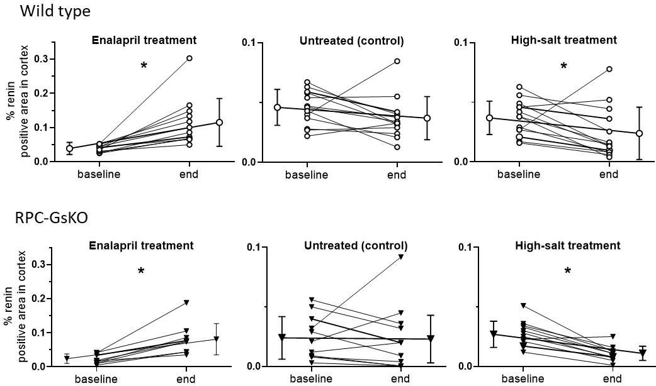
B.
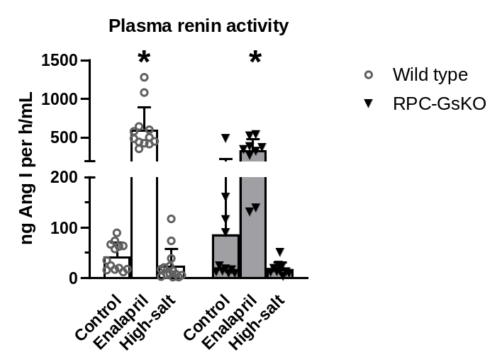
Figure S1. Angiotensin-converting-enzyme inhibitor (ACEi) enalapril increases, while high-salt diet decreases renin production in wild type and Gsα-deficient mice (RPC-GsKO)
A. Automatic quantification of immunofluorescent renin staining in cortical regions of whole kidney sections from wild type (upper panels) and RPC-GsKO mice (lower panels) for the time points and treatments shown. Data are single values and mean±SD. n=9-14 animals/ group. *p<0.05 with pairwise t-test.
B. Plasma renin activity (PRA) in wild type and RPC-GsKO mice after three months of treatment (end time point) with enalapril, high-salt diet, or without treatment (control). Bar plot with means ± SD and overlaid scatter dot plot. n=9-12 animals/group. *p<0.05 compared to the untreated control group of the same genotype.
A.
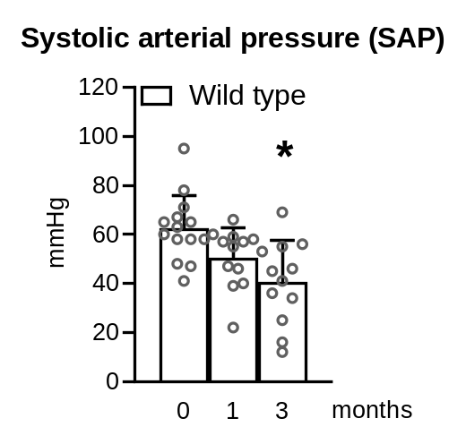
B.
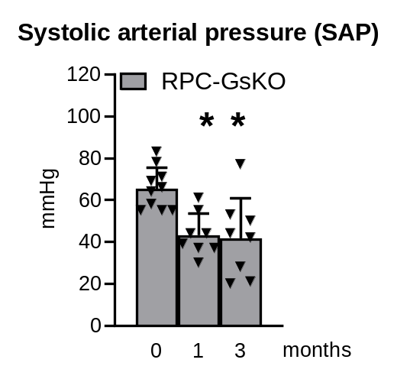

Figure S2. Angiotensin-converting-enzyme inhibitor (ACEi) lowers arterial blood pressure in wild type and RPC-specific Gsα-deficient (RPC-GsKO) mice
Systolic arterial pressure (SAP) of wild type (A) and RPC-GsKO mice (B) measured under light inhalation narcosis before start (0 months, baseline), after one (1), and three months (3) of enalapril treatment. Bar plot with means ± SD and overlaid scatter dot plot. n=8-14 animals/group. *p<0.05 compared to corresponding baseline (0 months).

A.
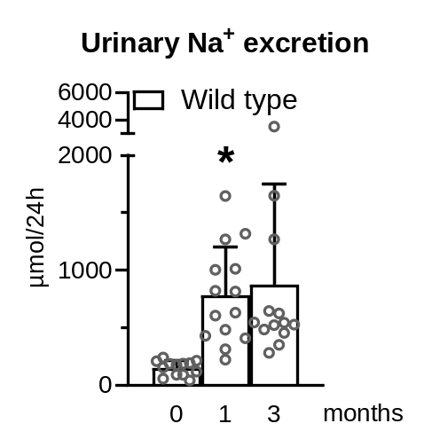
B.
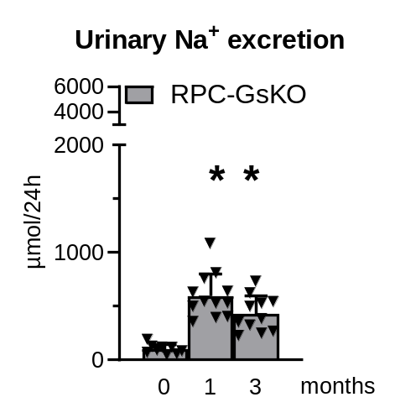

Figure S3. Urinary sodium excretion increases in wild type and RPC-specific Gsα-deficient (RPC-GsKO) mice on high-salt diet
Urinary sodium excretion of wild type (A) and RPC-GsKO mice (B) before start (0 months, baseline), after one (1), and three months (3) of high-salt diet. Bar plot with means ± SD and overlaid scatter dot plot. n=9-14 animals/group. *p<0.05 compared to corresponding baseline (0 months).

A.
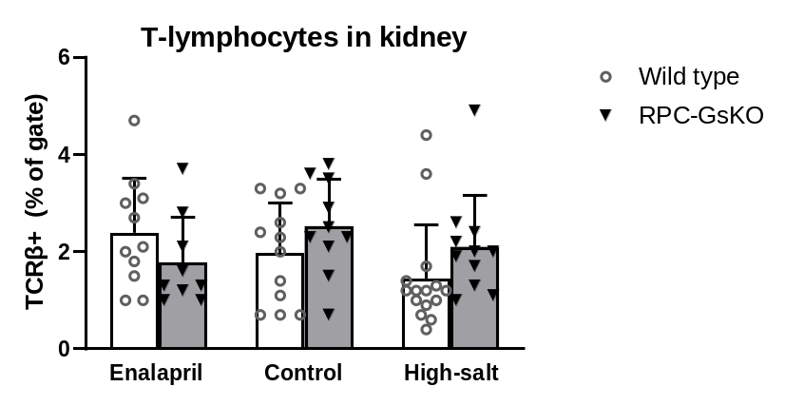

B.
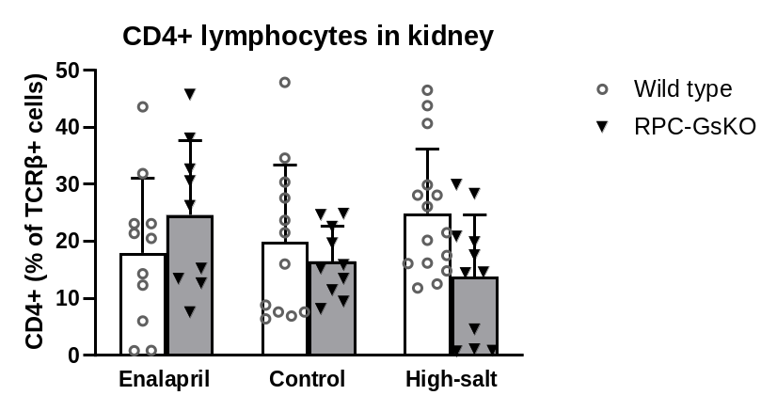

C.
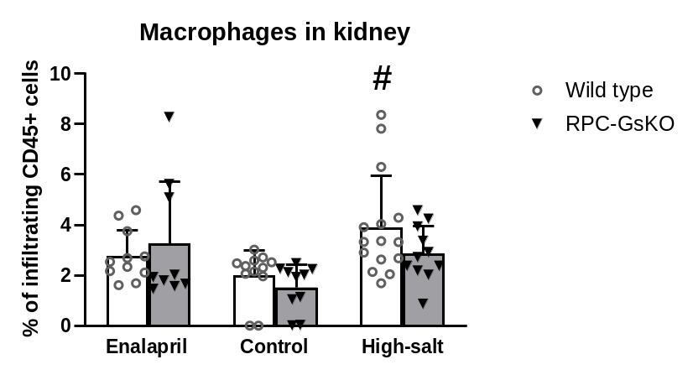
Figure S4. Renal immune cell infiltration in wild type and RPC-specific Gsα-deficient mice (RPC-GsKO) at end time point
Flow cytometry of total T-lymphocytes (A), regulatory CD4+ T-lymphocytes (B), and macrophages (C) in the kidneys of wild type and RPC-GsKO mice after three months of treatment with enalapril, high-salt diet, or without treatment (control). Bar plot with means ± SD and overlaid scatter dot plot. n=9-15 animals/group. #p<0.05 compared to the untreated control group of the same genotype.

