e-Figure 1
A number of participants with having multiple stress and overlap between stress

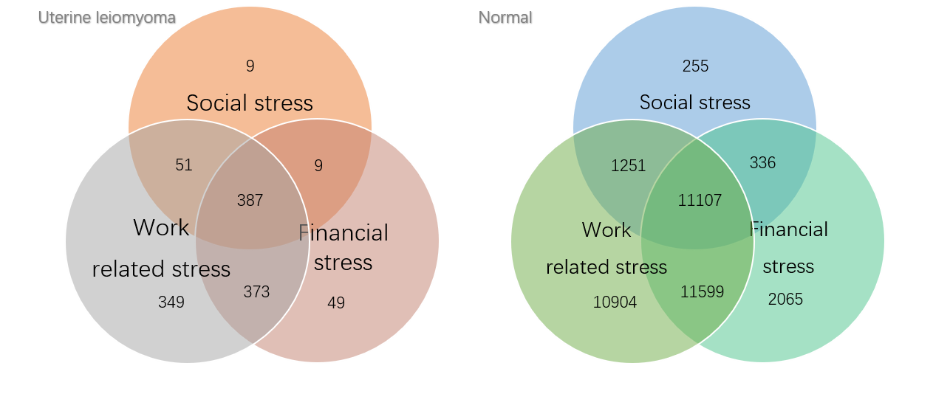

e-Table 1 The association between BMI (numerical) and UL prevalence
Variable | Uterine leiomyoma |  | Crude OR | Adjusted OR*
 | No | Yes
BMI | 22.6±4.1 | 23.7±4.4 | 1.03 (1.02,1.03) | 1.013 (1.01,1.02)

*Adjusted for age at enrolment, smoking status, passive smoking status, drinking status, education, occupation, region, age at menarche, parity, oral contraceptive use, diabetes, and hypertension.

e-Table 2
The association between stress and UL stratified by work type (manual vs non-manual)
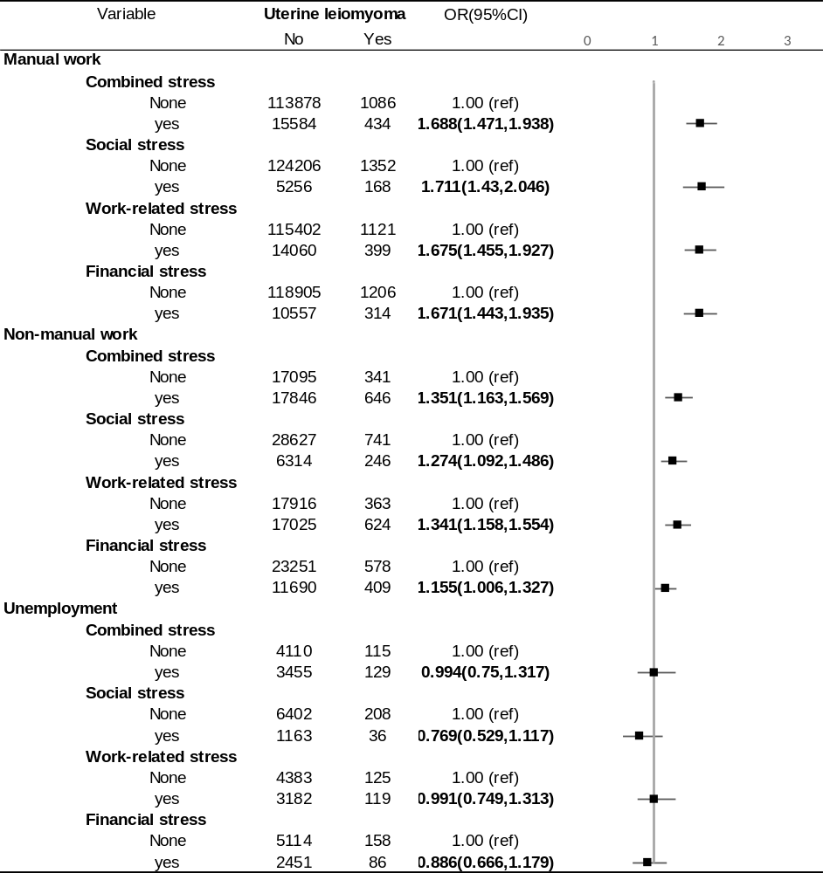

e-Table 3
Associations between stress and UL by age
