Supporting Information

Development of a pancreatic islet organoid platform for high-throughput drug screening for type 2 diabetes treatments
Kyoung Jin Choi ^{1†}, Yoon-Ju Na ^{1 2 3†}, Jeong Hui Im ¹ ², Hee Min Yoo ⁴ ⁵, Won Hoon Jung¹, Sung Bum Park¹, Byumseok Koh¹, Mi-Young Son⁶, Ki Young Kim ^{1 2 *}
† These authors contributed equally to this work.

*Corresponding Author:
Ki Young Kim
Address: Therapeutics & Biotechnology Division, Korea Research Institute of Chemical Technology, P.O. Box 107, Yuseong-gu, Daejeon 34114, Republic of Korea
Tel: +82-42-860-7471, E-mail: kykim@krict.re.kr

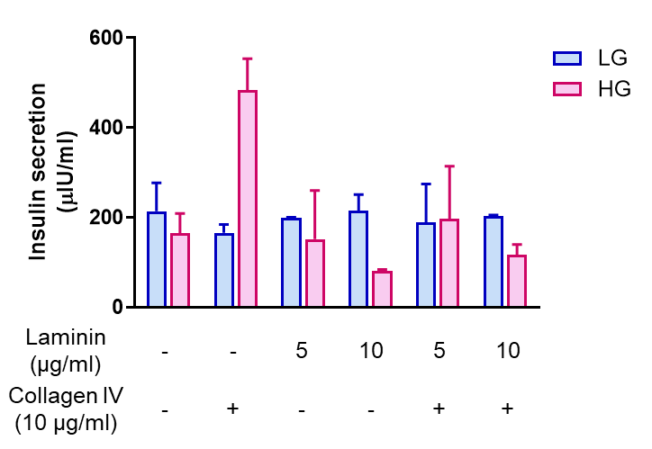
Figure S1. Effects of ECM components on glucose-stimulated insulin secretion in β-cell organoids
β-cell organoids were cultured in the presence of laminin (5 or 10 μg/mL) or collagen IV (10 μg/mL), and glucose-stimulated insulin secretion (GSIS) was assessed under low glucose (LG) and high glucose (HG) conditions. Insulin secretion is presented as μU/mL. Data are shown as mean ± S.D. (n = 2).

Figure S2. Optimization of Type 2 diabetes–inducing conditions using combinatorial metabolic and inflammatory stressors
β-cell organoids were exposed to different combinations of Type 2 diabetes–associated stressors, including free fatty acids (FFA), cytokine mixture (CM), and high glucose (HG), and the expression of β-cell–related genes was analyzed by quantitative PCR (qPCR) at the indicated time points (3, 5, and 7 days). Relative mRNA expression levels of genes associated with β-cell function (IAPP, PDX1), ER stress and apoptosis (TXNIP, sXBP1), inflammation (MCP1, IL-1β, TNF-α), oxidative stress (iNOS), and endocrine progenitor/de-differentiation marker (Ngn3) are shown. Expression levels were normalized to 18S rRNA and presented as fold change relative to control. Data are shown as mean ± S.D. (n = 2).

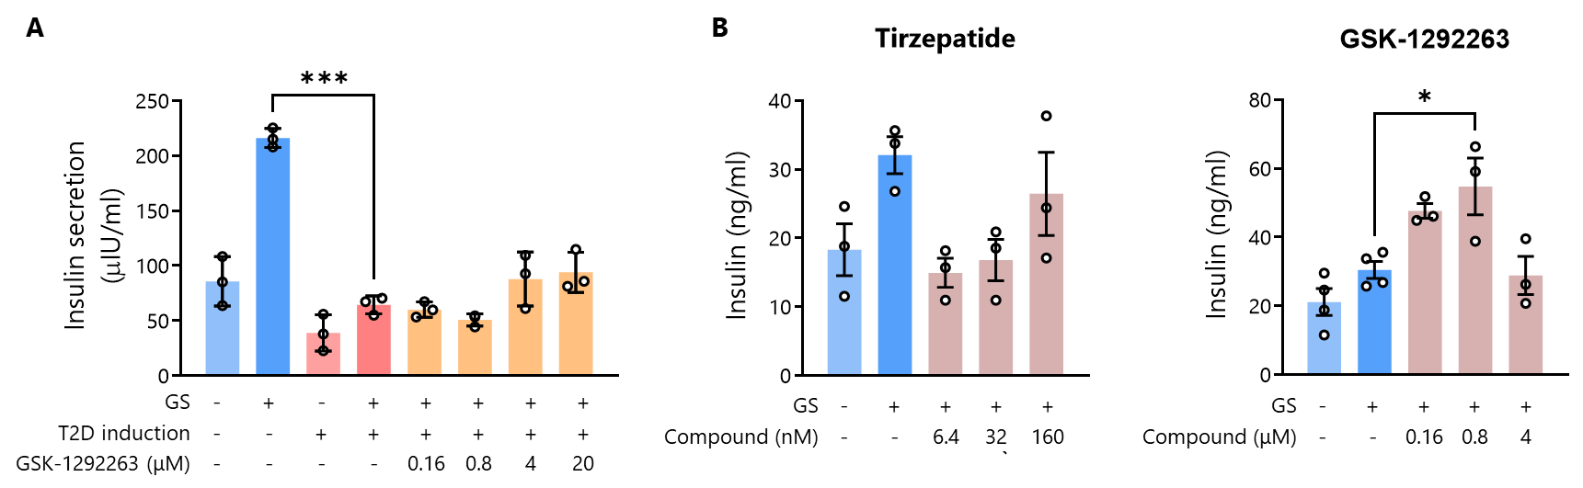
Figure S3. Differential insulin secretory responses to GSK-1292263 between human islet organoids and rat insulinoma cells
(A) Glucose-stimulated insulin secretion (GSIS) assay in T2D-induced human islet organoids treated with GSK-1292263 at the indicated concentrations. Insulin secretion was not significantly altered by GSK-1292263 treatment under glucose-stimulated (GS) conditions.
(B) GSIS assay in the rat insulinoma RIN-m5F cell line treated with Tirzepatide (TZP) or GSK-1292263 at the indicated concentrations. Data are presented as mean ± S.D. (n=3). Statistical significance was determined using appropriate statistical tests (* P < 0.05, *** P < 0.001).

