Supplementary Information
Reconstituting Placenta-Embryo Crosstalk in a Microfluidic Chip for Human-Relevant Developmental Toxicity Studies

Manon Murdeu^{1,2}, Isabel Wegner², Xiaolei Lin², Vera M. Kissling¹, Jacob Folz³, Paula Navascués⁴, Andreas Hierlemann², Julia A. Boos^{2,5,6 ¥}, Tina Buerki-Thurnherr^{1 ¥}

¹Laboratory for Nanomaterials in Health, Swiss Federal Laboratories for Materials Science and Technology (Empa), 9014 St. Gallen, Switzerland
²Bioengineering Laboratory, Department of Biosystems Science and Engineering, ETH Zürich, 4056 Basel, Switzerland
³Department of Health Sciences and Technology, ETH Zürich, 8092 Zürich, Switzerland
⁴Laboratory for Advanced Fibers, Swiss Federal Laboratories for Materials Science and Technology (Empa), 9014 St. Gallen, Switzerland
⁵SCAHT - Swiss Centre for Applied Human Toxicology, 4055 Basel, Switzerland
⁶Department of Pharmaceutical Sciences, University of Basel, 4001 Basel, Switzerland

¥ Shared last author
Tina Buerki-Thurnherr
E-mail: tina.buerki@empa.ch
Orcid ID: 0000-0003-3723-6562
Julia Boos
E-mail: julia.boos@unibas.ch
Orcid ID: 0000-0001-9490-9810

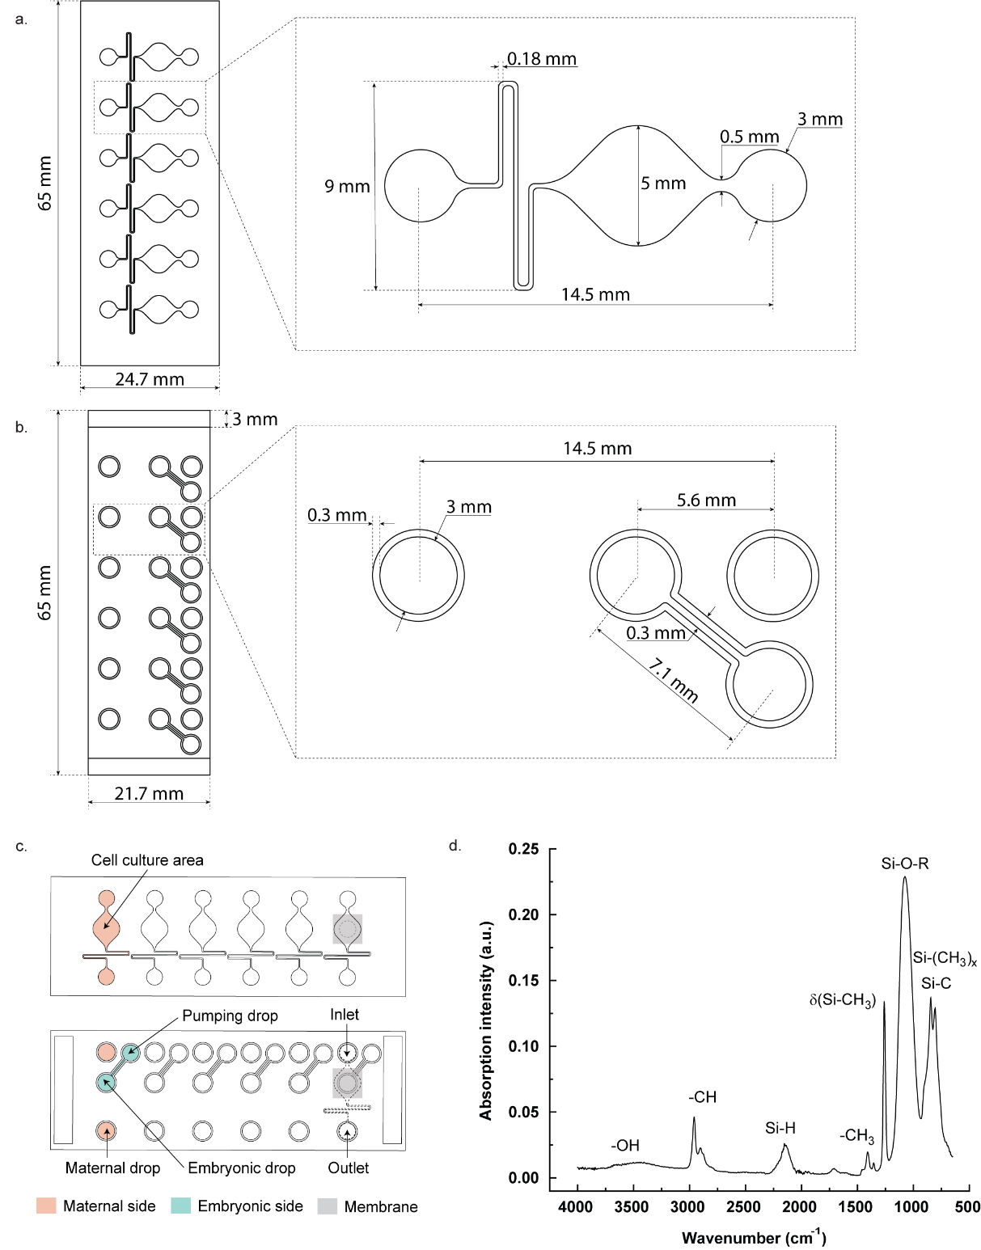
Supplementary Fig. 1: Design and structural features of the microfluidic platform. a, Top view of the maternal layer with respective channel and culture area dimensions. b, Top view of the embryonic layer with embryonic drops and channel dimensions. Each embryonic drop and channel incorporated a hydrophobic rim structure to prevent liquid outflow. c, The chip layout shows the maternal layer (top) and the embryonic layer (bottom) with six independent units, each featuring a maternal cell culture area (pink, 50 µL) and an embryonic drop connected to a pumping drop (blue, 20 µL) to enable medium exchange on the embryonic side d, ATR-FTIR characterization of the thin film with SiO:CH chemistry.
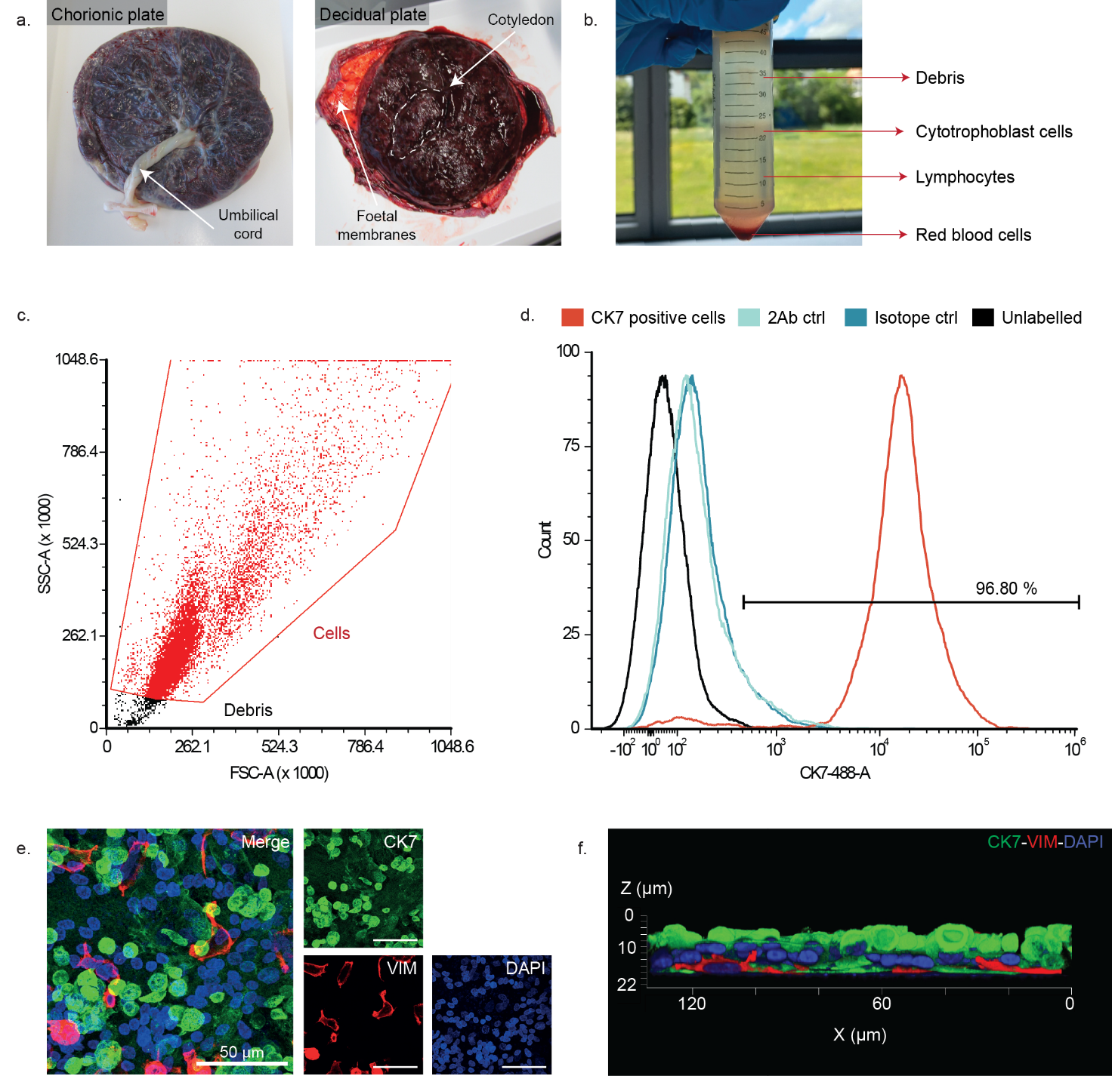
Supplementary Fig. 2: Primary CTB isolation from term placenta and purity check. a, Term placentae were obtained after signed informed consent from caesarean sections. Photographs of a placenta showing the chorionic plate facing the foetus and the decidual plate facing the endometrium. In the decidual plate, the functional units of the placenta, the cotyledons, can be identified. b, Percoll gradient after centrifugation. CTBs are typically located between the 30 mL and 12 mL marks of the Falcon tube. c-d, Representative flow cytometry gating strategy (c) and analysis (d) for purity assessment of isolated CTBs. Cells were stained for cytokeratin 7 (CK7) with appropriate controls: isotype control (IgG1) and secondary antibody only for autofluorescence (488 nm). Purity assessment of the trophoblast layer on chip shown in e, immunofluorescence image and f, 3D rendering. Staining for trophoblast marker (CK7, green), mesenchymal marker (vimentin, red), and nuclei (DAPI, blue). Scale bar: 50 µm.
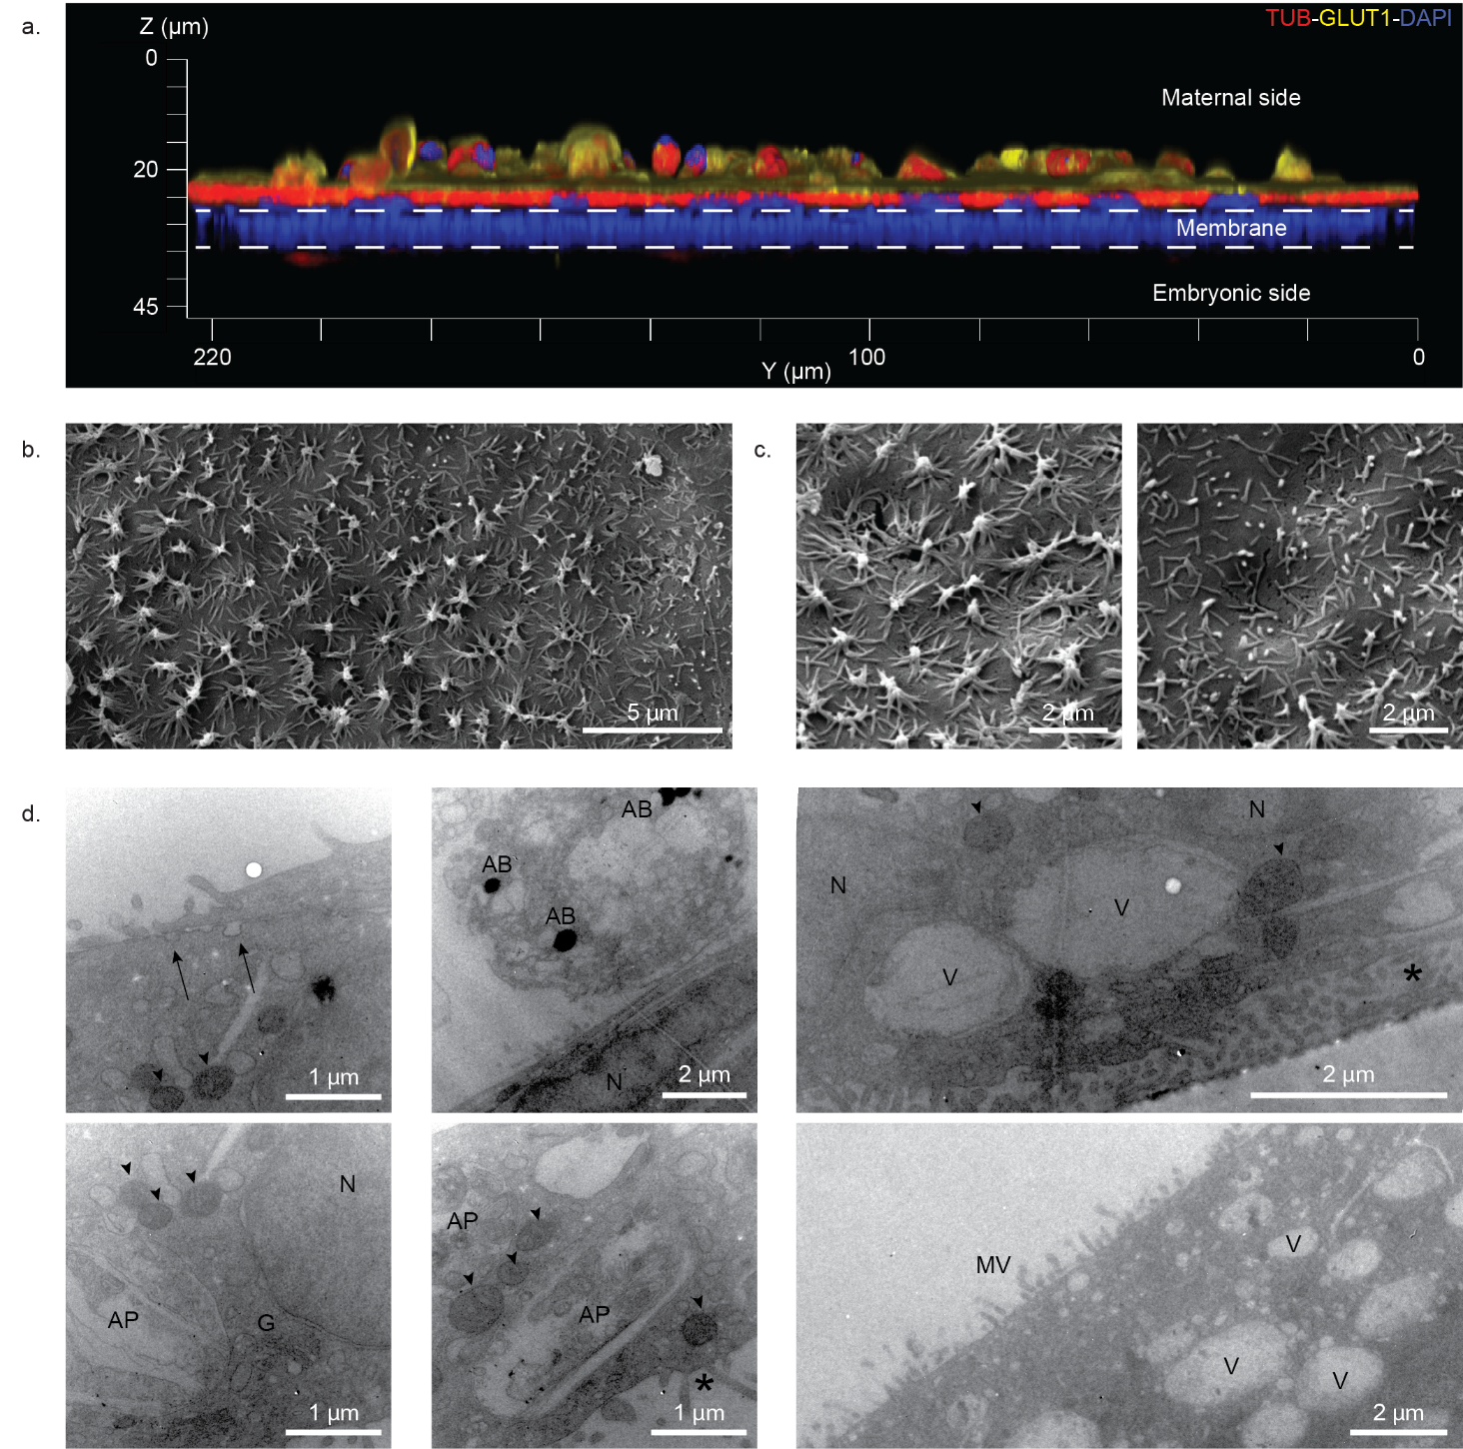

Supplementary Fig. 3: Morphological assessment of the placental barrier on chip on DIV4. a, 3D rendering of immunofluorescence staining of trophoblast cells on the maternal side of the membrane showing glucose transporter-1 (GLUT1, yellow), microtubules (tubulin, red), and nuclei (DAPI, blue). b-c, Scanning electron microscopy of microvilli on the apical side of the trophoblast layer (DIV4). b, Overview showing regions with different microvillus types. Scale bar: 5 µm. c, Higher magnification highlighting microvilli variations. Scale bar: 2 µm. d, Transmission electron microscopy of trophoblast structures (DIV4). Structures characteristic of the syncytiotrophoblast can be observed: coated vesicles and pinocytosis (arrows) on the apical membrane; apoptotic bodies (AB) in cells shedding at the apical surface; multinucleated (N, nucleus) cells; vacuoles and large vesicles (V); basal interdigitations (*); scattered, small and round mitochondria (arrow heads); autophagosomes (AP) in proximity to the Golgi apparatus (G) and microvilli (MV) on the apical surface. Scale bars: 1 µm, 2 µm.
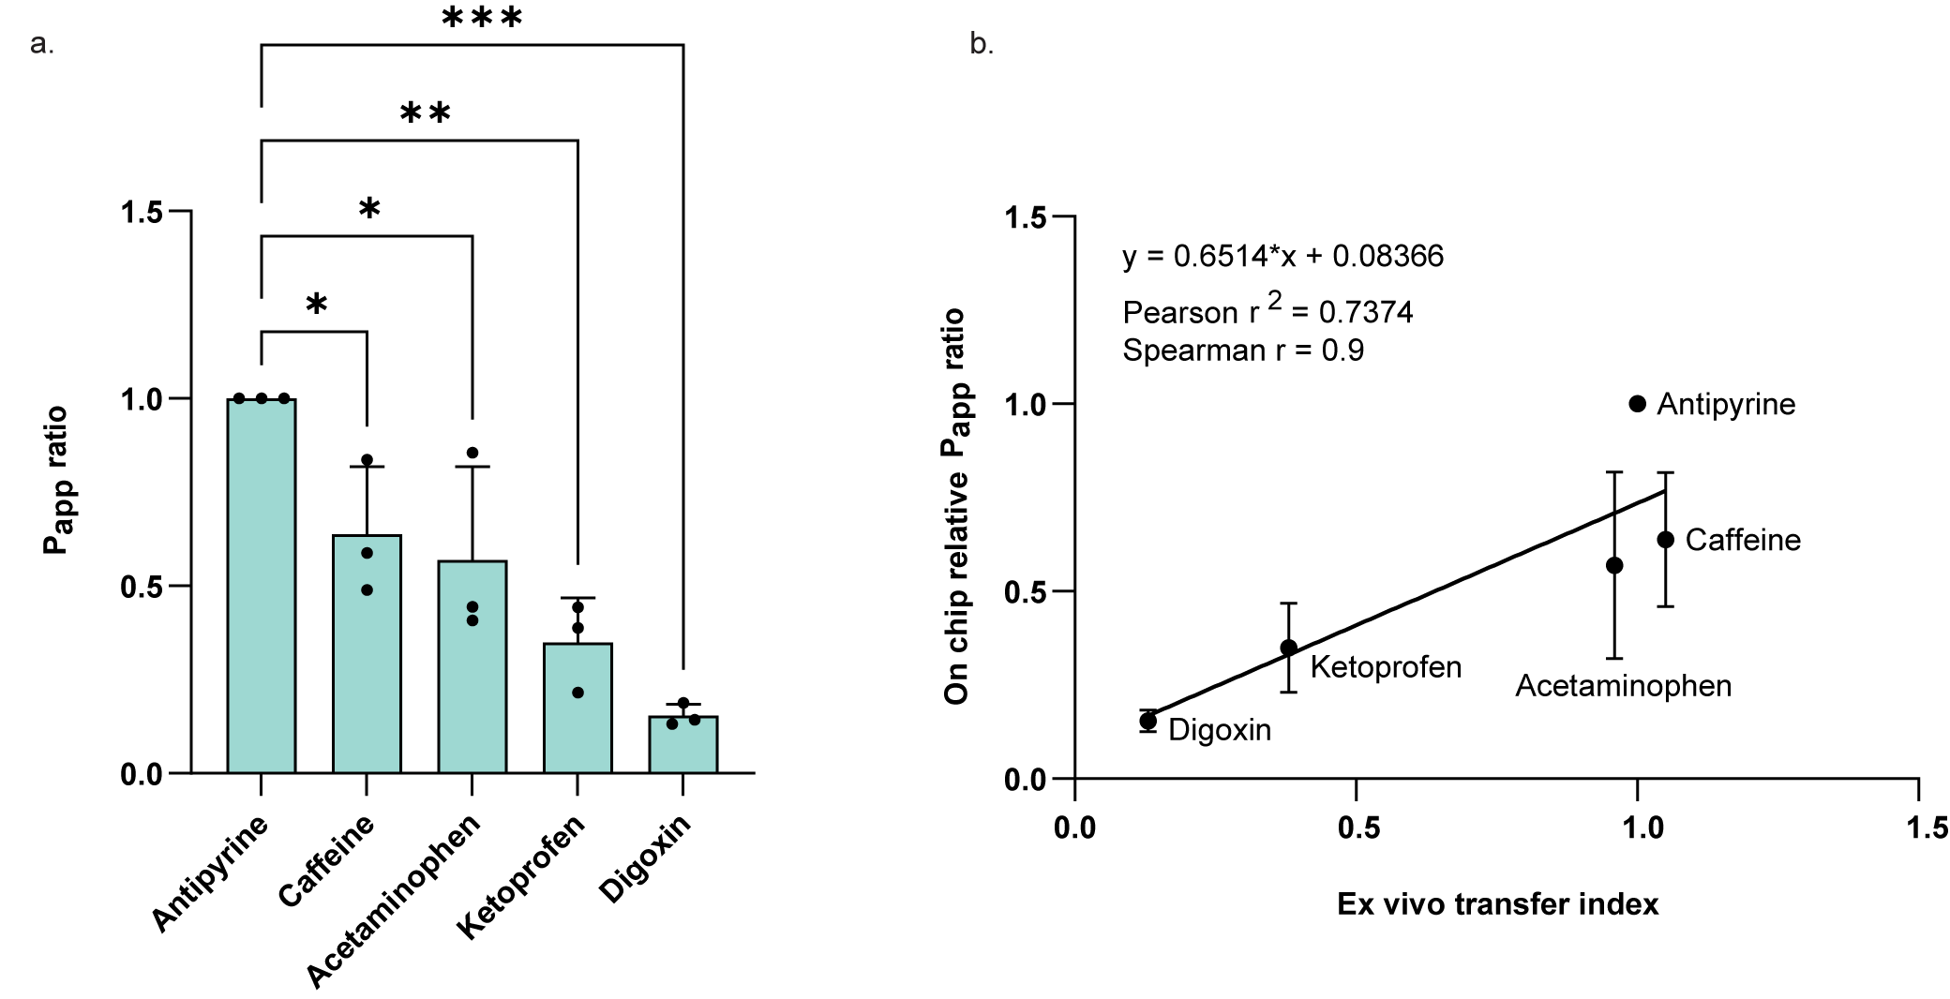

Supplementary Fig. 4: Apparent permeability ratio (P_{app, 1h}) across the placental barrier on chip for six compounds: antipyrine, creatinine, caffeine, acetaminophen, ketoprofen, digoxin. a, Data represent mean and SD of n=3 independent biological experiments, each measured in two technical replicates. b, Correlation between on chip relative apparent permeability ratio and ex vivo placenta perfusion transfer index. Ex vivo data from literature.^{1–4} Data represent mean and SD of n=3 independent biological experiments, each measured in two technical replicates. Pearson (r²=0.7374; α=0.05; p=0.0624) and Spearman correlation (r=0.9; α=0.05; p=0.0833) were calculated.
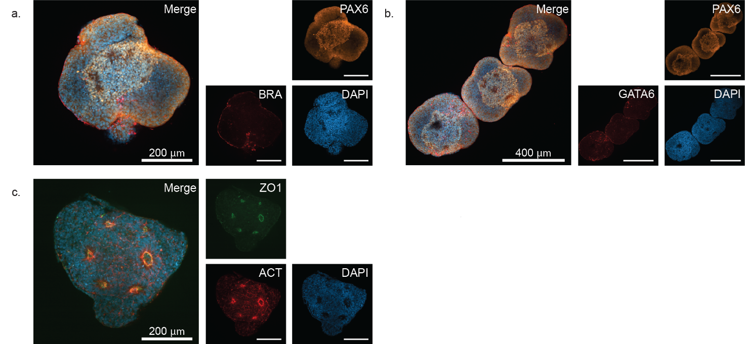

Supplementary Fig. 5: EB germ layer characterization. Immunofluorescence staining of EB on plate on DIV9. a, Staining for ectodermal marker PAX6 (orange), mesodermal marker brachyury (red), and nuclei (DAPI, blue). Scale bars: 200 µm. b, Staining for ectodermal marker PAX6 (orange), endodermal marker GATA6 (red), and nuclei (DAPI, blue). Scale bars: 400 µm. c, Neural rosette characterization: staining for tight junctions (ZO-1, green), actin filaments (actin, red), and nuclei (DAPI, blue). Scale bars: 200 µm.
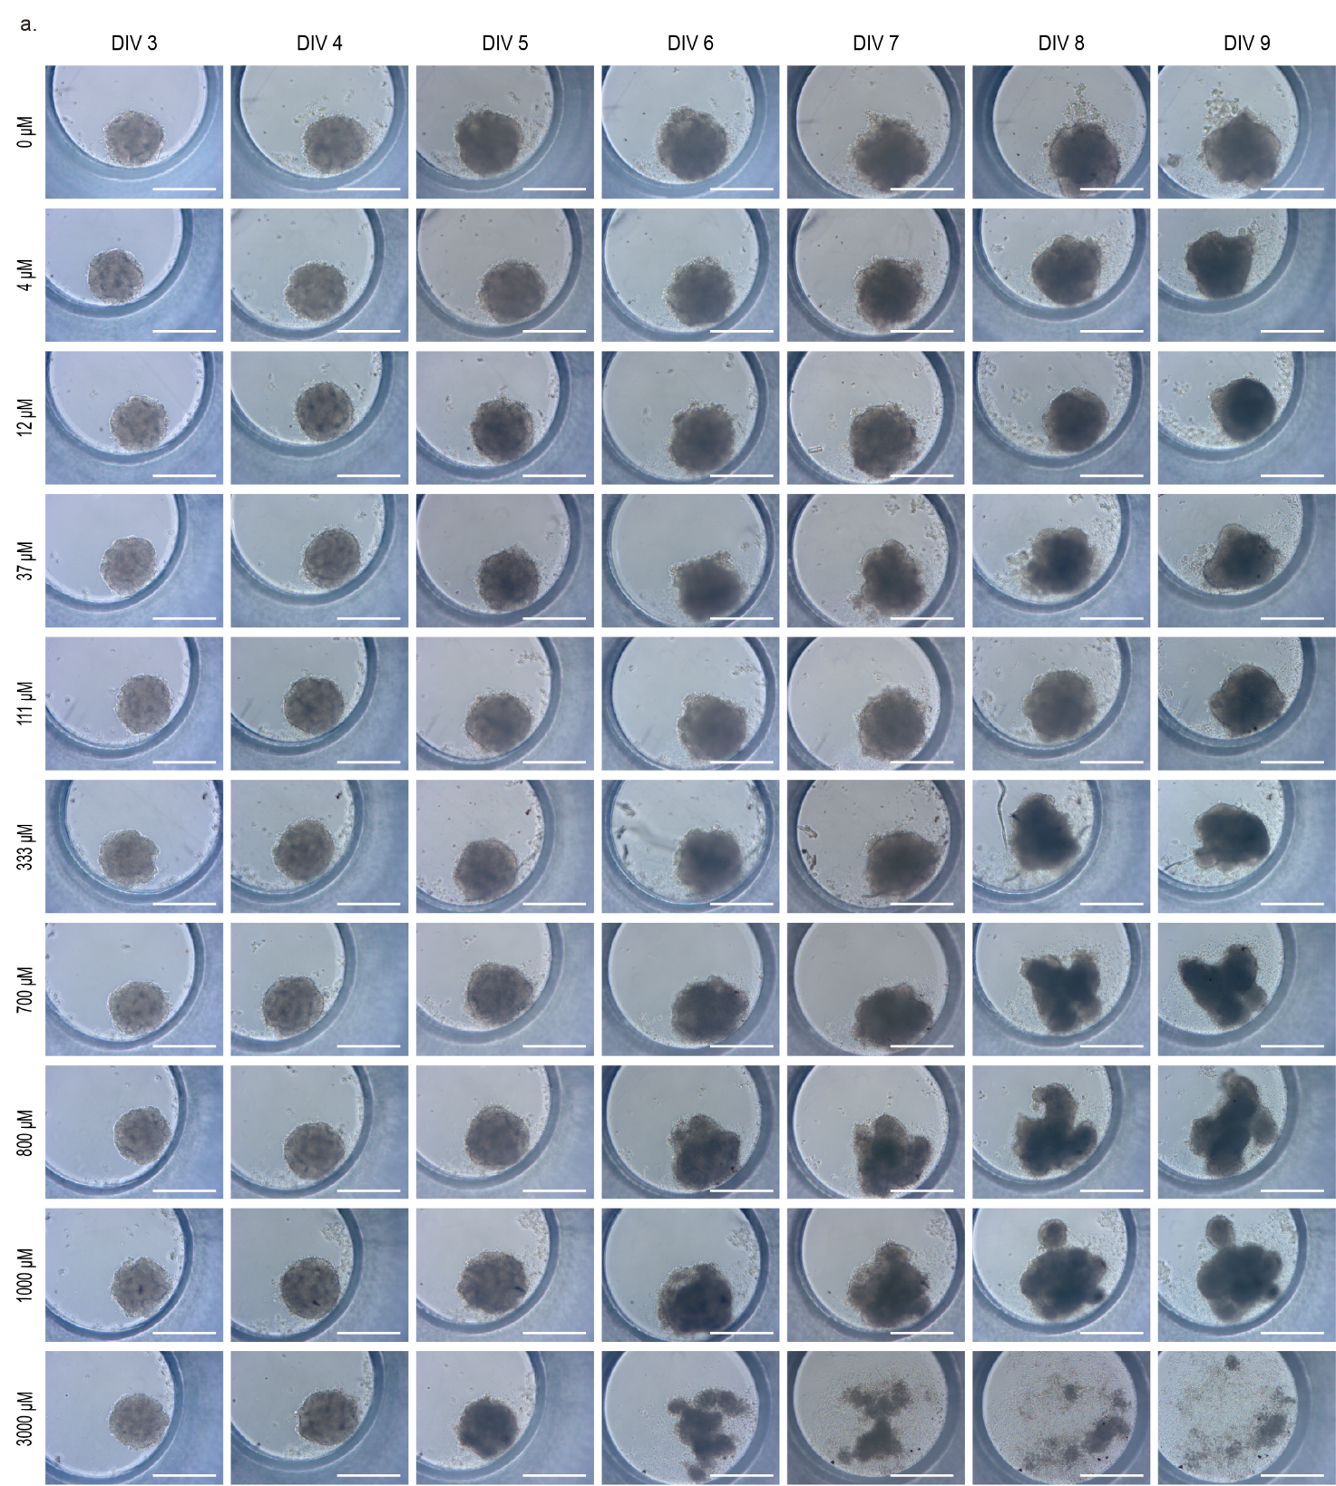

Supplementary Fig. 6: VPA dose-response in EBs. a, Light microscopy images of EBs cultured on plates and exposed daily to different VPA concentrations from DIV4 to DIV9. Scale bars: 200 µm.

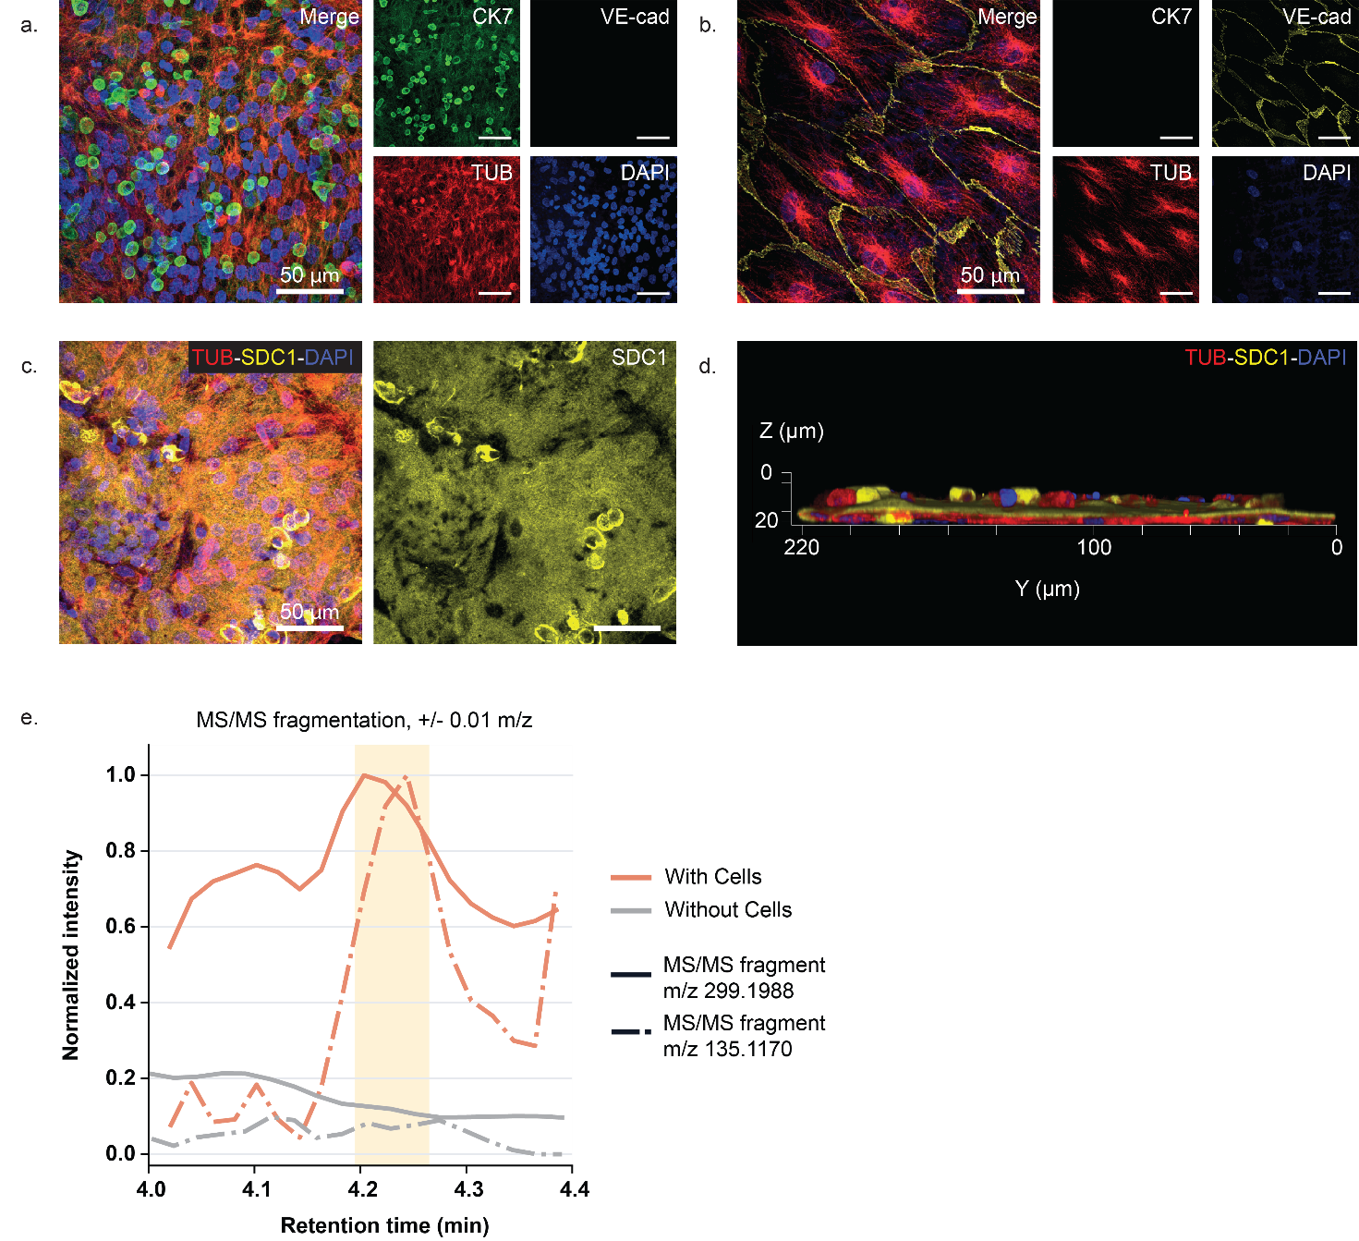
Supplementary Figure 7: Effects of VPA exposure of the placental barrier and metabolism of RA. a-b, Immunofluorescent staining of trophoblast cells on a, the maternal side of the membrane and b, endothelial cells on the embryonic side of the membrane on DIV9 after VPA exposure. Staining for trophoblast marker (CK7, green), microtubules (tubulin, red), endothelial marker (VE-cadherin, yellow) and nuclei (DAPI, blue). Scale bars: 50 µm. c-d, Immunofluorescent staining of c, trophoblast cells and d, orthogonal 3D rendering for syncytialization marker (SDC1, yellow), microtubules (TUB, red) and nuclei (DAPI, blue) on DIV9 after VPA exposure. Scale bars: 50 µm. e, LC-MS/MS chromatogram from annotated 4-hydroxy retinoic acid metabolite: MS/MS transitions based on the fragment reported in literature (m/z 299.1988),⁵ and a CFM-ID 4.0 predicted fragment⁶ of m/z 135.117 with input query of 4-hydroxy retinoic acid SMILES code.

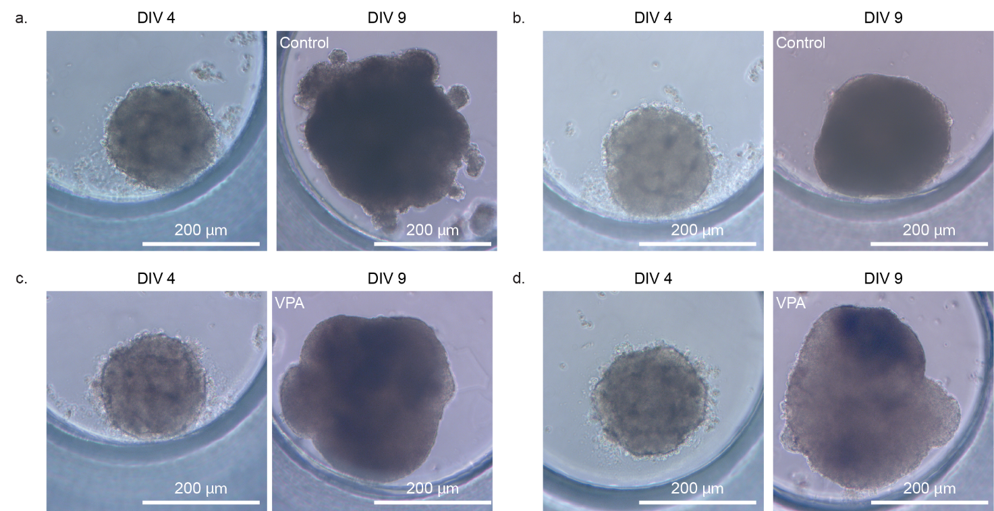

Supplementary Fig. 8: VPA treatment on chip. a-d, Light microscopy images of EBs before (DIV4) and after (DIV9) culturing on chip with or without VPA treatment, in monoculture a) and c) or co-culture b) and d). Scale bars: 200 µm.
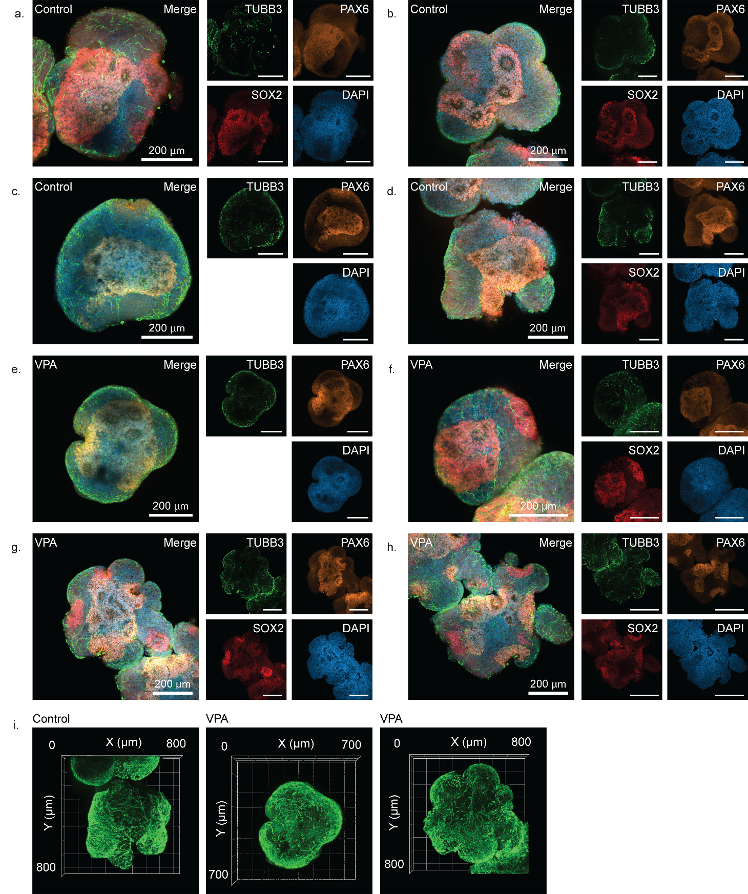
Supplementary Fig. 9: VPA exposure of EBs on chip in the absence of the placental barrier. a-d, Immunofluorescence staining of EB monoculture control and e-h, EB monoculture exposed to VPA at DIV9. Staining for ectodermal markers βIII tubulin (TUBB3, green) and PAX6 (orange), pluripotency marker SOX2 (red) and nuclei (DAPI). Scale bars: 200 µm. i, 3D rendering of the early neuronal marker TUBB3 in EB monoculture control (left), VPA exposed (centre and right).

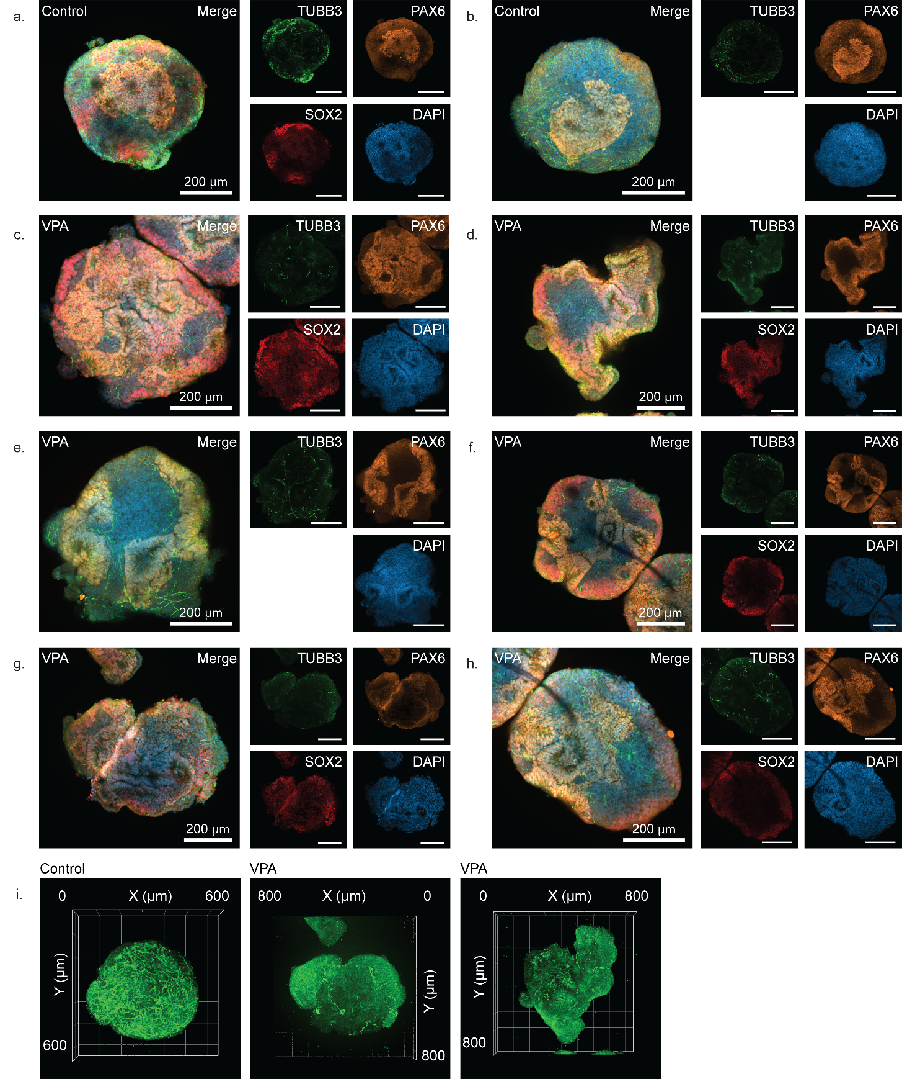
Supplementary Fig. 10: VPA exposure of EBs on chip in presence of the placental barrier. a-b, Immunofluorescence staining of EB co-culture control and c-h, EB co-culture exposed to VPA at DIV9. Staining for ectodermal markers βIII tubulin (TUBB3, green) and PAX6 (orange), pluripotency marker SOX2 (red) and nuclei (DAPI). Scale bars: 200 µm. i, 3D rendering of the early neuronal marker TUBB3 in EB co-culture control (left), VPA exposed (centre and right).

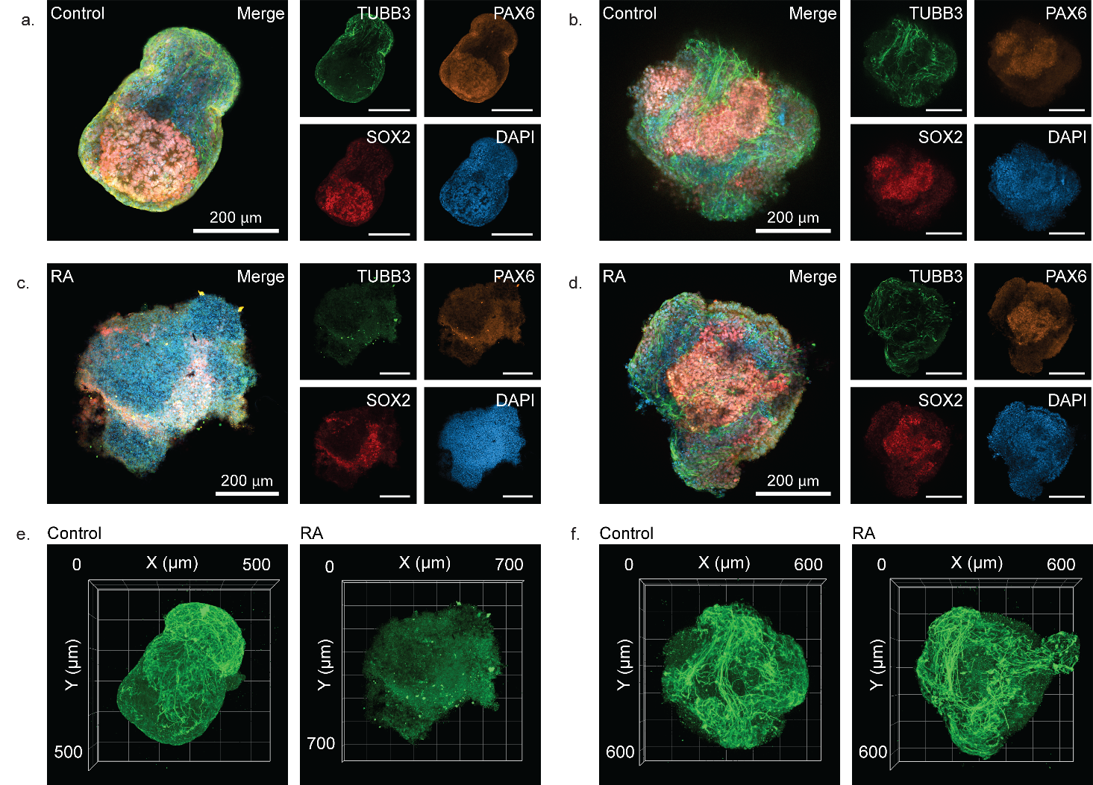
Supplementary Fig. 11: RA exposure of EBs on chip in presence of the placental barrier. a-d, Immunofluorescence staining of a, EB monoculture control, b, EB co-culture control, c, EB monoculture exposed to RA, d, EB co-culture exposed to RA at DIV9. Staining for ectodermal markers βIII tubulin (TUBB3, green) and PAX6 (orange), pluripotency marker SOX2 (red) and nuclei (DAPI). Scale bars: 200 µm. e-f, 3D rendering of the early neuronal marker TUBB3 in e, EB monoculture control (left), RA exposed (right) and f, EB co-culture control (left), RA exposed (right).

Supplementary Table 1_Antibodies list

Antibody | Stains for/Used for | Company and Ref. | Dilution
Mouse Anti-Human Cytokeratin 7 (CK7) | Trophoblast | Dako, M701829-2 | 1:200
Rat Anti-Tubulin antibody (Tub) | Microtubules | Abcam, ab6161 | 1:1000
VE-Cadherin (D87F2) XP® Rabbit mAb, CD144 (VE-Cad) | Vascular endothelial cadherin, adhesion molecule | Cell Signaling Technology, 2500S | 1:400
Rabbit Anti-Vimentin antibody (Vim) | Cytoskeleton, mesenchymal cells | Abcam, ab92547 | 1:400
CD138 Antibody, anti-human, REAfinity™, Syndecan-1 (SYN1) | Cell membrane | Miltenyi Biotec, 130-115-480 | 1:100
Glut1 (E4S6I) Rabbit mAb (GLUT1) | Glucose transporter 1 | Cell Signaling Technology, 73015S | 1:200
Goat Anti-SOX2 | Pluripotency | R&D Systems AF2018 | 1:50
Rabbit Anti-PAX6 | Ectoderm (rosettes) | GeneTex GTX113241 | 1:50
Mouse Anti-beta III Tubulin antibody [TU-20] - Neuronal Marker (TUB3) | Ectoderm (early neurons) | Abcam ab7751 | 1:50
Mouse Polyclonal Brachyury / Bry antibody (BRY) | Mesoderm | Abcam ab167337 | 1:50
Goat Polyclonal Human GATA-6 Antibody (GATA6) | Endoderm | R&D Systems AF1700 | 1:50
DAPI | Nucleus | Sigma Aldrich, D9542 | 1:1000 or 1:100 (EBs)
Goat anti-Mouse IgG (H+L) Highly Cross-Adsorbed Secondary Antibody, Alexa Fluor® 488 conjugate | For CK7 | Invitrogen, A11029 | 1:400
Goat anti-Rat IgG (H+L) Secondary Antibody, Alexa Fluor® 555 conjugate | For tubulin | Invitrogen, A21434 | 1:400
Goat anti-Rabbit IgG (H+L) Highly Cross-Adsorbed Secondary Antibody, Alexa Fluor 633 | For VE-cadherin, Glut1 and vimentin | Invitrogen, A21071 | 1:400
Donkey-anti-mouse 488 | For TUB3, BRY | Invitrogen, A31571 | 1:50
Donkey-anti-rabbit 555 | For PAX6, AFP | Invitrogen, A31572 | 1:50
Donkey-anti-goat 647 | For SOX2, GATA6, αSMA | Invitrogen, A32849 | 1:50
Phalloidin-iFluor 647 stain | F-actin | Abcam, ab176759 | According to manufacturer instructions
Conjugated ZO-1 (1A12) Alexa 488 | Tight junctions | Invitrogen, MA3-39100-A488 | 1:50
Mouse IgG1 kappa | Isotope control | Sigma Aldrich, M9269 | 1:1000
Rabbit anti-human chorionic gonadotropin (hCG) | Capture antibody hCG ELISA | Dako, A0231 | 1:1000
Mouse anti-human chorionic gonadotropin (hCG) | Detection antibody hCG ELISA | Serotec, MCA 1436 | 1:5000
Goat anti-mouse IgG HRP | Secondary detection antibody hCG ELISA | Biorad, 1706516 | 1:5000

Supplementary Table 2_ Summary of PMMA NP characterization

PMMA NP characteristics |  | 25nm | 150nm
 | 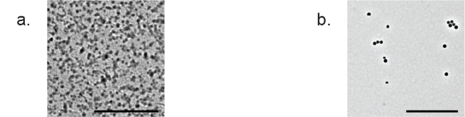
Diameter [nm] ^{c} |  | 25 | 150
Hydrodynamic diameter in 10% PBS [nm] ^{d} |  | 46.80 ± 0.14 | 152.13 ± 0.38
Polydispersity index in 10% PBS ^{d} |  | 0.108 ± 0.005 | 0.025 ± 0.017
Hydrodynamic diameter in ECM [nm] ^{d} |  | 42.7 ± 0.4 | 170.9 ± 0.5
Polydispersity index in ECM ^{d} |  | 0.194 ± 0.003 | 0.064 ± 0.019
Hydrodynamic diameter in ECM w/o phenol red [nm] ^{d} |  | 42.44 ± 0.18 | 201 ± 1
Polydispersity index in ECM w/o phenol red ^{d} |  | 0.201 ± 0.003 | 0.179 ± 0.013
Hydrodynamic diameter in ECM w/o phenol red after 24 h [nm] ^{d} |  | 44.35 ± 0.31 | 182.1 ± 1.6
Polydispersity index in ECM w/o phenol red after 24 h ^{d} |  | 0.202 ± 0.004 | 0.045 ± 0.036
Zeta potential in 10% PBS [mV] ^{d} |  | -16 ± 4 | - 40.8 ± 0.2

ª Transmission electron microscopy of 25 nm PMMA particles. Scale bar: 500 nm.
^{b} Transmission electron microscopy of 150 nm PMMA particles. Scale bar: 500 nm.
^{c} Supplied by the manufacturer.
^{d} Experimentally determined. Data shows mean ± SD of 3 consecutive runs.

Supplementary Table 3. LC-ESI-MS/MS analysis parameters for data acquisition and processing. Two LC methods were used. The first method (LC-1) was used for all metabolites except for the retinoic acid metabolite that used a second LC method (LC-2). ESI parameters were therefore different for LC-1 and LC-2. For LC-1, ESI source parameters are as follows. Data were acquired using heated electrospray ionization with a static spray voltage and static gas mode. Sheath gas, auxiliary gas, and sweep gas were set to 60, 15, and 2 arbitrary units, respectively. The ion transfer tube temperature was maintained at 350 °C and the vaporizer temperature at 400 °C. Quadrupole isolation was performed with a 1.6 m/z isolation window. Collision energy was applied in fixed mode with a CID activation time of 10 ms and an activation Q of 0.25. The ion trap scan rate was set to rapid with automatic scan range selection. Microscan count was 1, and data were acquired in centroid mode. In LC-2, ESI parameters were the same with the following exceptions. Sheath gas, auxiliary gas, and sweep gas were set to 50, 10, and 1 arbitrary units respectively. The ion transfer tube temperature was maintained at 300 °C and the vaporizer temperature at 350 °C. Data was acquired in profile mode.

Molecule Name | LC and MS method used | Adduct | ESI Spray Voltage (V) | Precursor m/z | Retention Time (min) | Collision Energy (%) | RF Lens (%) | Maximum Injection Time (ms) | Product ions m/z | m/z tolerance
antipyrine | LC-1  Tandem | [M+H]⁺ | +3500 | 189.1022 | 1.09 | 60 (HCD) | 50 | 20 | 189.1 | 0.6
ketoprofen | LC-1  Tandem | [M+H]⁺ | +3500 | 255.1016 | 1.49 | 35 (HCD) | 50 | 20 | 209.15, 105.06 | 0.6
acetaminophen | LC-1  Tandem | [M+H]⁺ | +3500 | 152.0706 | 0.4 | 35 (HCD) | 50 | 20 | 110.05, 65.02 | 0.6
caffeine | LC-1  Tandem | [M+H]⁺ | +3500 | 195.0877 | 1.04 | 50 (HCD) | 70 | 20 | 138.06, 110.15, 83.12, 69.05 | 0.6
digoxin | LC-1  Tandem | [M+HCOO]⁻ | -2500 | 825.4278 | 1.3 | 20 (CID) | 45 | 25 | 779.5 | 0.6
valproic acid | LC-1  tSIM | [M-H]⁻ | -4000 | 143.10775 | 1.38 |  | 45 | Auto AGC |  | 0.0004
4-hydroxy retinoic acid | LC-2  tSIM | [M+H]⁺ | +3300 | 317.2111 | 4.22 |  | 45 | 300 |  | 0.001
4-hydroxy retinoic acid | LC-2  Tandem | [M+H]⁺ | +3300 | 317.2111 | 4.22 | 30 (CID) | 45 | 375 | 299.198,  135.117 | 0.01

REFERENCES

1. Mose, T. et al. Placental Passage of Benzoic acid, Caffeine, and Glyphosate in an Ex Vivo Human Perfusion System. J. Toxicol. Environ. Health A 71, 984–991 (2008).
2. Conings, S. et al. Transplacental transport of paracetamol and its phase II metabolites using the ex vivo placenta perfusion model. Toxicol. Appl. Pharmacol. 370, 14–23 (2019).
3. Lagrange, F., Pehourcq, F., Bannwarth, B., Leng, J. J. & Saux, M. C. Passage of S-(+)- and R-(-)-ketoprofen across the human isolated perfused placenta. Fundam. Clin. Pharmacol. 12, 286–291 (1998).
4. Li, H., Van Ravenzwaay, B., Rietjens, I. M. C. M. & Louisse, J. Assessment of an in vitro transport model using BeWo b30 cells to predict placental transfer of compounds. Arch. Toxicol. 87, 1661–1669 (2013).
5. Arnold, S. L. M., Amory, J. K., Walsh, T. J. & Isoherranen, N. A sensitive and specific method for measurement of multiple retinoids in human serum with UHPLC-MS/MS. J. Lipid Res. 53, 587–598 (2012).
6. Wang, F. et al. CFM-ID 4.0: More Accurate ESI-MS/MS Spectral Prediction and Compound Identification. Anal. Chem. 93, 11692–11700 (2021).

