Additional file 10. Funding.
The first proof of funding corresponds to the financial support by the contribution of student and campus life of the Claude Bernard University Lyon 1 (Grant number 22CVEC_SAN). Lines corresponding to this study (PROMESS) are highlighted.
The second proof of funding corresponds to the additional funding provided through a grant awarded to BM (ANR-22-CE14-0073).

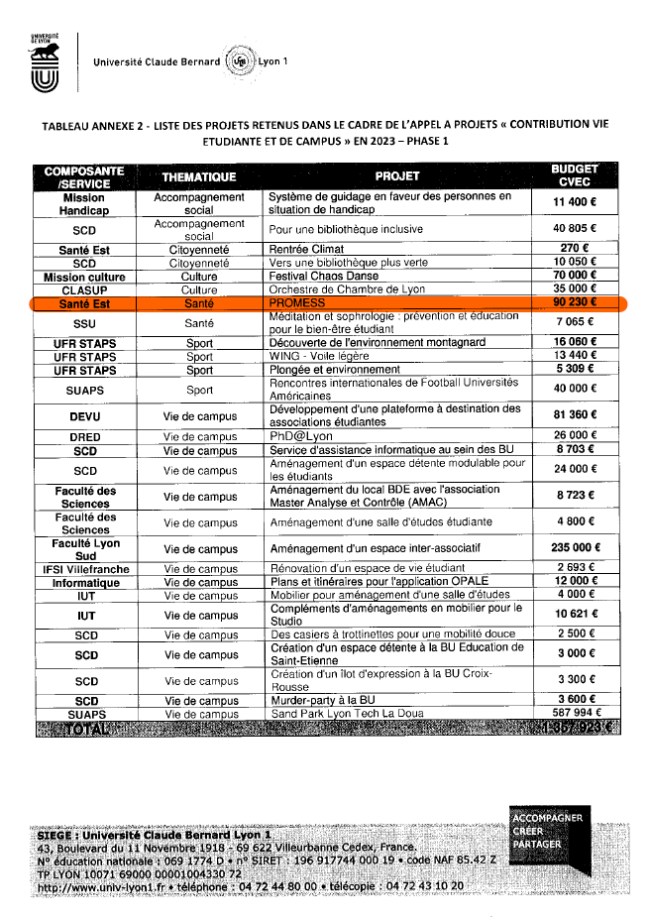

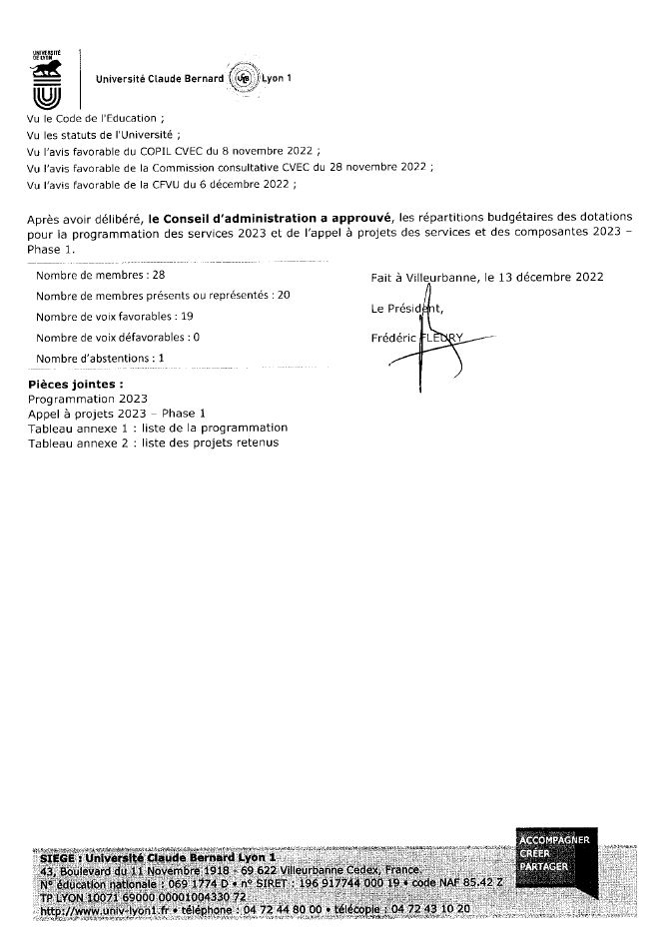

Email object: FUNDING – SHAPE-Med

Date : 2024/11/14
Dear colleagues,
We are pleased to inform you that the Health-Prime project submitted to the 2024 Structuring Call for Projects of SHAPE‑Med@Lyon (ANR‑22‑CE14‑0073) has been evaluated by national and international experts, as well as by the external members of the SHAPE‑Med@Lyon Scientific and Innovation Council (CSI). Following the CSI’s recommendation, the SHAPE‑Med@Lyon Steering Committee has selected the HEALTH‑PRIME project as one of the 11 funded projects.
As a reminder, this project, entitled “The effectiveness of a multimodal, individualized intervention on the health, quality of life, performance, and professional skills of future healthcare professionals”, was written by Sophie Schlatter with the support of C. Hautier and myself. It is based on a multidisciplinary partnership involving: Santé Lyon‑Est, Lyon‑Sud and the RESHAPE laboratory, STAPS and the LIBM laboratory, SSU, Université Lyon 2 and the POPs laboratory, and Université Savoie‑Mont Blanc.
We look forward to this collaboration and thank you for your participation.
We will get back to you as soon as we have more information.
Kind regards.
Anne-Marie Schott, MD, PhD
Faculté de Médecine Lyon-Est - Université Lyon 1
Laboratoire INSERM U1290 RESHAPE - reshapelab.fr
Pôle Santé Publique - Hospices Civils de Lyon
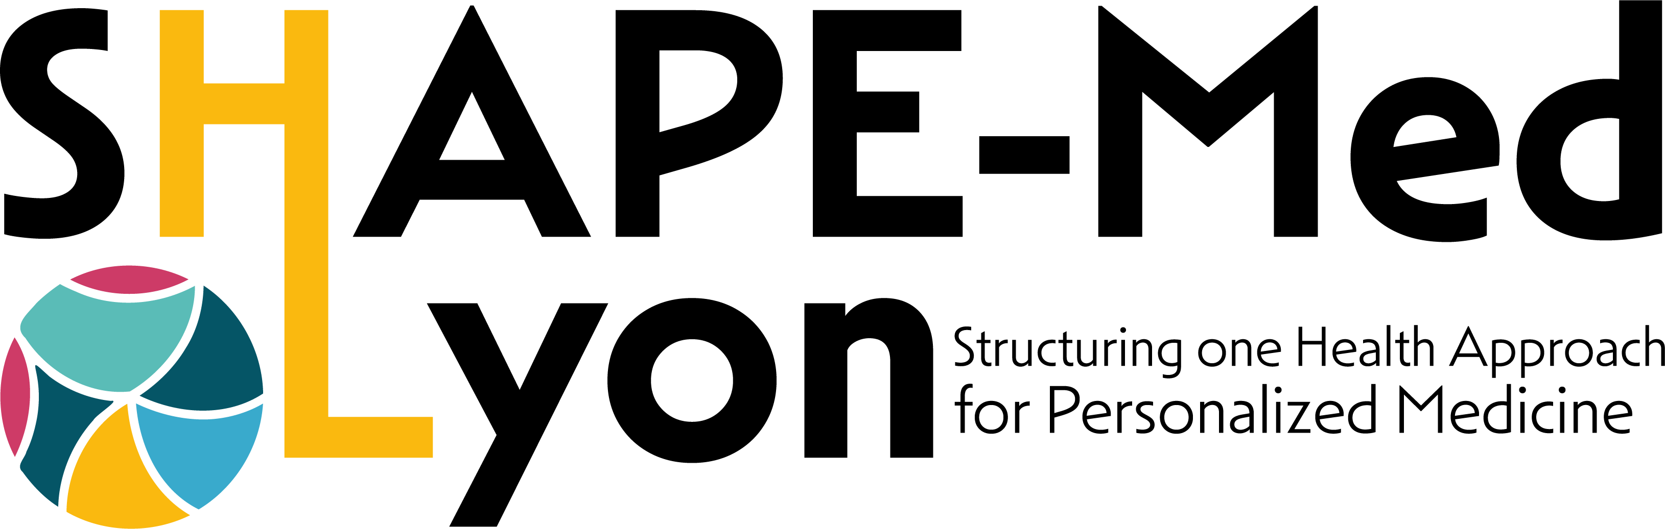

__________________________________________________________________
Original French version below
__________________________________________________________________

