Supporting Information for
Global patterns, supply-chain flows, and driving factors of forest loss footprints from 2001 to 2022

Excel 2
Table 4
Figure 32

Content
Supporting Information for 1
SI-Figure 1: Country-to-country forest loss footprint flows driven by HC across income groups and regions in 2001 and 2022 4
SI-Figure 2: Country-to-country forest loss footprint flows driven by LOG across income groups and regions in 2001 and 2022 5
SI-Table 1: Top 5 Producer Countries Contributing to the Forest Loss Footprint of Each Consumer Country, 2022. 6
SI-Table 2: Driving factors of Forest loss footprint and its trends. 11
SI-Table 3: Trend analysis of Forest loss footprints in international trade from a four-quadrant perspective (2001-2022) 14
SI-Table 4: Quadrant Classification of Key Countries Under Different Driving factors 22
SI-Figure 3: Global forest loss outsourcing typology (2001–2022)——Hard commodities 23
SI-Figure 4: Global forest loss outsourcing typology (2001–2022)——Logging 24
SI-Figure 5: Global forest loss outsourcing typology (2001–2022)——Permanent agriculture 24
SI-Figure 6: Global forest loss outsourcing typology (2001–2022)——Settlements & Infrastructure 25
SI-Figure 7: Global map displaying the spatial distribution of forest loss outsourcing typology——Hard commodities 25
SI-Figure 8: Global map displaying the spatial distribution of forest loss outsourcing typology——Logging 26
SI-Figure 9: Global map displaying the spatial distribution of forest loss outsourcing typology——Permanent agriculture 26
SI-Figure 10: Global map displaying the spatial distribution of forest loss outsourcing typology——Settlements & Infrastructure 27
SI-Figure 11: Feature Contributions to Forest Loss footprint : A SHAP Beeswarm Plot Analysis 28
SI-Figure 12: Feature Contributions to Forest Loss footprint : A SHAP Feature Importance Plot Analysis 29
SI-Figure 13: Feature Contributions to Hard commodities: A SHAP Beeswarm Plot Analysis 30
SI-Figure 14: Feature Contributions to Hard commodities: A SHAP Feature Plot Analysis 31
SI-Figure 15: Feature Contributions to Logging: A SHAP Beeswarm Plot Analysis 32
SI-Figure 16: Feature Contributions to Logging: A SHAP Feature Importance Plot Analysis 33
SI-Figure 17: Feature Contributions to Permanent agriculture: A SHAP Beeswarm Plot Analysis 34
SI-Figure 18: Feature Contributions to Permanent agriculture: A SHAP Feature Importance Plot Analysis 35
SI-Figure 19: Feature Contributions to Settlements & Infrastructure: A SHAP Beeswarm Plot Analysis 36
SI-Figure 20: Feature Contributions to Settlements & Infrastructure: A SHAP Feature Importance Plot Analysis 37
SI-Figure 21: Temporal dynamics of feature importance across forest loss driving factors. 38
SI-Figure 22: Heatmap of feature variable correlation analysis 39
SI-Figure 23: Comparative R² Performance of Six Mainstream Machine Learning Algorithms in Predicting Forest Loss Footprint 40
SI-Figure 24: Comparative RMSE Performance of Six Mainstream Machine Learning Algorithms in Predicting Forest Loss Footprint 41
SI-Figure 25: Comparative MAE Performance of Six Mainstream Machine Learning Algorithms in Predicting Forest Loss Footprint 41
SI-Figure 26: Comparative MAPE Performance of Six Mainstream Machine Learning Algorithms in Predicting Forest Loss Footprint 42
SI-Figure 27: Comparative MAPE Performance of Six Mainstream Machine Learning Algorithms in Predicting Forest Loss Footprint 42
SI-Figure 28: Dependence Plot Analysis for All Features Variables: Examining Joint Effects and Interaction Patterns Between Features with SHAP Value Relationships——forest loss footprint 42
SI-Figure 29: Dependence Plot Analysis for All Features Variables: Examining Joint Effects and Interaction Patterns Between Features with SHAP Value Relationships——Hard commodities 44
SI-Figure 30: Dependence Plot Analysis for All Feature Variables: Examining Joint Effects and Interaction Patterns Between Features with SHAP Value Relationships——Logging 44
SI-Figure 31: Dependence Plot Analysis for All Feature Variables: Examining Joint Effects and Interaction Patterns Between Features with SHAP Value Relationships——Permanent agriculture 45
SI-Figure 32: Dependence Plot Analysis for All Feature Variables: Examining Joint Effects and Interaction Patterns Between Features with SHAP Value Relationships——Settlements & Infrastructure 46

SI-Figure 1: Country-to-country forest loss footprint flows driven by HC across income groups and regions in 2001 and 2022
2001
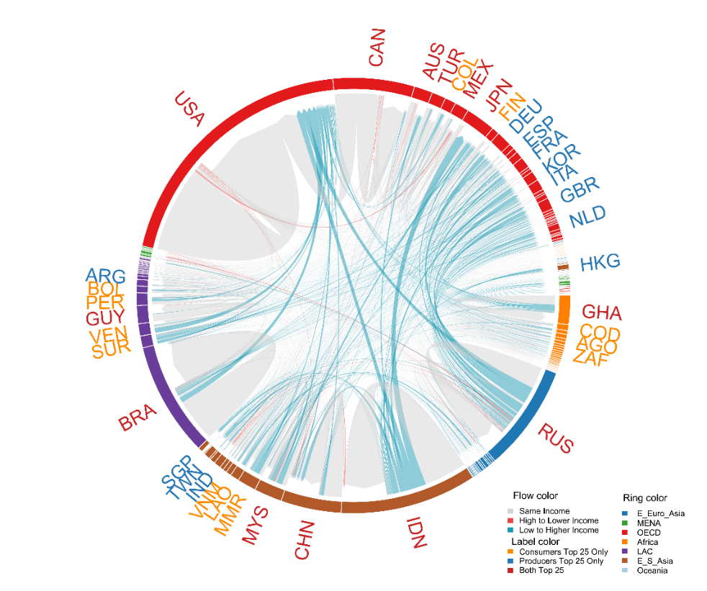
2022
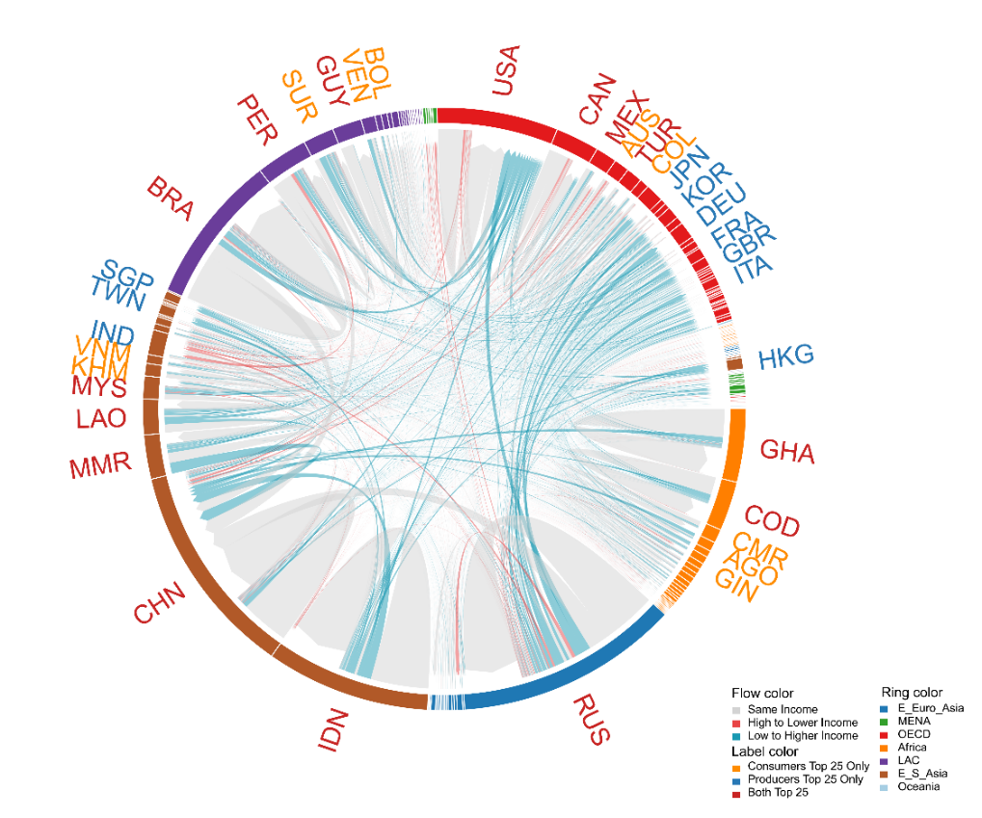

SI-Figure 2: Country-to-country forest loss footprint flows driven by LOG across income groups and regions in 2001 and 2022

2001
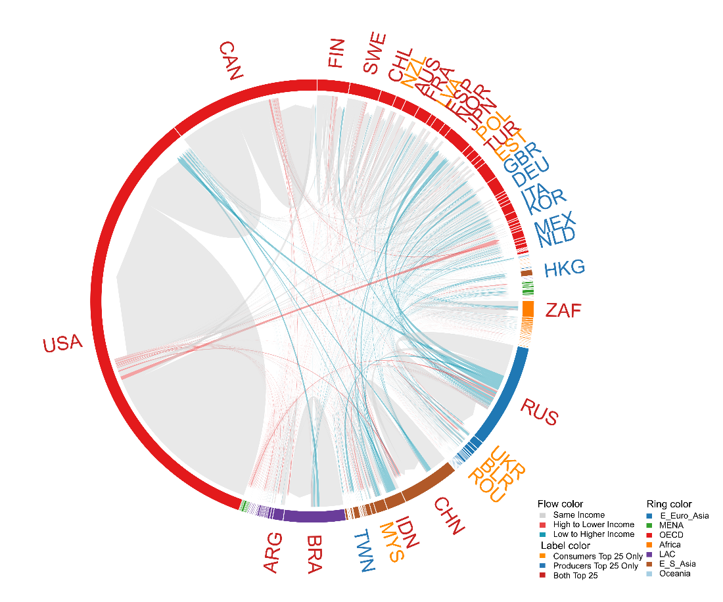
2022
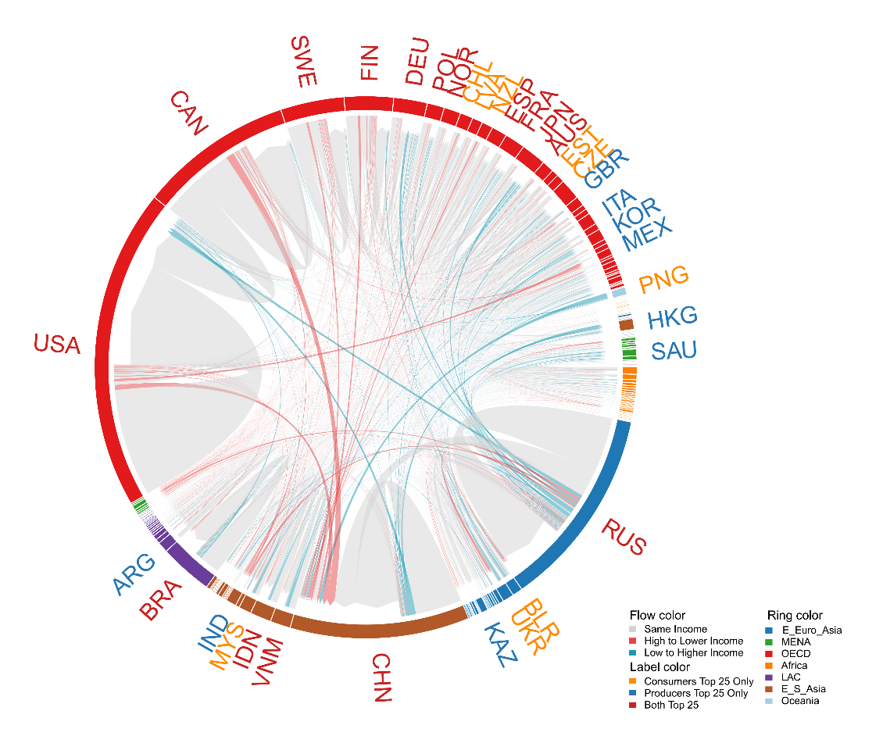

SI-Table 1: Top 5 Producer Countries Contributing to the Forest Loss Footprint of Each Consumer Country, 2022.
Cons-umer | TOP 1 | Ratio  (%) | TOP 2 | Ratio  (%) | TOP 3 | Ratio  (%) | TOP 4 | Ratio  (%) | TOP 5 | Ratio  (%)
ABW | BRA | 30.67 | PRY | 15.41 | USA | 9.71 | PAN | 4.56 | RUS | 4.40
AFG | BRA | 36.93 | RUS | 23.25 | COL | 4.11 | IDN | 2.37 | USA | 2.23
AGO | AGO | 94.52 | BRA | 2.34 | PRT | 0.50 | ZMB | 0.30 | COD | 0.23
ALB | BRA | 36.32 | ALB | 9.85 | RUS | 8.54 | TUR | 3.33 | PRY | 2.97
AND | ESP | 23.56 | RUS | 9.36 | BRA | 8.31 | FRA | 3.75 | SWE | 3.70
ANT | BRA | 14.63 | USA | 14.53 | VEN | 8.57 | RUS | 7.72 | SWE | 5.01
ARE | BRA | 39.91 | RUS | 6.27 | FIN | 4.83 | CHN | 3.76 | NGA | 3.75
ARG | ARG | 72.87 | BRA | 16.80 | PRY | 1.31 | USA | 1.27 | RUS | 0.76
ARM | RUS | 55.34 | BRA | 13.74 | UKR | 3.42 | PRY | 2.02 | IDN | 1.68
ATG | BRA | 28.97 | USA | 15.62 | ATG | 7.52 | RUS | 6.95 | CAN | 5.37
AUS | AUS | 44.30 | NZL | 5.79 | MYS | 4.90 | RUS | 3.89 | USA | 3.47
AUT | AUT | 31.30 | DEU | 6.78 | RUS | 6.74 | SWE | 6.05 | CZE | 4.41
AZE | RUS | 71.35 | BRA | 11.28 | TUR | 1.63 | UKR | 1.59 | BLR | 1.29
BDI | BDI | 30.25 | COD | 29.82 | UGA | 15.27 | ZMB | 7.88 | TZA | 7.56
BEL | BRA | 14.70 | RUS | 7.21 | SWE | 5.12 | FIN | 4.73 | COL | 3.29
BEN | BEN | 34.63 | BRA | 21.92 | IDN | 9.75 | CIV | 4.39 | GHA | 3.02
BFA | CIV | 53.51 | GHA | 7.95 | BRA | 4.23 | ZMB | 2.39 | MOZ | 2.36
BGD | BRA | 52.35 | BGD | 10.48 | IDN | 6.60 | PRY | 6.08 | ARG | 6.05
BGR | BGR | 23.53 | TZA | 9.52 | RUS | 8.71 | ETH | 3.88 | BRA | 3.20
BHR | BRA | 42.14 | RUS | 5.19 | MYS | 4.40 | SWE | 4.18 | USA | 3.77
BHS | USA | 36.82 | BRA | 21.43 | BHS | 10.72 | CAN | 7.64 | PRY | 3.24
BIH | BIH | 21.44 | HRV | 12.54 | BRA | 12.24 | RUS | 6.10 | HUN | 4.66
BLR | BLR | 79.54 | RUS | 6.44 | BRA | 4.17 | CIV | 1.56 | PRY | 0.50
BLZ | BLZ | 84.45 | MEX | 3.22 | USA | 2.20 | BRA | 1.32 | LAO | 1.10
BMU | USA | 20.62 | RUS | 18.73 | CAN | 12.64 | BRA | 10.56 | SWE | 1.80
BOL | BOL | 98.21 | BRA | 1.20 | PRY | 0.08 | PER | 0.07 | ARG | 0.06
BRA | BRA | 96.68 | PRY | 0.97 | ARG | 0.71 | COL | 0.20 | USA | 0.16
BRB | USA | 22.04 | BRA | 20.28 | CAN | 13.08 | RUS | 6.20 | CHN | 2.46
BRN | BRN | 27.27 | MYS | 18.98 | ARG | 8.75 | IDN | 6.87 | SLE | 6.63
BTN | BTN | 34.02 | RUS | 8.87 | ETH | 4.42 | BRA | 3.17 | ZMB | 3.01
BWA | ZMB | 61.06 | ZAF | 16.54 | BRA | 3.64 | MWI | 3.41 | SWE | 2.61
CAF | CAF | 98.70 | CMR | 0.15 | BRA | 0.15 | ZMB | 0.10 | RUS | 0.08
CAN | CAN | 81.56 | USA | 7.60 | BRA | 1.77 | RUS | 0.82 | CHN | 0.74
CHE | BRA | 7.53 | SWE | 6.98 | RUS | 6.86 | DEU | 6.48 | USA | 5.09
CHL | CHL | 42.86 | BRA | 30.49 | PRY | 3.46 | USA | 2.90 | CAN | 2.66
CHN | CHN | 36.31 | RUS | 14.40 | BRA | 10.84 | CAN | 5.21 | MYS | 3.40
CIV | CIV | 97.15 | BRA | 1.07 | FIN | 0.19 | IDN | 0.15 | RUS | 0.11
CMR | CMR | 96.61 | BRA | 0.65 | FIN | 0.42 | RUS | 0.19 | MYS | 0.18
COD | COD | 89.91 | ZMB | 7.56 | BRA | 0.58 | TZA | 0.45 | RWA | 0.21
COG | COG | 76.25 | BRA | 4.71 | AGO | 2.41 | CMR | 2.06 | ZMB | 1.71
COL | COL | 85.15 | BRA | 4.06 | USA | 2.25 | BOL | 2.02 | CAN | 0.95
CPV | BRA | 26.64 | PRT | 13.60 | MOZ | 4.45 | ZMB | 4.43 | RUS | 3.98
CRI | NIC | 27.28 | CRI | 25.76 | BRA | 9.19 | USA | 8.31 | HND | 3.61
CUB | CUB | 37.17 | BRA | 20.89 | RUS | 8.81 | CAN | 7.15 | CHN | 3.95
CYM | USA | 18.33 | HND | 12.49 | BRA | 9.48 | RUS | 7.23 | PRY | 6.29
CYP | MOZ | 9.77 | BRA | 9.04 | MYS | 7.83 | THA | 6.90 | RUS | 5.97
CZE | CZE | 45.01 | RUS | 7.57 | POL | 4.53 | SWE | 4.15 | BRA | 3.19
DEU | DEU | 14.31 | RUS | 8.77 | SWE | 8.09 | BRA | 8.05 | FIN | 5.32
DJI | IDN | 32.21 | ETH | 13.99 | BRA | 11.11 | MYS | 8.03 | RUS | 2.79
DNK | SWE | 24.60 | RUS | 9.45 | NOR | 6.69 | EST | 6.51 | LVA | 5.86
DOM | DOM | 43.14 | BRA | 14.34 | USA | 6.11 | COL | 4.20 | BOL | 2.59
DZA | BRA | 30.82 | ARG | 13.60 | RUS | 12.88 | SWE | 5.47 | FIN | 5.22
ECU | ECU | 69.70 | BRA | 6.97 | COL | 6.25 | USA | 2.69 | PER | 2.42
EGY | BRA | 35.24 | RUS | 15.00 | PRY | 12.52 | IDN | 4.74 | ARG | 4.67
ERI | BRA | 18.17 | ZMB | 8.48 | MOZ | 6.71 | RUS | 6.56 | ZWE | 5.28
ESP | ESP | 29.48 | BRA | 8.86 | SWE | 5.23 | FIN | 4.32 | CIV | 3.21
EST | EST | 40.13 | RUS | 12.52 | LVA | 6.56 | CIV | 4.37 | FIN | 4.30
ETH | ETH | 64.74 | RUS | 4.35 | BRA | 3.58 | ZMB | 3.38 | MYS | 2.54
FIN | FIN | 79.70 | RUS | 7.59 | EST | 2.74 | SWE | 2.37 | LVA | 1.07
FJI | FJI | 21.01 | BRA | 9.08 | IDN | 7.66 | NZL | 5.47 | AUS | 5.46
FRA | FRA | 17.29 | CIV | 7.81 | SWE | 6.57 | BRA | 6.33 | RUS | 5.28
GAB | GAB | 83.80 | BRA | 3.90 | PRY | 1.45 | CMR | 1.30 | KHM | 0.78
GBR | SWE | 12.06 | GBR | 11.92 | BRA | 6.99 | RUS | 6.40 | FIN | 5.89
GEO | RUS | 69.15 | BRA | 9.45 | UKR | 6.65 | TUR | 3.56 | PRY | 2.09
GHA | GHA | 93.52 | BRA | 2.65 | MYS | 0.41 | SWE | 0.34 | FIN | 0.33
GIN | GIN | 91.91 | BRA | 3.97 | CIV | 0.51 | IDN | 0.36 | RUS | 0.33
GMB | BRA | 54.41 | MYS | 12.47 | IDN | 7.24 | ARG | 4.55 | PRY | 2.13
GRC | MOZ | 19.26 | GRC | 9.17 | RUS | 8.09 | SWE | 6.19 | BRA | 5.99
GRL | SWE | 14.89 | RUS | 12.00 | BRA | 4.67 | NOR | 4.26 | FIN | 4.04
GTM | GTM | 70.23 | HND | 4.95 | MEX | 4.18 | USA | 3.61 | NIC | 3.52
GUY | GUY | 50.06 | USA | 8.85 | BRA | 7.52 | CAN | 4.46 | RUS | 4.44
HKG | BRA | 19.82 | CHN | 19.78 | RUS | 9.91 | CAN | 7.74 | USA | 5.77
HND | HND | 83.68 | NIC | 3.30 | GTM | 2.60 | USA | 2.24 | BRA | 1.52
HRV | HRV | 49.39 | LBR | 7.97 | BRA | 4.15 | RUS | 4.06 | SWE | 2.55
HTI | HTI | 30.98 | BRA | 21.24 | IDN | 6.96 | PER | 5.37 | USA | 5.23
HUN | HUN | 27.93 | RUS | 8.71 | SWE | 6.16 | BLR | 4.82 | POL | 4.10
IDN | IDN | 94.50 | MYS | 0.90 | BRA | 0.82 | TZA | 0.39 | RUS | 0.34
IND | IND | 15.32 | BRA | 11.79 | RUS | 8.98 | MOZ | 8.68 | IDN | 6.75
IRL | GBR | 8.60 | SWE | 8.18 | USA | 8.14 | IRL | 7.64 | BRA | 7.15
IRN | BRA | 32.35 | RUS | 30.55 | FIN | 4.47 | TUR | 4.41 | PRY | 3.12
IRQ | BRA | 36.77 | RUS | 33.02 | VNM | 5.72 | ARG | 2.67 | CHN | 1.70
ISL | AGO | 12.51 | SWE | 12.31 | GHA | 9.59 | RUS | 7.05 | NOR | 5.84
ISR | RUS | 26.32 | BRA | 20.71 | PRY | 7.67 | USA | 4.79 | FIN | 3.94
ITA | ITA | 13.49 | RUS | 9.83 | BRA | 8.86 | SWE | 8.48 | FIN | 4.18
JAM | JAM | 21.20 | USA | 19.17 | BRA | 19.17 | CAN | 8.27 | RUS | 4.22
JOR | BRA | 40.19 | RUS | 20.99 | SWE | 3.40 | CHN | 3.09 | COL | 2.48
JPN | JPN | 19.82 | CAN | 9.45 | BRA | 9.15 | RUS | 8.15 | MYS | 6.66
KAZ | RUS | 89.37 | BLR | 1.66 | KAZ | 1.14 | UKR | 0.66 | BRA | 0.65
KEN | TZA | 26.25 | UGA | 22.15 | ZMB | 16.52 | KEN | 12.03 | IDN | 2.68
KGZ | RUS | 78.01 | UKR | 5.75 | BRA | 1.87 | FIN | 1.15 | BLR | 1.06
KHM | KHM | 93.93 | THA | 1.56 | IDN | 1.20 | BRA | 0.69 | VNM | 0.57
KOR | BRA | 15.43 | KOR | 13.37 | RUS | 9.25 | VNM | 6.58 | CAN | 5.80
KWT | BRA | 14.66 | USA | 9.07 | SWE | 7.32 | CAN | 7.11 | MYS | 6.85
LAO | LAO | 98.87 | THA | 0.44 | HND | 0.17 | KHM | 0.10 | RUS | 0.05
LBN | BRA | 25.14 | RUS | 21.00 | FIN | 7.06 | PRY | 5.09 | SWE | 4.43
LBR | LBR | 95.56 | BRA | 1.68 | MOZ | 1.31 | PRY | 0.34 | IDN | 0.13
LBY | BRA | 42.64 | SWE | 6.02 | RUS | 5.17 | TUR | 4.70 | FIN | 4.17
LIE | RUS | 28.53 | BLR | 7.26 | UKR | 5.37 | BRA | 4.84 | SWE | 2.92
LKA | LKA | 37.07 | BRA | 15.19 | IDN | 7.15 | RUS | 4.63 | USA | 3.65
LSO | RUS | 8.89 | ZMB | 7.32 | TZA | 6.83 | MOZ | 6.42 | LBR | 5.00
LTU | LTU | 40.46 | RUS | 12.46 | BLR | 6.89 | LVA | 5.66 | UKR | 4.57
LUX | BRA | 15.50 | RUS | 8.25 | CIV | 4.68 | SWE | 4.54 | BOL | 3.92
LVA | LVA | 81.33 | RUS | 3.34 | LTU | 3.22 | EST | 2.41 | BLR | 1.32
MAC | BRA | 23.33 | CHN | 15.52 | RUS | 8.39 | CAN | 5.04 | USA | 4.90
MAR | BRA | 27.75 | SWE | 7.82 | ARG | 7.77 | RUS | 6.32 | ESP | 5.11
MCO | RUS | 28.33 | BLR | 6.62 | UKR | 5.44 | BRA | 5.06 | SWE | 2.98
MDA | RUS | 25.58 | MDA | 22.70 | UKR | 8.91 | BRA | 7.90 | ECU | 3.17
MDG | MDG | 94.76 | BRA | 1.20 | CHN | 0.45 | MYS | 0.45 | ARG | 0.37
MDV | GIN | 38.43 | BRA | 28.71 | IDN | 3.99 | PRY | 3.40 | MYS | 2.94
MEX | MEX | 58.58 | USA | 14.98 | CAN | 5.10 | BRA | 4.56 | RUS | 1.51
MKD | RUS | 25.81 | MKD | 12.29 | BRA | 7.88 | HRV | 4.98 | SWE | 4.94
MLI | CIV | 19.26 | MLI | 10.93 | BRA | 8.08 | RUS | 4.83 | MOZ | 3.07
MLT | BRA | 7.42 | ZMB | 7.22 | BOL | 5.93 | GIN | 5.25 | MOZ | 4.71
MMR | MMR | 93.17 | IDN | 2.65 | BRA | 1.78 | THA | 0.89 | BOL | 0.30
MNE | MNE | 20.48 | RUS | 18.69 | BRA | 10.67 | UKR | 3.99 | LAO | 2.38
MNG | RUS | 63.66 | BRA | 5.40 | CHN | 4.89 | USA | 1.47 | BLR | 1.42
MOZ | MOZ | 97.49 | ZMB | 0.91 | ARG | 0.29 | PRY | 0.21 | ZAF | 0.16
MRT | BRA | 36.14 | IDN | 9.70 | MYS | 5.71 | ARG | 5.03 | MOZ | 3.16
MUS | MYS | 21.07 | BRA | 13.37 | SWE | 6.34 | IDN | 5.55 | FIN | 4.74
MWI | MWI | 60.48 | ZMB | 32.67 | MOZ | 2.12 | TZA | 1.04 | ZAF | 0.75
MYS | MYS | 63.02 | BRA | 8.52 | IDN | 5.58 | USA | 2.40 | SWE | 2.13
NAM | ZMB | 46.54 | ZAF | 17.66 | LAO | 13.16 | BRA | 4.42 | AGO | 2.74
NCL | BRA | 22.01 | RUS | 6.52 | NCL | 5.65 | FRA | 4.09 | AUS | 4.07
NER | CIV | 22.96 | GHA | 19.60 | BRA | 15.57 | RUS | 2.95 | MOZ | 2.87
NGA | NGA | 79.24 | BRA | 6.65 | SWE | 1.92 | RUS | 1.36 | CHN | 1.17
NIC | NIC | 85.64 | CRI | 2.36 | BRA | 2.17 | HND | 1.88 | GTM | 1.53
NLD | BRA | 12.80 | SWE | 8.91 | RUS | 7.01 | CIV | 4.56 | FIN | 3.52
NOR | NOR | 42.98 | SWE | 23.90 | LBR | 5.38 | EST | 4.42 | FIN | 2.80
NPL | BRA | 23.99 | NPL | 19.42 | ARG | 14.34 | PRY | 10.31 | IDN | 4.60
NZL | NZL | 64.71 | AUS | 5.28 | USA | 3.97 | BRA | 3.76 | CAN | 3.29
OMN | BRA | 29.02 | TZA | 16.75 | FIN | 5.83 | MYS | 5.19 | ARG | 4.16
PAK | TZA | 19.13 | IDN | 18.23 | MOZ | 11.97 | BRA | 11.16 | PRY | 6.17
PAN | PAN | 64.06 | USA | 7.40 | BRA | 7.13 | COL | 2.85 | CAN | 2.06
PER | PER | 87.74 | BRA | 3.95 | BOL | 2.79 | USA | 0.81 | COL | 0.56
PHL | PHL | 54.96 | BRA | 14.32 | IDN | 9.73 | CAN | 2.91 | USA | 2.51
PNG | PNG | 92.22 | IDN | 1.94 | AUS | 0.93 | MYS | 0.57 | RUS | 0.53
POL | POL | 32.93 | RUS | 8.95 | SWE | 7.10 | FIN | 4.76 | BLR | 4.14
PRK | PRK | 86.33 | RUS | 3.02 | CHN | 1.52 | BRA | 1.13 | ZMB | 0.93
PRT | PRT | 32.65 | ESP | 8.47 | BRA | 7.74 | RUS | 3.94 | AGO | 3.82
PRY | PRY | 92.38 | BRA | 6.24 | ARG | 0.40 | CHN | 0.11 | USA | 0.11
PSE | BRA | 35.15 | RUS | 6.94 | CHN | 6.07 | PRY | 5.65 | SWE | 2.85
PYF | USA | 11.90 | BRA | 8.50 | RUS | 8.08 | CAN | 7.20 | CHN | 4.53
QAT | BRA | 37.39 | TZA | 10.75 | RUS | 7.00 | MYS | 3.96 | USA | 2.96
ROU | ROU | 25.96 | RUS | 13.99 | BRA | 6.92 | UKR | 5.41 | POL | 4.20
RUS | RUS | 83.97 | BLR | 3.57 | PRY | 2.63 | BRA | 1.22 | FIN | 0.95
RWA | RWA | 32.54 | TZA | 29.57 | ZMB | 10.42 | UGA | 3.25 | COD | 3.00
SAU | BRA | 31.41 | RUS | 11.28 | SWE | 9.57 | FIN | 6.22 | USA | 5.29
SDS | TZA | 36.95 | ZMB | 10.59 | BRA | 7.34 | KEN | 5.80 | ETH | 4.38
SEN | CIV | 19.17 | BRA | 18.46 | SWE | 6.75 | GHA | 6.70 | FIN | 4.10
SGP | BRA | 20.99 | MYS | 16.41 | IDN | 11.58 | USA | 7.11 | CHN | 5.42
SLE | SLE | 90.68 | BRA | 2.97 | RUS | 0.49 | MOZ | 0.42 | ZMB | 0.41
SLV | NIC | 18.57 | GTM | 16.51 | HND | 13.48 | SLV | 11.80 | USA | 7.21
SMR | RUS | 21.61 | BRA | 14.09 | ARG | 4.94 | BLR | 4.20 | UKR | 4.02
SOM | BRA | 35.62 | ETH | 31.57 | IDN | 4.66 | MYS | 4.16 | TZA | 3.04
SRB | SRB | 25.49 | RUS | 17.13 | BRA | 7.20 | CIV | 6.11 | UKR | 2.88
STP | BRA | 14.93 | ZMB | 8.48 | MOZ | 7.34 | AGO | 7.23 | ZWE | 5.34
SUD | BRA | 30.82 | TZA | 17.29 | IDN | 12.70 | RUS | 6.17 | ETH | 2.85
SUR | SUR | 80.65 | PRY | 4.23 | BRA | 3.85 | RUS | 1.47 | MYS | 1.46
SVK | SVK | 15.89 | RUS | 9.59 | CZE | 6.03 | POL | 5.80 | CIV | 5.27
SVN | BRA | 19.05 | SVN | 5.55 | RUS | 4.94 | CAF | 4.13 | ZMB | 3.97
SWE | SWE | 76.46 | NOR | 4.50 | FIN | 2.91 | EST | 2.70 | LVA | 2.61
SWZ | SWZ | 51.09 | MOZ | 23.58 | ZAF | 11.67 | ZMB | 4.01 | BRA | 1.18
SYC | BRA | 19.43 | ZMB | 10.57 | MYS | 6.40 | RUS | 4.49 | MOZ | 4.31
SYR | RUS | 43.24 | BRA | 12.87 | FIN | 6.28 | TUR | 3.62 | SWE | 3.59
TCD | TCD | 91.73 | CMR | 0.90 | BRA | 0.75 | ZMB | 0.62 | MOZ | 0.60
TGO | TGO | 41.79 | BRA | 19.81 | GHA | 12.35 | IDN | 6.45 | MYS | 4.04
THA | THA | 51.59 | USA | 4.76 | BRA | 4.46 | LAO | 4.15 | IDN | 3.78
TJK | RUS | 81.17 | BRA | 2.41 | BLR | 1.44 | PRY | 0.97 | LTU | 0.97
TKM | RUS | 72.55 | UKR | 3.76 | BRA | 3.71 | TUR | 3.02 | BLR | 1.47
TTO | RUS | 27.38 | BRA | 19.85 | USA | 11.21 | CAN | 7.55 | TTO | 4.64
TUN | BRA | 18.29 | RUS | 16.19 | FIN | 12.52 | SWE | 8.94 | ARG | 3.88
TUR | TUR | 22.59 | RUS | 14.78 | BRA | 12.45 | FIN | 4.85 | SWE | 4.64
TWN | RUS | 21.00 | BRA | 19.19 | CAN | 7.78 | VNM | 6.58 | USA | 5.05
TZA | TZA | 90.88 | ZMB | 5.38 | IDN | 0.51 | UGA | 0.50 | BRA | 0.40
UGA | UGA | 79.10 | ZMB | 11.63 | TZA | 5.84 | BRA | 0.35 | KEN | 0.27
UKR | RUS | 48.72 | UKR | 22.43 | POL | 3.76 | BRA | 2.57 | FIN | 2.28
URY | URY | 48.39 | BRA | 38.27 | ARG | 3.55 | PRY | 2.52 | RUS | 0.93
USA | USA | 55.54 | CAN | 17.88 | BRA | 4.04 | MEX | 2.13 | RUS | 1.73
USR | RUS | 12.65 | ZWE | 11.05 | ZMB | 10.56 | ETH | 6.22 | LTU | 3.60
UZB | RUS | 49.76 | BRA | 19.35 | ZMB | 2.94 | BLR | 1.89 | USA | 1.63
VEN | VEN | 67.31 | BRA | 18.46 | COL | 3.93 | USA | 2.82 | CAN | 1.02
VGB | RUS | 74.16 | BRA | 4.28 | USA | 2.83 | CAN | 1.13 | PRY | 0.96
VNM | VNM | 53.79 | CIV | 12.23 | LAO | 7.93 | BRA | 5.77 | KHM | 2.97
VUT | RUS | 12.01 | ZMB | 5.28 | ETH | 5.08 | AUS | 4.20 | BRA | 4.11
WSM | BRA | 15.67 | IDN | 10.69 | RUS | 8.45 | USA | 5.29 | ZMB | 4.24
YEM | BRA | 31.57 | TZA | 6.63 | ARG | 6.56 | RUS | 5.94 | ETH | 5.43
ZAF | ZAF | 46.75 | MOZ | 11.44 | BRA | 7.26 | ZMB | 6.22 | RUS | 3.34
ZMB | ZMB | 93.82 | TZA | 1.50 | MOZ | 1.28 | ZWE | 1.17 | COD | 0.83
ZWE | ZMB | 46.07 | ZWE | 30.94 | MOZ | 8.64 | ZAF | 3.36 | ARG | 1.44

SI-Table 2: Driving factors of Forest loss footprint and its trends.
Name | Indicator Name | Long definition
urban_pop_pct | Urban population (% of total population) | Urban population refers to people living in urban areas as defined by national statistical offices. It is calculated using World Bank population estimates and urban ratios from the United Nations World Urbanization Prospects. The indicator represents the share of the country's population residing in areas classified as urban, reflecting the degree of urbanization and its potential impact on land use and forest conversion.
pop_density | Population density (people per sq. km of land area) | Population density is midyear population divided by land area in square kilometers. Population is based on the de facto definition of population, which counts all residents regardless of legal status or citizenship—except for refugees not permanently settled in the country of asylum, who are generally considered part of the population of their country of origin. Land area is a country's total area, excluding area under inland water bodies, national claims to continental shelf, and exclusive economic zones. In most cases the definition of inland water bodies includes major rivers and lakes.
pop_growth_pct | Population growth (annual %) | Annual population growth rate for year t is the exponential rate of growth of midyear population from year t-1 to t, expressed as a percentage. Population is based on the de facto definition of population, which counts all residents regardless of legal status or citizenship. This indicator captures demographic dynamics that may drive land conversion and forest loss.
gdp_per_capita | GDP per capita (constant 2015 US$) | GDP per capita is gross domestic product divided by midyear population. GDP is the sum of gross value added by all resident producers in the economy plus any product taxes and minus any subsidies not included in the value of the products. It is calculated without making deductions for depreciation of fabricated assets or for depletion and degradation of natural resources. Data are in constant 2015 U.S. dollars, representing economic development level and potential purchasing power affecting forest product demand.
agri_value_added_pct | Agriculture, forestry, and fishing, value added (% of GDP) | Agriculture corresponds to ISIC divisions 1-5 and includes forestry, hunting, and fishing, as well as cultivation of crops and livestock production. Value added is the net output of a sector after adding up all outputs and subtracting intermediate inputs. It is calculated without making deductions for depreciation of fabricated assets or depletion and degradation of natural resources. This indicator represents the economic importance of primary sectors and their potential contribution to forest conversion.
manuf_value_added_pct | Manufacturing, value added (% of GDP) | Manufacturing refers to industries belonging to ISIC divisions 15-37. Value added is the net output of a sector after adding up all outputs and subtracting intermediate inputs. It is calculated without making deductions for depreciation of fabricated assets or depletion and degradation of natural resources. This indicator reflects industrialization level, which may influence forest loss through resource extraction, infrastructure development, and urban expansion.
forest_area_pct | Forest area (% of land area) | Forest area is land under natural or planted stands of trees of at least 5 meters in situ, whether productive or not, and excludes tree stands in agricultural production systems (for example, in fruit plantations and agroforestry systems) and trees in urban parks and gardens. Data are based on country reporting to FAO's Global Forest Resources Assessment. This variable represents baseline forest cover and is directly related to potential forest loss magnitude.
agri_land_pct | Agricultural land (% of land area) | Agricultural land refers to the share of land area that is arable, under permanent crops, and under permanent pastures. Arable land includes land defined by the FAO as land under temporary crops (double-cropped areas are counted once), temporary meadows for mowing or for pasture, land under market or kitchen gardens, and land temporarily fallow. Permanent cropland is land cultivated with crops that occupy the land for long periods and need not be replanted after each harvest. This indicator represents agricultural pressure on forest land.
gov_effect | Government effectiveness (estimate) | Government effectiveness captures perceptions of the quality of public services, the quality of the civil service and the degree of its independence from political pressures, the quality of policy formulation and implementation, and the credibility of the government's commitment to such policies. Estimate gives the country's score on the aggregate indicator, in units of a standard normal distribution, i.e. ranging from approximately -2.5 to 2.5. Higher values indicate better governance, which may influence forest conservation capacity.
renew_energy_cons_pct | Renewable energy consumption (% of total final energy consumption) | Renewable energy consumption is the share of renewable energy in total final energy consumption. Renewable energy includes hydroelectric, solid biofuels, wind, solar, liquid biofuels, biogas, geothermal, marine, and waste. This indicator reflects the country's energy transition and may relate to reduced pressure on forest resources for fuel.
cereal_yield | Cereal yield (kg per hectare) | Cereal yield, measured as kilograms per hectare of harvested land, includes wheat, rice, maize, barley, oats, rye, millet, sorghum, buckwheat, and mixed grains. Production data on cereals relate to crops harvested for dry grain only. Cereal crops harvested for hay or harvested green for food, feed, or silage and those used for grazing are excluded. This indicator represents agricultural productivity, where higher yields may reduce pressure for agricultural expansion into forests.
fertilizer_use | Fertilizer consumption (kilograms per hectare of arable land) | Fertilizer consumption measures the quantity of plant nutrients used per unit of arable land. Fertilizer products cover nitrogenous, potash, and phosphate fertilizers (including ground rock phosphate). Traditional nutrients—animal and plant manures—are not included. This indicator represents agricultural intensification level, which may influence the land-sparing versus land-sharing dynamics affecting forest conservation.
food_imports_pct | Food imports (% of merchandise imports) | Food imports comprise the commodities in SITC sections 0 (food and live animals), 1 (beverages and tobacco), and 4 (animal and vegetable oils and fats) and SITC division 22 (oil seeds, oil nuts, and oil kernels). This indicator represents food dependency and potential displacement of agricultural production pressure from domestic forests to international supply chains (telecoupling effect).
protected_areas_pct | Terrestrial protected areas (% of total land area) | Terrestrial protected areas are totally or partially protected areas of at least 1,000 hectares that are designated by national authorities as scientific reserves with limited public access, national parks, natural monuments, nature reserves or wildlife sanctuaries, protected landscapes, and areas managed mainly for sustainable use. Marine areas, unclassified areas, littoral (intertidal) areas, and sites protected under local or provincial law are excluded. This indicator represents formal conservation efforts and policy commitment to forest protection.

SI-Table 3: Trend analysis of Forest loss footprints in international trade from a four-quadrant perspective (2001-2022)
Country | Tbarbar | Coefficient | Quadrant_country | exports_first_year | filtered
AGO | 0.0614 | 0.0099 | 1 | 61818.05 | FALSE
BLR | 0.5303 | 0.0226 | 1 | 17715.12 | TRUE
BLZ | 0.0726 | 0.0019 | 1 | 4573.36 | FALSE
BOL | 0.4213 | 0.0034 | 1 | 117591.8 | FALSE
CAF | 0.0487 | 0.0002 | 1 | 16515.14 | FALSE
CIV | 1.0705 | 0.0467 | 1 | 120917.4 | TRUE
CMR | 0.0895 | 0.0059 | 1 | 21664.4 | FALSE
COD | 0.1165 | 0.0007 | 1 | 80149.63 | FALSE
COG | 0.0235 | 0.0013 | 1 | 5438.39 | FALSE
COL | 0.4425 | 0.0036 | 1 | 211282.3 | FALSE
CZE | 0.0365 | 0.0187 | 1 | 3361.58 | FALSE
EST | 0.1816 | 0.0167 | 1 | 16392.23 | FALSE
ETH | 0.1436 | 0.0016 | 1 | 9926.37 | FALSE
FIN | 1.0679 | 0.0367 | 1 | 146018.4 | TRUE
FJI | 0.0117 | 0.0006 | 1 | 928.78 | FALSE
GHA | 0.2579 | 0.018 | 1 | 42758.6 | FALSE
GIN | 0.0353 | 0.0034 | 1 | 7505.45 | FALSE
HND | 0.2716 | 0.0153 | 1 | 39559.64 | FALSE
KHM | 0.3949 | 0.0201 | 1 | 25533.06 | FALSE
LAO | 0.3555 | 0.0287 | 1 | 17954.82 | FALSE
LBR | 0.1222 | 0.0088 | 1 | 12070.46 | FALSE
LKA | 0.0486 | 0.0032 | 1 | 3449.11 | FALSE
LTU | 0.0642 | 0.0057 | 1 | 7888.96 | FALSE
LVA | 0.3115 | 0.014 | 1 | 24544.1 | FALSE
MDG | 0.2121 | 0.0092 | 1 | 18099.95 | FALSE
MMR | 0.4018 | 0.0155 | 1 | 17042.61 | FALSE
MOZ | 0.5257 | 0.0253 | 1 | 50102.64 | TRUE
NIC | 0.4969 | 0.0074 | 1 | 42060.32 | FALSE
NZL | 0.3598 | 0.0019 | 1 | 47662.67 | FALSE
PER | 0.2346 | 0.0169 | 1 | 57802.96 | FALSE
PNG | 0.314 | 0.0191 | 1 | 12981.1 | FALSE
PRK | 0.0632 | 0.0016 | 1 | 7512.98 | FALSE
PRT | 0.0066 | 0.0089 | 1 | 16510.86 | FALSE
PRY | 1.3246 | 0.0005 | 1 | 144723.3 | TRUE
RUS | 3.9823 | 0.1343 | 1 | 498886.7 | TRUE
SLE | 0.0327 | 0.0021 | 1 | 4567.45 | FALSE
SUR | 0.0499 | 0.0043 | 1 | 1975.77 | FALSE
SWE | 1.4844 | 0.0296 | 1 | 139910.9 | TRUE
THA | 0.3755 | 0.012 | 1 | 32421.08 | FALSE
TZA | 0.5223 | 0.0146 | 1 | 69033.79 | TRUE
UGA | 0.1621 | 0.0092 | 1 | 28187.8 | FALSE
VUT | 0.0016 | 0.0002 | 1 | 53.11 | FALSE
ZMB | 0.3762 | 0.0299 | 1 | 23885.62 | FALSE
ZWE | 0.028 | 0.0018 | 1 | 7541.33 | FALSE
ALB | -0.0193 | 0.0002 | 2 | 1505.92 | FALSE
AND | -0.0053 | 0.0001 | 2 | 1.07 | FALSE
ATG | -0.0052 | 0.0001 | 2 | 21.25 | FALSE
AUS | -0.2935 | 0.012 | 2 | 54169.31 | FALSE
BRB | -0.0121 | 0.0004 | 2 | 10 | FALSE
CHE | -0.2927 | 0.0007 | 2 | 1031.48 | FALSE
CYM | -0.0066 | 0.0004 | 2 | 9.05 | FALSE
CYP | -0.0173 | 0.0005 | 2 | 14.18 | FALSE
DEU | -2.1375 | 0.0191 | 2 | 14389.18 | TRUE
ESP | -0.695 | 0.0334 | 2 | 23988.37 | TRUE
FRA | -1.3224 | 0.0035 | 2 | 30580.74 | TRUE
GBR | -1.9621 | 0.0391 | 2 | 19129.87 | TRUE
GRC | -0.1902 | 0.0076 | 2 | 3984.1 | FALSE
GUY | -0.1323 | 0.0027 | 2 | 4259.65 | FALSE
HRV | -0.019 | 0.0029 | 2 | 2594.69 | FALSE
HUN | -0.0507 | 0.0052 | 2 | 7334.36 | FALSE
ITA | -1.2347 | 0.037 | 2 | 7839.34 | TRUE
JAM | -0.0362 | 0.0008 | 2 | 1063.81 | FALSE
JPN | -2.6702 | 0.0588 | 2 | 22315.89 | TRUE
LIE | -0.0023 | 0.0001 | 2 | 2.24 | FALSE
MDA | -0.0012 | 0.0004 | 2 | 119.13 | FALSE
MEX | -0.3503 | 0.0462 | 2 | 143214.6 | FALSE
MWI | -0.0166 | 0.0002 | 2 | 2116.35 | FALSE
NGA | -0.1231 | 0.0029 | 2 | 41062.66 | FALSE
NLD | -0.8519 | 0.011 | 2 | 593.69 | TRUE
NOR | -0.234 | 0.0028 | 2 | 21166.63 | FALSE
POL | -0.0334 | 0.0028 | 2 | 18427.85 | FALSE
SGP | -0.7587 | 0.0002 | 2 | 41.81 | TRUE
SLV | -0.0992 | 0.0005 | 2 | 9356.33 | FALSE
SVN | -0.0356 | 0.0023 | 2 | 573.3 | FALSE
SYR | -0.1117 | 0.0033 | 2 | 82.67 | FALSE
TCD | -0.0005 | 0.0004 | 2 | 853.06 | FALSE
TWN | -0.6475 | 0.0079 | 2 | 807.26 | TRUE
USA | -7.6439 | 0.1447 | 2 | 1549104 | TRUE
ABW | -0.0141 | -0.0003 | 3 | 0 | FALSE
AFG | -0.0239 | -0.0009 | 3 | 67.1 | FALSE
ARM | -0.0309 | -0.0006 | 3 | 80.97 | FALSE
AUT | -0.1499 | -0.0009 | 3 | 6635.01 | FALSE
AZE | -0.0885 | -0.0041 | 3 | 350.46 | FALSE
BDI | -0.0074 | -0.0009 | 3 | 1315.2 | FALSE
BEL | -0.6458 | -0.0068 | 3 | 888.31 | TRUE
BEN | -0.0216 | -0.0014 | 3 | 3688.19 | FALSE
BFA | -0.0563 | -0.0029 | 3 | 55.28 | FALSE
BGD | -0.2071 | -0.0061 | 3 | 2243.07 | FALSE
BGR | -0.0167 | -0.0002 | 3 | 6116.56 | FALSE
BHS | -0.0182 | -0.0001 | 3 | 210.72 | FALSE
BIH | -0.0126 | -0.0003 | 3 | 831.82 | FALSE
BRN | -0.0071 | -0.0001 | 3 | 1149.46 | FALSE
BTN | -0.0012 | -0.0002 | 3 | 131.18 | FALSE
BWA | -0.0367 | -0.0013 | 3 | 83.21 | FALSE
CHN | -5.0664 | -0.4402 | 3 | 189742.7 | TRUE
CUB | -0.0653 | -0.0009 | 3 | 16598.19 | FALSE
DNK | -0.2825 | -0.0017 | 3 | 3918.87 | FALSE
DOM | -0.038 | -0.0013 | 3 | 9647.87 | FALSE
DZA | -0.2894 | -0.0085 | 3 | 452.68 | FALSE
EGY | -0.4899 | -0.01 | 3 | 60.9 | FALSE
ERI | -0.0043 | 0 | 3 | 1.04 | FALSE
GEO | -0.1687 | -0.0079 | 3 | 444.61 | FALSE
GMB | -0.0151 | -0.0004 | 3 | 3.1 | FALSE
HTI | -0.0201 | -0.0002 | 3 | 1728.07 | FALSE
IND | -1.8327 | -0.0689 | 3 | 24554.64 | TRUE
IRL | -0.2155 | -0.0046 | 3 | 8334.14 | FALSE
IRN | -0.566 | -0.0002 | 3 | 171.45 | TRUE
IRQ | -0.1688 | -0.009 | 3 | 4.11 | FALSE
ISR | -0.3228 | -0.0036 | 3 | 118.69 | FALSE
JOR | -0.1276 | -0.0032 | 3 | 0 | FALSE
KAZ | -0.3645 | -0.0178 | 3 | 1849.45 | FALSE
KEN | -0.0832 | -0.0158 | 3 | 18012.99 | FALSE
KGZ | -0.0469 | -0.0033 | 3 | 293.39 | FALSE
KOR | -1.0409 | -0.0091 | 3 | 4772.53 | TRUE
LBN | -0.1543 | -0.0037 | 3 | 190.04 | FALSE
LBY | -0.046 | -0.0019 | 3 | 5.25 | FALSE
LSO | -0.0146 | -0.0008 | 3 | 0.27 | FALSE
LUX | -0.0722 | -0.0034 | 3 | 63.32 | FALSE
MAR | -0.1514 | -0.003 | 3 | 847.54 | FALSE
MDV | -0.0083 | -0.0005 | 3 | 3.62 | FALSE
MKD | -0.0114 | -0.0009 | 3 | 1516.77 | FALSE
MLI | -0.0578 | -0.0019 | 3 | 333.24 | FALSE
MLT | -0.0103 | -0.0002 | 3 | 0.25 | FALSE
MNE | -0.0158 | -0.0001 | 3 | 481.57 | FALSE
MNG | -0.0172 | -0.0028 | 3 | 3558.27 | FALSE
MRT | -0.0262 | -0.0007 | 3 | 30.62 | FALSE
MUS | -0.0726 | -0.0001 | 3 | 142.61 | FALSE
NAM | -0.0299 | -0.0006 | 3 | 372.73 | FALSE
NCL | -0.005 | -0.0001 | 3 | 339.14 | FALSE
NER | -0.0218 | -0.0008 | 3 | 0 | FALSE
NPL | -0.0191 | -0.0021 | 3 | 1003.19 | FALSE
PAK | -0.1527 | -0.0055 | 3 | 130.73 | FALSE
PHL | -0.0064 | -0.0006 | 3 | 23998.88 | FALSE
PSE | -0.0242 | -0.0015 | 3 | 0.98 | FALSE
ROU | -0.0323 | -0.0041 | 3 | 14646.71 | FALSE
RWA | -0.0358 | -0.0023 | 3 | 1413.84 | FALSE
SDN | -0.0236 | -0.0005 | 3 | 16.98 | FALSE
SEN | -0.0525 | -0.0006 | 3 | 59.96 | FALSE
SMR | -0.0055 | 0 | 3 | 0 | FALSE
SOM | -0.0132 | -0.0005 | 3 | 221.33 | FALSE
SRB | -0.0914 | -0.0062 | 3 | 2103.68 | FALSE
STP | -0.0025 | -0.0001 | 3 | 0 | FALSE
SYC | -0.0108 | 0 | 3 | 0 | FALSE
TGO | -0.0122 | -0.0007 | 3 | 2569.82 | FALSE
TJK | -0.0371 | -0.003 | 3 | 17.75 | FALSE
TKM | -0.0965 | -0.0041 | 3 | 23.94 | FALSE
TTO | -0.0298 | -0.0005 | 3 | 1593.5 | FALSE
TUN | -0.088 | -0.0012 | 3 | 118.83 | FALSE
TUR | -0.5184 | -0.0092 | 3 | 19682.67 | TRUE
URY | -0.0565 | -0.0011 | 3 | 7133.53 | FALSE
UZB | -0.0341 | -0.0022 | 3 | 88.29 | FALSE
VEN | -0.2274 | -0.004 | 3 | 99723.49 | FALSE
VGB | -0.0064 | -0.0002 | 3 | 3.34 | FALSE
ARG | 0.961 | -0.0552 | 4 | 135883.4 | TRUE
BRA | 6.3289 | -0.0899 | 4 | 2594319 | TRUE
CAN | 5.2373 | -0.0512 | 4 | 754509.6 | TRUE
CHL | 0.2469 | -0.0163 | 4 | 67031.45 | FALSE
CRI | 0.0111 | -0.0058 | 4 | 14993.31 | FALSE
ECU | 0.0749 | -0.005 | 4 | 39626.42 | FALSE
GAB | 0.0063 | -0.0006 | 4 | 5079.47 | FALSE
GTM | 0.3088 | -0.0111 | 4 | 48828.73 | FALSE
IDN | 2.9079 | -0.0785 | 4 | 647623.5 | TRUE
MYS | 3.0208 | -0.0283 | 4 | 311319.4 | TRUE
PAN | 0.04 | -0.0056 | 4 | 15927.44 | FALSE
SSD | 0.0144 | -0.0045 | 4 | 2621.85 | FALSE
SVK | 0.0057 | -0.0014 | 4 | 3752.87 | FALSE
SWZ | 0.0116 | -0.001 | 4 | 6628.89 | FALSE
UKR | 0.1224 | -0.0069 | 4 | 26959.9 | FALSE
VNM | 0.4033 | -0.0001 | 4 | 39511.04 | FALSE
ZAF | 0.0148 | -0.0154 | 4 | 71797.58 | FALSE

SI-Table 4: Quadrant Classification of Key Countries Under Different Driving factors
ISO3 | Total | HC | Log | PA | SI
RUS | Q1 | Q1 | Q1 | Q2 | Q1
CHN | Q3 | Q3 | Q3 | Q3 | Q3
IND) | Q3 | Q3 | Q3 | Q3 | Q3
USA | Q2 | Q2 | Q2 | Q3 | Q2
BRA | Q4 | Q1 | Q4 | Q4 | Q4
CAN | Q4 | Q4 | Q4 | Q3 | Q2
IDN | Q4 | Q4 | Q4 | Q4 | Q4
JPN | Q2 | Q2 | Q2 | Q2 | Q2

SI-Figure 3: Global forest loss outsourcing typology (2001–2022)——Hard commodities

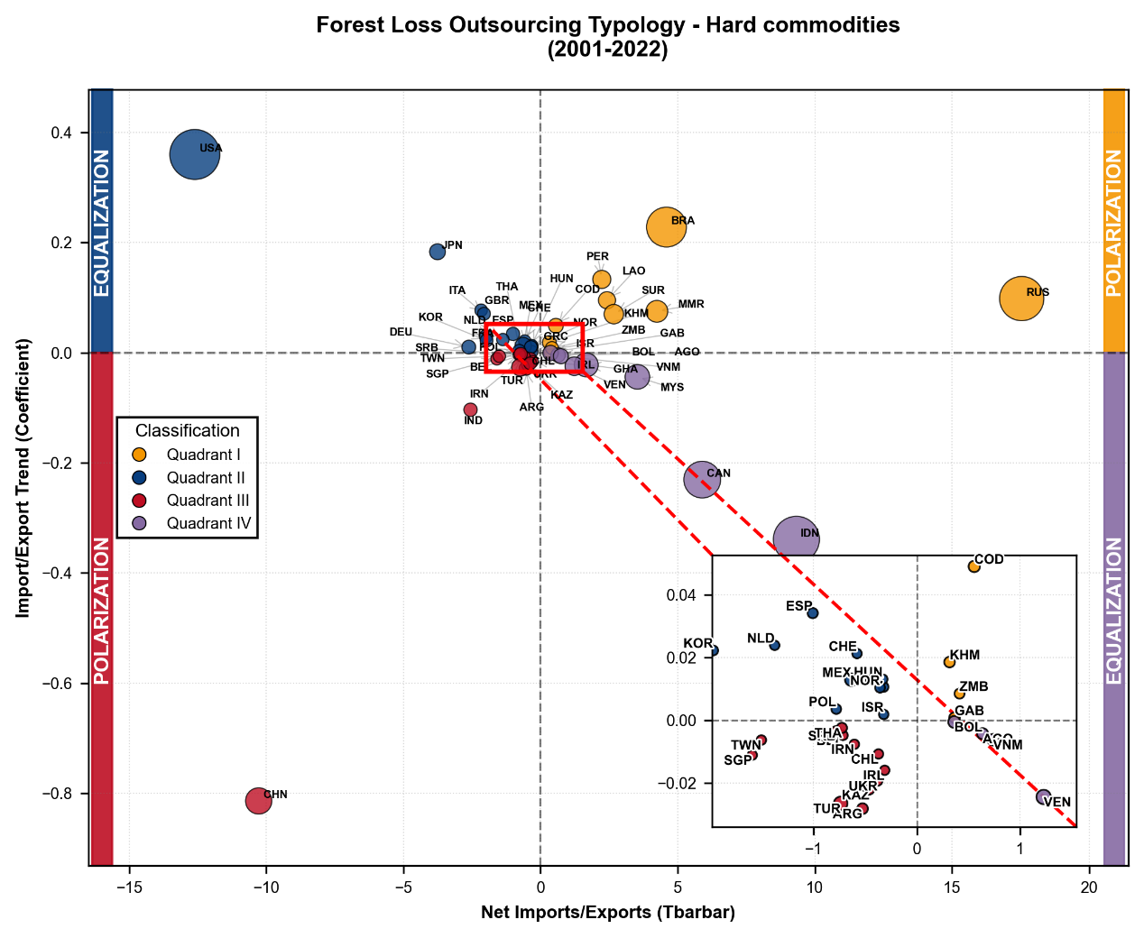

SI-Figure 4: Global forest loss outsourcing typology (2001–2022)——Logging
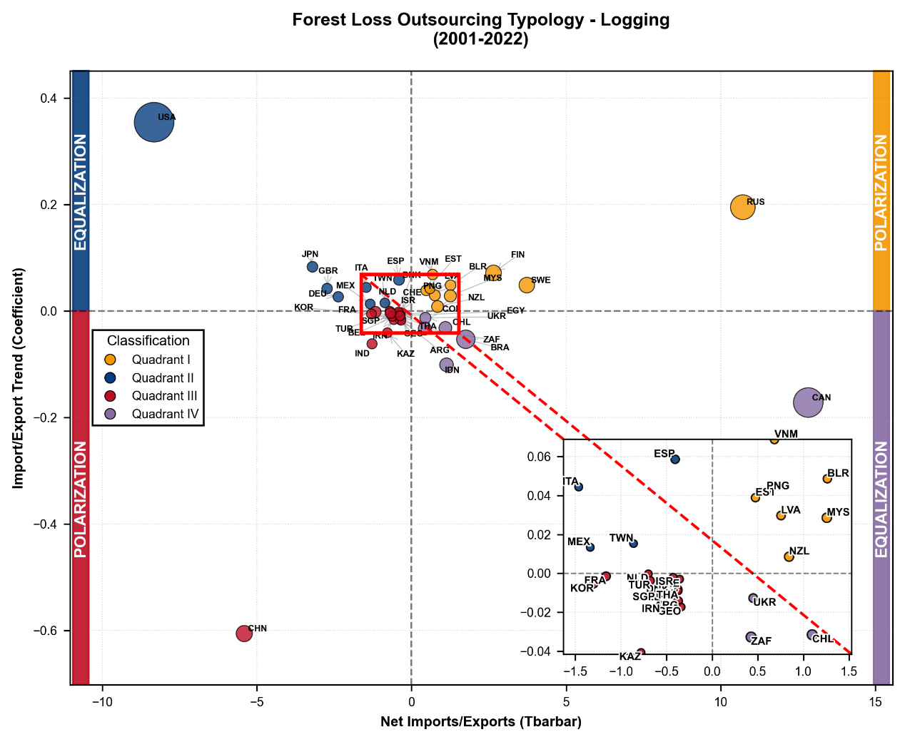

SI-Figure 5: Global forest loss outsourcing typology (2001–2022)——Permanent agriculture
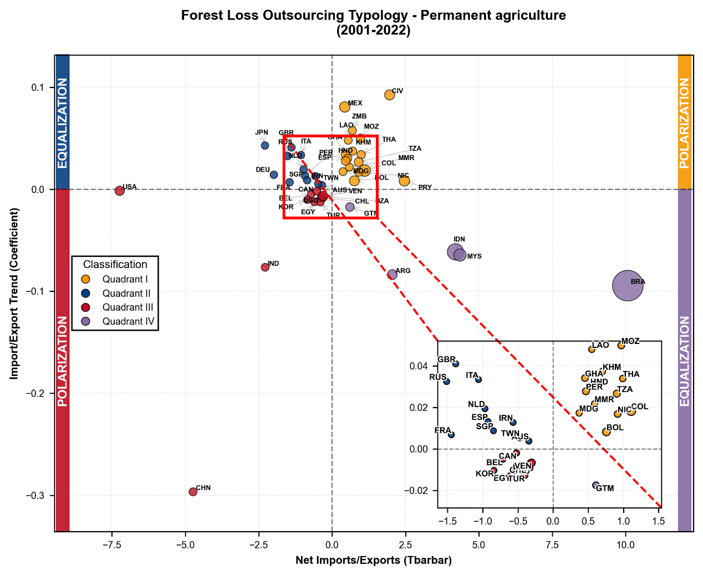

SI-Figure 6: Global forest loss outsourcing typology (2001–2022)——Settlements & Infrastructure
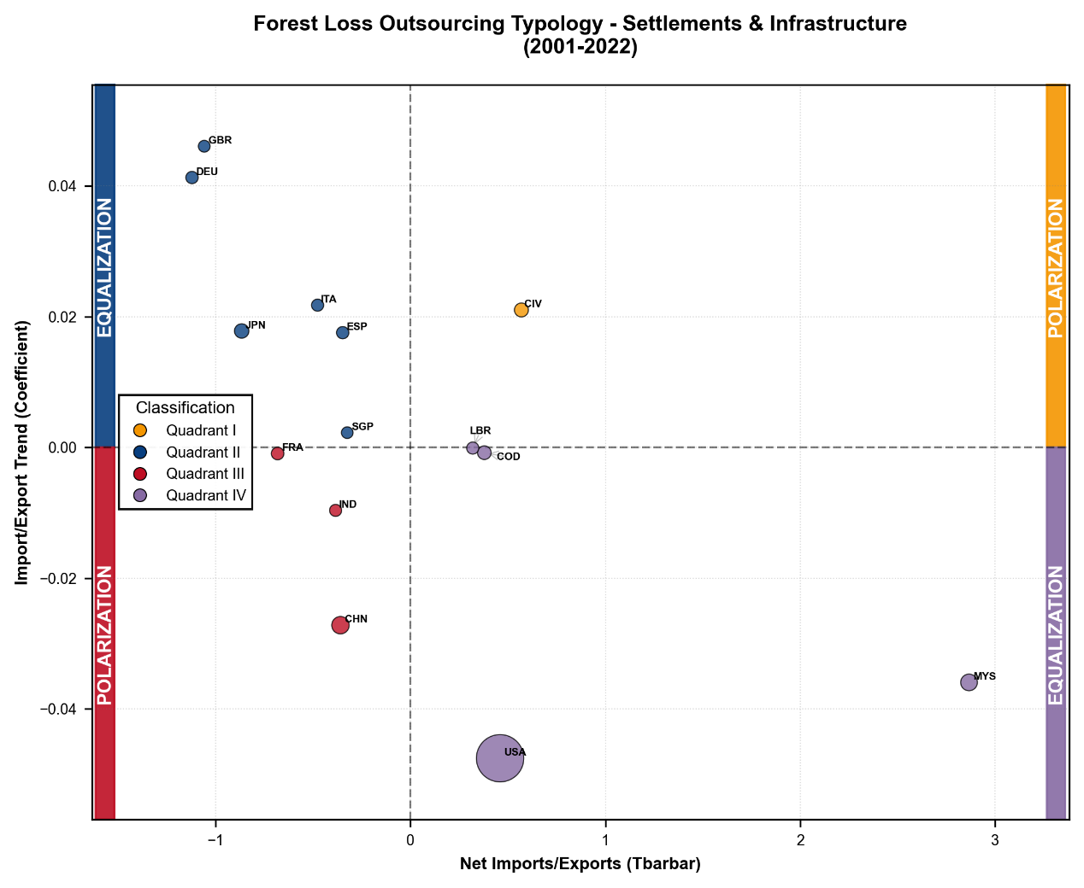

SI-Figure 7: Global map displaying the spatial distribution of forest loss outsourcing typology——Hard commodities
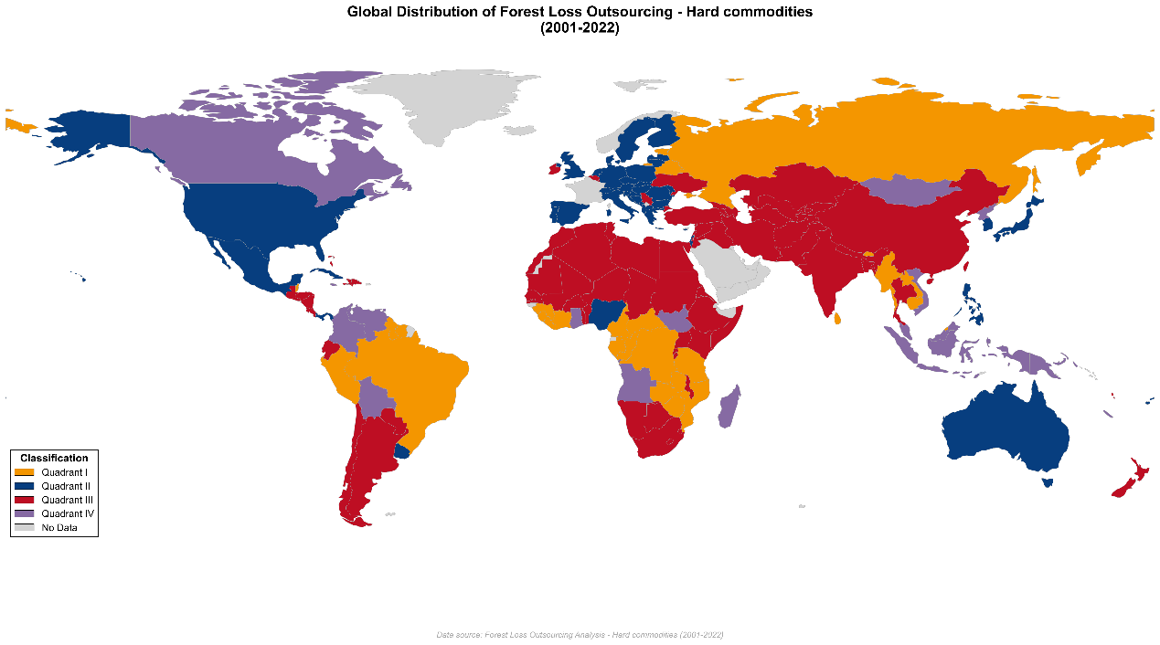

SI-Figure 8: Global map displaying the spatial distribution of forest loss outsourcing typology——Logging
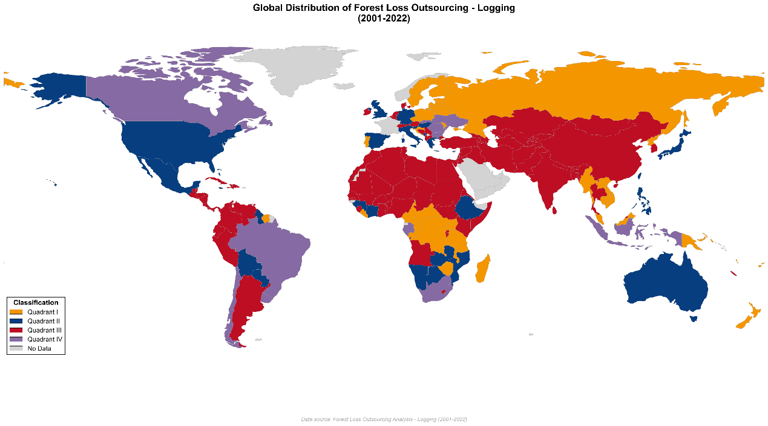

SI-Figure 9: Global map displaying the spatial distribution of forest loss outsourcing typology——Permanent agriculture
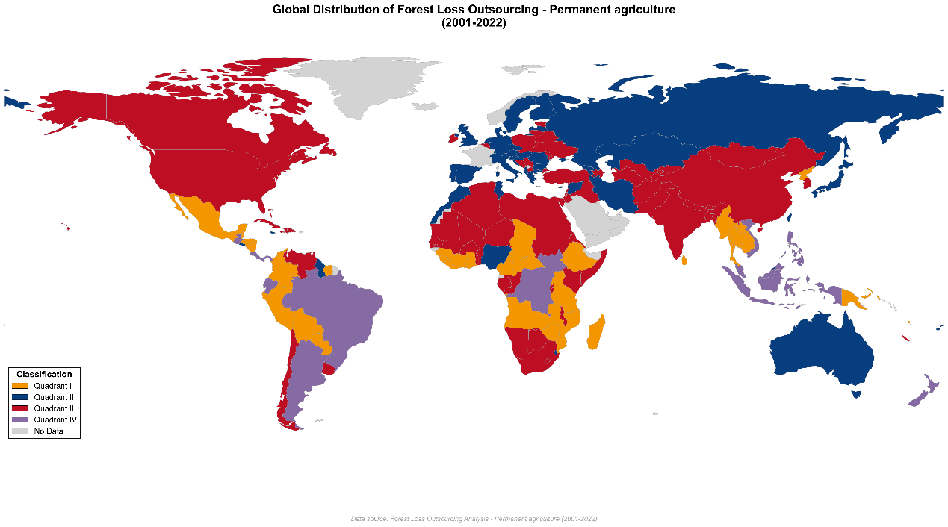

SI-Figure 10: Global map displaying the spatial distribution of forest loss outsourcing typology——Settlements & Infrastructure
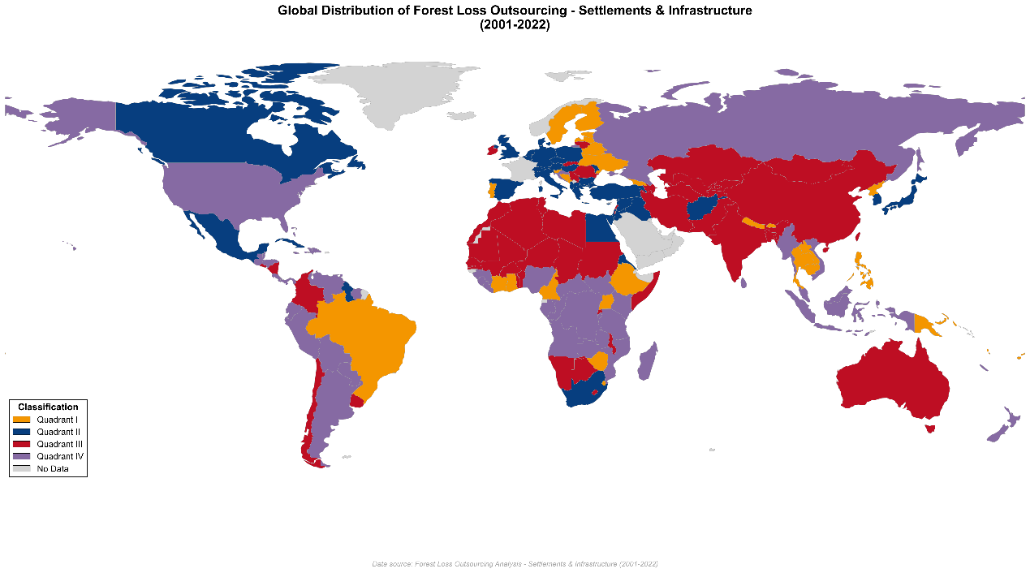

SI-Figure 11: Feature Contributions to Forest Loss footprint : A SHAP Beeswarm Plot Analysis
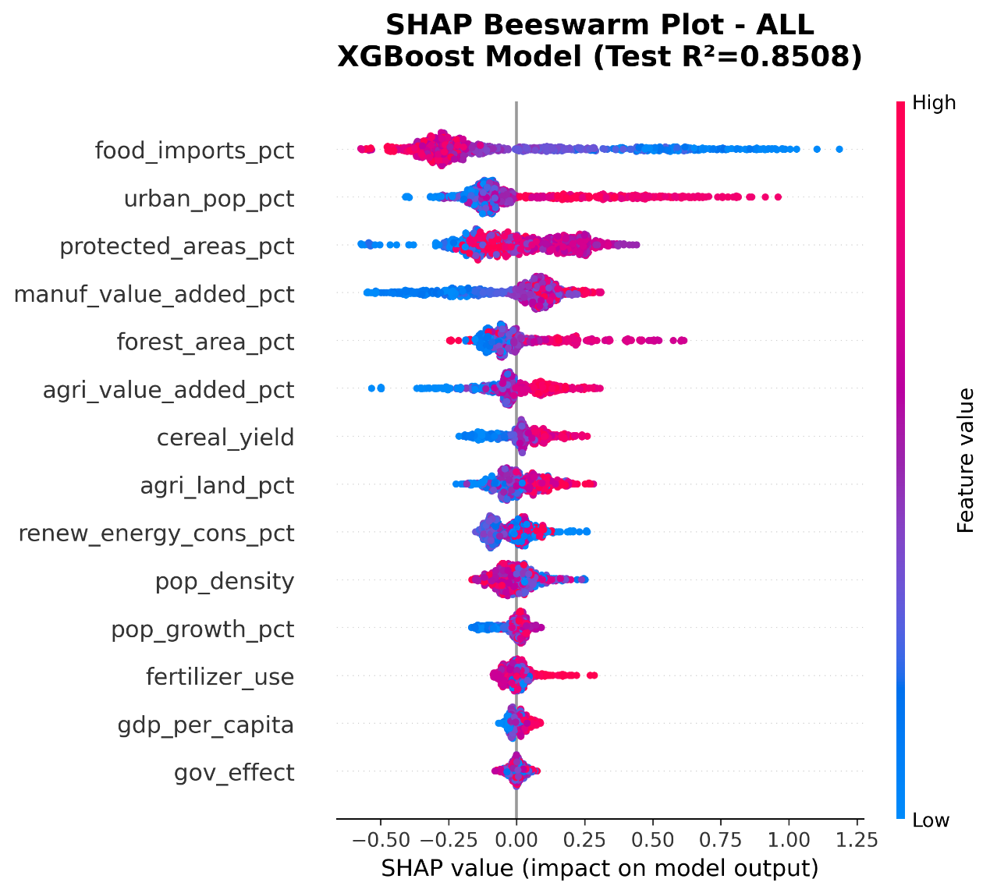

SI-Figure 12: Feature Contributions to Forest Loss footprint : A SHAP Feature Importance Plot Analysis

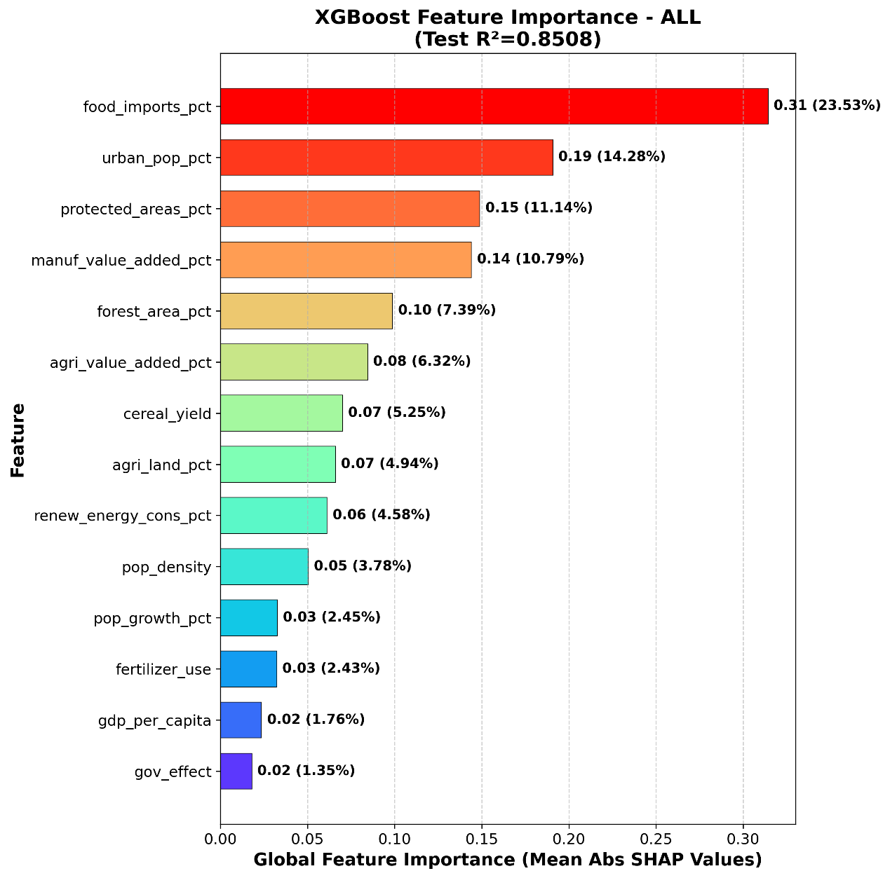

SI-Figure 13: Feature Contributions to Hard commodities: A SHAP Beeswarm Plot Analysis
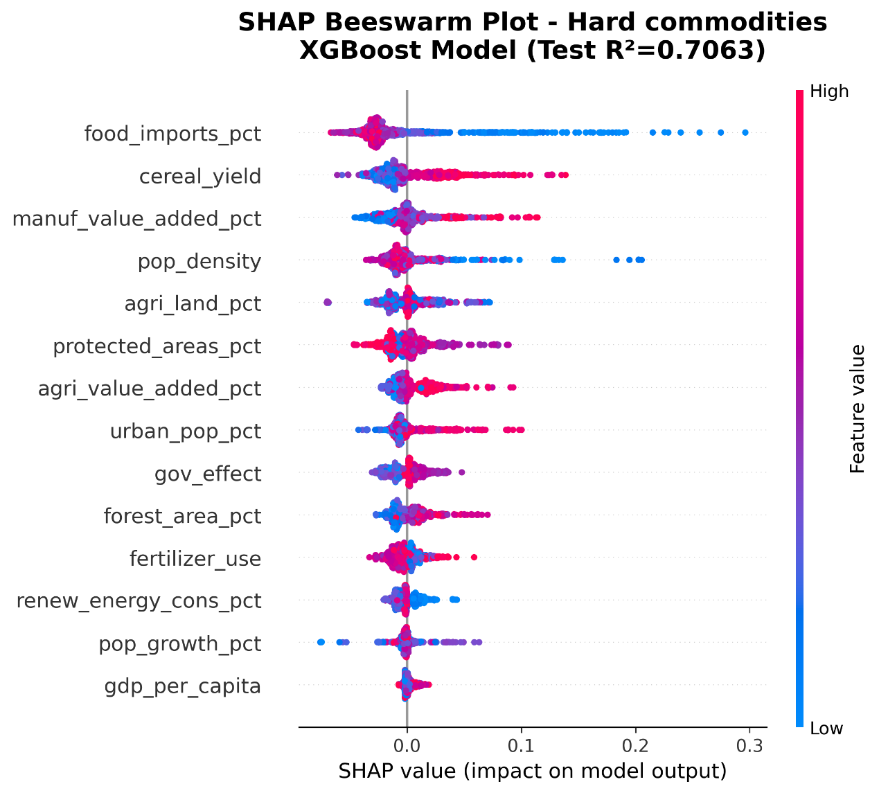

SI-Figure 14: Feature Contributions to Hard commodities: A SHAP Feature Plot Analysis

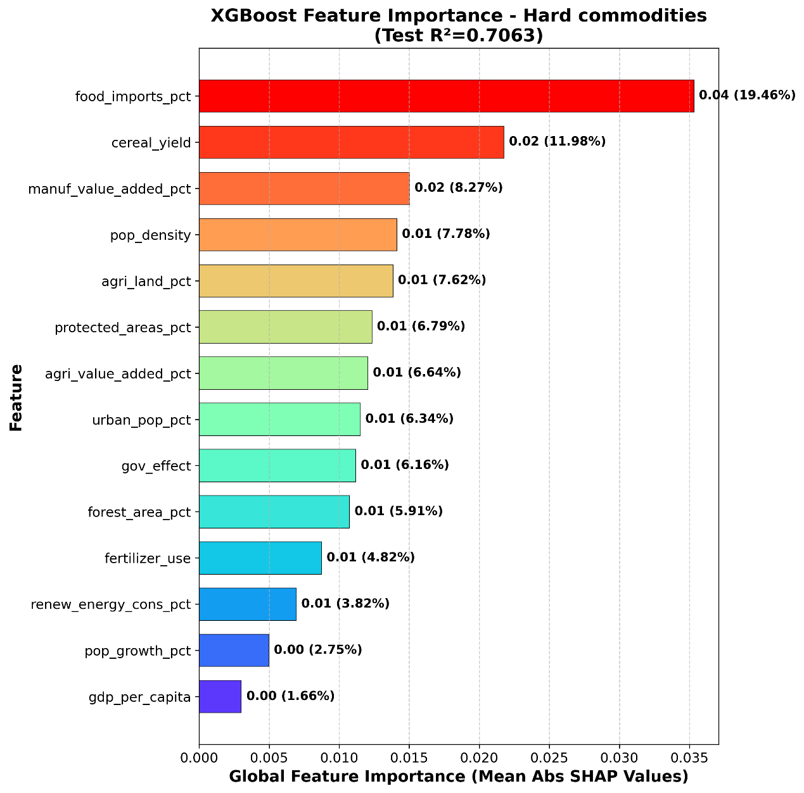

SI-Figure 15: Feature Contributions to Logging: A SHAP Beeswarm Plot Analysis
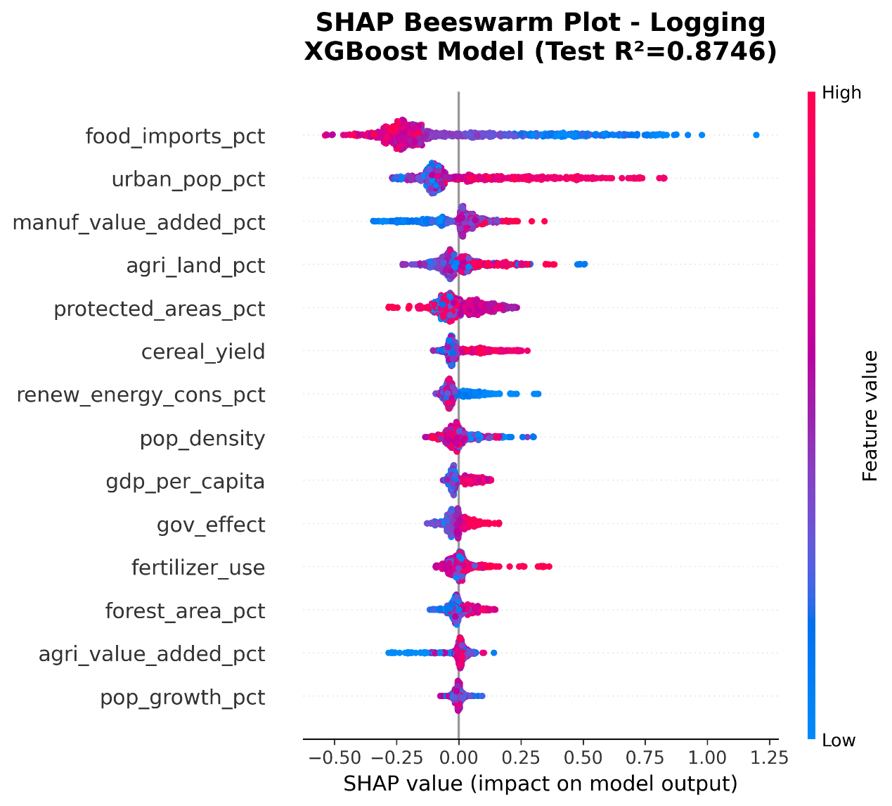

SI-Figure 16: Feature Contributions to Logging: A SHAP Feature Importance Plot Analysis

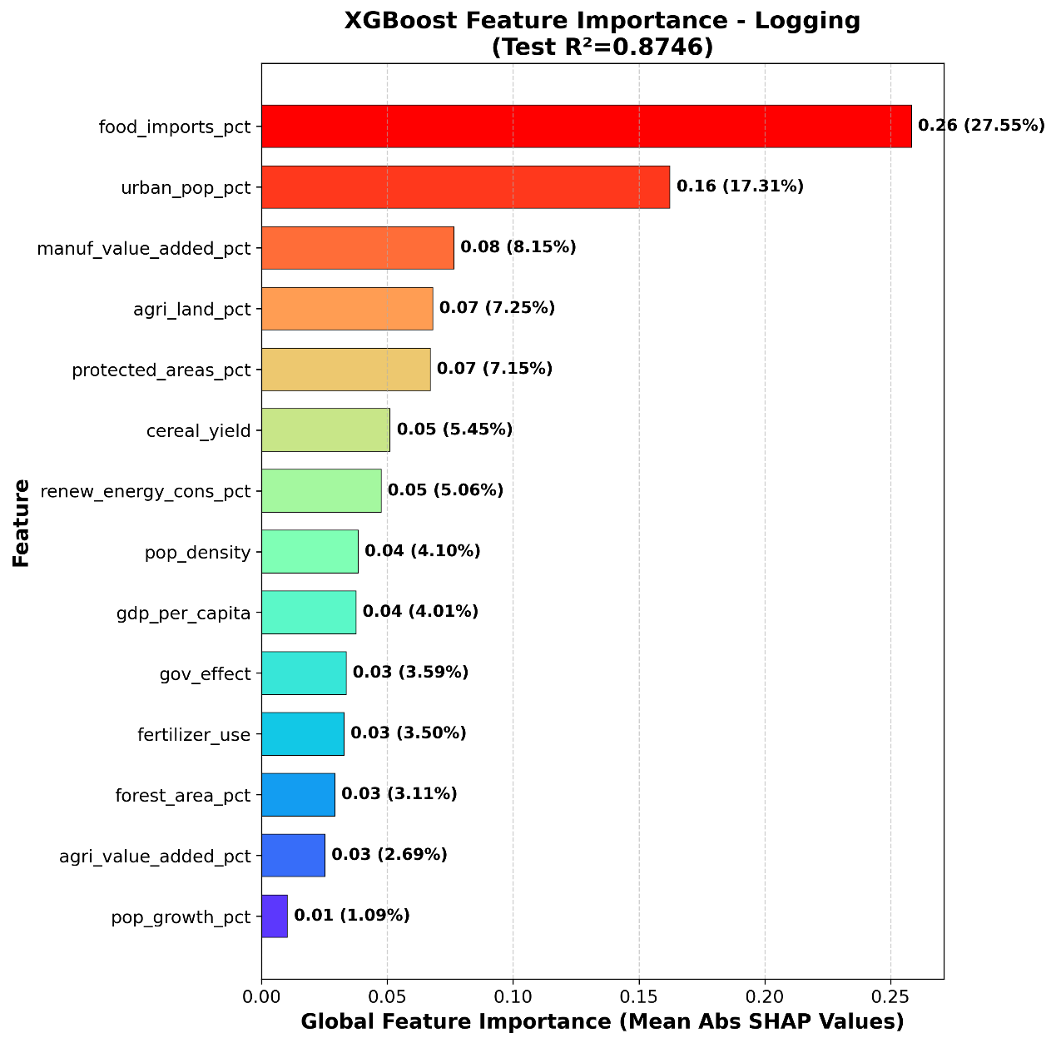

SI-Figure 17: Feature Contributions to Permanent agriculture: A SHAP Beeswarm Plot Analysis
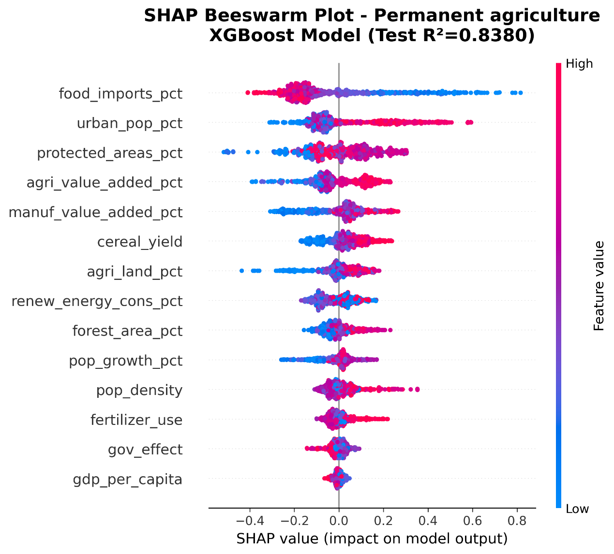

SI-Figure 18: Feature Contributions to Permanent agriculture: A SHAP Feature Importance Plot Analysis

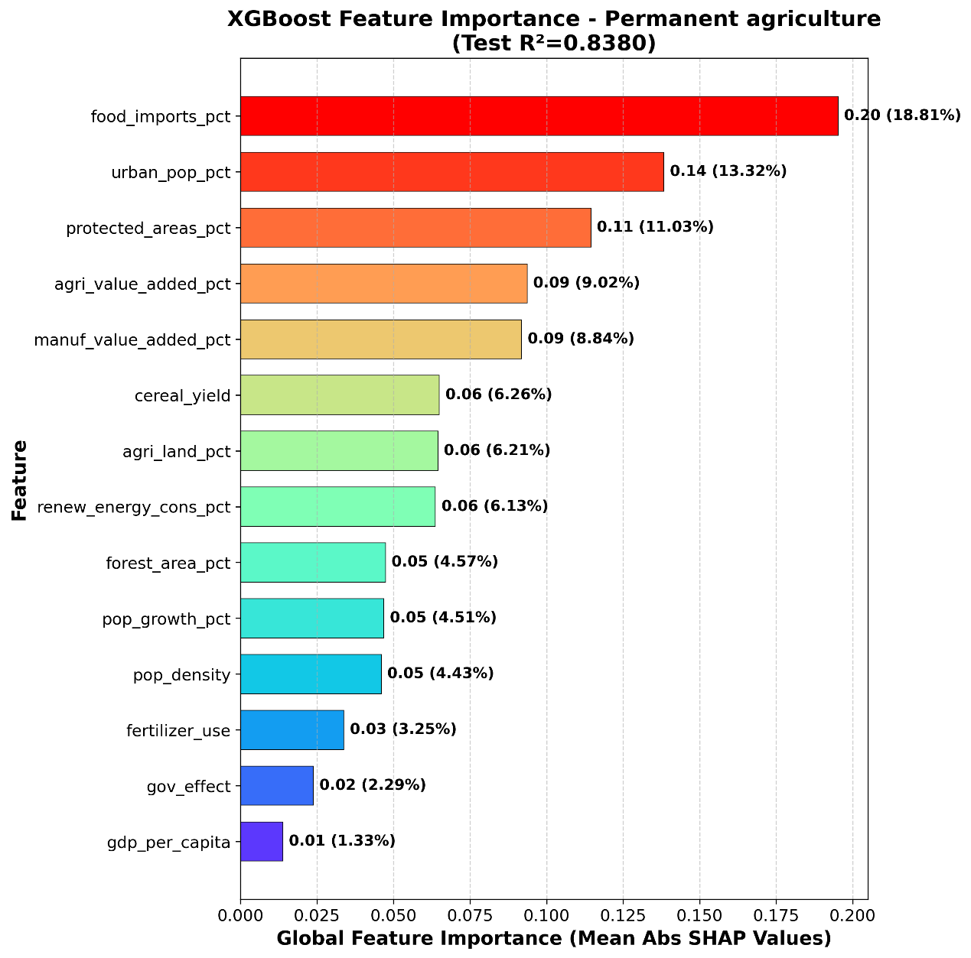

SI-Figure 19: Feature Contributions to Settlements & Infrastructure: A SHAP Beeswarm Plot Analysis
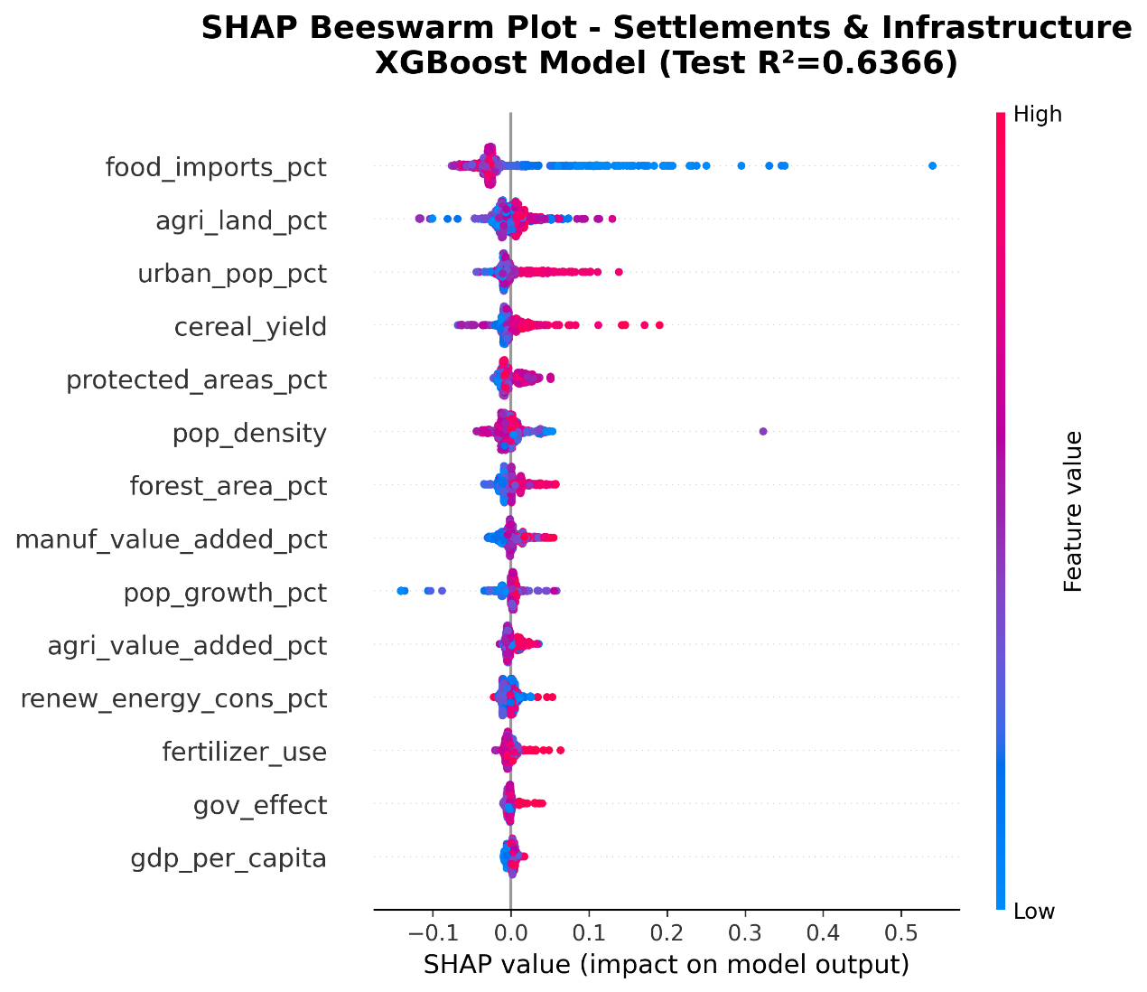

SI-Figure 20: Feature Contributions to Settlements & Infrastructure: A SHAP Feature Importance Plot Analysis
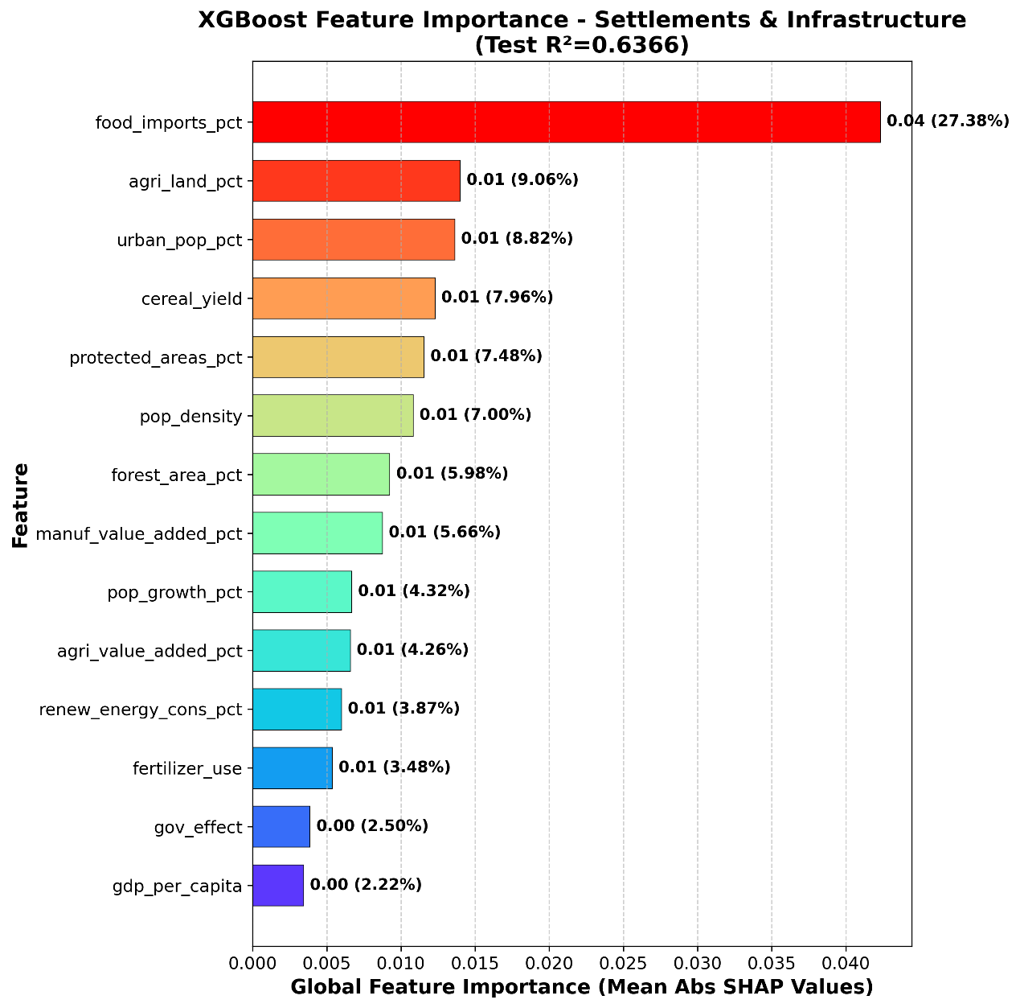

SI-Figure 21: Temporal dynamics of feature importance across forest loss driving factors.

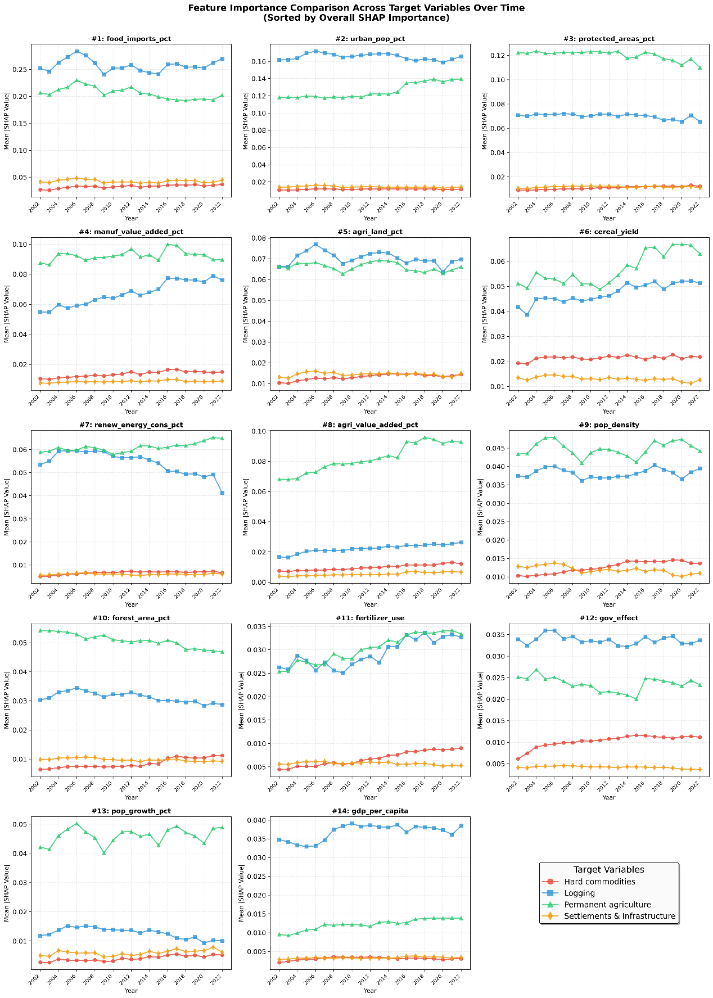

SI-Figure 22: Heatmap of feature variable correlation analysis
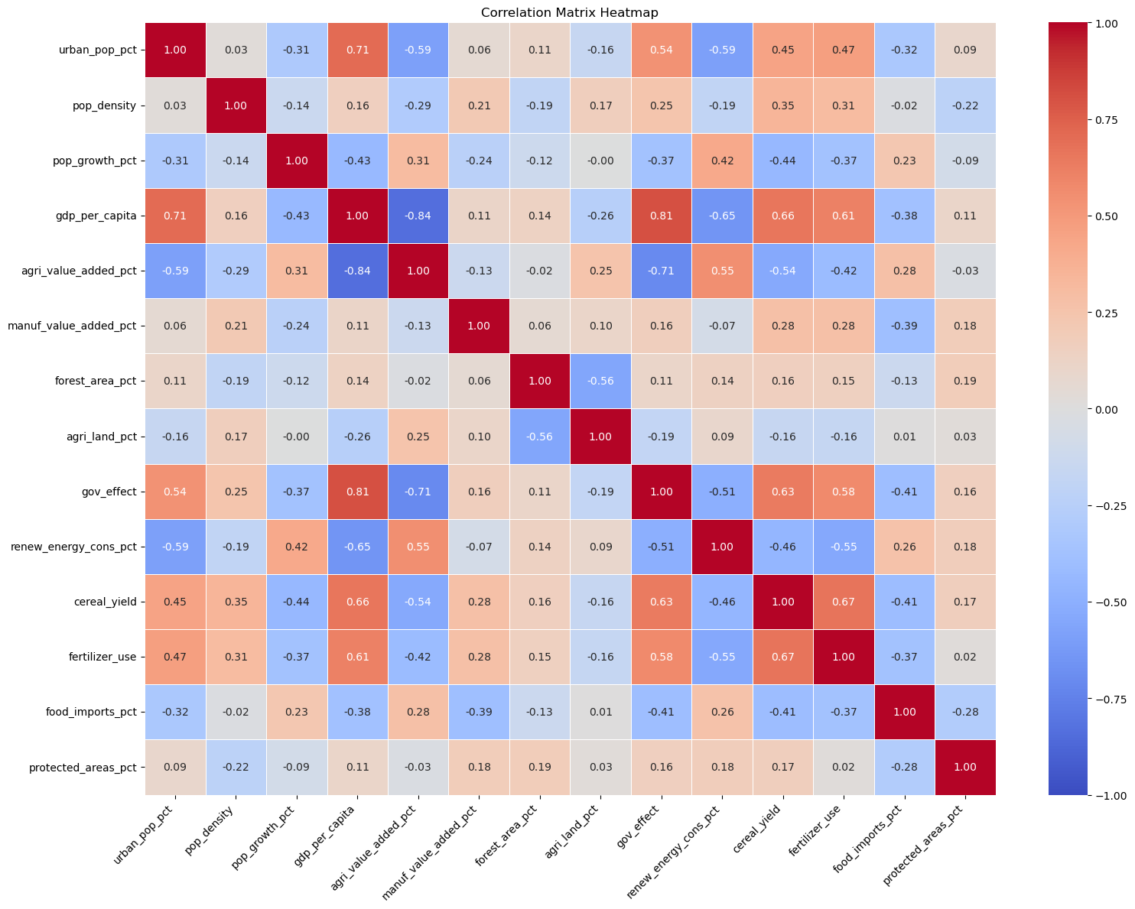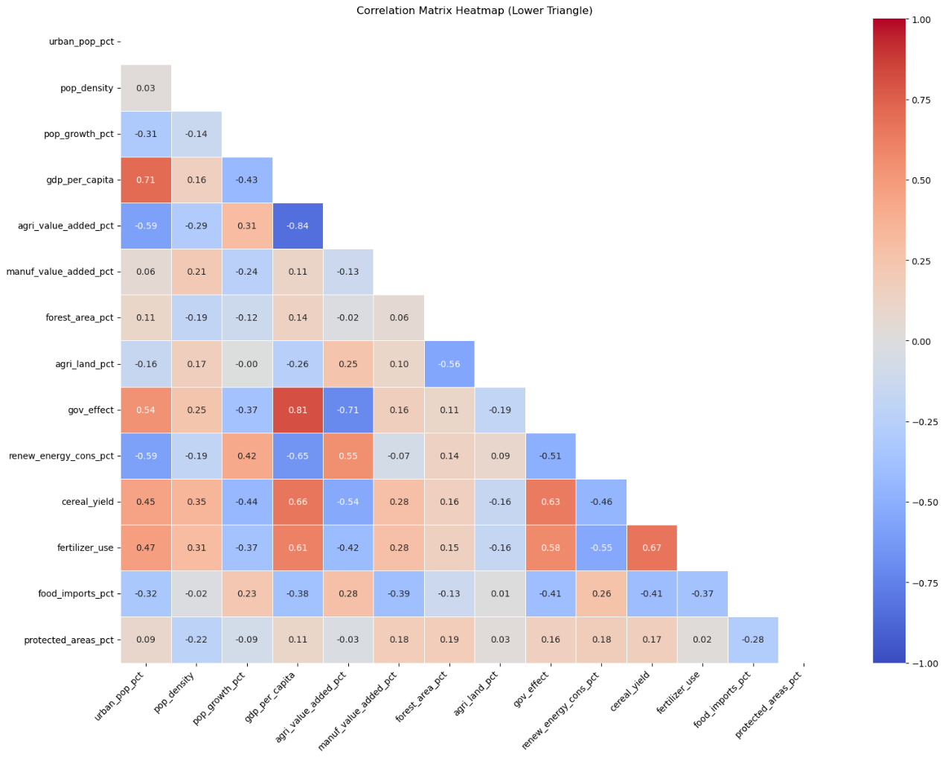

SI-Figure 23: Comparative R² Performance of Six Mainstream Machine Learning Algorithms in Predicting Forest Loss Footprint
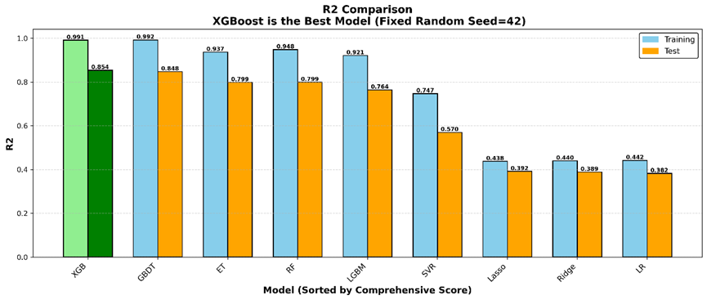

SI-Figure 24: Comparative RMSE Performance of Six Mainstream Machine Learning Algorithms in Predicting Forest Loss Footprint
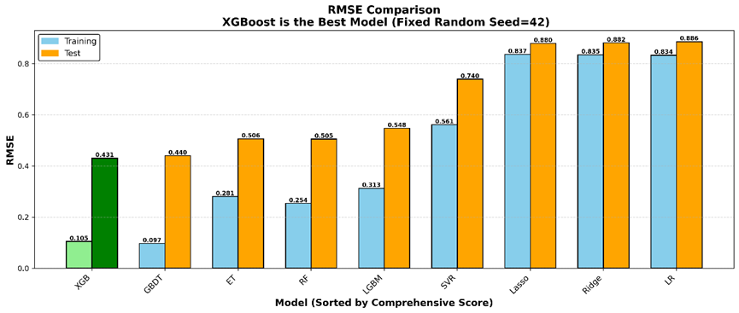

SI-Figure 25: Comparative MAE Performance of Six Mainstream Machine Learning Algorithms in Predicting Forest Loss Footprint
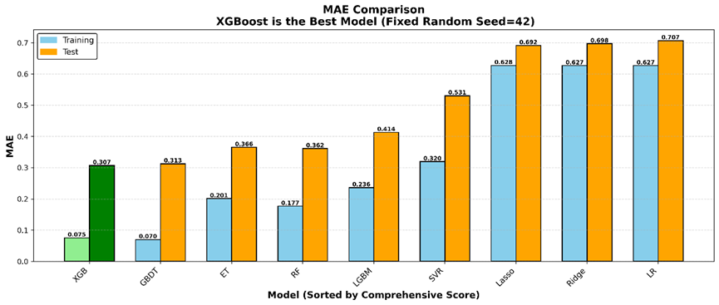

SI-Figure 26: Comparative MAPE Performance of Six Mainstream Machine Learning Algorithms in Predicting Forest Loss Footprint
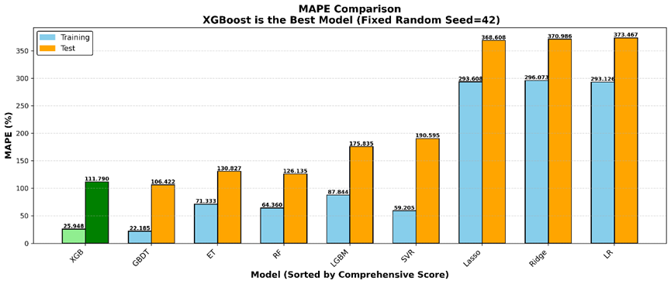

SI-Figure 27: Comparative MAPE Performance of Six Mainstream Machine Learning Algorithms in Predicting Forest Loss Footprint
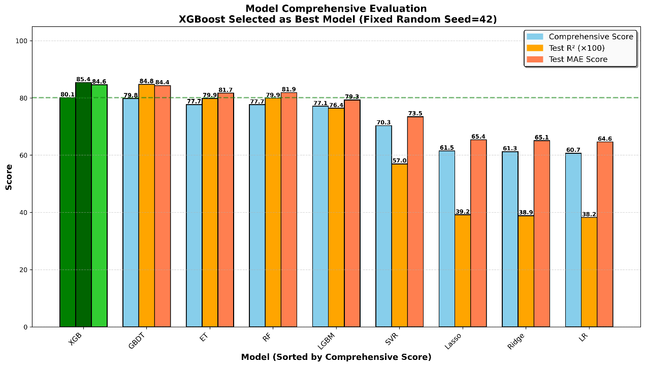

SI-Figure 28: Dependence Plot Analysis for All Features Variables: Examining Joint Effects and Interaction Patterns Between Features with SHAP Value Relationships——forest loss footprint

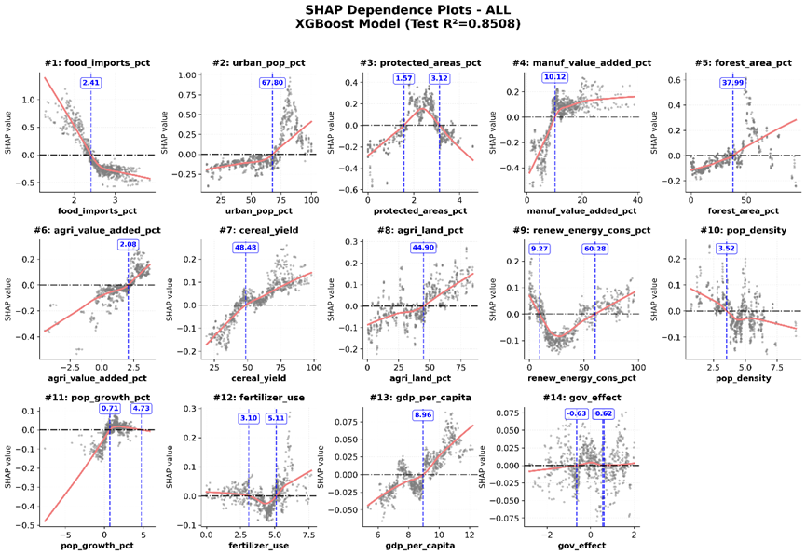

SI-Figure 29: Dependence Plot Analysis for All Features Variables: Examining Joint Effects and Interaction Patterns Between Features with SHAP Value Relationships——Hard commodities

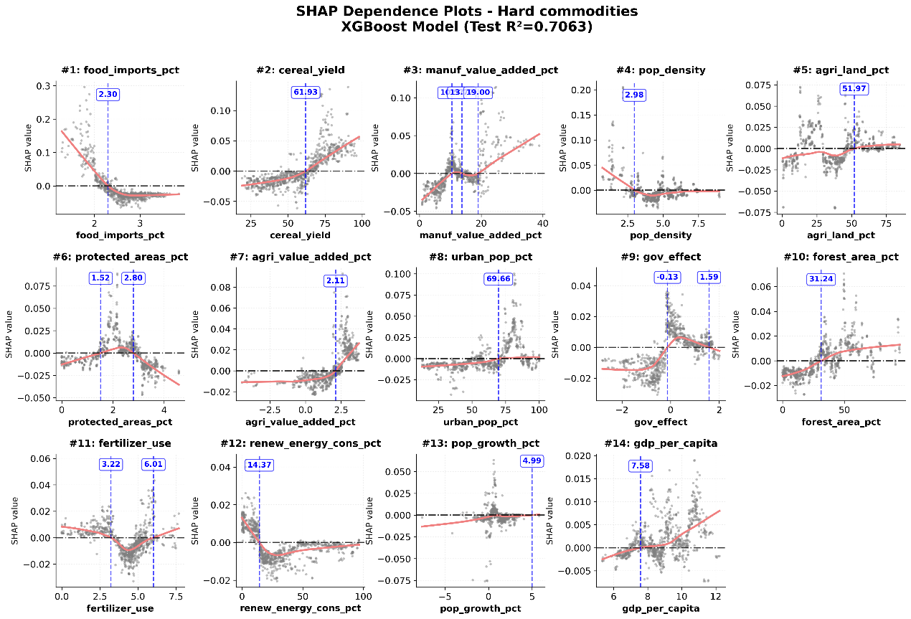

SI-Figure 30: Dependence Plot Analysis for All Feature Variables: Examining Joint Effects and Interaction Patterns Between Features with SHAP Value Relationships——Logging

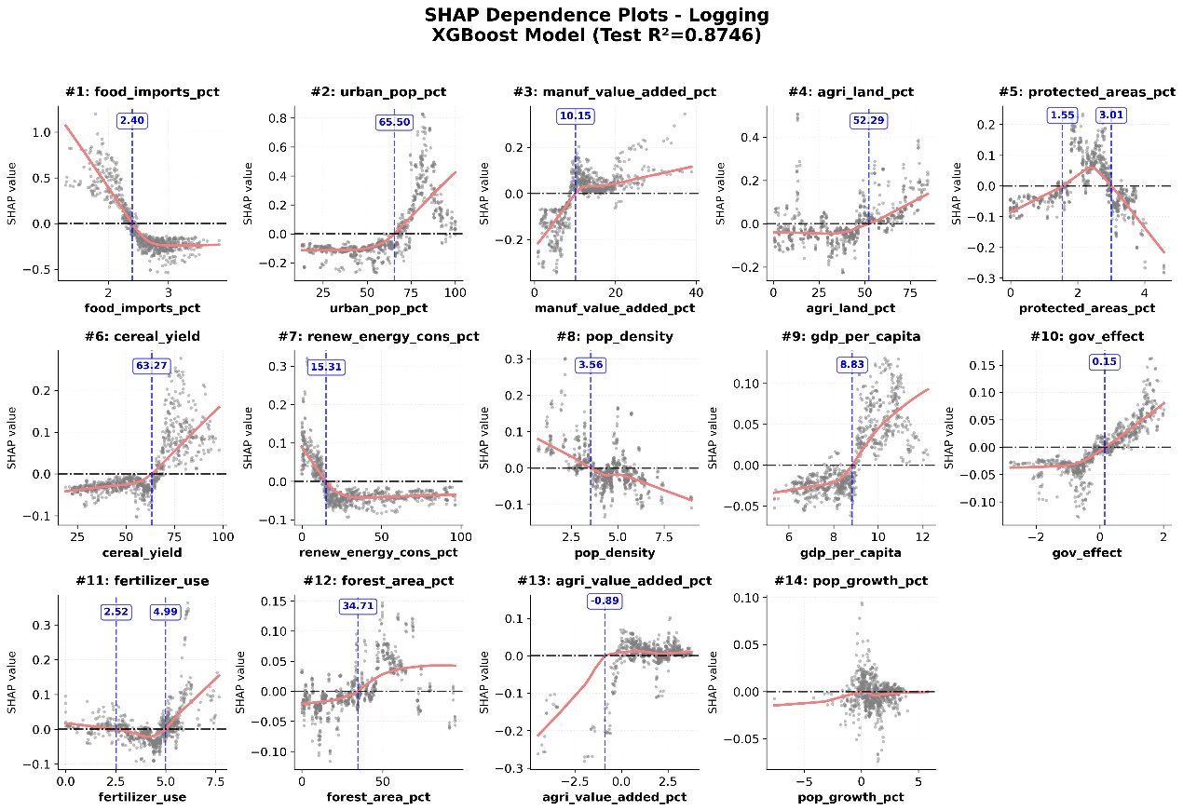

SI-Figure 31: Dependence Plot Analysis for All Feature Variables: Examining Joint Effects and Interaction Patterns Between Features with SHAP Value Relationships——Permanent agriculture

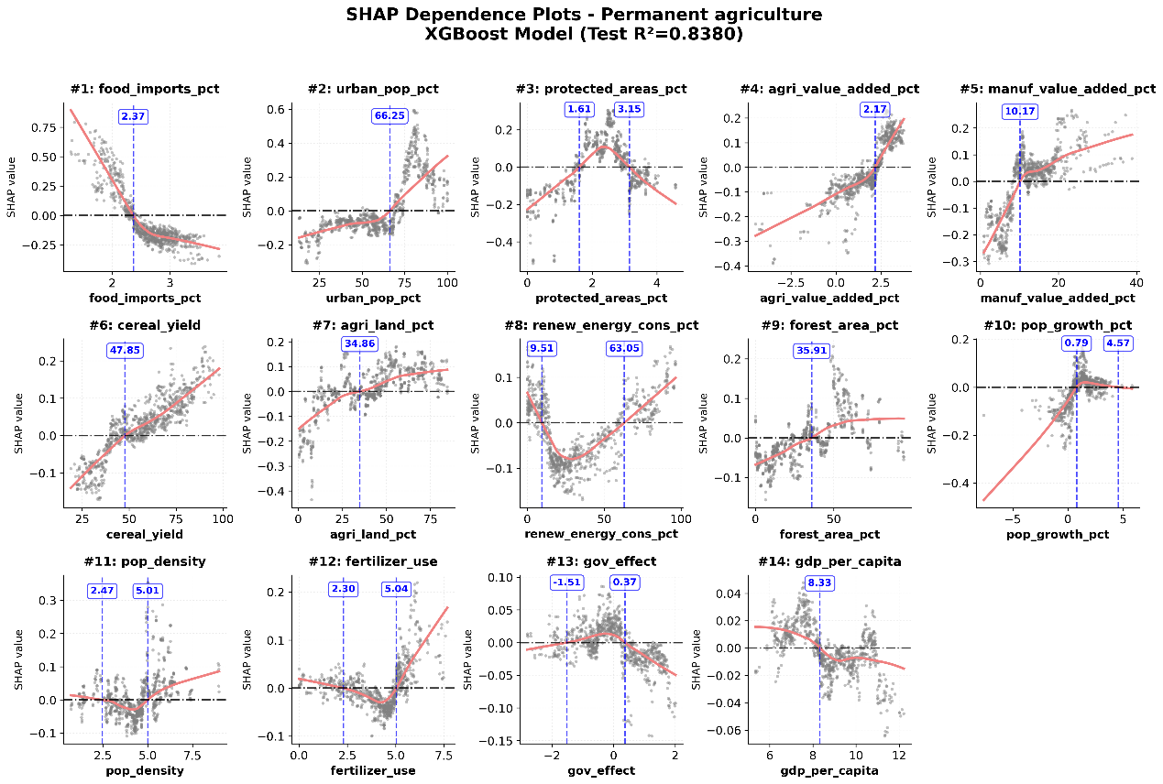

SI-Figure 32: Dependence Plot Analysis for All Feature Variables: Examining Joint Effects and Interaction Patterns Between Features with SHAP Value Relationships——Settlements & Infrastructure

