Figure S1. Pedigree chart of included families

Figure S2. Samples of verifying the high-risk SVs via IGV
a. Deletion from chr1:129099763 to chr1:129806803, co-segregated in family X20
b. Inversation from chr12:124450102 to chr12:124450163, co-segregated in family X21
c. Intra-translocation from chr16:10858372 to chr16:10858596, co-segregated in family X07
d. Inter-translocation from chr21:34033056 to 34033371, co-segregated in family X08

Figure S3. Samples of verifying of high-risk SNVs via IGV
a. Variant chr12:78571428:C:T , co-segregated in family X03
b. Variant chr16:58750617:G:T, co-segregated in family X20
c. Variant chr17:42427647:C:T, co-segragated in family X08
d. Variant chr19:35510353:C:T, co-segragated in family X14

Figure S4, OCD/SCZ-GWAS-derived virtual panel
a. Work flow of OCD/SCZ-GWAS-derived virtual panel
b. Overepresentation analysis on OCD/SCZ-GWAS-derived genes
c. KEGG enrichment analysis on OCD/SCZ-GWAS-derived genes
d. GO enrichment analysis on OCD/SCZ-GWAS-derived genes

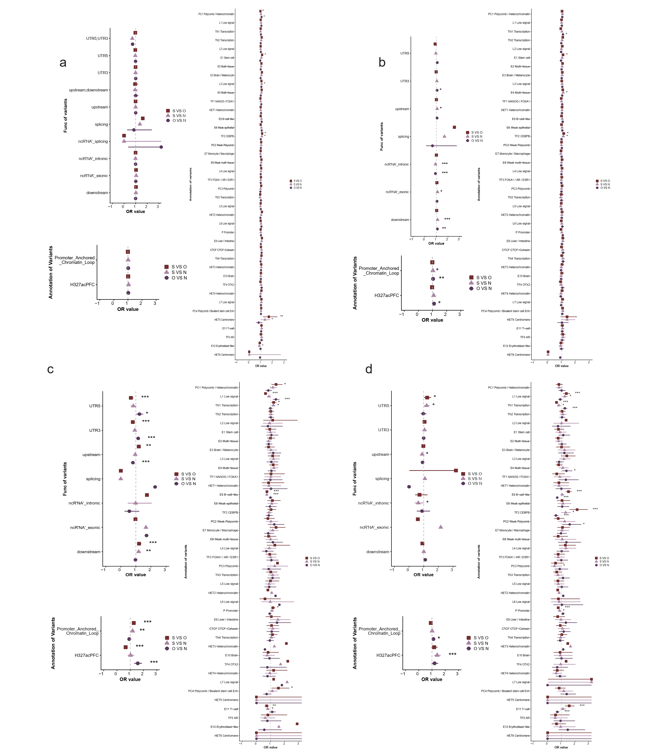
Figure S5 Burden test of regulatory functions in non-coding regions.
The top-left, bottom-left and right panel in each panel showed the results with Refseq annotation, Psychencode atlas and Sei annotation.
a. Enrichment in whole genome.
b. Enrichment within the CS_ncs geneset regions.
c. Enrichment within the OS_ncs geneset regions.
d. Enrichment within the SS_ncs geneset regions.
† O, obsessive-compulsive disorder; S, schizophrenia; N, healthy control.
††“*”indicated p<0.05,“**”indicated p<0.005,“***”indicated p<0.001

Figure S6. Distribution of the count of the functional element
Matrix combining patients in the cohort and counts of functional elements detected on every patient.
Rows are panel functional elements detected in the patients, and columns are the patients.
The upper panels show patient diagnoses. Counts of the functional elements were showed as z-score.

Figure S7 Gene-based association test in non-coding co-segregated regions
Several risk genes from rare variants association test in non-coding region were in the PPI interaction with the coding variants in the same protein-protein interaction (PPI) network.
The construction of original network was shown in Figure 3.
The involved genes derived from non-coding variants were colored yellow.

Figure S8. Overepresentation analyses of genesets
a. Overrepresentation analysis of green module in OCD and greenyellow module in SCZ
b. Overrepresentation analysis of brown modules in SCZ and OCD
c. Overrepresentation analysis of black module in SCZ
d. Overrepresentation analysis of early-pregnancy modules
e. Overrepresentation analysis of mid-pregnancy modules

