Supplementary Information
This file contains Supplementary Figures, videos and Supplementary Tables.
Supplementary Figures

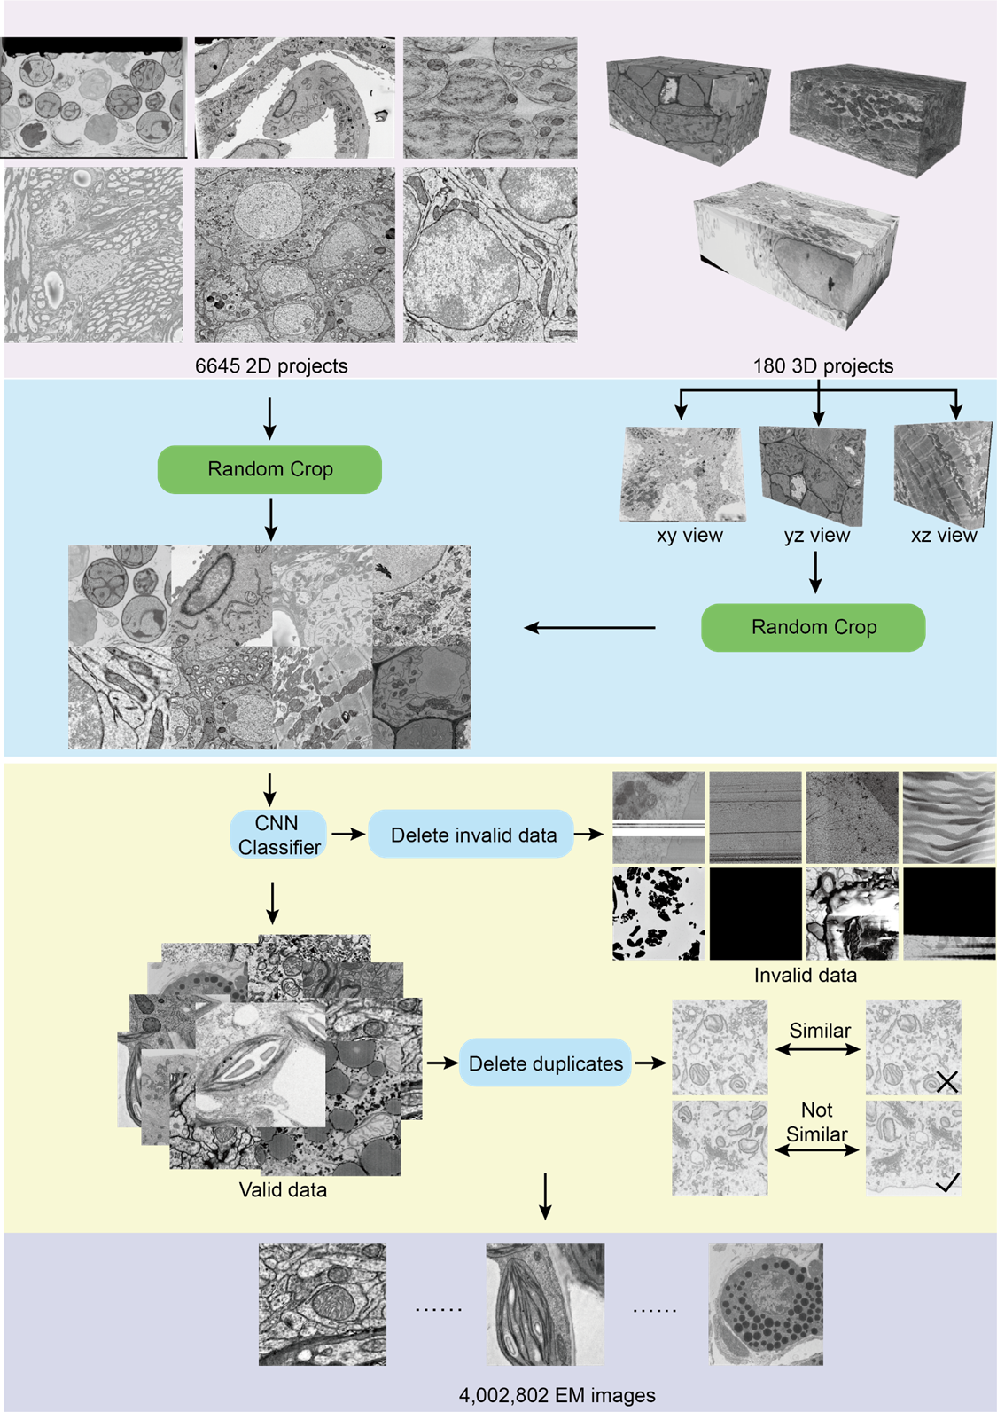
Supplementary Fig. 1. Image processing workflow for preparing the high-quality Electron Microscopy Cell Foundation (EMCF) dataset.

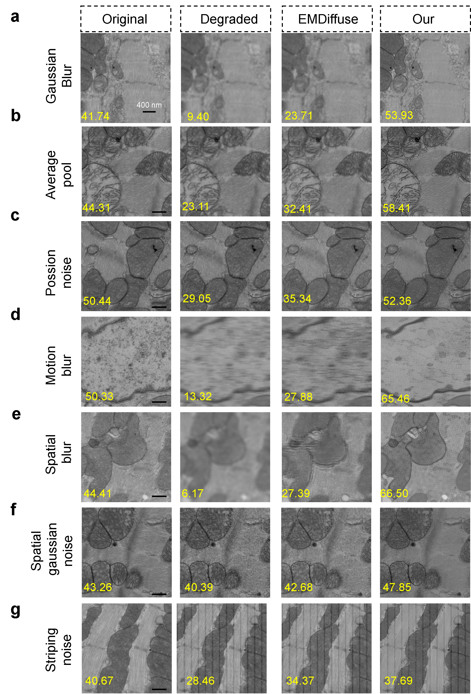

Supplementary Fig. 2 Comparison of SR results from EMDiffuse and EMCellFiner on microscopy images degraded via different synthetic perturbations. a, 3×3 Gaussian blur. b, 4×4 mean filtering. c, Poisson noise (intensity-dependent, simulating low-light conditions). d, Motion blur (9-pixel horizontal kernel). e, 5×5 mean filtering (detail suppression). f, Additive white noise (σ=10, per-pixel i.i.d.). g, Column-wise stripe artifacts (10-pixel spacing, 20-intensity reduction, mimicking EM scan noise). Degraded inputs were generated by 4× downsampling with combined perturbations to emulate real-world EM image distortions. Sharpness scores are shown for related images.

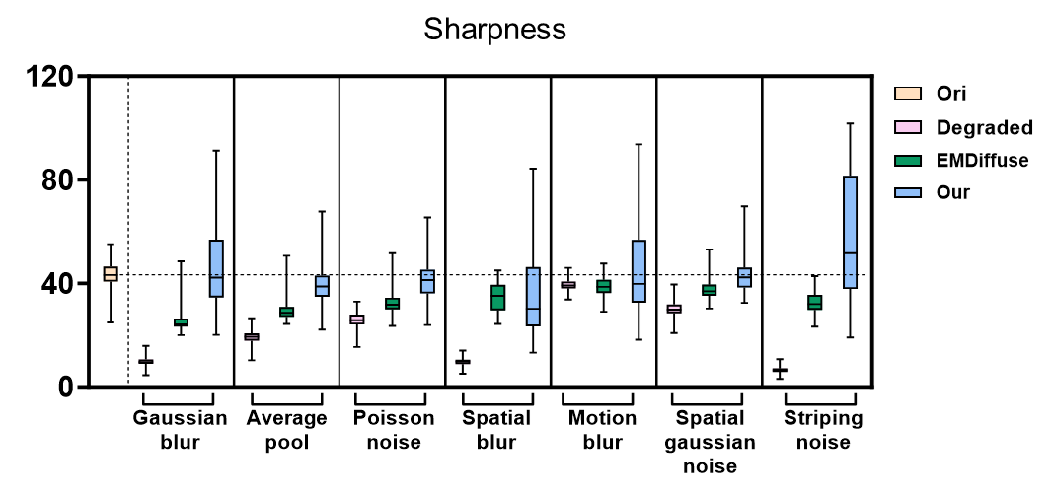
Supplementary Fig. 3 Comparison of sharpness for SR reconstructions generated by EMCellFiner and EMDiffuse across various degradation patterns. The data sources used for these tests are detailed in Supplementary Table 1.

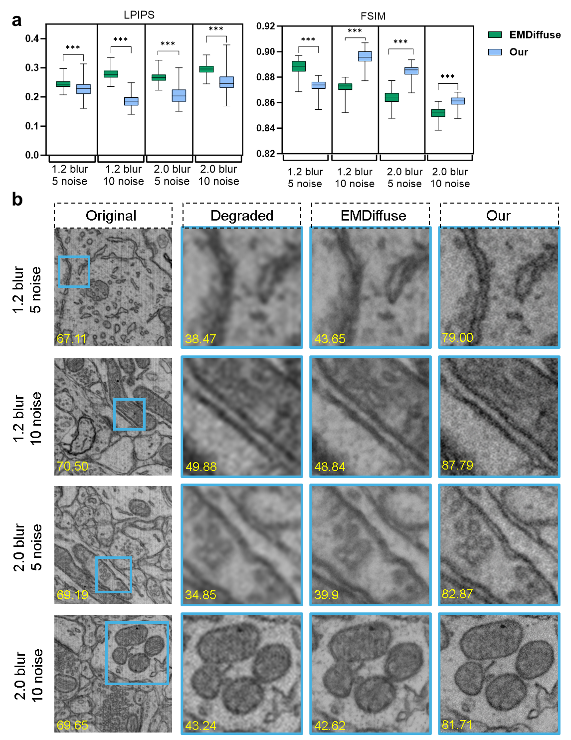
Supplementary Fig. 4 Comparison super-resolution reconstructions generated by EMCellFiner and EMDiffuse under different blur and noise. a, Statistic comparison on the dataset (Supplementary table 1) in terms of LPIPS and FSIM. b, Representative SR images reconstructed by EMCellFiner and EMDiffuse. Sharpness values are shown for related images.

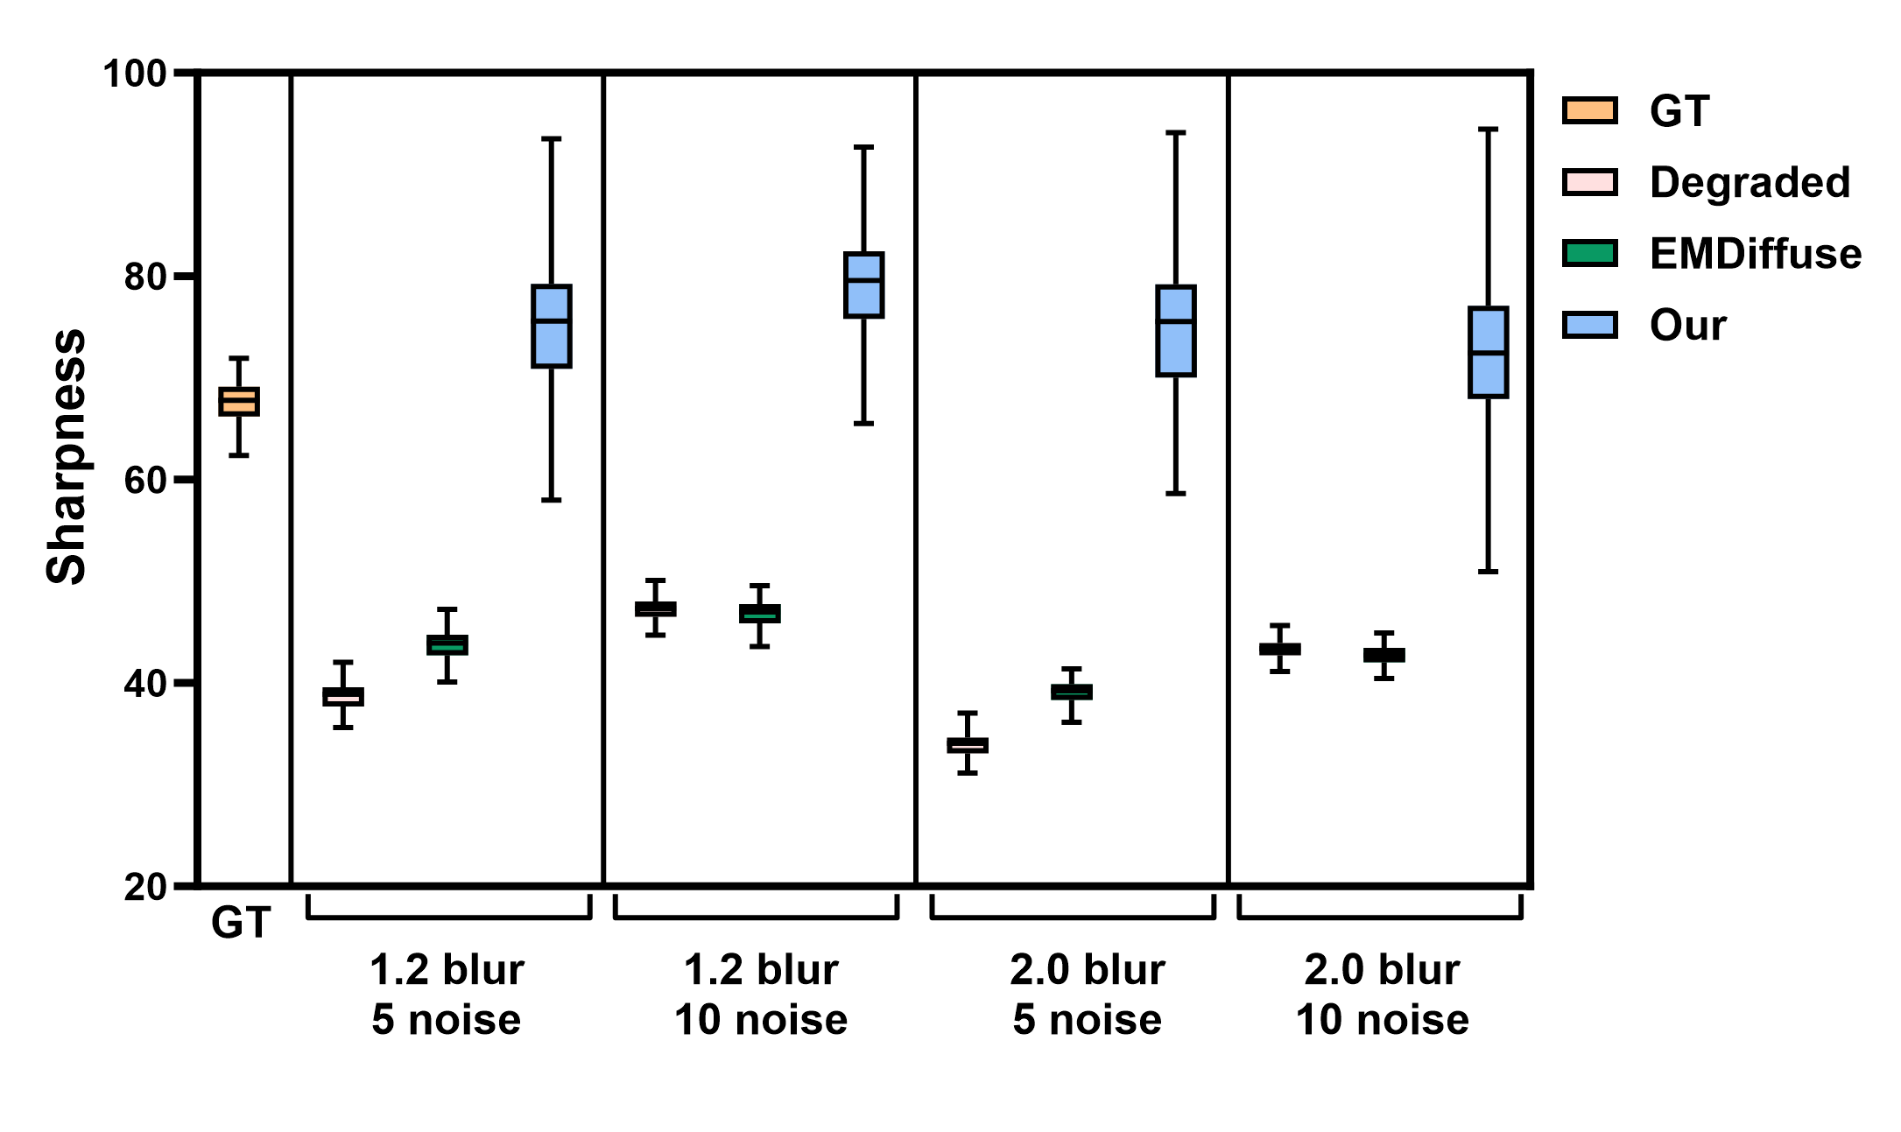
Supplementary Fig. 5 Sharpness comparison super-resolution reconstructions generated by EMCellFiner and EMDiffuse under different blur and noise. The data sources used for these tests are detailed in Supplementary Table 1.

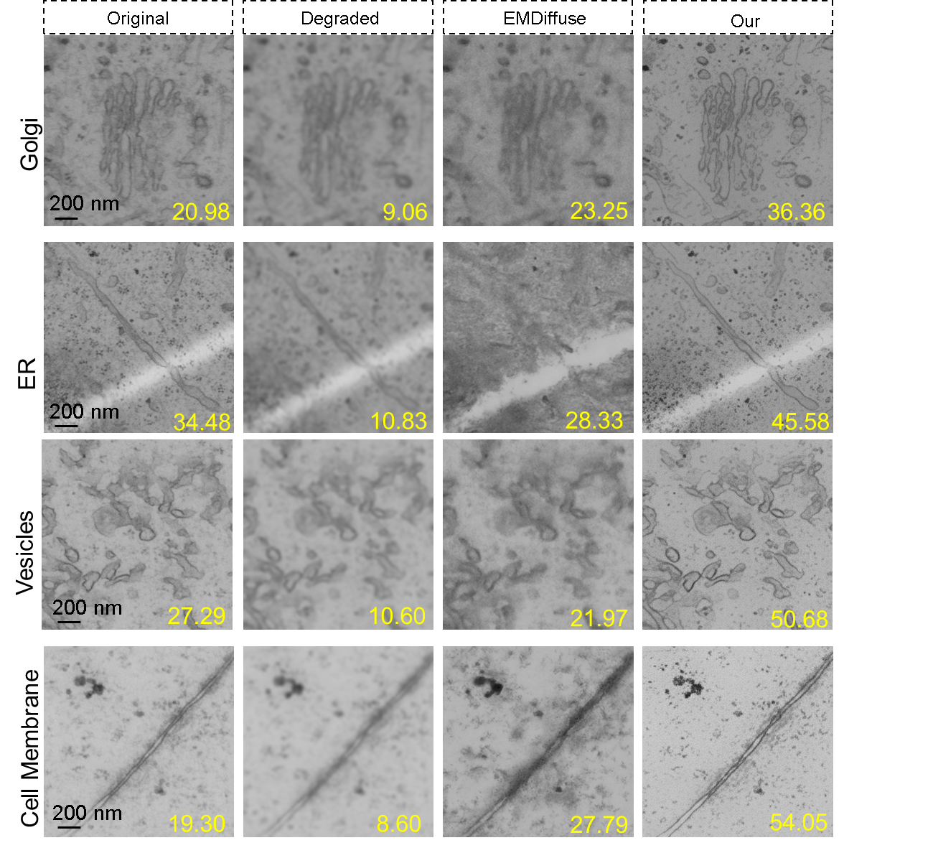
Supplementary Fig. 6 Comparative analysis of super-resolution performance on the different organelles from Kuiper2022NCB dataset generated by EMDiffuse and EMCellFiner. Degraded images were generated from ground truth images (512 pixel) via 3×3 Gaussian blurring and 4× down sampling. Sharpness values are shown for related images. EMCellFiner consistently provides sharper and more defined membrane boundaries across organelles.

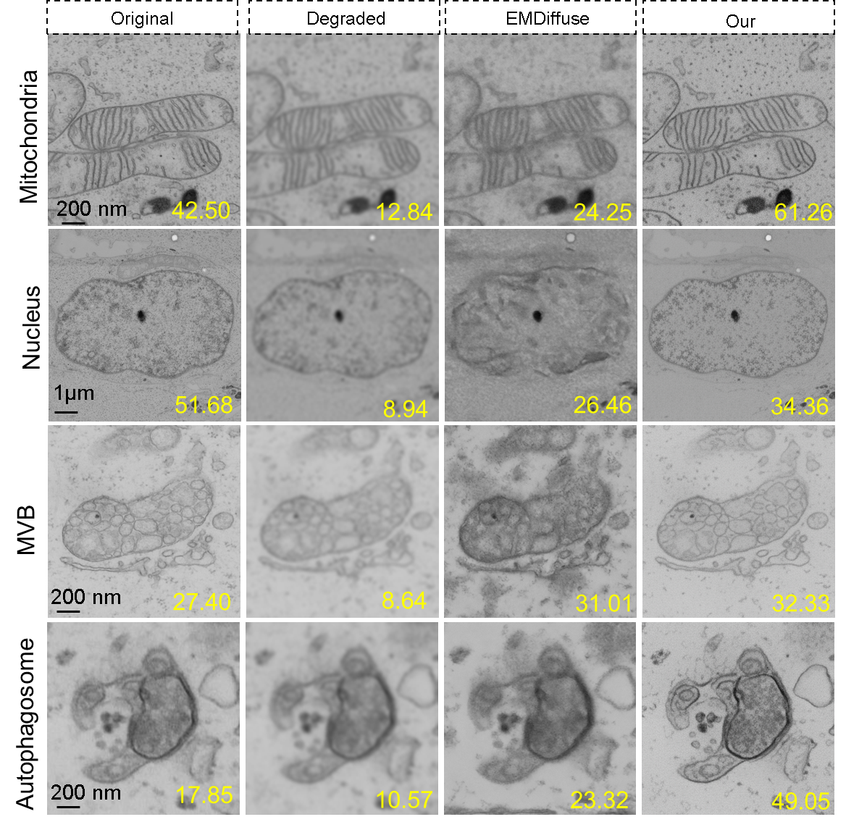

Supplementary Fig. 7 Comparative analysis of super-resolution performance on the different organelles from Kuiper2022NCB dataset by EMDiffuse and EMCellFiner. Degraded images were generated from ground truth images (512px) via 3×3 Gaussian blurring and 4× downsampling. Sharpness values are shown for related images. EMCellFiner consistently provides sharper and more defined membrane boundaries across organelles.

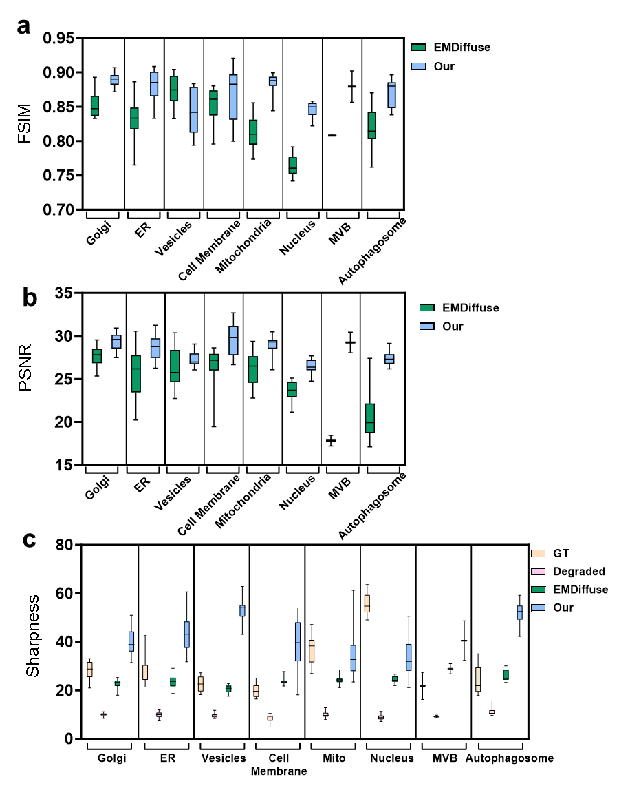
Supplementary Fig. 8 Comparison of FSIM, PSNR and sharpness for super-resolution reconstructions generated by EMCellFiner and EMDiffuse under high Signal-to-Noise Ratio conditions. Degraded images were generated from ground truth images (512px) via 3×3 Gaussian blurring and 4× downsampling. The data sources used for these tests are detailed in Supplementary Table 1. For each organelle type, EMCellFiner reconstructions consistently exhibit superior structural clarity compared to those from EMDiffuse. Notably, the sharpness scores for EMCellFiner reconstructions frequently exceed those of the original ground truth images, suggesting that our method not only restores but actively enhances high-frequency features, leading to a perceptually sharper output.

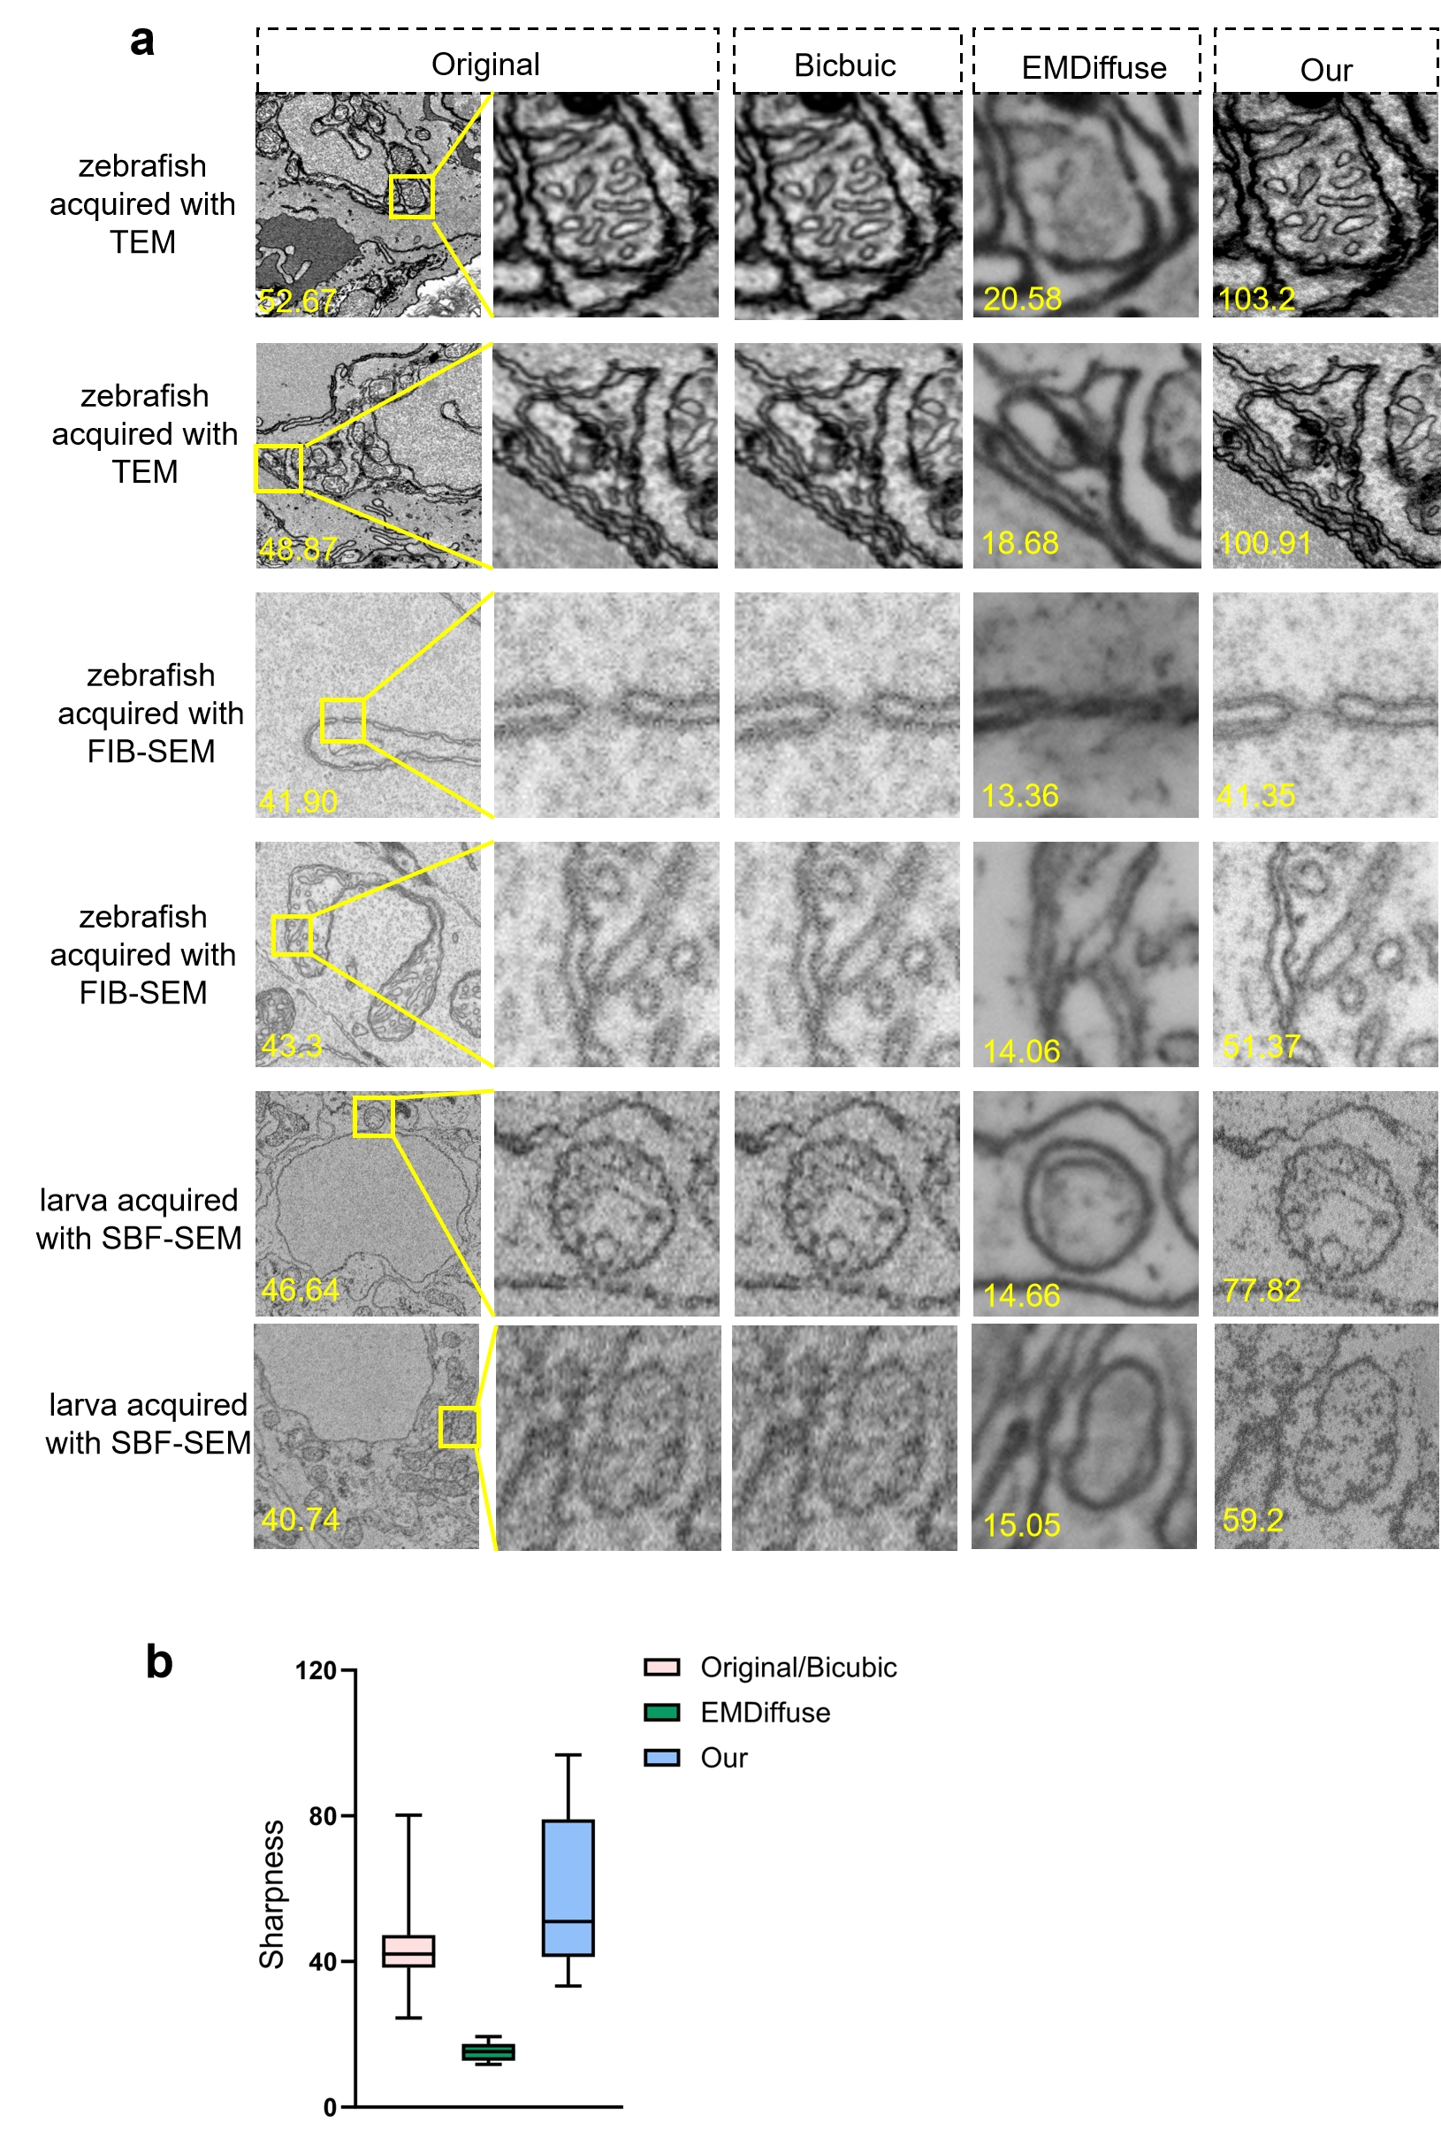
Supplementary Fig. 9 a, Representative SR images reconstructed by EMCellFiner and EMDiffuse under low Signal-to-Noise Ratio conditions. Sharpness values are shown for related images. b, Sharpness comparison SR reconstructions generated by EMCellFiner and EMDiffuse under low Signal-to-Noise Ratio conditions. The data sources obtained from different electron microscopy acquisitions used for these tests are detailed in Supplementary Table 1.
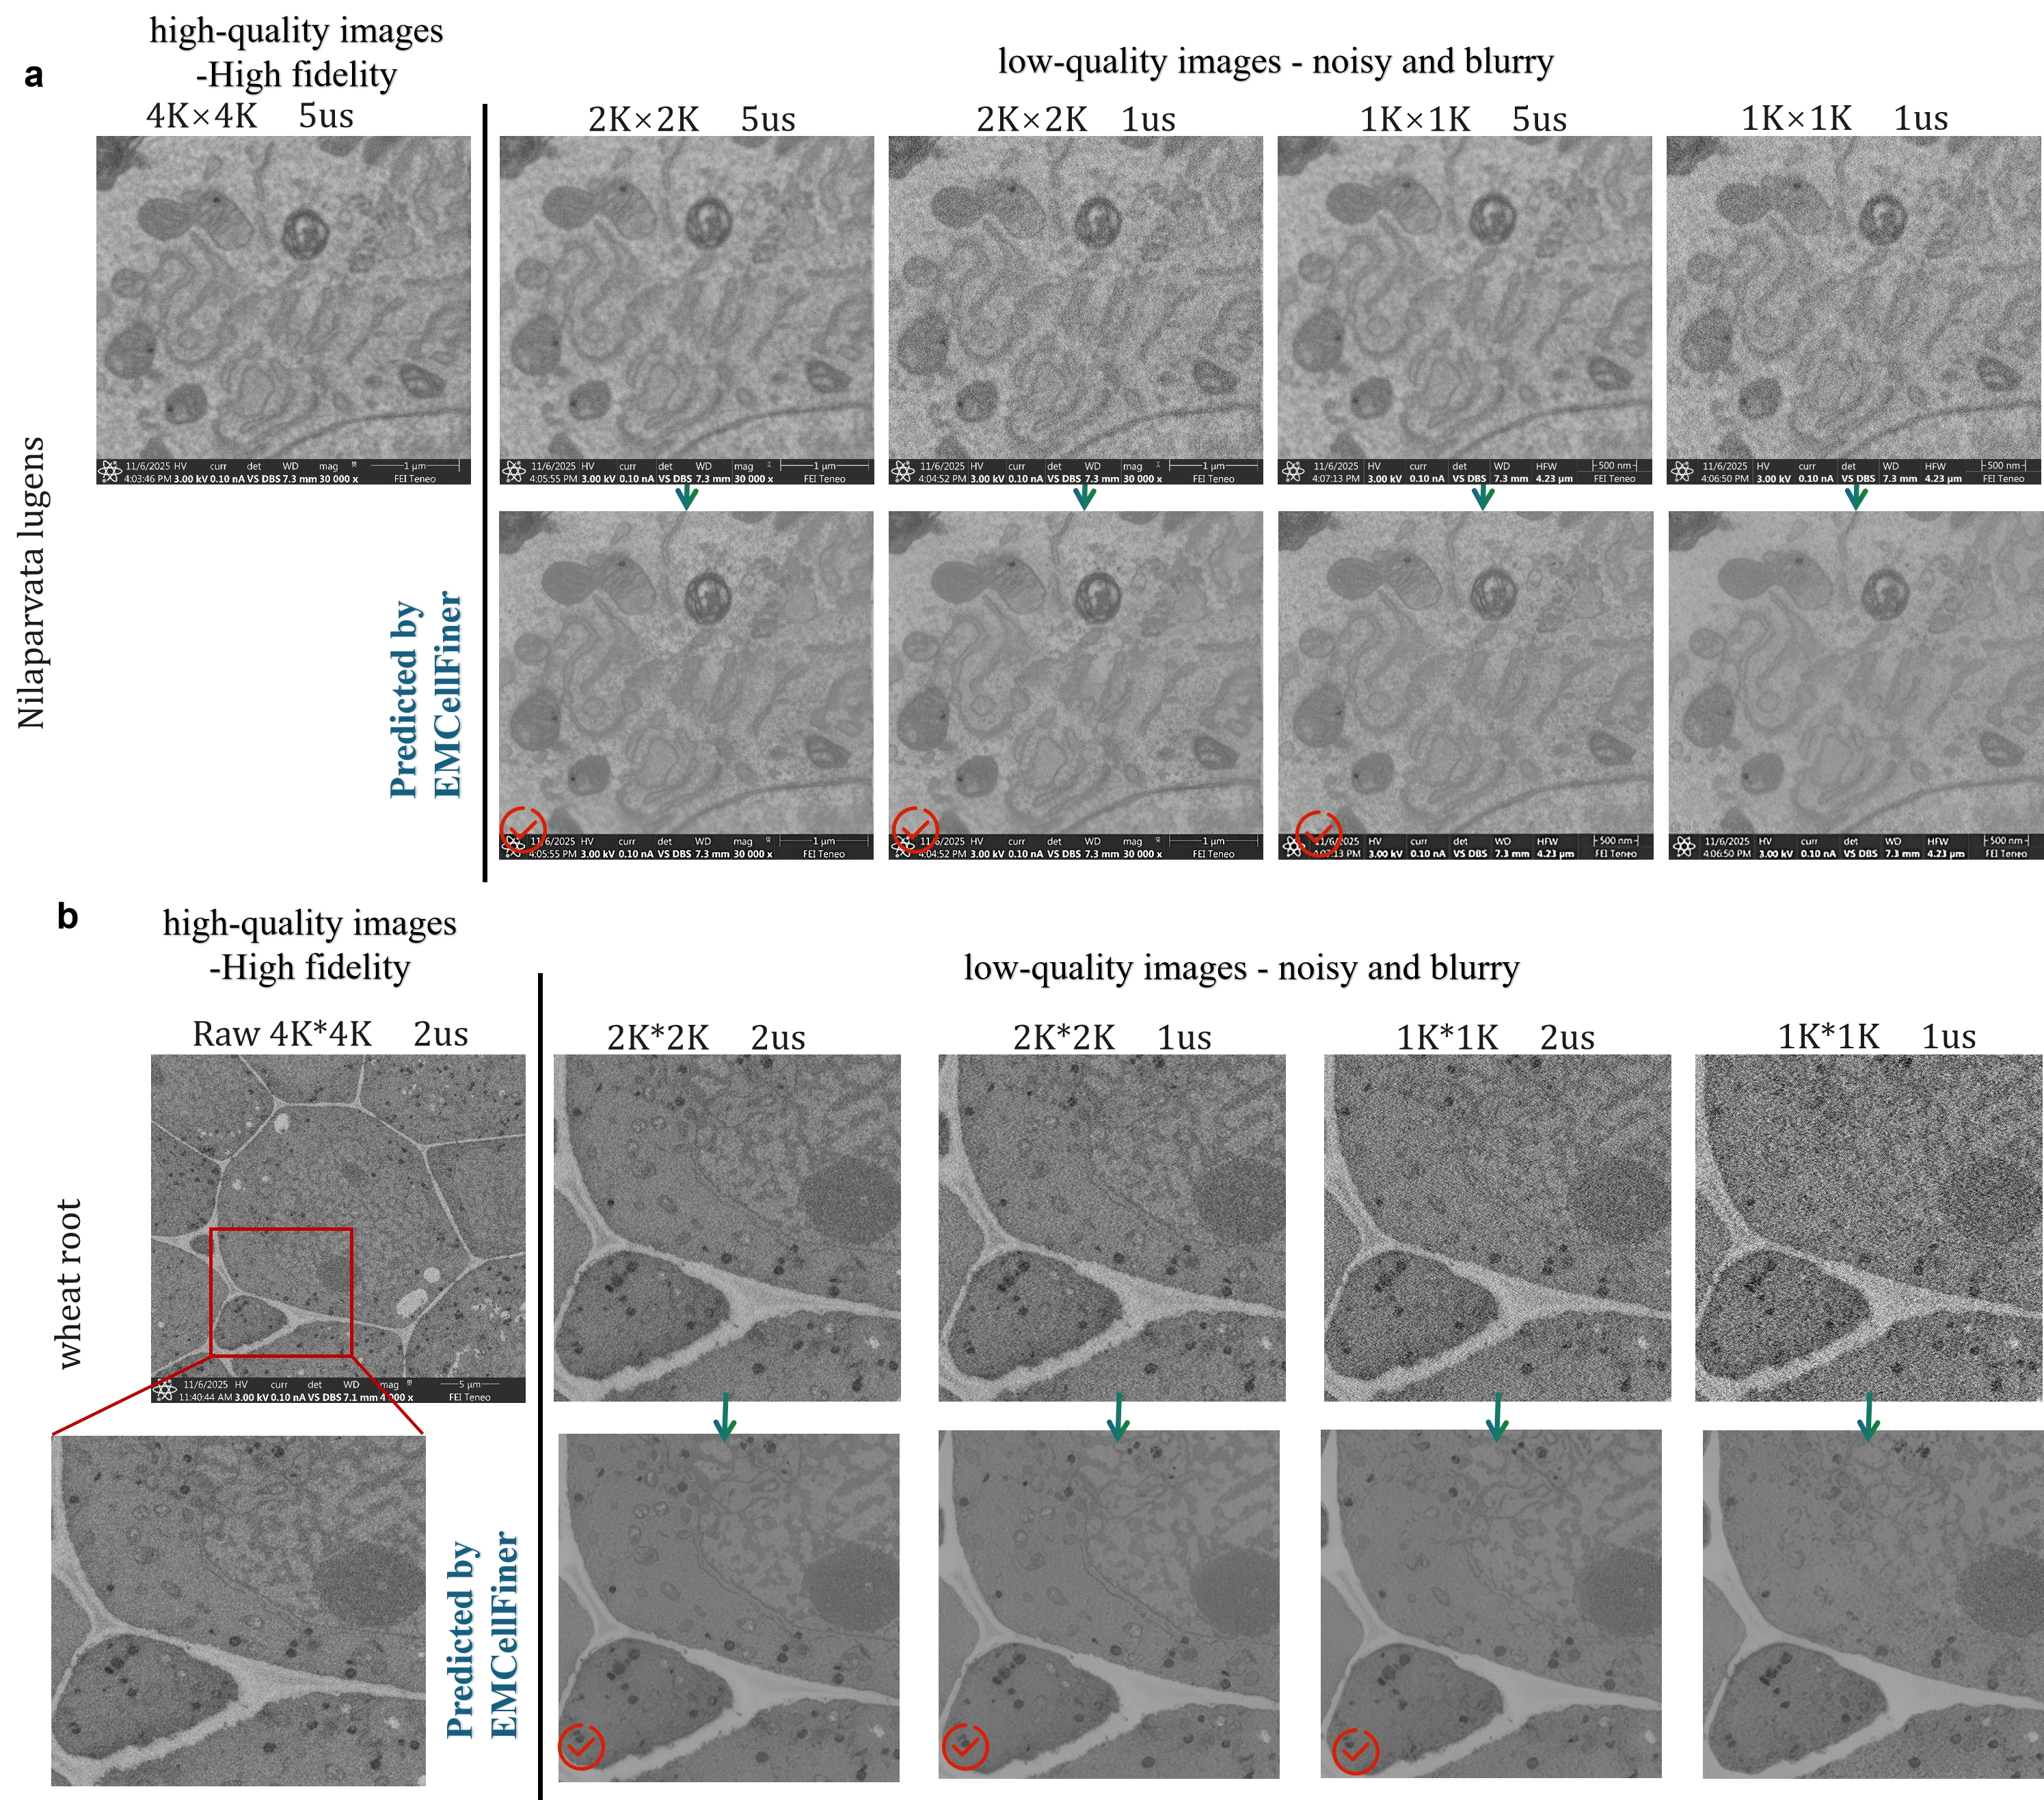
Supplementary Fig. 10 Application of EMCellFiner across varying pixel resolutions and dwell time in scanning electron microscopy. Images were acquired using a dual beam SEM (FIB Helios G3 UC; Thermo Fisher). a, Nilaparvata lugens, b, wheat root. For the N. lugens sample, reducing the resolution to 2,048 × 2,048 pixels with a 1μs dwell time—relative to the high-fidelity 4,096 × 4,096-pixel resolution at 5 μs dwell time—achieves comparable image quality while reducing acquisition time by a factor of 20. For the wheat root sample, lowering the resolution to 1,024 × 1,024 pixels at 2 μs dwell time—relative to the high-fidelity 4,096 × 4,096-pixel resolution at the same dwell time—yields similar results with a 16-fold reduction in acquisition time. These examples highlight the efficiency gains enabled by EMCellFiner in maintaining high-quality imaging under accelerated acquisition conditions.

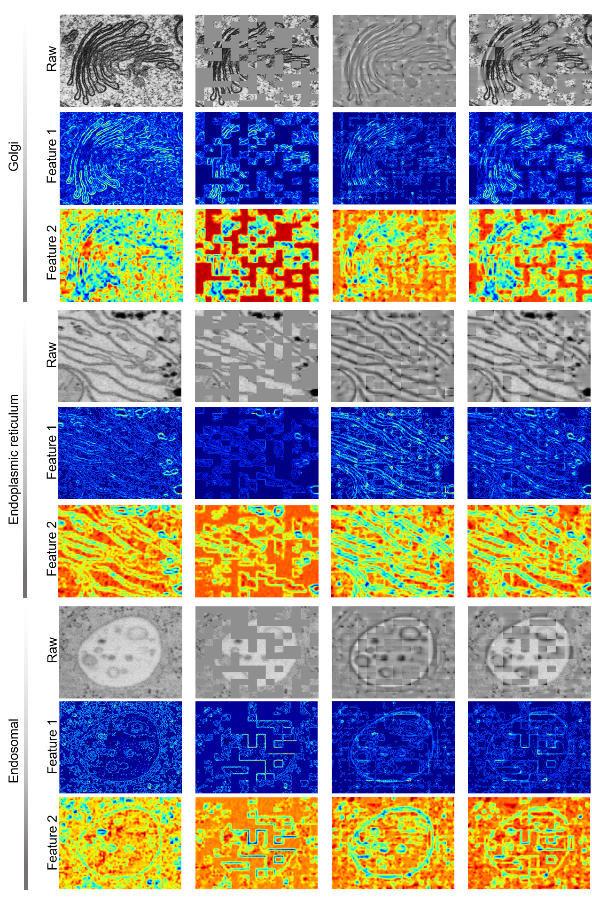

Supplementary Fig. 11 Attention heatmaps generated by two analysis methods: Texture Complexity&Entropy analysis (Method 1) and Patch-Level Consistency analysis (Method 2) from different layers of EMCellFound for identifying Golgi apparatus, endoplasmic reticulum (ER), and endosomes.

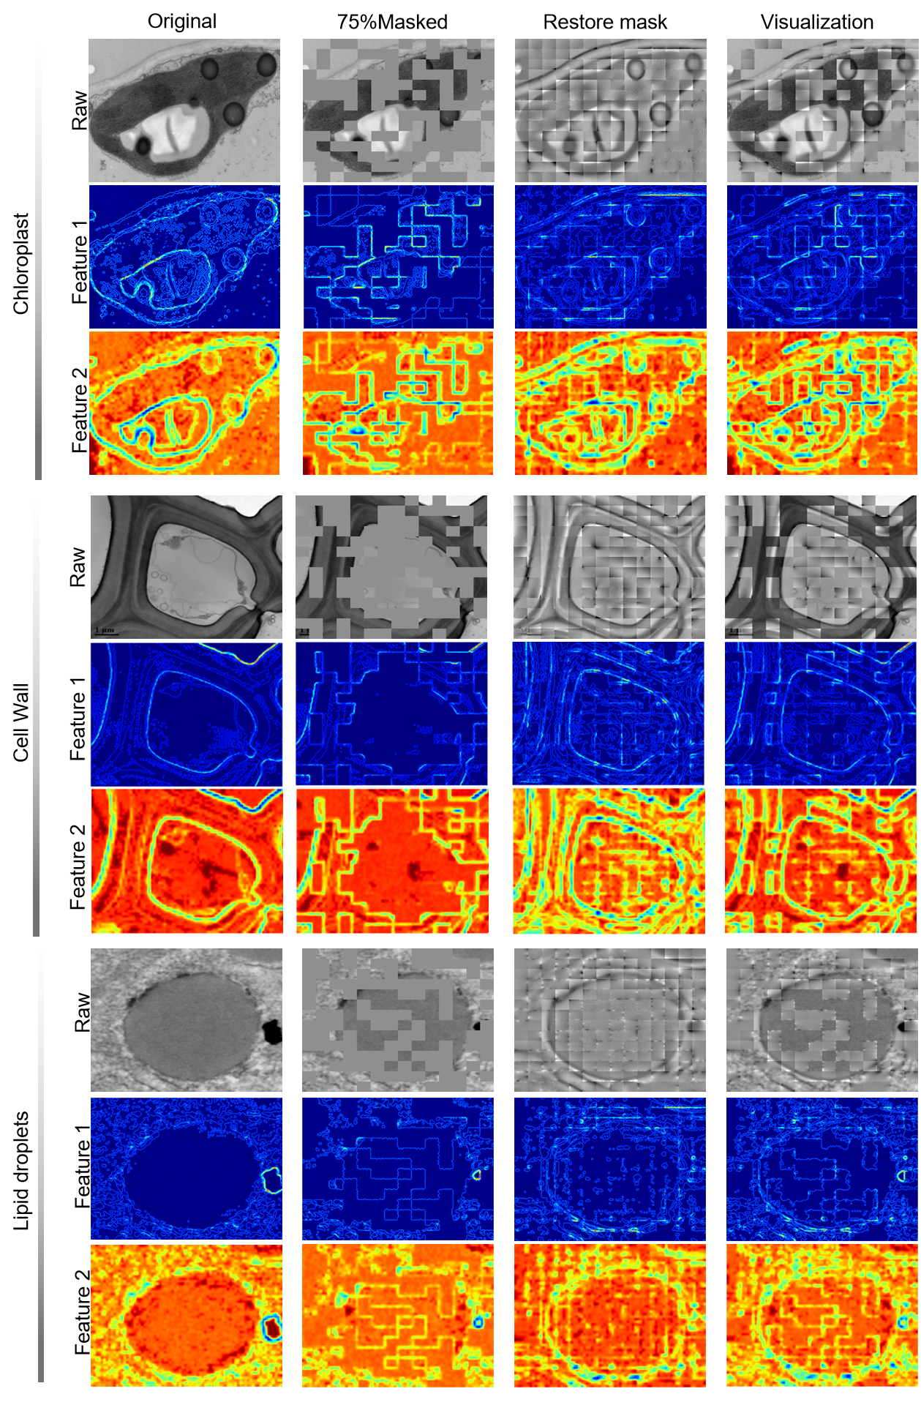
Supplementary Fig. 12 Attention heatmaps generated by two analysis methods: Texture Complexity&Entropy analysis (Method 1) and Patch-Level Consistency analysis (Method 2) from different layers of EMCellFound for identifying chloroplast, cell wall, Lipid droplets (LD).

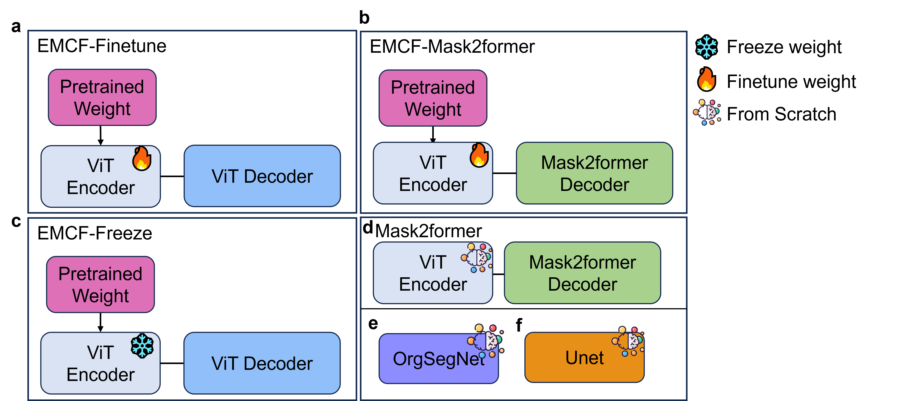
Supplementary Fig. 13 Model implementation and training strategies for comparative evaluation in Fig. 4. a, EMCF-Finetune. The pretrained EMCellFound (EMCF) encoder (a Vision Transformer (ViT) architecture) is integrated with a ViT-based decoder as the segmentation head. All model parameters (encoder and decoder) are fine-tuned end-to-end for semantic segmentation. b, EMCF+Mask2Former. This strategy employs a hybrid architecture where the pretrained EMCF (ViT Encoder) is coupled with a Mask2Former segmentation head. Both the pretrained encoder and the Mask2Former head parameters are fine-tuned. c, EMCF-Freeze. The pretrained EMCF (ViT Encoder) parameters are kept fixed (frozen), and only the parameters of the ViT-based decoder (segmentation head) are trained. d, Mask2Former (Baseline). A standard Mask2Former segmentation model is trained from scratch. Both its internal ViT Encoder and Mask2Former Decoder parameters are randomly initialized before training. e, OrgSegNet and Unet (Baselines). The specialized domain model OrgSegNet and the general baseline Unet model are trained from scratch. Their parameters are randomly initialized prior to training.

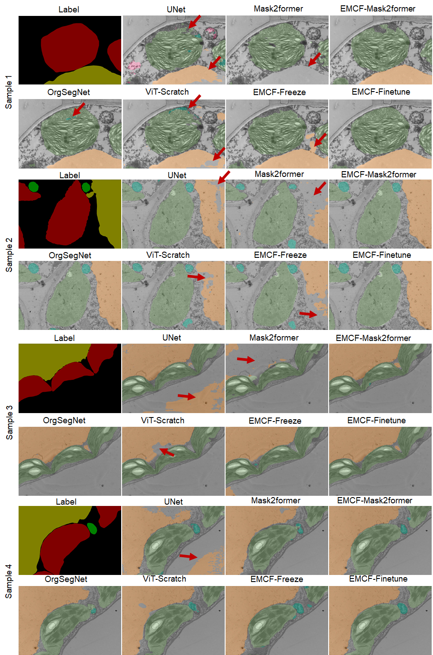
Supplementary Fig. 14 Representative TEM images of the diverse morphology of organelles segmented by seven models. The red arrows indicate recognition errors.
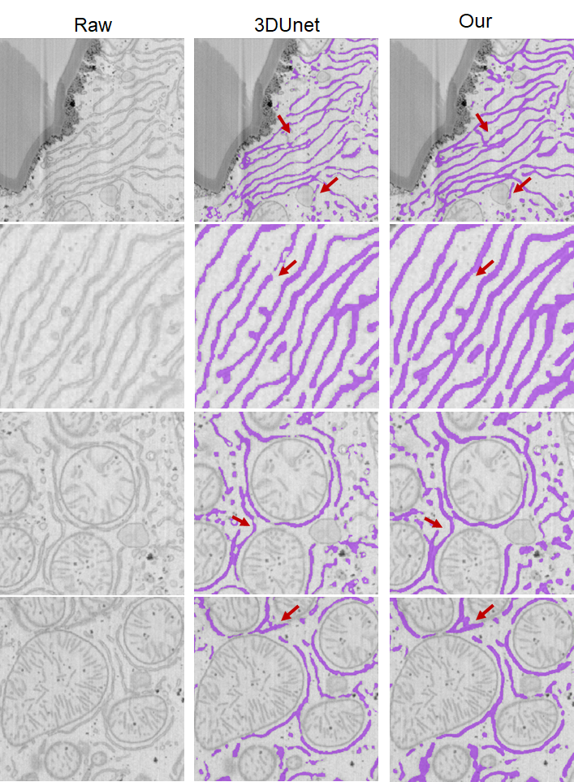

Supplementary Fig. 15. Comparison of ER segmentation results between 3D U-Net and EMCF on the Liver-6 dataset. EMCF achieves more continuous ER segmentation in 2D EM images, while 3D U-Net generates fragmented ER structures, leading to discontinuities in the 3D reconstruction. Red arrows highlight the differences between the two methods.

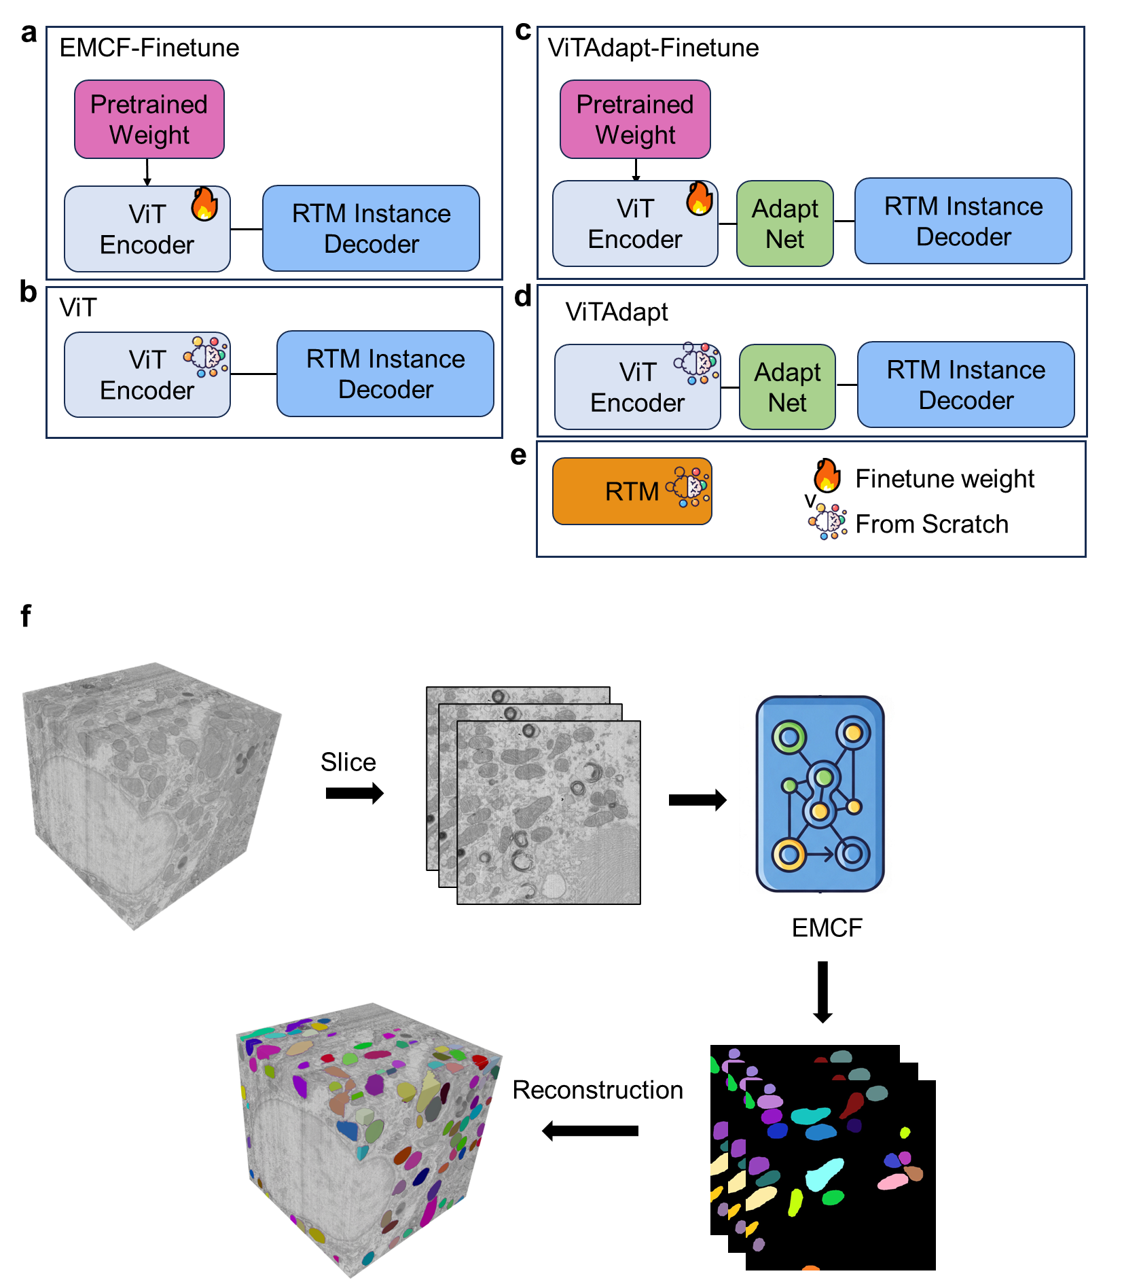
Supplementary Fig. 16. Model implementation and training strategies for comparative evaluation in Fig. 5. a, EMCF-Finetune. The pretrained EMCellFound (EMCF) encoder (a Vision Transformer (ViT) architecture) is integrated with RTM decoder as the instance head. All model parameters (encoder and decoder) are fine-tuned end-to-end for instance segmentation. b, ViT. The ViT Encoder with RTM Instance Decoder parameters are initiated from scratch. c, ViTAdapt-Finetune. The pretrained EMCellFound (EMCF) encoder (a Vision Transformer (ViT) architecture) with the Adapt structure is integrated with RTM decoder as the instance head. All model parameters (encoder and decoder) are fine-tuned end-to-end for instance segmentation. d, ViT-Adapt (Baseline). The ViT Encoder with Adapt structure and RTM Instance Decoder parameters are initiated from scratch. e. RTM. The RTM model with CNN backbone, whose parameters are initiated from scratch. f. The pipeline of Mitochondria 3D reconstruction using EMCF model.
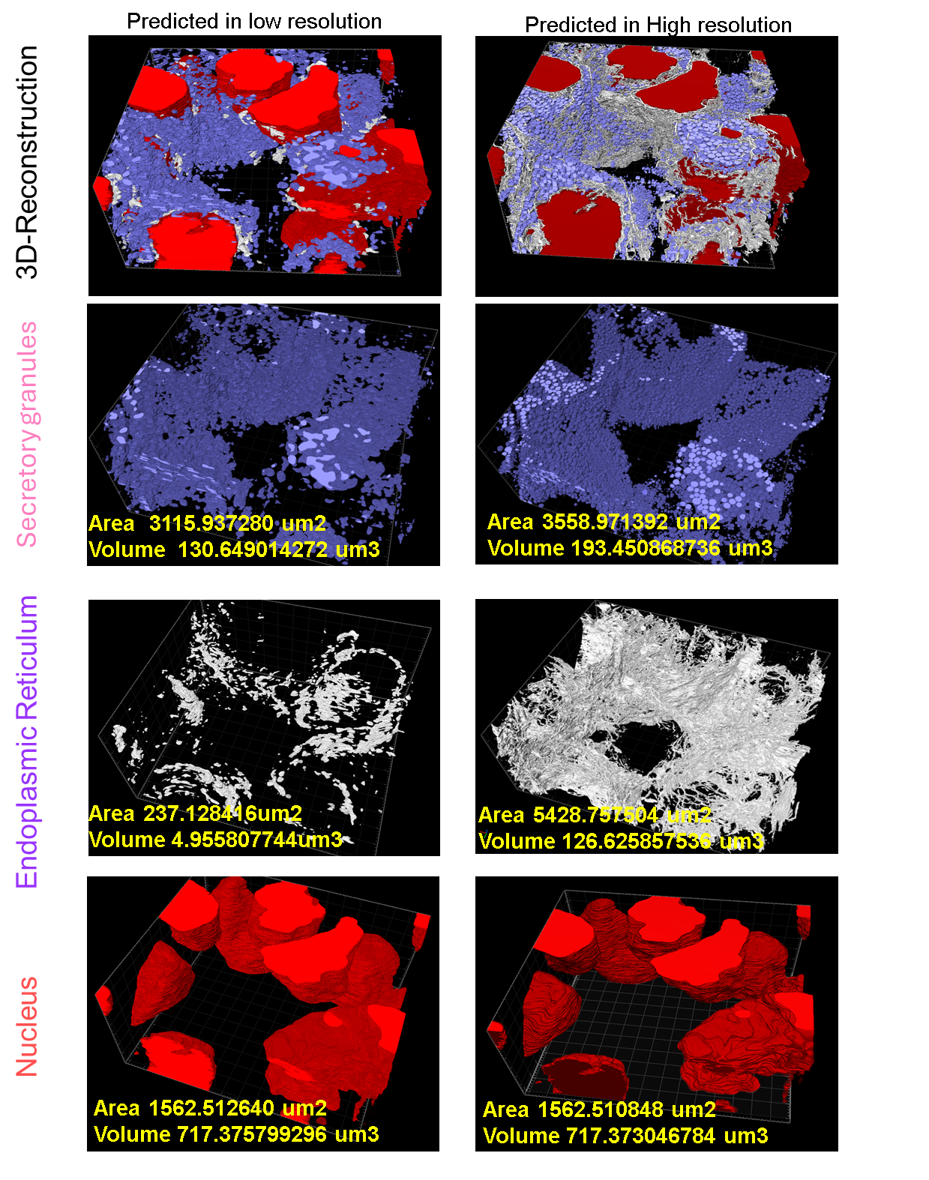
Supplementary Fig. 17. Comparative 3D reconstruction of four organelle types, showcasing the low-resolution input and the high-resolution output achieved by EMCellfiner.

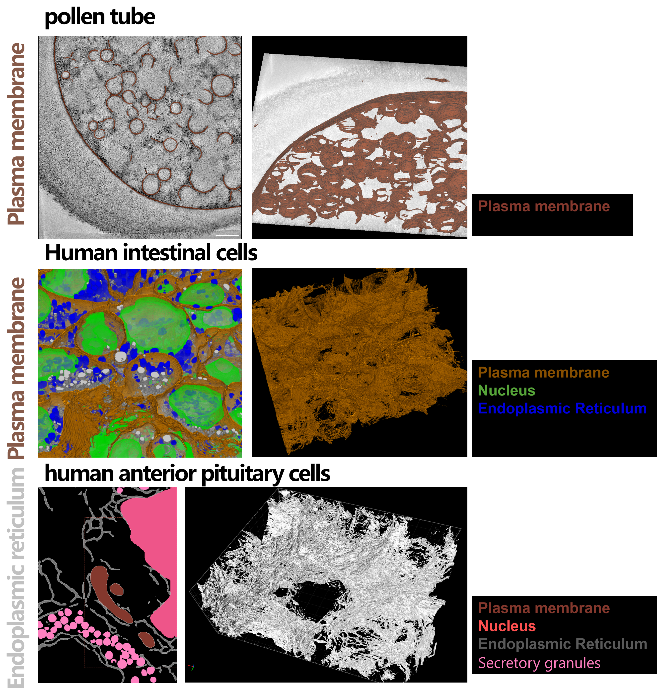

Supplementary Fig. 18. Representative EMCFsys supports automated segmentation of plasma membranes in pollen tubes, cell membranes in human anterior pituitary cells, tubular and sheet-like ER.

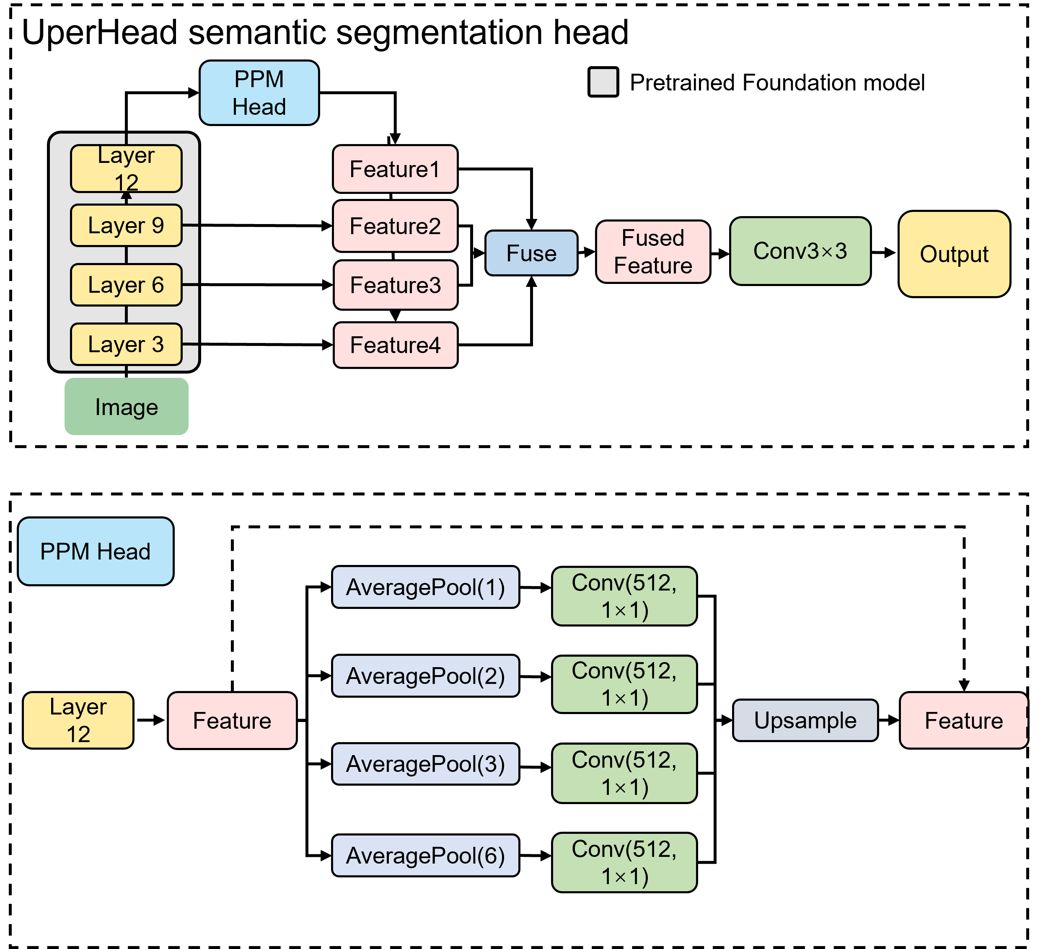
Supplementary Fig. 19 UperNet Head for segmentation for EMCellFound backbone.

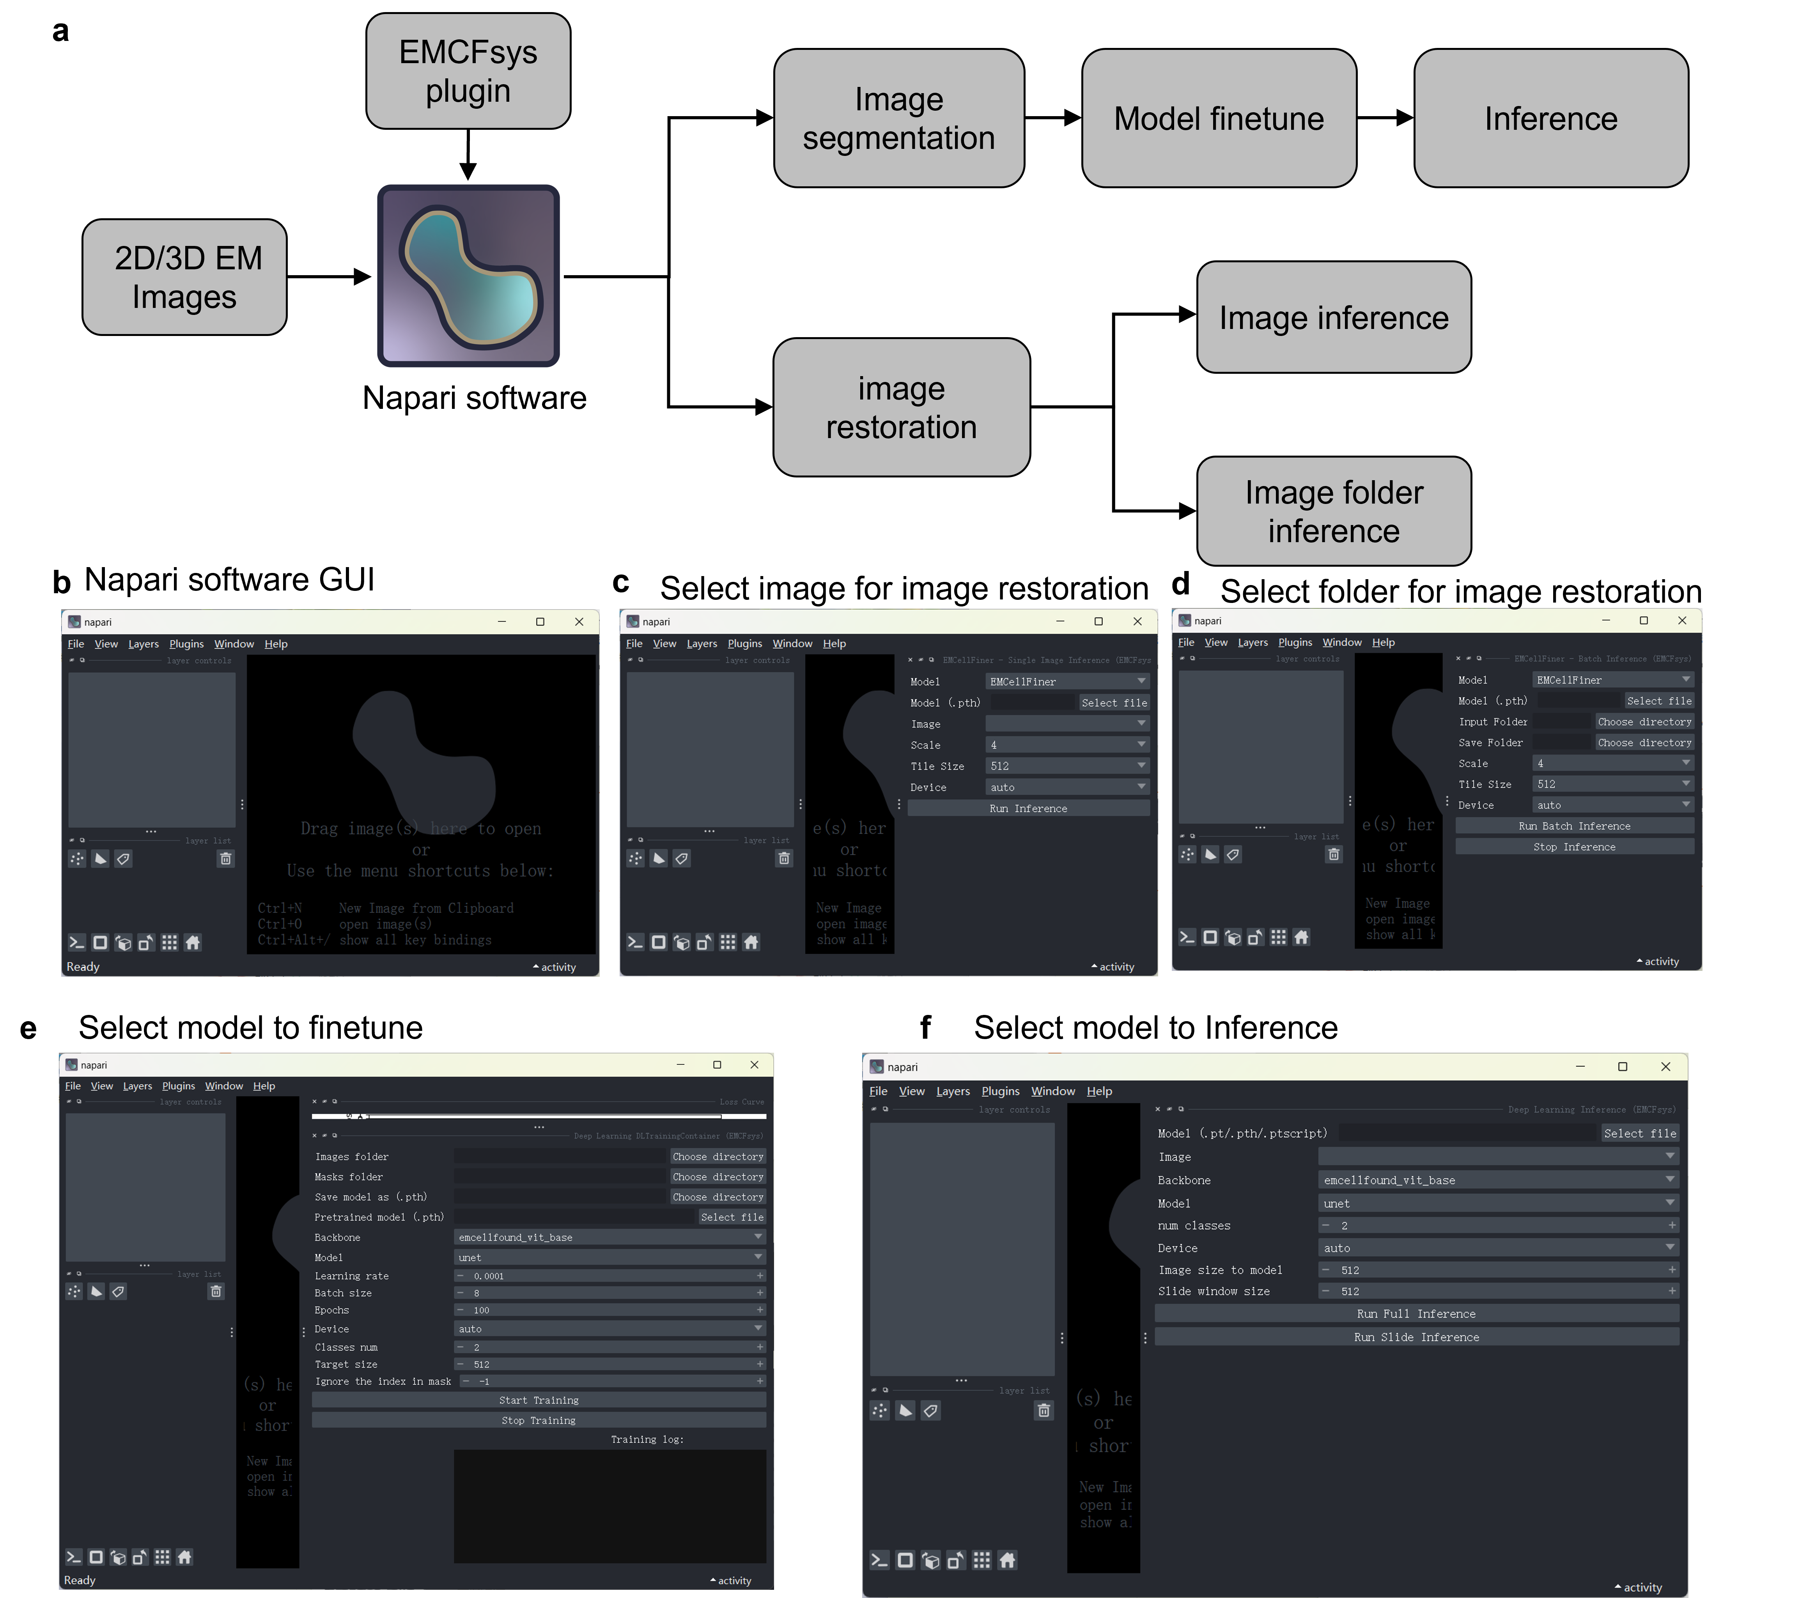
Supplementary Fig. 20 Overview and GUI of the emcfsys napari plugin.
a, Schematic workflow of the emcfsys plugin for 2D/3D Electron Microscopy (EM) image analysis within the napari environment. The plugin facilitates two primary pipelines: image segmentation (including model finetuning and inference using EMCellFound) and image restoration (supporting both single image and batch folder inference using EMCellFiner). b, Initial napari software GUI upon loading the emcfsys plugin. c, d, Interfaces for image restoration, showing the selection of models and parameters for single image processing c and batch folder processing d, e, Model finetuning interface, allowing users to select backbones (e.g., emcellfound_vit_base), set hyperparameters such as learning rate, batch size, and epochs, and monitor training status. f, Model inference interface, demonstrating the setup for deploying trained models, including options for full image inference or sliding window inference to handle large-scale EM datasets.

Supplementary Video 1. Automated prediction of slice results plasma membranes in pollen tubes.
Supplementary Video 2. Tutorial demonstration of the EMCFsys Napari plugin for organelle segmentation and image super-resolution.

Supplementary Table 1 Information on datasets involved in predicting.
Figs | dataset | dataset size | data description | data link
Fig. 2 c & d  Supplementary Fig. 2  Supplementary Fig. 3 | nijholt | 117 | / | https://www.nanotomy.org/
Supplementary Fig. 4  Supplementary Fig. 5 | jrc_mus-nacc-2 | 100 | Mouse nucleus accumbens from a wild-type, adult male mouse | https://www.openorganelle.net/datasets/jrc_mus-nacc-2
Supplementary Fig. 6  Supplementary Fig. 7  Supplementary Fig. 8 | Kuiper2022NCB | golgi-14  er-18  vesicles-11  cell membrane-14  mito-14  nucleus-17  mvb-2  autophagosome-13 | / | https://www.nanotomy.org/
Fig. 2e & f  Supplementary Fig. 9 | EMPIAR-10459,  Hiroki Nishida2021,  Zebrafish_Lobe | 35 | / | https://empiar.ipr.pdbj.org/en/entry/10459/
Supplementary Fig. 14 | Plant TEM dataset | train:650  val:180  test:180 | / | plantorganelle hunter dataset in  https://cstr.cn/31253.11.sciencedb.01335
Supplementary Fig. 15  Fig. 4 e | jrc-liver-6 | 3 2000×2000 pixels images for training  volume size:8000×8000×8500 | Liver cells from male mouse 10 weeks old | https://www.openorganelle.net/datasets/jrc_mus-liver-6
Fig. 5 a&c | LEE | train:133  val:88  test:89  1024×1024 pixels images | Electron Microscopy data used in a study of an excitatory network in Mouse V1. | https://bossdb.org/project/lee2016
Fig. 5 a&c | jrc_mus-kidney-2 | train:42  test:30  val:38  1024×1024 pixels images | kidney cells from wild-type, 8 week old mouse | https://www.openorganelle.net/datasets/jrc_mus-kidney-2
Fig. 5 a&c | bock | train:87  test:30  val:30  1024×1024 pixels images | Volume of mouse primary visual cortical data | https://bossdb.org/project/bock2011
Fig. 5 b&d&e | jrc_mus-kidney-2 | 1024×1024×1024 randomly selected volume data | kidney cells from wild-type, 8 weeks old mouse | https://www.openorganelle.net/datasets/jrc_mus-kidney-2

