Supplementary material for:
Stronger environmental adaption of abundant than rare microbes in wetland soils from the Qinghai-Tibet Plateau

Wenjie Wan^{1, 2}, Geoffrey Michael Gadd^{3, 4}, Yuyi Yang^{1, 2 *}, Wenke Yuan^{1, 2}, Jidong Gu^{5, 6}, Wenzi Liu^{1, 2 *}

¹Key Laboratory of Aquatic Botany and Watershed Ecology Wuhan Botanical Garden, Chinese Academy of Sciences, Wuhan 430074, PR China
²Center of the Plant Ecology, Core Botanical Gardens, Chinese Academy of Sciences, Wuhan 430074, PR China
³Geomicrobiology Group, School of Life Sciences, University of Dundee, Dundee DD1 5EH, Scotland, UK
⁴State Key Laboratory of Heavy Oil Processing, State Key Laboratory of Petroleum Pollution Control, China University of Petroleum, Beijing 102249, PR China
⁵Laboratory of Environmental Microbiology and Toxicology, School of Biological Sciences, The University of Hong Kong, Pokfulam Road, Hong Kong, SAR, China
⁶Environmental Engineering, Guangdong Technion Israel Institute of Technology, Guangdong, PR China

*Corresponding Author
E-mail: liuwz@wbgcas.cn (Wenzi Liu); yangyy@wbgcas.cn (Yuyi Yang)
Address: Wuhan Botanical Garden, Lumo Road No.1, Wuchang District, Wuhan PR China. Phone: +86-27-87700853; Fax: +86-27-87510251.

Table S1 Terrain properties of 33 sampling sites.
Sites | Lon | Lat | Alt | MAT | MAP | Plant richness | Plant coverage
 | (°/E) | (°/N) | (m) | (°C) | (mm) |  | (%)
L1 | 103.76 | 33.26 | 2663 | 5.14 | 690 | 3 | 50
L2 | 100.13 | 36.63 | 3202 | 1.01 | 313 | 2 | 50
L3 | 99.22 | 36.71 | 3093 | 1.31 | 224 | 2 | 45
L4 | 97.99 | 37.03 | 2950 | 4.28 | 182 | 1 | 50
L5 | 97.59 | 37.13 | 2856 | 4.22 | 177 | 4 | 40
L6 | 96.86 | 37.30 | 2817 | 4.41 | 137 | 2 | 45
L7 | 95.58 | 37.46 | 3181 | 1.98 | 89 | 4 | 70
L8 | 90.55 | 29.18 | 4450 | 2.27 | 267 | 2 | 40
L9 | 89.36 | 28.26 | 4436 | 1.73 | 302 | 1 | 30
L10 | 87.82 | 28.33 | 4207 | 1.59 | 385 | 5 | 75
L11 | 86.28 | 29.51 | 4745 | -0.13 | 228 | 3 | 75
L12 | 81.61 | 30.74 | 4620 | 0.07 | 620 | 3 | 80
L13 | 80.16 | 31.89 | 4410 | -0.94 | 279 | 1 | 60
L14 | 81.79 | 32.10 | 4641 | -1.28 | 240 | 1 | 30
L15 | 82.90 | 32.39 | 4461 | -0.08 | 206 | 1 | 65
L16 | 83.21 | 32.44 | 4495 | -0.37 | 198 | 2 | 80
L17 | 84.70 | 32.15 | 4410 | 0.18 | 197 | 1 | 30
L18 | 85.08 | 31.23 | 4645 | -0.61 | 217 | 2 | 50
L20 | 99.55 | 30.30 | 4481 | -0.09 | 630 | 2 | 45
P1 | 103.22 | 33.22 | 3631 | 1.32 | 734 | 4 | 50
P2 | 102.42 | 34.21 | 3482 | 1.29 | 639 | 5 | 65
P4 | 91.67 | 32.09 | 4695 | -2.82 | 366 | 3 | 50
P5 | 91.89 | 31.57 | 4624 | -1.92 | 392 | 3 | 41
P6 | 91.09 | 29.68 | 3647 | 7.08 | 414 | 6 | 75
P7 | 83.46 | 30.05 | 4591 | 0.35 | 474 | 1 | 55
R1 | 106.07 | 30.75 | 2547 | 17.62 | 1038 | 6 | 90
R3 | 93.30 | 35.31 | 4536 | -4.49 | 245 | 2 | 32
R4 | 92.44 | 34.22 | 4545 | -3.54 | 281 | 2 | 50
R5 | 91.10 | 30.48 | 4275 | 2.39 | 344 | 5 | 71
R6 | 90.05 | 28.83 | 4478 | 1.68 | 255 | 2 | 32
R7 | 88.10 | 28.16 | 4402 | 1.10 | 384 | 4 | 60
R8 | 86.96 | 29.33 | 4507 | 0.44 | 230 | 4 | 62
R9 | 80.81 | 32.39 | 4481 | -1.65 | 154 | 2 | 80
Note: Lon, Lat, Alt, MAT, and MAP represent longitude, latitude, altitude, mean annual temperature, and mean annual precipitation, respectively.

Table S2 Main physicochemical properties of 32 soils.
Sites | Tem | pH | EC | Moisture | TC | TP | NH₄⁺-N
 | (°C) |  | (dS/m) | (%) | (%) | (mg/g) | (mg/kg)
L1 | 17.7 | 7.75 | 0.34 | 16.20 | 8.92 | 0.051 | 0.83
L2 | 26.7 | 8.11 | 0.50 | 39.70 | 7.22 | 0.035 | 9.14
L3 | 22.9 | 8.27 | 1.18 | 48.27 | 4.80 | 0.080 | 0.71
L4 | 17.3 | 8.85 | 2.12 | 18.05 | 2.00 | 0.049 | 0.45
L5 | 20.2 | 8.28 | 1.75 | 19.32 | 4.53 | 0.047 | 0.59
L6 | 29.6 | 8.54 | 0.57 | 34.56 | 3.64 | 0.060 | 1.02
L7 | 23.9 | 8.14 | 2.85 | 42.88 | 4.49 | 0.048 | 0.61
L8 | 24.4 | 7.89 | 0.59 | 17.74 | 0.45 | 0.062 | 0.42
L9 | 17.1 | 7.75 | 1.29 | 41.52 | 3.61 | 0.058 | 0.79
L10 | 23.3 | 7.95 | 1.08 | 44.04 | 3.51 | 0.046 | 0.47
L11 | 13.9 | 8.28 | 0.26 | 19.45 | 2.40 | 0.062 | 0.74
L12 | 15.2 | 7.06 | 0.41 | 18.28 | 1.09 | 0.052 | 0.73
L13 | 18.4 | 8.7 | 0.26 | 16.21 | 0.89 | 0.093 | 0.25
L14 | 13 | 8.75 | 0.21 | 15.44 | 5.26 | 0.044 | 0.58
L15 | 24.2 | 8.03 | 0.60 | 49.66 | 9.65 | 0.055 | 1.71
L16 | 27.1 | 8.23 | 0.22 | 38.74 | 9.48 | 0.030 | 0.68
L17 | 16.6 | 9.42 | 0.42 | 27.96 | 4.96 | 0.038 | 1.38
L18 | 21.8 | 8.33 | 0.20 | 24.43 | 0.95 | 0.177 | 0.63
L20 | 17.8 | 7.89 | 0.23 | 34.06 | 2.48 | 0.055 | 1.24
P1 | 24.3 | 5.82 | 0.06 | 42.12 | 2.63 | 0.070 | 5.88
P2 | 15 | 7.43 | 0.92 | 57.74 | 13.45 | 0.169 | 0.93
P4 | 8.8 | 7.96 | 0.29 | 9.19 | 1.76 | 0.031 | 0.39
P5 | 12.3 | 8.72 | 0.07 | 41.35 | 4.88 | 0.066 | 1.38
P6 | 21.2 | 8.02 | 0.28 | 23.39 | 1.82 | 0.055 | 1.08
P7 | 19.3 | 8.53 | 0.15 | 19.62 | 1.37 | 0.059 | 0.49
R1 | 25.7 | 8.06 | 0.14 | 29.08 | 1.69 | 0.053 | 0.48
R3 | 19.6 | 9.46 | 0.11 | 18.71 | 1.40 | 0.021 | 0.36
R4 | 21.4 | 8.66 | 1.32 | 19.78 | 2.56 | 0.061 | 0.56
R5 | 20.3 | 8.13 | 0.20 | 42.98 | 2.61 | 0.023 | 0.95
R6 | 18.2 | 7.95 | 0.57 | 18.69 | 1.30 | 0.065 | 0.69
R7 | 19.4 | 7.9 | 0.68 | 36.09 | 6.50 | 0.045 | 0.56
R8 | 18.1 | 8.42 | 0.15 | 32.52 | 1.14 | 0.059 | 1.12
R9 | 25.2 | 8.03 | 0.28 | 43.97 | 4.96 | 0.054 | 0.20
Note: Tem, EC, TC, and TP denote temperature, electrical conductivity, total carbon, and total phosphorus, respectively.

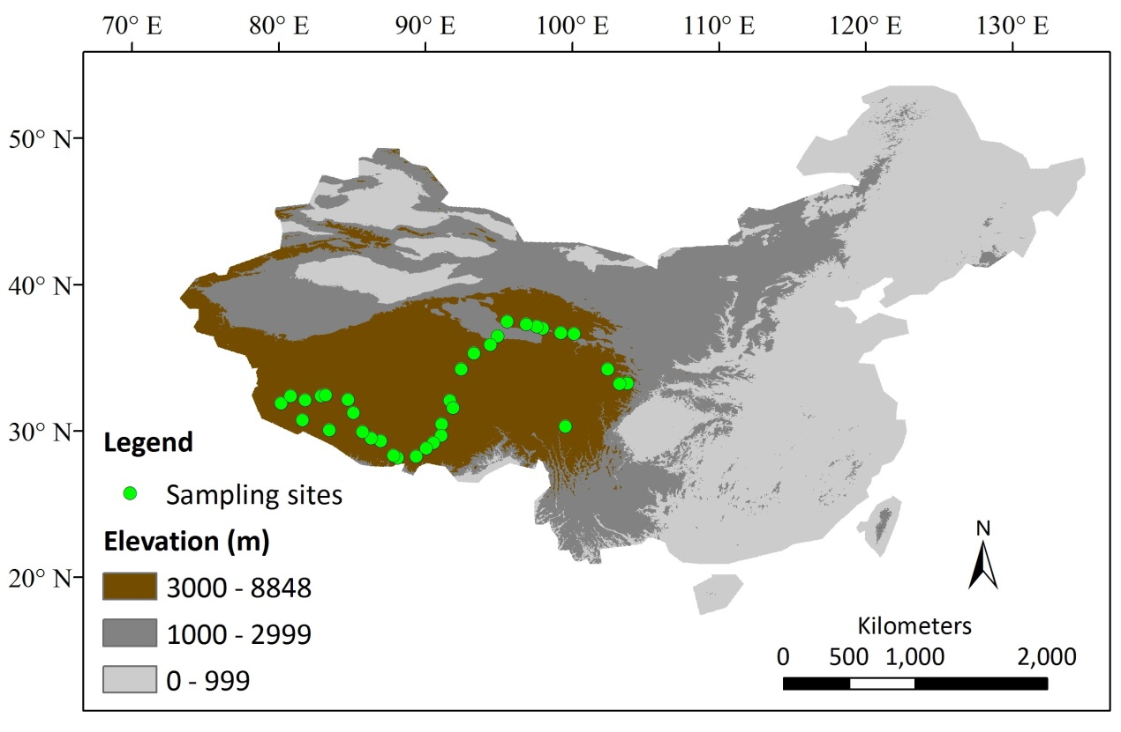
Fig. S1. The map of sampling sites in wetlands in Qinghai-Tibet Plateau.

Fig. S2 Boxplot showing differences in SES.MNTD values between abundant and rare microbial sub-communities. The asterisks above the line represent significance (*, p < 0.05; ***, p < 0.001).

Fig. S3 Effects of environmental factors on the compositions of rare and abundant microbial sub-communities based on redundancy analysis (RDA). Numbers in parentheses in the axis labels represent the proportion of variance accounted for by the principal coordinates. The significance of physicochemical variables was determined applying permutational multivariate analysis of variance (PERMAVONA) and is indicated by asterisks next to the variable names (*, p < 0.05; **, p < 0.01; ***, p < 0.001). Lon, Lat, Alt, MAT, MAP PR, PC, Tem, EC, Moi, TC, TP, and NH4 represent longitude, latitude, altitude, mean annual temperature, mean annual precipitation, plant richness, plant coverage, temperature, electrical conductivity, moisture, total carbon, total phosphorus, and ammonia nitrogen, respectively.

Fig. S4 Environmental associations of the relative abundance of rare and abundant bacterial taxa in wetlands evaluated by correlation and best random forest model. Circle size denotes variable’s importance based on the random forest model with p < 0.05. Colors in the boxes represent Spearman correlations. Lon, Lat, Alt, MAT, MAP PR, PC, Tem, EC, Moi, TC, TP, and NH4 represent longitude, latitude, altitude, mean annual temperature, mean annual precipitation, plant richness, plant coverage, temperature, electrical conductivity, moisture, total carbon, total phosphorus, and ammonia nitrogen, respectively.

Fig. S5 Environmental associations of the relative abundance of rare and abundant fungal taxa in wetlands estimated by correlation and best random forest model. Circle size denotes variable’s importance based on the random forest model with p < 0.05. Colors in the boxes represent Spearman correlations. Lon, Lat, Alt, MAT, MAP PR, PC, Tem, EC, Moi, TC, TP, and NH4 represent longitude, latitude, altitude, mean annual temperature, mean annual precipitation, plant richness, plant coverage, temperature, electrical conductivity, moisture, total carbon, total phosphorus, and ammonia nitrogen, respectively.

Fig. S6 Occurrence thresholds of rare and abundant bacteria and fungi in wetland soils with respect to environmental variables with noticeable effects on community composition: Lon, Lat, Alt, MAT, and MAP. The z-scores of all community members are shown. Yellow symbols show taxa decreasing with increasing environmental gradient (z-), while green symbols describe increasing taxa (z+).

Fig. S7 Occurrence thresholds of rare and abundant bacteria and fungi in wetland soils with respect to environmental variables with significant effects on community structure: PR, PC, Tem, pH, and EC. The z-scores of all community members are shown. Yellow symbols depict taxa declining with increasing environmental gradient (z-), while green symbols describe increasing taxa (z+).

Fig. S8 Occurrence thresholds of rare and abundant bacteria and fungi in wetland soils with respect to environmental variables with significant effects on community structure: Moi, TC, TP, and NH4. The z-scores of all community members are shown. Yellow symbols describe taxa declining with increasing environmental gradient (z-), while green symbols show increasing taxa (z+).

Fig. S9 Phylogenetic signal reflecting the level of trait conservatism for environmental preferences of major phyla in rare and abundant bacterial sub-communities applying Blomberg’s K statistic. Lon, Lat, Alt, MAT, MAP PR, PC, Tem, EC, Moi, TC, TP, and NH4 represent longitude, latitude, altitude, mean annual temperature, mean annual precipitation, plant richness, plant coverage, temperature, electrical conductivity, moisture, total carbon, total phosphorus, and ammonia nitrogen, respectively.

Fig. S10 Phylogenetic signal demonstrating the level of trait conservatism for environmental preferences of major phyla in rare and abundant fungal sub-communities employing Blomberg’s K statistic. Lon, Lat, Alt, MAT, MAP PR, PC, Tem, EC, Moi, TC, TP, and NH4 represent longitude, latitude, altitude, mean annual temperature, mean annual precipitation, plant richness, plant coverage, temperature, electrical conductivity, moisture, total carbon, total phosphorus, and ammonia nitrogen, respectively.

Fig. S11 The fraction of turnover in the assembly of rare and abundant microbial sub-communities calculated using null model

Fig. S12 Linear regressions between changes in soil ammonia nitrogen and βNTI. Asterisks close to numbers denote significant level (*, p < 0.05; **, p < 0.01; ***, p < 0.001).

Fig. S13 Patterns of βNTI across different categories in soil ammonia nitrogen for the rare and abundant microbial sub-communities. Numbers above the column represent significant level (p < 0.05).

