Assessment of respiratory and cardiovascular risks from ambient PM_{2.5} exposure in Ratchaburi, Thailand

Sitthipong Pengjan ^{1,2}, Sebastien Bonnet ^{1,2}, Savitri Garivait ^{1,2,*}

¹The Joint Graduate School of Energy and Environment, King Mongkut’s University of Technology Thonburi, Bangkok, Thailand
²Center of Excellence on Energy Technology and Environment, Ministry of Higher Education, Science, Research and Innovation, Bangkok, Thailand
*Correspondence: savitri.gar@kmutt.ac.th

Supplementary Material

Table of contents |  | Page
Table S1 | Annual average registered population of Ratchaburi and annual average age with their standard deviations (SD), classified by age groups and gender categories during 2015–2019. | 2
Table S2 | Life expectancy at birth in Ratchaburi and Thailand during 2015–2019. | 2
Table S3 | Statistics of respiraory morbidity in Ratchaburi during 2015–2019. | 3
Table S5 | Comparison of the relationship between respiratory mortality and ambient PM_{2.5} exposure across age groups (all genders) in this study versus other studies. | 5
Table S6 | Comparison of the relationship between respiratory mortality and ambient PM_{2.5} exposure by gender category (all age groups) in this study versus other studies. | 6
Table S7 | Association between respiratory morbidity and ambient PM_{2.5} exposure in Ratchaburi during 2015–2019. | 7
Table S8 | Comparison of the relationship between respiratory morbidity and ambient PM_{2.5} exposure across age groups (all genders) in this study versus other studies. | 8
Table S9 | Comparison of the relationship between respiratory morbidity and ambient PM_{2.5} exposure by gender category (all age groups) in this study versus other studies. | 9
Table S10 | Comparison of the relationship between cardiovascular mortality and ambient PM_{2.5} exposure across age groups (all genders) in this study versus other studies. | 10
Table S11 | Comparison of the relationship between cardiovascular mortality and ambient PM_{2.5} exposure by gender category (all age groups) in this study versus other studies. | 11
Table S12 | Association between cardiovascular morbidity and ambient PM_{2.5} exposure in Ratchaburi during 2015–2019. | 12
Table S13 | Comparison of the relationship between cardiovascular morbidity and ambient PM_{2.5} exposure across age groups (all genders) in this study versus other studies. | 13
Table S14 | Comparison of the relationship between cardiovascular morbidity and ambient PM_{2.5} exposure by gender category (all age groups) in this study versus other studies. | 14
Fig. S1 | Annual average population pyramid and population density in Ratchaburi in 2015. | 15
Fig. S2 | Annual average population pyramid and population density in Ratchaburi in 2016. | 15
Fig. S3 | Annual average population pyramid and population density in Ratchaburi in 2017. | 15
Fig. S4 | Annual average population pyramid and population density in Ratchaburi in 2018. | 16
Fig. S5 | Proportion of hospital outpatient visits for non-accidental morbidity (ICD-10: A00–R99) by sub-cause in Ratchaburi during 2015–2019. | 16
References |  | 16

Table S1 Annual average registered population of Ratchaburi and annual average age with their standard deviations (SD), classified by age groups and gender categories during 2015–2019.
Year | Parameter | All-age and All-gender | Children | Adult | Elderly | Male | Female
2015 | Annual average registered population (SD) | 836,433  (501) | 144,373  (710) | 556,039  (797) | 136,013  (858) | 405,719  (286) | 430,714  (322)
2015 | Annual average age (SD) | 37.15  (21.31) | 7.18  (4.37) | 36.39  (12.55) | 70.35  (8.43) | 35.80  (20.83) | 38.43  (21.67)
2015 | Percentage of all-age and all-gender | 100% | 17% | 67% | 16% | 49% | 51%
2016 | Annual average registered population (SD) | 837,937  (876) | 142,483  (321) | 555,285  (417) | 140,163  (1075) | 406,321  (565) | 431,615  (385)
2016 | Annual average age (SD) | 37.56  (21.39) | 7.22  (4.24) | 36.62  (12.62) | 70.45  (8.43) | 36.19  (20.91) | 38.85  (21.75)
2016 | Percentage of all-age and all-gender | 100% | 17% | 66% | 17% | 48% | 52%
2017 | Annual average registered population (SD) | 839,862  (412) | 141,004  (599) | 553,542  (622) | 145,313  (1,398) | 407,430  (330) | 432,432  (194)
2017 | Annual average age (SD) | 37.90  (21.44) | 7.31  (4.25) | 36.79  (12.66) | 70.43  (8.36) | 36.49  (20.95) | 39.22  (21.80)
2017 | Percentage of all-age and all-gender | 100% | 17% | 66% | 17% | 49% | 51%
2018 | Annual average registered population (SD) | 840,753  (524) | 138,631  (758) | 551,253  (685) | 150,865  (1,526) | 407,848  (437) | 432,905  (186)
2018 | Annual average age (SD) | 38.31  (21.52) | 7.38  (4.26) | 36.97  (12.69) | 70.43  (8.40) | 36.87  (21.04) | 39.67  (21.88)
2018 | Percentage of all-age and all-gender | 100% | 16% | 66% | 18% | 49% | 51%
2019 | Annual average registered population (SD) | 840,963  (399) | 135,693  (1,012) | 548,072  (901) | 157,195  (1,794) | 407,600  (360) | 433,363  (180)
2019 | Annual average age (SD) | 38.73  (21.60) | 7.45  (4.26) | 37.14  (12.73) | 70.43  (8.43) | 37.28  (21.13) | 40.10  (21.95)
2019 | Percentage of all-age and all-gender | 100% | 16% | 65% | 19% | 48% | 52%
Average | Annual average registered population (SD) | 839,189  (569) | 140,437  (713) | 552,838  (703) | 145,910  (1,387) | 406,984  (408) | 432,206  (267)
Average | Annual average age (SD) | 37.93  (21.45) | 7.31  (4.26) | 36.78  (12.65) | 70.42  (8.41) | 36.53  (20.97) | 39.25  (21.81)
Average | Percentage of all-age and all-gender | 100% | 17% | 66% | 17% | 48% | 52%

Table S2 Life expectancy at birth in Ratchaburi and Thailand during 2015–2019.
Year | Ratchaburi |  |  | Thailand
Year | All-gender | Male | Female | All-gender | Male | Female
2015 | 78.06 | 74.00 | 82.12 | 75.00 | 71.60 | 78.40
2016 | 75.66 | 70.90 | 80.42 | 75.20 | 71.80 | 78.60
2017 | 75.06 | 70.86 | 79.26 | 75.40 | 72.00 | 78.80
2018 | 75.08 | 70.94 | 79.22 | 75.55 | 72.20 | 78.90
2019 | 77.32 | 73.15 | 81.49 | 77.05 | 73.00 | 81.10
Average (SD) | 76.24 (1.23) | 71.97 (1.34) | 80.50 (1.17) | 75.64 (0.73) | 72.12 (0.48) | 79.16 (0.99)
Source: RBPHO (2020 and 2021).

Table S3 Statistics of respiratory morbidity in Ratchaburi during 2015–2019.
Year | Parameter | All age - all gender |  | Age group |  |  | Gender group
Year | Parameter | All age - all gender |  | Children | Adult | Elderly | Male | Female
2015 | Number of hospital visits | 101,626 |  | 40,886 | 46,025 | 14,715 | 45,808 | 55,818
2015 | Percentage number of hospital outpatient visits of all age – all gender (%) | 100 |  | 40.23 | 45.29 | 14.48 | 45.08 | 54.92
2015 | Age average (SD) (years) | 29.30 (24.40) |  | 5.65 (3.69) | 36.78 (12.42) | 71.63 (8.45) | 27.41 (25.64) | 30.86 (23.23)
2015 | Hospital outpatient visits rate (per 1,000 population) | 121.50 |  | 283.20 | 82.77 | 108.19 | 112.91 | 129.59
2016 | Number of hospital visits | 110,143 |  | 42,646 | 50,960 | 16,537 | 49,768 | 60,375
2016 | Percentage number of hospital visits of all age – all gender (%) | 100 |  | 38.72 | 46.27 | 15.01 | 45.18 | 54.82
2016 | Age average (SD) (years) | 30.08 (24.43) |  | 5.75 (3.65) | 36.96 (12.40) | 71.59 (8.47) | 28.04 (25.69) | 31.76 (23.20)
2016 | Hospital outpatient visits rate (per 1,000 population) | 131.45 |  | 299.31 | 91.77 | 117.98 | 122.48 | 139.88
2017 | Number of hospital visits | 101,406 |  | 35,967 | 48,534 | 16,903 | 45,012 | 56,394
2017 | Percentage number of hospital visits of all age – all gender (%) | 100 |  | 35.47 | 47.86 | 16.67 | 44.39 | 55.61
2017 | Age average (SD) (years) | 31.91 (24.56) |  | 6.02 (3.71) | 37.31 (12.40) | 71.47 (8.45) | 29.80 (25.86) | 33.58 (23.33)
2017 | Hospital outpatient visits rate (per 1,000 population) | 120.74 |  | 255.08 | 87.68 | 116.32 | 110.48 | 130.41
2018 | Number of hospital visits | 79,277 |  | 27,805 | 37,360 | 14,112 | 35,351 | 43,926
2018 | Percentage number of hospital visits of all age – all gender (%) | 100 |  | 35.07 | 47.13 | 17.80 | 44.59 | 55.41
2018 | Age average (SD) (years) | 32.50 (24.91) |  | 6.05 (3.76) | 37.42 (12.50) | 71.60 (8.55) | 30.49 (26.28) | 34.12 (23.62)
2018 | Hospital outpatient visits rate (per 1,000 population) | 94.29 |  | 200.57 | 67.77 | 93.54 | 86.68 | 101.47
2019 | Number of hospital visits | 84,287 |  | 27,283 | 41,599 | 15,403 | 37,150 | 47,137
2019 | Percentage number of hospital visits of all age – all gender (%) | 100 |  | 32.37 | 49.35 | 18.28 | 44.08 | 55.92
2019 | Age average (SD) (years) | 33.55 (24.52) |  | 6.64 (3.80) | 37.14 (12.61) | 71.51 (8.65) | 31.84 (25.95) | 34.90 (23.24)
2019 | Hospital outpatient visits rate (per 1,000 population) | 100.23 |  | 201.06 | 75.90 | 97.99 | 91.14 | 108.77

Table S4 Statistics of cardiovascular morbidity in Ratchaburi during 2015–2019.
Year | Parameter | All age - all gender | Age group |  |  | Gender group
Year | Parameter | All age - all gender | Children | Adult | Elderly | Male | Female
2015 | Number of hospital visits | 88,790 | 158 | 35,188 | 53,444 | 34,947 | 53,843
2015 | Percentage number of hospital visits of all age – all gender (%) | 100 | 0.18 | 39.63 | 60.19 | 39.36 | 60.64
2015 | Age average (SD) (years) | 63.04 (13.84) | 6.99 (3.77) | 49.74 (8.02) | 71.97 (8.38) | 62.65 (13.87) | 63.29 (13.81)
2015 | Hospital outpatient visits rate (per 1,000 population) | 106.15 | 1.09 | 63.28 | 392.93 | 86.14 | 125.01
2016 | Number of hospital visits | 105,771 | 151 | 41,283 | 64,337 | 41,087 | 64,684
2016 | Percentage number of hospital visits of all age – all gender (%) | 100 | 0.14 | 39.03 | 60.83 | 38.85 | 61.15
2016 | Age average (SD) (years) | 63.18 (13.84) | 8.01 (3.76) | 49.68 (8.12) | 71.97 (8.44) | 62.68 (13.80) | 63.49 (13.86)
2016 | Hospital outpatient visits rate (per 1,000 population) | 126.23 | 1.06 | 74.35 | 459.02 | 101.12 | 149.86
2017 | Number of hospital visits | 115,876 | 161 | 43,902 | 71,813 | 45,255 | 70,621
2017 | Percentage number of hospital visits of all age – all gender (%) | 100 | 0.14 | 37.89 | 61.97 | 39.05 | 60.95
2017 | Age average (SD) (years) | 63.46 (13.84) | 8.63 (3.68) | 49.65 (8.12) | 72.02 (8.50) | 62.89 (13.84) | 63.82 (13.83)
2017 | Hospital outpatient visits rate (per 1,000 population) | 137.97 | 1.14 | 79.31 | 494.20 | 111.07 | 163.31
2018 | Number of hospital visits | 102,862 | 140 | 37,747 | 64,975 | 40,535 | 62,327
2018 | Percentage number of hospital visits of all age – all gender (%) | 100 | 0.14 | 36.69 | 63.17 | 39.41 | 60.59
2018 | Age average (SD) (years) | 63.86 (13.67) | 9.44 (3.67) | 49.92 (7.92) | 72.07 (8.53) | 63.26 (13.60) | 64.24 (13.71)
2018 | Hospital outpatient visits rate (per 1,000 population) | 122.35 | 1.01 | 68.47 | 430.68 | 99.39 | 143.97
2019 | Number of hospital visits | 111,657 | 171 | 39,320 | 72,166 | 44,101 | 67,556
2019 | Percentage number of hospital visits of all age – all gender (%) | 100 | 0.15 | 35.22 | 64.63 | 39.50 | 60.50
2019 | Age average (SD) (years) | 64.17 (13.59) | 10.14 (3.16) | 49.96 (7.83) | 72.04 (8.57) | 63.48 (13.61) | 64.62 (13.56)
2019 | Hospital outpatient visits rate (per 1,000 population) | 132.77 | 1.26 | 71.74 | 459.09 | 108.20 | 155.89

Table S5 Comparison of the relationship between respiratory mortality and ambient PM_{2.5} exposure across age groups (all genders) in this study versus other studies.
Ref. | City, Country | Duration | Age | Gender | Form | Highest lag | β | Std E
Pengjan et al. (2026) | Ratchaburi, Thailand | 2015 - 2019 | Adult (15-59y) | All | Log-linear | lag7 | 0.00160 | 0.00214
Pengjan et al. (2026) | Ratchaburi, Thailand | 2015 - 2019 | Elderly (≥60y) | All | Log-linear | lag0 | 0.00366* | 0.00180
Li et al. (2018) | Ningbo, China | 2014 - 2015 | <65 | All | Log-linear | lag4 | -0.00078 | 0.00501
 | Ningbo, China | 2014 - 2015 | ≥65y | All | Log-linear | lag4 | 0.00064 | 0.17917
Liu et al. (2021) | 4 Cities, China | 2014 - 2017 | 0-74y | All | Log-linear | lag0-3 | 0.00019 | 0.00036
 | 4 Cities, China | 2014 - 2017 | ≥75y | All | Log-linear | lag0-3 | 0.00060* | 0.00024
 | 4 cities, China: Urban areas | 2014 - 2017 | 0-74y | All | Log-linear | lag0-3 | -0.00007 | 0.00051
 | 4 cities, China: Urban areas | 2014 - 2017 | ≥75y | All | Log-linear | lag0-3 | 0.00058 | 0.00030
 | 4 cities, China: Rural areas | 2014 - 2017 | 0-74y | All | Log-linear | lag0-3 | 0.00040 | 0.00052
 | 4 cities, China: Rural areas | 2014 - 2017 | ≥75y | All | Log-linear | lag0-3 | 0.00046 | 0.00039
Note: *β is significant at p-value < 0.05.

Table S6 Comparison of the relationship between respiratory mortality and ambient PM_{2.5} exposure by gender category (all age groups) in this study versus other studies.
Ref. | City, Country | Duration | Age | Gender | Form | Highest lag | β | Std E
Pengjan et al. (2026) | Ratchaburi, Thailand | 2015 - 2019 | All | Male | Log-linear | lag6 | 0.00107 | 0.00146
Pengjan et al. (2026) | Ratchaburi, Thailand | 2015 - 2019 | All | Female | Log-linear | lag0 | 0.00272 | 0.00190
Li et al. (2018) | Ningbo, China | 2014 - 2015 | All | Male | Log-linear | lag4 | -0.00230 | 0.00461
 | Ningbo, China | 2014 - 2015 | All | Female | Log-linear | lag4 | 0.00076 | 0.00284
Liu et al. (2021) | 4 Cities, China | 2014 - 2017 | All | Male | Log-linear | lag0-3 | 0.00066* | 0.00024
 | 4 Cities, China | 2014 - 2017 | All | Female | Log-linear | lag0-3 | 0.00039 | 0.00029
 | 4 cities, China: Urban areas | 2014 - 2017 | All | Male | Log-linear | lag0-3 | 0.00072* | 0.00028
 | 4 cities, China: Urban areas | 2014 - 2017 | All | Female | Log-linear | lag0-3 | 0.00009 | 0.00039
 | 4 cities, China: Rural areas | 2014 - 2017 | All | Male | Log-linear | lag0-3 | 0.00033 | 0.00037
 | 4 cities, China: Rural areas | 2014 - 2017 | All | Female | Log-linear | lag0-3 | 0.00091* | 0.00045
Shin et al. (2022) | 24 cities, Canada | 2001 - 2012 | ≥1y | Male | Log-linear | lag0 | 0.00198 | 0.00180
 | 24 cities, Canada | 2001 - 2012 | ≥1y | Female | Log-linear | lag2 | 0.00109 | 0.00121
 | 24 cities, Canada: Warm season | 2001 - 2012 | ≥1y | Male | Log-linear | lag1 | 0.00129 | 0.00202
 | 24 cities, Canada: Warm season | 2001 - 2012 | ≥1y | Female | Log-linear | lag1 | 0.00000 | 0.00256
 | 24 cities, Canada: Cold season | 2001 - 2012 | ≥1y | Male | Log-linear | lag2 | 0.00188 | 0.00227
 | 24 cities, Canada: Cold season | 2001 - 2012 | ≥1y | Female | Log-linear | lag1 | 0.00237 | 0.00234
Note: *β is significant at p-value < 0.05.

Table S7 Association between respiratory morbidity and ambient PM_{2.5} exposure in Ratchaburi during 2015–2019.
Lag | Parameter | All-age and  All-gender | Age group |  |  | Gender group
Lag | Parameter | All-age and  All-gender | Children | Adult | Elderly | Male | Female
0 | β | 0.00104* | 0.00099 | 0.00110* | 0.00101 | 0.00098 | 0.00110*
0 | SE | 0.00052 | 0.00064 | 0.00055 | 0.00072 | 0.00055 | 0.00055
0 | $p$-value | 0.04526 | 0.12171 | 0.04537 | 0.15761 | 0.07623 | 0.04537
1 | β | 0.00066 | 0.00073 | 0.00067 | 0.00051 | 0.00041 | 0.00086*
1 | SE | 0.00041 | 0.00050 | 0.00043 | 0.00057 | 0.00043 | 0.00043
1 | $p$-value | 0.10674 | 0.14522 | 0.12333 | 0.37513 | 0.34904 | 0.04734
2 | β | 0.00020 | 0.00018 | 0.00020 | 0.00020 | 0.00010 | 0.00028
2 | SE | 0.00027 | 0.00034 | 0.00030 | 0.00038 | 0.00029 | 0.00029
2 | $p$-value | 0.47680 | 0.60772 | 0.50892 | 0.61568 | 0.74610 | 0.34460
3 | β | -0.00003 | -0.00015 | -0.00002 | 0.00011 | 0.00003 | -0.00009
3 | SE | 0.00029 | 0.00034 | 0.00030 | 0.00040 | 0.00030 | 0.00030
3 | $p$-value | 0.92325 | 0.67646 | 0.95174 | 0.79576 | 0.92718 | 0.77957
4 | β | 0.00005 | -0.00008 | 0.00008 | 0.00019 | 0.00014 | -0.00003
4 | SE | 0.00028 | 0.00034 | 0.00030 | 0.00039 | 0.00030 | 0.00030
4 | $p$-value | 0.86849 | 0.82655 | 0.80077 | 0.64110 | 0.65166 | 0.92657
5 | β | 0.00032 | 0.00026 | 0.00037 | 0.00031 | 0.00028 | 0.00034
5 | SE | 0.00027 | 0.00033 | 0.00029 | 0.00038 | 0.00029 | 0.00029
5 | $p$-value | 0.24284 | 0.44078 | 0.19989 | 0.41856 | 0.33586 | 0.23982
6 | β | 0.00043 | 0.00045 | 0.00049 | 0.00029 | 0.00025 | 0.00057
6 | SE | 0.00041 | 0.00050 | 0.00043 | 0.00056 | 0.00043 | 0.00043
6 | $p$-value | 0.29812 | 0.37586 | 0.26319 | 0.62060 | 0.57556 | 0.19130
7 | β | -0.00017 | -0.00026 | -0.00013 | -0.00014 | -0.00023 | -0.00012
7 | SE | 0.00051 | 0.00063 | 0.00054 | 0.00071 | 0.00054 | 0.00054
7 | $p$-value | 0.75339 | 0.69221 | 0.82266 | 0.85470 | 0.68556 | 0.83651
0-1 | β | 0.00171* | 0.00172* | 0.00177* | 0.00153* | 0.00138* | 0.00196*
0-1 | SE | 0.00045 | 0.00054 | 0.00047 | 0.00062 | 0.00047 | 0.00047
0-1 | $p$-value | 0.00015 | 0.00159 | 0.00018 | 0.01297 | 0.00340 | 0.00004
0-2 | β | 0.00190* | 0.00189* | 0.00197* | 0.00173* | 0.00147* | 0.00223*
0-2 | SE | 0.00046 | 0.00057 | 0.00049 | 0.00064 | 0.00049 | 0.00049
0-2 | $p$-value | 0.00005 | 0.00087 | 0.00007 | 0.00721 | 0.00292 | 0.00001
0-3 | β | 0.00187* | 0.00174* | 0.00194* | 0.00184* | 0.00151* | 0.00215*
0-3 | SE | 0.00046 | 0.00056 | 0.00049 | 0.00063 | 0.00049 | 0.00049
0-3 | $p$-value | 0.00006 | 0.00203 | 0.00008 | 0.00355 | 0.00202 | 0.00001
0-4 | β | 0.00191* | 0.00167* | 0.00202* | 0.00203* | 0.00166* | 0.00212*
0-4 | SE | 0.00054 | 0.00066 | 0.00056 | 0.00073 | 0.00056 | 0.00056
0-4 | $p$-value | 0.00039 | 0.01122 | 0.00038 | 0.00547 | 0.00340 | 0.00019
0-5 | β | 0.00223* | 0.00192* | 0.00240* | 0.00234* | 0.00193* | 0.00246*
0-5 | SE | 0.00054 | 0.00066 | 0.00057 | 0.00074 | 0.00057 | 0.00057
0-5 | $p$-value | 0.00004 | 0.00381 | 0.00003 | 0.00155 | 0.00075 | 0.00002
0-6 | β | 0.00265* | 0.00237* | 0.00289* | 0.00263* | 0.00219* | 0.00303*
0-6 | SE | 0.00062 | 0.00076 | 0.00065 | 0.00085 | 0.00066 | 0.00066
0-6 | $p$-value | 0.00002 | 0.00192 | 0.00001 | 0.00212 | 0.00091 | 0.00000
0-7 | β | 0.00249* | 0.00211* | 0.00275* | 0.00248* | 0.00195* | 0.00291*
0-7 | SE | 0.00056 | 0.00068 | 0.00059 | 0.00077 | 0.00059 | 0.00059
0-7 | $p$-value | 0.00001 | 0.00205 | 0.00000 | 0.00131 | 0.00095 | 0.00000
Note: *β is significant at p-value < 0.05.
Table S8 Comparison of the relationship between respiratory morbidity and ambient PM_{2.5} exposure across age groups (all genders) in this study versus other studies.
Ref. | City, Country | Duration | Incidence | Age | Gender | Form | Highest lag | Β | Std E
This study | Ratchaburi, Thailand | 2015 - 2019 | Hospital outpatient visits | Children (0-14y) | All | Log-linear | lag0-6 | 0.00237* | 0.00076
This study | Ratchaburi, Thailand | 2015 - 2019 | Hospital outpatient visits | Adult (15-59y) | All | Log-linear | lag0-6 | 0.00289* | 0.00065
This study | Ratchaburi, Thailand | 2015 - 2019 | Hospital outpatient visits | Elderly (≥60y) | All | Log-linear | lag0-6 | 0.00263* | 0.00085
Strosnider et al. (2019) | 17 states, United States | 2000 - 2014 | Emergency Department Visits | 0-19y | All | Log-linear | lag0-6 | 0.00237* | 0.00025
 | 17 states, United States | 2000 - 2014 | Emergency Department Visits | 15-65y | All | Log-linear | lag0-6 | 0.00198* | 0.00020
 | 17 states, United States | 2000 - 2014 | Emergency Department Visits | ≥65y | All | Log-linear | lag0-6 | 0.00080 | 0.00028
Gu et al. (2020) | 252 cities, China | 2013 - 2017 | Hospital admission | <65y | All | Log-linear | lag0 | 0.00024* | 0.00003
 | 252 cities, China | 2013 - 2017 | Hospital admission | 65-74y | All | Log-linear | lag0 | 0.00041* | 0.00008
 | 252 cities, China | 2013 - 2017 | Hospital admission | ≥75y | All | Log-linear | lag0 | 0.00048* | 0.00006
Priyankara et al. (2021) | Kandy, Sri Lanka | 2019 | Hospital admission | <65y | All | Log-linear | lag1 | 0.08020 | 0.08778
 | Kandy, Sri Lanka | 2019 | Hospital admission | ≥65y | All | Log-linear | lag0-6 | 0.10080* | 0.07393
Wang et al. (2023) | Wuhan, China | 2017 - 2019 | Hospital admission | <65y | All | Log-linear | lag0-1 | 0.00113* | 0.00025
 | Wuhan, China | 2017 - 2019 | Hospital admission | 65-74y | All | Log-linear | lag0-1 | 0.00135* | 0.00037
 | Wuhan, China | 2017 - 2019 | Hospital admission | ≥75y | All | Log-linear | lag0-1 | 0.00109* | 0.00032
Note: *β is significant at p-value < 0.05.

Table S9 Comparison of the relationship between respiratory morbidity and ambient PM_{2.5} exposure by gender category (all age groups) in this study versus other studies.
Ref. | City, Country | Duration | Incidence | Age | Gender | Form | Highest lag | Β | Std E
This study | Ratchaburi, Thailand | 2015 - 2019 | Hospital outpatient visits | All | Male | Log-linear | lag6 | 0.00219* | 0.00066
This study | Ratchaburi, Thailand | 2015 - 2019 | Hospital outpatient visits | All | Female | Log-linear | lag0 | 0.00303* | 0.00066
Gu et al. (2020) | 252 cities, China | 2013 - 2017 | Hospital admission | <65y | All | Log-linear | lag0 | 0.00028* | 0.00003
 | 252 cities, China | 2013 - 2017 | Hospital admission | 65-74y | All | Log-linear | lag0 | 0.00031* | 0.00004
Priyankara et al. (2021) | Kandy, Sri Lanka | 2019 | Hospital admission | All | Male | Log-linear | lag0 | 0.00222* | 0.00109
 | Kandy, Sri Lanka | 2019 | Hospital admission | All | Female | Log-linear | lag0 | 0.00232* | 0.00115
Shin et al. (2022) | 24 cities, Canada | 2001 - 2012 | Hospitalization | ≥1y | Male | Log-linear | lag1 | 0.00070 | 0.00048
 | 24 cities, Canada | 2001 - 2012 | Hospitalization | ≥1y | Female | Log-linear | lag1 | 0.00178* | 0.00040
 | 24 cities, Canada: Warm season | 2001 - 2012 | Hospitalization | ≥1y | Male | Log-linear | lag2 | 0.00080 | 0.00086
 | 24 cities, Canada: Warm season | 2001 - 2012 | Hospitalization | ≥1y | Female | Log-linear | lag1 | 0.00257* | 0.00072
 | 24 cities, Canada: Cold season | 2001 - 2012 | Hospitalization | ≥1y | Male | Log-linear | lag0 | 0.00119 | 0.00076
 | 24 cities, Canada: Cold season | 2001 - 2012 | Hospitalization | ≥1y | Female | Log-linear | lag1 | 0.00119 | 0.00098
Wang et al. (2023) | Wuhan, China | 2017 - 2019 | Hospital admission | All | Male | Log-linear | lag0-1 | 0.00091* | 0.00025
 | Wuhan, China | 2017 - 2019 | Hospital admission | All | Female | Log-linear | lag0-1 | 0.00148* | 0.00027
Note: *β is significant at p-value < 0.05.

Table S10 Comparison of the relationship between cardiovascular mortality and ambient PM_{2.5} exposure across age groups (all genders) in this study versus other studies.
Ref. | City, Country | Duration | Age | Gender | Form | Highest lag | β | Std E
Pengjan et al. (2026) | Ratchaburi, Thailand | 2015 - 2019 | Adult (15-59y) | All | Log-linear | lag0-5 | 0.00630* | 0.00215
Pengjan et al. (2026) | Ratchaburi, Thailand | 2015 - 2019 | Elderly (≥60y) | All | Log-linear | lag4 | 0.00188* | 0.00091
Chen et al. (2018) | 30 cities, China | 2013 - 2015 | 0-64y | All | Log-linear | lag0 | 0.00013 | 0.00017
 | 30 cities, China | 2013 - 2015 | 65-74y | All | Log-linear | lag0 | 0.00029 | 0.00015
 | 30 cities, China | 2013 - 2015 | ≥75y | All | Log-linear | lag0 | 0.00009* | 0.00005
Li et al. (2018) | Ningbo, China | 2014 - 2015 | <65y | All | Log-linear | lag2 | -0.00026 | 0.00337
 | Ningbo, China | 2014 - 2015 | ≥65y | All | Log-linear | lag2 | 0.00126 | 0.00248
Cheng et al. (2019) | Hefei, China | 2013 - 2015 | <74y | All | Log-linear | lag0 | 0.00067 | 0.00039
 | Hefei, China | 2013 - 2015 | ≥75y | All | Log-linear | lag0-1 | 0.00046 | 0.00026
Gong et al. (2019) | Beijing, China | 2006 - 2011 | 0-64y | All | Log-linear | lag0-1 | 0.00028* | 0.00063
 | Beijing, China | 2006 - 2011 | ≥65y | All | Log-linear | lag0-1 | 0.00055* | 0.00034
Liu et al. (2021) | 4 Cities, China | 2014 - 2017 | 0-74y | All | Log-linear | lag0-3 | 0.00024 | 0.00017
 | 4 Cities, China | 2014 - 2017 | ≥75y | All | Log-linear | lag0-3 | 0.00099* | 0.00013
 | 4 cities, China: Urban areas | 2014 - 2017 | 0-74y | All | Log-linear | lag0-3 | 0.00037 | 0.00022
 | 4 cities, China: Urban areas | 2014 - 2017 | ≥75y | All | Log-linear | lag0-3 | 0.00098* | 0.00016
 | 4 cities, China: Rural areas | 2014 - 2017 | 0-74y | All | Log-linear | lag0-3 | 0.00009 | 0.00028
 | 4 cities, China: Rural areas | 2014 - 2017 | ≥75y | All | Log-linear | lag0-3 | 0.00096* | 0.00024
Yap et al. (2019) | Whole country, Singapore | 2001 - 2013 | <65y | All | Log-linear | lag0-5 | -0.00115 | 0.00090
 | Whole country, Singapore | 2001 - 2013 | ≥65y | All | Log-linear | lag0-5 | 0.00147* | 0.00053
Note: *β is significant at p-value < 0.05.

Table S11 Comparison of the relationship between cardiovascular mortality and ambient PM_{2.5} exposure by gender category (all age groups) in this study versus other studies.
Ref. | City, Country | Duration | Age | Gender | Form | Highest lag | β | Std E
Pengjan et al, (2026) | Ratchaburi, Thailand | 2015 - 2019 | All | Male | Log-linear | lag03 | 0.00270* | 0.00092
Pengjan et al. (2026) | Ratchaburi, Thailand | 2015 - 2019 | All | Female | Log-linear | lag0-7 | 0.00233 | 0.00238
Li et al. (2018) | Ningbo, China | 2014 - 2015 | All | Male | Log-linear | lag2 | 0.00045 | 0.00304
 | Ningbo, China | 2014 - 2015 | All | Female | Log-linear | lag2 | 0.00202* | 0.00246
Chen et al. (2018) | 30 cities, China | 2013 - 2015 | All | Male | Log-linear | lag0 | 0.00016 | 0.00010
 | 30 cities, China | 2013 - 2015 | All | Female | Log-linear | lag0 | 0.00009 | 0.00008
Cheng et al. (2019) | Hefei, China | 2013 - 2015 | All | Male | Log-linear | lag0 | 0.00038 | 0.00029
 | Hefei, China | 2013 - 2015 | All | Female | Log-linear | lag0-5 | 0.00148* | 0.00039
Gong et al. (2019) | Beijing, China | 2006 - 2011 | All | Male | Log-linear | lag0-1 | 0.00062* | 0.00039
 | Beijing, China | 2006 - 2011 | All | Female | Log-linear | lag0-1 | 0.00050* | 0.00046
Liu et al. (2021) | 4 Cities, China | 2014 - 2017 | 0-74y | Male | Log-linear | lag0-3 | 0.00069* | 0.00014
 | 4 Cities, China | 2014 - 2017 | ≥75y | Female | Log-linear | lag0-3 | 0.00076* | 0.00016
 | 4 cities, China: Urban areas | 2014 - 2017 | 0-74y | Male | Log-linear | lag0-3 | 0.00078* | 0.00018
 | 4 cities, China: Urban areas | 2014 - 2017 | ≥75y | Female | Log-linear | lag0-3 | 0.00080* | 0.00020
 | 4 cities, China: Rural areas | 2014 - 2017 | 0-74y | Male | Log-linear | lag0-3 | 0.00055* | 0.00024
 | 4 cities, China: Rural areas | 2014 - 2017 | ≥75y | Female | Log-linear | lag0-3 | 0.00068* | 0.00029
Shin et al. (2022) | 24 cities, Canada | 2001 - 2012 | ≥1y | Male | Log-linear | lag0 | 0.00188* | 0.00070
 | 24 cities, Canada | 2001 - 2012 | ≥1y | Female | Log-linear | lag1 | 0.00060 | 0.00071
 | 24 cities, Canada: Warm season | 2001 - 2012 | ≥1y | Male | Log-linear | lag1 | 0.00188 | 0.00123
 | 24 cities, Canada: Warm season | 2001 - 2012 | ≥1y | Female | Log-linear | lag1 | -0.00020 | 0.00123
 | 24 cities, Canada: Cold season | 2001 - 2012 | ≥1y | Male | Log-linear | lag0 | 0.00237 | 0.00167
 | 24 cities, Canada: Cold season | 2001 - 2012 | ≥1y | Female | Log-linear | lag1 | 0.00109 | 0.00133
Note: *β is significant at p-value < 0.05.

Table S12 Association between cardiovascular morbidity and ambient PM_{2.5} exposure in Ratchaburi during 2015–2019.
Lag | Parameter | All-age and  All-gender | Age group |  |  | Gender group
Lag | Parameter | All-age and  All-gender | Children | Adult | Elderly | Male | Female
0 | β | 0.00064 | 0.00114 | 0.00077 | 0.00055 | 0.00057 | 0.00070
0 | SE | 0.00093 | 0.00236 | 0.00094 | 0.00095 | 0.00093 | 0.00095
0 | $p$-value | 0.50046 | 0.64040 | 0.42053 | 0.57492 | 0.55388 | 0.47198
1 | β | 0.00064 | -0.00028 | 0.00085 | 0.00051 | 0.00050 | 0.00073
1 | SE | 0.00071 | 0.00167 | 0.00073 | 0.00074 | 0.00073 | 0.00074
1 | $p$-value | 0.37859 | 0.87588 | 0.24626 | 0.49943 | 0.50209 | 0.32858
2 | β | -0.00030 | -0.00086 | -0.00030 | -0.00030 | -0.00037 | -0.00026
2 | Std E | 0.00050 | 0.00120 | 0.00051 | 0.00052 | 0.00051 | 0.00052
2 | $p$-value | 0.56055 | 0.48074 | 0.56468 | 0.57273 | 0.47626 | 0.62694
3 | β | -0.00080 | -0.00110 | -0.00097 | -0.00069 | -0.00078 | -0.00082
3 | SE | 0.00052 | 0.00119 | 0.00052 | 0.00053 | 0.00052 | 0.00053
3 | $p$-value | 0.12018 | 0.36474 | 0.06192 | 0.19417 | 0.13370 | 0.12016
4 | β | -0.00034 | -0.00118 | -0.00049 | -0.00024 | -0.00029 | -0.00037
4 | SE | 0.00050 | 0.00119 | 0.00051 | 0.00051 | 0.00051 | 0.00051
4 | $p$-value | 0.50514 | 0.32964 | 0.33590 | 0.65304 | 0.57820 | 0.48083
5 | β | 0.00075 | -0.00095 | 0.00079 | 0.00073 | 0.00077 | 0.00074
5 | SE | 0.00048 | 0.00095 | 0.00049 | 0.00049 | 0.00048 | 0.00049
5 | $p$-value | 0.11839 | 0.31980 | 0.10522 | 0.13899 | 0.11254 | 0.13360
6 | β | 0.00125 | 0.00002 | 0.00147* | 0.00112 | 0.00125 | 0.00125
6 | SE | 0.00072 | 0.00150 | 0.00073 | 0.00074 | 0.00073 | 0.00074
6 | $p$-value | 0.08188 | 0.99041 | 0.04423 | 0.12854 | 0.08511 | 0.09062
7 | β | -0.00089 | 0.00251 | -0.00084 | -0.00092 | -0.00076 | -0.00098
7 | SE | 0.00088 | 0.00177 | 0.00089 | 0.00090 | 0.00089 | 0.00090
7 | $p$-value | 0.31288 | 0.15782 | 0.35027 | 0.30799 | 0.39804 | 0.27678
0-1 | β | 0.00128 | 0.00027 | 0.00161* | 0.00105 | 0.00105 | 0.00143
0-1 | SE | 0.00078 | 0.00209 | 0.00079 | 0.00080 | 0.00079 | 0.00080
0-1 | $p$-value | 0.10042 | 0.90538 | 0.04177 | 0.18876 | 0.18306 | 0.07342
0-2 | β | 0.00098 | 0.00202 | 0.00130 | 0.00076 | 0.00069 | 0.00116
0-2 | SE | 0.00080 | 0.00221 | 0.00081 | 0.00082 | 0.00081 | 0.00082
0-2 | $p$-value | 0.22385 | 0.36623 | 0.10827 | 0.36197 | 0.40357 | 0.15629
0-3 | β | 0.00017 | 0.00305 | 0.00033 | 0.00006 | -0.00009 | 0.00034
0-3 | SE | 0.00080 | 0.00217 | 0.00081 | 0.00082 | 0.00081 | 0.00082
0-3 | $p$-value | 0.84224 | 0.15943 | 0.69775 | 0.94668 | 0.91860 | 0.69249
0-4 | β | -0.00017 | 0.00308 | -0.00016 | -0.00018 | -0.00038 | -0.00003
0-4 | SE | 0.00094 | 0.00263 | 0.00095 | 0.00096 | 0.00094 | 0.00096
0-4 | $p$-value | 0.86570 | 0.24438 | 0.87547 | 0.86113 | 0.70016 | 0.97743
0-5 | β | 0.00058 | 0.00227 | 0.00063 | 0.00056 | 0.00039 | 0.00071
0-5 | SE | 0.00093 | 0.00274 | 0.00094 | 0.00095 | 0.00094 | 0.00095
0-5 | $p$-value | 0.54432 | 0.41401 | 0.51583 | 0.56877 | 0.69200 | 0.46787
0-6 | β | 0.00183 | 0.00101 | 0.00210 | 0.00168 | 0.00165 | 0.00196
0-6 | SE | 0.00106 | 0.00312 | 0.00107 | 0.00108 | 0.00107 | 0.00109
0-6 | $p$-value | 0.08250 | 0.75822 | 0.05043 | 0.12200 | 0.12442 | 0.07052
0-7 | β | 0.00094 | -0.00038 | 0.00125 | 0.00075 | 0.00089 | 0.00098
0-7 | SE | 0.00097 | 0.00267 | 0.00098 | 0.00099 | 0.00098 | 0.00100
0-7 | $p$-value | 0.33895 | 0.89509 | 0.20402 | 0.46160 | 0.37269 | 0.33222
Note: *β is significant at p-value < 0.05.

Table S13 Comparison of the relationship between cardiovascular morbidity and ambient PM_{2.5} exposure across age groups (all genders) in this study versus other studies.
Ref. | City, Country | Duration | Incidence | Age | Gender | Form | Highest lag | Β | Std E
This study | Ratchaburi, Thailand | 2015 – 2019 | Hospital outpatient visits | Children (0-14y) | All | Log-linear | lag0-4 | 0.00308 | 0.00263
This study | Ratchaburi, Thailand | 2015 – 2019 | Hospital outpatient visits | Adult (15-59y) | All | Log-linear | lag0-1 | 0.00161* | 0.00079
This study | Ratchaburi, Thailand | 2015 – 2019 | Hospital outpatient visits | Elderly (≥60y) | All | Log-linear | lag0-6 | 0.00168 | 0.00108
Su et al. (2016) | Beijing, China | 2007 - 2018 | Emergency room visits | <45y | All | Log-linear | lag0-7 | 0.00051* | 0.00163
 | Beijing, China | 2007 - 2018 | Emergency room visits | 45-74y | All | Log-linear | lag0-7 | 0.00098* | 0.00272
 | Beijing, China | 2007 - 2018 | Emergency room visits | ≥75y | All | Log-linear | lag7 | 0.00093* | 0.00263
Gu et al. (2020) | 252 cities, China | 2013 - 2017 | Hospital admission | <65y | All | Log-linear | lag0 | 0.00022* | 0.00003
 | 252 cities, China | 2013 - 2017 | Hospital admission | 65-74y | All | Log-linear | lag0 | 0.00028* | 0.00004
 | 252 cities, China | 2013 - 2017 | Hospital admission | ≥75y | All | Log-linear | lag0 | 0.00036* | 0.00005
Wang et al. (2020) | Wuhan, China | 2015 - 2017 | Hospital Admissions | 0-64y | All | Log-linear | lag7 | 0.00104* | 0.00026
 | Wuhan, China | 2015 - 2017 | Hospital Admissions | ≥65y | All | Log-linear | lag7 | 0.00097* | 0.00022
Wu et al. (2022) | Lanzhou, China | 2014 - 2019 | Hospital Admissions | <65 | All | Log-linear | lag0-1 | 0.00050 | 0.00053
 | Lanzhou, China | 2014 - 2019 | Hospital Admissions | ≥65y | All | Log-linear | lag0-1 | 0.00149* | 0.00050
Wang et al. (2023) | Wuhan, China | 2017 - 2019 | Hospital admission | <65y | All | Log-linear | lag0-1 | 0.00138* | 0.00047
 | Wuhan, China | 2017 - 2019 | Hospital admission | 65-74y | All | Log-linear | lag0-1 | 0.00161* | 0.00042
 | Wuhan, China | 2017 - 2019 | Hospital admission | ≥75y | All | Log-linear | lag0-1 | 0.00119* | 0.00032
Note: *β is significant at p-value < 0.05.

Table S14 Comparison of the relationship between cardiovascular morbidity and ambient PM_{2.5} exposure by gender category (all age groups) in this study versus other studies.
Ref. | City, Country | Duration | Incidence | Age | Gender | Form | Highest lag | Β | Std E
This study | Ratchaburi, Thailand | 2015 - 2019 | Hospital outpatient visits | All | Male | Log-linear | lag0-6 | 0.00165 | 0.00107
This study | Ratchaburi, Thailand | 2015 - 2019 | Hospital outpatient visits | All | Female | Log-linear | lag0-6 | 0.00196 | 0.00109
Su et al. (2016) | Beijing, China | 2007 - 2018 | Emergency room visits | All | Male | Log-linear | lag0-7 | 0.00123* | 0.00333
 | Beijing, China | 2007 - 2018 | Emergency room visits | All | Female | Log-linear | lag7 | 0.00015* | 0.00023
Gu et al., (2020) | 252 cities, China | 2013 - 2017 | Hospital admission | <65y | All | Log-linear | lag0 | 0.00028* | 0.00003
 | 252 cities, China | 2013 - 2017 | Hospital admission | 65-74y | All | Log-linear | lag0 | 0.00026* | 0.00004
Wang et al. (2020) | Wuhan, China | 2015 - 2017 | Hospital Admissions | All | Male | Log-linear | lag7 | 0.00100* | 0.00023
 | Wuhan, China | 2015 - 2017 | Hospital Admissions | All | Female | Log-linear | lag7 | 0.00100* | 0.00026
Shin et al. (2022) | 24 cities, Canada | 2001 - 2012 | Hospitalization | ≥1y | Male | Log-linear | lag3 | -0.00050 | 0.00056
 | 24 cities, Canada | 2001 - 2012 | Hospitalization | ≥1y | Female | Log-linear | lag2 | 0.00020 | 0.00061
 | 24 cities, Canada: Warm season | 2001 - 2012 | Hospitalization | ≥1y | Male | Log-linear | lag2 | -0.00060 | 0.00059
 | 24 cities, Canada: Warm season | 2001 - 2012 | Hospitalization | ≥1y | Female | Log-linear | lag3 | 0.00070 | 0.00076
 | 24 cities, Canada: Cold season | 2001 - 2012 | Hospitalization | ≥1y | Male | Log-linear | lag1 | 0.00040 | 0.00109
 | 24 cities, Canada: Cold season | 2001 - 2012 | Hospitalization | ≥1y | Female | Log-linear | lag1 | 0.00149* | 0.00070
Wu et al. (2022) | Lanzhou, China | 2014 - 2019 | Hospital Admissions | All | Male | Log-linear | lag0-1 | 0.00159* | 0.00053
 | Lanzhou, China | 2014 - 2019 | Hospital Admissions | All | Female | Log-linear | lag0-1 | 0.00070 | 0.00051
Wang et al. (2023) | Wuhan, China | 2017 - 2019 | Hospital admission | All | Male | Log-linear | lag0-1 | 0.00133* | 0.00039
 | Wuhan, China | 2017 - 2019 | Hospital admission | All | Female | Log-linear | lag0-1 | 0.00145* | 0.00040
Note: *β is significant at p-value < 0.05.
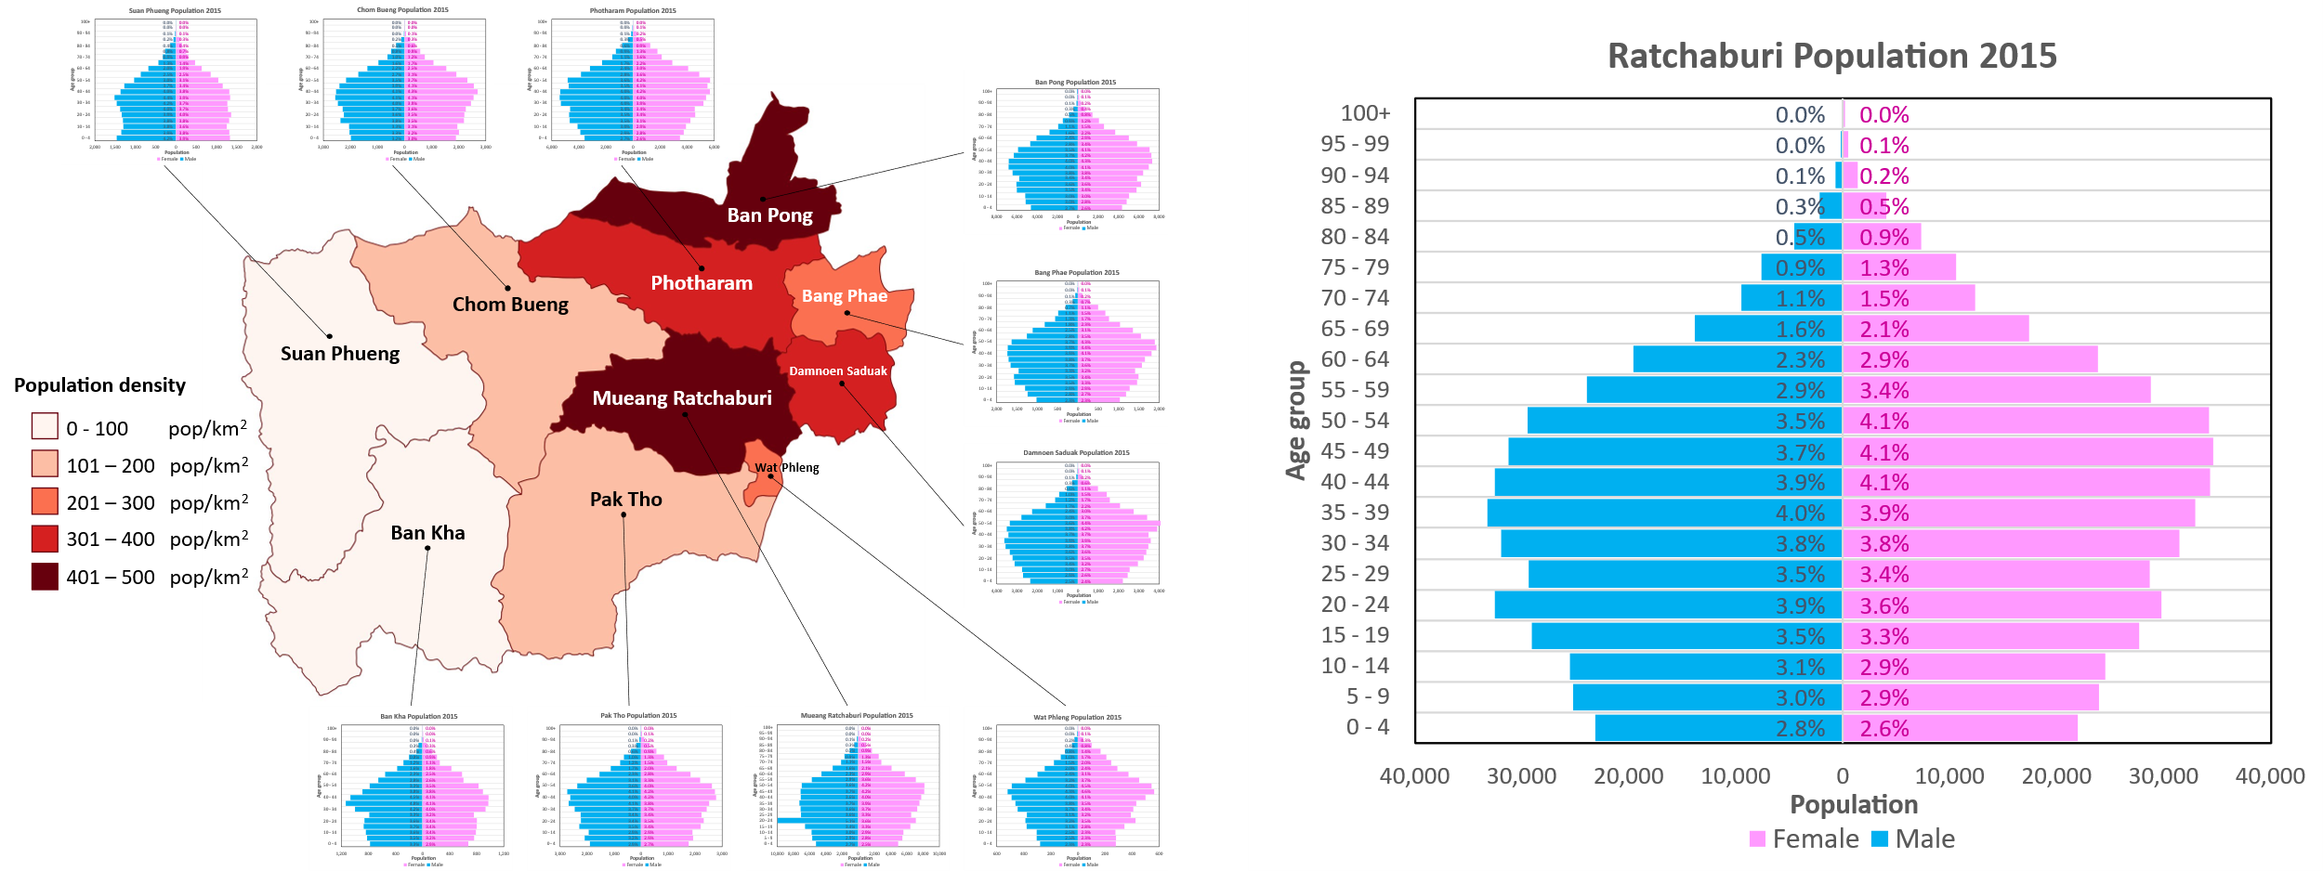
Fig. S1 Annual average population pyramid and population density in Ratchaburi in 2015.

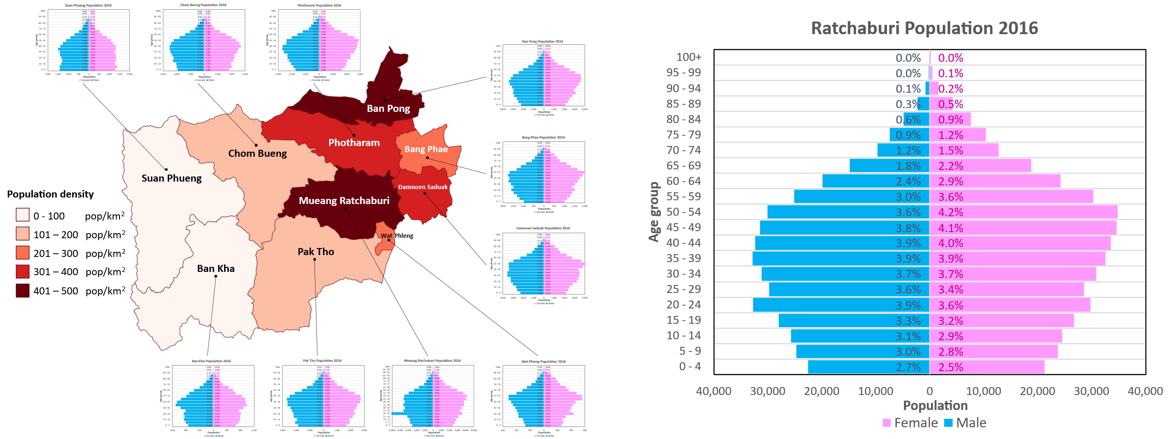
Fig. S2 Annual average population pyramid and population density in Ratchaburi in 2016.

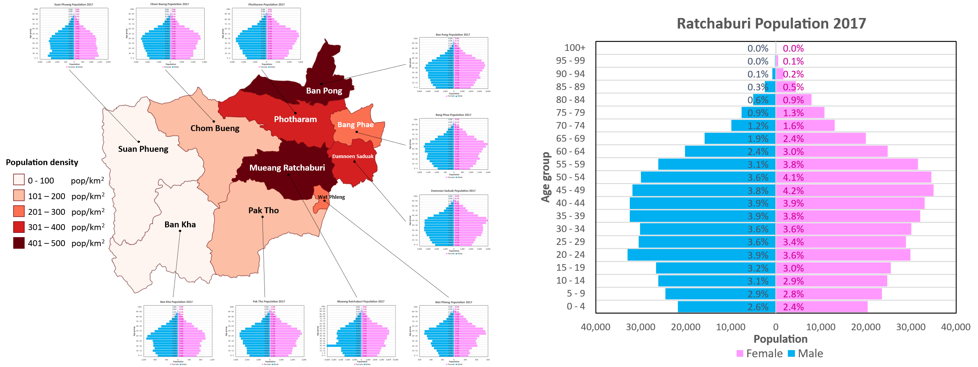Fig. S3 Annual average population pyramid and population density in Ratchaburi in 2017.

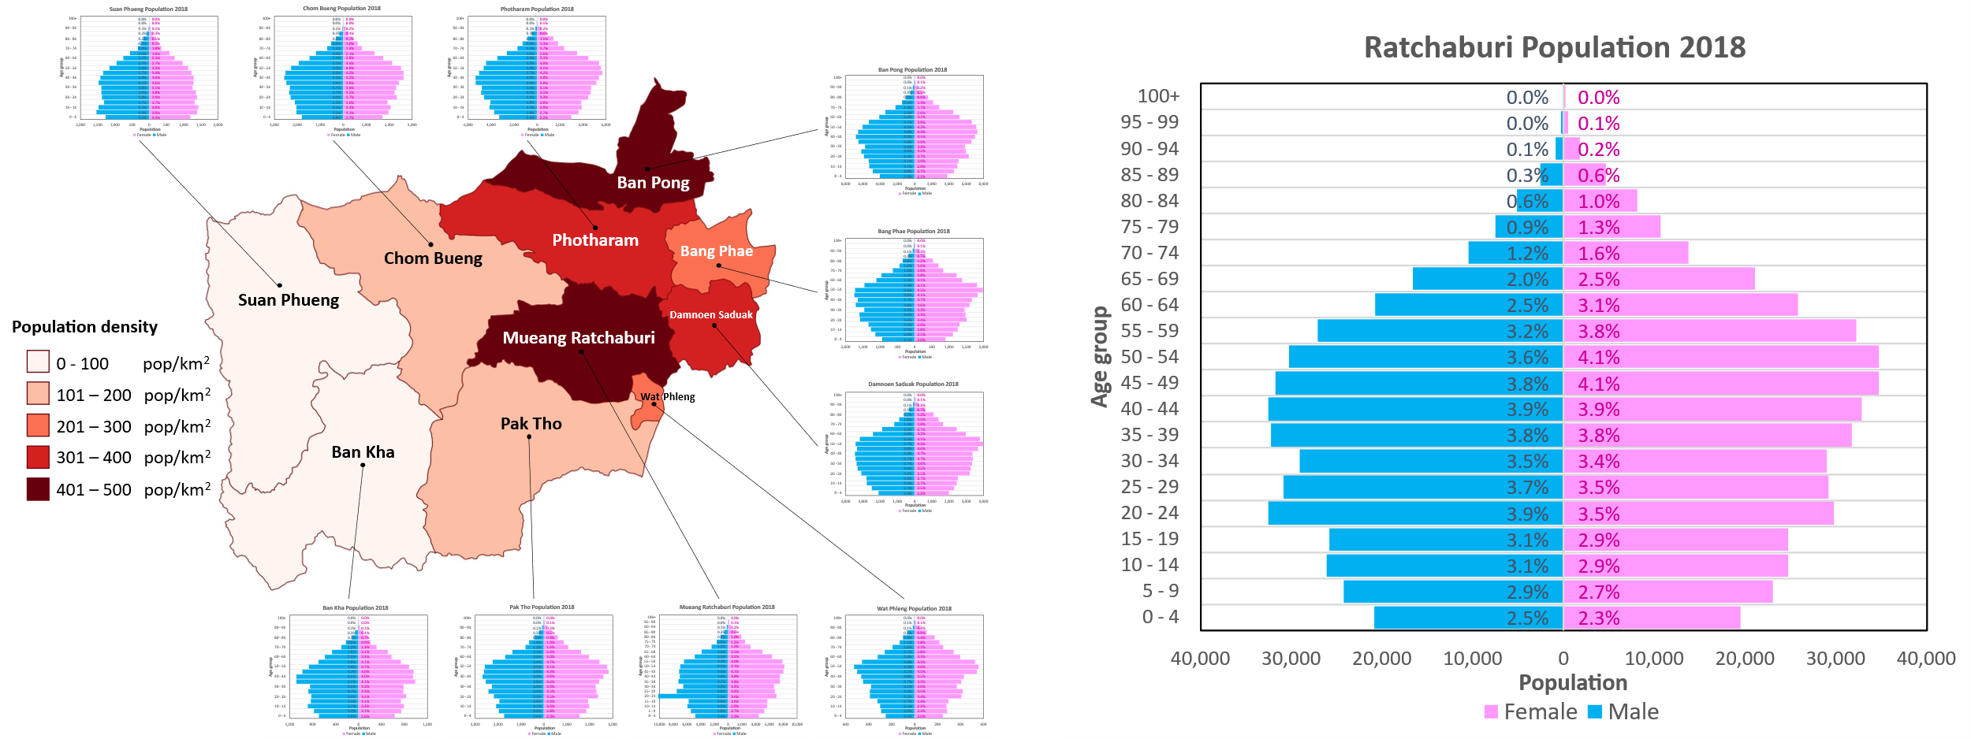
Fig. S4 Annual average population pyramid and population density in Ratchaburi in 2018.

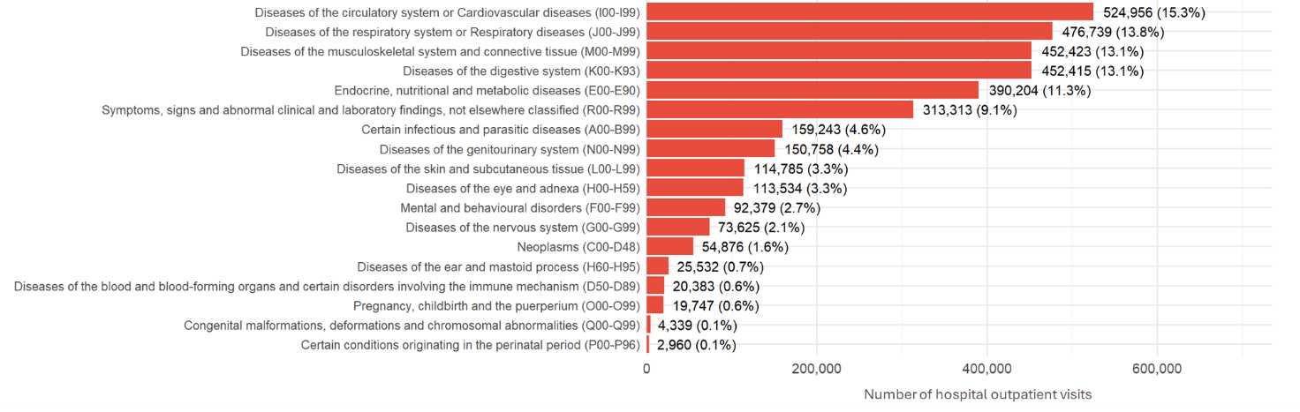

Fig. S5 Proportion of hospital outpatient visits for non-accidental morbidity (ICD-10: A00–R99) by sub-cause in Ratchaburi during 2015–2019.

References
Chen C, Zhu P, Lan L et al (2018) Short-term exposures to PM_{2.5} and cause-specific mortality of cardiovascular health in China. Environ Res 161: 188-194. https://doi.org/10.1016/j.envres.2017.10.046
Cheng H, Zhu F, Lei R et al (2019) Associations of ambient PM_{2.5} and O₃ with cardiovascular mortality: a time-series study in Hefei, China. Int J Biometeorol 63: 1437-1447. https://doi.org/10.1007/s00484-019-01766-2
Gong T, Sun Z, Zhang X et al (2019) Associations of black carbon and PM_{2.5} with daily cardiovascular mortality in Beijing, China. Atmos Environ 214: 116876. https://doi.org/10.1016/j.atmosenv.2019.116876
Gu J, Shi Y, Zhu Y, Chen N, Wang H, Zhang Z, Chen T (2020) Ambient air pollution and cause-specific risk of hospital admission in China: A nationwide time-series study. PLoS Med 17(8): e1003188. https://doi.org/10.1371/journal.pmed.1003188
Li D, Wang JB, Zhang ZY et al (2018) Association between short-term exposure to ambient air pollution and daily mortality: a time-series study in Eastern China. Environ Sci Pollut Res 25: 16135-16143. https://doi.org/10.1007/s11356-018-1759-y
Liu T, Meng H, Yu M et al (2021) Urban-rural disparity of the short-term association of PM_{2.5} with mortality and its attributable burden. The Innovation, 2(4): 100171. https://doi.org/10.1016/j.xinn.2021.100171
Office of Permanent Secretary (OPM), Ministry of Public Health (2016) Public health statistics A.D.2015. Nonthaburi
Office of Permanent Secretary (OPM), Ministry of Public Health (2017) Public health statistics A.D.2016. Nonthaburi
Office of Permanent Secretary (OPM), Ministry of Public Health (2018) Public health statistics A.D.2017. Nonthaburi
Office of Permanent Secretary (OPM), Ministry of Public Health (2019) Public health statistics A.D.2018. Nonthaburi
Office of Permanent Secretary (OPM), Ministry of Public (Health 2020) Public health statistics A.D.2019. Nonthaburi
Pengjan S, Bonnet S, Garivait S. (2026). Cardiovascular and Respiratory Mortality from Ambient PM_{2.5} and Health Benefit Assessment: A Case Study from Ratchaburi, Thailand. Environments, 13 (3), 139. https://doi.org/https://doi.org/10.3390/environments13030139
Priyankara S, Senarathna M, Jayaratne R (2021) Ambient PM_{2.5} and PM₁₀ Exposure and Respiratory Disease Hospitalization in Kandy, Sri Lanka. Int J Environ Res Public Health, 18(18): 9617. https://doi.org/10.3390/ijerph18189617
Ratchaburi Provincial Public Health Office (RBPHO), Ministry of Public Health (2020) General Information of Ratchaburi. from http://rbpho.moph.go.th/upload-file/doc/files/11032020-093141-5931.pdf. Accessed 14 September 2020
Ratchaburi Provincial Public Health Office (RBPHO), Ministry of Public Health (2021) 2020 Annual Report. https://anyflip.com/bookcase/urqfe. Accessed 07 December 2021
Shin HH, Maquiling A, Thomson EM, Park IW, Stieb DM, Dehghani P (2022) Sex-difference in air pollution-related acute circulatory and respiratory mortality and hospitalization. Sci Total Environ 806: 150515. https://doi.org/10.1016/j.scitotenv.2021.150515
Strosnider HM, Chang HH, Darrow, LA, Liu Y, Vaidyanathan A, Strickland MJ (2019) Age-specific associations of ozone and fine particulate matter with respiratory emergency department visits in the United States. Am J Respir Crit Care Med 199(7): 882-890. https://doi.org/10.1164/rccm.201806-1147OC
Su C, Breitner S, Schneider A, Liu L, Franck U, Peters A, Pan X (2016) Short-term effects of fine particulate air pollution on cardiovascular hospital emergency room visits: a time-series study in Beijing, China. Int Arch Occup Environ Health 89(4): 641-657. https://doi.org/10.1007/s00420-015-1102-6
Wang J, Huang Z, Liu X et al (2023) Effects of ambient air pollution on cause-specific hospitalizations in Wuhan during 2017–2019. Ecotoxicol Environ Saf 253: 114686. https://doi.org/10.1016/j.ecoenv.2023.114686
Wang X, Yu C, Zhang Y, Shi F, Meng R, Yu Y (2020) Attributable risk and economic cost of cardiovascular hospital admissions due to ambient particulate matter in Wuhan, China. Int J Environ Res Public Health 17(15): 5453. https://doi.org/10.3390/ijerph17155453
Wu T, Yang X, Chu A, Xie X, Bai M, Peng Y, Zhang Z (2022) Acute effects of fine particulate matter (PM_{2.5}) on hospital admissions for cardiovascular diseases in Lanzhou, China: A time-series study. Environ Sci Eur 34(1): 1-14. https://doi.org/10.1186/s12302-022-00634-y
Yap J, Ng Y, Yeo KK, Sahlén A, Lam CSP, Lee V, Ma S (2019) Particulate air pollution on cardiovascular mortality in the tropics: impact on the elderly. Environ Health 18(1): 1-9. https://doi.org/10.1186/s12940-019-0476-4

