Ambition Disparity Reveals Unlocked Mitigation Potential for Blue Carbon in the Paris Agreement
Radhika Bhargava Gajre¹, Anabel Kadri², Maria Fernanda Adame³, Stacy K. Baez⁴, Natasha Bhatia⁵, Jacob J. Bukoski⁶, Miguel Cifuentes-Jara7, Peter I. Macreadie⁸, Sai Qu¹, Michiel van Breugel¹, Hao Tang¹, Daniel A. Friess²
- Department of Geography, National University of Singapore, Singapore
- Department of Earth and Environmental Sciences, Tulane University, New Orleans, Louisiana, USA
- Australian Rivers Institute, Griffith University, Nathan, Brisbane, Australia
- The Pew Charitable Trusts, Washington, D.C., USA
- The Asian School of the Environment, Nanyang Technological University, Singapore
- Department of Forest Ecosystems & Society, Oregon State University, Corvallis, Oregon, USA
- Smithsonian Environmental Research Centre, Edgewater, Maryland, USA
- Royal Melbourne Institute of Technology, Melbourne, Victoria, Australia

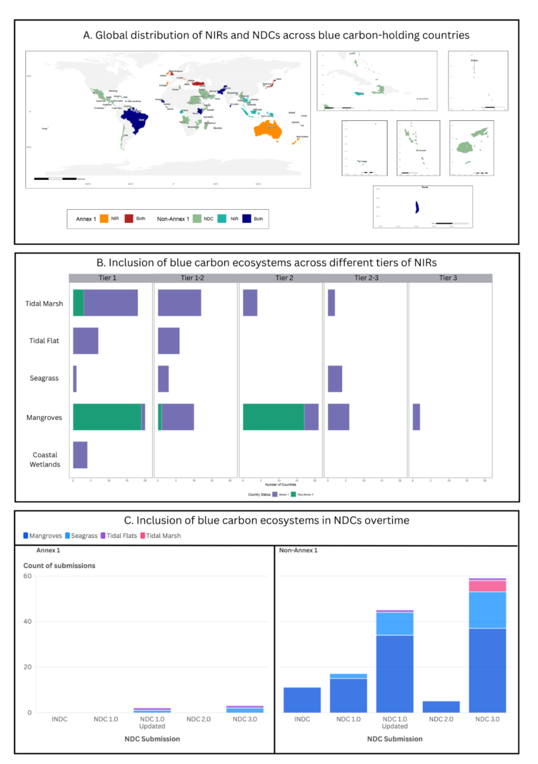
Supplementary Figure 1| Global distribution of blue carbon inclusion based on NIRs and NDCs between Annex I and Non-Annex I countries since 2015. A. Spatial distribution of countries where blue carbon ecosystems are accounted as a part of their NIRs, or included as mitigation targets in NDCs, or both. The map shows a total inclusion in either reports between 2015 and 2025 through multiple NIR and NDC submissions. B. Count of blue carbon ecosystems per NIR tier. The tier system progresses from Tier 1 inclusion, which utilises IPCC default values, to Tier 3, employing country-specific data. The Tier 1-2 methodology utilises country-specific and some default values. Tier 2 employs country-specific measurements (but no modelling), and Tier 2-3 incorporates some country-specific values with basic spatial models. C. Frequency distribution of inclusion of blue carbon ecosystems as mitigation targets in NDCs between 2015-2025 through INDC and NDC 1.0 – NDC 3.0 submissions.
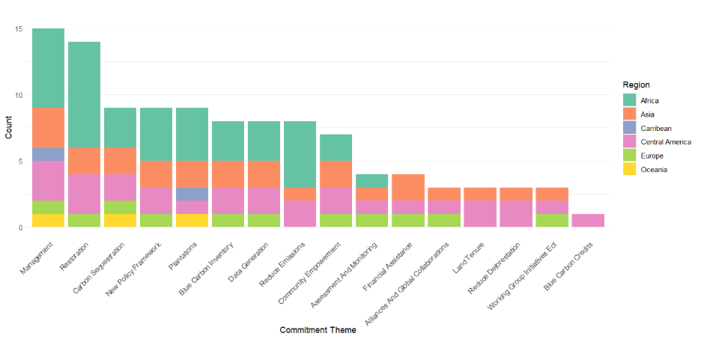
Supplementary Figure 2 | Regional distribution of Blue Carbon themes in Nationally Determined Contributions (NDCs) by target type between 2015 and 2025. Stacked bars represent the frequency of specific blue carbon themes across geographic regions, categorized by unconditional and quantitative target status.

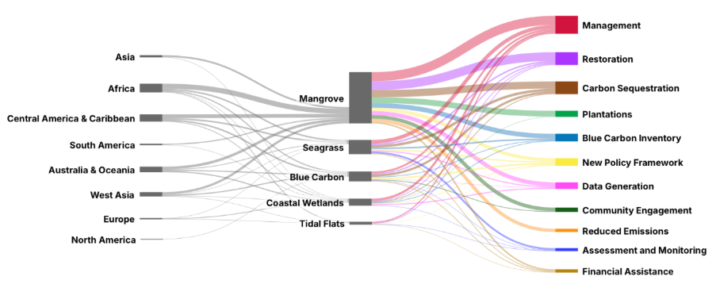
Supplementary Figure 3 | Integration of coastal blue carbon ecosystems into national climate mitigation targets (2015–2025). Sankey diagram illustrating the thematic flow from geopolitical groupings and geographic regions to all coastal ecosystems and their respective mitigation-oriented policy themes, as extracted from NDC reports submitted between 2015 and 2025. Node widths are proportional to the frequency of countries under those mitigation targets. The visualisation reveals a predominant focus on mangrove ecosystems within Non-Annex I regions, with 'Management' and 'Carbon Sequestration' emerging as the primary thematic drivers for emission reduction commitments. Conversely, seagrass and tidal marsh ecosystems exhibit lower levels of integration into formal mitigation pathways.

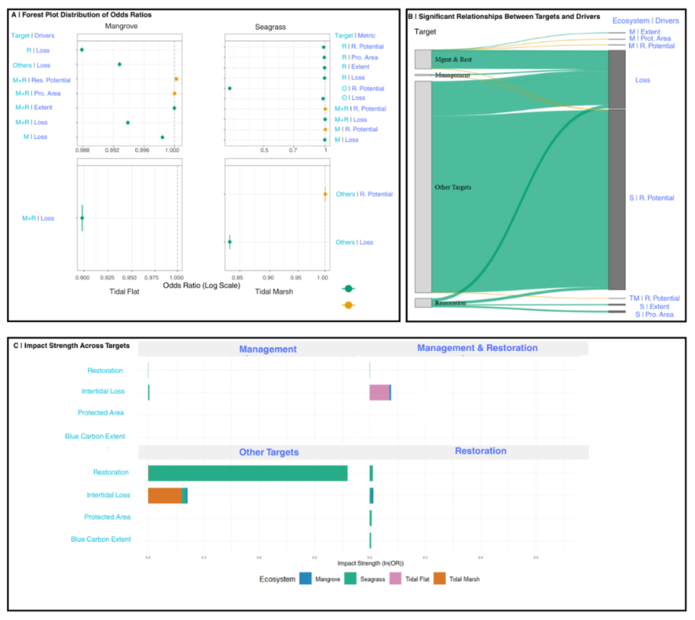
Supplementary Figure 4 | Drivers of inclusion of blue carbon-based mitigation action in NDCs. Multi-panel display of ecological drivers influencing the inclusion of blue carbon ecosystems in national climate policies. (A) Forest plot showing the odds ratios (OR) for metrics that significantly influence specific policy categories (A: General, AR: Adaptation/Resilience, I: Implementation, R: Restoration). Error bars represent 95% confidence intervals; points to the right of the dashed line (OR > 1) indicate positive associations, while points to the left (OR < 1) indicate negative associations. (B) Sankey diagram visualising the flow of influence from ecological metrics (right) to specific policy outcomes (left). Ribbon thickness represents the magnitude of the effect. (C) Heatmap summarising the influence of all metrics across the four studied ecosystems (M: Mangrove, S: Seagrass, TF: Tidal Flat, TM: Tidal Marsh). Colours represent binned OR values, highlighting consistent global patterns such as the negative impact of intertidal loss
Supplementary Table 1: Odds Ratio for Multinomial Logistic Regression (TM = Tidal Marsh, TF = Tidal Flat)
Ecosystem | Policy_Target | Variable | Odds_Ratio | P_Value | Lower_CI | Upper_CI | Significant
Mangrove | M | Intertidal Loss | 0.9984 | 0 | 0.9984 | 0.9984 | TRUE
Mangrove | MR | Intertidal Loss | 0.9939 | 0 | 0.9939 | 0.9939 | TRUE
Mangrove | O | Intertidal Loss | 0.9928 | 0 | 0.9928 | 0.9928 | TRUE
Mangrove | R | Intertidal Loss | 0.9879 | 0 | 0.9879 | 0.9879 | TRUE
Mangrove | MR | Restoration | 1.0002 | 6e-04 | 1.0001 | 1.0004 | TRUE
Mangrove | MR | Extent | 1 | 0.0064 | 1 | 1 | TRUE
Mangrove | MR | Protected Area | 1 | 0.008 | 1 | 1 | TRUE
Mangrove | M | Restoration | 1.0002 | 0.0779 | 1 | 1.0003 | FALSE
Mangrove | O | Protected Area | 1 | 0.1128 | 1 | 1 | FALSE
Mangrove | M | Extent | 1 | 0.1875 | 1 | 1 | FALSE
Mangrove | O | Extent | 1 | 0.4104 | 1 | 1 | FALSE
Mangrove | R | Protected Area | 1 | 0.4226 | 1 | 1 | FALSE
Mangrove | R | Area | 1 | 0.5527 | 1 | 1 | FALSE
Mangrove | R | Restoration | 1 | 0.6045 | 0.9999 | 1.0002 | FALSE
Mangrove | M | Protected Area | 1 | 0.6317 | 1 | 1 | FALSE
Mangrove | O | Restoration | 1 | 0.7285 | 0.9998 | 1.0001 | FALSE
Seagrass | M | Intertidal Loss | 0.9951 | 0 | 0.9951 | 0.9951 | TRUE
Seagrass | MR | Intertidal Loss | 0.9985 | 0 | 0.9985 | 0.9985 | TRUE
Seagrass | O | Restoration | 0.34 | 0 | 0.34 | 0.34 | TRUE
Seagrass | O | Intertidal Loss | 0.977 | 0 | 0.977 | 0.977 | TRUE
Seagrass | R | Extent | 0.9929 | 0 | 0.9929 | 0.9929 | TRUE
Seagrass | R | Protected Area | 0.9898 | 0 | 0.9898 | 0.9898 | TRUE
Seagrass | R | Restoration | 0.9831 | 0 | 0.9831 | 0.9831 | TRUE
Seagrass | R | Intertidal Loss | 0.9924 | 0 | 0.9924 | 0.9924 | TRUE
Seagrass | M | Restoration | 1.0008 | 0 | 1.0006 | 1.0009 | TRUE
Seagrass | MR | Restoration | 1.0009 | 0 | 1.0007 | 1.0012 | TRUE
Seagrass | M | Extent | 1 | 0.137 | 1 | 1 | FALSE
Seagrass | M | Protected Area | 1 | 0.31 | 1 | 1 | FALSE
Seagrass | O | Protected Area | 1 | 0.7037 | 0.9999 | 1.0001 | FALSE
Seagrass | MR | Protected Area | 1 | 0.9101 | 1 | 1 | FALSE
Seagrass | MR | Extent | 1 | 0.918 | 1 | 1 | FALSE
Seagrass | O | Extent | 1 | 0.9212 | 1 | 1 | FALSE
TF | MR | Intertidal Loss | 0.8982 | 0 | 0.8979 | 0.8986 | TRUE
TF | MR | Extent | 1 | 0.1178 | 1 | 1.0001 | FALSE
TF | MR | Protected Area | 0.9999 | 0.3562 | 0.9998 | 1.0001 | FALSE
TF | I | Extent | 1 | 0.7296 | 0.9999 | 1.0001 | FALSE
TF | M | Protected Area | 1 | 0.8048 | 0.9999 | 1.0001 | FALSE
TF | M | Intertidal Loss | 0.9915 | 0.8472 | 0.9095 | 1.081 | FALSE
TF | O | Intertidal Loss | 0.9939 | 0.8886 | 0.9123 | 1.0828 | FALSE
TF | O | Protected Area | 1 | 0.8966 | 0.9998 | 1.0002 | FALSE
TF | M | Extent | 1 | 0.9355 | 0.9999 | 1.0001 | FALSE
TM | O | Intertidal Loss | 0.8338 | 0 | 0.8337 | 0.8339 | TRUE
TM | O | Restoration | 1.0002 | 0 | 1.0001 | 1.0003 | TRUE
TM | MR | Protected Area | 1.0001 | 0.0546 | 1 | 1.0002 | FALSE
TM | O | Protected Area | 0.9998 | 0.1157 | 0.9996 | 1 | FALSE
TM | O | Extent | 1.0001 | 0.1797 | 1 | 1.0001 | FALSE
TM | MR | Extent | 1 | 0.2398 | 0.9999 | 1 | FALSE
TM | MR | Restoration | 0.9997 | 0.3787 | 0.9991 | 1.0003 | FALSE
TM | M | Restoration | 0.9998 | 0.6543 | 0.9987 | 1.0008 | FALSE
TM | M | Protected Area | 0.9978 | 0.6817 | 0.9874 | 1.0083 | FALSE
TM | MR | Intertidal Loss | 1.0011 | 0.7511 | 0.9943 | 1.0079 | FALSE
TM | M | Intertidal Loss | 0.9896 | 0.8038 | 0.9112 | 1.0747 | FALSE
TM | R | Intertidal Loss | 0.9925 | 0.8065 | 0.9348 | 1.0538 | FALSE
TM | R | Extent | 0.9999 | 0.8523 | 0.9992 | 1.0007 | FALSE
TM | M | Extent | 0.9999 | 0.9149 | 0.9982 | 1.0016 | FALSE
TM | R | Restoration | 1 | 0.9233 | 0.9998 | 1.0002 | FALSE
TM | R | Protected Area | 1 | 0.9347 | 0.9988 | 1.0011 | FALSE

Supplementary Table 2: Global datasets on blue carbon ecosystem extent, carbon stocks, protection and restoration
Ecosystem | Extent |  | Carbon stocks |  | Carbon Sequestration | Protected Area | Deforestation Rate | Restoration
Ecosystem | Dataset | Accuracy; resolution; year | Dataset | Accuracy; resolution; year | Carbon Sequestration | Protected Area |  | Restoration
Mangroves | (Bunting et al., 2018) | 94% ; 25 m ; 2020 | Aboveground Carbon(Simard et al., 2019) | Root mean Square (RMSE) from ground validation was 3.6m; 30m; 2000 | (Howard et al., 2023) | (IUCN & UNEP-WCMC, 2024) | (Leal & Spalding, 2024) | (Worthington et al., 2024)
Mangroves | (Bunting et al., 2018) | 94% ; 25 m ; 2020 | Soil Carbon(Sanderman et al., 2018) | Their model captured 84% of the variation; 30 m ; 2000 | (Howard et al., 2023) | (IUCN & UNEP-WCMC, 2024) |  | (Worthington et al., 2024)
Seagrasses | (McKenzie et al., 2020) | Not Reported; 30 m ; 2020 | Aboveground and soil carbon(Krause et al., 2025) | Confidence Interval = 12.4 to 44.9 Mg Corg​ ha−1 ; 30 m ; variable | (Howard et al., 2023) | (IUCN & UNEP-WCMC, 2024) | (UN Environmental Programme, 2025) | (Griscom et al., 2020)
Tidal Marshes | (Worthington et al., 2024) | 85%; 10 m; 2020 | Total Ecosystem Carbon(Macreadie et al., 2021) | NA; extrapolate to 1m soil depth; variable | (Howard et al., 2023) | (IUCN & UNEP-WCMC, 2024) | (Brook et al., 2025) | (Griscom et al., 2020)
Tidal Flats | (Murray et al., 2022) | CI 95%; 30 m; 2020 | Total Ecosystem Carbon(Howard et al., 2023) | NA | (Howard et al., 2023) | (IUCN & UNEP-WCMC, 2024) | (Convention on Wetlands et al., 2025) | No Data

