Supplementary figure legends
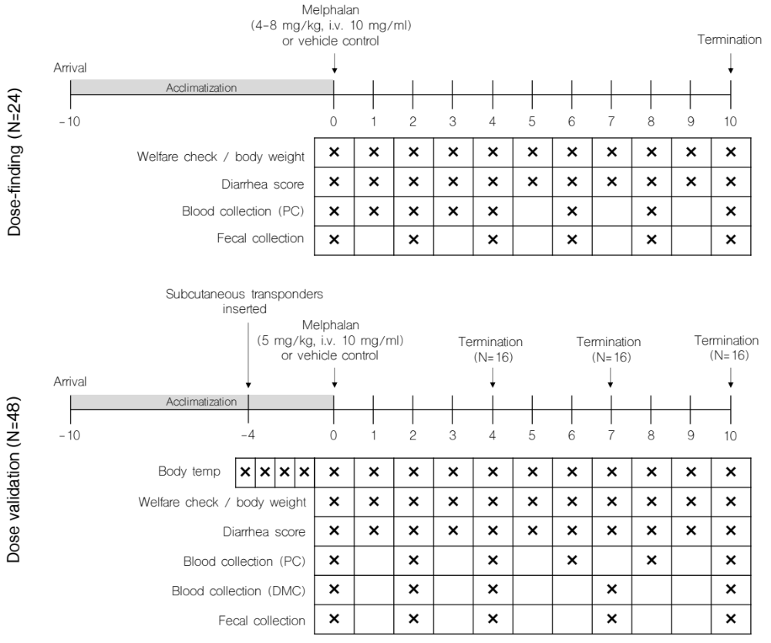
Figure S1: Experimental design and biospecimen collection.

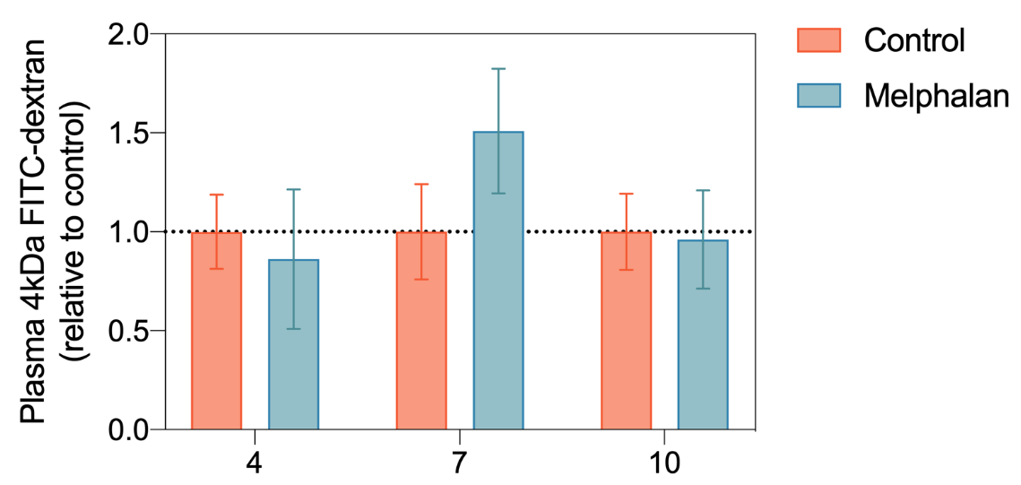
Figure S2: Plasma FITC-dextran concentration in control and melphalan-treated rats.

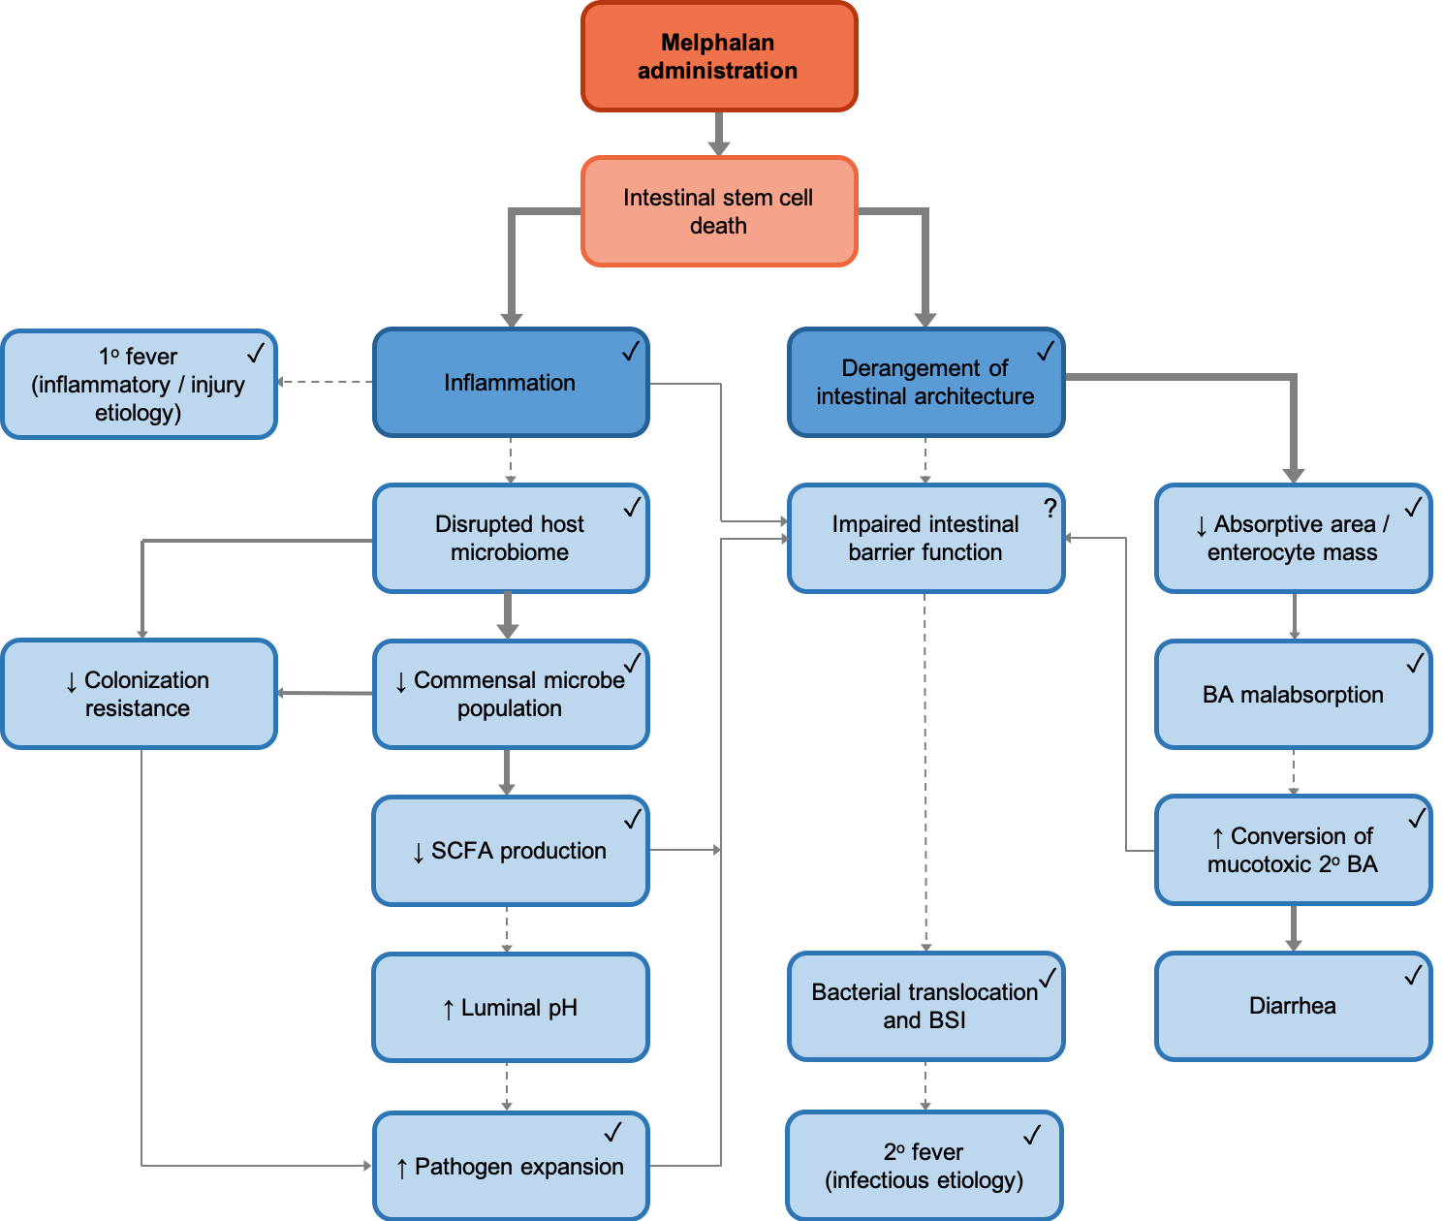
Figure S3: Mechanistic framework for melphalan-induced gut toxicity and fever. Ticks indicate data confirmed in HDM model. Thick solid lines indicate confirmed association. Thin solid lines indicate confirmed, but weak-moderate association, or associations confirmed in literature. Dotted lines indicate hypothesized association.

Supplementary tables

Table S1: Baseline characteristics according to ARRIVE guidelines
Table S1: Baseline characteristics (mean ± SEM)
 | Vehicle control | 5 mg/kg melphalan | P value
Body weight (g) | 177.1 ± 4.4 | 182.4 ± 4.2 | 0.42
Body temperature (ºC) | 37.24 ± 0.05 | 37.05 ± 0.04 | 0.06
Daily food intake (g) | 17.32 ± 0.53 | 17.14 ± 0.25 | 0.76
Daily water intake (g) | 18.36 ± 9.62 | 20.07 ± 0.70 | 0.08
Plasma citrulline (g) | 90.89 ± 2.37 | 93.78 ± 2.82 | 0.44

Table S2: Plasma bile acid concentrations
Table S2: Plasma bile acid concentrations
 |  |  | Control |  | Melphalan
 |  | Day | Mean | SEM | Mean | SEM | Sig
Total BA pool |  | 4 | 19.97 | 4.12 | 5.36 | 0.69
 |  | 7 | 22.99 | 4.45 | 7.16 | 1.78
 |  | 10 | 19.69 | 4.40 | 14.68 | 2.34
Primary BA | CA | 4 | 10.02 | 1.69 | 0.30 | 0.12 | *
Primary BA | CA | 7 | 10.62 | 1.40 | 2.68 | 1.27 | *
Primary BA | CA | 10 | 9.82 | 2.56 | 7.44 | 1.39
Primary BA | GCA | 4 | 0.12 | 0.04 | 0.07 | 0.03
Primary BA | GCA | 7 | 0.24 | 0.09 | 0.13 | 0.03
Primary BA | GCA | 10 | 0.20 | 0.05 | 0.12 | 0.02
Primary BA | TCA | 4 | 1.38 | 0.28 | 0.28 | 0.09 | **
Primary BA | TCA | 7 | 1.92 | 0.24 | 0.48 | 0.05 | ***
Primary BA | TCA | 10 | 1.67 | 0.22 | 0.57 | 0.09 | ***
Primary BA | CDCA | 4 | 1.72 | 0.72 | 4.00 | 0.24
Primary BA | CDCA | 7 | 1.59 | 0.28 | 4.00 | 0.28
Primary BA | CDCA | 10 | 1.71 | 0.47 | 7.00 | 1.31
Primary BA | GCDCA | 4 | 0.03 | 0.00 | 0.01 | 0.01
Primary BA | GCDCA | 7 | 0.03 | 0.01 | 0.01 | 0.01
Primary BA | GCDCA | 10 | 0.03 | 0.01 | 0.02 | 0.00
Primary BA | TCDCA | 4 | 0.17 | 0.01 | 0.19 | 0.01
Primary BA | TCDCA | 7 | 0.22 | 0.05 | 0.08 | 0.02 | **
Primary BA | TCDCA | 10 | 0.24 | 0.04 | 0.13 | 0.01 | **
Primary BA | α-MCA | 4 | 1.29 | 0.46 | 0.35 | 0.15
Primary BA | α-MCA | 7 | 1.28 | 0.12 | 0.37 | 0.16
Primary BA | α-MCA | 10 | 1.39 | 0.37 | 1.34 | 0.21
Primary BA | T-α-MCA | 4 | 0.49 | 0.04 | 0.17 | 0.04 | **
Primary BA | T-α-MCA | 7 | 0.55 | 0.09 | 0.23 | 0.04 | **
Primary BA | T-α-MCA | 10 | 0.61 | 0.08 | 0.35 | 0.03 | **
Primary BA | β-MCA | 4 | 0.71 | 0.26 | 0.93 | 0.51
Primary BA | β-MCA | 7 | 0.83 | 0.16 | 0.68 | 0.27
Primary BA | β-MCA | 10 | 0.92 | 0.28 | 0.97 | 0.17
Primary BA | T-β  -MCA | 4 | 0.16 | 0.01 | 0.09 | 0.02
Primary BA | T-β  -MCA | 7 | 0.19 | 0.03 | 0.14 | 0.03
Primary BA | T-β  -MCA | 10 | 0.26 | 0.05 | 0.11 | 0.01 | *
Secondary BA | DCA | 4 | 0.47 | 0.26 | 1.13 | 0.57
Secondary BA | DCA | 7 | 0.34 | 0.08 | 0.16 | 0.03
Secondary BA | DCA | 10 | 0.43 | 0.10 | 0.28 | 0.06
Secondary BA | GDCA | 4 | 0.01 | 0.01 | 0.06 | 0.01 | *
Secondary BA | GDCA | 7 | 0.02 | 0.01 | 0.01 | 0.01
Secondary BA | GDCA | 10 | 0.03 | 0.01 | 0.02 | 0.01
Secondary BA | TDCA | 4 | 0.10 | 0.01 | 0.44 | 0.09 | **
Secondary BA | TDCA | 7 | 0.25 | 0.13 | 0.11 | 0.04
Secondary BA | TDCA | 10 | 0.12 | 0.01 | 0.07 | 0.01
Secondary BA | LCA | 4 | 0.03 | 0.01 | 0.06 | 0.02
Secondary BA | LCA | 7 | 0.02 | 0.01 | 0.00 | 0.00
Secondary BA | LCA | 10 | 0.02 | 0.01 | 0.01 | 0.00
Secondary BA | ω-MCA | 4 | 1.22 | 0.51 | 2.82 | 0.72
Secondary BA | ω-MCA | 7 | 1.49 | 0.38 | 1.62 | 0.46
Secondary BA | ω-MCA | 10 | 1.81 | 0.41 | 1.50 | 0.19
Secondary BA | HDCA | 4 | 0.08 | 0.04 | 0.05 | 0.02
Secondary BA | HDCA | 7 | 0.11 | 0.02 | 0.05 | 0.02
Secondary BA | HDCA | 10 | 0.14 | 0.04 | 0.18 | 0.04

Supplementary methods
Methods: SCFA analysis methodological adaptations and Novogene rRNA sequencing detailed methodology.

SCFA analysis adaptations

Values were determined relative to a 7-point calibration curve (acetate: 0.0 and 8.0 mM; propionate: 0.0 to 4.0 mM; butyrate: 0.0 to 4.0 mM). Cecal contents were thawed on ice and diluted 1:9 with sterile, milliQ water and refrozen at -80ºC. On the day of analysis, samples were thawed on ice and 500 µl was added to 500 μl of calibration sample, 100 μl internal standard solution (1 mg/ml 2-ethylbutyrate in Milli-Q), 20 μl 20% (w/v) sulphosalicylic acid solution and two drops 37% HCl were added. The sample was centrifuged at 16100 g for 20 min at 4°C, and supernatant was transferred to a glass tube containing a spatula tip of sodium chloride. 2 ml of diethylether was added and the sample was vortexed for 10 min at room temperature and spun down at 3000 g for 10 min at 4°C. From the clear upper layer, a 500 μl aliquot was taken and transferred to a glass GC-vial. 50 μl of MBTSTFA + 1% TBDMCS was added and left to derivatize overnight at room temperature. 3 μl derivatized sample was injected into the GC-MS (7890A GC System and 5975C inert XI EI/CI MSD with an EI inert 350 source). Analysis was carried out in a split mode with an inlet split ratio of 20:1. Samples were analyzed in SIM acquisition mode; acetate at m/z 117, propionate at m/z 131, butyrate at m/z 145 and 2-ethylbutyrate at m/z 175. Injector, source and quadrupole temperatures were 280°C, 230°C and 150°C, respectively. A Zebron capillary GC column of 30 m x 0.25 mm, 0.25 μm film thickness was used (ZB-1, Phenomenex, Torrance, USA). The GC oven was programmed as follows: 40°C held for 0 min, increased to 70°C at 5°C min-1, held at 70°C for 3.5 min, increase to 160°C at 20°C min-1, increased to 280°C at 35°C min-1 and finally held at 280°C for 3 min with a total run time of 20.43 min. The flow was set a 1.0 ml min-1 with helium as carrier gas.

16S rRNA Sequencing by Novogene

Sequencing preparation
Genomic DNA extraction
Total genome DNA from samples was extracted using CTAB/SDS method. DNA concentration and purity was monitored on 1% agarose gels. According to the concentration, DNA was diluted to 1ng/μL using sterile water.
Amplicon Generation
16S rRNA/18SrRNA/ITS genes of distinct regions (16SV4/16SV3/16SV3-V4/16SV4-V5, 18S V4/18S V9, ITS1/ITS2, Arc V4) were amplified used specific primer (e.g. 16S V4: 515F-806R, 18S V4: 528F-706R, 18S V9: 1380F-1510R) with the barcode. All PCR reactions were carried out with Phusion® High-Fidelity PCR Master Mix (New England Biolabs).
PCR Products quantification and qualification
Mix same volume of 1X loading buffer (contained SYB green) with PCR products and operate electrophoresis on 2% agarose gel for detection. Samples with bright main strip between 400bp-450bp were chosen for further experiments.
PCR Products Mixing and Purification
PCR products was mixed at equal density ratios. The mixed PCR products were purified with Qiagen Gel Extraction Kit (Qiagen, Germany).
The libraries generated with NEBNext® UltraTM DNA Library Prep Kit for Illumina and quantified via Qubit and Q-PCR, would be analysed by Illumina platform.

Information analysis
Sequencing data processing
Paired-end reads was assigned to samples based on their unique barcodes and truncated by cutting off the barcode and primer sequences. Paired-end reads were merged using FLASH (V1.2.7, http://ccb.jhu.edu/software/FLASH/) ^{[21]}, a very fast and accurate analysis tool, which was designed to merge paired-end reads when at least some of the reads overlap the read generated from the opposite end of the same DNA fragment, and the splicing sequences were called raw tags. Quality filtering on the raw tags were performed under specific filtering conditions to obtain the high-quality clean tags^{[22]} according to the Qiime (V1.7.0, http://qiime.org/scripts/split_libraries_fastq.html)^{[23]} quality controlled process. The tags were compared with the reference database (Gold database,http://drive5.com/uchime/uchime_download.html) using UCHIME algorithm (UCHIME Algorithm,http://www.drive5.com/usearch/manual/uchime_algo.html)^{[24]} to detect chimera sequences (https://drive5.com/usearch/manual/chimeras.html). And then the chimera sequences were removed ^{[25]}. Then the Effective Tags finally obtained.
OTU cluster and Taxonomic annotation
Sequences analysis were performed by Uparse software (Uparse v7.0.1001 http://drive5.com/uparse/)^{[26]} using all the effective tags. Sequences with ≥97% similarity were assigned to the same OTUs. Representative sequence for each OTU was screened for further annotation. For each representative sequence, Mothur software was performed against the SSUrRNA database of SILVA Database (http://www.arb-silva.de/)^{[27]}for species annotation at each taxonomic rank (Threshold:0.8~1)^{[28]} (kingdom, phylum, class, order, family, genus, species). To obtain the phylogenetic relationship of all OTUs representative sequences, the MUSCLE ^{[29]} (Version 3.8.31,http://www.drive5.com/muscle/)can compare multiple sequences rapidly. OTUs abundance information were normalized using a standard of sequence number corresponding to the sample with the least sequences. Subsequent analysis of alpha diversity and beta diversity were all performed basing on this output normalized data.
Alpha Diversity
Alpha diversity is applied in analyzing complexity of biodiversity for a sample through 6 indices, including Observed-species, Chao1, Shannon, Simpson, ACE, Good-coverage. All these indices in our samples were calculated with QIIME (Version 1.7.0) and displayed with R software (Version 2.15.3).
Alpha Diversity Indices：
Community richness indices:
Chao - the Chao1 estimator (http://scikit-bio.org/docs/latest/generated/skbio.diversity.alpha.chao1.html#skbio.diversity.alpha.chao1; ACE - the ACE estimator (http://scikit-bio.org/docs/latest/generated/skbio.diversity.alpha.ace.html#skbio.diversity.alpha.ace);
Community diversity indices:
Shannon - the Shannon index (http://scikit-bio.org/docs/latest/generated/skbio.diversity.alpha.shannon.html#skbio.diversity.alpha.shannon); Simpson - the Simpson index (http://scikit-bio.org/docs/latest/generated/skbio.diversity.alpha.simpson.html#skbio.diversity.alpha.simpson);
The index of sequencing depth:
Coverage - the Good’s coverage (http://scikit-bio.org/docs/latest/generated/skbio.diversity.alpha.goods_coverage.html#skbio.diversity.alpha.goods_coverage);
The index of phylogenetic diversity:
PD_whole_tree - PD_whole_tree index(http://scikit-bio.org/docs/latest/generated/skbio.diversity.alpha.faith_pd.html?highlight=pd#skbio.diversity.alpha.faith_pd)
Beta Diversity
Beta diversity analysis was used to evaluate differences of samples in species complexity, Beta diversity on both weighted and unweighted unifrac were calculated by QIIME software (Version 1.7.0). Cluster analysis was preceded by principal component analysis (PCA), which was applied to reduce the dimension of the original variables using the FactoMineR package and ggplot2 package in R software (Version 2.15.3). Principal Coordinate Analysis (PCoA) was performed to get principal coordinates and visualize from complex, multidimensional data. A distance matrix of weighted or unweighted unifrac among samples obtained before was transformed to a new set of orthogonal axes, by which the maximum variation factor is demonstrated by first principal coordinate, and the second maximum one by the second principal coordinate, and so on. PCoA analysis was displayed by WGCNA package, stat packages and ggplot2 package in R software (Version 2.15.3). Unweighted Pair-group Method with Arithmetic Means (UPGMA) Clustering was performed as a type of hierarchical clustering method to interpret the distance matrix using average linkage and was conducted by QIIME software (Version 1.7.0).
LEfSe analysis was conducted by LEfSe software. Metastat was calculated by R software. P-value was calculated by method of permutation test while q-value was calculated by method of Benjamini and Hochberg False Discovery Rate^{[30]}. Anosim, MRPP and Adonis were performed by R software (Vegan package: anosim function, mrpp function and adonis function). AMOVA was calculated by mothur using amova function. T_test and drawing were conducted by R software.

