3/5/5
0/5/5
0/5/5
4/5/5
0/5
0/5
Extended Data Fig. 1. Pmel TCR-transgenic T cells targeting hgp100^{KVP} tumor neoantigen delay tumor progression in solid tumor models. Bulk unsorted Pmel T cells were stimulated twice and administered as ACT infusion (3e6/mouse) targeting large established hgp100^{KVP} neoantigen expressing B16 melanoma (Mel: top panel), and MC38 colon tumors (CRC: bottom panel). Note that bulk Pmel infusion at very high cell doses (2e7/mouse) can mediate tumor regressions without need for vaccination as shown in ref 49. Left column – Untreated, Middle Column – Pmel cells only, and Right Column- Pmel + VACV^{KVP} vaccination. Numbers indicate surviving mice at the end of the experiment.

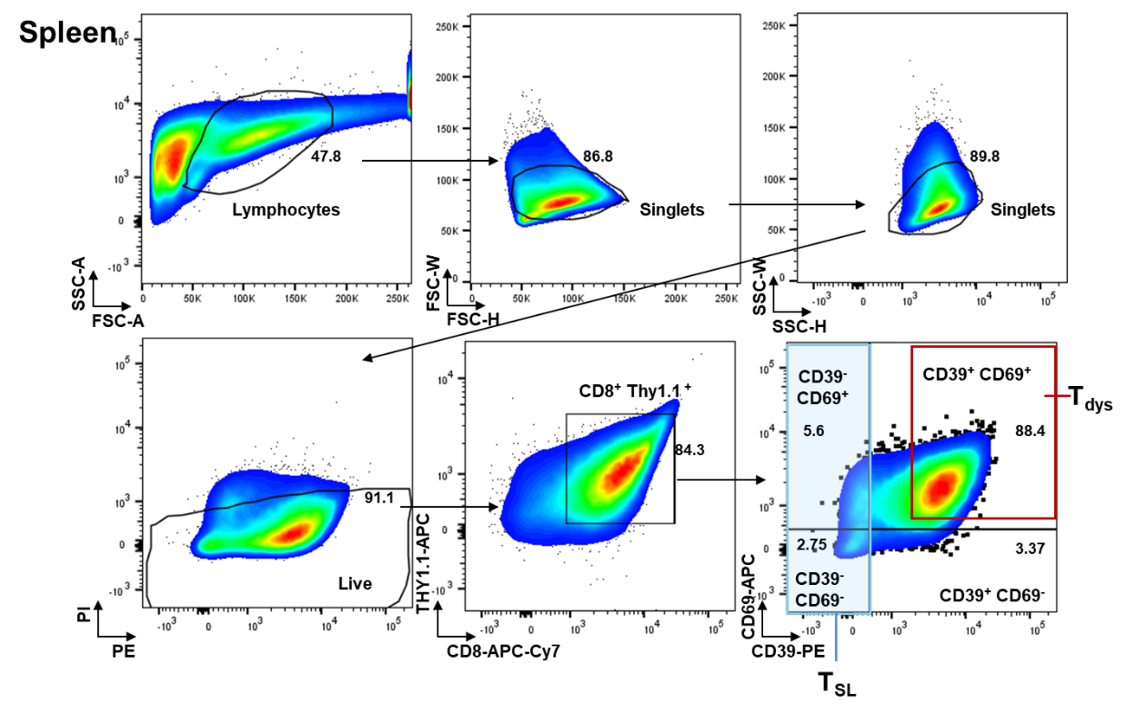

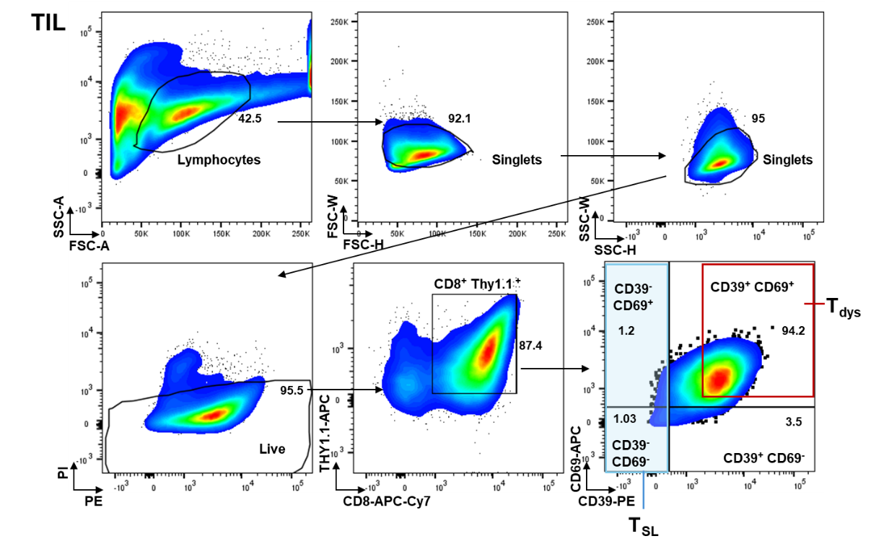

Extended Data Fig. 2. Gating strategy for analyzing or isolating CD39^{hi} or CD39⁺CD69⁺ T_{dys} and CD39^{lo} T_{SL} from Pmel TCR-transgenic T cells targeting hgp100^{KVP} tumor neoantigen from in vitro expanded restimulated splenocytes or TIL isolated from B16F10 tumors. Gates were separated to ensure minimal contamination for sorting purposes. Note for TIL-ACT cells were sorted for CD8⁺ Thy1.1⁺ for ACT since 94% of cells were CD39⁺ CD69⁺ T_{dys} subsets.

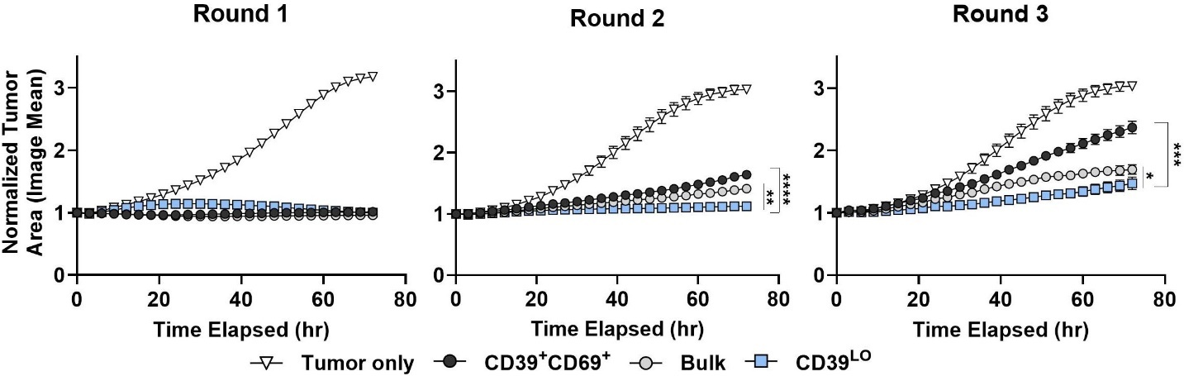
a
b
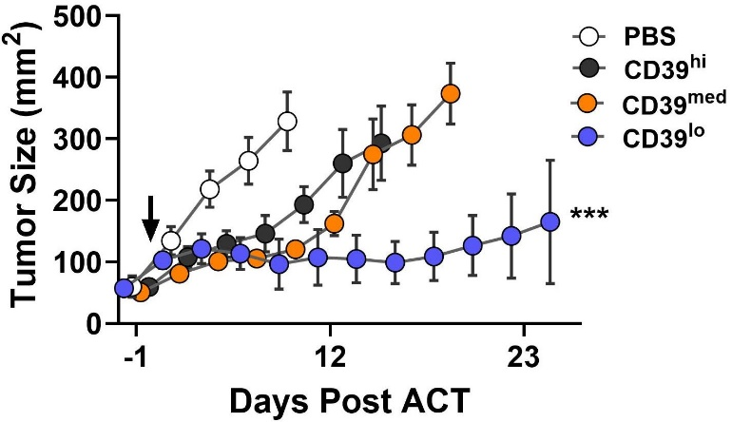

Extended Data Fig. 3. In vitro, in vivo antitumor efficacy of T_{SL} and T_{dys} cells during ACT. a.Bulk Pmel T cells, or FACS-sorted CD39^{lo} T_{SL} or CD39⁺CD69⁺ T_{dys} cells were tested against RFP-expressing B16^{KVP}-neoepitope expressing melanomas over three rounds of successive tumor killing experiments. Y-axis shows normalized tumor-area over each round of killing. ** P < 0.01, *** P < 0.001 by Mann-Whitney test for the groups compared. b. FACS-sorting based on cell surface expression of CD39 can also mark T_{dys} cells (CD39^{med} or CD39^{hi}) which are ineffective in treating established hgp100^{KVP} neoantigen expressing B16 melanoma when administered as ACT (1e6 cells/mouse). *** P < 0.001 by two-way ANOVA with Tukey’s multiple comparisons test.

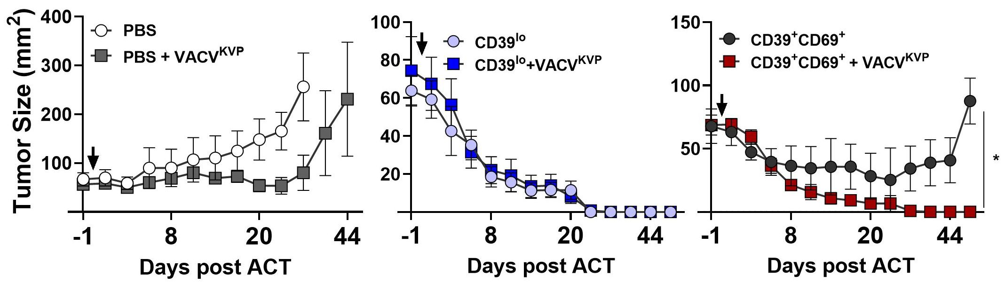

Extended Data Fig. 4. Effect of T_{SL} and T_{dys}-ACT with or without concurrent vaccination on MC38^{KVP} CRC tumors. FACS-sorted CD39^{lo} T_{SL} (middle panel) or CD39⁺CD69⁺ T_{dys} cells (right panel) were tested against hgp100^{KVP}-neoepitope expressing MC38 colon tumors implanted on mice. Vaccine only and no treatment is shown on left panel. CD39^{lo} T_{SL} can mediate complete tumor regressions in these tumor models while CD39⁺CD69⁺ T_{dys} cells need VACV^{KVP} for the same effect. *** P < 0.05 by two-way ANOVA with Tukey’s multiple comparisons test.

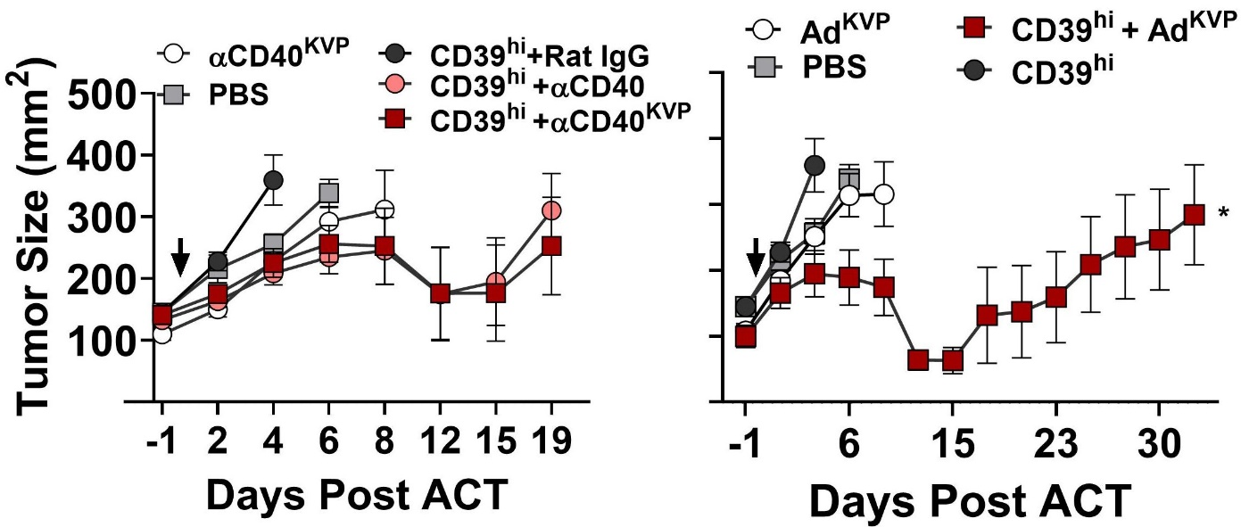
a
b

Extended Data Fig. 5. Impact of intraperitoneal neopeptide-αCD40 vaccine and intravenous Adenovirus neoepitope vaccine on T_{dys}-ACT. a.FACS-sorted CD39^{hi} T_{dys} cells were administered as ACT against hgp100^{KVP}-neoepitope expressing B16 melanoma tumors implanted on mice. Along with cells, agonistic 𝛂CD40 antibody with KVP-neoepitope (𝛂CD40^{KVP}), or 𝛂CD40 antibody alone or control antibody with KVP-neoepitope (Rat IgG^{KVP}), or 𝛂CD40^{KVP} antibody alone were compared as controls. b.FACS-sorted CD39^{hi} T_{dys} cells as ACT along with intravenous adenovirus vaccine encoding the hgp100^{KVP} (Ad^{KVP}) neoepitope a compared to vaccine only * P < 0.05 by two-way ANOVA with Tukey’s multiple comparisons test.

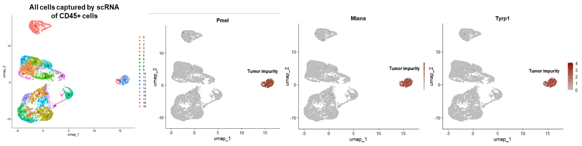
a
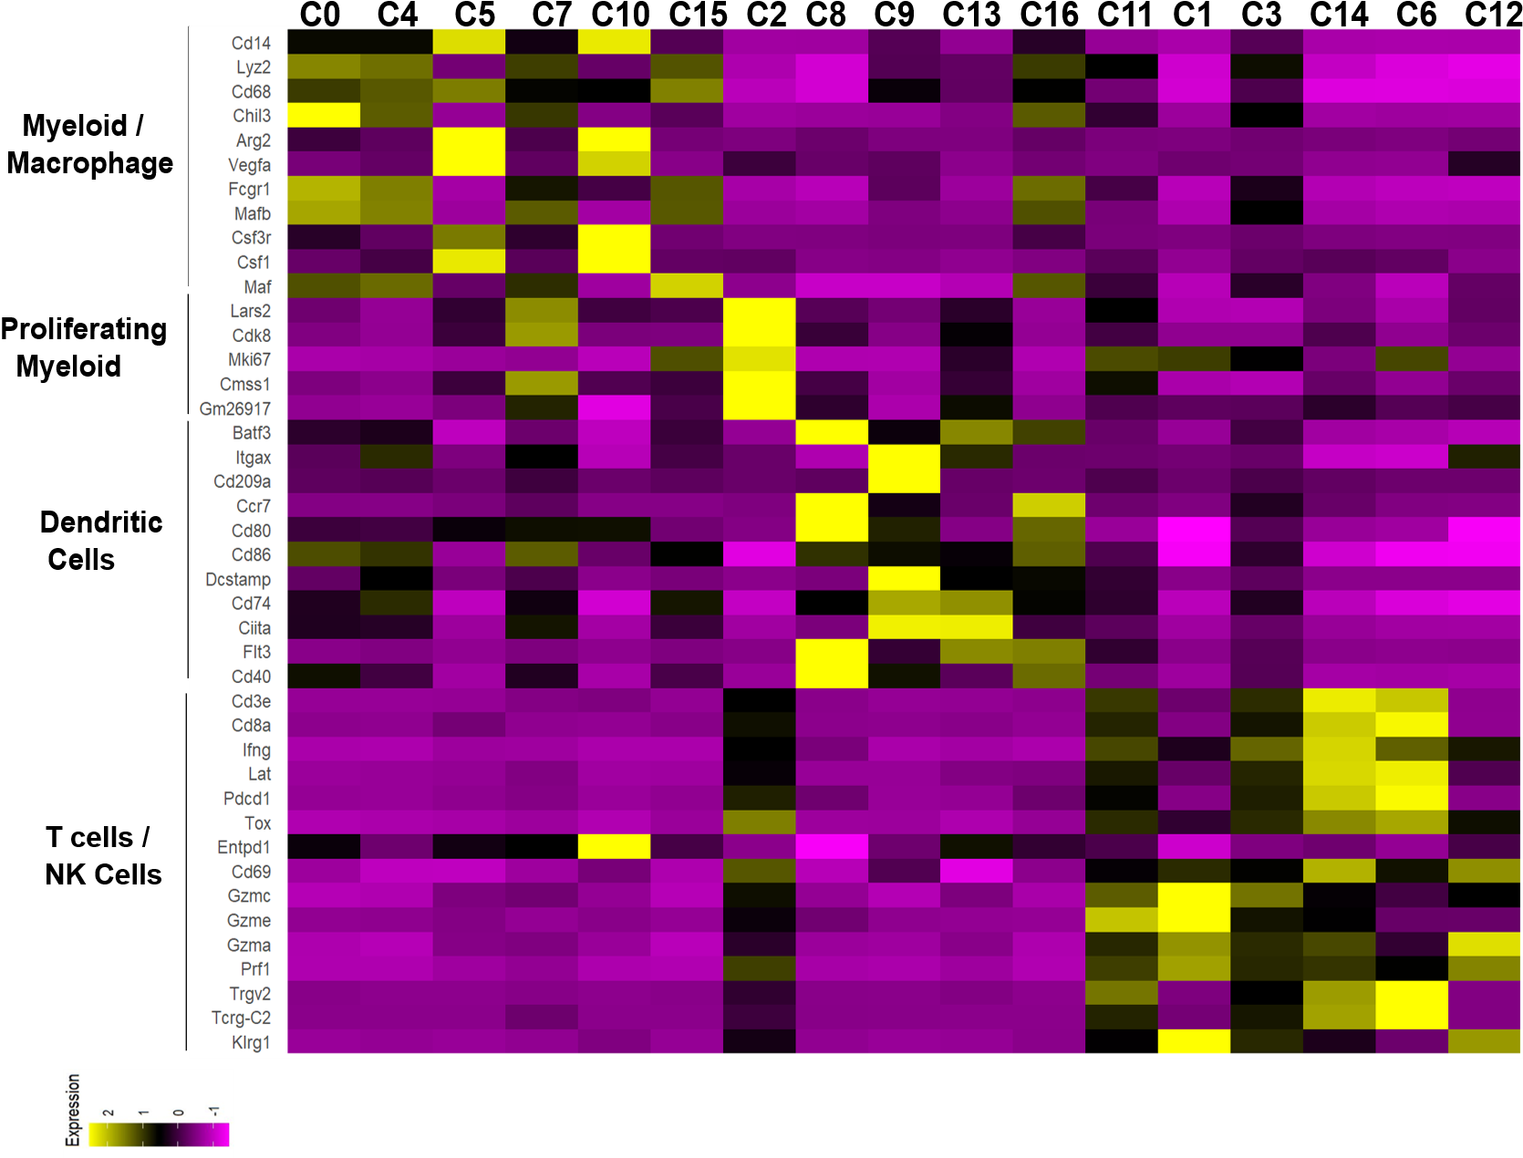
b
Extended Data Fig. 6. Tumor immune landscape after vaccine + T_{dys}-ACT. At day 3 post T_{dys}-ACT, CD45+ immune cells were subject to scRNA-seq. a. Initial scRNA-seq clustering visualization on UMAP showing tumor cell impurity (by expression of Pmel, MelanA and Tyrp1). Tumor cells were removed from analysis and reclustered to obtain the immune landscape in Fig. 3. b. Average expression of top 5-10 genes indicating canonical immune cell lineage markers of scRNA-seq clusters shown in Fig. 3. Complete list of differentially expressed genes (DEGs) is shown in Supplementary Table 1.
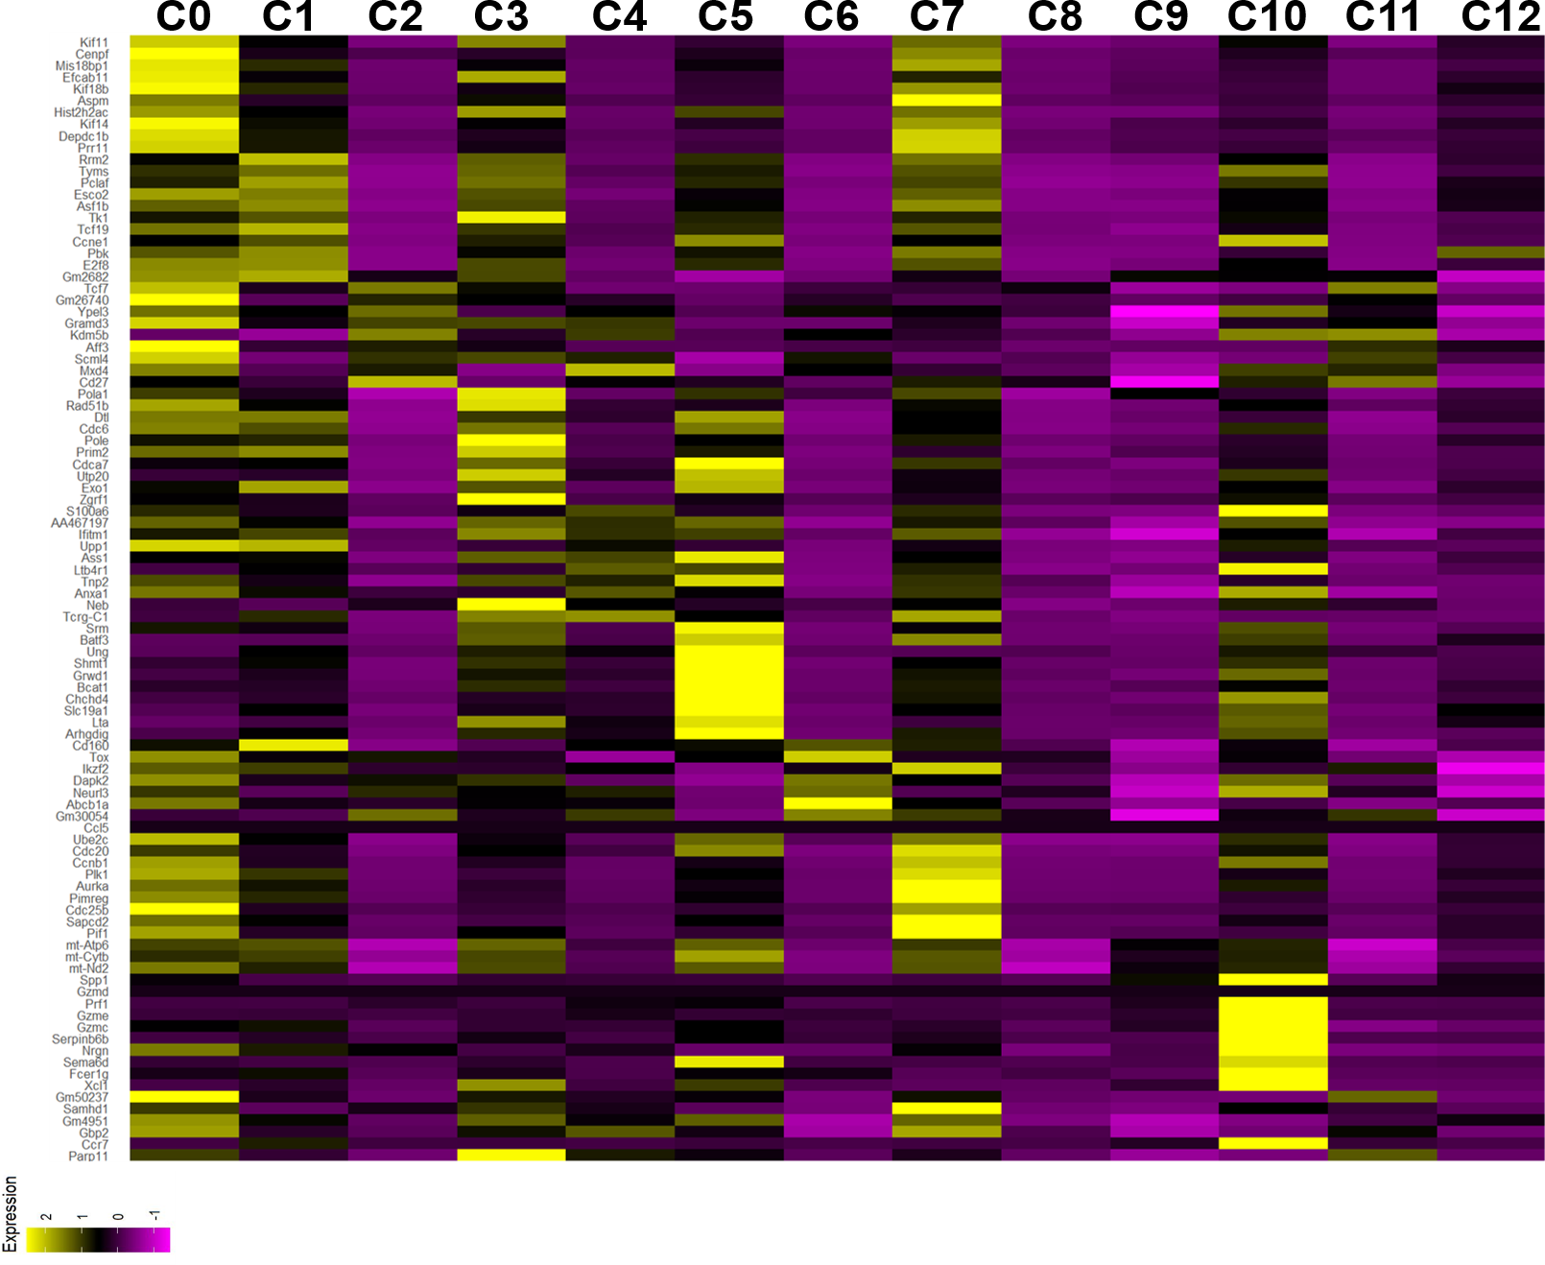
Extended Data Fig. 7. Differentially expressed genes per each cluster of combined Pmel T_{dys} and T_{SL} ACT infusion products. Average expression of top 10 genes per cluster of UMAP analysis of combined Pmel T_{SL} and T_{dys} infusion product scRNA-seq data. Complete list of differentially expressed genes (DEGs) is shown in Supplementary Table 2 (second tab).

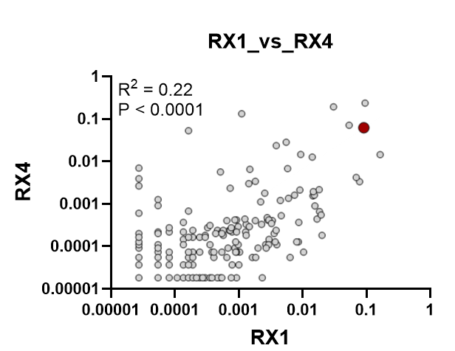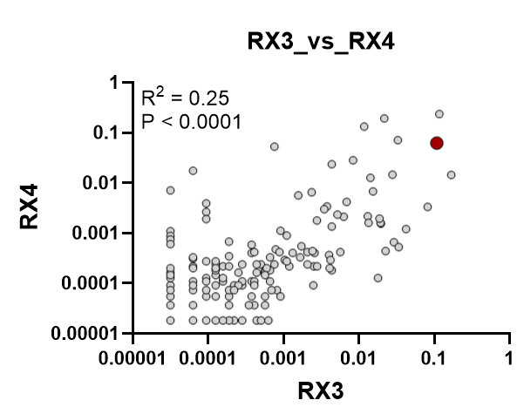

Extended Data Fig.8. CDR3β deep sequencing of human TIL-ACT infusion products administered to metastatic melanoma patient. TCR-deep sequencing between TIL infusions Rx1 and Rx4 (+V), and Rx3 (+V) and Rx4 (+V). TCR-1 recognizing GP100 is shown. TCR-7 was below detection limit. Note that the inclusion of additional TIL-fragments alters the clonal makeup of the original infusion product (Rx1, Rx2) which was then administered as final TIL infusion Rx4.

a
b
c
T_{SL} CD39- CD69- Stemlike Signature
KI67+ Proliferation Signature
T_{dys} CD39+ CD69+ Signature
Extended Data Fig.9. Mapping the phenotype and clonotypes of TIL-ACT + vaccination in a metastatic melanoma patient. a.Stemness and exhaustion genes of interest per each cluster of combined TIL-ACT infusion products (Rx1, and Rx3) administered to metastatic melanoma patient. Full list of DEG per cluster is shown in Supplementary Table 3. b.Gene signatures of TIL-ACT T_{SL} (ref 15), T_{dys} cells (ref 15), and proliferating TIL (ref 64) projected on TIL-ACT UMAP. Cluster 0 marks proliferating TIL, cluster 4 marks dysfunctional TIL, and cluster 9 marks stem-like TIL amplified by vaccine. c. CDR3β deep sequencing of PBL post-ACT shows amplification of the 2 GP100 TCR clones in grey (TCR-1 on left, and TCR-7 on right) after Rx3+vaccination (week 40) and week 120 respectively. Red denotes the frequency in the TIL-infusion product for comparison.

