Design principle for mitigating moisture induced degradation in 2D halide perovskites

Isaac Metcalf^{1,2}*, Shanize Forte³, Jianlin Zhou¹, Claudine Katan⁴, Esther Tsai⁵, Jacky Even⁶ and Aditya D. Mohite^{1,2,3}*

¹Department of Chemical and Biomolecular Engineering, Rice University, Houston, TX 77005, USA.
²Material Science and Nanoengineering, Rice University, Houston, TX 77005, USA.
³Applied Physics Graduate Program, Smalley‐Curl Institute, Rice University, Houston, TX, 77005, USA.
⁴Univ Rennes, ENSCR, CNRS, ISCR-UMR 6226, Rennes F-35000, France.
⁵Center for Functional Nanomaterials, Brookhaven National Laboratory, Upton, NY, USA
⁶Univ Rennes, INSA Rennes, CNRS, Institut FOTON - UMR 6082, Rennes F-35000, France.

Correspondence: iwm2@rice.edu and adm4@rice.edu

Supplementary Tables
Empirical Formula  (m-value) | Space group | Unit cell parameters (T = 300K) |  |  |  |  |  | R₁
Empirical Formula  (m-value) | Space group | a (Å) | b (Å) | c (Å) | α (°) | β (°) | γ (°) | R₁
(MA)₂Pb₂I₆ · 2H₂O  (m=2) | P2₁/m | 10.5743 | 4.6845 | 11.1890 | 90 | 101.12 | 90 | 0.0469
(3A)₂Pb₃I₈ · 2H₂O  (m=3) | I2/m | 11.1888 | 4.6581 | 30.8433 | 90 | 103.77 | 90 | 0.0499
(4A)₂Pb₄I₁₀ · 2H₂O  (m=4) | P2₁/m | 11.1094 | 4.6804 | 18.3515 | 90 | 93.47 | 90 | 0.0482
(5A)₂Pb₄I₁₀ · 2H₂O  (m=4) | P2₁/m | 11.2725 | 4.6498 | 18.8489 | 90 | 93.90 | 90 | 0.0793
(6A)₂Pb5I₁₂ · 2H₂O  (m=5) | I2/m | 11.0711 | 4.6544 | 45.8920 | 90 | 95.51 | 90 | 0.0593
(8A)₂Pb₆I₁₄ · 2H₂O  (m=6) | P2₁/m | 11.1111 | 4.6475 | 27.0964 | 90 | 93.63 | 90 | 0.0563
(2DA)PbI₄ · 2H₂O  (m=1) | I2/m | 10.4634 | 4.7698 | 15.5803 | 90 | 103.91 | 90 | 0.0331
(4DA)Pb₂I₆ · 2H₂O  (m=2) | P2₁/m | 10.8579 | 4.7167 | 10.9808 | 90 | 102.96 | 90 | 0.0471
(6DA)Pb₂I₆ · 1H₂O  (m=2) | P2₁/c | 10.7143 | 4.7651 | 45.5598 | 90 | 90 | 91.89 | 0.0377
(7DA)Pb₃I₈ · 2H₂O  (m=3) | I2/m | 11.1144 | 4.6622 | 30.1210 | 90 | 103.39 | 90 | 0.0809
(9DA)Pb₃I₈ · 1H₂O  (m=3) | Pnma | 11.0309 | 4.6376 | 61.7400 | 90 | 90 | 90 | 0.136
(10DA)Pb₄I₁₀ · 2H₂O  (m=4) | P2₁/m | 11.1510 | 4.6694 | 18.5550 | 90 | 95.48 | 90 | 0.0838
Table S1: Structural parameters of the principal hydrates. The m-value of the Pb_{m}I_{2m+2} ribbon is also indicated.

Empirical Formula  (dim/connectivity) | Space group | Unit cell parameters (T = 300K) |  |  |  |  |  | R₁
Empirical Formula  (dim/connectivity) | Space group | a (Å) | b (Å) | c (Å) | α (°) | β (°) | γ (°) | R₁
(4A)₃PbI₈ · 2H₂O  (1D / e) | Pc2a | 10.9655 | 4.5967 | 30.3983 | 90 | 90 | 90 | N/A
(5A)₆Pb₅I₁₆ ⋅ 4H₂O  (1D / e) | C2/m | 32.3818 | 27.4518 | 4.7415 | 90 | 90 | 96.52 | 0.0610
(2A)PbI₃  (1D / f) | P6₃/mmc | 8.7478 | 8.7478 | 8.1644 | 90 | 90 | 120 | 0.1253
(3DA)Pb₂I₆ · 2H₂O  (1D / e) | P-1 | 4.6205 | 10.9658 | 11.4516 | 79.51 | 88.75 | 89.60 | 0.0658
(3DA)₃Pb₆I₁₈ ⋅ 10H₂O  (1D / e+c) | P2₁/c | 19.5975 | 7.9506 | 21.2807 | 90 | 93.74 | 90 | 0.0539
(3DA)₄Pb₅I₁₈ · 12H₂O  (1D / e) | P-1 | 12.7606 | 9.1505 | 13.2196 | 90 | 96.51 | 90 | 0.0549
(5DA)₂Pb₃I₁₀  (1D / f+e) | P-1 | 8.8400 | 11.1995 | 11.5860 | 113.73 | 101.19 | 107.42 | 0.0385
(7DA)Pb₂I₆  (1D / e) | P2₁/n | 10.9406 | 4.6917 | 22.6848 | 91.02 | 90 | 90 | 0.0660
(FA)₂Pb₂I₆ · 4H₂O  (1D / e) | Pnma | 10.2813 | 4.6244 | 22.6410 | 90 | 90 | 90 | 0.0307
(NH₄)₂Pb₂I₆ · 4H₂O  (1D / e) | Pnma | 10.2713 | 4.6206 | 22.6461 | 90 | 90 | 90 | 0.0352
K₂Pb₂I₆ · 4H₂O  (1D / e) | Pnma | 10.1794 | 4.5856 | 22.5157 | 90 | 90 | 90 | 0.0404
(BZA)₂Pb₃I₈ · 2H₂O  (1D / e) | Fdd2 | 27.7073 | 54.4740 | 4.6265 | 90 | 90 | 90 | 0.0300
(i-4A)₂Pb₂I₆ · 2H₂O  (1D / e) | Pnma | 21.9535 | 4.7185 | 13.2606 | 90 | 90 | 90 | 0.0414
(i-5A)₄Pb₃I₁₀  (2D / f+c) | Pbcn | 21.9759 | 8.6505 | 27.4187 | 90 | 90 | 90 | 0.1402
Table S2: Structural parameters of the transient hydrates and other degradation phases. The dimensionality and connectivity of the PbI₆ octahedral sublattice is also indicated (c = corner-sharing, e = edge-sharing, f = face-sharing).

Empirical Formula (dim/connectivity) | Space group | Unit cell parameters (T = 300K) |  |  |  |  |  | R₁
Empirical Formula (dim/connectivity) | Space group | a (Å) | b (Å) | c (Å) | α (°) | β (°) | γ (°) | R₁
(MA)₄PbI₆ · 2H₂O  (0D / NA) | P2₁/n | 10.4720 | 11.3622 | 10.7036 | 90 | 91.75 | 90 | 0.0362
(2A)₁₃Pb₆I₂₅  (1D / c+f) | P-1 | 8.9246 | 25.1004 | 25.9634 | 108.48 | 92.12 | 90.3 | 0.2531
(3A)₆PbI₈  (0D / NA) | I2/a | 10.8879 | 30.1884 | 14.6122 | 90 | 108.03 | 90 | 0.0463
(5A)₆PbI₈  (0D / NA) | P2₁/c | 11.0257 | 16.8859 | 31.9200 | 90 | 91.89 | 90 | 0.1163
(6A)₁₀PbI₁₂  (0D / NA) | P2₁/c | 18.2567 | 17.5724 | 17.5779 | 90 | 104.17 | 90 | 0.3031
(3DA)PbI₄ · H₂O  (2D / c+e) | P2₁/n | 8.1266 | 11.7446 | 20.3696 | 103.23 | 95.52 | 96.47 | 0.0583
(5DA)₂PbI₆ · H₂O  (1D / c) | P2₁/n | 18.4515 | 8.9441 | 18.4680 | 90 | 109.75 | 90 | 0.0628
(6DA)₅Pb₂I₁₄ · 2H₂O  (0D / c) | P-1 | 14.7446 | 16.6429 | 16.8268 | 78.48 | 64.19 | 88.86 | 0.0480
(7DA)₃Pb₂I₁₀  (0D / f) | P-1 | 11.7002 | 12.0382 | 14.0420 | 67.80 | 71.12 | 86.87 | 0.0643
(7DA)₃PbI₈  (0D / NA) | I2/a | 10.9687 | 30.6024 | 14.1033 | 90 | 109.85 | 90 | 0.0431
(8DA)₃PbI₈  (0D / NA) | I2/a | 10.9515 | 30.0566 | 15.1139 | 90 | 107.65 | 90 | 0.0522
(9DA)₃PbI₈  (0D / NA) | I2/a | 11.0048 | 31.3800 | 15.6900 | 90 | 108.61 | 90 | 0.1529
(FA)₂PbI₄  (2D / c) | P2 | 6.3495 | 8.9397 | 26.9327 | 90 | 92.96 | 90 | 0.1568
(FA)₃PbI₅  (1D / c) | P4/nmm | 12.6508 | 12.6508 | 6.3234 | 90 | 90 | 90 | 0.0292
(i-5A)₆PbI₈  (0D / NA) | P-1 | 11.3391 | 16.3664 | 17.9748 | 108.34 | 100.70 | 104.01 | 0.0730
(MA)₂(4A)₄PbI₈  (0D / NA) | P2₁/c | 10.9420 | 16.6575 | 25.3761 | 90 | 92.80 | 90 | 0.0435
(FA)(4A)PbI₄  (1D / c+f) | P2₁/c | 15.2523 | 19.8665 | 14.2873 | 90 | 91.07 | 90 | 0.1093
Table S3: Structural parameters of the perovskitoid phases with high A’ concentration. The dimensionality and connectivity of the PbI₆ octahedral sublattice is also indicated (c = corner-sharing, e = edge-sharing, f = face-sharing).

Empirical Formula  (m-value) | Space group | Unit cell parameters (T = 300K) |  |  |  |  |  | R₁
Empirical Formula  (m-value) | Space group | a (Å) | b (Å) | c (Å) | α (°) | β (°) | γ (°) | R₁
(MA)(2A) Pb₂I₆ · 2H₂O  (m=4) | P2₁/m | 10.6318 | 4.6776 | 11.5249 | 90 | 102.34 | 90 | 0.0378
(MA)(4A) Pb₃I₈ · 2H₂O  (m=3) | I2/m | 10.9183 | 4.6487 | 30.3048 | 90 | 104.49 | 90 | 0.0406
(MA)(5A) Pb₃I₈ · 2H₂O  (m=3) | I2/m | 10.9573 | 4.6526 | 30.7897 | 90 | 103.29 | 90 | 0.0475
(MA)(6A) Pb₃I₈ · 2H₂O  (m=3) | I2/m | 10.9796 | 4.6447 | 31.2466 | 90 | 102.39 | 90 | 0.0604
(MA)(7A) Pb₄I₁₀ · 2H₂O  (m=4) | P2₁/m | 11.0533 | 4.6327 | 18.6185 | 90 | 94.00 | 90 | 0.0528
(MA)(8A) Pb₄I₁₀ · 2H₂O  (m=4) | P2₁/m | 11.0042 | 4.6208 | 18.8840 | 90 | 94.99 | 90 | 0.0876
Table S4: Structural parameters of the mixed MA-A’ hydrates. The m-value of the Pb_{m}I_{2m+2} ribbon is also indicated.

Empirical formula | Recipe
(MA)₂Pb₂I₆ · 2H₂O | 100mg MAI + 50mg PbI₂ + 500µL HI + 1000µL H₂O
(3A)₂Pb₃I₈ · 2H₂O | 75mg 3AI + 50mg PbI₂ + 500µL HI + 1000µL H₂O
(4A)₂Pb₄I₁₀ · 2H₂O | 50mg 4AI + 50mg PbI₂ + 500µL HI + 1000µL H₂O
(5A)₂Pb₄I₁₀ · 2H₂O | 50mg 5AI + 75mg PbI₂ + 500µL HI + 1000µL H₂O
(6A)₂Pb5I₁₂ · 2H₂O | 24mg 6AI + 55mg PbI₂ + 175µL HI + 1000µL H₂O
(8A)₂Pb₆I₁₄ · 2H₂O | 24mg 8AI + 55mg PbI₂ + 175µL HI + 1000µL H₂O
(2DA)PbI₄ · 2H₂O | 250mg EDAI₂ + 100mgPbI₂ + 100 µL H₂O
(4DA)Pb₂I₆ · 2H₂O | 25mg 4DAI₂ + 50mg PbI₂ + 1000 µL HI + 1000µL H₂O
(6DA)Pb₂I₆ · 1H₂O | 25mg 6DAI₂ + 50mg PbI₂ + 1000 µL HI + 1000µL H₂O
(7DA)Pb₃I₈ · 2H₂O | 25mg 7DAI₂ + 50mg PbI₂ + 1000 µL HI + 1000µL H₂O
(9DA)Pb₃I₈ · 1H₂O | 25mg 9DAI₂ + 50mg PbI₂ + 1000 µL HI + 1000µL H₂O
(10DA)Pb₄I₁₀ · 2H₂O | 25mg 10DAI₂ + 50mg PbI₂ + 1000 µL HI + 1000µL H₂O
Table S5: Recipes for the principal hydrates. Solutions were stirred at 150ºC for 1-2 hours, then kept at room temperature.

Empirical formula | Recipe
(5A)₆Pb₅I₁₆ ⋅ 4H₂O | 50mg 5AI + 50mg PbI₂ + 500µL HI + 1000µL H₂O
(2A)PbI₃ | 150mg 2AI + 100mg PbI₂ + 500µL HI+1000µL H₂O
(3DA)Pb₂I₆ · 2H₂O | 50mg 3DAI₂ + 100mg PbI₂ + 1000µL HI + 1500µL H₂O
(3DA)₃Pb₆I₁₈ ⋅ 10H₂O | 50mg 3DAI₂ + 100mg PbI₂ + 1000µL HI + 1500µL H₂O
(3DA)₄Pb₅I₁₈ · 12H₂O | 200mg 3DAI₂ + 100mg PbI₂ + 100µL H₂O (white crystal)
(5DA)₂Pb₃I₁₀ | 25mg 5DAI₂ + 50mg PbI₂ + 1000 µL HI + 1000µL H₂O
(7DA)Pb₂I₆ | 25mg 7DAI₂ + 50mg PbI₂ + 1000 µL HI + 1000µL H₂O
(FA)₂Pb₂I₆ · 4H₂O | 250mg FAI + 100mg PbI₂ + 200µL H₂O
(NH₄)₂Pb₂I₆ · 4H₂O | 250mg NH₄I + 100mg PbI₂ + 100µL H₂O
K₂Pb₂I₆ · 4H₂O | 200mg KI + 50mg PbI₂ + 100µL H₂O
(BZA)₂Pb₃I₈ · 2H₂O | 24mg BZAI + 55mg PbI₂ + 175µL HI + 1000µL H₂O
(i-4A)₂Pb₂I₆ · 2H₂O | 50mg i-4AI + 55mg PbI₂ + 250µL HI + 1000µL H₂O
(i-5A)₄Pb₃I₁₀ | 50mg i-5AI + 50mg PbI₂ + 500µL HI + 1000µL H₂O
Table S6: Recipes for the transient hydrates and other degradation phases. Solutions were stirred at 150ºC for 1-2 hours, then kept at room temperature.

Empirical formula | Recipe
(MA)₄PbI₆ · 2H₂O | 500mg MAI + 100mg PbI₂ + 200µL H₂O
(2A)₁₃Pb₆I₂₅ | 500mg 2AI + 200mg PbI₂ + 100µL H₂O
(3A)₆PbI₈ | 500mg 3AI + 50mg PbI₂ + 150µL H₂O
(4A)₆PbI₈ | 500mg 4AI + 50mg PbI₂ + 100µL H₂O
(5A)₆PbI₈ | 500mg 5AI + 50mg PbI₂ + 100µL H₂O
(6A)₁₀PbI₁₂ | 500mg 6AI + 20mg PbI₂ + 75µL H₂O
(3DA)PbI₄ · H₂O | 200mg 3DAI₂ + 100mg PbI₂ + 100µL H₂O (yellow crystal)
(5DA)₂PbI₆ · H₂O | 200mg 5DAI₂ + 25mg PbI₂ + 100µL H₂O
(6DA)₅Pb₂I₁₄ · 2H₂O | 300mg 6DAI₂ + 15mg PbI₂ + 100µL H₂O
(7DA)₃Pb₂I₁₀ | 150mg 7DAI₂ + 20mg PbI₂ + 100µL H₂O
(7DA)₃PbI₈ | 150mg 7DAI₂ + 20mg PbI₂ + 100µL H₂O
(8DA)₃PbI₈ | 150mg 8DAI₂ + 20mg PbI₂ + 100µL H₂O
(9DA)₃PbI₈ | 150mg 9DAI₂ + 20mg PbI₂ + 100µL H₂O
(FA)₂PbI₄ | 500mg FAI + 100mg PbI₂ + 200µL H₂O
(FA)₃PbI₅ | 500mg FAI + 50mg PbI₂ + 150µL H₂O
(i-5A)₆PbI₈ | 500mg i-5AI + 20mg PbI₂ + 100µL H₂O
(FA)(4A)PbI₄ | 180mg FAI + 200mg 4AI + 60mg PbI₂ + 100µL H₂O
Table S7: Recipes for the perovskitoid phases with high A’ concentration. Solutions were stirred at 165ºC for 1-2 hours, then kept at room temperature.

Empirical Formula | Recipe
(MA)(2A) Pb₂I₆ · 2H₂O | 50mg 2AI + 50mg MAI + 50mg PbI₂ + 500µL HI + 1000µL H₂O
(MA)(4A) Pb₃I₈ · 2H₂O | 40mg 4AI + 50mg MAI + 50mg PbI₂ + 250µL HI + 1000µL H₂O
(MA)(5A) Pb₃I₈ · 2H₂O | 40mg 5AI + 50mg MAI + 50mg PbI₂ + 250µL HI + 1000µL H₂O
(MA)(6A) Pb₃I₈ · 2H₂O | 10mg 6AI + 50mg MAI + 50mg PbI₂ + 250µL HI + 1000µL H₂O
(MA)(7A) Pb₄I₁₀ · 2H₂O | 20mg 7AI + 50mg MAI + 50mg PbI₂ + 250µL HI + 1000µL H₂O
(MA)(8A) Pb₄I₁₀ · 2H₂O | 10mg 8AI + 50mg MAI + 50mg PbI₂ + 250µL HI + 1000µL H₂O
Table S8: Recipes for the mixed MA-A’ hydrates. Solutions were stirred at 150ºC for 1-2 hours, then kept at room temperature.

Iodide salt | Mass salt (mg) | Vol. H₂O (µL) | Solubility (g/mL) | Mol. Frac salt (%)
MAI | 1457 | 650 (±10) | 2.24 (±0.04) | 20.2 (±0.3)
3AI | 1642 | 390 (±10) | 4.21 (±0.11) | 28.8 (±0.5)
4AI | 1760 | 180 (±10) | 9.78 (±0.58) | 46.7 (±1.4)
5AI | 1212 | 130 (±10) | 9.32 (±0.78) | 43.8 (±2.0)
6AI | 1542 | 190 (±10) | 8.12 (±0.45) | 38.9 (±1.3)
8AI | 1000 | 110 (±10) | 9.09 (±0.91) | 38.9 (±2.3)
FAI | 902 | 340 (±10) | 2.65 (±0.08) | 21.7 (±0.5)
CsI | 1000 | 1000 (±50) | 1.00 (±0.05) | 6.5 (±0.3)
3DAI₂ | 527 | 220 (±20) | 2.40 (±0.24) | 11.6 (±1.0)
4DAI₂ | 1443 | 940 (±20) | 1.54 (±0.03) | 7.4 (±0.1)
7DAI₂ | 342 | 160 (±20) | 2.14 (±0.31) | 9.1 (±1.2)
i-4AI | 1962 | 350 (±10) | 5.61 (±0.16) | 33.4 (±0.6)
i-5AI | 1000 | 270 (±10) | 3.70 (±0.14) | 23.7 (±0.7)
Table S9: Solubility of iodide salts in water. Each salt was added to a 20mL vial containing hexane (in which all salts were insoluble) to prevent water evaporation. The solution was stirred at room temperature, and water was added in increments until no visible precipitate remained. The error bars on the volume of water correspond to the final volume added before full dissolution. Mole fraction of salt at the saturation concentration is calculated as $\frac{moles salt}{moles salt+moles H2O}×100$, and sets the boundary between solid and liquid phases on the A’I – H₂O axis of the phase diagram.

Supplementary Figures

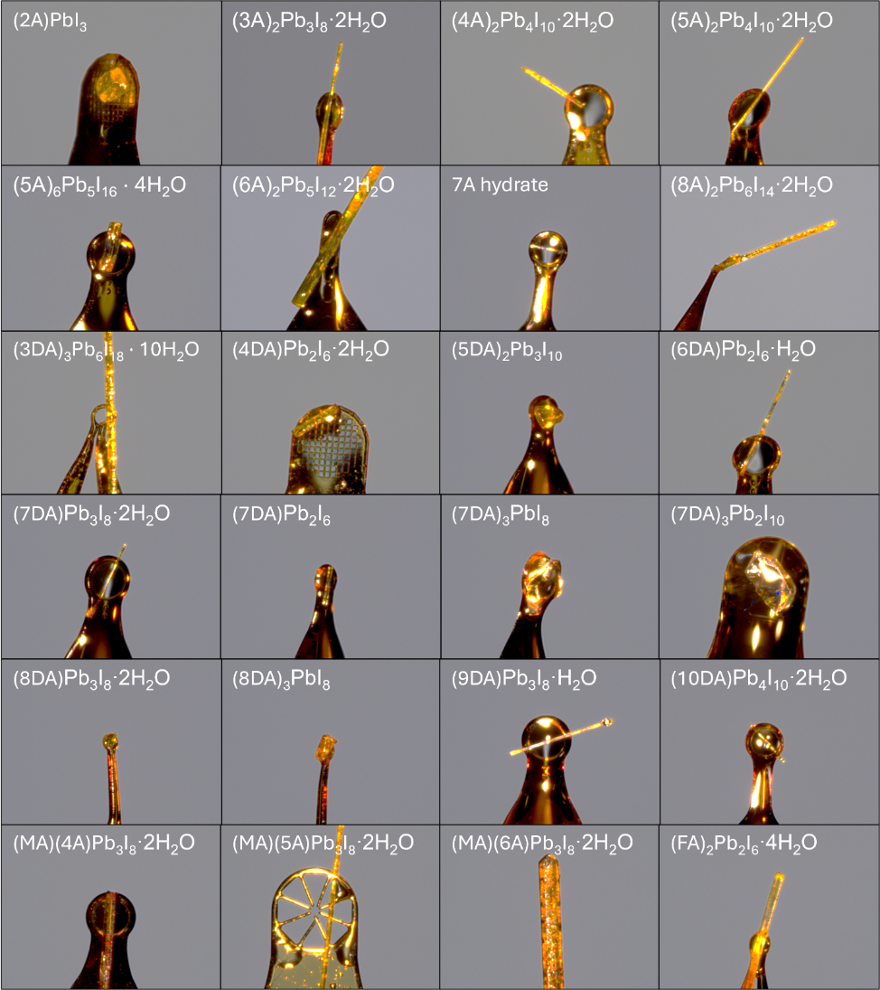
Figure S1: Crystals of hydrates and other phases characterized via single-crystal XRD. Each image is 1.2mm across.
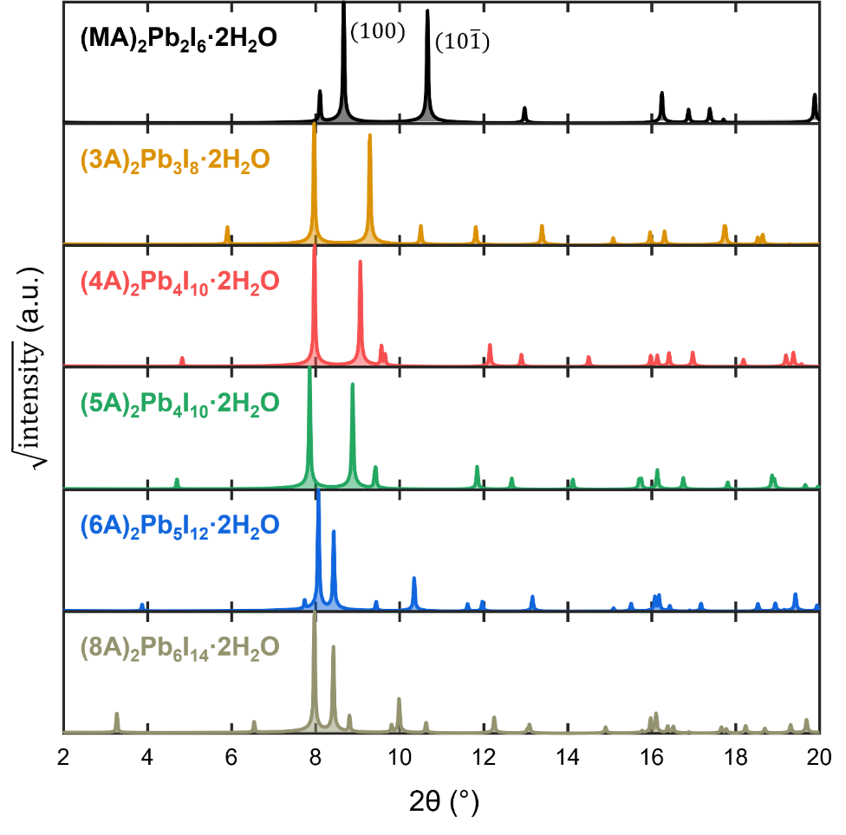
Figure S2: Simulated 1D XRD of the linear alkylammonium hydrate phases

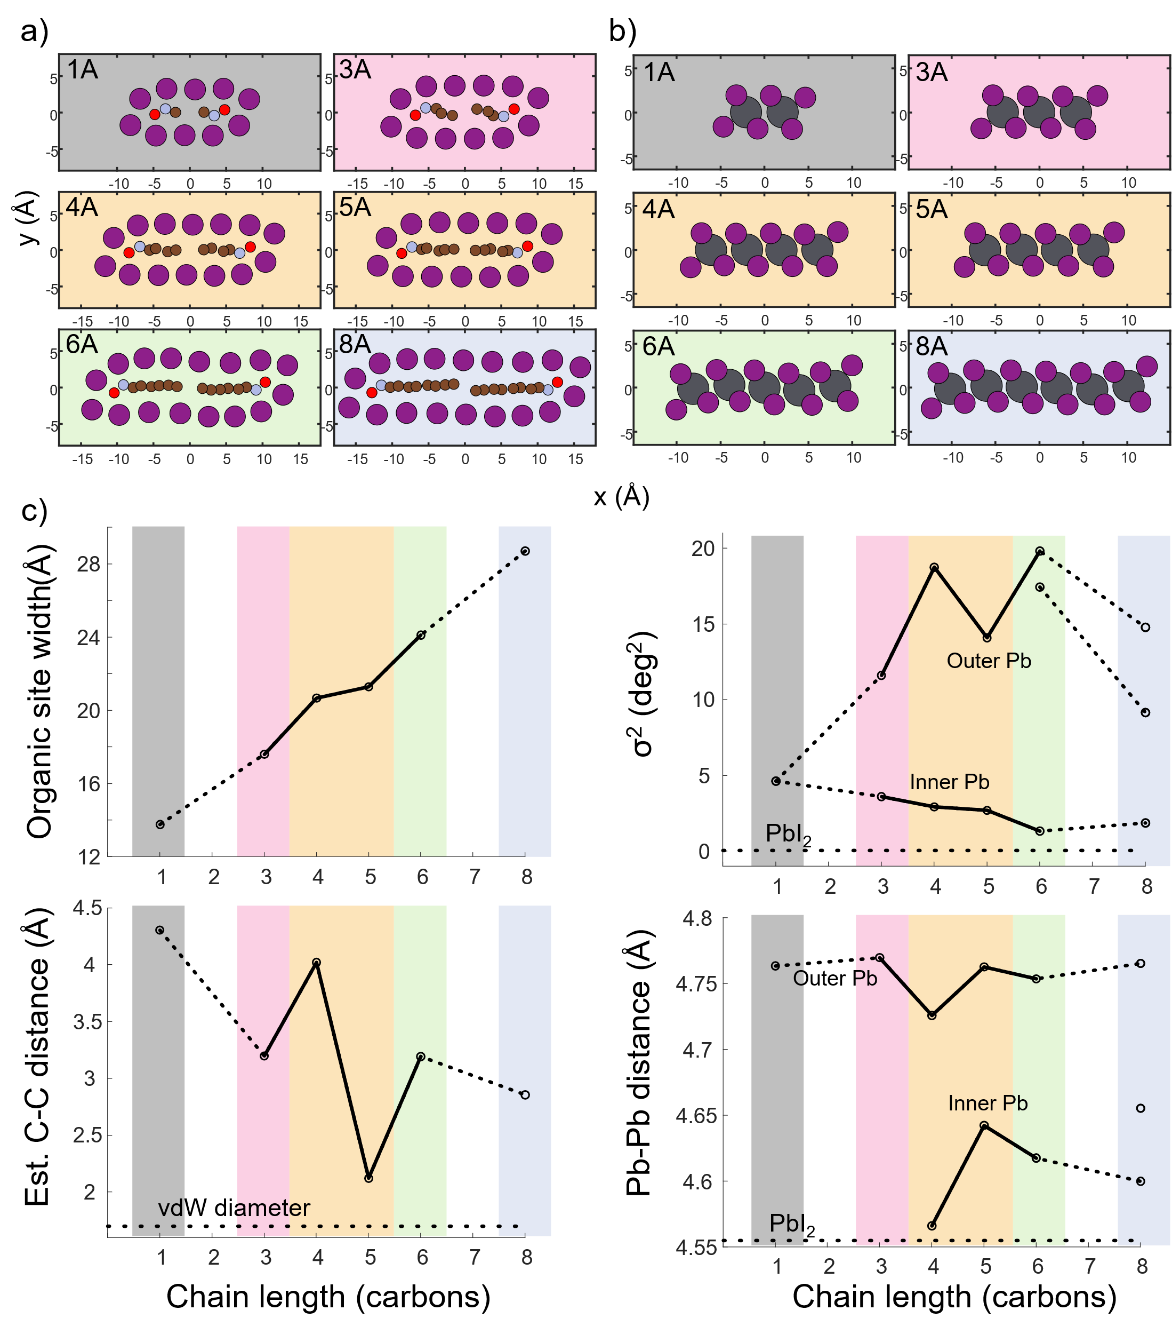
Figure S3: Structural parameters of the RP hydrate phases’ unit cells. a) Atomic positions of the organic site, showing the organic cations and the boundary of I⁻ anions. Atoms are color-coded: Gray=lead, Purple=iodine, red=oxygen (H₂O), blue=nitrogen (NH₃), brown: carbon (CH₂). The background color denotes ribbon length. Grey: m=2. Pink: m=3. Orange: m=4. Green: m=5. Blue: m=6. b) Atomic positions of the Pb-I ribbon. c) Structural parameters vs chain length for each hydrate. Top left: Organic site width measured as the (x,y) distance between the leftmost top iodide and the rightmost top iodide on adjacent ribbons. Width increases noticeably for increasing m-value, and increases more conservatively for increased spacer cation length at constant m-value. Bottom left: Estimated terminal carbon-carbon distance between opposite organic cations in the organic site, measured as the (x,y,z) distance between opposing N atoms minus twice the predicted ammonium length. Distance increases with m-value, and decreases with increased cation length at constant m-value. The dotted line shows the van der Waals diameter of carbon. Top right: Bond angle variance 𝜎² for each of the octahedra in the Pb-I ribbon. The dotted line shows the 𝜎² of octahedra in PbI₂. Bottom right: Pb-Pb interatomic distance across the ribbon. Terminal (outer) Pb show higher spacing than inner Pb. The dotted line shows the Pb-Pb distance in PbI₂. The 4A hydrate has a markedly shorter Pb-Pb distance than its neighboring hydrates.

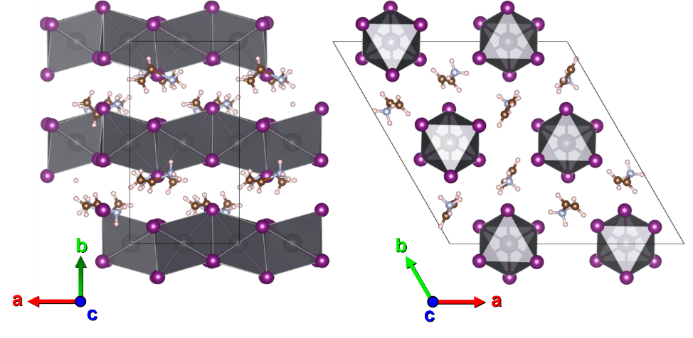
Figure S4: The structure of the 2A nonperovskite phase, (2A)PbI₃. 2A does not form a ribbon-like hydrate phase because its length is incompatible with the organic sites of hydrates with m-value two or three.

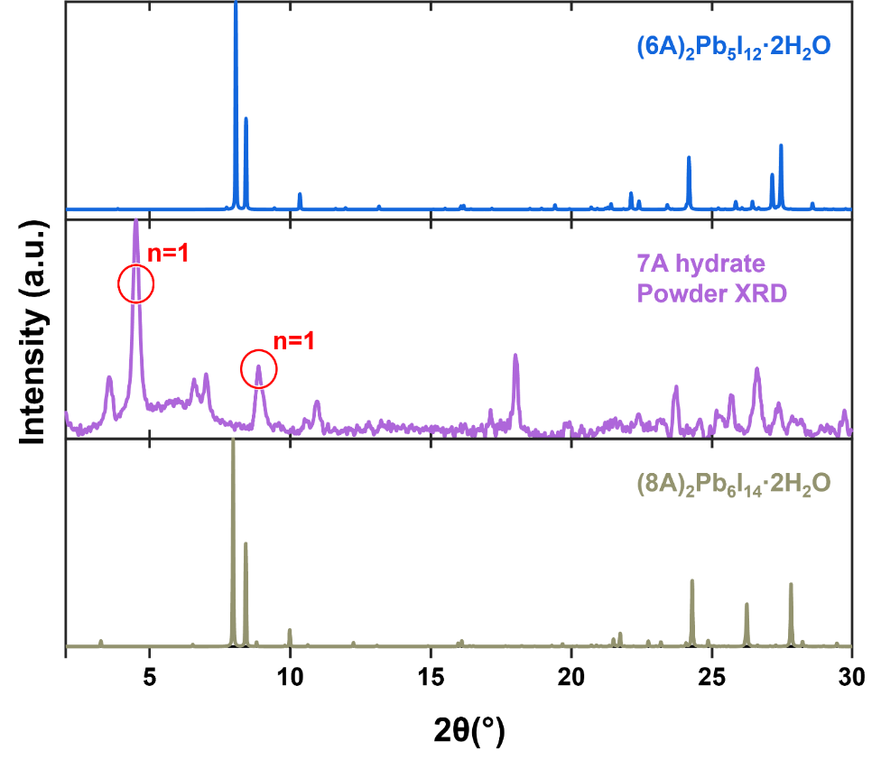
Figure S5: The unidentified 7A hydrate phase. (Top) simulated XRD pattern of 6A principal hydrate, (middle) collected powder XRD pattern of 7A hydrate (a mixture of hydrate phase and n=1 2D perovskite), and (bottom) simulated XRD pattern of 8A principal hydrate. The 7A hydrate XRD pattern does not show the strong (100) and (10-1) peaks around 8° shared by the other linear alkylammonium principal hydrates.

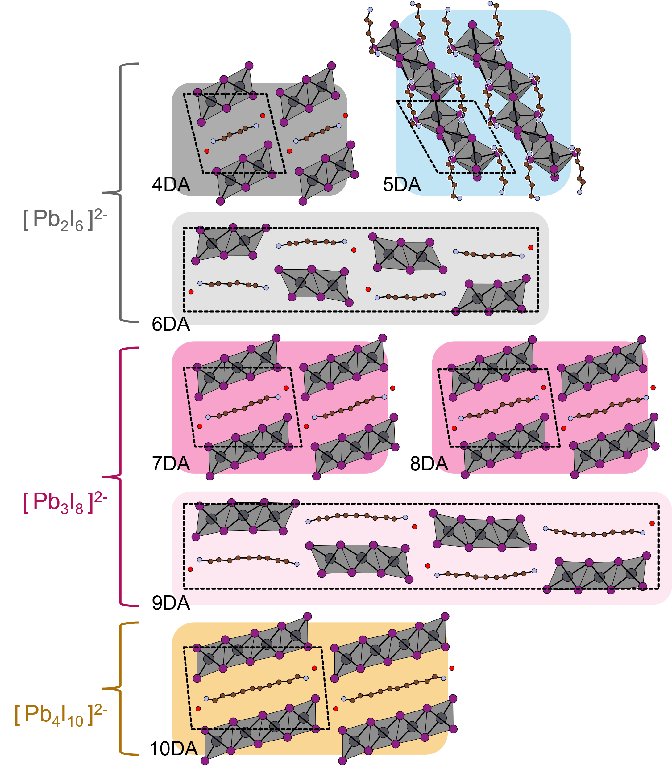
Figure S6: The crystal structures of principal DJ-type perovskite hydrates with linear alkyldiammonium spacer cations. Two alternating monoclinic structures are observed: a dihydrate phase for cations the right size to bridge across a Pb-I ribbon (4DA, 7DA, 8DA, 10DA), and a monohydrate phase for cations slightly too long to fit (6DA, 9DA). The 5DA cation cannot stabilize any ribbon length of either type and forms a unique nonhydrate phase upon water exposure. 2DA likewise forms a principal hydrate with m=1, but it does not form a DJ perovskite phase.
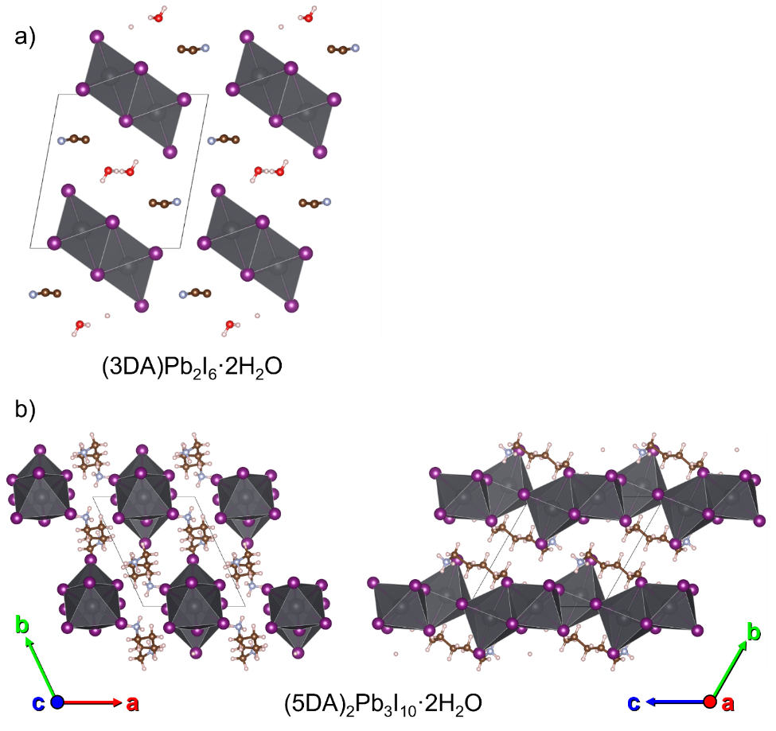
S7: a) The structure of the 3DA hydrate phase, (3DA)Pb₂I₆·2H₂O (1D, edge-sharing). b) The structure of the 5DA degradation phase, (5DA)₂Pb₃I₁₀, shown along two crystallographic axes (1D, face+edge-sharing).

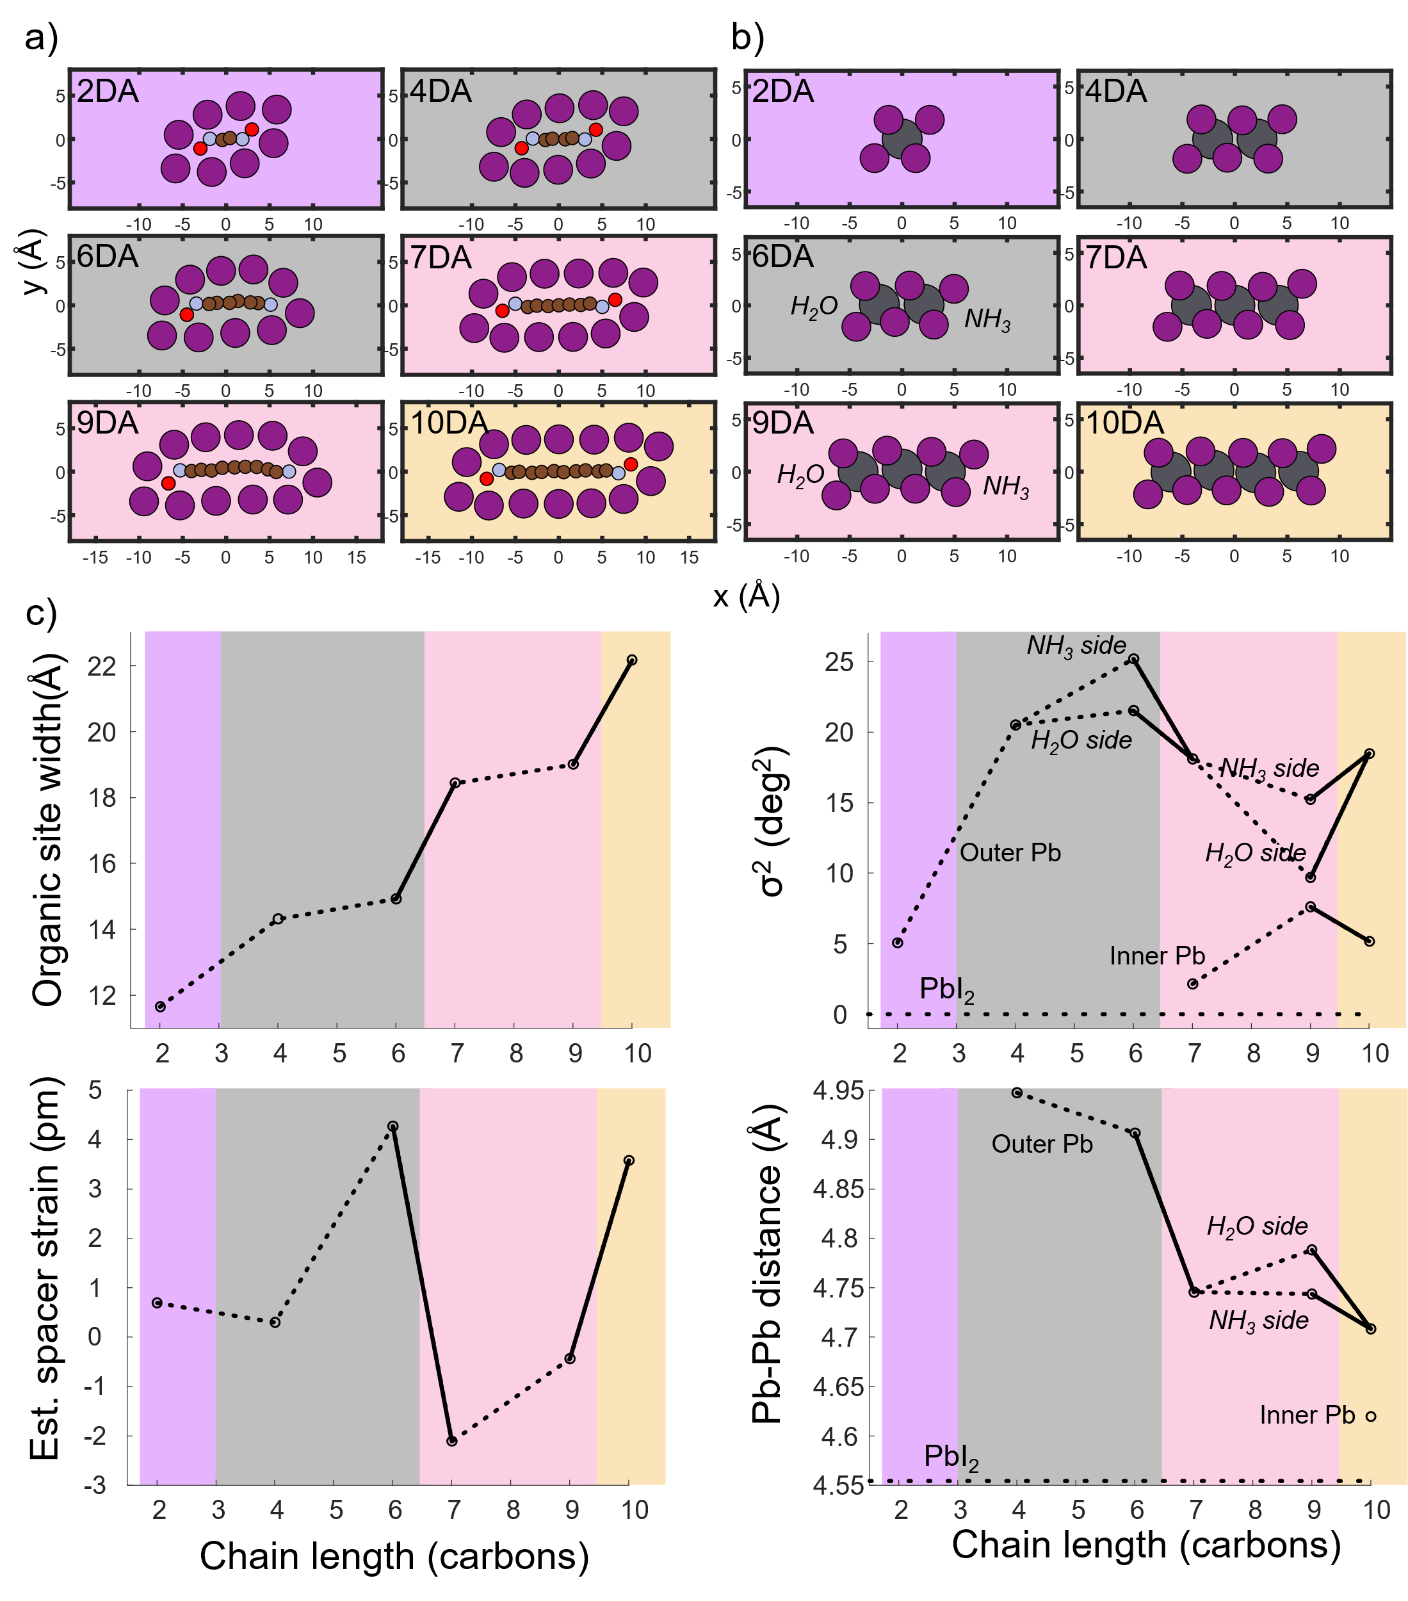
Figure S8: Structural parameters of the DJ hydrate phases’ unit cells. a) Atomic positions of the organic site, showing the organic cations and the boundary of I⁻ anions. Atoms are color-coded: Gray=lead, Purple=iodine, red=oxygen (H₂O), blue=nitrogen (NH₃), brown: carbon (CH₂). The background color denotes ribbon length. Purple: m=1. Grey: m=2. Pink: m=3. Orange: m=4. b) Atomic positions of the Pb-I ribbon. c) Structural parameters vs chain length for each hydrate. Top left: Organic site width measured as the average (x,y) distance between the opposing leftmost and rightmost iodides on adjacent ribbons. Width increases noticeably for increasing m-value, and very slightly increases for increased spacer cation length at constant m-value. Bottom left: Estimated strain of the spacer cation in pm, measured as the observed minus the predicted spacer cation length. Compared to two RP cations, a single DJ cation has much less capacity to change its length. Top right: Bond angle variance 𝜎² for each of the octahedra in the Pb-I ribbon. The dotted line shows the 𝜎² of octahedra in PbI₂. Bottom right: Pb-Pb interatomic distance across the ribbon. Terminal (outer) Pb show higher spacing than inner Pb. The dotted line shows the Pb-Pb distance in PbI₂. The DJ hydrates, in particular those of ribbon length 2, show significantly higher Pb-Pb spacing compared to the RP hydrates.

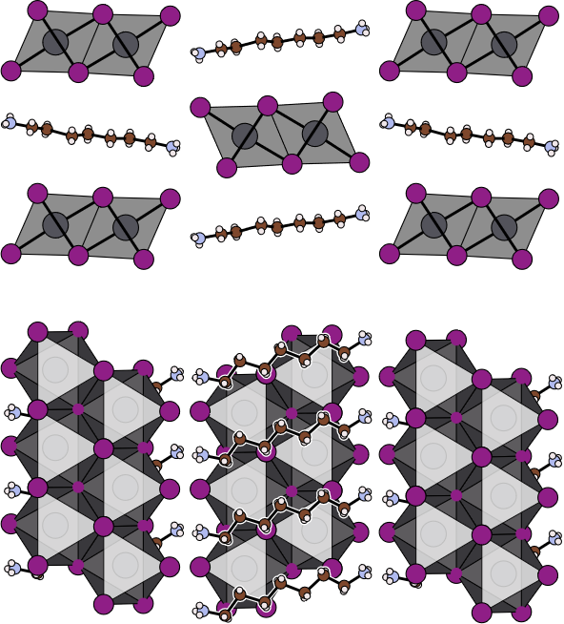
Figure S9: The crystal structure of the nonhydrate phase (7DA)Pb₂I₆, which adopts a similar ribbon-like structure to the hydrate phases. Top: In-plane view. Bottom: Down-axis view. In this case the ribbons tilt in alternating directions with no down-axis offset between adjacent ribbons.

Figure S10: 1D XRD of the powder collected upon introducing 100mg of 2D n=1 perovskite to 1mL of liquid water. RP-type alkylammonium perovskites form PbI₂ for shorter chain cations and the 2D phase for longer chain cations, with 7A forming a hydrate as the transitional case. DJ-type alkyldiammonium perovskites universally form the hydrate phase with the exception of 5DA, which forms PbI₂. The behavior of 5DA is related to the cation’s lack of an associated hydrate structure.

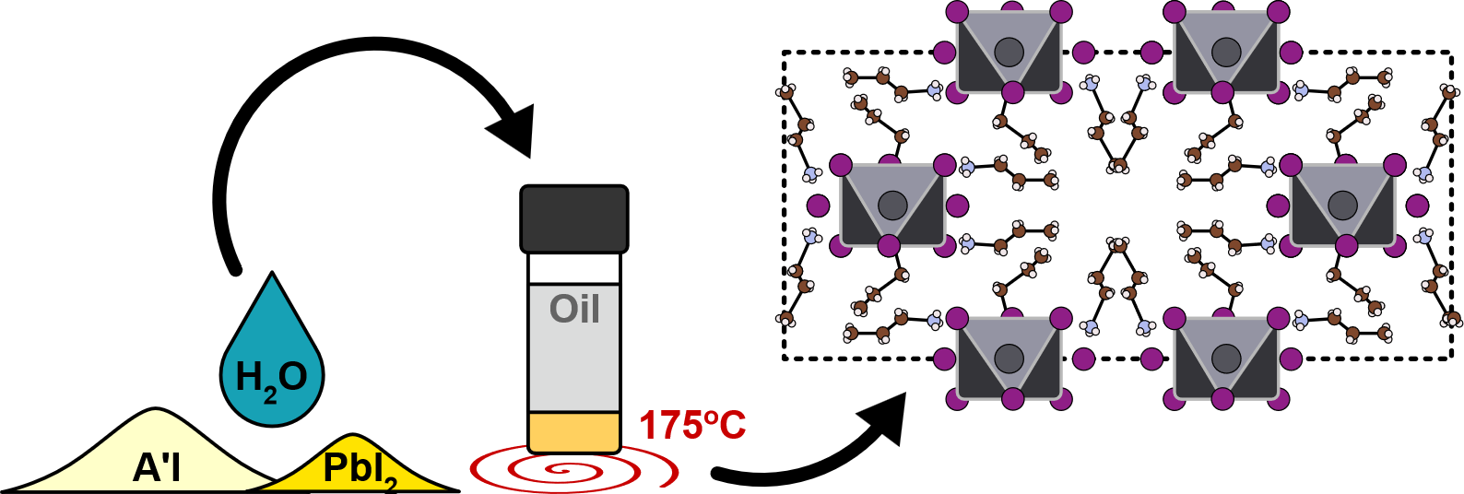

Figure S11: The synthesis procedure for growing perovskitoid phases with high [A’]. A’I is added to H₂O near its saturation limit, where it acts as a solvent for a small amount of PbI₂. The solution is heated to 175ºC with an overlayer of mineral oil to minimize water evaporation within the vial. Once the solution is dissolved the hot plate is turned off and the solution is allowed to cool to room temperature over ~1 hour, yielding mm-scale perovskitoid crystals.

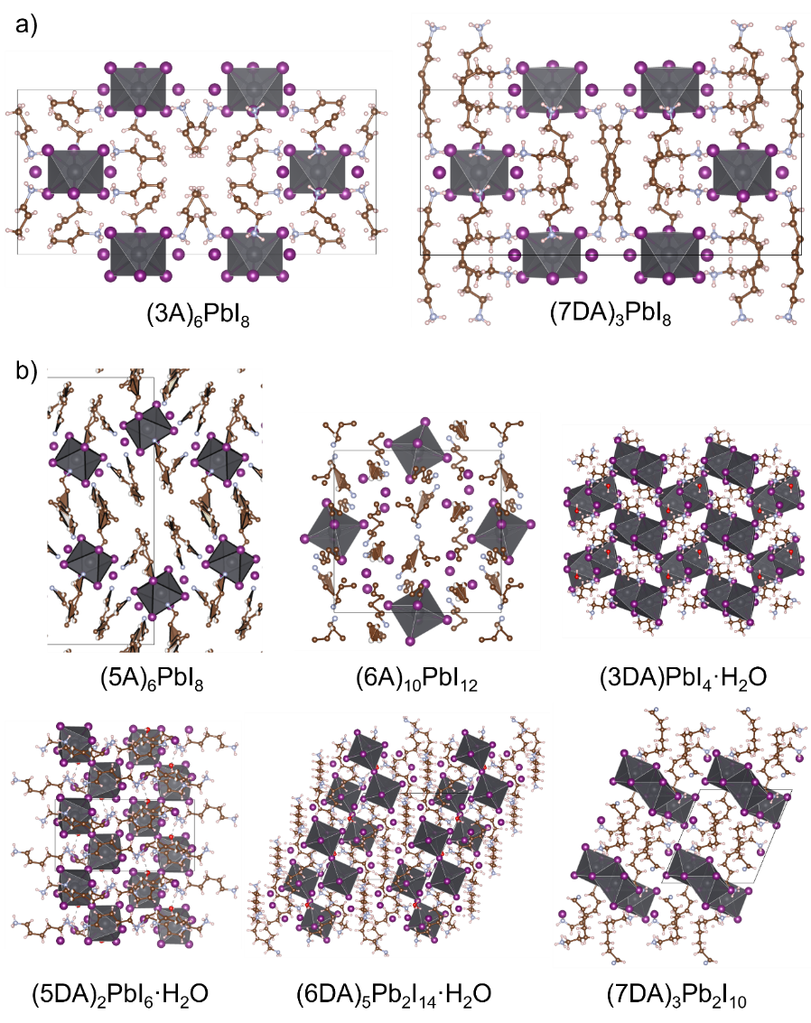
Figure S12: Structures of other A’-rich phases. a) The 0D phases 3A₆PbI₈ (left) and 7DA₆PbI₈. 3A, 7DA, 8DA, and 9DA all adopt similar 0D structures. b) The 0D phases of other spacer cations: (5A)₆PbI₈ (0D, similar to 4A), (6A)₁₀PbI₁₂ (0D), (3DA)PbI₄·H₂O (2D, edge+corner-sharing), (5DA)₂PbI₆·H₂O (1D, corner-sharing), (6DA)₅Pb₂I₁₄·H₂O (0D, corner-sharing), and (7DA)₃Pb₂I₁₀ (0D, face-sharing).
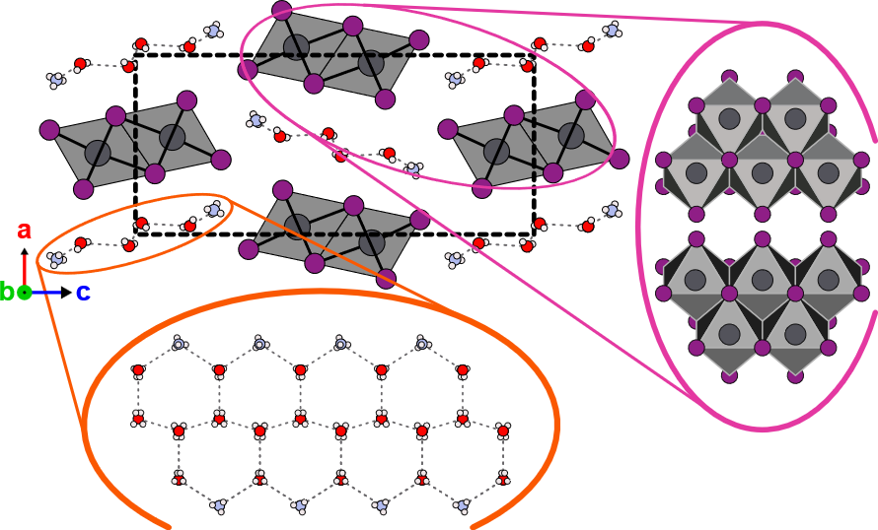

Figure S13: The structure of the ammonium hydrate, (NH₄)₂Pb₂I₆ · 4H₂O. H₂O and NH₄ form a honeycomb-like quasi-1D lattice in the out of plane direction (bottom pull-out view). This 1D structure is reminiscent of the crystal structure of 3D ice. The H₂O molecules at the extrema of the organic site are substituted with NH₄ cations for charge compensation. The Pb-I ribbon tilts such that the structure adopts an orthorhombic Pnma space group, with no b-axis offset between adjacent ribbons (side pull-out view). The hydrate phases FA₂Pb₂I₆ · 4H₂O and K₂Pb₂I₆ · 4H₂O adopt a nearly identical structure.

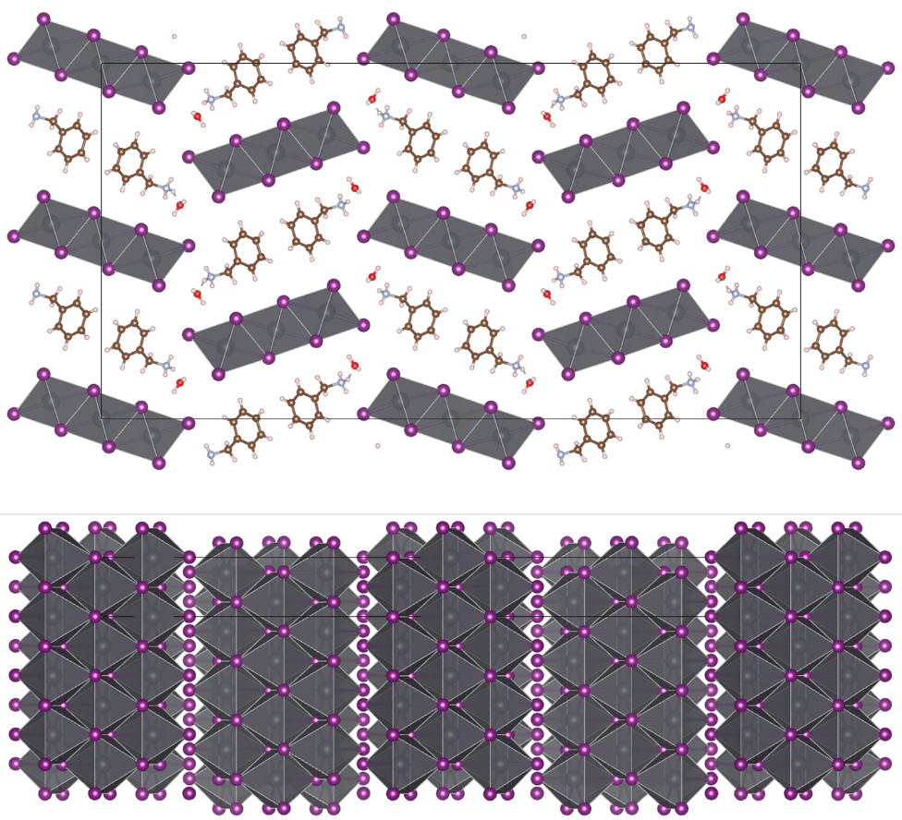
Figure S14: The crystal structure of the BZA perovskite hydrate phase, (BZA)₂Pb₃I₈ · 2H₂O, along two crystallographic axes. In this case the ribbons show the opposite tilting of (7DA)Pb₂I₆. The structure adopts an F2dd space group with a b/4 offset between adjacent ribbons.

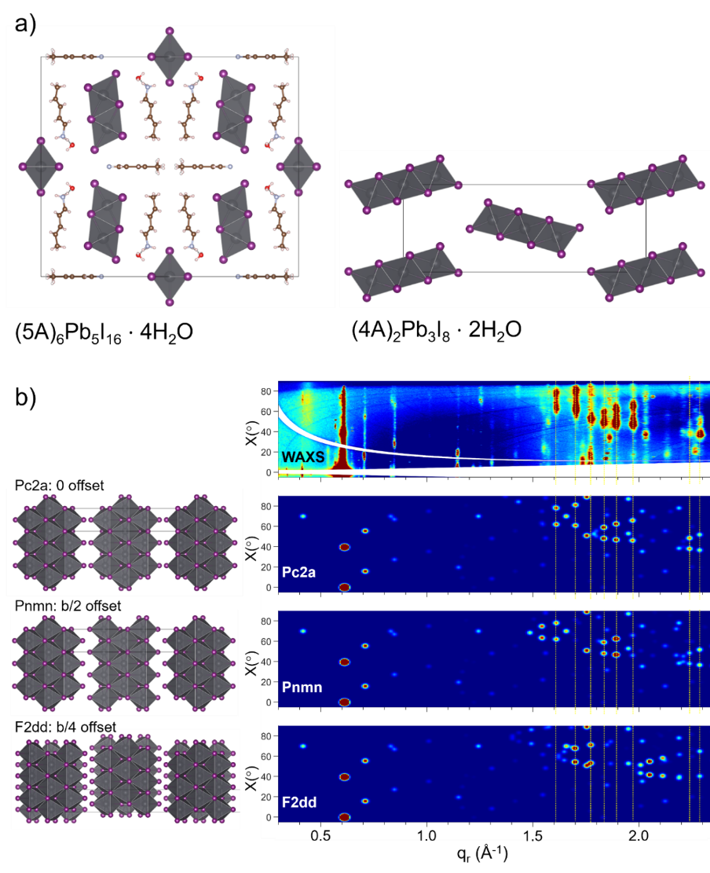
Figure S15: The transient hydrates of 5A and 4A. a) The 5A transient hydrate (5A)₆Pb₅I₁₆⋅4H₂O (left) and the inorganic sublattice of the 4A transient hydrate (4A)₂Pb₃I₈⋅2H₂O. The 4A transient hydrate was identified through in-situ WAXS and as-such the positions of the spacer cations could not be resolved, although they likely resemble those of the BZA hydrate. b) The collected WAXS pattern of the 4A transient hydrate shown in polar coordinates (top) and the simulated WAXS patterns of potential space groups compatible with the measured unit cell (bottom). The Pc2a space group best aligns with the collected WAXS pattern.
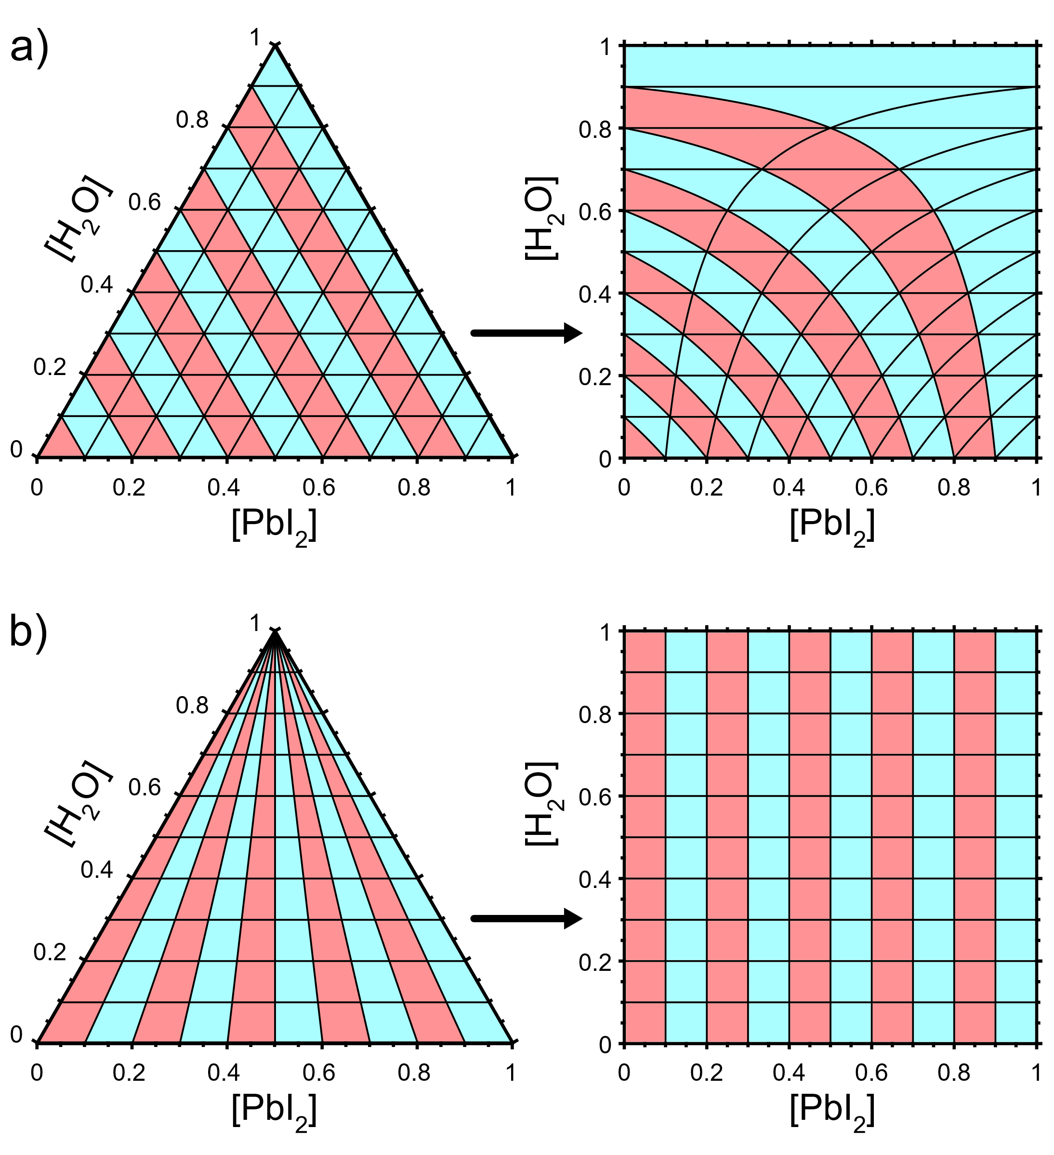
Figure S16: Side-by-side comparison of ternary and pseudo-binary plots. a) Lines from the A’I – PbI₂ axis to the H₂O axes on the ternary plot appear as curves on the pseudo-binary plot. b) Lines from the A’I – PbI₂ axis to the H₂O corner on the ternary plot appear as vertical lines on the pseudo-binary plot. Horizontal lines are preserved between plots.

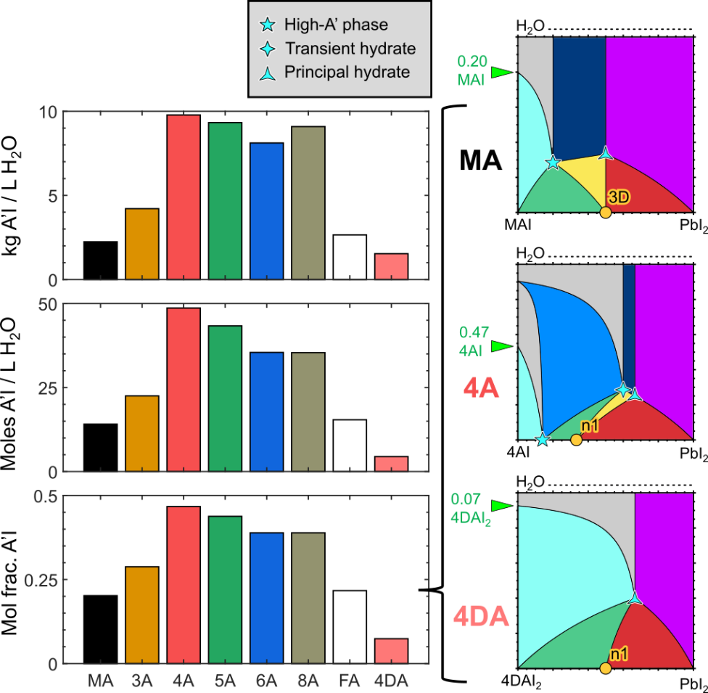
Figure S17: (left) Water solubility of the spacer cation salts expressed in kg/L (top), moles/L (middle), and mole fraction A’I at the saturation concentration (bottom). MAI and FAI are much less soluble than spacer cation salts, with 4AI showing the maximum solubility. The DJ cation salt 4DAI₂ has significantly lower solubility. The saturation mole fraction determines the intersection of the leftmost (cyan) three-phase region on the ternary diagram with the A’I – H₂O axis (right). The maximum solubility of each iodide salt in water is indicated on the left edge of its phase diagram by a green arrow.

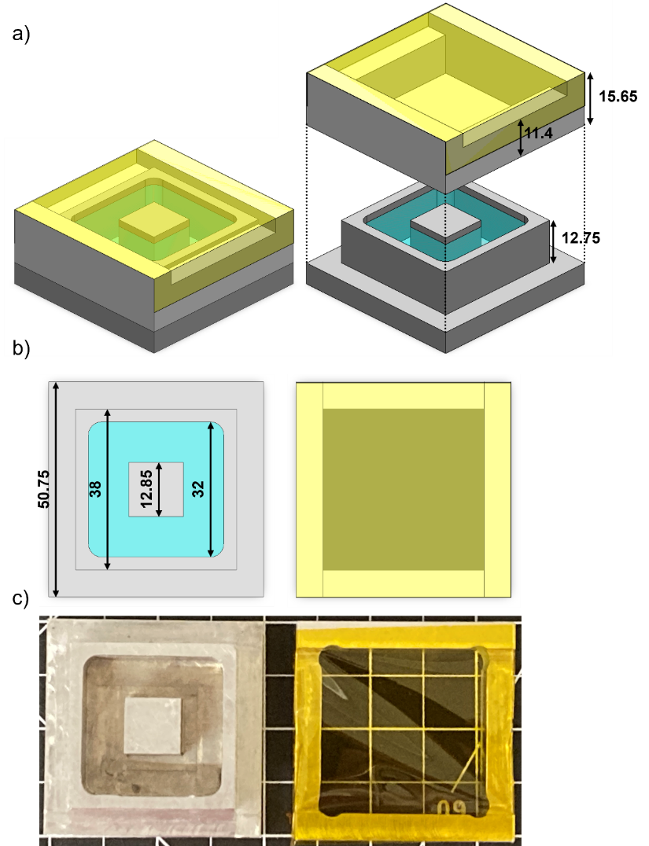

Figure S18: a) Isometric view of the home-built humidity chamber model with lid on (left) and off (right), showing the dimensions in z (units of mm). b) Top view of the chamber (left) and lid (right) model showing the dimensions in y (dimensions in x are identical). c) Top view photograph of the humidity chamber (left) and lid (right).

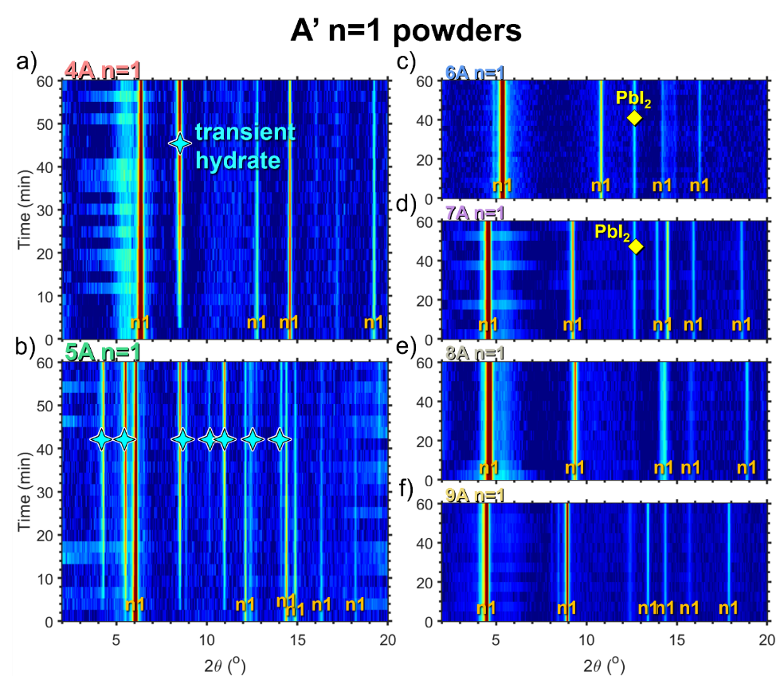
Figure S19: Degradation behavior of RP-type linear alkylammonium n=1 powders. Contour plots showing the diminishing of the 2D phase and the emergence of new degradation phases in the XRD patterns of 2D n=1 perovskite powders over time. Phases are labelled by type: 2D perovskite, transient hydrate, and PbI₂. a) 4A n=1; b) 5A n=1; c) 6A n=1; d) 7A n=1; e) 8A n=1; f) 9A n=1.

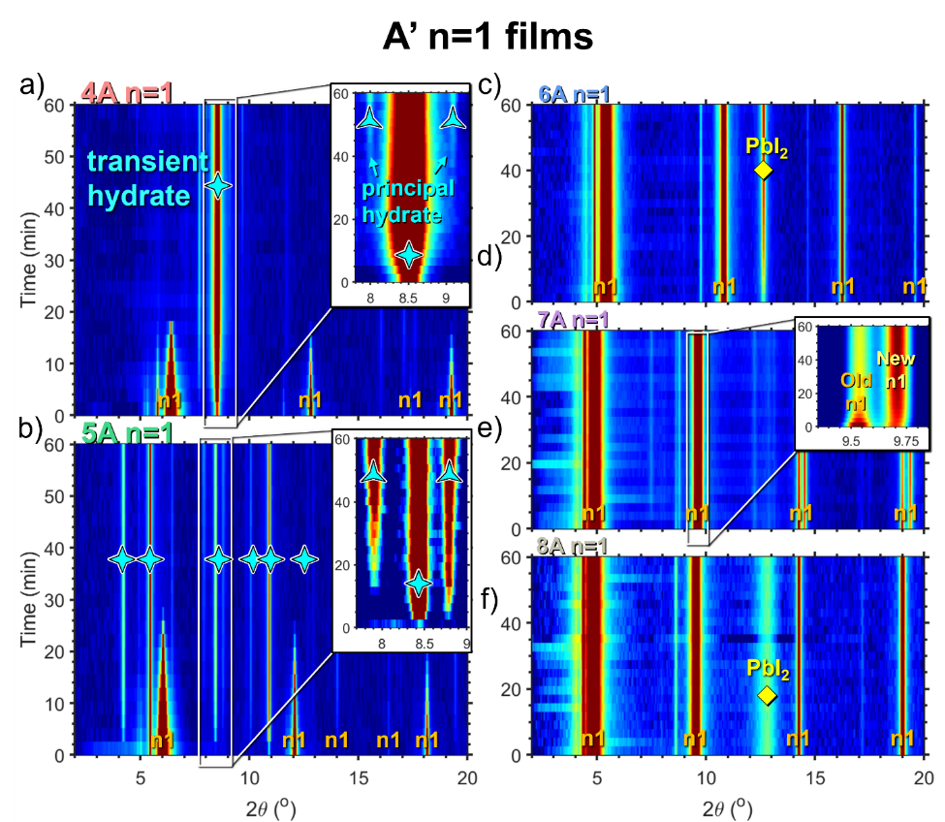
Figure S20: Degradation behavior of RP-type linear alkylammonium n=1 films. Contour plots showing the diminishing of the 2D phase and the emergence of new degradation phases in the XRD patterns of 2D n=1 perovskite films over time. Phases are labelled by type: 2D perovskite, transient hydrate, principal hydrate, and PbI₂. a) 4A n=1; b) 5A n=1; c) 6A n=1; d) 7A n=1; e) 8A n=1.

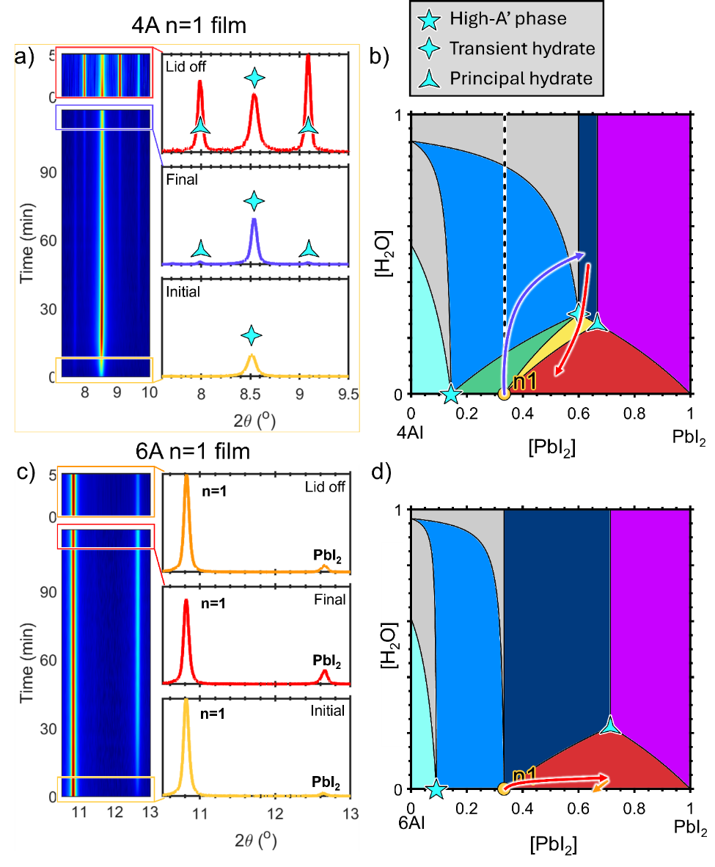
Figure S21: a) Degradation behavior of the 4A n=1 2D perovskite film before and after the lid to the humidity chamber is removed. The linecuts (right) are the normalized averages of subsections of the degradation (right). b) The apparent path in composition charted across the pseudo-binary phase diagram by the 4A n=1 system, gradually forming transient hydrate as moisture content increases and quickly forming principal hydrate once the lid is removed. c) Degradation behavior of the 6A n=1 2D perovskite film before and after the lid to the humidity chamber is removed. d) The apparent path in composition charted across the pseudo-binary phase diagram by the 6A n=1 system, gradually converting to PbI₂ as 6AI escapes from the film surface. The distances traversed on the phase diagram are exaggerated for clarity.

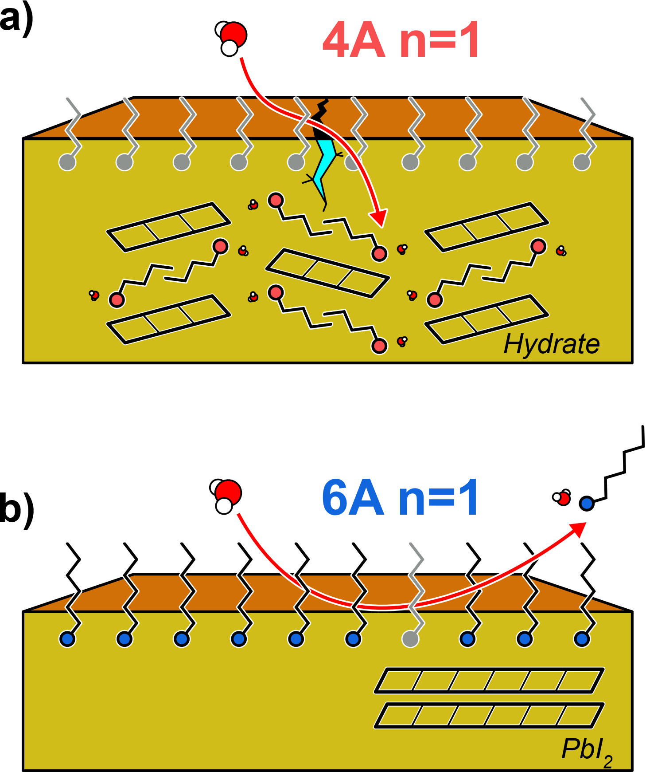

Figure S22: Barrier to moisture ingress in phase-stable films. a) Schematic of degradation in a 4A n=1 film. Spacer cations at the surface immediately begin forming hydrate phase, damaging the film quality and accelerating moisture ingress. b) Schematic of degradation in a 6A n=1 film. Spacer cations at the surface remain in the perovskite phase and present a barrier to moisture ingress. The slow solvation of surface cations leaves behind PbI₂.

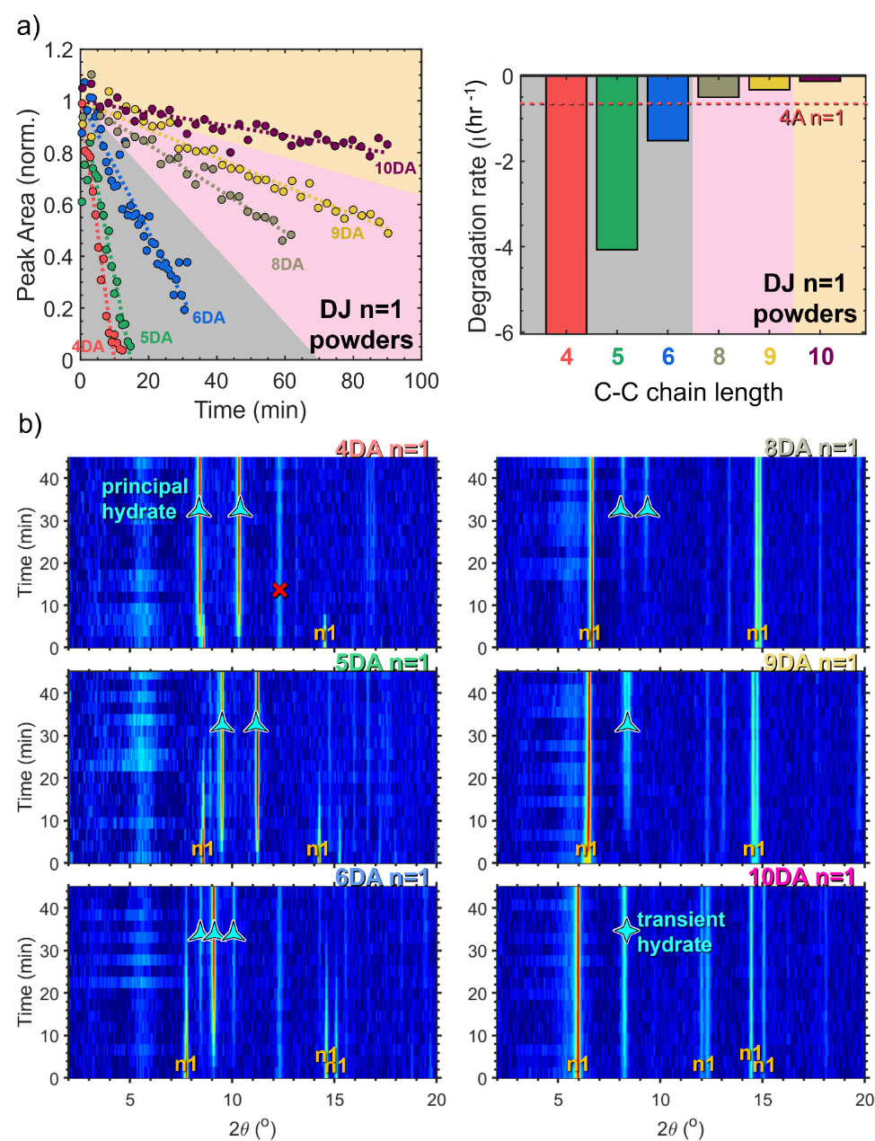
Figure S23: Degradation behavior of DJ-type linear alkylammonium n=1 powders. a) Normalized (001) Bragg peak intensity over time (left) and fitted degradation rates (right) for DJ n=1 powder samples with diammonium spacer cation chain lengths from 4 to 10, degraded with 8mL H₂O loading. The background color denotes ribbon length. Grey: m=2. Pink: m=3. Orange: m=4. b) Contour plots showing the diminishing of the 2D phase and the emergence of new degradation phases in the XRD patterns of each perovskite sample over time. Phases are labelled by type: DJ n=1 2D perovskite, principal hydrate, transient hydrate, and PbI₂. The peak in some diffraction patterns at 2θ ~ 12.3º is an unidentified impurity peak that appears in various samples with constant intensity over time and does not appear related to the degradation process.

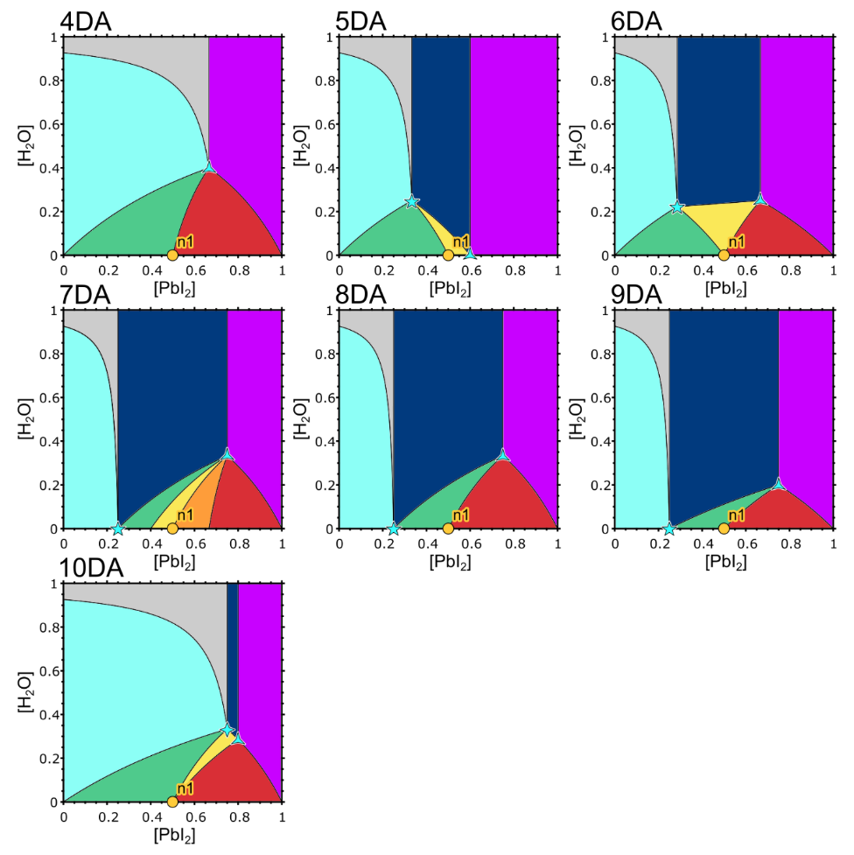
Figure S24: Pseudo-binary phase diagrams of linear alkyldiammonium spacer cations from 4DA to 10DA.

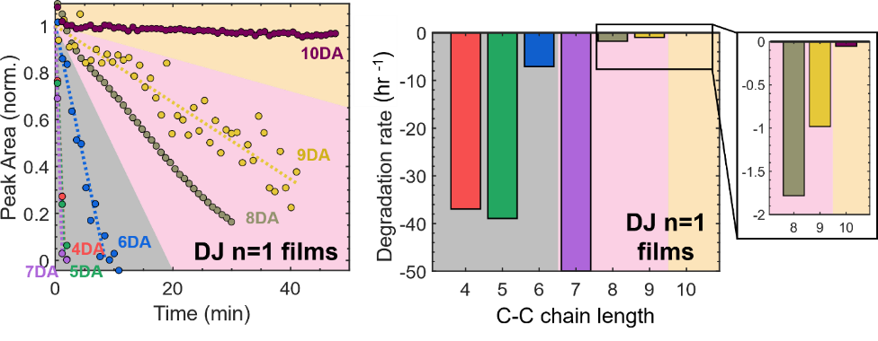
Figure S25: Degradation behavior of DJ-type linear alkylammonium n=1 films. Normalized (001) Bragg peak intensity over time (left) and fitted degradation rates (right) for DJ n=1 film samples with diammonium spacer cation chain lengths from 4 to 10, degraded with 2mL H₂O loading. The background color denotes ribbon length. Grey: m=2. Pink: m=3. Orange: m=4.

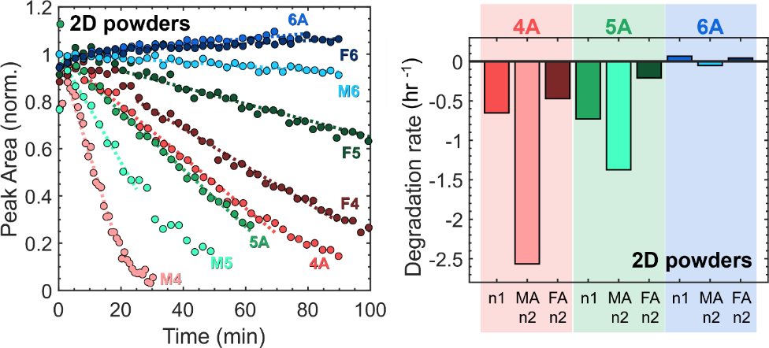
Figure S26: Comparing n=1, MA n=2, and FA n=2 stability. Normalized (002) Bragg peak intensity over time (left) and fitted degradation rates (right) for n=1, MA n=2, and FA n=2 powder samples with 4A, 5A, and 6A as the spacer cation, degraded with 8mL H₂O loading. The background color denotes A’-site cation. Red: 4A. Green: 5A. Blue: 6A. MA-4A, 5A, and 6A n=2 is abbreviated as M4, M5, and M6, while FA-4A, 5A, and 6A n=2 is abbreviated F4, F5, and F6. As a general rule the relative stability of the perovskite phases was found to be: (most stable) FA n=2 > n=1 > MA n=2 (least stable).

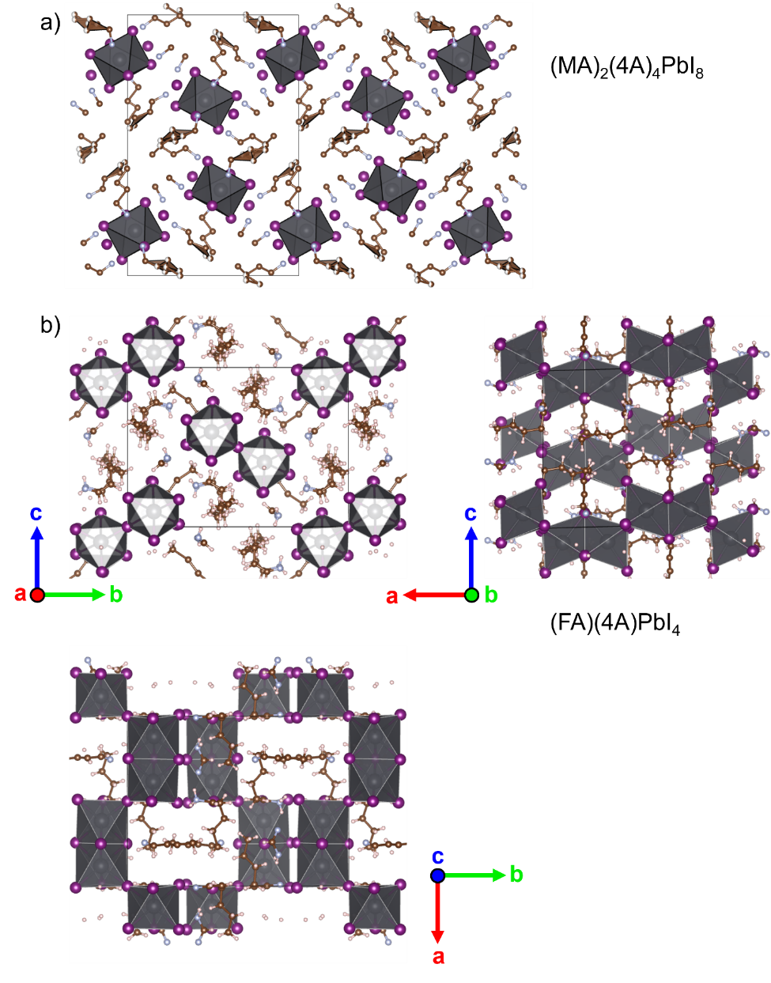
Figure S27: a) The structure of the mixed MA-4A phase (MA)₂(4A)₄PbI₈. b) The structure of the mixed FA-4A phase (FA)(4A)PbI₄.
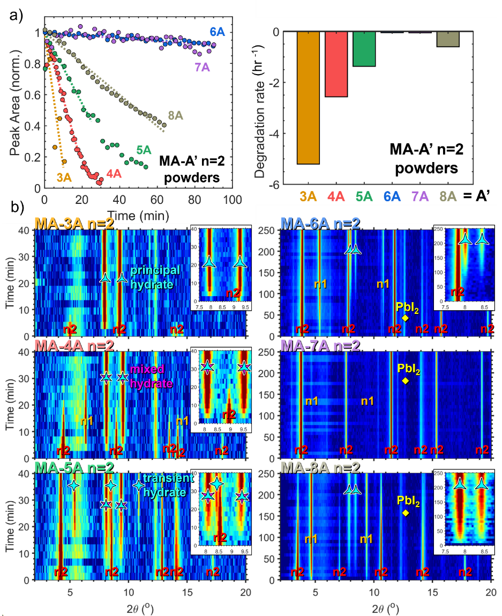
Figure S28: Degradation behavior of RP-type MA n=2 powders. a) Normalized (002) Bragg peak intensity over time (left) and fitted degradation rates (right) for MA-A’ n=2 powder samples with spacer cation chain lengths from 3 to 8, degraded with 8mL H₂O loading. b) Contour plots showing the diminishing of the 2D phase and the emergence of new degradation phases in the XRD patterns of each perovskite sample over time. Phases are labelled by type: n=1, MA n=2, principal hydrate, transient hydrate, mixed MA-A’ hydrate, and PbI₂.
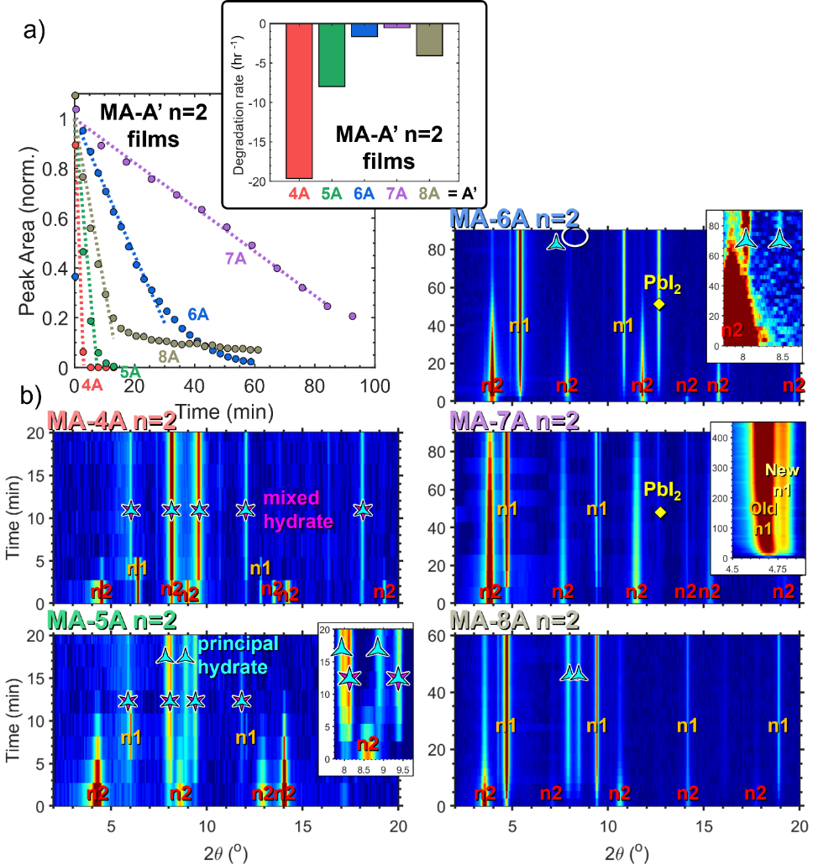
Figure S29: Degradation behavior of RP-type MA n=2 films. a) Normalized (002) Bragg peak intensity over time (bottom left) and fitted degradation rates (top right, inset) for MA-A’ n=2 film samples with spacer cation chain lengths from 3 to 8, degraded with 10mL H₂O loading. b) Contour plots showing the diminishing of the 2D phase and the emergence of new degradation phases in the XRD patterns of each perovskite sample over time. Phases are labelled by type: n=1, MA n=2, principal hydrate, mixed MA-A’ hydrate, and PbI₂.

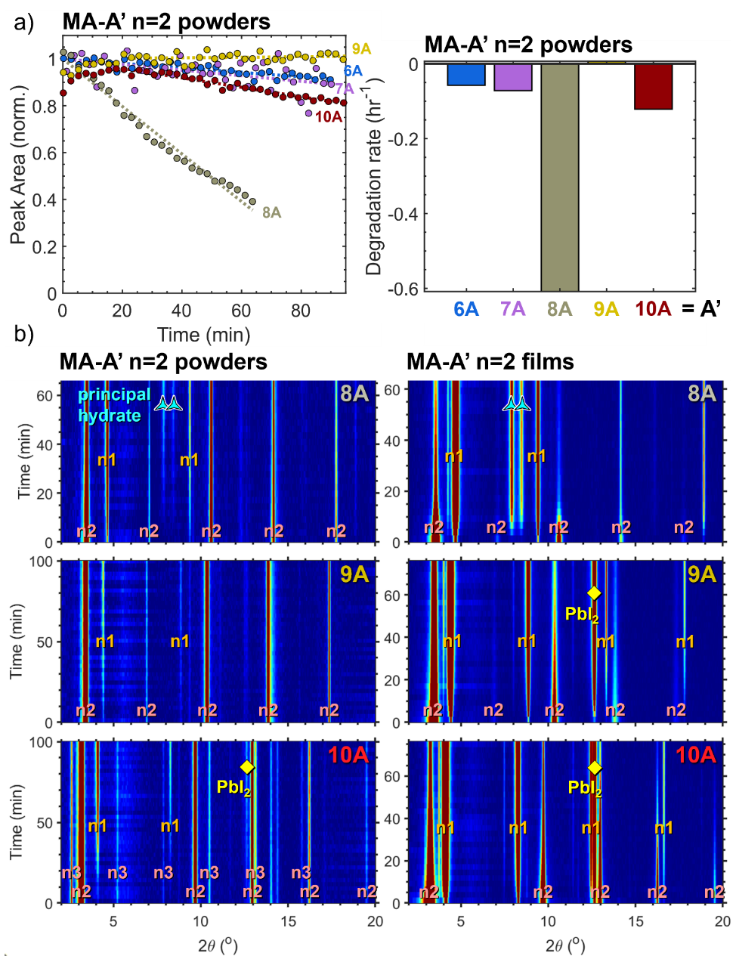
Figure S30: Degradation behavior of MA n=2 powders and films with long-chain spacer cations. a) Normalized (002) Bragg peak intensity over time (left) and fitted degradation rates (right) for MA-A’ n=2 powder samples with spacer cation chain lengths from 6 to 10, degraded with 8mL H₂O loading. b) Contour plots showing the diminishing of the 2D phase and the emergence of new degradation phases in the XRD patterns of MA-8A, 9A, and 10A n=2 powders (left) and films (right) over time. Phases are labelled by type: n=1, MA n=2, MA n=3, principal hydrate, and PbI₂. The n=3 in the MA-10A powder is an impurity, not a degradation phase.
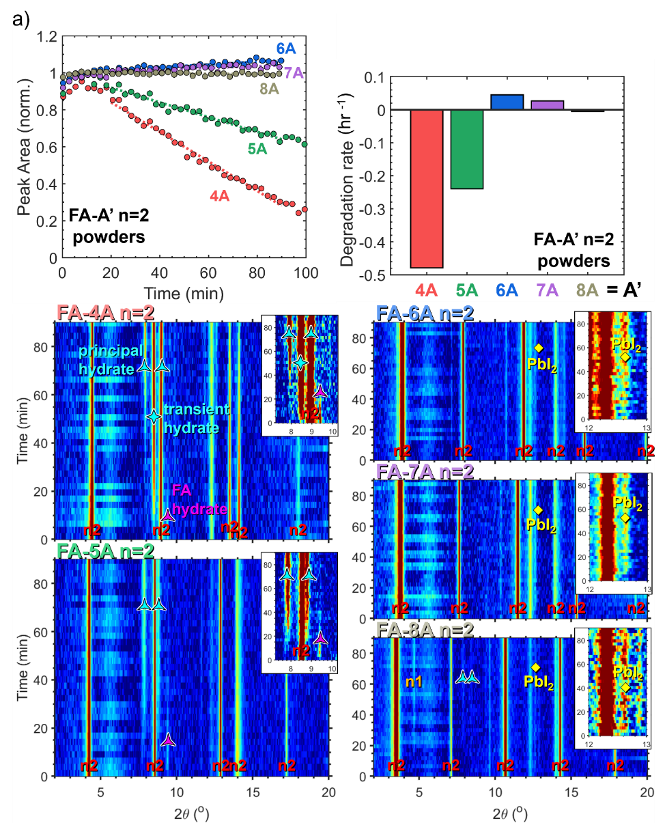
Figure S31: Degradation behavior of RP-type FA n=2 powders. a) Normalized (002) Bragg peak intensity over time (left) and fitted degradation rates (right) for FA-A’ n=2 powder samples with spacer cation chain lengths from 4 to 8, degraded with 8mL H₂O loading. b) Contour plots showing the diminishing of the 2D phase and the emergence of new degradation phases in the XRD patterns of each perovskite sample over time. Phases are labelled by type: n=1, FA n=2, principal hydrate, transient hydrate, FA hydrate, and PbI₂.

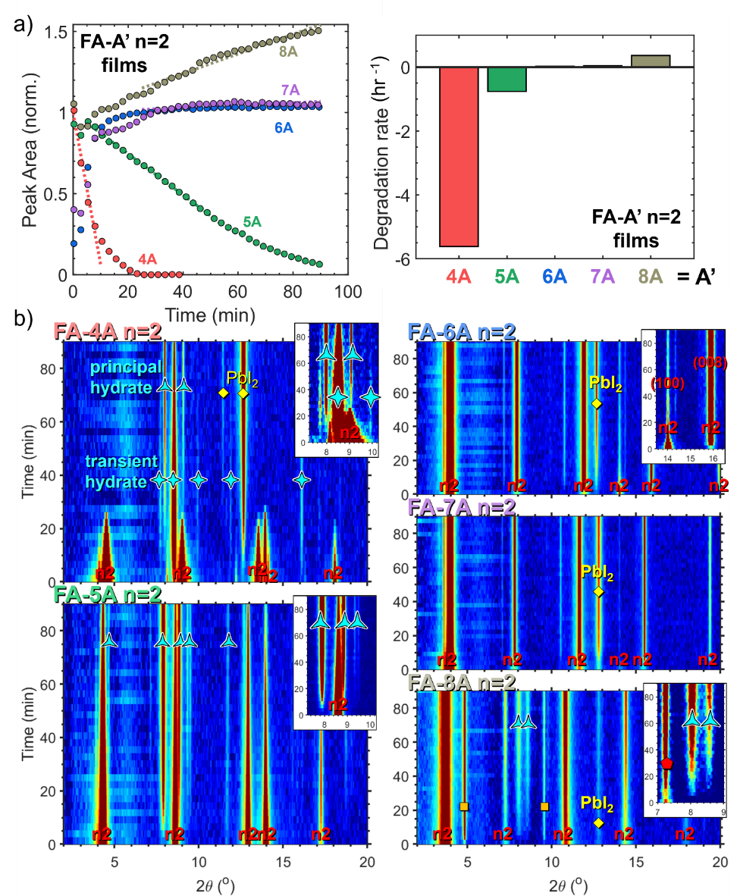
Figure S32: Degradation behavior of RP-type FA n=2 films. a) Normalized (002) Bragg peak intensity over time (left) and fitted degradation rates (right) for FA-A’ n=2 film samples with spacer cation chain lengths from 4 to 8, degraded with 10mL H₂O loading. b) Contour plots showing the diminishing of the 2D phase and the emergence of new degradation phases in the XRD patterns of each perovskite sample over time. Phases are labelled by type: n=1, FA n=2, principal hydrate, transient hydrate, FA hydrate, and PbI₂.

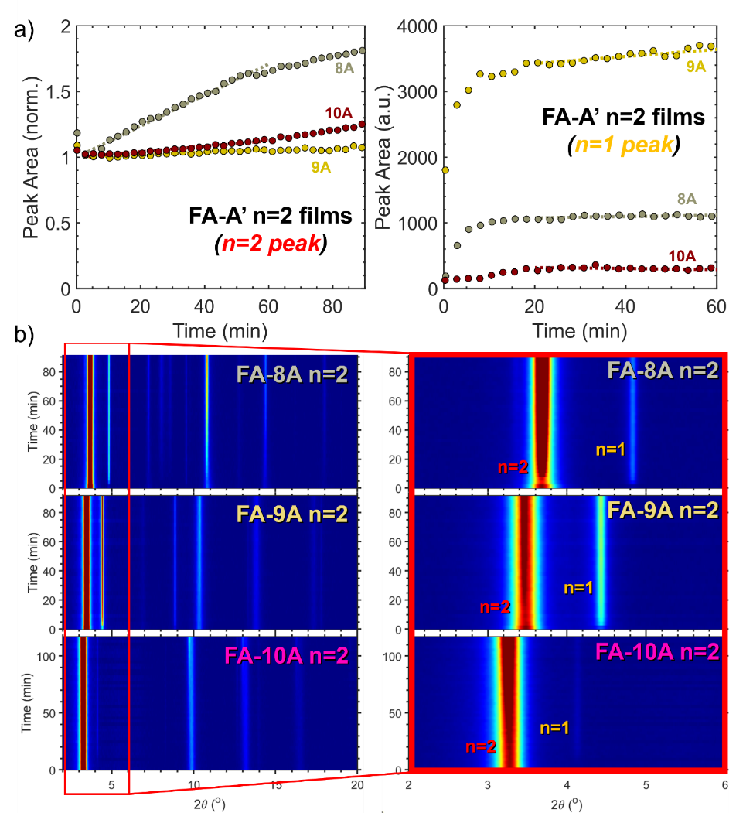
Figure S33: Degradation behavior of RP-type FA n=2 films with spacer cations 8A, 9A, and 10A. a) Normalized Bragg peak intensity over time for the n=2 (002) peak (left), and the n=1 (002) peak (right), in FA-A’ n=2 film samples with spacer cation chain lengths from 8 to 10, degraded with 10mL H₂O loading. b) Contour plots from 2θ = 2°-20° (left), and 2θ = 2°-6° (right), showing the diminishing of the n=2 phase and the emergence of the n=1 phase in the XRD patterns of each perovskite sample over time.

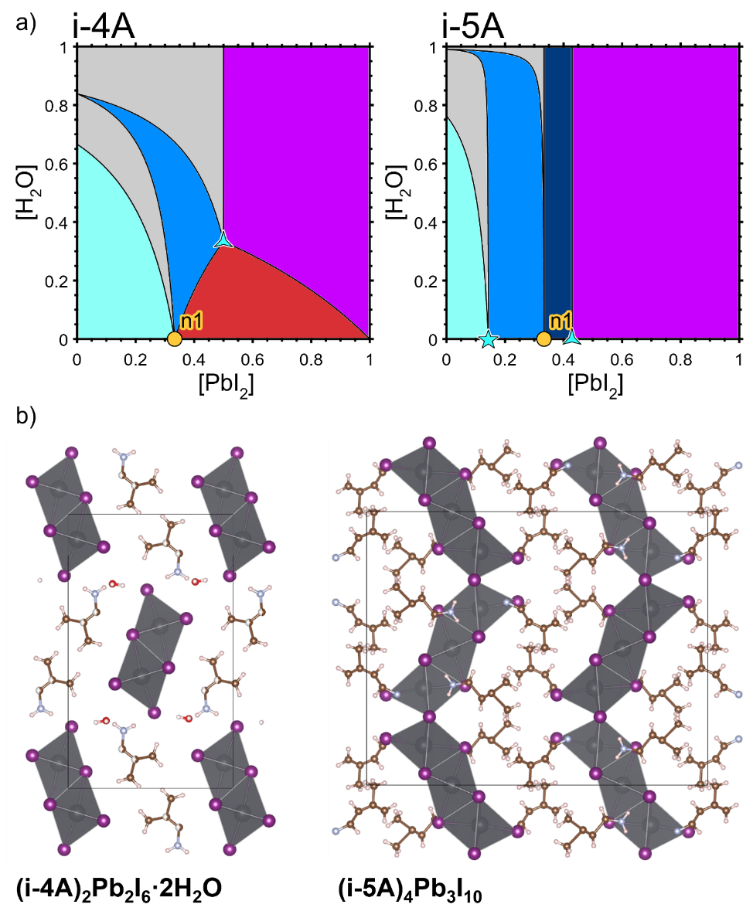
Figure S34: a) The pseudo-binary phase diagrams of the branched cations i-4A (left) and i-5A (right). b) The crystal structures of the i-4A hydrate (i-4A)₂Pb₂I₆·2H₂O (left) and the i-5A degradation phase (i-5A)₄Pb₃I₁₀ (right).

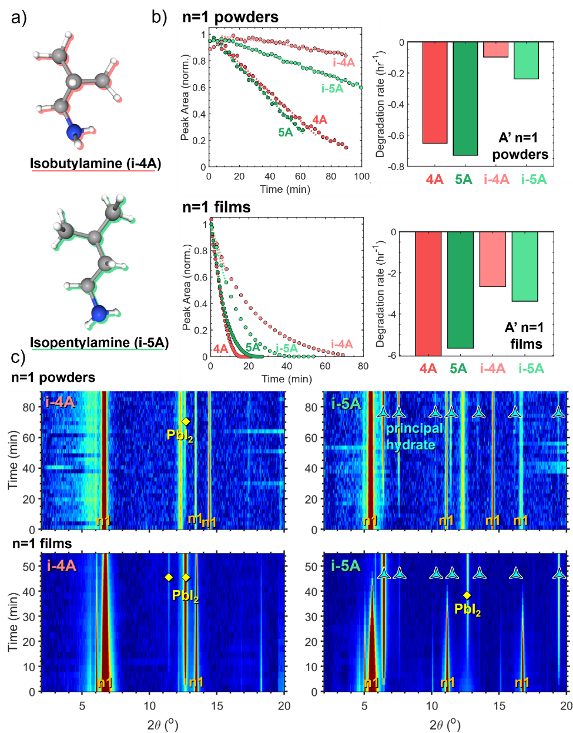
Figure S35: Degradation behavior of rationally-designed n=1 2D perovskite powders and films incorporating the branched spacer cations i-4A and i-5A. a) The structure of the i-4A (top) and i-5A (bottom) molecules. b) Normalized (002) Bragg peak intensity over time (left) and fitted degradation rates (right) for powder samples under 8mL H₂O loading (top) and film samples under 10mL H₂O loading (bottom) of 4A, 5A, i-4A, and i-5A n=1. c) Contour plots showing the diminishing of the 2D phase and the emergence of new degradation phases in the XRD patterns of i-4A (left) and i-5A (right) n=1 powders (top) and n=1 films (bottom) over time. Phases are labelled by type: n=1, hydrate, and PbI₂. Because i-4A has intermediate length between 3A and 4A, and because it is wider than the linear alkylammonium cations, it cannot accommodate any hydrate structure. As a result the moisture stability of i-4A n=1 increases dramatically compared to 4A, 5A, and i-5A n=1.
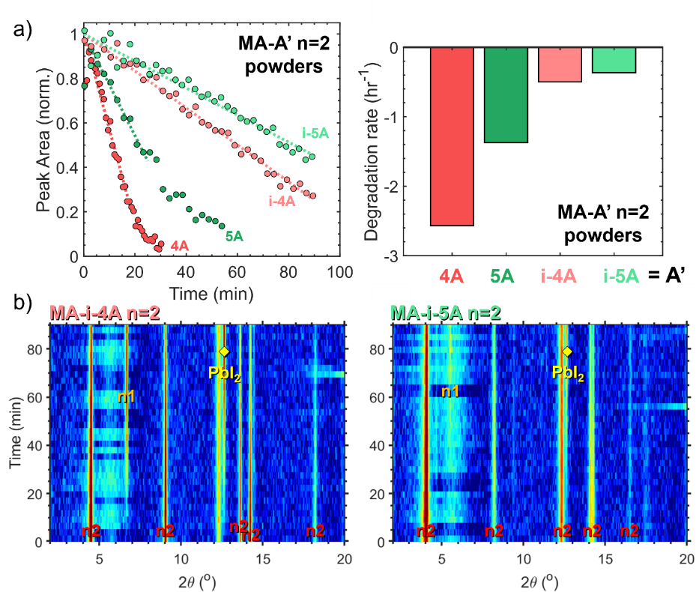
Figure S36: Degradation behavior of rationally-designed MA n=2 2D perovskite powders incorporating the branched spacer cations i-4A and i-5A. a) Normalized (002) Bragg peak intensity over time (left) and fitted degradation rates (right) for powder samples of MA-4A, 5A, i-4A, and i-5A n=2 under 8mL H₂O loading. b) Contour plots showing the diminishing of the 2D phase and the emergence of new degradation phases in the XRD patterns of MA-i-4A (left) and MA-i-5A (right) n=2 powders. Phases are labelled by type: MA-A’ n=2, n=1 and PbI₂. Because both 2D perovskites degrade via the same pathway under these conditions, the bulkiness of the i-5A cation gives it a superior moisture stability.
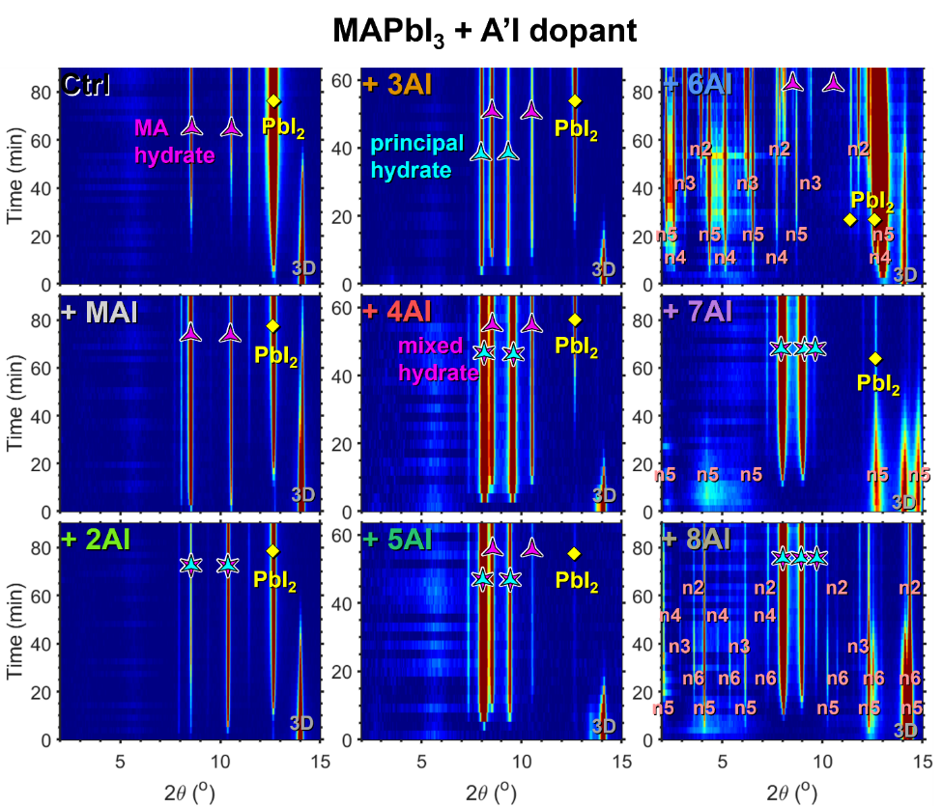
Figure S37: Degradation behavior of MAPbI₃ films with 25mol% A’I dopant. Contour plots showing the diminishing of the 3D phase and the emergence of new degradation phases in the XRD patterns of each perovskite sample over time. Phases are labelled by type: 3D MAPbI₃, n=1-6, MA hydrate, principal hydrate, mixed hydrate, and PbI₂.

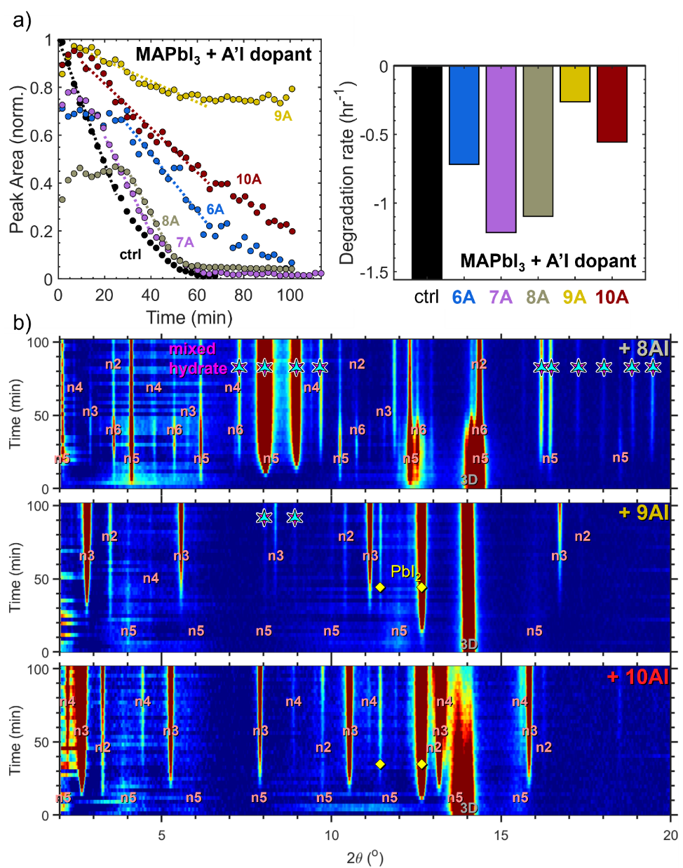
Figure S38: Degradation behavior of MAPbI₃ films with 25mol% long-chain A’I dopant. a) Normalized 3D (100) Bragg peak intensity over time (left) and fitted degradation rates (right) for MAPbI₃ films doped with 25 mol% A’I, degraded with 2mL H₂O loading. b) Contour plots showing the diminishing of the 3D phase and the emergence of new degradation phases in the XRD patterns of each perovskite sample over time. Phases are labelled by type: 3D MAPbI₃, n=1-6, mixed hydrate, and PbI₂.

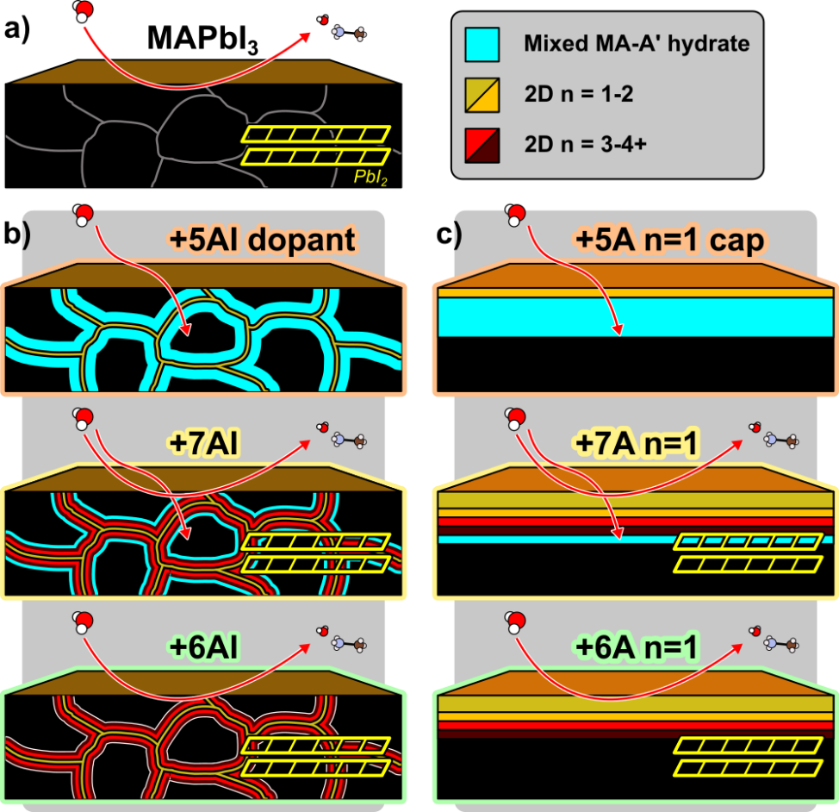

Figure S39: Schematic of degradation in mixed 3D-2D films. a) Pure MAPbI₃. b) MAPbI₃ doped with 25% 5AI (top), 7AI (middle), and 6AI (bottom). c) MAPbI₃ capped with 5A n=1 (top), 7A n=1 (middle), and 6A n=1 (bottom).

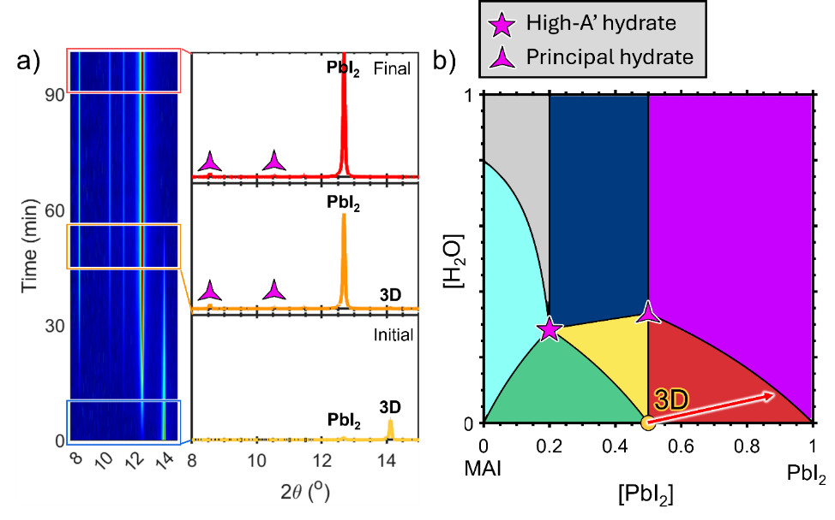
Figure S40: a) Degradation behavior of the undoped MAPbI₃ film. b) The apparent path in composition charted across the pseudo-binary phase diagram by the MAPbI₃ system, rapidly converting to PbI₂ as MAI escapes from the film surface and simultaneously forming a small amount of principal hydrate as moisture content increases.

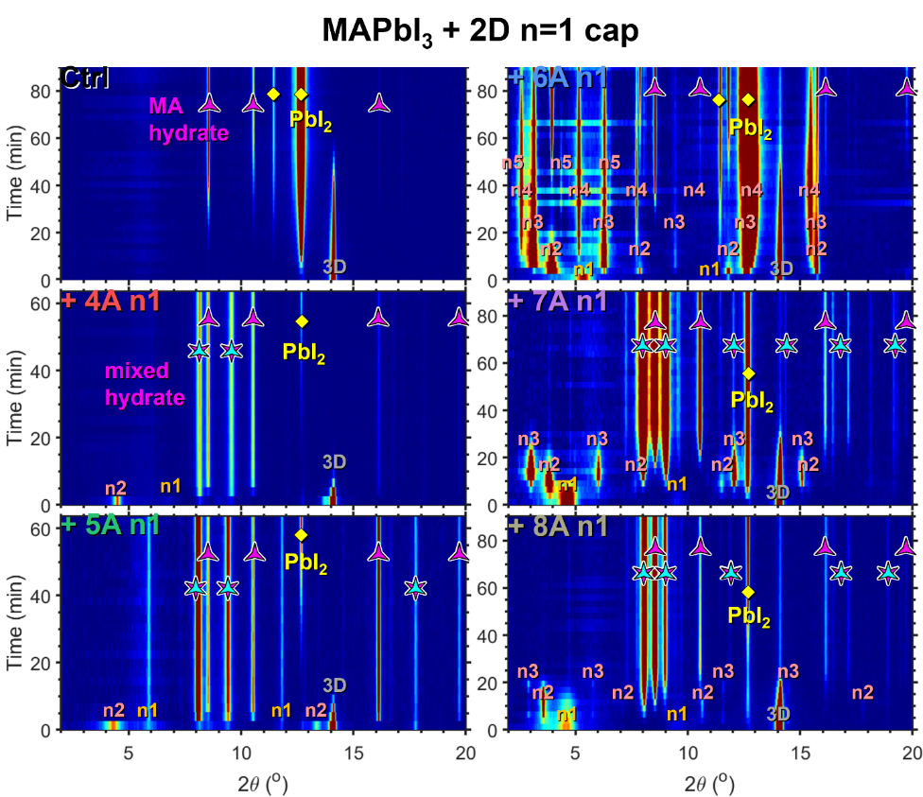
Figure S41: Degradation behavior of MAPbI₃ films with n=1 capping layer. Contour plots showing the diminishing of the 3D phase and the emergence of new degradation phases in the XRD patterns of each perovskite sample over time. Phases are labelled by type: 3D MAPbI₃, n=1-6, MA hydrate, principal hydrate, mixed hydrate, and PbI₂.

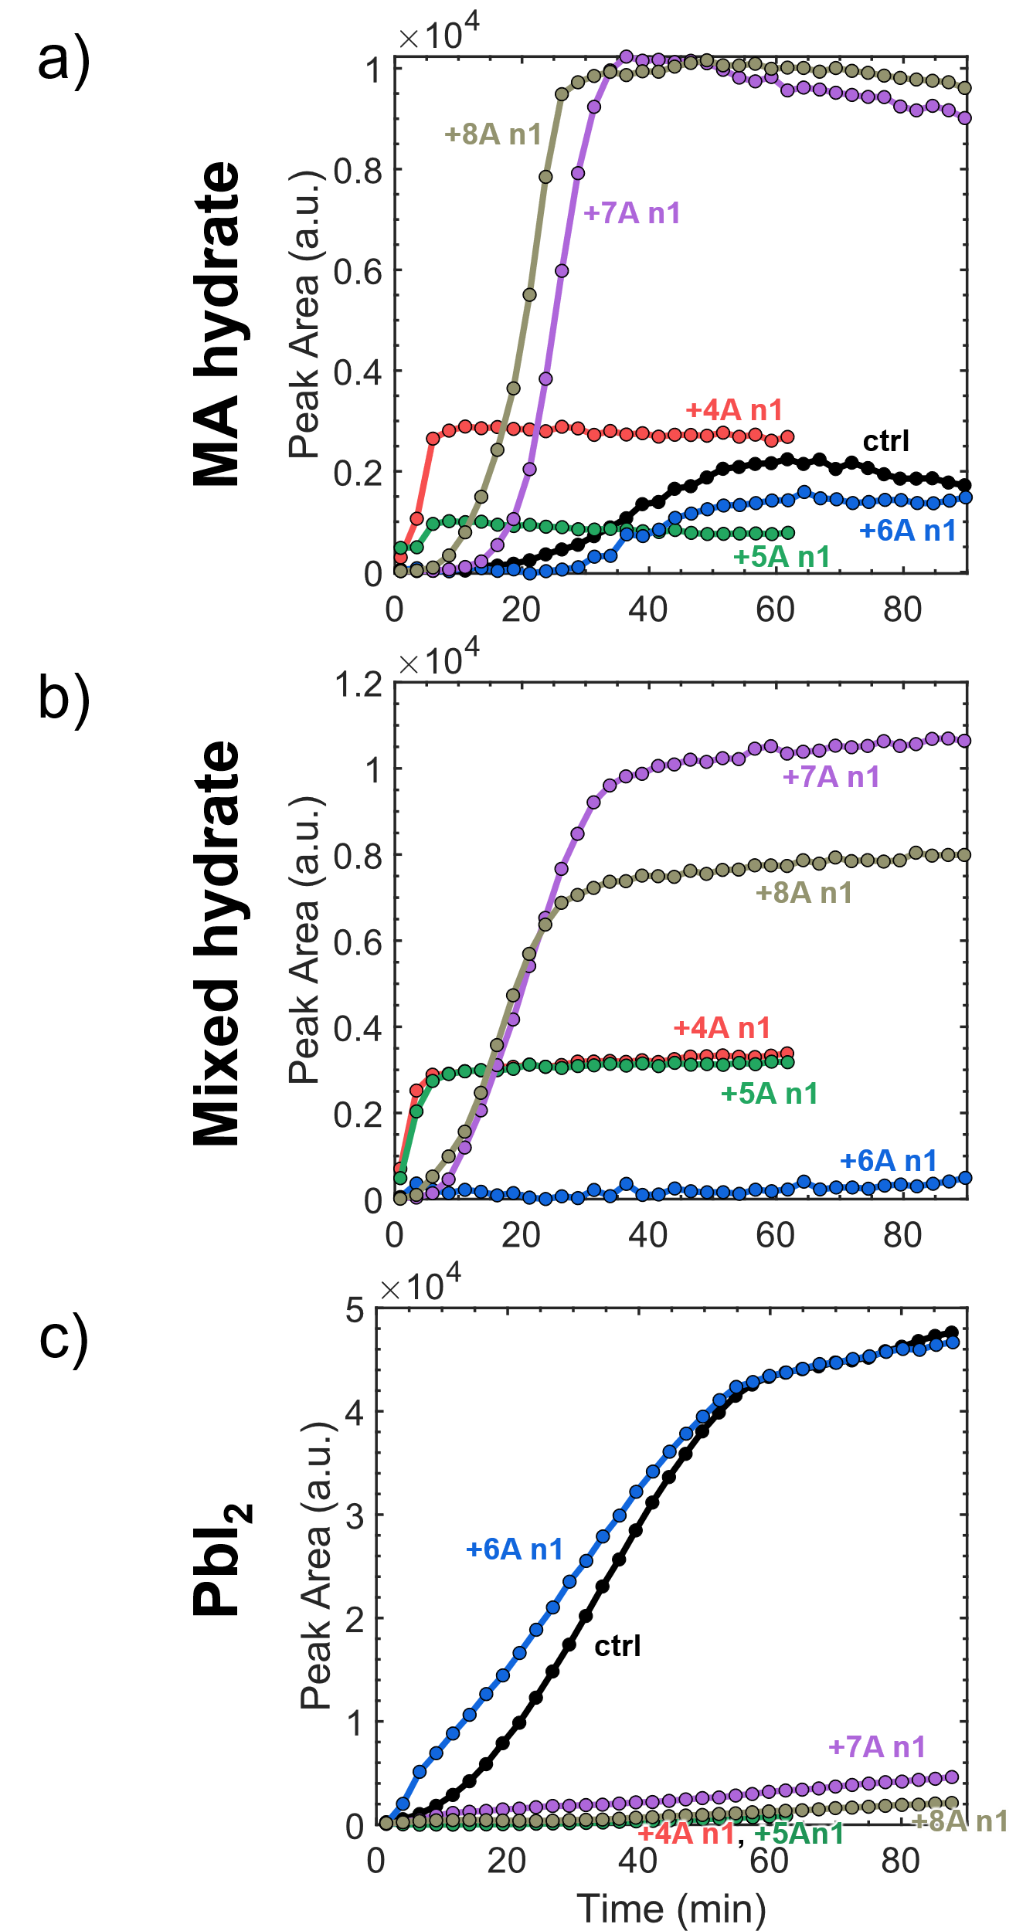
Figure S42: Phase evolution in capped MAPbI₃ – 2D n=1 films. Absolute Bragg peak intensity over time in the capped films for peaks corresponding to a) the principal MA hydrate, b) the mixed MA-A’ hydrate, and c) PbI₂.

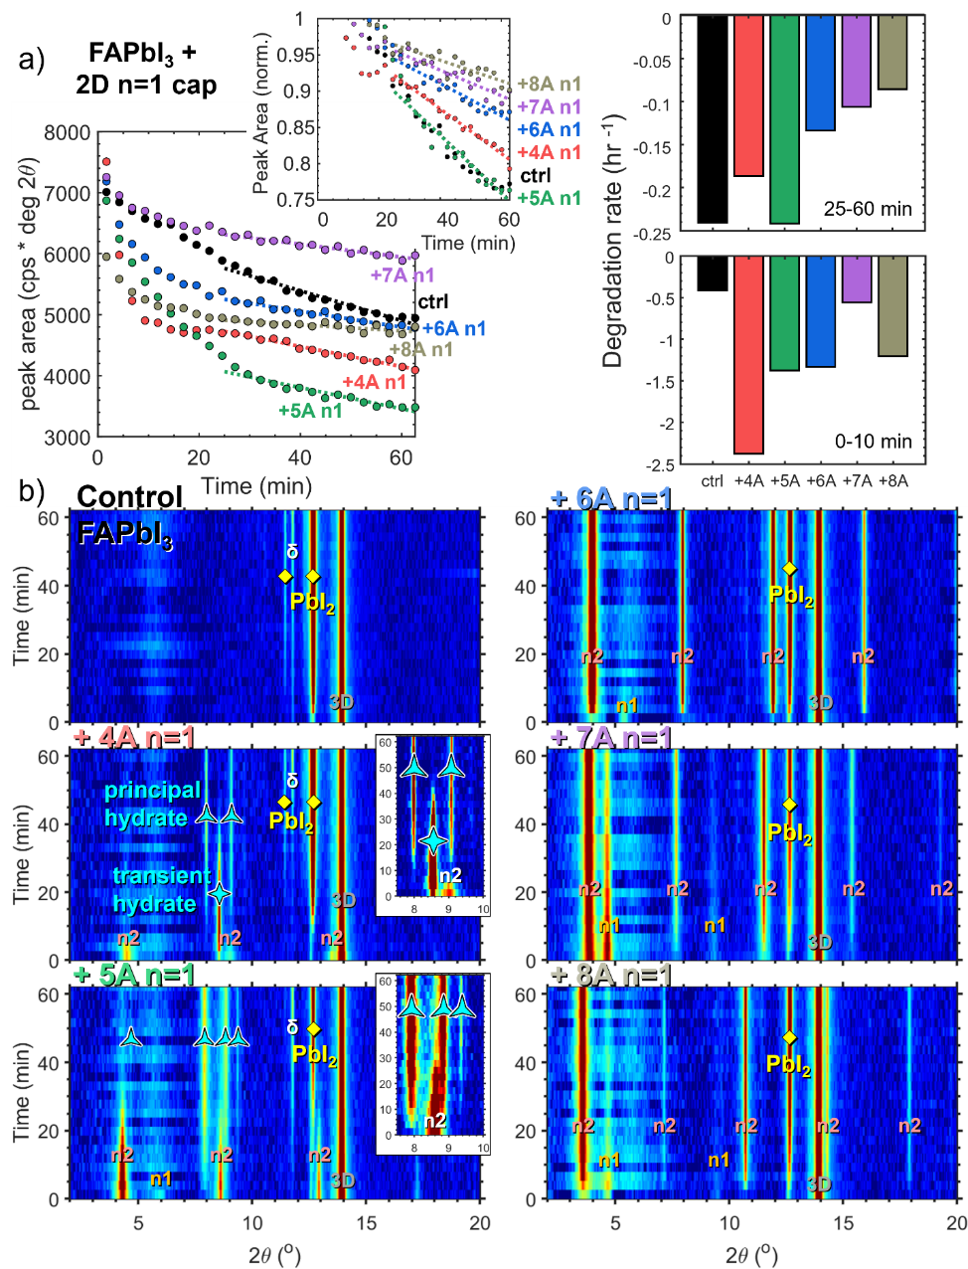
Figure S43: Degradation behavior of FAPbI₃ films with RP n=1 capping layers. a) Absolute (bottom left) and normalized (top left) 3D (100) Bragg peak intensity over time, and fitted degradation rates at the end (top right) and beginning (bottom right) of degradation for FAPbI₃ -2D n=1 bilayer films with spacer cation chain lengths from 4 to 8, degraded with 8mL H₂O loading. b) Contour plots showing the diminishing of the 3D phase and the emergence of new degradation phases in the XRD patterns of each perovskite sample over time. Phases are labelled by type: 3D FAPbI₃, n=1-2, principal hydrate, transient hydrate, δ-phase FAPbI₃, and PbI₂.

