Table 1 shows the average diameters of the nanoweb.
Sample code | FESEM image | Diameter distribution
PAN |  | 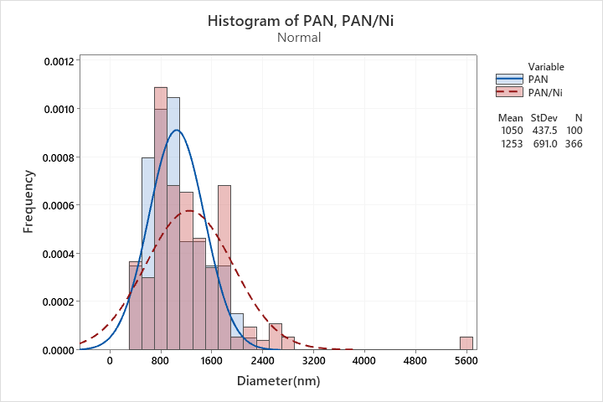
PAN/Ni

