Title
Digitalisation impacts on energy transitions and climate targets

Authors & Affiliations
Charlie Wilson ^{1,2 *}, Volker Krey ¹, Florian Maczek ¹, Yee Van Fan ², Behnam Zakeri ^{1,3},
Aneeque Javaid ¹, Alessio Mastrucci ¹, Remi Paccou ^{4,5}, Hamish Beath ⁶, Jan Bieser ⁷, Vlad Coroamǎ ⁸, Felix Creutzig ^{9,10}, Eric Masanet ¹¹, Bas van Ruijven ¹, Keywan Riahi ¹

¹ International Institute for Applied Systems Analysis (IIASA), Laxenburg, Austria
² Environmental Change Institute (ECI), University of Oxford, Oxford, UK
³ Institute for Data, Energy, and Sustainability (IDEaS), Vienna University of Economics and Business, Vienna, Austria
⁴ Sustainability Research Institute, Schneider Electric, Grenoble, France
⁵ Centre International de Recherche sur l’Environnement et le Développement (CIRED), Ecole des Ponts ParisTech, Nogent-sur-Marne, France
⁶ Centre for Environmental Policy, Imperial College London, London, UK
⁷ Institute for Public Sector Transformation, University of Applied Sciences, Bern, Switzerland
⁸ Roegen Centre for Sustainability, Zurich, Switzerland
⁹ Potsdam Institute for Climate Impact Research (PIK), Potsdam, Germany
¹⁰ Bennett Institute for Innovation and Public Policy, University of Sussex, Brighton, UK
¹¹ Bren School of Environmental Science and Management, University of California, Santa Barbara, USA

* corresponding author: charlie.wilson@eci.ox.ac.uk

Supplementary Information
Table 4. A policy and research agenda for climate-aligned digitalisation.
Table 5. Summary and examples of main MESSAGEiX scenario implementation assumptions (1) end-use sectors.
Table 6. Summary and examples of main MESSAGEiX scenario implementation assumptions (2) energy system integration.

Figure 8. Intermittent renewables and storage.
Figure 9. Electrification rates in buildings, transport, and the full energy system.
Figure 10. Electricity generation by resource type.
Figure 11. Distributed solar power generation.
Figure 12. Digitalisation impacts on global CO2 emissions to 2050.
Figure 13. Digitalisation impacts on regional CO2 emissions to 2050.
Figure 14. Sectoral contributions to CO2 emission reductions from climate-misaligned to climate-aligned digitalisation.
Figure 15. Digitalisation impacts on carbon dioxide removal (CDR) needs to 2050 under strengthened climate ambition (2°C).
Figure 16. Projected global electricity demand of data centres extended through 2050 consistent with the Shared Socioeconomic Pathways (SSPs).

Table 4. A policy and research agenda for climate-aligned digitalisation.

Setting incentives in deployment contexts | The information gains brought about by digitalisation are generally not used to save energy, but to save time, accelerating the economy ¹. Sufficiency-oriented business models that avoid lower costs, time burdens, or other frictions being turned into more emissions-intensive activity can balance private benefits for users with public goods ². Mostly, though, business models are shaped by market incentives and deployment conditions. If market actors prioritise using more private cars and maximising oil extraction over promoting shared mobility and transitioning to cleaner energy, then digital technologies and AI will be deployed to serve those objectives. Uber has little incentive to constrain rising demand for its convenient platform-enabled ride-hailing service, even if this ends up eroding public transport. Such incentives must come from market access rules that govern how different mobility providers use public infrastructure in cities. Teleworking or videoconferencing don’t displace travel if driving is easy and flying is cheap. Building energy management systems don’t help decarbonise power systems if energy tariffs encourage local optimisation.
Managing induced demand | Stringent climate policies set incentives to steer digital and AI applications towards supporting emission-reducing outcomes. But managing induced demand is through a wider set of market design, pricing, urban planning, efficiency standards, regulatory frameworks and other rules shaping the demand for energy-related activity across buildings, transport, and consumer goods sectors, and how this demand integrates into energy systems. Relevant policy actors are distributed across economic sectors and scales from local to national. Understanding the direction and magnitude of digital application impacts is a necessary first step.
Assessing & reporting indirect impacts | Scope 1-2 emissions reporting from the operational footprints of digital and AI infrastructure (direct impacts) improves comparability for benchmarking, discretionary investment, and diffusion of best practice ^{3,4}. But, as our modelling shows, downstream Scope 3 emissions from the effects of digital applications on energy-related activity are much more important. These indirect impacts are much harder to assess as deployment contexts vary, system boundaries are less clearly defined, and data on user behaviour are not systematically collected ⁵. Recent efforts by ITU to standardise indirect impact assessment protocols are a step in the right direction but need to be mainstreamed in digitally-enabled business models and reporting ^{6,7}. It is particularly important that rebound and induced demand from digital applications are identified, estimated, and included ⁸. This is methodologically challenging. Comprehensive scope 1-3 emissions accounting enables targeting of high-impact digital applications (like shared mobility platforms), differentiating in favour of best-in-class providers, and transferring ‘what works’ across deployment contexts. Making progress will be hard and needs both carrot (e.g., preferential green financing) and stick (e.g., legal obligations).
Building better evidence | The research community can contribute by building evidence and using it to improve modelling. An up-to-date and expanding evidence base is needed on digital application impacts in different sectors and geographies. Openness and transparency in structured databases are important enablers of confidence and uptake. The IEA’s Energy and AI Observatory ⁹ collects data on energy or emission impacts of AI applications but in its early stage is biased towards industry examples with limited acknowledgement of induced demand let alone attempts to quantify it. National databases tend to be similarly one-sided ^{10,11}.
Making digitalisation explicit in modelling | Drawing on improved evidence, global climate futures analysis should explicitly represent digital transformation. This includes the quantitative scenario modelling used to inform climate targets, pathways, and policies, as well as storylines of future global development ^{12,13}. The ongoing process to evolve the SSP framework is an immediate opportunity (ICONICS, https://sep.du.edu). Making the phenomenon explicit raises its salience, improves the usefulness of models as policy laboratories, and helps identify robust risk mitigation strategies. Predictive and user-friendly assessments of the impacts of different policy designs can help support policymakers in developing and implementing effective measures, which in turn need to be systematically monitored.
Integrating systemic impacts into multi-level assessments | Comprehensive multi-level impact assessments are needed to integrate direct and indirect application-level effects into frameworks capturing systemic effects. This requires methodological innovation to bridge between lifecycle analysis and other detailed process-based methods on the one hand, and macroeconomic modelling and methods on the other. Several macroeconomic studies have projected AI productivity gains and impacts on GDP growth without estimating resulting CO₂ emissions ^{14,15}. Macroeconomic models with detailed representations of economic structure, relative prices, and inter-sectoral effects beyond the energy system are yet to be reconciled with the application-level impacts that can be resolved in detailed process-based models like MESSAGEiX used in this study.

Table 5. Summary and examples of main MESSAGEiX scenario implementation assumptions (1) end-use sectors.

model component | sector (subsectors) | modifiers  (examples only) | Undermine |  | Reference  (SSP2) | Enable |  | notes
model component | sector (subsectors) | modifiers  (examples only) | Extreme | Cautious | Reference  (SSP2) | Cautious | Extreme
MESSAGEiX-Transport | transport (passenger & freight) | examples: % changes in final energy from reference in 2050 in EEU region | e.g. +17% truck freight | e.g. +6% truck freight | - SSP2 - | e.g. -16% truck freight | e.g. -17% truck freight | demand modifiers applied to SSP2 regional final energy output in 2 subsectors and 6 modes
MESSAGEiX-Buildings | buildings (residential & commercial) | examples: % changes in final energy from reference in 2050 in PAS region | e.g. +12% residential cooling | e.g. +8% residential cooling | - SSP2 - | e.g. -13% residential cooling | e.g. -24% residential cooling | demand modifiers applied to SSP2 regional final energy output in 2 subsectors and 5 energy services
new projections + MESSAGEiX-Buildings | ICT (data centres & networks) | examples: absolute values in 2050 in WEU region | e.g. 347 EJ | e.g. 324 EJ | e.g. 197 EJ | e.g. 85 EJ | e.g. 79 EJ | demand projections calibrated to historical trends and uncertainties; ICT sector netted out of commercial buildings sub-sector to avoid double counting
MESSAGEiX-Materials | industry (5 energy-intensive sectors + other manufacturing) | examples: % changes from reference in 2050 in NAM region | no change (=Reference) | e.g. -2.8% aluminium smelting | - SSP2 - | e.g. -4.7% aluminium smelting | e.g. -4.7% aluminium smelting | demand modifiers applied to SSP2 energy intensity and final energy in 6 subsectors and 11 processes; also to 4 bulk material flows
MESSAGEiX | end-use sectors (electrification rates) | examples: parameter adjustment on end-use electrification rates (all regions & years) | no change (=Reference) | no change (=Reference) | - SSP2 - | e.g. -1% p.a. reduction in deployment constraint for EVs & HPs | e.g. -1.5% p.a. reduction in deployment constraint for EVs & HPs | MESSAGEiX constrains maximum electrification rates to ensure feasible transition speeds as electric substitutes for conventional technologies become cost-competitive. Electric vehicles (EVs) and heat pumps (HPs) are the two main examples.

Table 6. Summary and examples of main MESSAGEiX scenario implementation assumptions (2) energy system integration.

model component | sector (subsectors) | modifiers  (examples only) | Undermine |  | Reference  (SSP2) | Enable |  | notes
model component | sector (subsectors) | modifiers  (examples only) | Extreme | Cautious | Reference  (SSP2) | Cautious | Extreme | notes
MESSAGEiX | energy system (VRE Integration costs) | examples: parameter adjustment on VRE integration cost (all regions & years) | no change (=Reference) | no change (=Reference) | e.g. 30% of PV resources in low-cost integration (tier 1) | e.g. 35% of PV resources in low-cost integration (tier 1) | e.g. 70% of PV resources in low-cost integration (tier 1) | System integration cost of VRE includes grid management and congestion costs, and the additional cost of non-VRE (thermal) generators (cycling cost, low-utilization rate, etc). In MESSAGEiX, there are four tiers for solar PV penetration sorted from 1 (low VRE share) to 4 (high VRE share). Integration costs increase at higher VRE shares due to more grid congestion ¹⁶.
MESSAGEiX | energy system (VRE capacity contribution to reserve margin) | examples: parameter adjustment on VRE reserve margin in 2050 in WEU region | e.g. 5% greater peak load compared to SSP2 | e.g. 1% higher peak load compared to SSP2 | - SSP2 - | e.g. 2% lower peak load compared to SSP2 | e.g. 7% lower peak load compared to SSP2 | Different technologies provide firm capacity based on their availability and power output predictability. Operating reserve margins are the extra firm capacity available for covering demand peaks and fluctuations. With improved output predictability, VRE capacity can contribute to operating reserve margins during periods of power scarcity, and can also reduce peak loads - both these are parameterised in MESSAGEiX ^{17,18}.
MESSAGEiX | energy system (VRE capacity contribution to reserve margin) | examples: parameter adjustment on maximum solar PV capacity contribution to peak capacity in 2050 in WEU region | e.g. max 10% solar PV capacity value | e.g. max 14% solar PV capacity value | e.g. max 15% solar PV capacity value | e.g. max 34% solar PV capacity value | e.g. max 36% solar PV capacity value
MESSAGEiX | energy system (VRE impact on operating reserve & flexibility needs) | examples: parameter adjustment on solar PV flexibility needs (all regions & years) | e.g. up to 57% of solar PV generation needed as storage discharge or flexible generation | e.g. up to 56% of solar PV generation needed as storage discharge or flexible generation | e.g. up to 45% of solar PV generation needed as storage discharge or flexible generation | e.g. up to 31% of solar PV generation needed as storage discharge or flexible generation | e.g. up to 20% of solar PV generation needed as storage discharge or flexible generation | In MESSAGEiX, VRE impacts short-term balancing needs in the system, i.e., how the rest of the system can adjust its power output to match supply and demand ¹⁸. Supply technologies, storage, and demand response contribute to flexibility. VRE requires flexibility to balance out its variability. For example, 20% flexibility needs means that for 1 TWh of solar PV generation there must be 0.2 TWh flexible generation or storage discharge.
MESSAGEiX |  | examples: parameter adjustment on EV smart charging flexibility (all regions & years) | e.g. 3% of EV charging load is flexible | e.g. 3% of EV charging load is flexible | e.g. 5% of EV charging load is flexible | e.g. 5% of EV charging load is flexible | e.g. 20% of EV charging load is flexible
MESSAGEiX | energy system (distributed VRE output) | examples: parameter adjustment on maximum rooftop PV shares in building sector (all regions & years) | no change | no change | e.g. 35% max share | e.g. 40% max share | e.g. 45% max share | MESSAGEix constrains the maximum share of residential and commercial sector electricity that can be supplied by rooftop solar PV.
MESSAGEiX | energy supply | examples: % changes from reference in 2050 in all regions | e.g. -10% unconventional reserves extraction cost, +3% conventional reserve size | e.g. -10% unconventional reserves extraction cost | - SSP2 - | no change (=Reference) | no change (=Reference) | reserve sizes & resource costs modified in sensitivity test but not included in final implementation as only marginal effects observed to 2050

absolute storage capacity (GW)

CurPol

2°C

storage relative to total power capacity (%)

CurPol

2°C

Figure 8. Intermittent renewables and storage.

Legend: Variable renewable energy (VRE) share of total electricity generation (x-axis) vs storage (y-axis) in absolute terms (top panels) and in relative terms as a share of total electricity generation capacity (bottom panels) under current climate ambition (CurPol) and strengthened climate ambition (2°C). VRE includes wind, solar, hydro but excludes biomass. Data points for each scenario are 5 year time steps from 2025-2050.

By coordinating storage and flexible demand resources on integrated electricity networks, digital-climate alignment reduces the need for storage at higher VRE shares. This has a knock-on effect of increasing VRE curtailment but in a more efficient overall system.

Note: The clustering of some data points in Undermine-Cautious is due to a significantly higher share of electricity from gas, which leads to less need for storage as flexible/backup capacity.

 | buildings in 2050 | transport in 2050 | all end-use in 2050

CurPol

2°C

Figure 9. Electrification rates in buildings, transport, and the full energy system.

Legend. Electrification rates relative to reference scenario, calculated as the electricity share of total final energy. Top row = current climate ambition (CurPol); bottom row = strengthened climate ambition (2°C).

Heat pump and electric vehicle transitions (electrification of final energy) are marginally accelerated in Enable scenarios due to additional value streams from demand flexibility services (e.g. load shifting out of peak demand periods), and marginally slowed in Undermine scenarios due to myopic localised controls creating dis-integrated system operation.

Electricity as a share of final energy consumption in buildings and transport sectors is up to 1.7% and 2.1% higher respectively in the Enable scenarios relative to the SSP2 reference scenario under current climate ambition.

global electricity mix
CurPol
2°C

Figure 10. Electricity generation by resource type.

Legend. Shares of total electricity generation by fossil fuel and renewable resource type (shaded areas, left y-axis) and total electricity generation (line, right y-axis). Top row = current climate ambition (CurPol); bottom row = strengthened climate ambition (2°C).

Digitalisation sizes the energy system: the total electricity supply in 2050 under Undermine-Extreme assumptions is roughly double Enable-Extreme. Climate-aligned digitalisation in Enable scenarios also accelerates the transition to renewable energy and the phase out of fossil fuels for electricity generation, with wind and solar approaching a 60% share under current climate ambition (CurPol, upper panel). Stringent climate policy (2°C, lower panel) strengthens decarbonisation incentives, driving both faster electrification and VRE deployment that amplifies the effect of digitalisation.

 | % roof top solar in total electricity supply
CurPol | 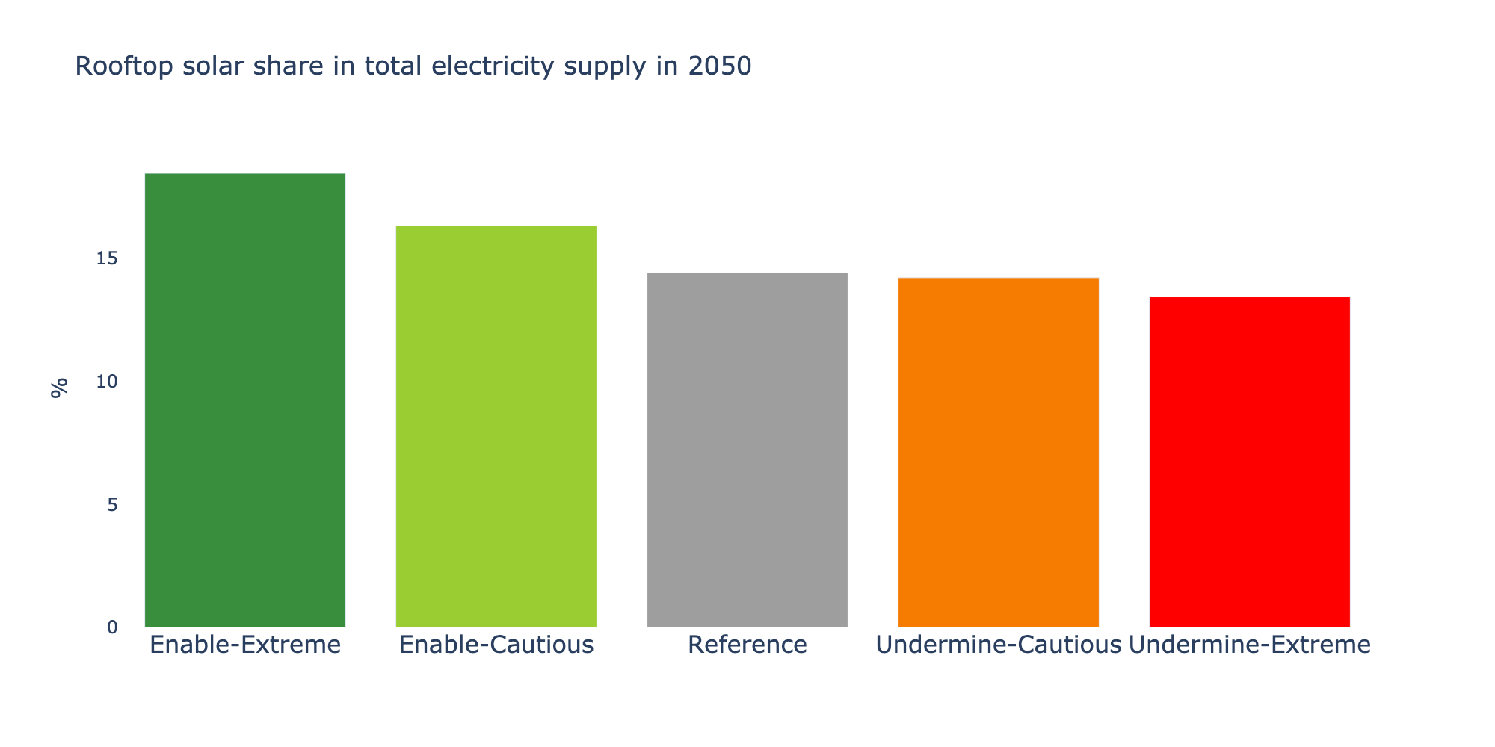
2°C | 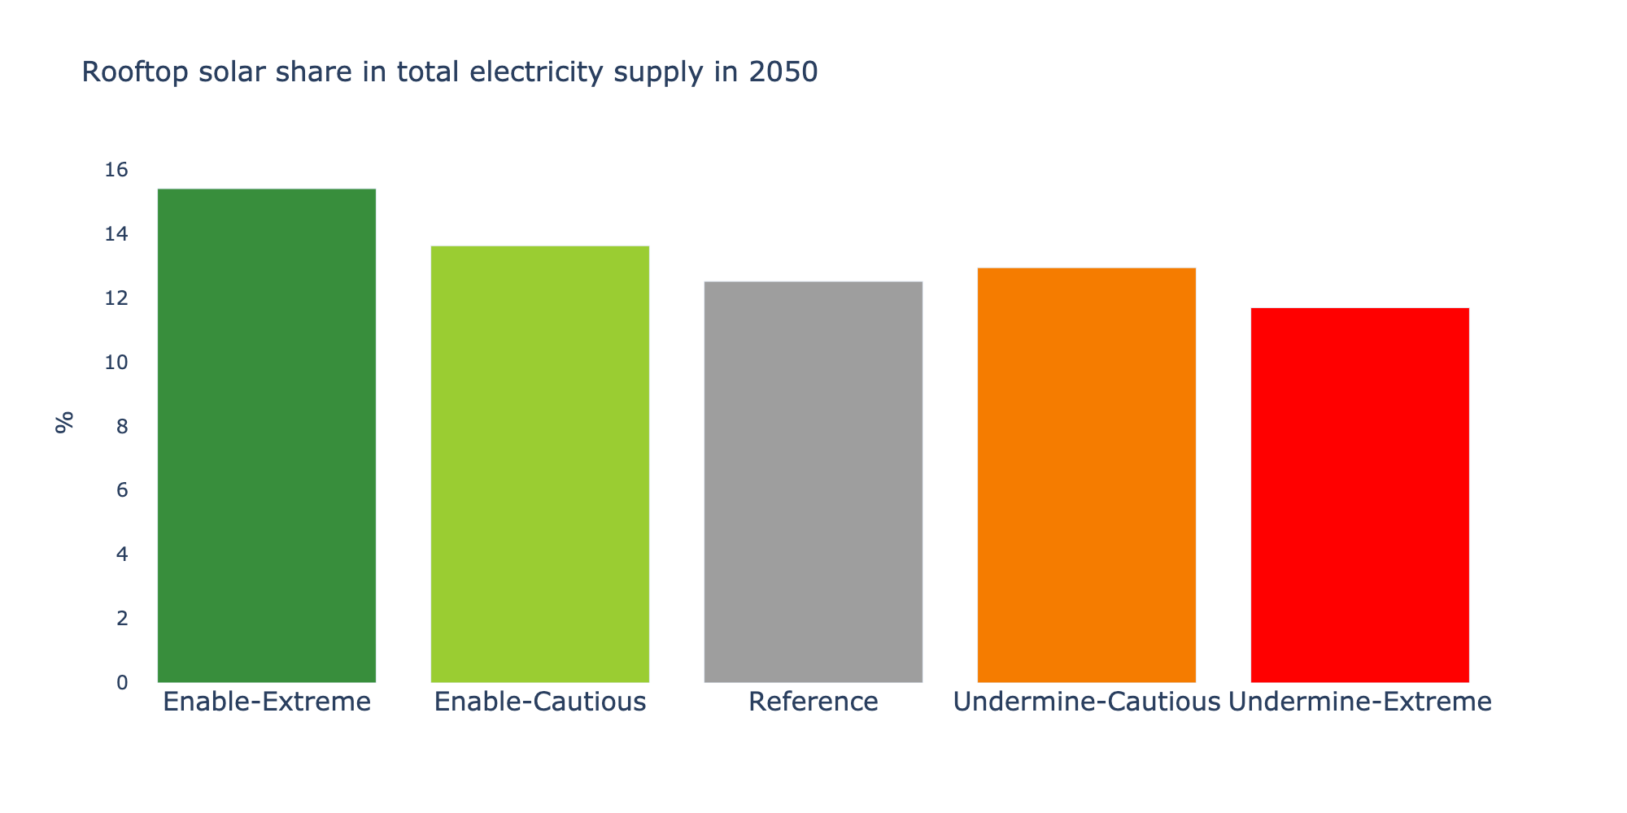

Figure 11. Distributed solar power generation.

Legend. Share of rooftop solar in total electricity generation in 2050. Top row = current climate ambition (CurPol); bottom row = strengthened climate ambition (2°C).

Climate-aligned digitalisation in Enable scenarios enables rooftop PV deployment by fully integrating distributed resources for system balancing. Digitalisation in Undermine scenarios sees end users optimising own use of distributed generation but imposing costs on overall system integration. Under strengthened climate ambition, larger absolute volumes of solar output (Figure 10) mean constraints on rooftop capacity are reached more quickly so the rooftop share is slightly lower than under current climate ambition.

global fossil CO₂ emissions
CurPol
2°C

Figure 12. Digitalisation impacts on global CO₂ emissions to 2050.

Legend: CO₂ emissions from fossil fuel combustion to 2050 globally in four digitalisation scenarios and a reference SSP2 scenario under current climate ambition (CurPol, upper panel) and strengthened climate ambition (2°C, lower panel). SSP1-5 pathways are shown for comparison. % differences in 2050 are relative to the reference scenario; note these % differences are amplified for lower absolute levels or in some declining emission pathways.

regional fossil CO₂ emissions (12 world regions)
CurPol
2°C

Figure 13. Digitalisation impacts on regional CO₂ emissions to 2050.

Legend: CO₂ emissions from fossil fuel combustion to 2050 in 12 world regions in four digitalisation scenarios and a reference SSP2 scenario under current climate ambition (CurPol, upper panel) and strengthened climate ambition (lower panel). SSP1-5 pathways are shown for comparison. % differences in 2050 are relative to the reference scenario; note these %s are amplified for lower absolute levels or in some declining emission pathways.

Region labels: AFR = Sub-saharan Africa; CHN = China; EEU = Central & eastern Europe; FSU = Former Soviet Union; LAM = Latin America & the Caribbean; MEA = Middle East & North Africa; NAM = north america; PAO = Pacific OECD; PAS = Other pacific Asia; RCPA = Rest of Centrally Planned Asia; SAS = South Asia; WEU = Western Europe.

The effect of digitalisation is overlaid on each region’s secular development trajectory which accounts for most of the inter-region variation. Compared with current climate ambition (CurPol, upper panel), projections under strengthened climate ambition are more consistent, trending downwards to zero, given the constraints of a very limited global carbon budget (2°C, lower panel).

However in our Undermine scenario with current climate ambition, digitalisation drives emissions further up in the Middle East, Africa, and Latin America while trends in Europe and Pacific Asia remain strongly downwards.

Figure 14. Sectoral contributions to CO₂ emission reductions from climate-misaligned to climate-aligned digitalisation.

Legend: Emission-reduction wedges from Undermine-Extreme to Enable-Extreme scenarios under strengthened climate ambition (2°C). ‘Supply’ denotes emissions from energy supply sectors (electricity & heat) assigned to final use or ‘Demand’ sectors. This is equivalent to conventional sectoral reporting combining Scope 1 (direct) + Scope (2) indirect emissions.

In the wedge plot, upstream electricity sector emissions are assigned to the corresponding end-use sector. Supply-side emission reductions are attributable both to the electrification of end-use (switching from direct use of fossil fuels) and to the decarbonisation of electricity generation. Emission-reduction wedges from supply-side electricity decarbonisation are of similar magnitude across all the end-use sectors (transport, industry, buildings).

The largest wedge of emission reductions from Undermine to Enable scenarios is from transportation, particularly fossil-fuelled passenger vehicles on land. The Undermine-Extreme scenario describes the compound risk of readily-available ride-hailing and mobility-as-a-service platforms making private vehicle travel cheaper and easier. This leads to defection from public and active transport especially in cities. In the absence of sufficiency norms & structural constraints on activity growth (Figure 1), digitalisation drives up auto-dependent mobility. In contrast, the Enable-Extreme scenario sees a more rapid transition to shared and electric mobility systems optimised from an urban or system planning perspective.

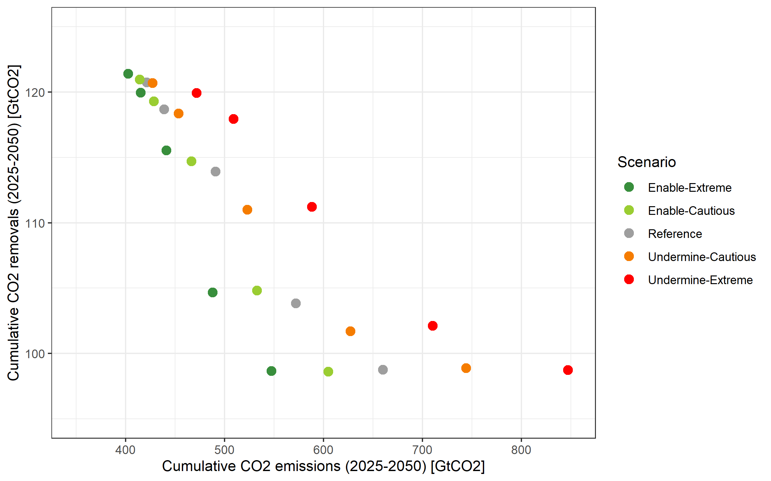

Figure 15. Digitalisation impacts on carbon dioxide removal (CDR) needs to 2050 under strengthened climate ambition (2°C).

Legend: Cumulative GtCO₂ removals (CDR) for given levels of cumulative GtCO₂ emissions over the period to 2050. The range of cumulative emissions within each digitalisation and reference scenario are generated by varying climate policy stringency (carbon price) to 2050 at multiples of roughly 2, 4, 8, and 16 over the main scenario variant.

An important feasibility dimension to Paris targets is the long-term dependence on carbon dioxide removal (CDR) imposed by slower near-term emission reductions. Cost-optimal emission pathways postpone large volumes of expensive and immature technological CDR to the second half of the century. This is beyond the timeframe of our digitalisation scenarios. However, even to 2050, the benefits of climate-aligned digitalisation for Paris target feasibility can be seen in the reduced risk of CDR reliance. Figure 15 shows the interdependence of medium-term (to 2050) cumulative emissions and removals for a given full century carbon budget.

For relatively higher cumulative emissions to 2050 upwards of 550 GtCO₂, climate-aligned digitalisation in Enable scenarios reduces the need for cumulative removals but only marginally by around 10% relative to the reference scenario. At lower cumulative emissions <500 GtCO₂ to 2050, the effect of digitalisation on CDR volumes is negligible. These scenario variants with more constrained carbon budgets (and so lower probabilities of overshoot) already exploit available upscaling of CDR volumes to 2050 (120 GtCO₂) so there is no additional flexibility for digitalisation to act on.

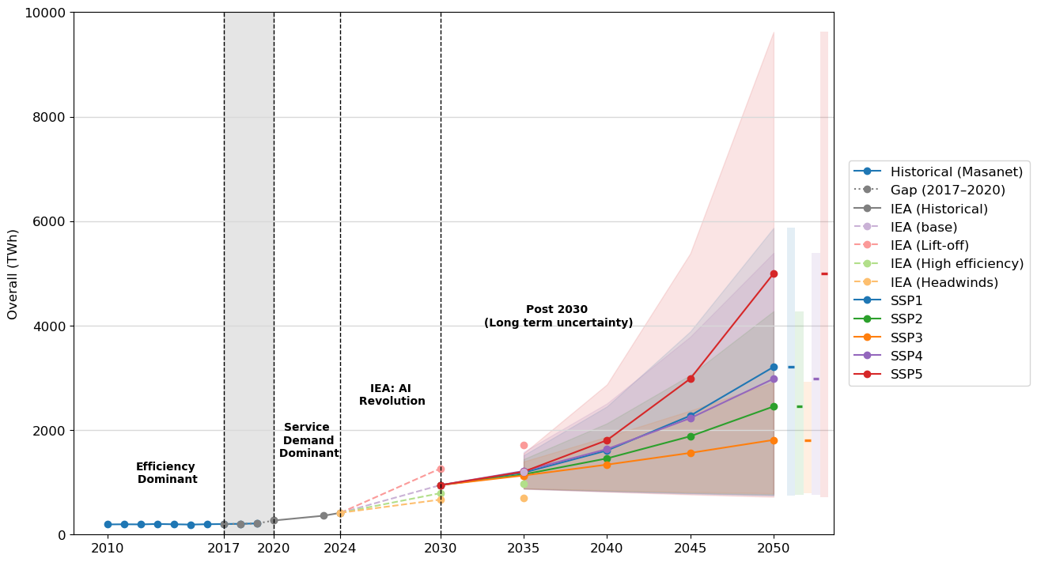

Figure 16. Projected global electricity demand of data centres extended through 2050 consistent with the Shared Socioeconomic Pathways (SSPs).

Shaded funnels = lower to upper bound ranges per SSP. Source: ¹⁹.

1. Spreng, D. Possibilities for substitution between energy, time and information. Energy Policy 21, 13–23 (1993).
2. Bocken, N. M., Niessen, L. & Short, S. W. The sufficiency-based circular economy—an analysis of 150 companies. Frontiers in sustainability 3, 899289 (2022).
3. Lovoskaya, A., Habib, N., Villanova del Moral, A. & Fourrier, C. CO₂ Emissions and Models Performance: Insights from the Open LLM Leaderboard. Hugging Face https://huggingface.co/blog/leaderboard-emissions-analysis.
4. Ramachandran Anu, Sarabu Chethan, Gupta Udit, Ghose Shomit, & Lee Vivian S. Sustainably Advancing Health AI: A Decision Framework to Mitigate the Energy, Emissions, and Cost of AI Implementation. NEJM Catalyst 6, CAT.25.0125 (2025).
5. Bieser, J. C. T., Hintemann, R., Hilty, L. M. & Beucker, S. A review of assessments of the greenhouse gas footprint and abatement potential of information and communication technology. Environmental Impact Assessment Review 99, 107033 (2023).
6. ITU. Enabling the Net Zero Transition: Assessing How the Use of Information and Communication Technology Solutions Impact Greenhouse Gas Emissions of Other Sectors. Recommendation ITU-T L.1480 (12/2022). (2022).
7. Furberg, A. et al. Guidelines for assessments of the global information and communication technology sector’s direct energy use and climate impact: Key aspects and future scenarios. Renewable and Sustainable Energy Reviews 226, 116176 (2026).
8. Luccioni, A. S., Strubell, E. & Crawford, K. From Efficiency Gains to Rebound Effects: The Problem of Jevons’ Paradox in AI’s Polarized Environmental Debate. Preprint at https://doi.org/10.48550/arXiv.2501.16548 (2025).
9. IEA. Energy and AI Observatory. (2025).
10. ADViCE. State of AI for Decarbonisation 2025. https://www.turing.ac.uk/research/research-projects/advice.
11. ADEME. Environmental Assessment of the Direct and Indirect Effects of Digital Technology on Use Cases (IT4Green). (2025).
12. Carlsen, H., Nykvist, B., Joshi, S. & Heintz, F. Chasing artificial intelligence in shared socioeconomic pathways. One Earth 7, 18–22 (2024).
13. Luers, A. et al. Will AI accelerate or delay the race to net-zero emissions? Nature 628, 718–720 (2024).
14. Cerutti, M. E. M. et al. Global Impact of AI: Mind the Gap. (2025).
15. OECD. Miracle or Myth? Assessing the Macroeconomic Productivity Gains from Artificial Intelligence. (2025).
16. Hirth, L., Ueckerdt, F. & Edenhofer, O. Integration costs revisited – An economic framework for wind and solar variability. Renewable Energy 74, 925–939 (2015).
17. Johnson, N. et al. A reduced-form approach for representing the impacts of wind and solar PV deployment on the structure and operation of the electricity system. Energy Economics 64, 651–664 (2017).
18. Sullivan, P., Krey, V. & Riahi, K. Impacts of considering electric sector variability and reliability in the MESSAGE model. Energy Strategy Reviews 1, 157–163 (2013).
19. Fan, Y. V., Wilson, C. & Kamiya, G. Data Centre Energy Demand Projections within Shared Socioeconomic Pathways. Energy & Climate Change (under review).

