Assessing ecosystem vulnerability to interannual climate variability: South American protected areas as a natural experiment

Supplementary materials

Hernán Dieguez^{1,2*}, Viviana Bondaruk^{2,3}, Gervasio Piñeiro^{2,3,4} & José Paruelo^{1,2,5,6}

1. Departamento de Métodos Cuantitativos y Sistemas de Información. Facultad de Agronomía. Universidad de Buenos Aires. Av. San Martín 4453, C1417DSE, Ciudad Autónoma de Buenos Aires. Argentina.
2. Laboratorio de Análisis Regional y Teledetección. IFEVA-Facultad de Agronomía. Universidad de Buenos Aires - CONICET. Av. San Martín 4453, C1417DSE, Ciudad Autónoma de Buenos Aires. Argentina.
3. Cátedra de Ecología, Departamento de RRNN y Ambiente. Facultad de Agronomía. Universidad de Buenos Aires. Av. San Martín 4453, C1417DSE, Ciudad Autónoma de Buenos Aires. Argentina.
4. Departamento de Sistemas Ambientales. Facultad de Agronomía. Universidad de la República. Av. Garzón 780, Montevideo. Uruguay.
5. Instituto Nacional de Investigación Agropecuaria (INIA) - La Estanzuela. Ruta 50 Km. 11, Colonia. Uruguay.
6. IECA – Facultad de Ciencias. Universidad de la República. Iguá 4225, 11400, Montevideo. Uruguay.

*Corresponding author: hdieguez@agro.uba.ar; Av. San Martín 4453, C1417DSE
Supplementary material 1: Examples of contrasting mean annual NDVI (NDVI_{m}) responses to interannual precipitation variability across sites. Similar relationships can be constructed with temperature. Panels show relationships between NDVI_{m} and total annual precipitation (TAP) for representative protected areas illustrating different response patterns: (a) positive, negative or null slopes, and similar R² despite contrasting slopes (b) contrasting R² despite similar slope, and (c) a better fit (higher R²) of the logarithmic model compared to the linear model indicating a saturating response. Points represent individual years, and black lines indicate fitted models, with equations and coefficients of determination (R²) shown in each panel.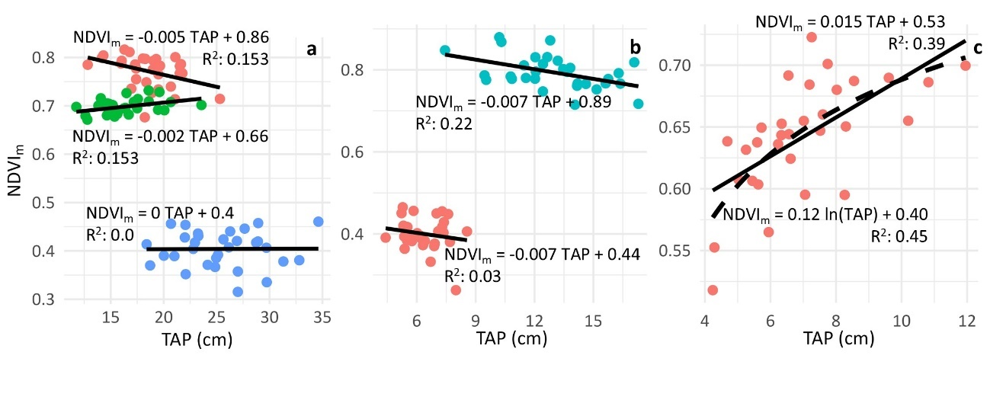

Supplementary material 2: Results of pairwise comparisons (two-tailed Dunn’s test) among climatic classes. Z statistics (p-values) are reported for each comparison and variable.
 | Sensitivity to precipitation | Association with precipitation | Sensitivity to temperature | Association with temperature | Δ R² NDVI_{m} vs TAP (Log – Lin) | Δ CV (Dry – Wet) | Δ CV (Cold – Warm)
Arid – Semi-arid | -2.04 (0.0207) | -3.14 (0.0009) | 1.11 (0.1336) | -1.66 (0.0488) | -3.29 (0.0005) | -1.46 (0.0721) | 0.22 (0.4147)
Arid – Dry subhumid | -1.56 (0.0599) | -2.52 (0.0058) | -0.29 (0.3856) | 0.09 (0.4643) | -4.01 (0.0000) | -0.77 (0.2213) | -0.08 (0.4683)
Semi-arid – Dry subhumid | 0.13 (0.4498) | 0.05 (0.4782) | -1.27 (0.1021) | 1.53 (0.0629) | -1.38 (0.0836) | -0.46 (0.3244) | 0.27 (0.3933)
Arid – Subhumid | 0.25 (0.3998) | 0.38 (0.3524) | -1.75 (0.0400) | -0.71 (0.2390) | -0.81 (0.2103) | 0.48 (0.3140) | -0.86 (0.1960)
Semi-arid – Subhumid | 2.41 (0.0079) | 3.70 (0.0001) | -3.06 (0.0011) | 0.97 (0.1666) | 2.58 (0.0049) | 2.05 (0.0200) | -1.15 (0.1248)
Dry subhumid – Subhumid | 1.83 (0.0339) | 2.93 (0.0017) | -1.23 (0.1094) | -0.71 (0.2381) | 3.43 (0.0003) | 1.22 (0.1121) | -0.67 (0.2527)
Arid – Humid | 1.18 (0.1197) | -0.39 (0.3465) | -2.79 (0.0026) | -2.15 (0.0159) | -2.03 (0.0311) | 1.22 (0.1113) | -2.29 (0.0110)
Semi-arid – Humid | 4.35 (0.0000) | 4.15 (0.0000) | -4.85 (0.0000) | -0.05 (0.4816) | 2.49 (0.0063) | -3.55 (0.0002) | 2.96 (0.0015)
Dry subhumid – Humid | 2.90 (0.0019) | 2.84 (0.0023) | -1.89 (0.0292) | -1.85 (0.0325) | 3.38 (0.0004) | 1.95 (0.0259) | -1.75 (0.0400)
Subhumid – Humid | 0.91 (0.1811) | -0.96 (0.1675) | -0.54 (0.2961) | -1.31 (0.0945) | -1.05 (0.1465) | -0.63 (0.2642) | 1.26 (0.1036)

Supplementary material 3: Results of one-sample Wilcoxon signed-rank tests against zero. Medians (p-values) are reported for each climate class and variable.

 | Sensitivity to precipitation | Sensitivity to temperature | Δ R² NDVIm vs TAP (Log – Lin) | Δ R² NDVIm vs AMT (Log – Lin) | Δ CV (Dry – Wet) | Δ CV (Cold – Warm)
Arid | 6.1e-06 (0.23) | -0.0004 (0.62) | -0.002 (0.2) | 0.0000 (0.4) | 0.0008 (0.4) | -0.0087 (0.23)
Semi-arid | 1.0e-04 (0.003) | -0.02 (0.007) | 0.0269 (0.013) | -0.0000 (0.98) | 0.0204 (0.008) | -0.0051 (0.02)
Dry subhumid | 5.9e-05 (0.02) | -0.0023 (0.55) | 0.0292 (0.022) | 0.0000 (0.67) | 0.0074 (0.002) | 0.0001 (0.67)
Subhumid | 7.4e-06 (0.26) | 0.0102 (0.014) | -0.0006 (0.58) | 0.0000 (0.06) | -0.0019 (0.94) | 0.0035 (0.33)
Humid | 4.7e-06 (0.54) | 0.0145 (<0.001) | 0.0004 (0.08) | 0.0000 (0.28) | -0.0016 (0.14) | 0.0061 (<0.001)

