Supplementary Materials
Qualitative Interview Questions
- How do you describe your pre-displacement lives and conditions? What were the circumstances leading to your displacement?
သင်၏ နေရပ်စွန့်ခွာမီ ဘဝနှင့် အခြေအနေများကို ဘယ်လိုဖော်ပြမလဲ။ သင့်ကို နေရပ်စွန့်ခွာစေတဲ့ အခြေအနေတွေက ဘာတွေလဲ။
- How do you understand “Resilience”?How do you perceive your own resilience and the resilience of your community?
ပြန်လည်ထူထောင်နိုင်စွမ်း" ဆိုတာကို ဘယ်လိုနားလည်လဲ။ ကိုယ့်ကိုယ်ကိုယ်နဲ့ ကိုယ့်အသိုင်းအဝိုင်းရဲ့ ပြန်လည်ထူထောင်နိုင်စွမ်းကို ဘယ်လိုမြင်လဲ။
Prompt question for 2 - Can you describe specific instances or experiences where you observed resilience among IDP communities? What factors do you think contributed to this resilience?
နေရပ်စွန့်ခွာရသူ အသိုင်းအဝိုင်းတွေကြားမှာ ပြန်လည်ထူထောင်နိုင်စွမ်းကို သင်တွေ့မြင်ခဲ့တဲ့ အချက်အလက်တွေ ဒါမှမဟုတ် အတွေ့အကြုံတွေကို ပြောပြနိုင်လား။ ဒီပြန်လည်ထူထောင်နိုင်စွမ်းကို ဖြစ်ပေါ်စေတဲ့ အချက်တွေက ဘာတွေလို့ ထင်လဲ။
- How do you feel about current approaches to supporting internally displaced populations (IDPs) in Myanmar?
မြန်မာနိုင်ငံမှာ နေရပ်စွန့်ခွာရသူတွေကို ထောက်ပံ့ရေးအတွက် လက်ရှိလုပ်ဆောင်နေတဲ့ နည်းလမ်းတွေကို ဘယ်လိုခံစားလဲ။
Prompt question for 3 - What are working well and what key elements do you believe are missing or insufficient? What role do you believe NGOs and other development organizations should play in shifting the focus from vulnerability to resilience for IDP communities in Myanmar? What long-term strategies do you think are necessary?
ဘာတွေက အဆင်ပြေနေလဲ၊ ဘာတွေက လိုအပ်နေသေးလဲ။ မြန်မာနိုင်ငံမှာ နေရပ်စွန့်ခွာရသူ အသိုင်းအဝိုင်းတွေ အားနည်းချက်ကနေ ပြန်လည်ထူထောင်နိုင်စွမ်းကို ရောက်အောင် အစိုးရမဟုတ်တဲ့ အဖွဲ့အစည်းတွေနဲ့ ဖွံ့ဖြိုးရေး အဖွဲ့အစည်းတွေက ဘာလုပ်သင့်လဲ။ ရေရှည် စီမံကိန်းတွေအနေနဲ့ ဘာတွေလိုအပ်လဲ။
- How have internally displaced persons in Myanmar developed coping mechanisms and resilience approaches to navigate the challenges of displacement?
မြန်မာနိုင်ငံမှာ နေရပ်စွန့်ခွာရသူတွေက နေရပ်စွန့်ခွာရတဲ့ ခက်ခဲမှုတွေကို ကျော်ဖြတ်ဖို့ ဘယ်လို ကြုံတွေ့ဖြေရှင်းနည်းတွေနဲ့ ပြန်လည်ထူထောင်နိုင်စွမ်းနည်းလမ်းတွေကို ဖွံ့ဖြိုးခဲ့လဲ။
Prompt question 4 -what role do social networks and community support play in this process? How has displacement affected your mental well-being?
ဒီလုပ်ငန်းစဉ်မှာ လူမှုကွန်ရက်နဲ့ အသိုင်းအဝိုင်းထောက်ပံ့မှုတွေက ဘယ်လိုအခန်းကဏ္ဍမှ ပါဝင်လဲ။ နေရပ်စွန့်ခွာတာက သင့်စိတ်ကျန်းမာရေးကို ဘယ်လိုအကျိုးသက်ရောက်လဲ။

Supplementary Table 1. Thematic Analysis of the interview content (n=23)
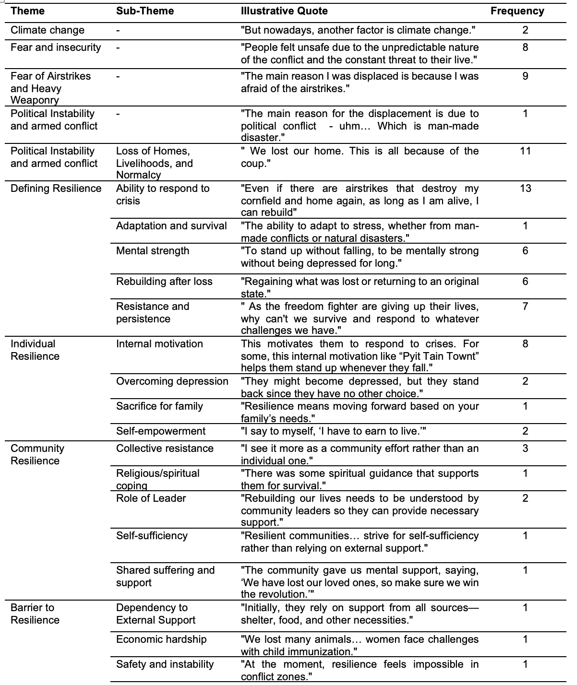

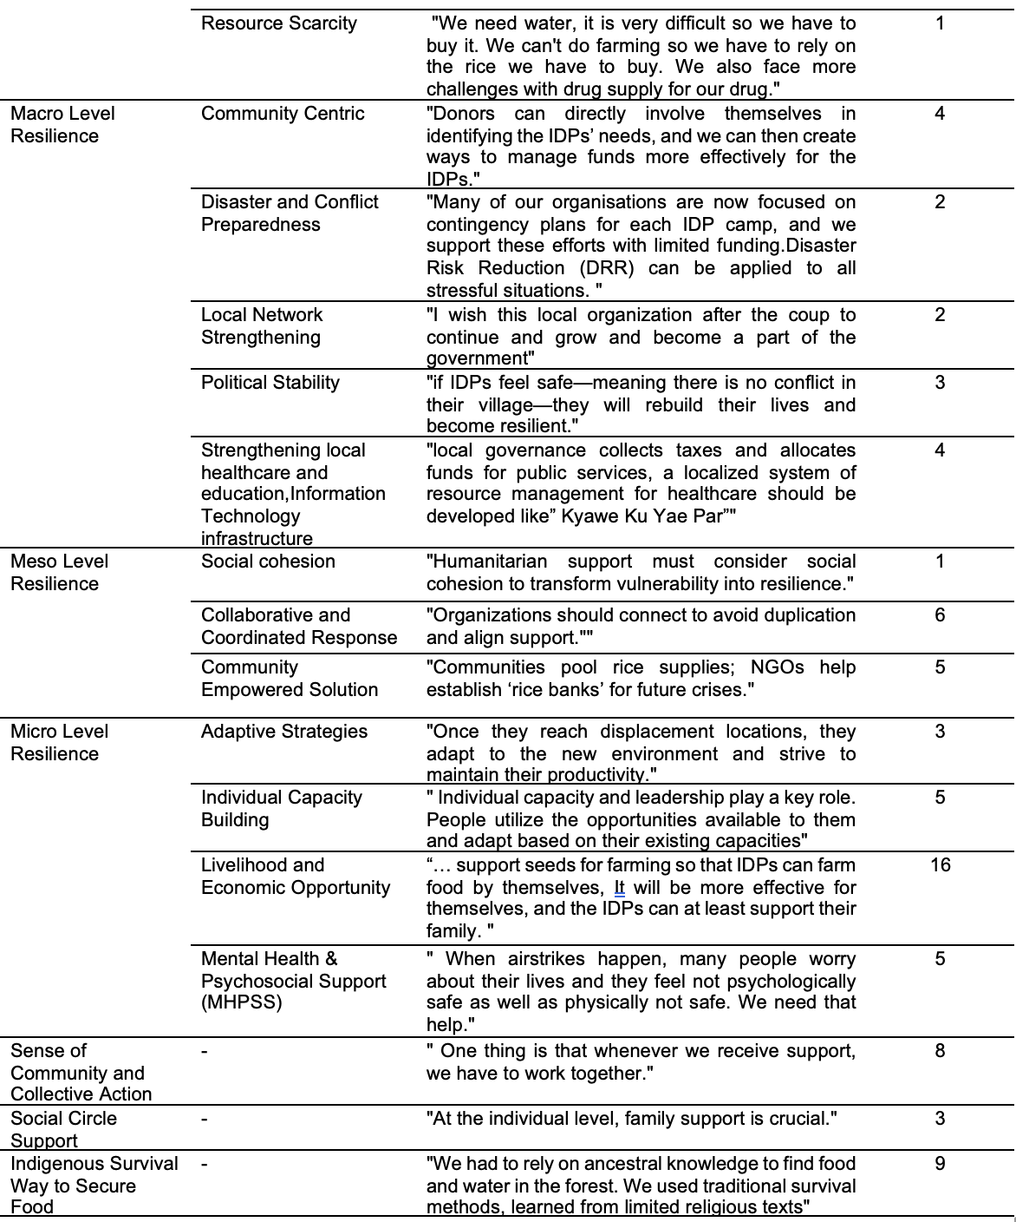

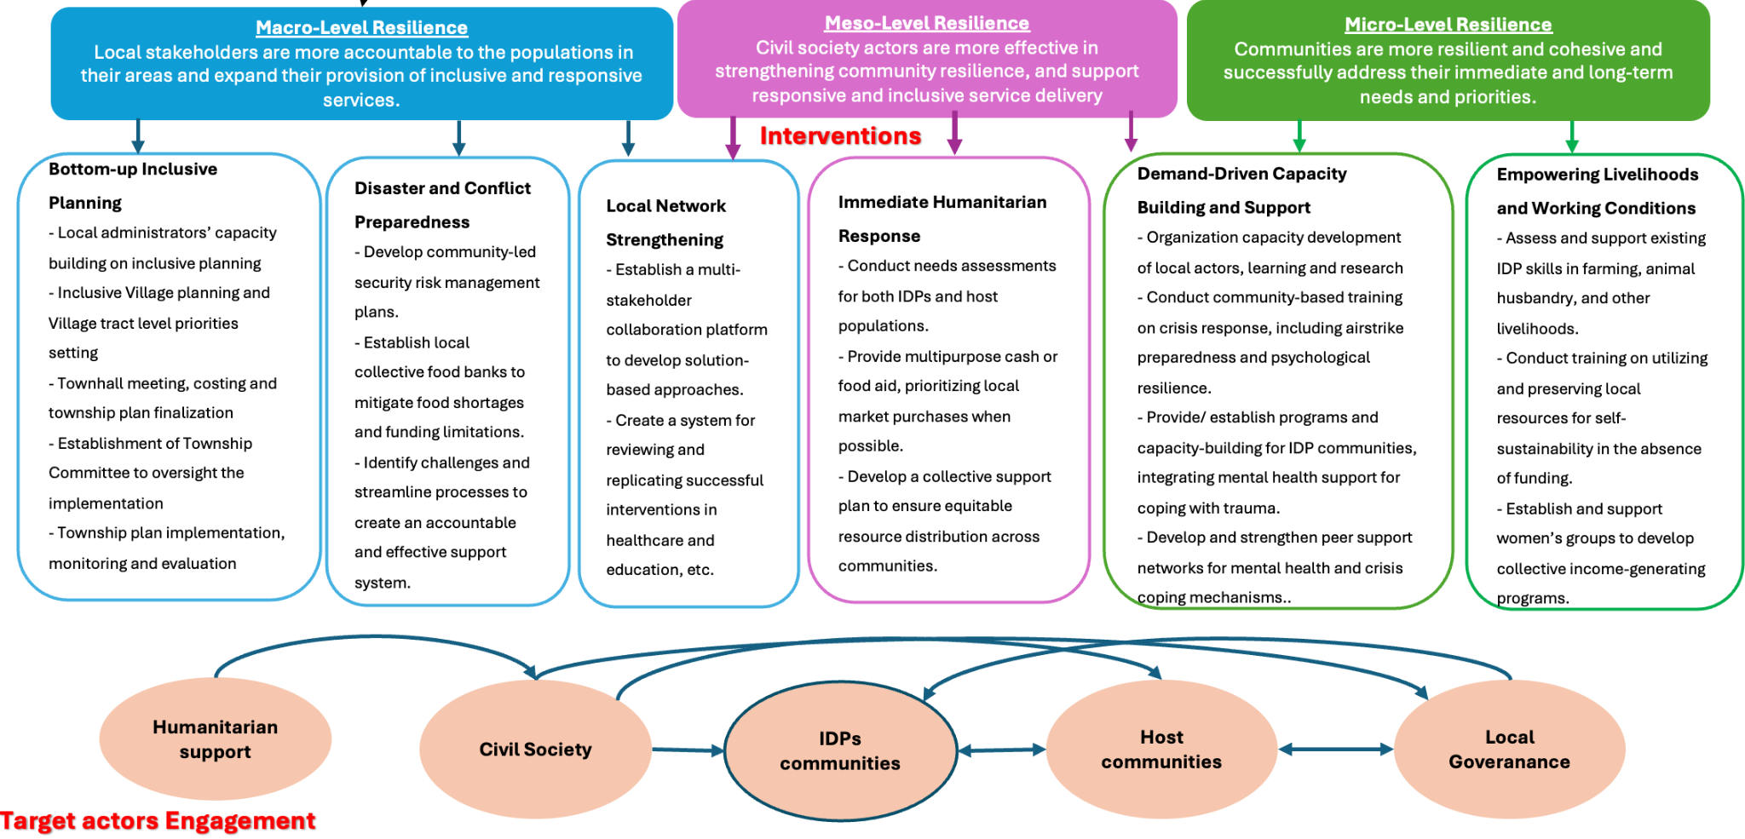

Supplementary Fig.1 . Conceptual Framework for Enhancing Resilience Among the Internally Displaced Populations (IDPs) in Myanmar

Consolidated criteria for reporting qualitative studies (COREQ): 32-item checklist

Developed from:
Tong A, Sainsbury P, Craig J. Consolidated criteria for reporting qualitative research (COREQ): a 32-item checklist for interviews and focus groups. International Journal for Quality in Health Care. 2007. Volume 19, Number 6: pp. 349 – 357

Manuscript: Reevaluating Gaps and Strengthening Support Strategies for Internally Displaced Populations (IDPs) in Southeastern Myanmar Post-Military Coup: A Qualitative Study

No. Item | Guide questions/description | Reported on Page #
Domain 1: Research team and reﬂexivity
Personal Characteristics
1. Interviewer/facilitator | Which author/s conducted the inter view or focus group? | Interview
2. Credentials | What were the researcher’s credentials? E.g. PhD, MD | PhD candidate
3. Occupation | What was their occupation at the time of the study? | PhD candidate
4. Gender | Was the researcher male or female? | Male
5. Experience and training | What experience or training did the researcher have? | MPH
Relationship with participants
6. Relationship established | Was a relationship established before study commencement? | Nil
7. Participant's knowledge of the interviewer | What did the participants know about the researcher? e.g. personal goals, reasons for doing the research | Reasons for doing the research
8. Interviewer characteristics | What characteristics were reported about the interviewer/facilitator? e.g. Bias, assumptions, reasons and interests in the research topic | Bias, assumptions, reasons and interests in the research topic

Domain 2: study design
Theoretical framework
9. Methodological orientation and Theory | What methodological orientation was stated to underpin the study? e.g. grounded theory, discourse analysis, ethnography, phenomenology, content analysis | Grounded theory
Participant selection
10. Sampling | How were participants selected? e.g. purposive, convenience, consecutive, snowball | mix of purposive and snowball sampling approaches
11. Method of approach | How were participants approached? e.g. face-to-face, telephone, mail, email | in-depth online and in-person interviews
12. Sample size | How many participants were in the study? | 23
13. Non-participation | How many people refused to participate or dropped out? Reasons? | Nil
Setting
14. Setting of data collection | Where was the data collected? e.g. home, clinic, workplace | IDP camps in person and homes of participants online  .
15. Presence of non-participants | Was anyone else present besides the participants and researchers? | one-to-one interview
16. Description of sample | What are the important characteristics of the sample? e.g. demographic data, date | demographic data
Data collection
17. Interview guide | Were questions, prompts, and guides provided by the authors? Was it pilot-tested? | Supplementary files
18. Repeat interviews | Were repeat interviews carried out? If yes, how many? | No.
19. Audio/visual recording | Did the research use audio or visual recording to collect the data? | Audio record and transcript
20. Field notes | Were ﬁeld notes made during and/or after the interview or focus group? | Yes
21. Duration | What was the duration of the interviews or focus group? | 20 – 40 minutes
22. Data saturation | Was data saturation discussed? | Yes
23. Transcripts returned | Were transcripts returned to participants for comment and/or correction? | Yes
Domain 3: analysis and ﬁndings
Data analysis
24. Number of data coders | How many data coders coded the data?
25. Description of the coding tree | Did the authors describe the coding tree? | Yes
26. Derivation of themes | Were themes identiﬁed in advance or derived from the data? | No
27. Software | What software, if applicable, was used to manage the data? | CMATA, Taguette software along with excel for coding and Canva for theory map
28. Participant checking | Did participants provide feedback on the ﬁndings? | Yes
Reporting
29. Quotations presented | Were participant quotations presented to illustrate the themes/ﬁndings? Was each quotation identiﬁed? e.g. participant number | Yes
30. Data and ﬁndings consistent | Was there consistency between the data presented and the ﬁndings? | Yes,
31. Clarity of major themes | Were major themes presented in the ﬁndings? | Yes
32. Clarity of minor themes | Is there a description of diverse cases or a discussion of minor themes? | Discussion of major and minor themes

