One-pot synthesis and in silico ADME profiling of 1,4-dihydropyridine derivatives catalyzed by ProMSA ionic liquid under solvent-free conditions
Nitin R. Rode^{a*}, Kishor B. Kaleª, Santosh S. Terdale^{b}
ªDepartment of Chemistry, Nowrosjee Wadia College, Pune-411 001, Maharashtra, India
^{b}Department of Chemistry, Savitribai Phule Pune University, Ganeshkhind, Pune-411 007, Maharashtra, India,
*E-mail: nrrode@nowrosjeewadiacollege.edu.in, kbkale@nowrosjeewadiacollege.edu.in, santosh.terdale@unipune.ac.in

Experimental:
Materials and methods
Chemicals were purchased from Merks, Sigma, Spectrochem chemical companies and used without further purification. ¹H NMR spectra were recorded in CDCl₃ solution on Bruker 400 MHz spectrometer; the chemical shifts are reported in ppm (δ) relative to internal standard TMS (0 ppm). FT-IR of neat compounds was recorded on Tensor 37 (Platinum ATR). The melting points were obtained on melting point apparatus in open capillary method and were uncorrected. The product were isolated and purified by recrystallization from ethanol. All yield refers to the isolated product.
General procedure for synthesis of 1, 4-dihydropyridine derivatives (5a-5g)
A round-bottom flask was charged with aromatic aldehyde (10 mmol), ethyl or methyl acetoacetate (20 mmol), ammonium acetate (15 mmol), and the AAIL catalyst ProMSA (10 mol%). The reaction mixture was stirred at 100˚C for the appropriate time, and progress was monitored by TLC. Upon completion, the reaction mixture was cooled to room temperature, and ethanol (10 mL) was added. The mixture was stirred for 30 minutes to obtain the crude solid product. The solid was collected by filtration using Whatman filter paper, washed thoroughly with cold ethanol and hexane to remove traces of aldehyde, and recrystallized from ethanol if necessary.
General procedure for synthesis of 1, 4-dihydropyridine derivatives (6a-6g)
A round-bottom flask was charged with dimedone (10 mmol), aromatic aldehyde (10 mmol), ethyl or methyl acetoacetate (10 mmol), ammonium acetate (15 mmol), and the AAIL catalyst ProMSA (10 mol%). The reaction mixture was stirred at 100˚C for the appropriate time, and progress was monitored by TLC. Upon completion, the reaction mixture was cooled to room temperature, and ethanol (10 mL) was added. The mixture was stirred for 30 minutes to obtain the crude solid product. The solid was collected by filtration using Whatman filter paper, washed thoroughly with cold ethanol and hexane to remove traces of aldehyde, and recrystallized from ethanol if necessary.
Table S1: Lipinksi Rule
Entry | MW | H-bond acceptors | H-bond donors | iLOGP | MR | Violation
1 | 335.78 | 4 | 1 | 3.24 | 90.71 | 0
2 | 346.33 | 6 | 1 | 2.68 | 94.52 | 0
3 | 346.33 | 6 | 1 | 2.68 | 94.52 | 0
4 | 331.36 | 5 | 1 | 3.29 | 92.19 | 0
5 | 317.34 | 5 | 2 | 2.68 | 87.73 | 0
6 | 359.85 | 3 | 1 | 3.39 | 101.67 | 0
7 | 371.43 | 5 | 2 | 3.23 | 105.18 | 0
8 | 325.4 | 3 | 1 | 3.1 | 96.66 | 0
9 | 370.4 | 5 | 1 | 2.9 | 105.49 | 0
10 | 363.84 | 4 | 1 | 3.59 | 100.33 | 0
11 | 375.42 | 6 | 2 | 3.37 | 103.83 | 0
12 | 357.42 | 4 | 1 | 3.48 | 101.43 | 0
13 | 353.45 | 3 | 1 | 3.57 | 106.44 | 0
14 | 369.45 | 4 | 1 | 3.49 | 107.96 | 0

Table S2: Veber Rule
Entry | Rotatable bonds | TPSA | Violation
1 | 5 | 64.63 | 0
2 | 6 | 110.45 | 0
3 | 6 | 110.45 | 0
4 | 6 | 73.86 | 0
5 | 5 | 84.86 | 0
6 | 3 | 55.4 | 0
7 | 4 | 84.86 | 0
8 | 3 | 55.4 | 0
9 | 4 | 101.22 | 0
10 | 7 | 64.63 | 0
11 | 8 | 94.09 | 0
12 | 4 | 55.4 | 0
13 | 4 | 55.4 | 0
14 | 5 | 64.63 | 0

Table S3: Ghose Filter
Entry | MW | WLOGP | MR | Heavy atoms | Violation
1 | 335.78 | 2.54 | 90.71 | 23 | 0
2 | 346.33 | 1.79 | 94.52 | 25 | 0
3 | 346.33 | 1.79 | 94.52 | 25 | 0
4 | 331.36 | 1.9 | 92.19 | 24 | 0
5 | 317.34 | 1.59 | 87.73 | 23 | 0
6 | 359.85 | 3.74 | 101.67 | 25 | 0
7 | 371.43 | 2.8 | 105.18 | 27 | 0
8 | 325.4 | 3.08 | 96.66 | 24 | 0
9 | 370.4 | 2.99 | 105.49 | 27 | 0
10 | 363.84 | 3.32 | 100.33 | 25 | 0
11 | 375.42 | 2.38 | 103.83 | 27 | 0
12 | 357.42 | 4.03 | 101.43 | 26 | 0
13 | 353.45 | 3.78 | 106.44 | 26 | 0
14 | 369.45 | 3.48 | 107.96 | 27 | 0

Table S4: Egan rule
Entry | iLOGP | TPSA | Violation
1 | 3.24 | 64.63 | 0
2 | 2.68 | 110.45 | 0
3 | 2.68 | 110.45 | 0
4 | 3.29 | 73.86 | 0
5 | 2.68 | 84.86 | 0
6 | 3.39 | 55.4 | 0
7 | 3.23 | 84.86 | 0
8 | 3.1 | 55.4 | 0
9 | 2.9 | 101.22 | 0
10 | 3.59 | 64.63 | 0
11 | 3.37 | 94.09 | 0
12 | 3.48 | 55.4 | 0
13 | 3.57 | 55.4 | 0
14 | 3.49 | 64.63 | 0

Table S5: Muegge Rule
Entry | MW | iLOGP | TPSA | H-bond acceptors | H-bond donors | Rotatable bonds | Violation
1 | 335.78 | 3.24 | 64.63 | 4 | 1 | 5 | 0
2 | 346.33 | 2.68 | 110.45 | 6 | 1 | 6 | 0
3 | 346.33 | 2.68 | 110.45 | 6 | 1 | 6 | 0
4 | 331.36 | 3.29 | 73.86 | 5 | 1 | 6 | 0
5 | 317.34 | 2.68 | 84.86 | 5 | 2 | 5 | 0
6 | 359.85 | 3.39 | 55.4 | 3 | 1 | 3 | 0
7 | 371.43 | 3.23 | 84.86 | 5 | 2 | 4 | 0
8 | 325.4 | 3.1 | 55.4 | 3 | 1 | 3 | 0
9 | 370.4 | 2.9 | 101.22 | 5 | 1 | 4 | 0
10 | 363.84 | 3.59 | 64.63 | 4 | 1 | 7 | 0
11 | 375.42 | 3.37 | 94.09 | 6 | 2 | 8 | 0
12 | 357.42 | 3.48 | 55.4 | 4 | 1 | 4 | 0
13 | 353.45 | 3.57 | 55.4 | 3 | 1 | 4 | 0
14 | 369.45 | 3.49 | 64.63 | 4 | 1 | 5 | 0

5a
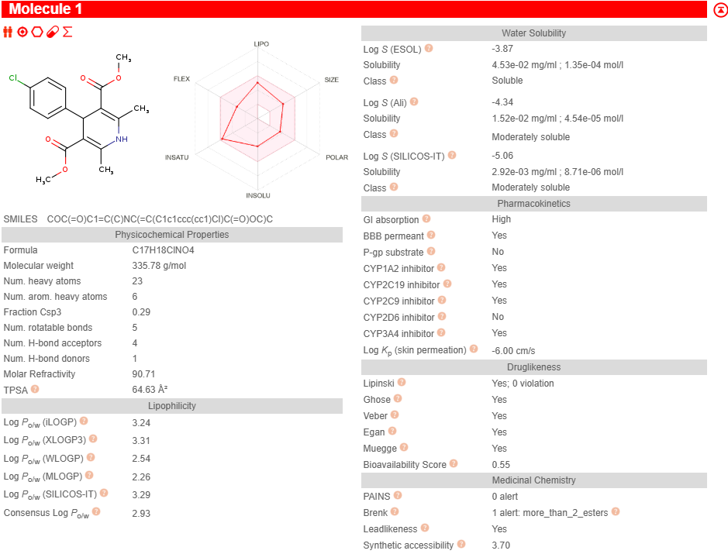

5b
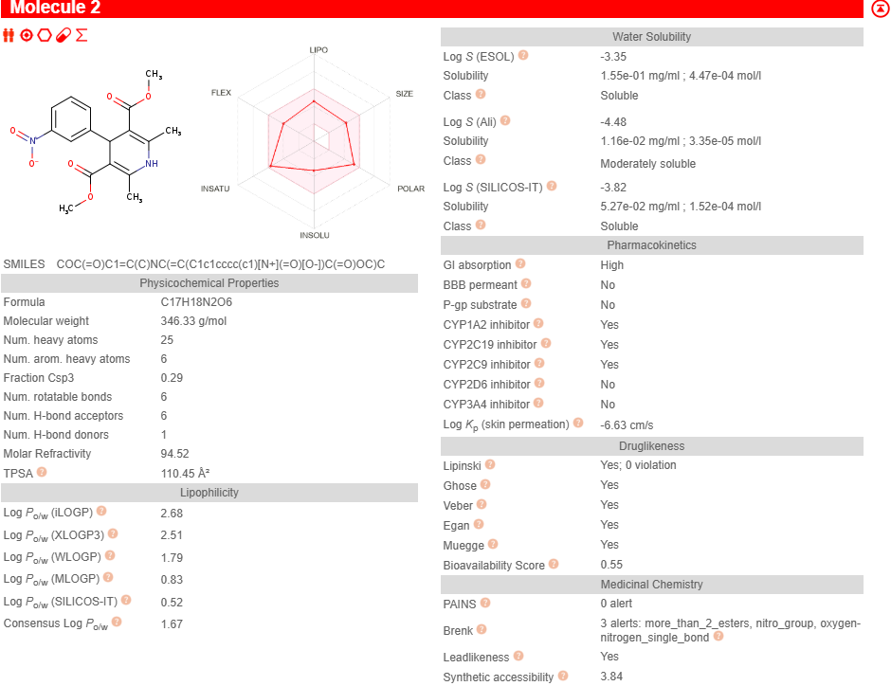
5c
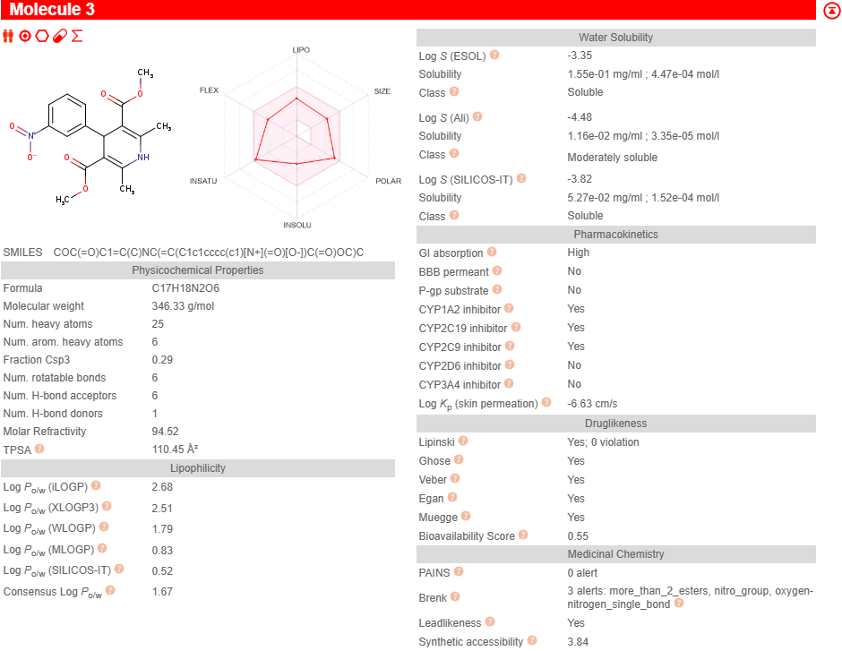

5d
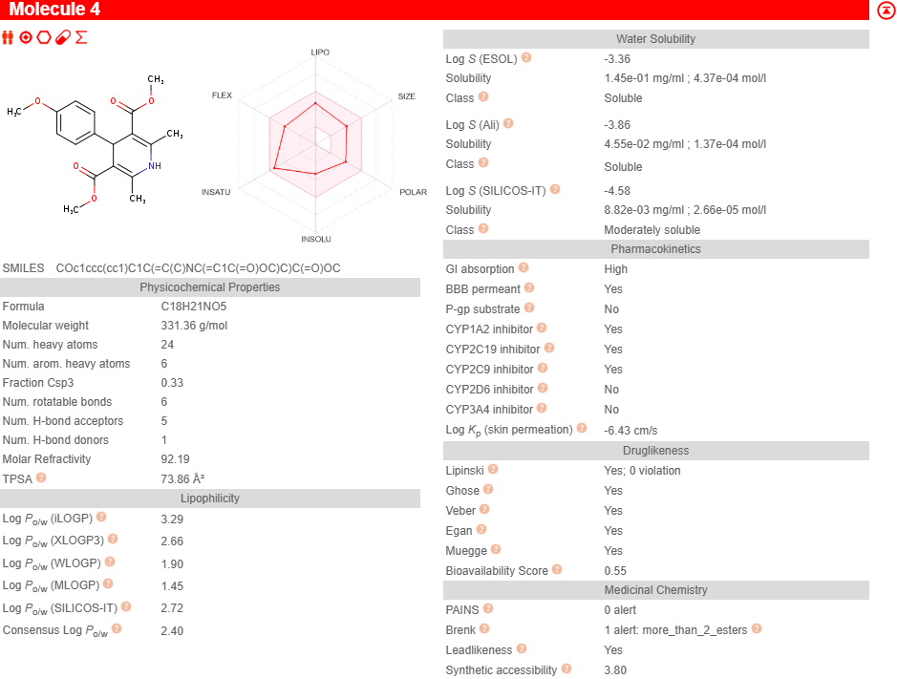
5e
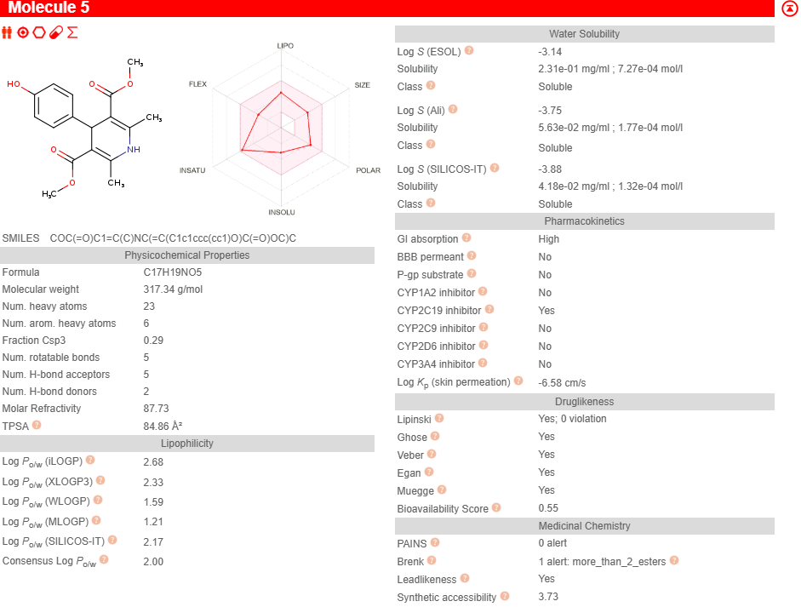

5f
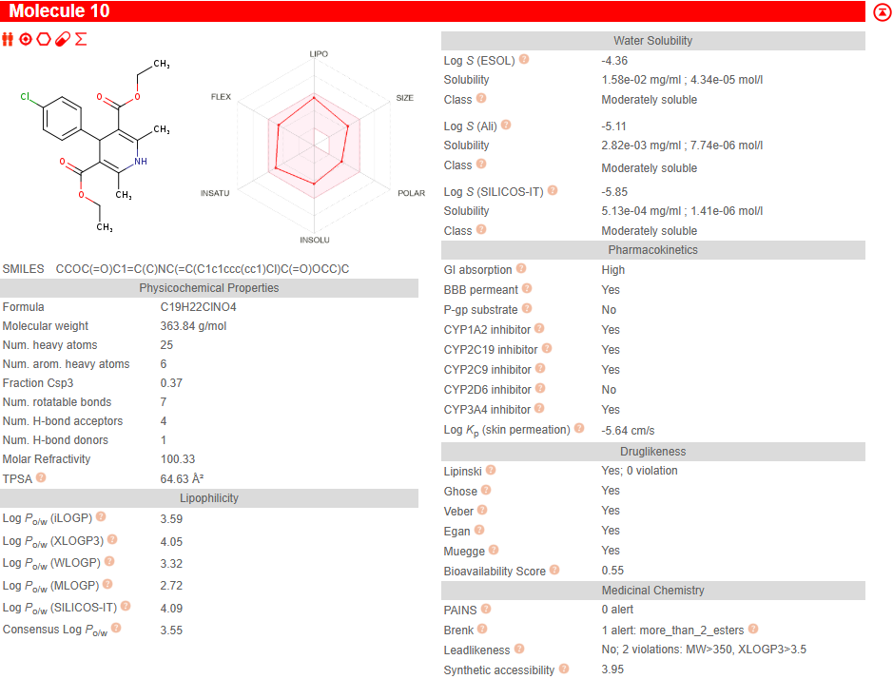
5g
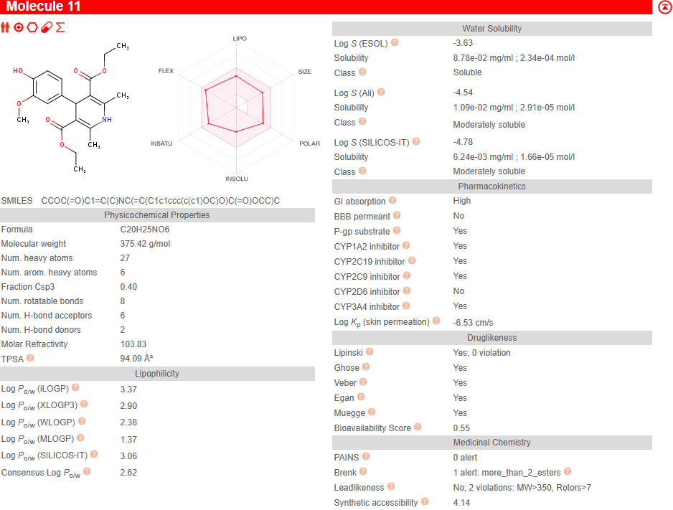

6a
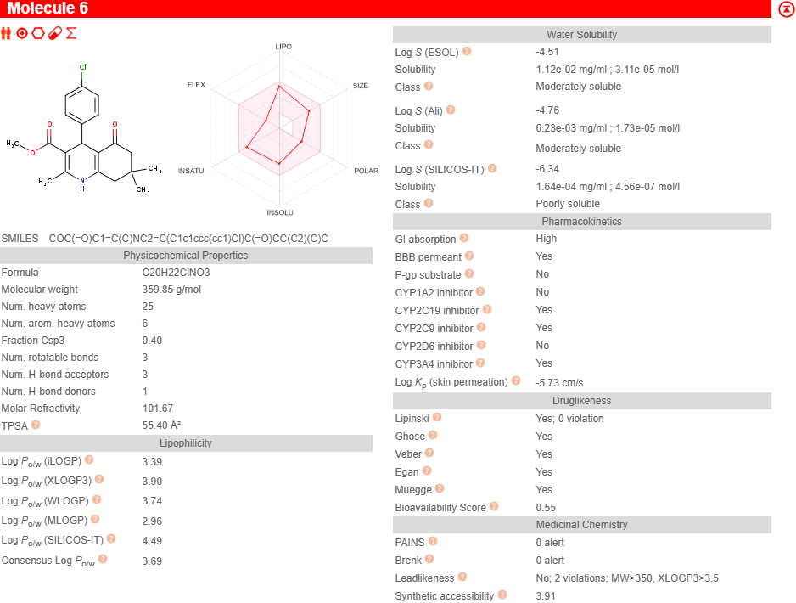
6b
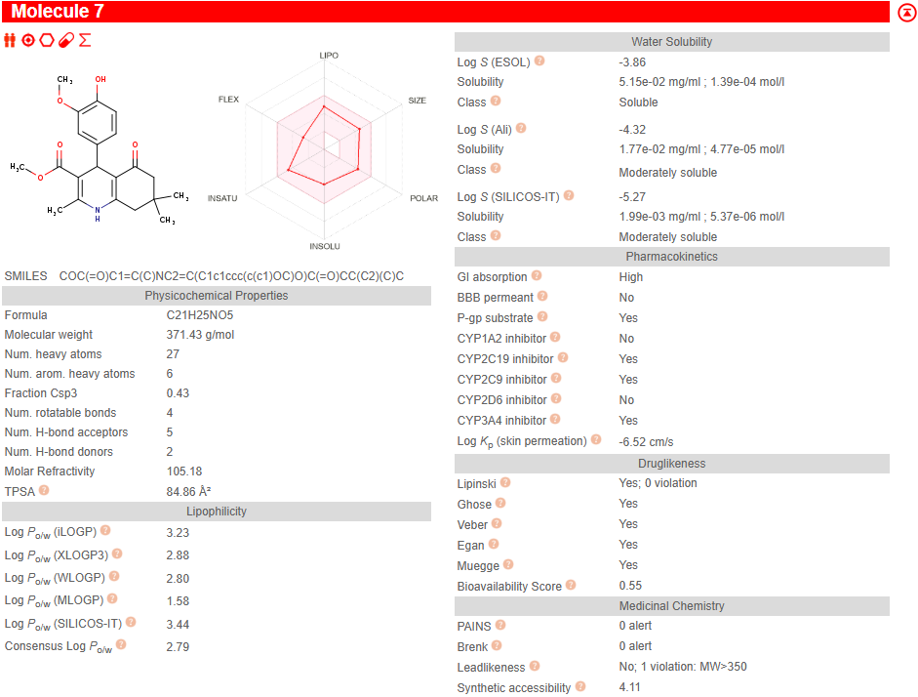

6c
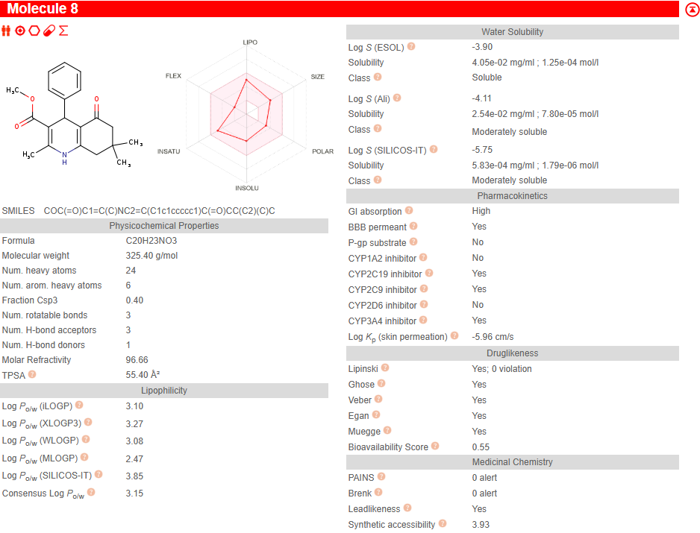
6d
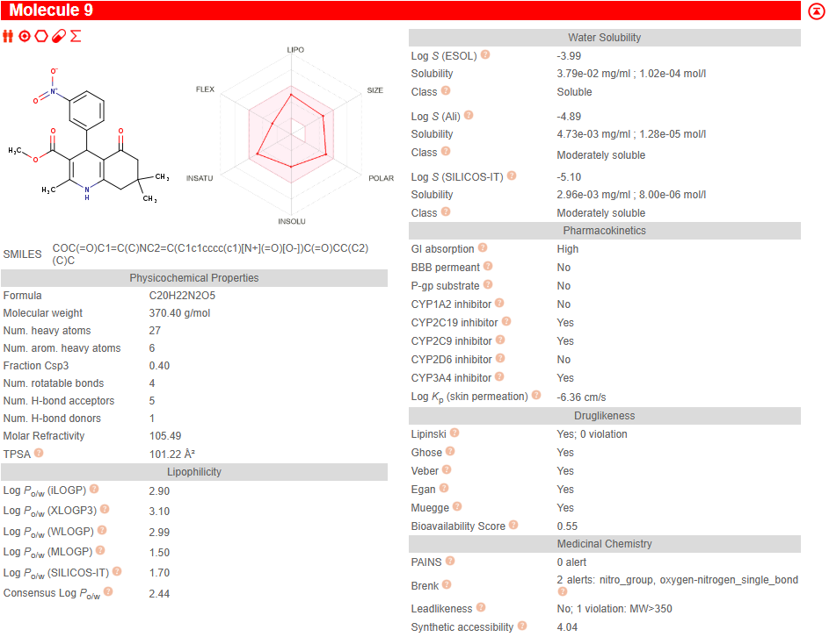

6e
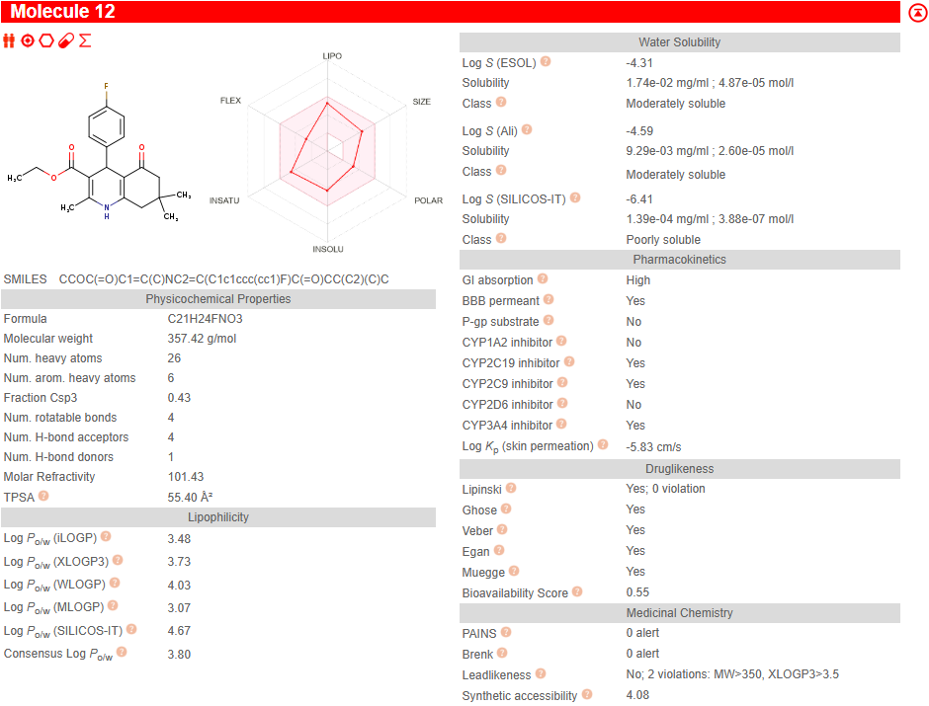
6f
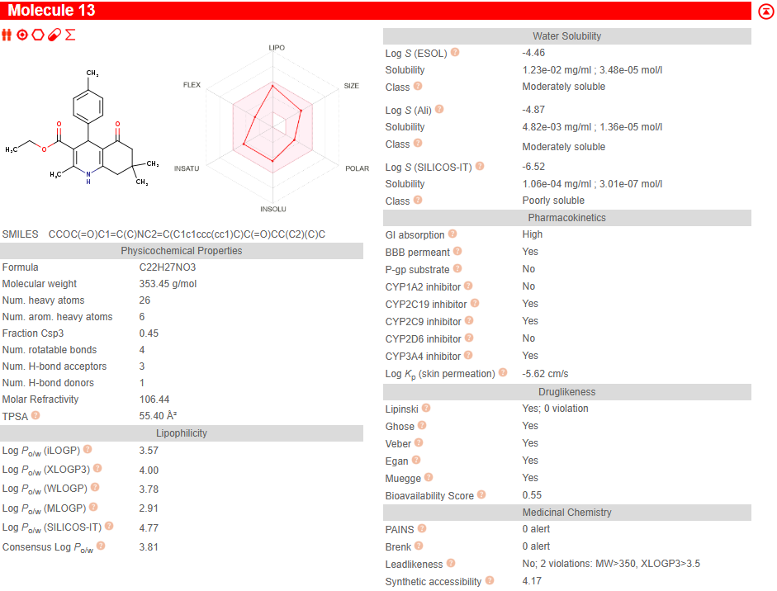

6g
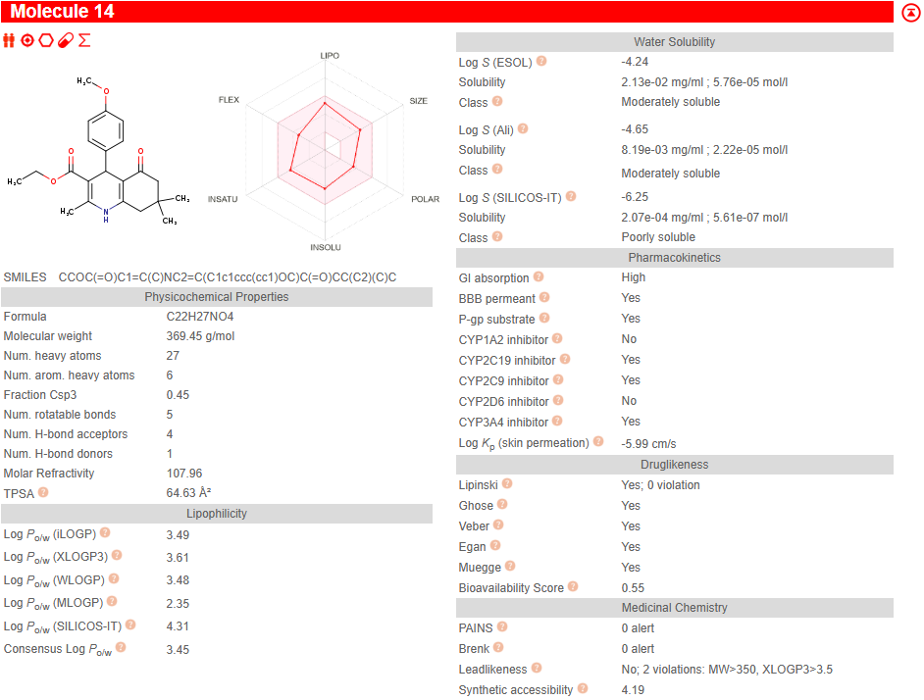

PRM 01) 5a
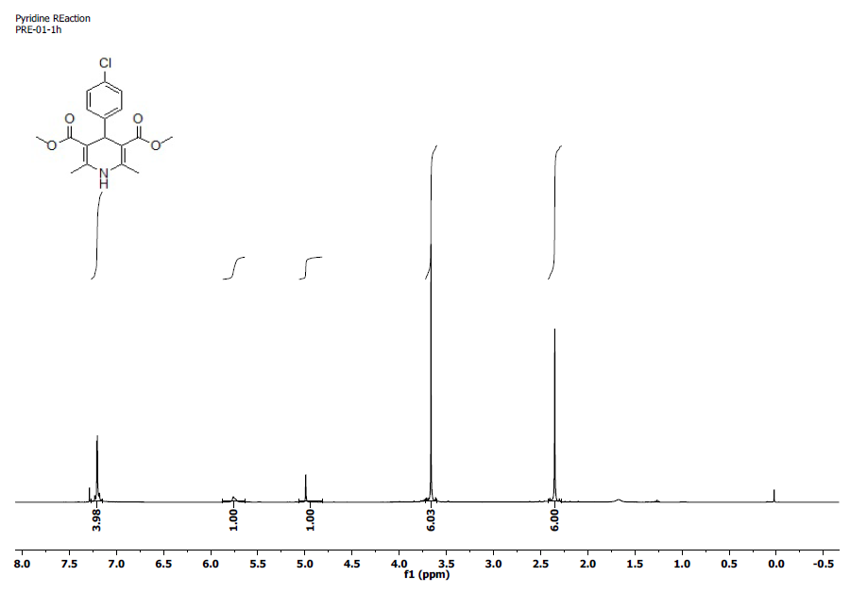
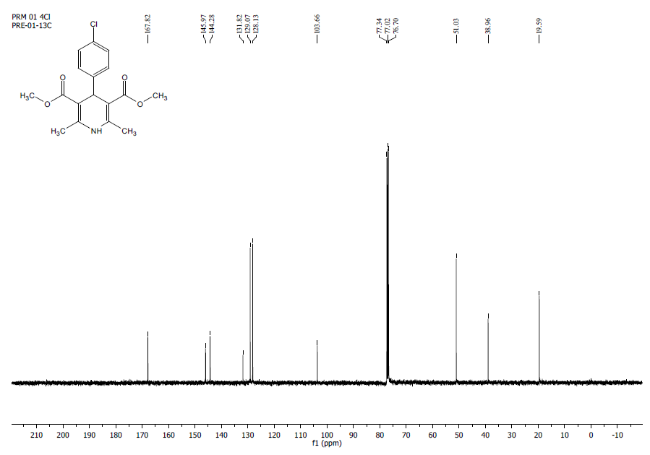
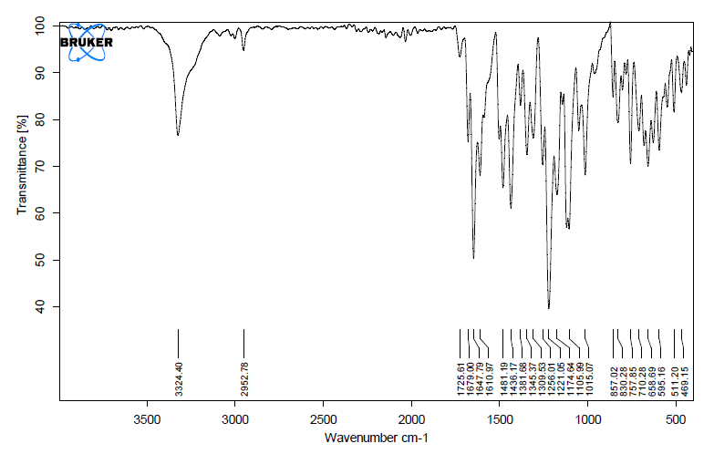
PRM 02) 5b
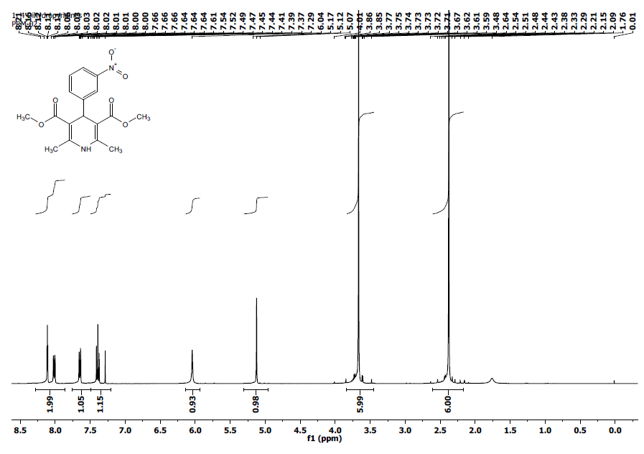
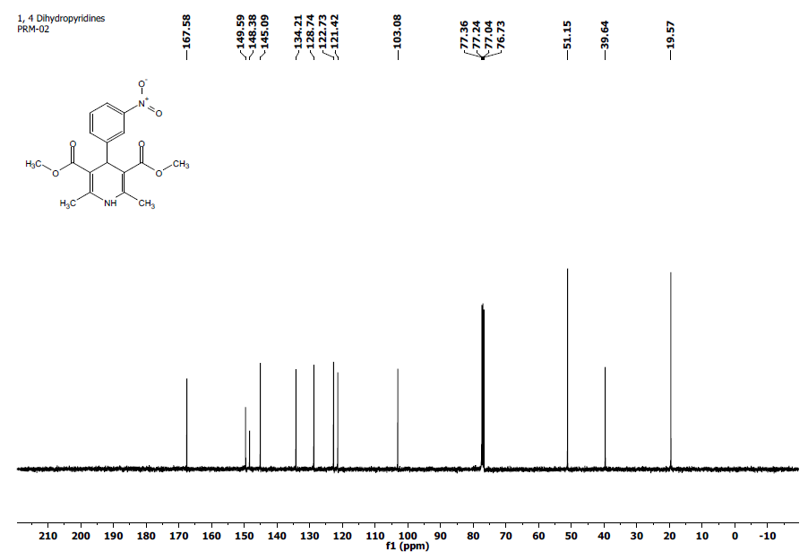
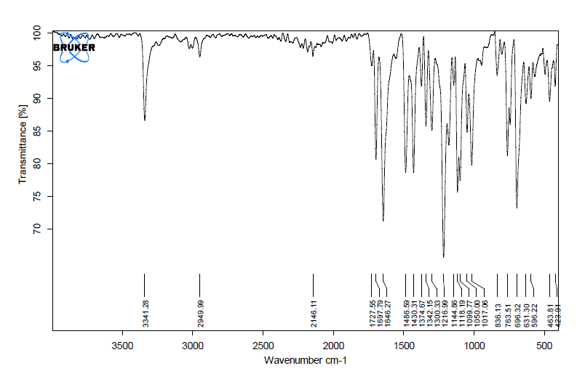

PRM 03) 5c
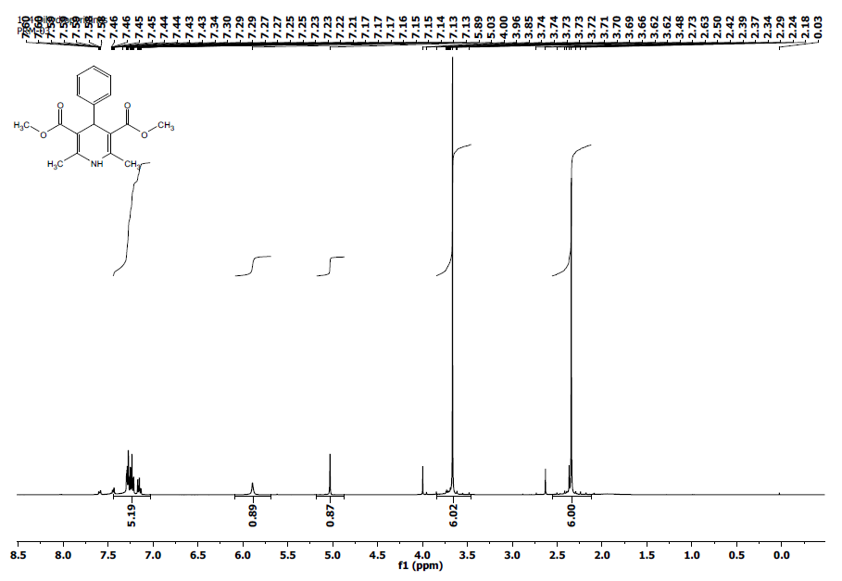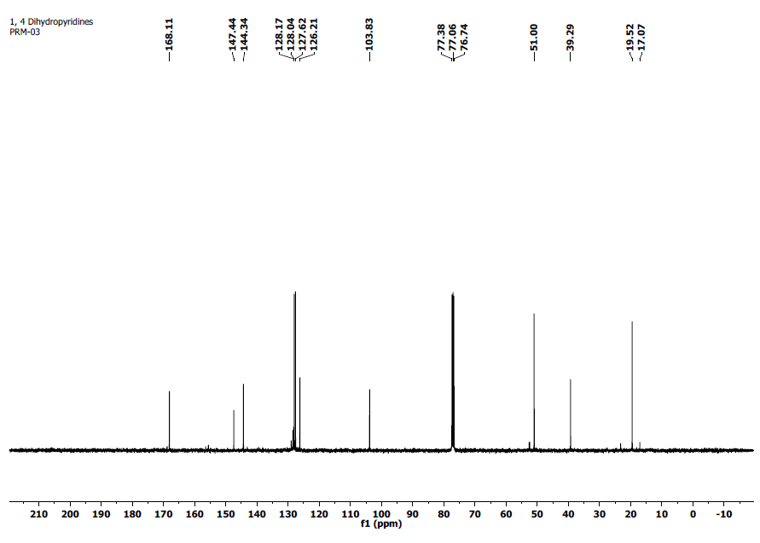

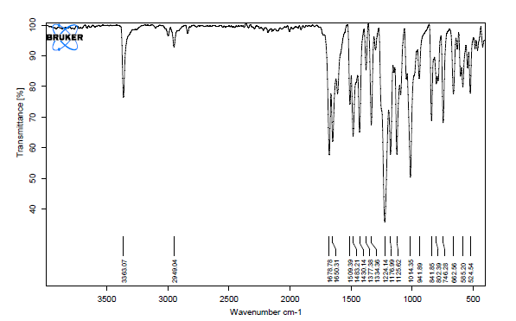
PRM 04) 5d
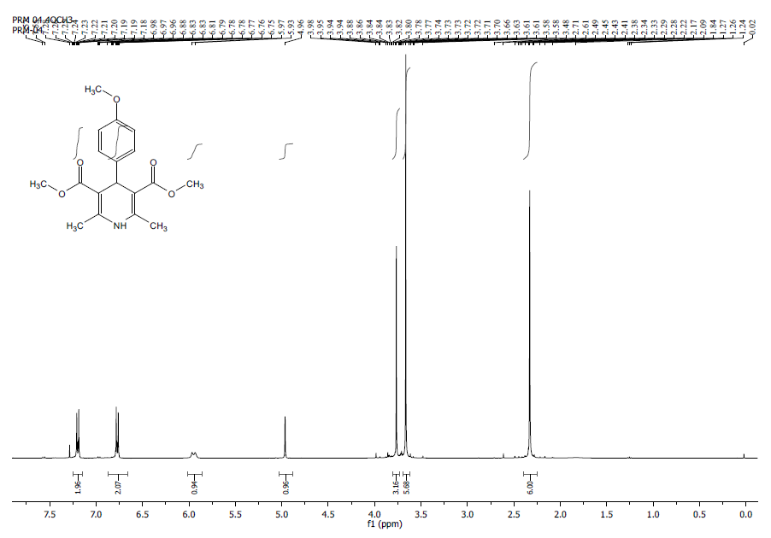
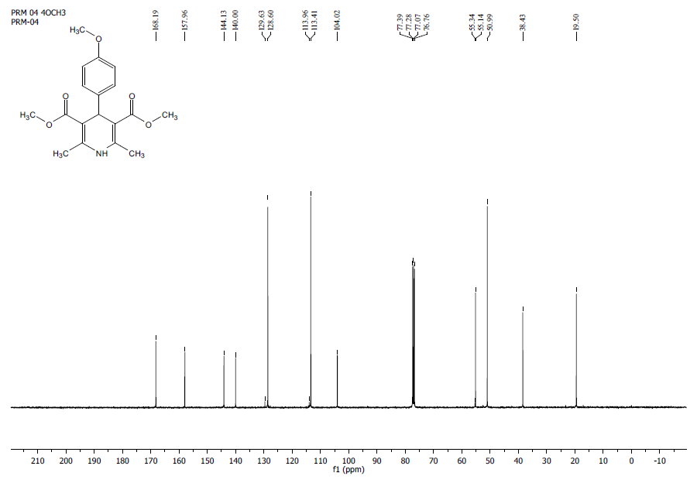
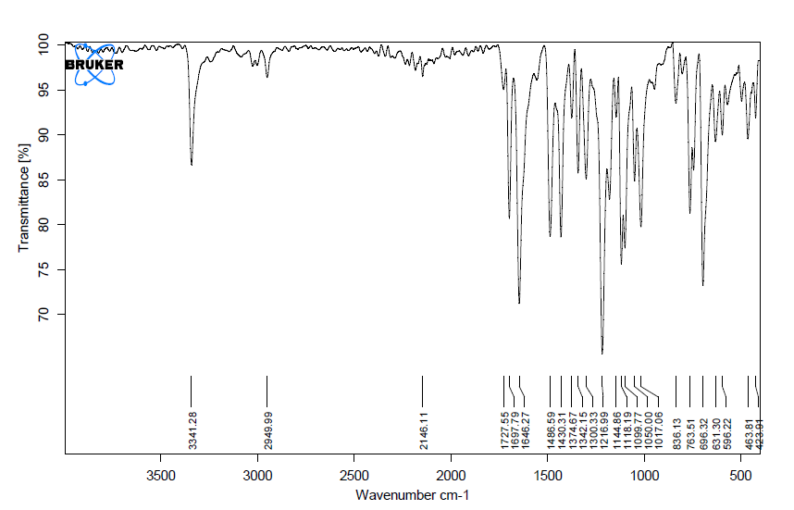

PRM 05) 5e
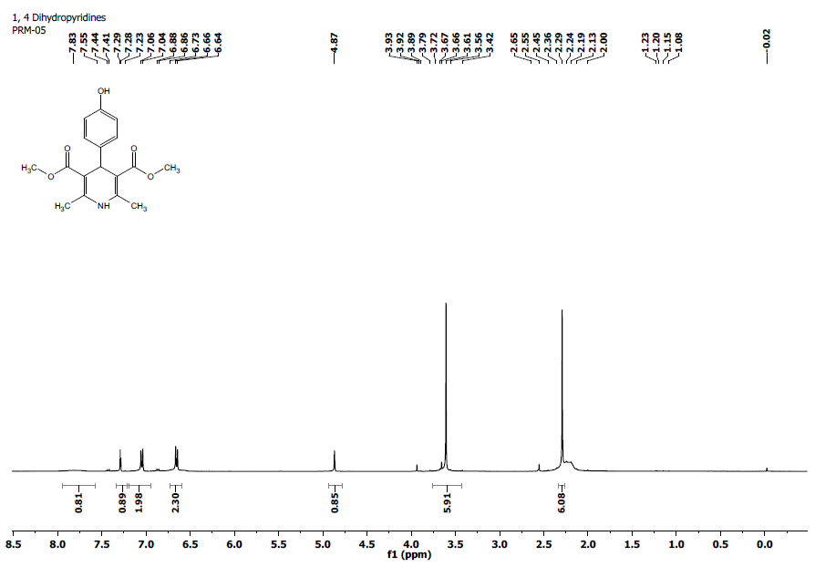
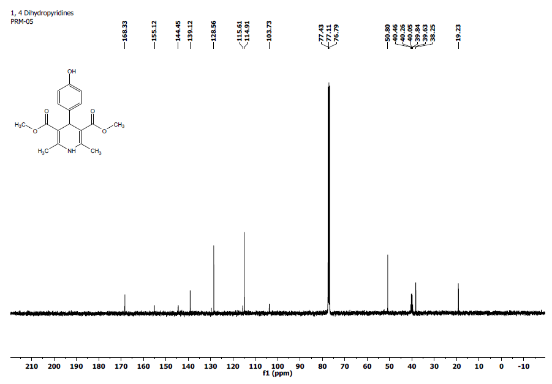
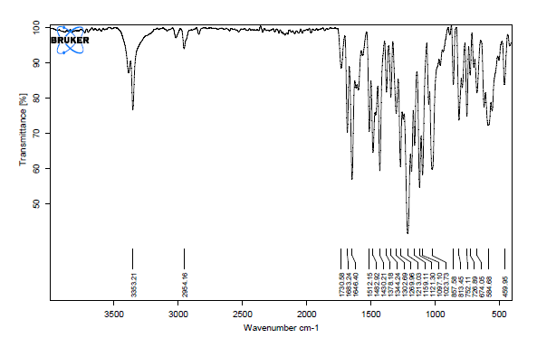
PRE 01) 5f

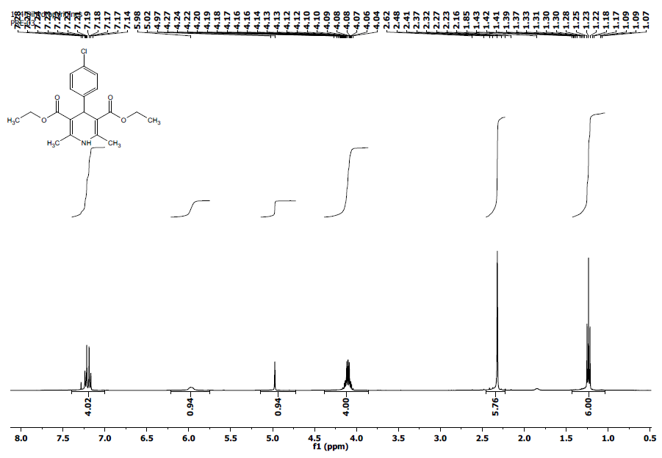
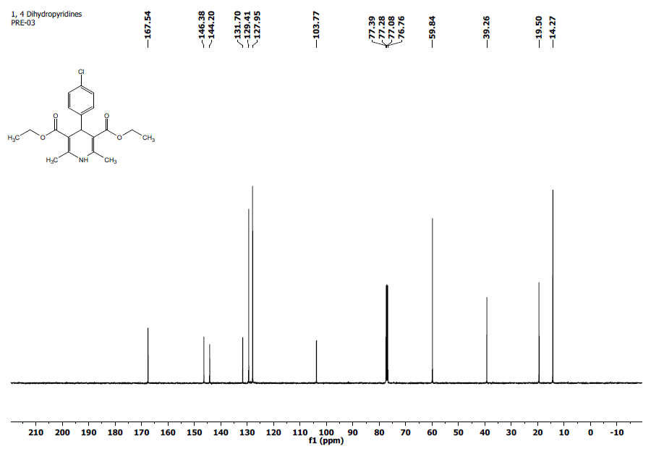
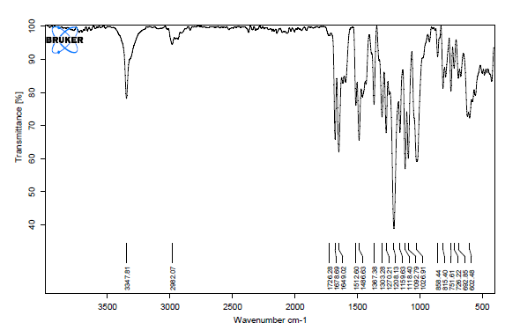

PRE 02) 5g
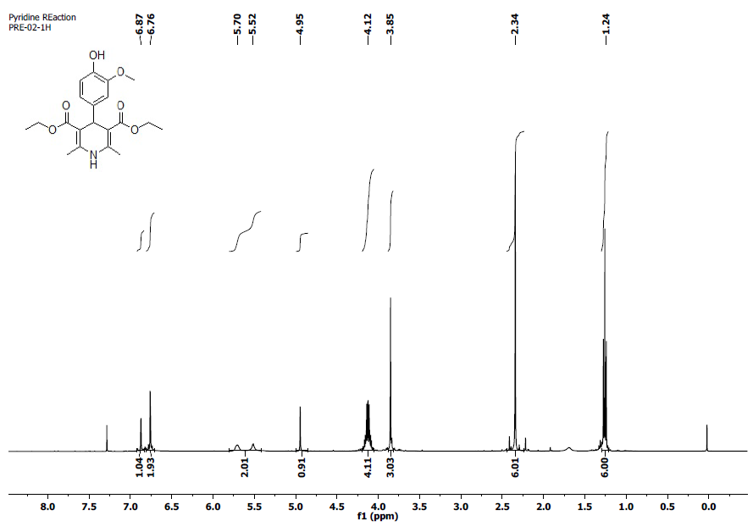
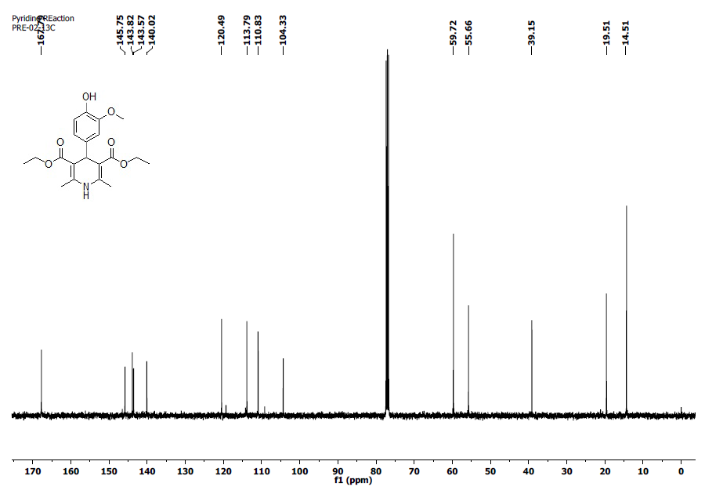
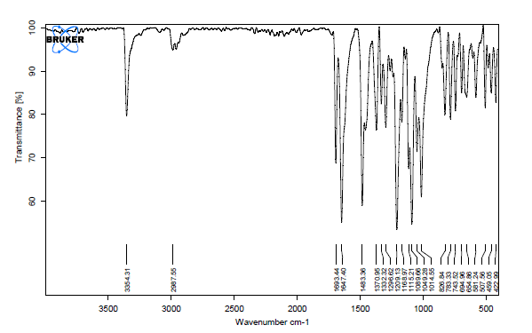
DPM 1 ) 6a
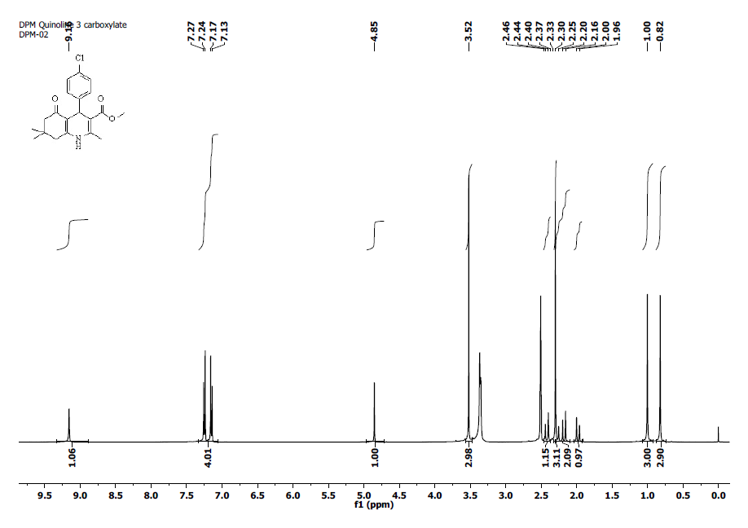
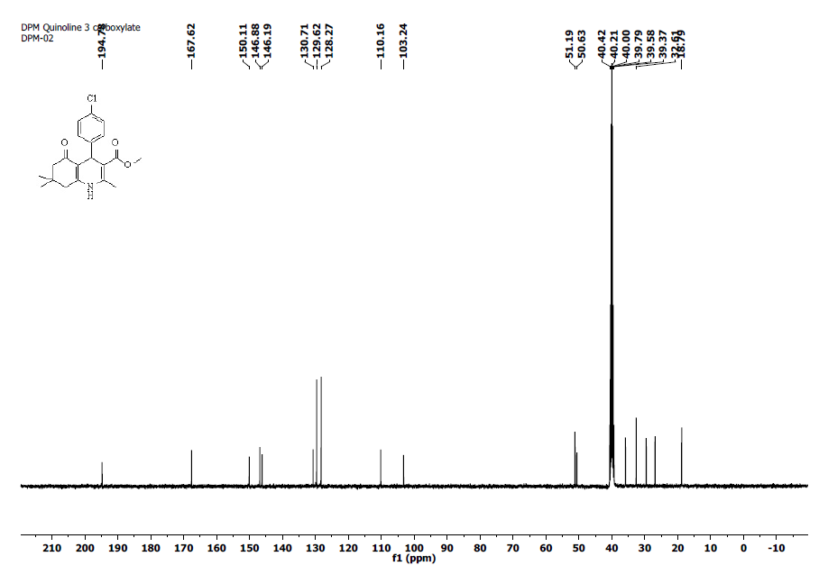
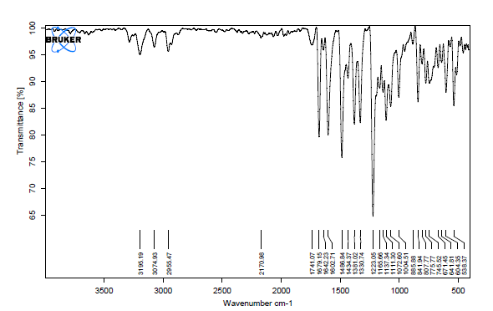

DPM 2) 6b
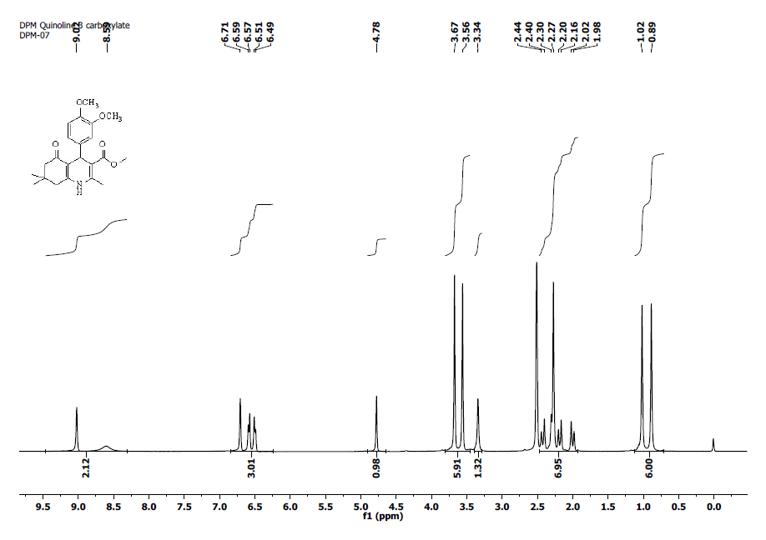
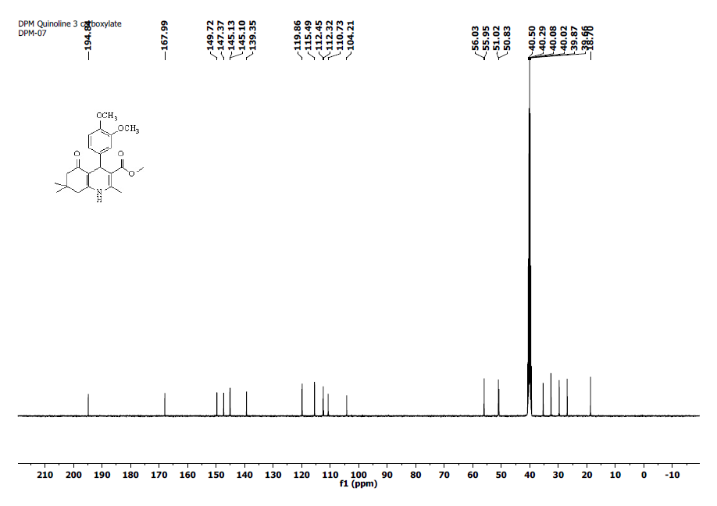
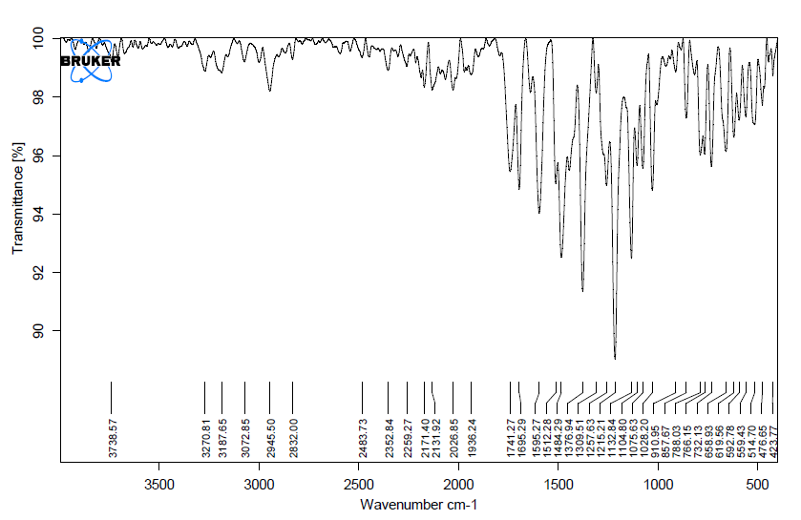

DPM 03) 6c
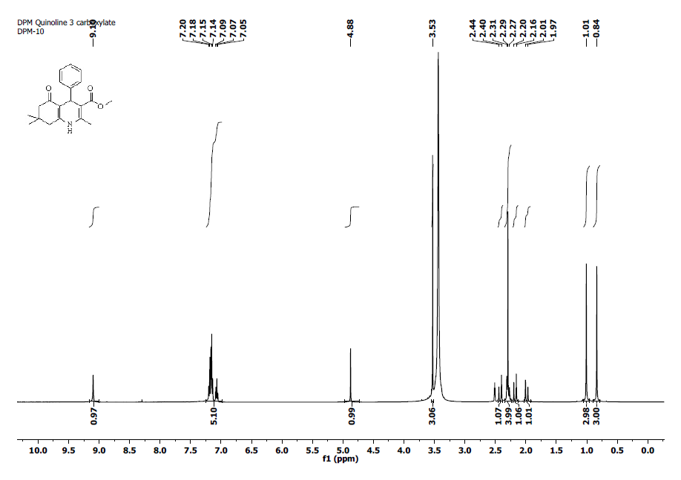
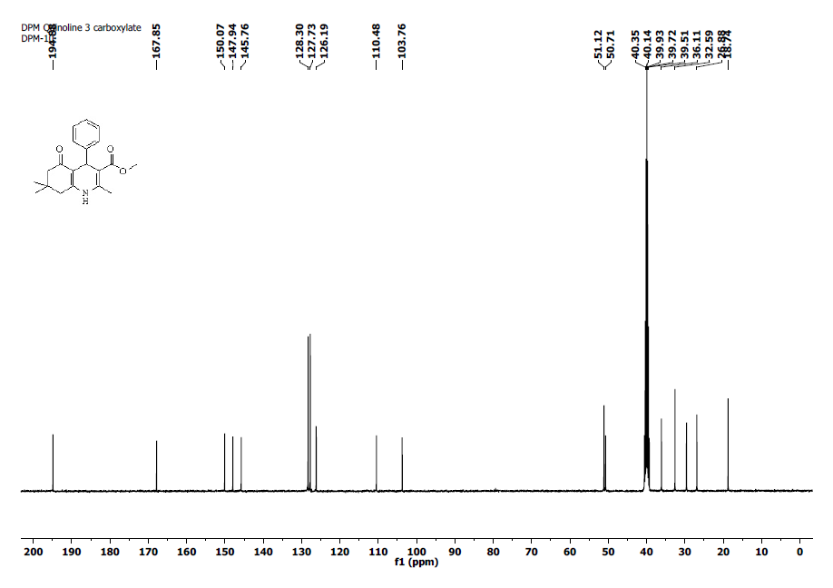
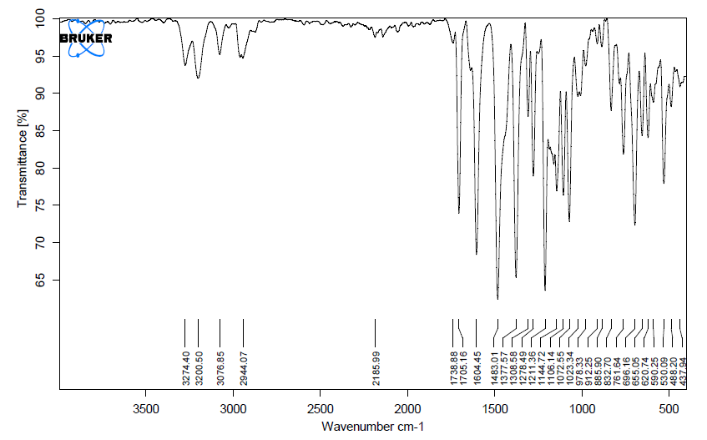

DPM 04) 6d
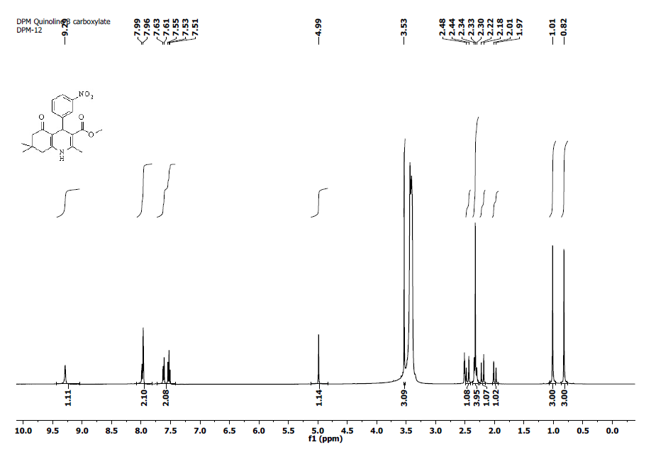
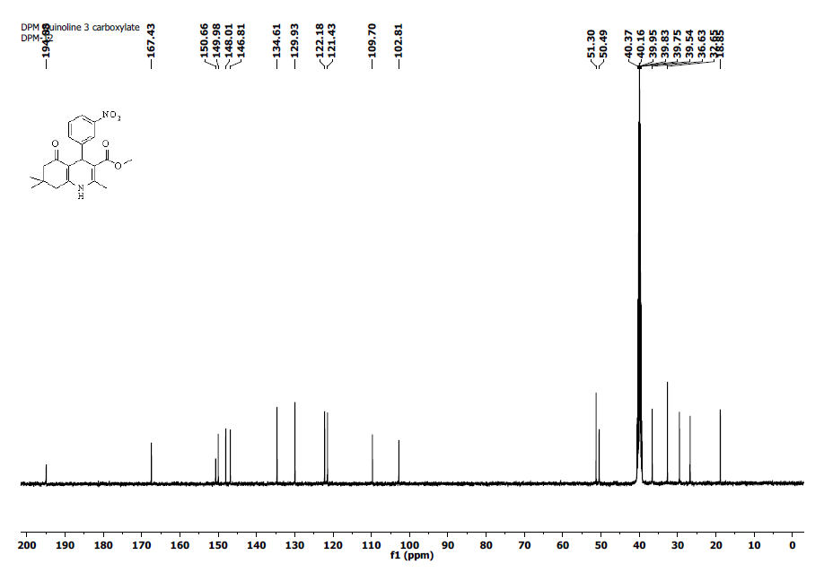
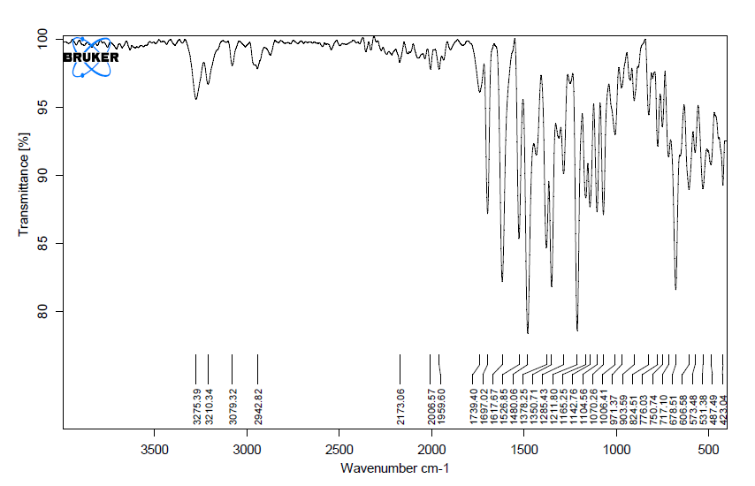
DPE 01) 6e
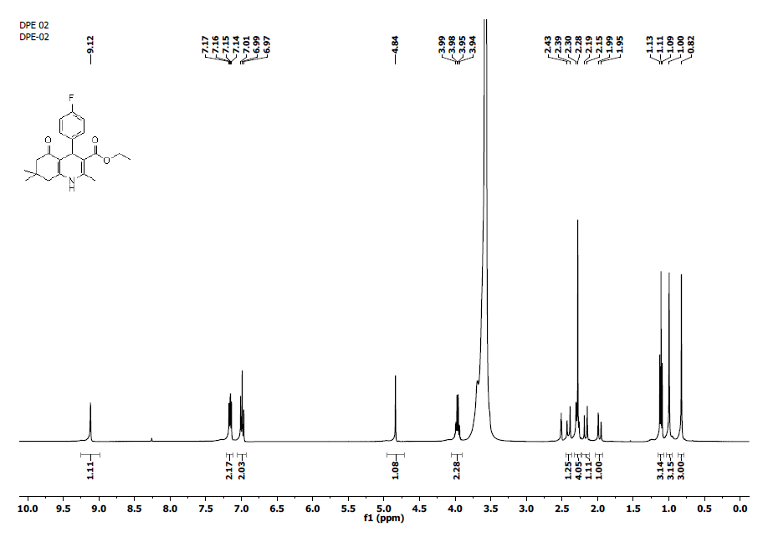
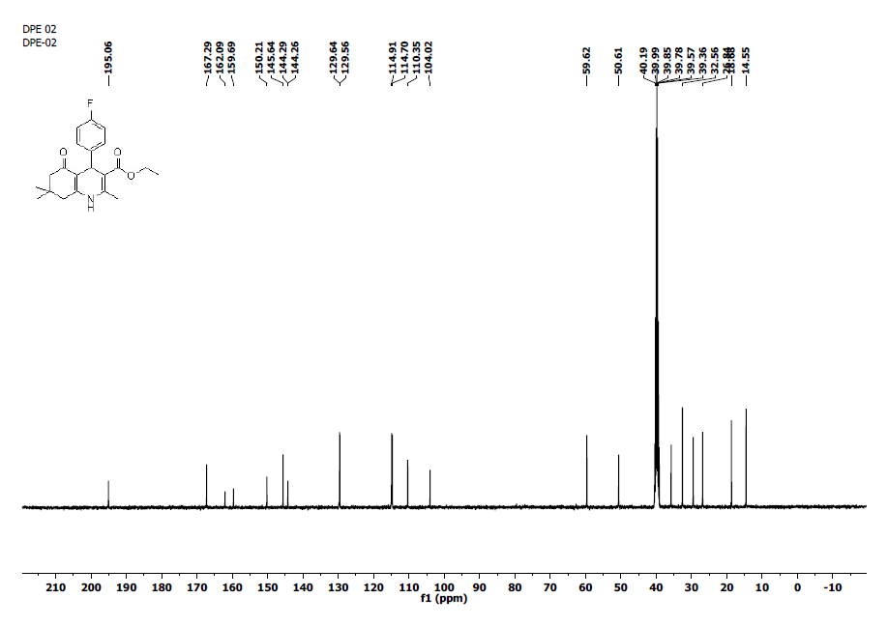
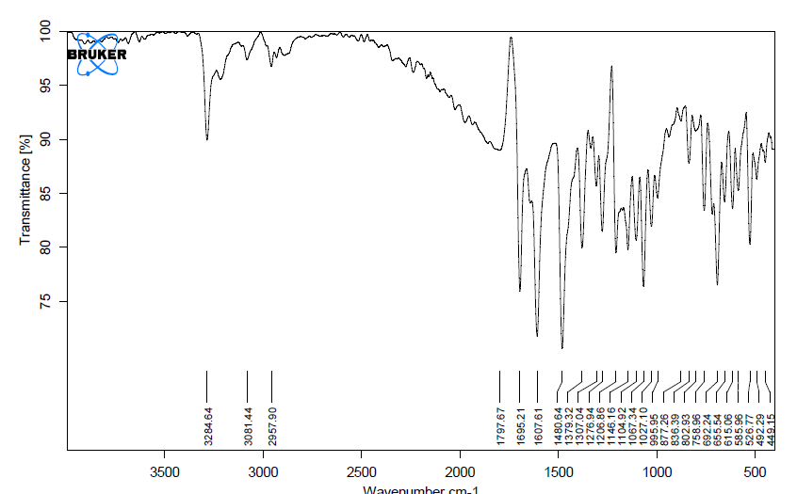

DPE 02) 6f
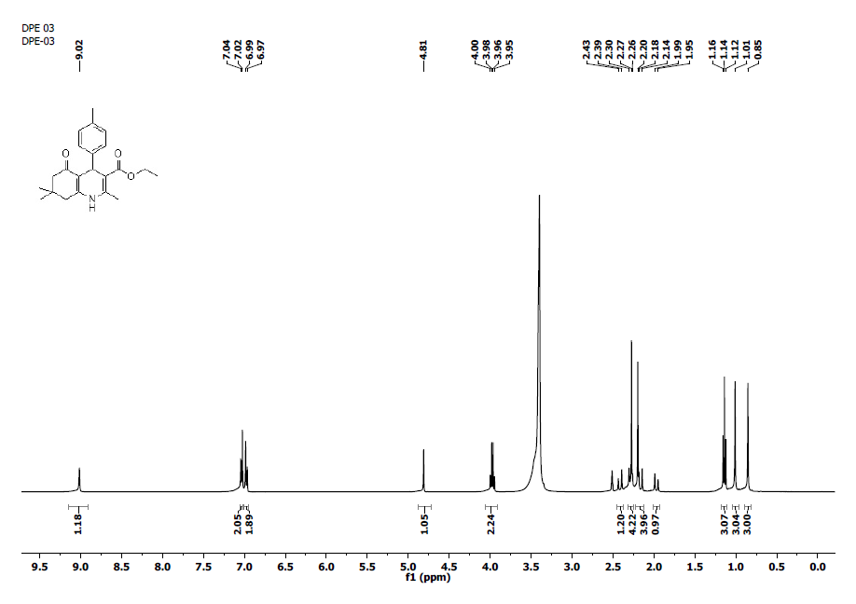
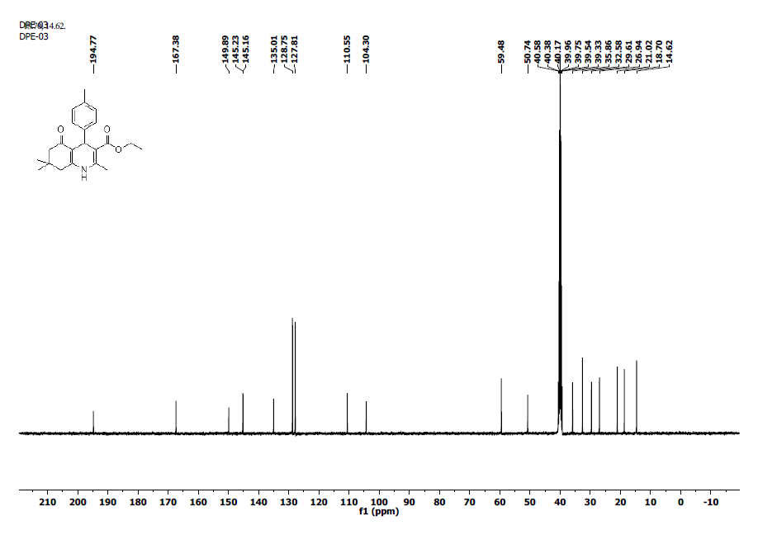
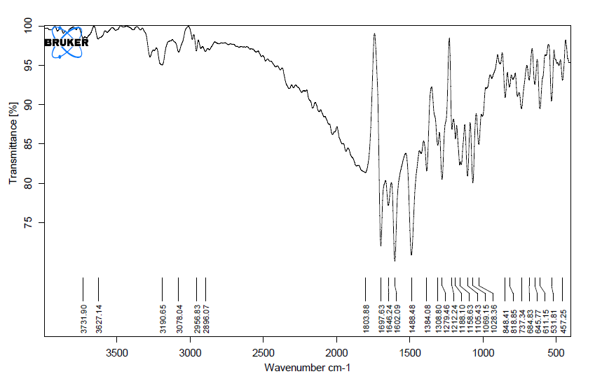
DPE 03) 6g
