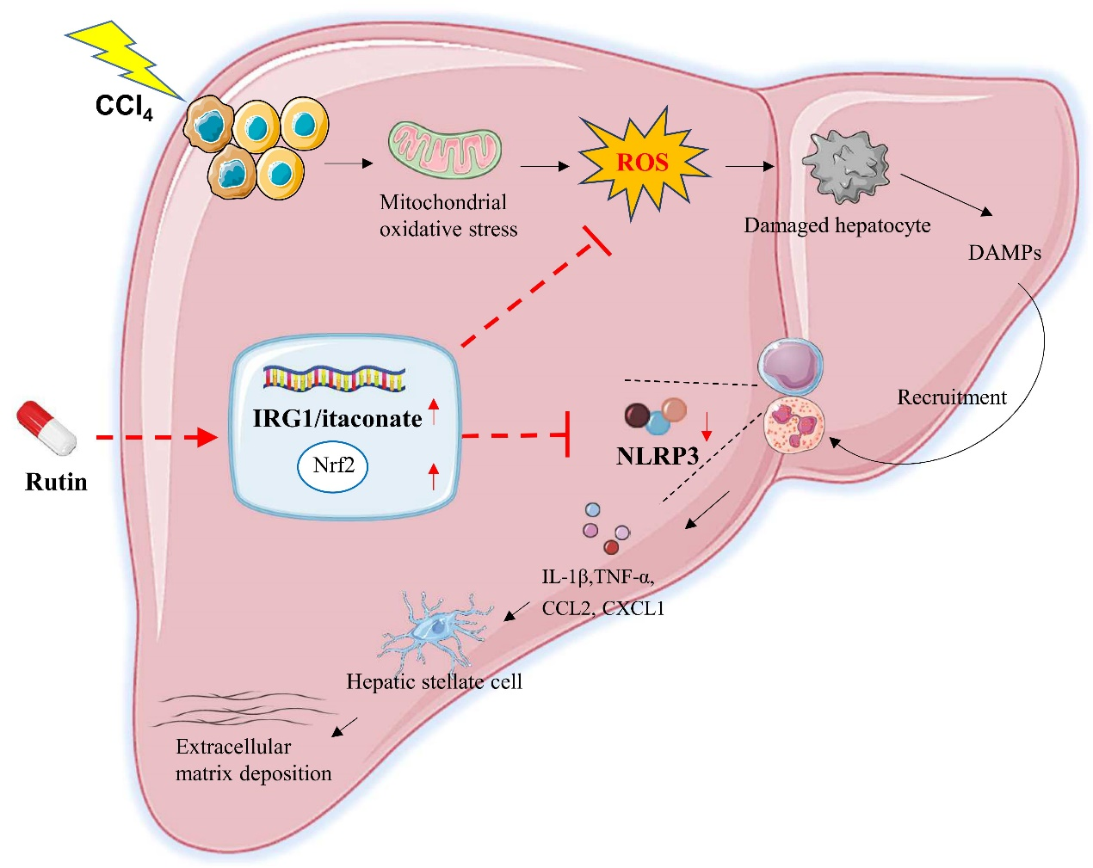
Diagram of the underlying mechanisms of Rutin alleviated hepatic fibrosis.

