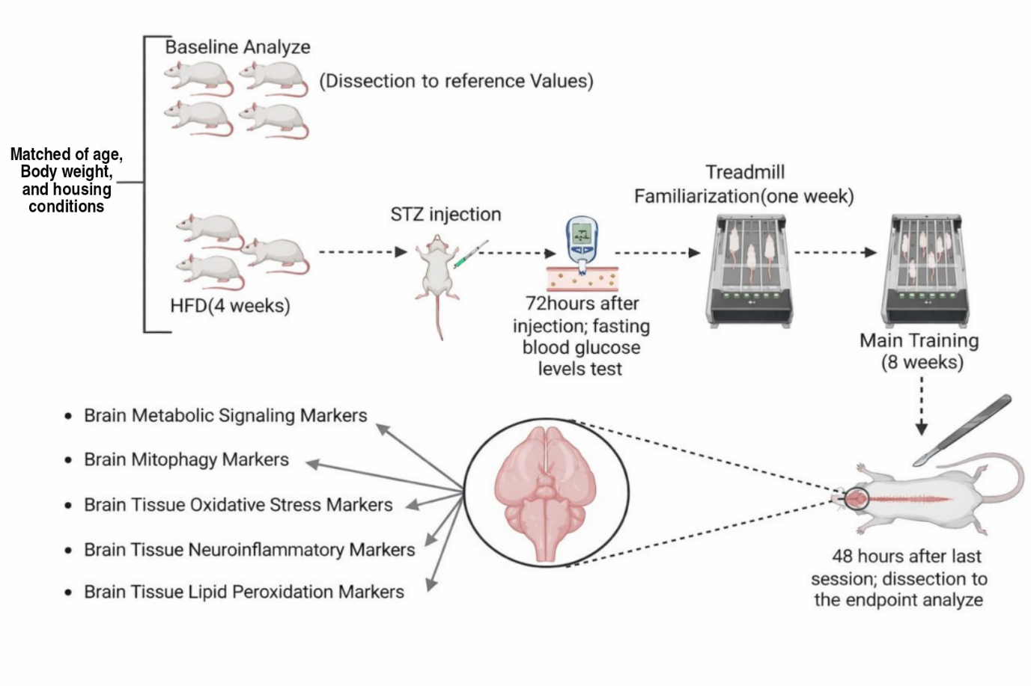
Figure1.Schematic representation of the experimental design

