Supplementary file 1

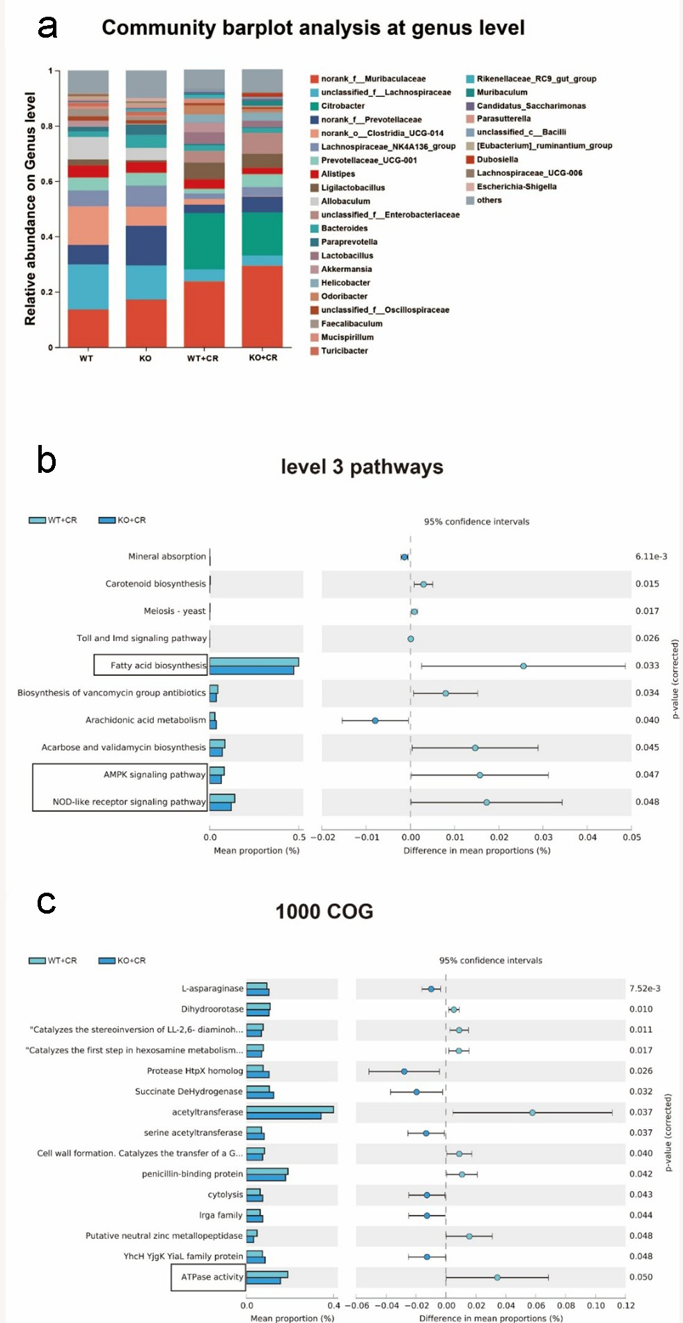
Fig. S1 (a) Bacterial composition at genus level; (b-c) Prediction of 16S rRNA gene function based on KEGG at level 3 (b) and the most abundant 1000 COG functions (c). WT (healthy control); WT: wild type; WT+CR: C. rodentium-induced WT colitis; KO: ATPIF1^{−/−}; KO+CR: C. rodentium-induced ATPIF1^{−/−} colitis.

Table S1. Primer sequences in RT-qPCR
Items | Forward primer (5'-3') | Reverse primer (5'-3')
TNF-α | CCCTCACACTCAGATCATCTTCT | GCTACGACGTGGGCTACAG
IL-1β | GCAACTGTTCCTGAACTCAACT | ATCTTTTGGGGTCCGTCAACT
IL-6 | TAGTCCTTCCTACCCCAATTTCC | TTGGTCCTTAGCCACTCCTTC
ZO-1 | GCCGCTAAGAGCACAGCAA | GCCCTCCTTTTAACACATCAGA
GAPDH | TCTGGAAAGCTGTGGCGTGAT | TCTGGAAAGCTGTGGCGTGAT

