Supplementary Material: Integrated bioinformatics analysis reveals ISG15, IFIH1, OAS2, MX1, and CXCL10 as predictive biomarkers of neoadjuvant chemotherapy response in triple-negative breast cancer

Results
PPI Network Construction:
The network had a systematic analysis using four algorithms from the CytoHubba plugin: MCC (Maximal Clique Centrality) in Figure Supp 1 and Table Supp 1. Bottleneck centrality in Figure Supp 2 and Table Supp 2. Degree centrality in Figure Supp 3 and Table Supp 3. Finally Closeness centrality in Figure Supp 4 and Table Supp 4. We utilized these centrality measure to effectively identify hub genes. The results were additionally cross-validated using the original degree analysis in Cytoscape.

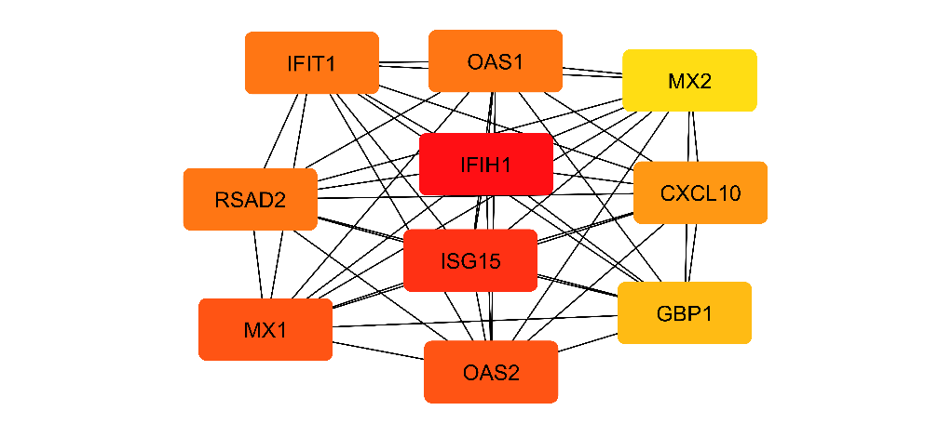
Figure Supp 1. This network displays the Top 10 highly interconnected hub genes identified via MCC. The nodes represent the key proteins/genes (IFIH1, ISG15, IFIT1, OAS1, MX1, MX2, RSAD2, OAS2, GBP1, and CXCL10), and the connecting lines (edges) indicate known protein-protein interactions (PPIs). The color intensity reflects the node's centrality score, highlighting the highly interconnected nature of these critical components

Table Supp 1. MCC centrality Metrics for the Top 10 Hub Genes.
Rank | Name | Score
1 | IFIH1 | 2.63E+11
2 | ISG15 | 2.63E+11
3 | MX1 | 2.63E+11
4 | OAS2 | 2.63E+11
5 | RSAD2 | 2.63E+11
6 | OAS1 | 2.63E+11
7 | IFIT1 | 2.63E+11
8 | CXCL10 | 2.63E+11
9 | GBP1 | 2.63E+11
10 | MX2 | 2.63E+11

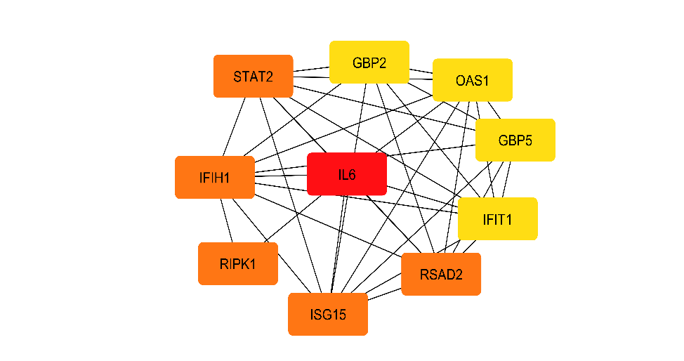
Figure Supp 2. subnetwork displays the PPIs among the Top 10 Bottleneck Hub Genes. These genes function as critical bridges, connecting major network modules and pathways. Nodes represent the proteins/genes, and edges indicate known interactions.

Table Supp 2. Bottleneck centrality Metrics for the Top 10 Hub Genes.
Rank | Name | Score
1 | IL6 | 5
2 | RSAD2 | 2
2 | ISG15 | 2
2 | IFIH1 | 2
2 | RIPK1 | 2
5 | STAT2 | 2
7 | GBP5 | 1
7 | OAS1 | 1
7 | GBP2 | 1
7 | IFIT1 | 1
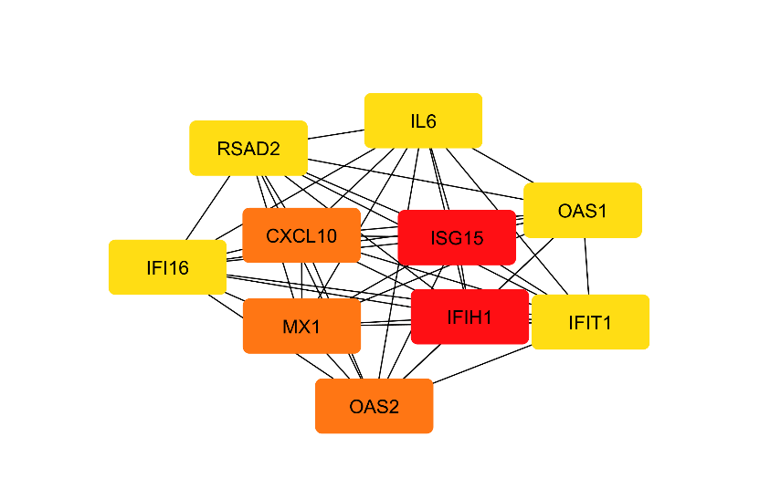
Figure Supp 3. Visualization of Top Hub Genes Based on Degree Centrality. The subnetwork displays the top 10 hub genes identified by the Degree Centrality metric, highlighting the most connected components of the full interaction network. These genes are crucial due to their extensive number of direct PPIs.

Table Supp 3. Degree centrality Metrics for the Top 10 Hub Genes.
Rank | Name | Score
1 | ISG15 | 22
1 | IFIH1 | 22
3 | MX1 | 21
3 | CXCL10 | 21
3 | OAS2 | 21
6 | RSAD2 | 20
6 | IL6 | 20
6 | OAS1 | 20
6 | IFIT1 | 20
6 | IFI16 | 20

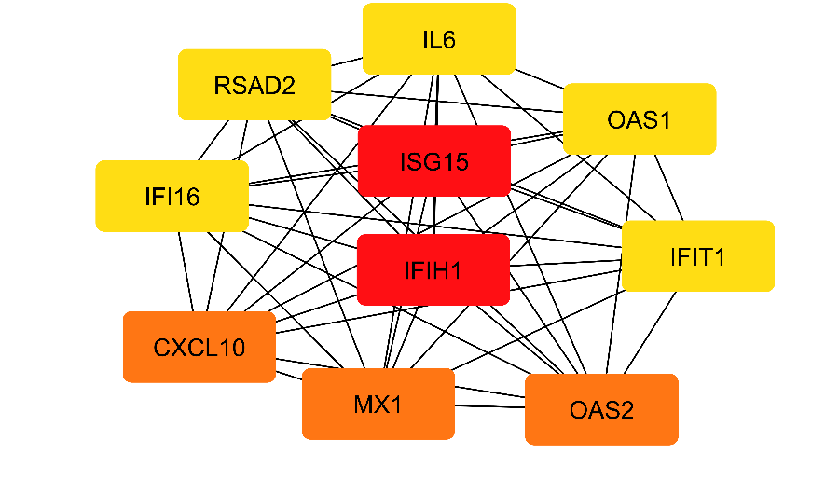
Figure Supp 4. Visualization of Top Hub Genes Based on Closeness Centrality. The subnetwork displays the top 10 hub genes identified using the Closeness Centrality metric. These genes are the most centrally located within the network, minimizing their distance to all other nodes. This central positioning suggests they are crucial for rapid signal propagation and coordination across the network.

Table Supp 4. Closeness centrality Metrics for the Top 10 Hub Genes.
Rank | Name | Score
1 | ISG15 | 24
1 | IFIH1 | 24
3 | MX1 | 23.5
3 | CXCL10 | 23.5
3 | OAS2 | 23.5
6 | RSAD2 | 23
6 | IL6 | 23
6 | OAS1 | 23
6 | IFIT1 | 23
6 | IFI16 | 23

